Developing an information map

For whom is this guidance intended?

This guidance is intended for University staff responsible for setting up records management systems in their part of the University. It gives detailed advice on how to map the functions and information held by business units prior to establishing filing schemes and retention schedules.

What is an information map?

As its name suggests, an information map shows the different types of information held by the University, and where this information can be found. It is derived from an analysis of the functions, activities and transactions carried out by the University.

A function is what the University does to achieve its goals and strategies, such as teaching, research, governance or finance. An activity is how we carry out our functions, such as by developing teaching quality standards. Transactions are the individual tasks which make up activities. Each part of the University will probably contribute towards several functions.

Information maps will exist at different levels of detail, ranging from a high-level overview of the University’s functions, to detailed listing of all the types of records created by a particular task and the flow of information between tasks.

The information map should cover records in all formats, including paper files, maps and plans, e-mail, databases, and any other electronic information.

Why do we need an information map?

The Freedom of Information (Scotland) Act 2002 places an obligation on us to respond to requests from anyone for any of the information we hold, including research information. Although we do not always have to provide the requested information, in all cases we have to say whether or not we hold it. We cannot answer these questions unless we know what information the University holds.

An information map will also provide business benefits. It will help us to locate and manage the University’s information assets as for the first time we will know what information we hold and why. The information map will form the basis of retention schedules, setting out how long we should hold particular types of information, and will also provide a structure for organising our information.

The mapping process also offers benefits for other functions apart from records management. For example, it will be of use in supporting planning functions.

Who compiles and maintains the information map?

The University Records Manager will manage the highest-level information map. More detailed maps will be managed and compiled by individuals in the University responsible for carrying out the functions covered by the map, or by nominated administrators with responsibility for records management in particular business areas. As functions sometimes cross organisational boundaries, it may be necessary for staff from different sections to co-operate to draw up a joint map for particular functions.

How do I develop an information map?

For smaller, carefully delimited functions it would be possible to develop an information map using a combination of brainstorming, interviews and questionnaires.

However, for larger functional areas a more structured approach is preferable. For this you may choose to use the IDEF(0) methodology. A functional and process map for the University’s planning functions, compiled using this methodology can be seen at: http://www.recordsmanagement.ed.ac.uk/InfoStaff/rmstaff/rmprojects/jiscplanfun.htm#Project%20report.

The Integrated DEFinition (IDEF) methodology consists of a suite of methods that can be used to analyse an organisation and its processes. The IDEF(0) method is used to specify function models, in other words "what do I do" models. As shown in Figure 1, the model indicates major functions and the inputs (I), controls (C), outputs (O), and mechanisms (M) associated with each activity. These are collectively referred to as ICOMs.

Figure 1: IDEF(0) methodology: ICOMs

Inputs are the resources consumed or transformed by a process. Outputs are the things created by the process. Controls are the standards, policies, guidelines, etc that guide the process. Mechanisms are the agents (people, manual tools, automated tools, etc) that accomplish the actions delineated within the process. Records and information will appear on the lower level maps as inputs or outputs.

Start an information map by listing at a very high level the functions that your business area carries out. For example, the high level functions of the University’s Planning Section are: agreeing strategic priorities, monitoring progress, managing the planning process, developing the University budget and data anlysis.

These functions should then be decomposed to show lower-level activities and ICOMs. For example, monitoring progress against the University plan broke down into a number of activities, such as compiling accountability returns and monitoring student number. At the lowest level of granularity, the map will identify the types of information used and produced by each function. These will make up the records which should be captured to document the function concerned. For example, when the activities involved in compiling accountability returns were identified it was clear that they gave rise to records such as progress reports and instructions on how to compile progress reports.
The hierarchy of diagrams is maintained via a numbering schema that connects parent and child diagrams. Figure 2 shows this with an A0, A1, and A12 numbering as an example.

An example of a functional model compiled using the IDEF (0) methodology is available at:
http://www.recordsmanagement.ed.ac.uk/InfoStaff/rmstaff/rmprojects/PlanFunReport/InfoMapvfinal.pdf

In developing an information map it is important to ensure that the map is fully comprehensive and covers all the situations in your business area. This may involve consulting with other members of staff in your area.

Maintaining the information map

Organisations change over time, and for an information map to remain of value it must be kept up to date. It is advisable to review schedules every five years to confirm that they are still relevant. Issues to consider are:
- Have the functions changed since the schedule was compiled?
- Have the processes changed?
- Has the information generated and used changed?

This programme of review is intended to identify changes which might otherwise have been overlooked. It is not intended to replace ad hoc updates made to the information map as and when change occurs.

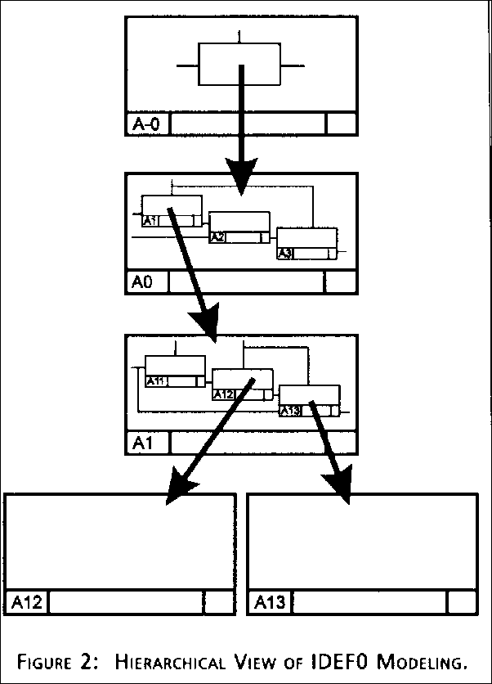

If you amend your information map, a copy of the new map should be sent to the Records Management Section.

What help is available?

The University Records Management Section provides advice, guidance and training on data protection, records management and freedom of information issues. Although we cannot develop and maintain your information map for you, we can provide training on developing an information map, facilitate workshops to help you develop your information map, give you detailed advice on work in progress and serve as expert advisers on records management project boards. Copies of all final draft information maps should be sent to the Section for comment, and final information maps should be sent to the Section to help us maintain the University’s overall information map.

The Joint Information Systems Committee (JISC) have prepared a high-level study of the functions and activities of universities which can use as the starting point for preparing information maps. It can be found at: http://www.jisc.ac.uk/index.cfm?name=recordsman_papers_cycle

Further information on the IDEF methodology is available from Robert P Hanrahan’s The IDEF Process Modelling Methodology (1995), available at http://www.stsc.hill.af.mil/crosstalk/frames.asp?uri=1995/06/IDEF.asp

Susan Graham
April 2004

From Robert P Hanrahan, The IDEF Process Modelling Methodology (1995), available at http://www.stsc.hill.af.mil/crosstalk/frames.asp?uri=1995/06/IDEF.asp.
From Robert P Hanrahan, The IDEF Process Modelling Methodology (1995), available at http://www.stsc.hill.af.mil/crosstalk/frames.asp?uri=1995/06/IDEF.asp.

