Project:Koi

Ben Howard possibly.philip@gmail.com

Bomb Code inc.

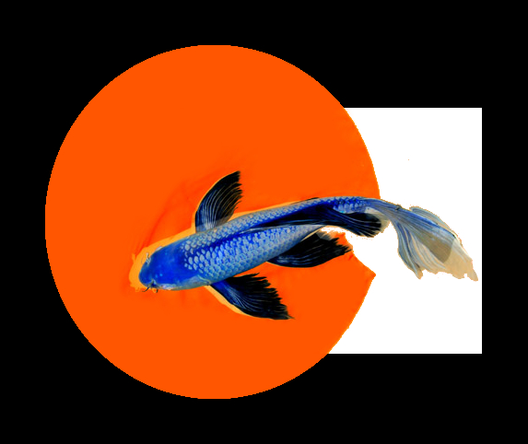
Copyrights and Legal Notice

All algorithmic intellectual property is the sole work of Ben Howard
Bomb Code inc,Koi and  are registered trademarks of Ben Howard.

Signatures

____________________________________________________________________ Date:______________________
P Benjamin Howard

Date: _____________________
Instructor, OIT

Date: _____________________
Instructor, OIT

Change Log
Date | Version | Who | What Changed
10/03/10 | Alpha
10/12/10 | 1.5 | Ben | Gimp plugin application direction

Copyrights and Legal Notice ii
Signatures ii
Change Log iii
1 Introduction 5
1.1 Project Goal Statement 5
1.2 Major Features or Objectives 5
2 Customers 5
3 Project Success 5
4 Risk Management 5
5 Technical Environment 6
6 Summer Work Plan 6
7 Appendix A – Glossary 6

Introduction
Koi is a system that can identify and highlight image manipulation artifacts. In a world of digital media, every image is suspect of forgery. Koi can put to rest the fear publishers, news agencies and critics have of showcasing an image later found to be digitally edited. Front page news has had its share of embarrassing forgeries published. With Koi in place an image can be properly inspected for signs of forgery before it is published. Some companies have forged images for public relations campaigns which news media picked up, individuals fake images for media attention or because of social pressure online. Images “photoshopped” for fun have ended up being the center of news media attention only to be discovered as fakes.. Modern companies have started using social networking site content in their employee hiring process. Knowing if an image has been altered could provide employers with an edge in hiring the best employees possible. With digital images becoming ever more popular police and other law enforcement agencies need to be able to verify whether images have been altered for use in court as evidence. With forged images rampant, publishing and verifying content is a huge edge in the information age. Whenever an image is digitally altered the software doing the modification changes the original image in ways that may not be detectable to the unaided eye. By applying filters, running transforms and other proprietary Koi algorithms on an image the modifications can be highlighted and exposed. Every contact leaves a trace – Koi can find it.

Project Goal Statement
Koi will be a Gimp plugin able to identify image manipulation artifacts in an image, highlight modified areas and return a percent chance of forgery by June 2011.

Major Features or Objectives

- Return an accurate percent chance of image forgery
- highlight areas likely to be forged in an image

Customers
Publishers of digital images will benefit greatly from the security of knowing they are publishing unedited images. News agencies stake their reputation on publishing the truth and with Koi they will be able to verify second hand image content before they publish it. Modern companies have started using social networking site content in their employee hiring process. Knowing if an image has been altered could provide employers with an edge. With digital images becoming ever more popular police and other law enforcement agencies need to be able to verify whether images have been altered for use in court as evidence. The public will also enjoy news and other digital image content more because they will be able to trust it.

Project Success
- Koi will identify 80% of altered images
- Koi will highlight altered ares in an image

Risk Management
Risk ID | Risk Description | Risk Impact (1-10) | Risk Likelihood (1-10) | Risk Priority (Impact * Likelihood)
1 | Algorithmic detection of image modification is inaccurate | 10 | 2 | 20
2 | Algorithmic detection of image modification is too slow | 3 | 3 | 9
3 | Programming in a Linux environment is too complicated | 2 | 1 | 2
4

Technical Environment
Technical Area | Technical Tool Used | Where You Learned the Technology
Programming Language(s) | C, c# | OIT
Image processing | software | I have learned this through personal research and development
Linux programming environment | Linux | I am learning this through research and expert help
Parallel processing | Multi threaded applications | I know some but will need to learn more
Open source |  | I am learning this through research
Gimp plugin | Gimp API's | I will be learning this during the course

Summer Work Plan
Over the summer I did some research in the area of image manipulation artifact detection. It can be done and there are standard algorithms emerging. I feel confident that I will be able to write software to identify most forged images by artifact detection alone. I have spent some time setting up a linux development environment and if it becomes too time consuming to work with I will switch back to Microsoft visual studio which I am very familiar with.

Appendix A – Glossary
Image processing. Anytime a software algorithm performs an operation on an image.
Image manipulation: anytime an image is modified from its original state.
Artifact. A finger print left behind intentionally or not by digital editing software.
The Gimp: a free photo editing suite.

