**HAML Website**

<https://haml.info/>

Within this website is a lot of information about what HAML is and how it works, and important links to other sources, like the HAML documentation and other code maintenance information.

**HAML Documentation**

<https://haml.info/docs/yardoc/file.REFERENCE.html#using_haml>

If you could only look at one link, we would recommend this one. It contains information on every language feature, all the options, and how to install it as a Ruby gem.

**HAML Github**

<https://github.com/haml/haml>

A lot of useful information.

**HAML Tutorial**

<https://haml.info/tutorial.html>

Found within the HAML website, this tutorial is recommended for first time users. Once you get used to the syntax, writing HTML code will become a much less tedious process.

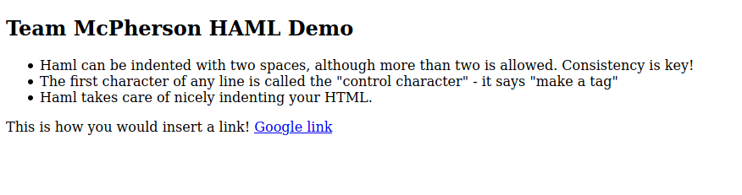

**FILE: test.haml - the HAML code we wrote**

!!!

#main

.note

%h2 Team McPherson HAML Demo

%ul

%li

Haml can be indented with two spaces,

although more than two is allowed.

Consistency is key!

%li

The first character of any line is called

the "control character" - it says "make a tag"

%li

Haml takes care of nicely indenting your HTML.

.note

This is how you would insert a link!

%a{:href => "https://google.com"}

Google link

**COMMAND LINE: haml test1.haml test1.html**

**FILE: test.html - the generated html output**

<!DOCTYPE html>

<div id='main'>

<div class='note'>

<h2>Team McPherson HAML Demo</h2>

<ul>

<li>

Haml can be indented with two spaces,

although more than two is allowed.

Consistency is key!

</li>

<li>

The first character of any line is called

the "control character" - it says "make a tag"

</li>

<li>

Haml takes care of nicely indenting your HTML.

</li>

</ul>

</div>

<div class='note'>

This is how you would insert a link!

<a href='https://google.com'>

Google link

</a>

</div>

</div>

**Test Questions**

**Question 1. Given the following HTML document, convert it into HAML.**

!!!

#main

.note

%h2 HAML Notes

%ul

%li

The !!! at the top declares an HTML document type.

%li

This syntax is so easy to write and is much more readable!

**ANSWER**

<!DOCTYPE html>

<div id='main'>

<div class='note'>

<h2>HAML Notes</h2>

<ul>

<li>

The !!! at the top declares an HTML document type.

</li>

<li>

This syntax is so easy to write and is much more readable!

</li>

</ul>

</div>

</div>

**Question 2. Convert the following HTML into HAML**

<!DOCTYPE html>

<html>

<div>

<body class="intro">

<h1 id="hello">Hello World!</h1>

<p>Can you convert me into HAML?</p>

</div>

</body>

</html>

**ANSWER**

!!!

%html

%body.intro

%div

%h1#hello Hello World!

%p Can you convert me into HAML?