How to Install Python on your machine

1. Follow this link: <https://www.python.org/downloads/release/python-387/>
2. Scroll to the very bottom
3. Click “Windows embeddable package (64-bit)” – will start a download

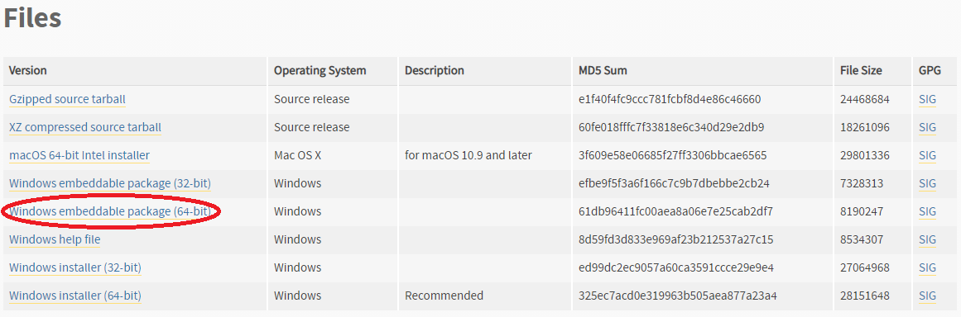

1. Wait for the download to finish – will be a .zip file

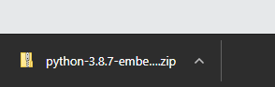

1. Open downloads and copy the file
2. Open the windows sidebar (windows key)
3. Open your file explorer and click on your C:\ drive

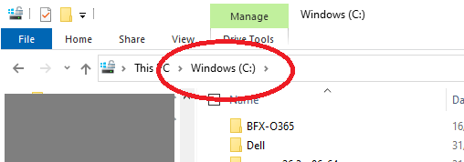

1. Paste the .zip file into here (press Ctrl-V)
2. Right-click on the file and choose “Extract All…”
3. Press Enter (or the button that says “Extract”)
4. This folder is where your “python.exe” is going to be stored.

Adding Python to PATH \*\***important**\*\*

1. Open the windows sidebar again
2. Type “env” and press enter
3. Click on the button that reads “Environmental Variables…”
4. Under **User variables**, click on **New** – add variable name as “PY­_HOME” and **Variable** value as “C:\python-3.8.7-embed-amd64” (or whatever the zip file output folder was called)
5. Under **User variables** again, click on **Path** and click on **Edit**
6. On the popup window, click on **New** and add **%PY_HOME%**
7. Click Ok.

Check if working

1. Click windows sidebar
2. Type “cmd” and press enter
3. In the command window that pops up, type “**python --version**" – it should give you something like “Python 3.8.3” as output if the installation was successful.
4. Type “exit” or click the X to close the window

How to set up the script

1. If you haven’t got firefox on your PC, follow this link: <https://www.mozilla.org/en-GB/firefox/download/thanks/>
2. Double-click on the installer and follow the wizard
3. Navigate to the folder that holds the script
4. Double click on “AmendPath.ps1”
5. Follow the instructions within
6. Click on “Run.bat”