Template of extended abstract in two‑column

format for the proceedings

A.B. First author1, C. Coauthor1 and D.E. Second coauthor2

1 School of Engineering, Department of Mechanical Engineering, Tokyo Institute of Technology, Japan

2 Frontier Research Center for Energy and Resources, The University of Tokyo, Japan

E-mail: e-mail address of a representative author

# Introduction

This document is a template of the abstract for *1st Interdisciplinary Workshop for Young Scientists*.

# How to submit

Please send the PDF files by e-mail to post.aceees@gmail.com by October 5, 2018. For additional information, please contact by e-mail to the address above.

# Format of page

Prepare your extended abstract in full-size format, on A4 paper (210 x 297 mm). The abstract text should be written with the fonts of “Times New Roman” in 11pt. Please embed all the fonts in the pdf file. Margins: top & bottom = 25mm, left & right = 20 mm.

# Number of pages

You are allowed only one page for your extended abstract.

# Figures and tables

Please prepare your figures with considering that they will be printed in the black & white　proceedings (color version is available as electrical data provided via the website). Please use shades of gray, line thickness or dashes to compare data in line graphs. Figures and Tables should be preferably placed at the top or bottom of the page in which they are first cross-referenced.

Table 1. Type the title of table here.

|  |  |  |
| --- | --- | --- |
| A | B | C |
| Pressure | 152 | Experiment |
| Temperature | 233 | Simulation |
| Stress | 566 | Experiment |
| Strain | 22 | Simulation |

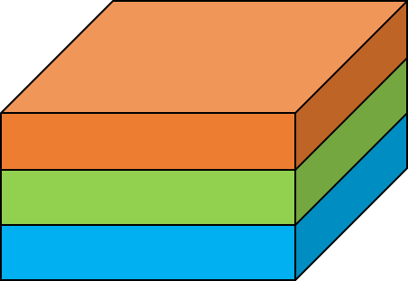

Figure 1. Type the title of figure here.

# Equations

Equations should be numbered consecutively, using Arabic numerals enclosed in parentheses, flush right with the right margin, as in Eq. (1).

 (1)

# Bibliography

Cite the bibliographies like this [1] and put it after the main text.

# Conclusions

We look forward to your abstract submissions.

# References

1. T. Koudai and J. Ookayama, Leading Researches in the World, *Proc. of 15th International Conference*  (2010) pp. 114-118.
2. K. Suzukake, J. Kougaku and T. Rigaku, Supreme Technology in Engineering, *Int. J. Technology* 10 (2009) pp. 54-68.