The Rule of Thumb:

A Five Year Overview of
Domestic Violence in
South Carolina

2007 – 2011

South Carolina Department of Public Safety
Office of Highway Safety and Justice Programs

April 2013

The Rule of Thumb:

A Five Year Overview of
Domestic Violence in South Carolina

2007 – 2011

Prepared by:

South Carolina Department of Public Safety
Office of Highway Safety and Justice Programs
Statistical Analysis Center
Editor: Rob McManus

This publication was partially funded by Federal Grant Number 2011-BJ-CX-K003 from the United States Department of Justice, Bureau of Justice Statistics. Points of view or opinions stated are those of the principal researcher and do not necessarily represent the opinion or official position of the United States Department of Justice

INTRODUCTION

The phrase “The Rule of Thumb” has been used to describe both the process of estimation in the absence of exact tools of measurement and the degree of force (beating with a rod no thicker than his thumb) a husband was permitted to use against his wife under English common law. Though there is considerable discussion and disagreement about the accuracy of the historical basis for the latter use of the phrase, it has (correctly or incorrectly) entered into the lexicon of domestic violence. Having no interest in attempting to resolve the dispute, this report is a logical nexus of these two uses of the phrase: an estimate and description of domestic violence in South Carolina using the best available informational tools.

This report is the third (with one interruption) in what is intended to be a continuing series of five year trend reports on domestic violence in South Carolina. The information presented in the tables, graphs and charts of this publication is based on incident reports submitted to the South Carolina Law Enforcement Division (SLED) by state and local law enforcement agencies. These reports are edited and reviewed, corrected as necessary and compiled to form the basis of the information presented in this report. It is important to note that the information in this report is only as complete and accurate as the information reported to local law enforcement and subsequently submitted to SLED. By their very nature, unreported crimes cannot be included in the report. The definition of domestic violence is dependent upon both how a domestic relationship is defined, and how an act of violence is defined. While there are a variety of legal and social definitions of domestic violence, this report uses a broad definition, parsed into meaningful sub-categories, in order to provide as much useful information as is reasonably possible. Particular emphasis has been placed on providing information at the county level, with the intention of providing decision makers at that level with readily available policy relevant information.

We wish to express our thanks and appreciation to the sheriffs, chiefs of police, state and local law enforcement officers as well as the administrative staff whose hard work in gathering and submitting crime and arrest data to SLED made publication of this report possible. It is also important to note that publications such as this would not be possible without the ongoing and active assistance of SLED’s Crime Information Center. The report itself is a product of the South Carolina Department of Public Safety, Office of Highway Safety and Justice Programs Statistical Analysis Center; funded in part by the United States Department of Justice, Bureau of Justice Statistics.

TABLE OF CONTENTS

COUNTING & DEFINING DOMESTIC VIOLENCE 3

STATEWIDE OVERVIEW 5
Offenses 6
Victimization Circumstances 10
Victim Characteristics 18
Victim Offender Relationships 30

STATEWIDE FIVE YEAR TRENDS 43
Domestic Violence 44
Homicide 46
Sexual Violence 48
Robbery 50
Aggravated Assault 52
Simple Assault 54
Intimidation 56
Criminal Domestic Violence Proxy 58
Ex-Spouse Violence 60
Family Violence 62
Marital Violence 64
Violence in Romantic Relationships 66

COUNTY RANKINGS 2011 69
Domestic Violence 70
Homicide 72
Sexual Violence 74
Robbery 76
Aggravated Assault 78
Simple Assault 80
Intimidation 82
Criminal Domestic Violence Proxy 84
Ex-Spouse Violence 86
Family Violence 88
Marital Violence 90
Violence in Romantic Relationships 92

COUNTY FIVE YEAR PROFILES 95
(Counties follow in alphabetical order)

SUMMARY 235

COUNTING AND DEFINING DOMESTIC VIOLENCE

Data from the South Carolina Incident Based Reporting System (SCIBRS) provides the basis of this report. The SCIBRS data start with the statewide uniform incident report. An incident report is filled out whenever a criminal event is reported to law enforcement. The responding officer fills out an incident report which contains detailed information about the incident, the victim and the offender as well as any associated arrests. Much, though not all, of this information is then entered into SCIBRS and maintained by SLED. Analysis of SCIBRS data will often vary from published crime rates and counts for a variety of reasons. Chief among these is that SCIBRS data allows for the flexibility to use whatever unit of count (victim, offense, offender, arrestee, etc.) is most appropriate. The unit of count used throughout this report was victim, however there are nuances associated with some factors that can result in different totals. These situations are noted and explained, as succinctly as possible, throughout the report. Additionally, edits, updates and corrections are made over a two-year period in order to provide agencies with the maximum window of opportunity to report as fully and accurately as possible. As a result, totals from a specific year can subsequently vary from previously published totals for that same year. Any data published here concerning figures for prior years supersede those published in previous reports. It is also important to be aware that SCIBRS does not restrict analysis to use of the most serious offense, as is often the case with many reported crime rates. SCIBRS data from 2007 through 2011 is the source of crime data for this report. The sum of categories for some tables, charts or graphs may not total 100% in some cases due to rounding.

For the purposes of this report, it was necessary to define what constitutes a domestic relationship and what constitutes violence in order to then define domestic violence. SCIBRS collects detailed information concerning the relationship between the victim(s) and offender(s) in an incident. Domestic relationships were defined as being one of the following: marital (involving spouses or common-law spouses), family (involving family relations by blood or marriage, other than spouses), romantic (boyfriends and girlfriends, both heterosexual and homosexual) and ex-spouses. Violence was defined as including the following offenses: murder, voluntary manslaughter, rape, forcible sodomy, sexual assault with an object, forcible fondling, robbery, aggravated assault, simple assault and intimidation. The operational definition of domestic violence was a situation in which the victimization met both definitions (domestic relationship and a violent offense). Victimization rates were calculated using the equation below:

Victimization Rate = Number of Victims X 10,000
Population (or sub-population)

State and county population estimates used to calculate victimization rates were provided by the South Carolina Budget and Control Board, Office of Research and Statistics (ORS).

Blank page

STATEWIDE OVERVIEW OF DOMESTIC VIOLENCE

Simple assault was the most frequently reported domestic violence offense, accounting for 68.4% of all domestic violence offenses.

DOMESTIC VIOLENCE: Domestic violence consists of murder, negligent homicide, rape, forcible sodomy, sexual assault with an object, forcible fondling, robbery, aggravated assault, simple assault or intimidation where the victim was married or had previously been married to the offender, where the victim was related by blood or marriage to the offender or was romantically involved with the offender. Homicide includes both murder and negligent homicide; sexual violence includes rape, forcible sodomy, sexual assault with an object and forcible fondling.

DOMESTIC VIOLENCE OFFENSES
2007 – 2011

Offense Number Percent

Homicide 412 0.2%
Sexual Violence 6,111 2.4%
Robbery 595 0.2%
Aggravated Assault 42,699 16.5%
Simple Assault 177,157 68.4%
Intimidation 32,196 12.4%
Total 259,170 100.0%

Notes: Up to five offenses can be reported per victim. The 259,170 offenses listed above represent the total of violent offenses (as defined by this report) committed against 259,140 victims of domestic violence.
Source: SCIBRS, SLED.

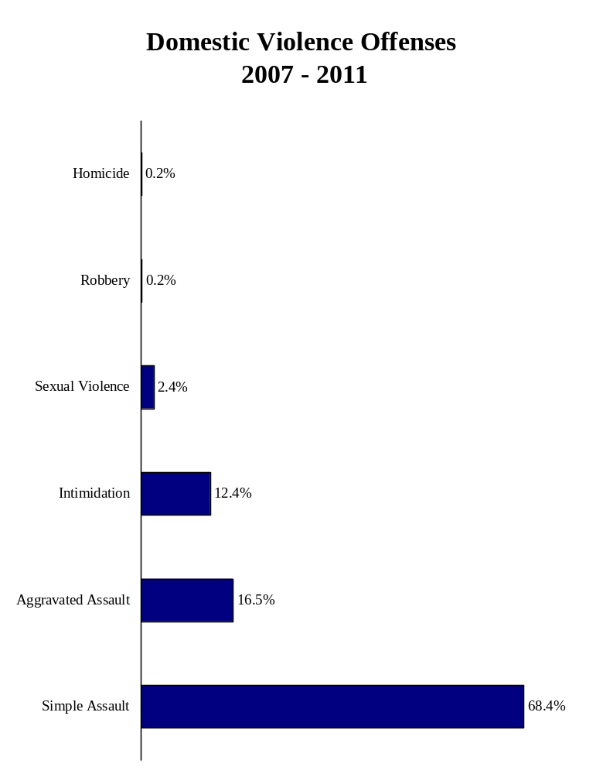
Domestic victim to offender relationships were reported among 41.8% of all violent crime victims from 2007 through 2011.

DOMESTIC VIOLENCE
AS PART OF TOTAL VIOLENT VICTIMIZATION
2007 – 2011

Domestic Violence Total Victims Percent of
Offense Victims of Violence Total Victims

Homicide 412 1,652 24.9%
Sexual Violence 6,111 19,062 32.1%
Robbery 595 36,417 1.6%
Aggravated Assault 42,699 116,099 36.8%
Simple Assault 177,157 340,478 52.0%
Intimidation 32,196 106,589 30.2%
Total 259,170 620,297 41.8%

Notes: Up to five offenses can be reported per victim. The Total row represents the number of victims reporting domestic violence, the number of victims reporting violence and the percent that the former represents of the latter. It does not represent the sum of domestic violence victims or total victims by each offense category. This distinction is necessary because some victims were victims of more than one offense. Consequently, the sum of the Domestic Violence Victims column and the Total Victims of Violence column exceeds the total shown at the bottom of each column.
Source: SCIBRS, SLED.
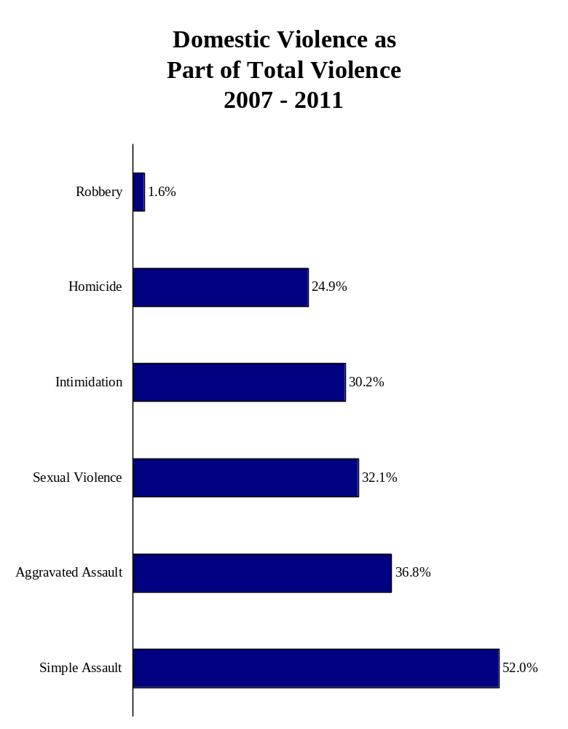
Domestic violence was reported most frequently between 9:00 and 9:59 PM.

DOMESTIC VIOLENCE BY TIME OF DAY
2007 – 2011

Time of Day Number Percent

Midnight - 12:59 AM 13,650 5.3%
1:00 –1:59 AM 10,472 4.1%
2:00 – 2:59 AM 8,288 3.2%
3:00 – 3:59 AM 6,118 2.4%
4:00 – 4:59 AM 4,394 1.7%
5:00 – 5:59 AM 3,364 1.3%
6:00 – 6:59 AM 3,717 1.4%
7:00 – 7:59 AM 5,195 2.0%
8:00 – 8:59 AM 7,865 3.1%
9:00 – 9:59 AM 6,994 2.7%
10:00 – 10:59 AM 8,308 3.2%
11:00 – 11:59 AM 9,003 3.5%
Noon – 12:59 PM 11,435 4.4%
1:00 – 1:59 PM 9,840 3.8%
2:00 – 2:59 PM 10,142 3.9%
3:00 – 3:59 PM 11,587 4.5%
4:00 – 4:59 PM 12,579 4.9%
5:00 – 5:59 PM 14,295 5.5%
6:00 – 6:59 PM 15,871 6.2%
7:00 – 7:59 PM 16,353 6.3%
8:00 – 8:59 PM 17,508 6.8%
9:00 – 9:59 PM 18,255 7.1%
10:00 – 10:59 PM 17,370 6.7%
11:00 – 11:59 PM 15,160 5.9%
Total 257,763 100.0%

Note: 1,660 cases were missing time data.
Source: SCIBRS, SLED.
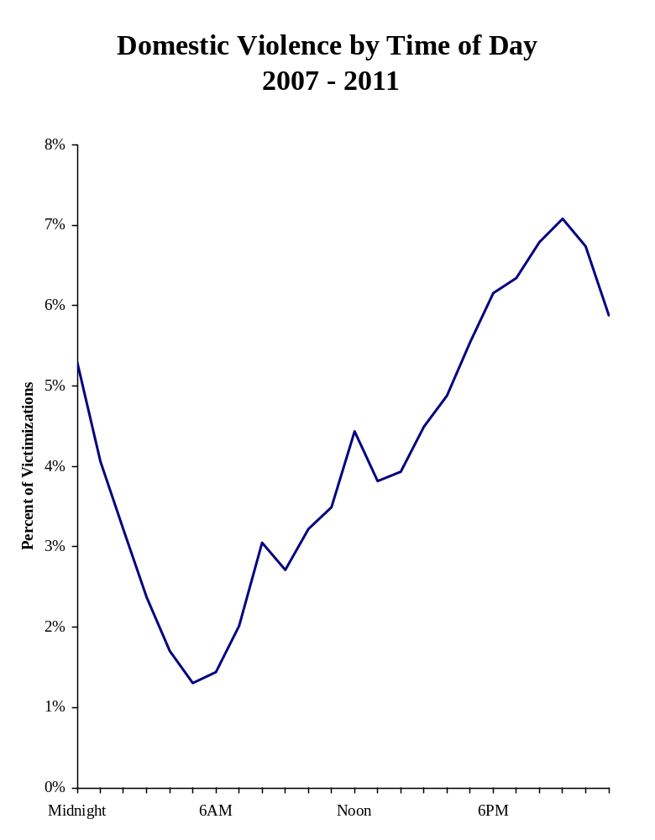
More domestic violence was reported on Saturday than any other day of the week.

DOMESTIC VIOLENCE BY DAY OF THE WEEK
2007 – 2011

Day of the Week Number Percent

Sunday 39,816 15.4%
Monday 34,437 13.3%
Tuesday 33,951 13.1%
Wednesday 33,046 12.8%
Thursday 34,296 13.2%
Friday 39,366 15.2%
Saturday 44,228 17.1%
Total 259,140 100.0%

Source: SCIBRS, SLED.
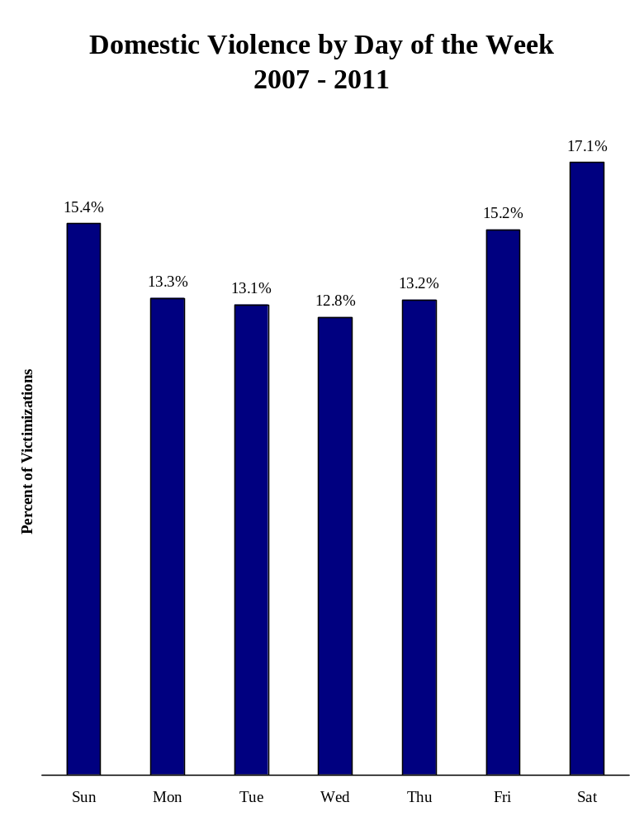
The five most frequent times of the day/day of the week during which domestic violence was reported, were during Friday and Saturday night.

MOST FREQUENT DAYS OF THE WEEK/TIMES OF THE DAY FOR DOMESTIC VIOLENCE
2007 – 2011

Day & Time Number Percent

Saturday 9:00 PM 2,799 1.10%
Friday 9:00 PM 2,765 1.08%
Saturday 10:00 PM 2,755 1.08%
Friday 10:00 PM 2,742 1.08%
Friday 11:00 PM 2,707 1.06%
Monday 9:00 PM 2,674 1.05%
Saturday 8:00 PM 2,660 1.04%
Saturday Midnight 2,633 1.03%
Sunday 8:00 PM 2,622 1.03%
Monday 8:00 PM 2,574 1.01%
Tuesday 9:00 PM 2,532 0.99%
Thursday 9:00 PM 2,524 0.99%
Sunday 9:00 PM 2,516 0.99%
Friday 8:00 PM 2,506 0.98%
Saturday 11:00 PM 2,502 0.98%
Sunday 6:00 PM 2,485 0.97%
Saturday 7:00 PM 2,483 0.97%
Thursday 10:00 PM 2,473 0.97%
Wednesday 9:00 PM 2,445 0.96%
Monday 10:00 PM 2,424 0.95%
Wednesday 8:00 PM 2,421 0.95%
Sunday 7:00 PM 2,419 0.95%

Notes: Only times accounting for 0.95% or more of victimizations are included in the chart. The highlighted times represent the most frequently reported time for that day of the week. Times represent the hour from the time noted up to the start of the following hour; e.g., Saturday 9:00 PM includes any domestic violence occurring from 9:00 PM to 9:59 PM on Saturday.
Source: SCIBRS, SLED.

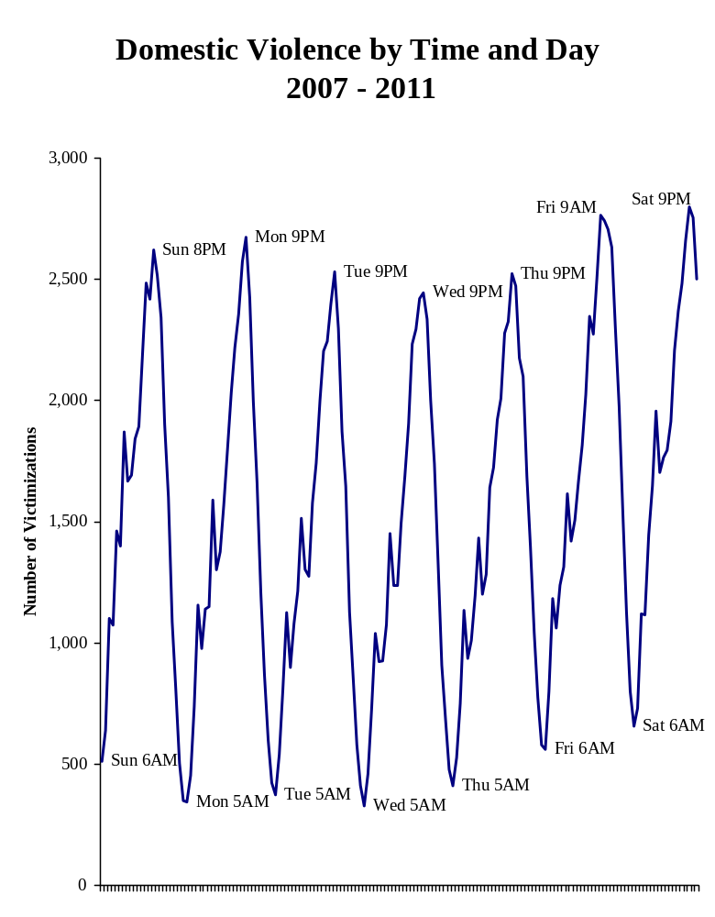
There were 412 deaths resulting from domestic violence. The most commonly reported injury category was minor injuries.

DOMESTIC VIOLENCE INJURIES
2007 – 2011

Injury Number Percent

Broken Bones 960 0.8%
Death 412 0.3%
Internal Injuries 1,546 1.3%
Knocked Unconscious 409 0.3%
Loss of Teeth 311 0.3%
Minor Injury 104,643 88.7%
Other Major Injury 3,879 3.3%
Severe Laceration 5,777 4.9%
Total 117,937 100.0%

Notes: SCIBRS allows up to 5 injuries to be reported per victim. The 117,937 injuries represent the total number of injuries reported for 116,481 domestic violence victims with a reported injury or death.
Source: SCIBRS, SLED.

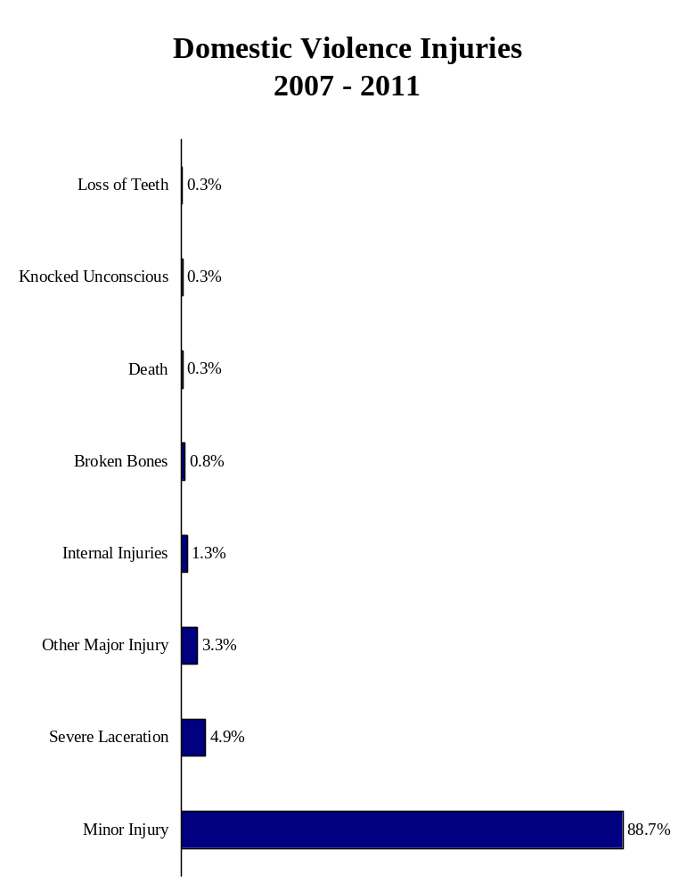
The domestic violence victimization rate among females was 155.2% higher than the domestic violence victimization rate among males.

DOMESTIC VIOLENCE VICTIMIZATION BY SEX
2007 – 2011

Number of
Sex Victims Percent Rate

Female 188,873 72.9% 161.8
Male 70,200 27.1% 63.4
Unknown 67 <0.1% NA
Total 259,140 100.0% 112.4

Note: Victimization rate is expressed per 10,000.
Source: SCIBRS, SLED.
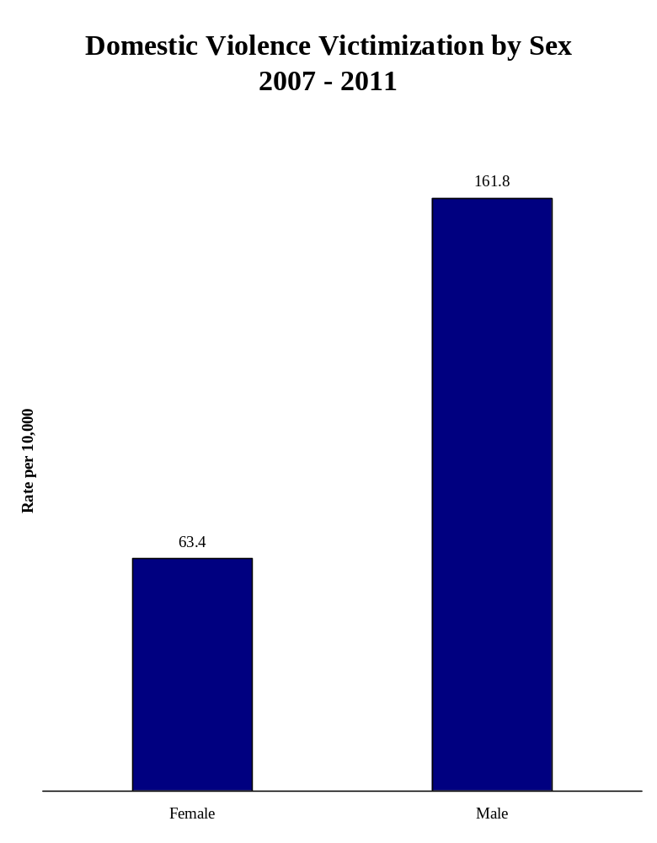
The domestic violence victimization rate was highest among the 18 to 24 year old age group.

DOMESTIC VIOLENCE VICTIMIZATION BY AGE
2007 – 2011

Number of
Age Group Victims Percent Rate

4 & younger 2,976 1.1% 19.6
5 – 9 4,155 1.6% 28.3
10 – 14 7,149 2.8% 49.0
15 – 17 11,081 4.3% 118.4
18 – 24 58,473 22.6% 257.8
25 – 34 68,933 26.6% 233.9
35 – 44 53,106 20.5% 175.8
45 – 54 33,449 12.9% 103.3
55 – 64 11,284 4.4% 40.1
65 & older 5,054 2.0% 16.4
Unknown/age range 3,480 1.3% NA
Total 259,140 100.0% 113.9

Notes: There were 3,480 domestic violence victims missing age data or with their age entered as a range. The total victimization rate includes those victims. Victimization rate is expressed per 10,000.
Sources: SCIBRS, SLED; population estimates, ORS.
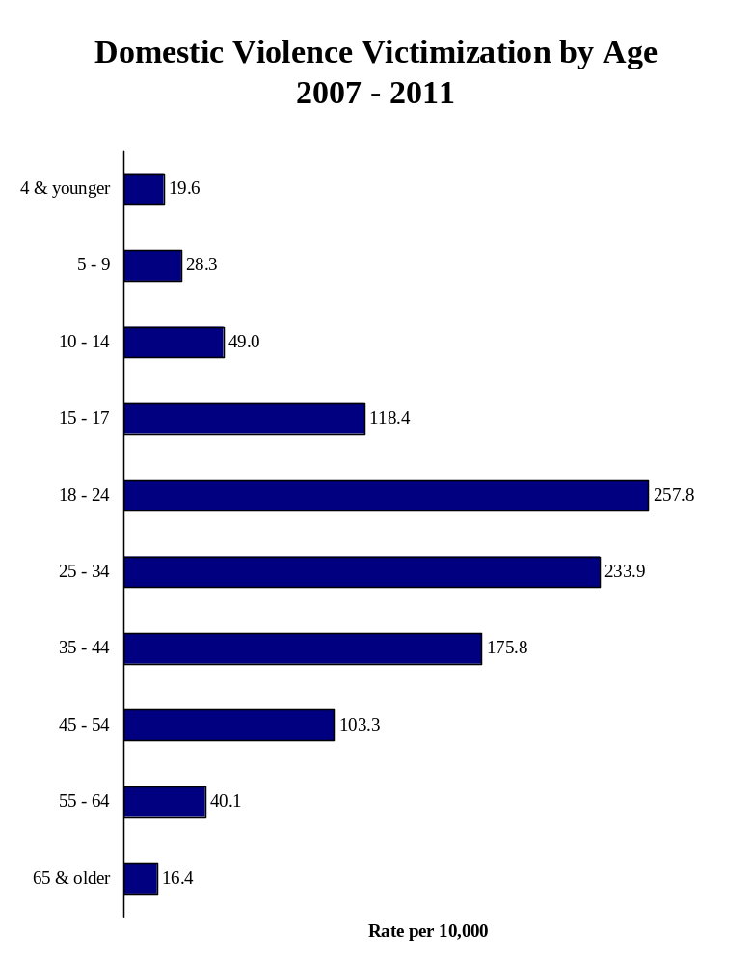
White victims accounted for 54% of domestic violence victims, Black victims accounted for 45.3%.

DOMESTIC VIOLENCE VICTIMIZATION BY RACE
2007 – 2011

Race Number Percent

Asian 718 0.3%
Black 117,423 45.3%
Native American 372 0.1%
White 140,052 54.0%
Unknown/Missing 575 0.2%
Total 259,140 100.0%

Source: SCIBRS, SLED.

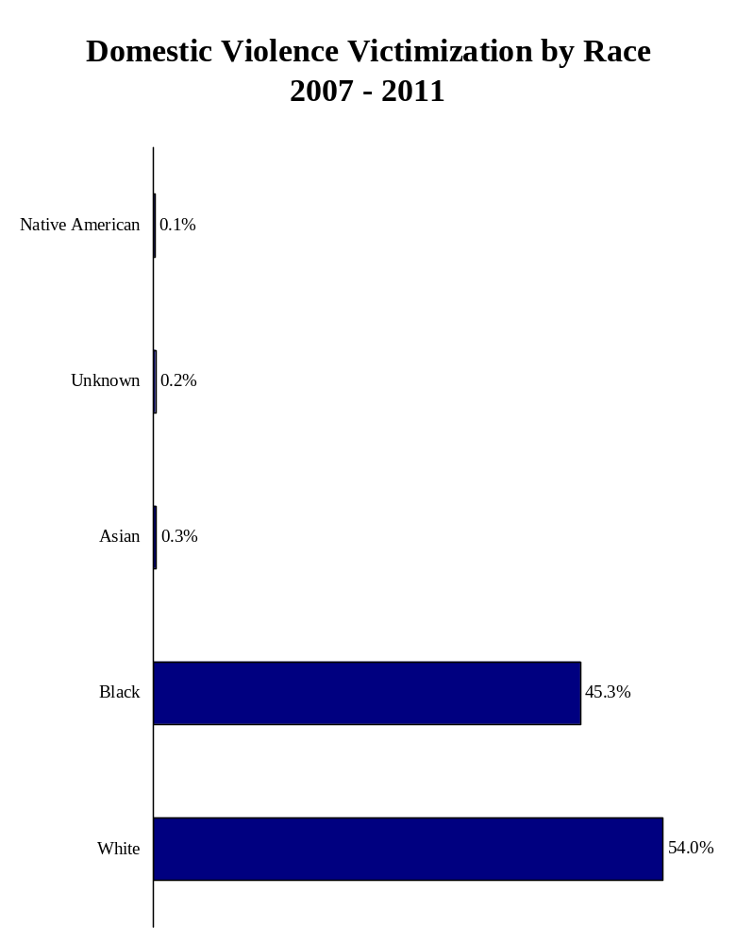
The domestic violence victimization rate among the Non-White population was 71.5% higher than the domestic violence victimization rate among the White population.

DOMESTIC VIOLENCE VICTIMIZATION BY RACIAL GROUP
2007 – 2011

Number of
Racial Group Victims Percent Rate

Non-White 118,513 45.7% 157.7
Unknown 575 0.2% NA
White 140,052 54.0% 91.9
Total 259,140 100.0% 113.9

Notes: SCIBRS categorizes race as Asian, Black, Native American or White. The ORS population estimates have additional racial categories. The collapsed categories of White and Non-White were used to calculate victimization rates since the racial categories used by SCIBRS and the population estimates do not match. The victimization rate is expressed per 10,000.
Sources: SCIBRS data, SLED; population estimates, ORS.
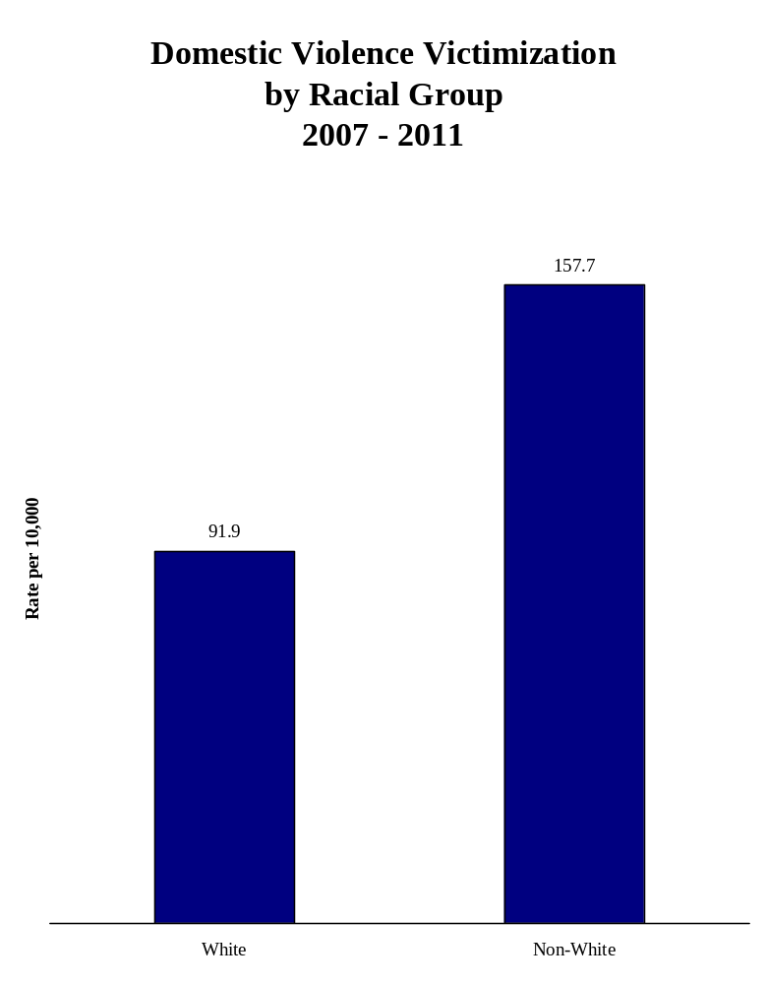
The domestic violence victimization rate among Hispanics was 46.1% lower than the domestic violence victimization rate among Non-Hispanics.

ETHNICITY: SCIBRS categorizes ethnicity into two categories: Hispanic and Non-Hispanic. SCIBRS also measures ethnicity separately from race. As a result, a victim of domestic violence should be classified as having both a racial category and an ethnic category.

DOMESTIC VIOLENCE VICTIMIZATION BY ETHNICITY
2007 – 2011

Number of
Ethnicity Victims Percent Rate

Hispanic 6,481 2.5% 62.1
Non-Hispanic 250,320 96.6% 115.3
Unknown 2,339 0.9% NA
Total 259,140 100.0% 113.9

Note: Victimization rate is expressed per 10,000.
Sources: SCIBRS, SLED; population estimates, ORS.

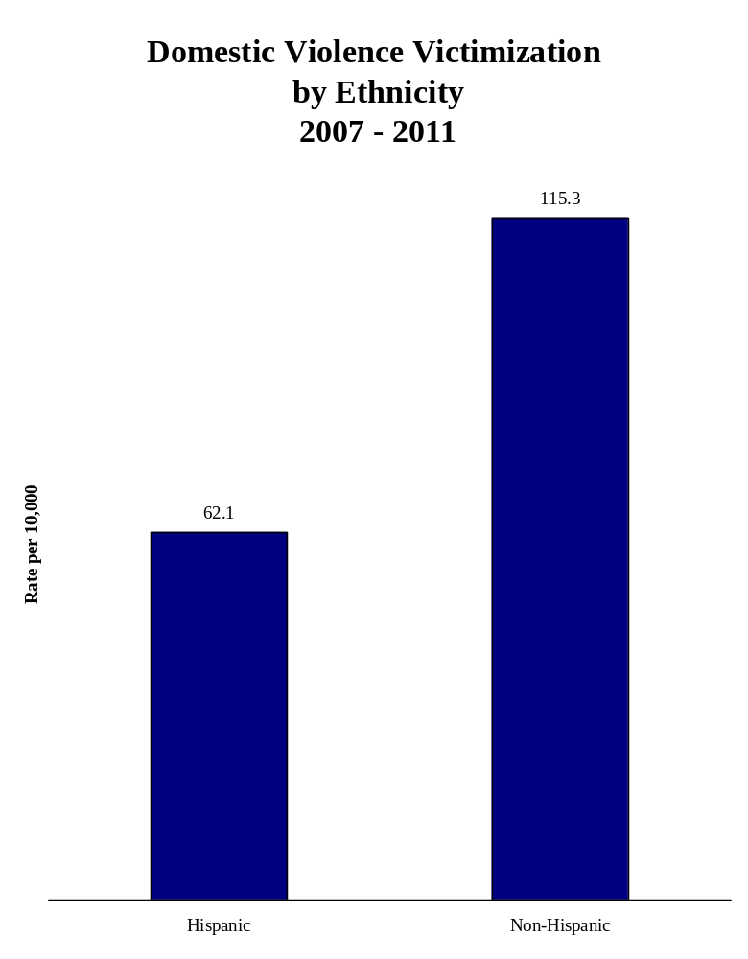

Victims of domestic violence were most often residents of the jurisdiction where the incident was reported.

DOMESTIC VIOLENCE BY VICTIM RESIDENCE STATUS
2007 – 2011

Victim Residence Number Percent

In State, Not in Jurisdiction 22,200 8.6%
Out of State 3,599 1.4%
Reporting Jurisdiction 232,327 89.7%
Unknown 1,014 0.4%
Total 259,140 100.0%

Source: SCIBRS data, SLED.

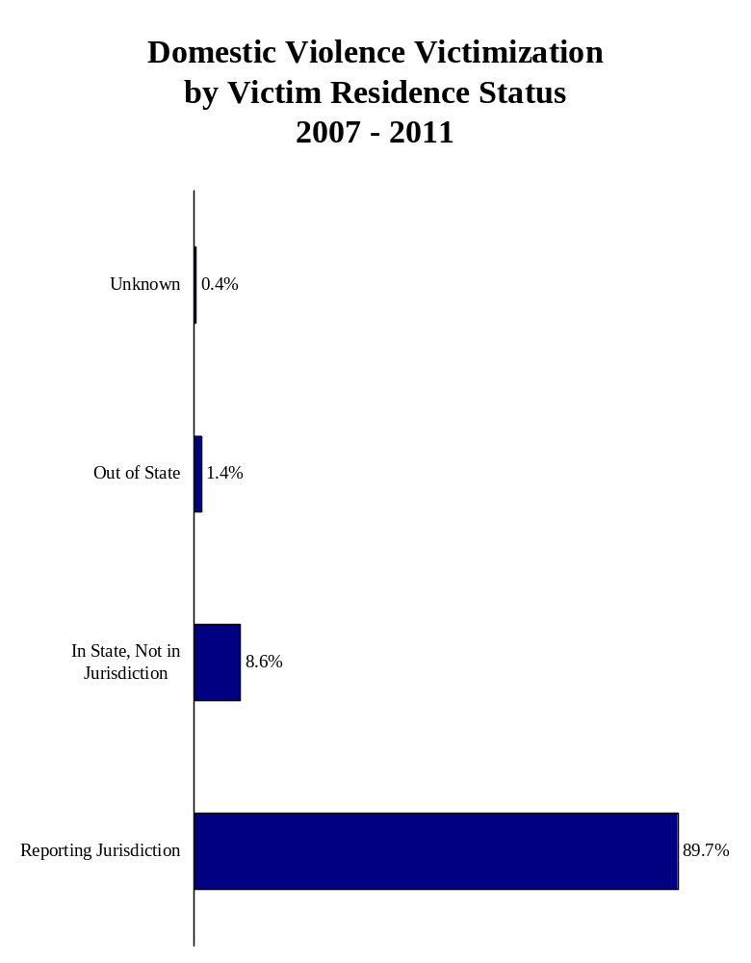
Romantic relationships were the most frequently reported category of victim to offender relationship among domestic violence victims.

VICTIM TO OFFENDER RELATIONSHIP: SCIBRS records the relationship between the victim and offender into one of 26 categories. For the purpose of this report, four broad categories encompassing domestic relationships were constructed: ex-spouse, family, marital and romantic.

DOMESTIC VIOLENCE VICTIMIZATION
BY VICTIM/OFFENDER REALTIONSHIP
2007 – 2011

Victim Was: Number Percent

Ex-spouse 6,353 2.4%
Family 85,885 32.9%
Marital 68,813 26.4%
Romantic 99,818 38.3%
Total 260,869 100.0%

Notes: SCIBRS allows up to 10 victim to offender relationships to be recorded per victim. This is needed to provide complete data in cases where more than one offender is involved. As a result, the number of victim to offender relationships exceeds the number of victims.
Source: SCIBRS, SLED.
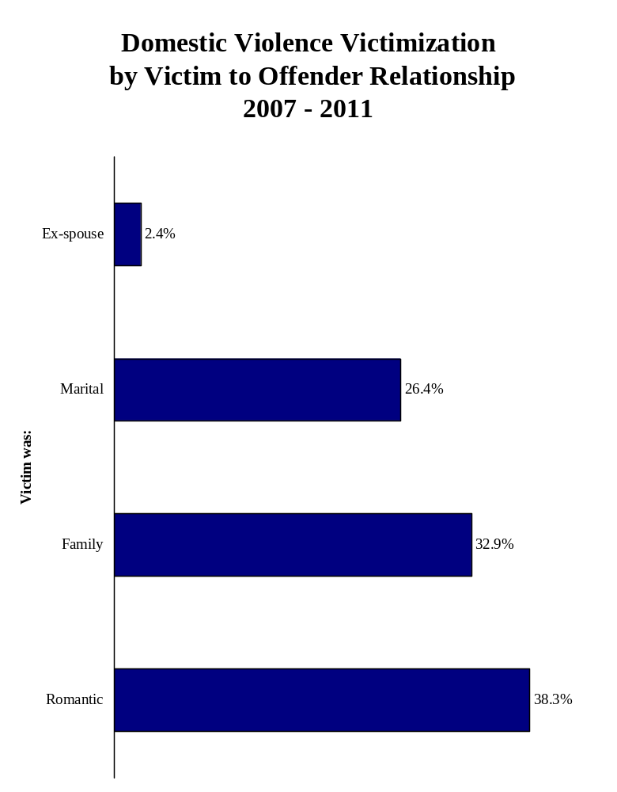
Ex-wives were 77.4% of the domestic violence victims of violence involving ex-spouses.

DOMESTIC VIOLENCE VICTIMIZATION
BETWEEN EX-SPOUSES
2007 – 2011

Victim Was: Number Percent

Ex-Husband 1,437 22.6%
Ex-Wife 4,916 77.4%
Total 6,353 100.0%

Source: SCIBRS, SLED.
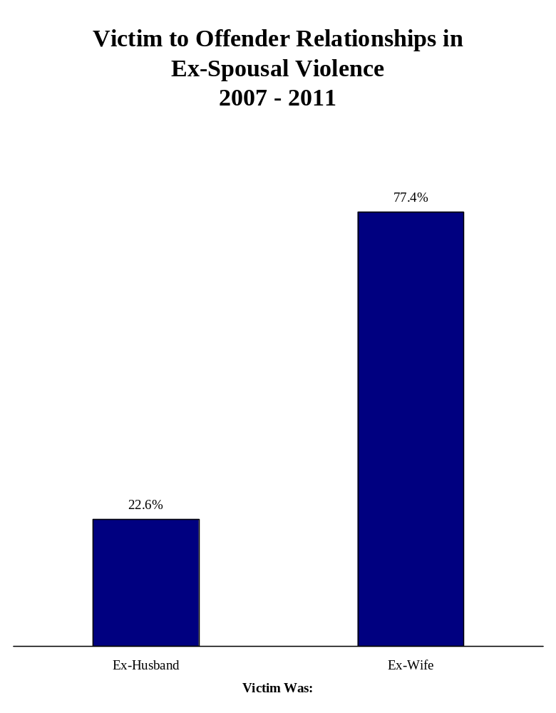
The category, other family members, was the most frequently reported family victim to offender relationship, accounting for 25.4% of family domestic violence victims.

DOMESTIC VIOLENCE VICTIMIZATION
AMONG FAMILY MEMBERS
2007 – 2011

Victim Was: Number Percent

Child 16,677 17.7%
Grandchild 1,355 1.4%
Grandparent 1,639 1.7%
In-law 5,118 5.4%
Other Family 23,967 25.4%
Parent 18,363 19.5%
Sibling 20,353 21.6%
Stepchild 3,406 3.6%
Stepparent 2,850 3.0%
Stepsibling 680 0.7%
Total 94,408 100.0%

Notes: Other family members include extended family relationships such as cousins, aunts, uncles, nephews, nieces and other family relationships not specifically accounted for among the SCIBRS codes.
Source: SCIBRS, SLED.
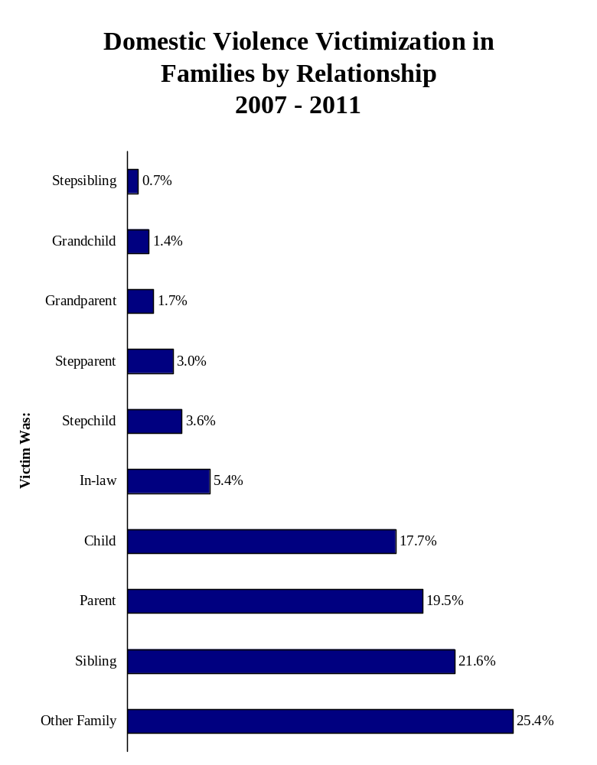
Wives accounted for 79.8% of the victims of domestic violence involving spouses.

DOMESTIC VIOLENCE VICTIMIZATION
INVOLVING SPOUSES
2007 – 2011

Victim Was: Number Percent

Husband 14,931 21.7%
Wife 53,879 78.3%
Unknown 3 <0.1%
Total 68,813 100.0%

Source: SCIBRS data, SLED.
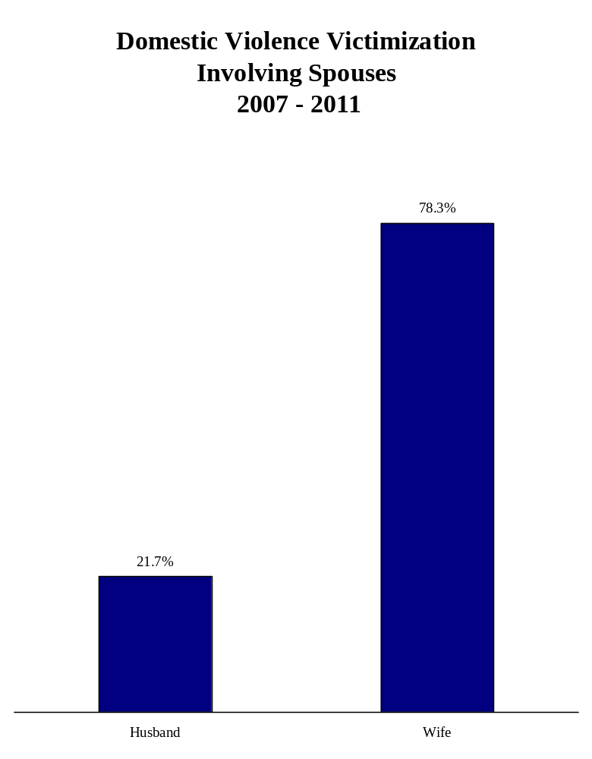
Girlfriends accounted for 81.1% of the victims of domestic violence occurring in romantic relationships.

DOMESTIC VIOLENCE VICTIMIZATION
BETWEEN PARTNERS
IN ROMANTIC RELATIONSHIPS
2007 – 2011

Victim Was: Number Percent

Boyfriend 18,860 18.9%
Girlfriend 80,946 81.1%
Unknown 12 <0.1%
Total 99,818 100.0%

Source: SCIBRS, SLED.
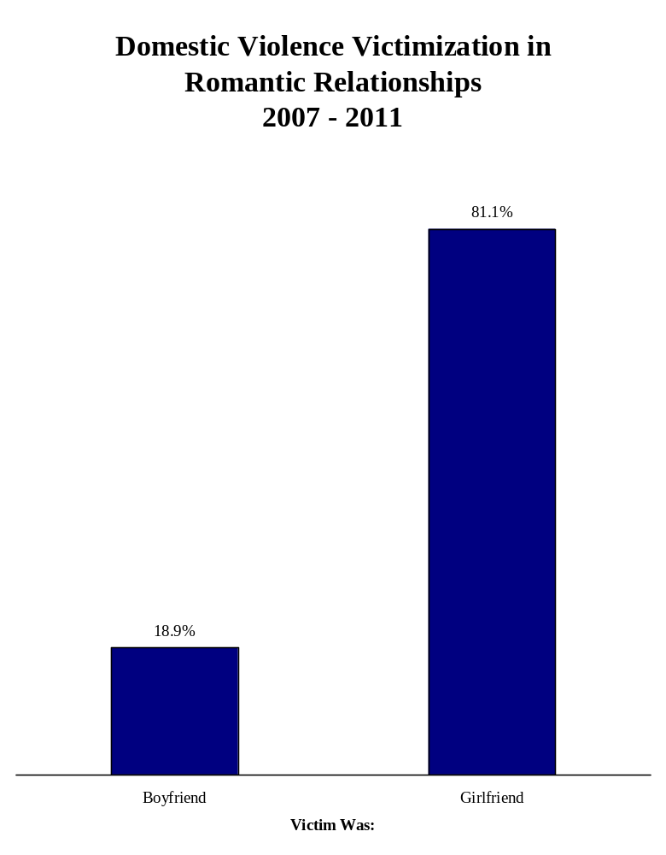
The 18 to 24 year old age group accounted for 34.1% of domestic violence victims within romantic relationships.

VICTIMS OF DOMESTIC VIOLENCE
IN ROMANTIC RELATIONSHIPS
BY AGE
2007 – 2011

Number of
Age Group Victims Percent

10 – 14 254 0.3%
15 – 17 3,017 3.1%
18 – 24 33,660 34.1%
25 – 34 32,334 32.7%
35 – 44 18,354 18.6%
45 – 54 9,225 9.3%
55 – 64 1,677 1.7%
65 & older 305 0.3%
Total 98,826 100.0%

Notes: 992 victims were missing age data or had age entered as a range.
Sources: SCIBRS, SLED; population estimates, ORS.
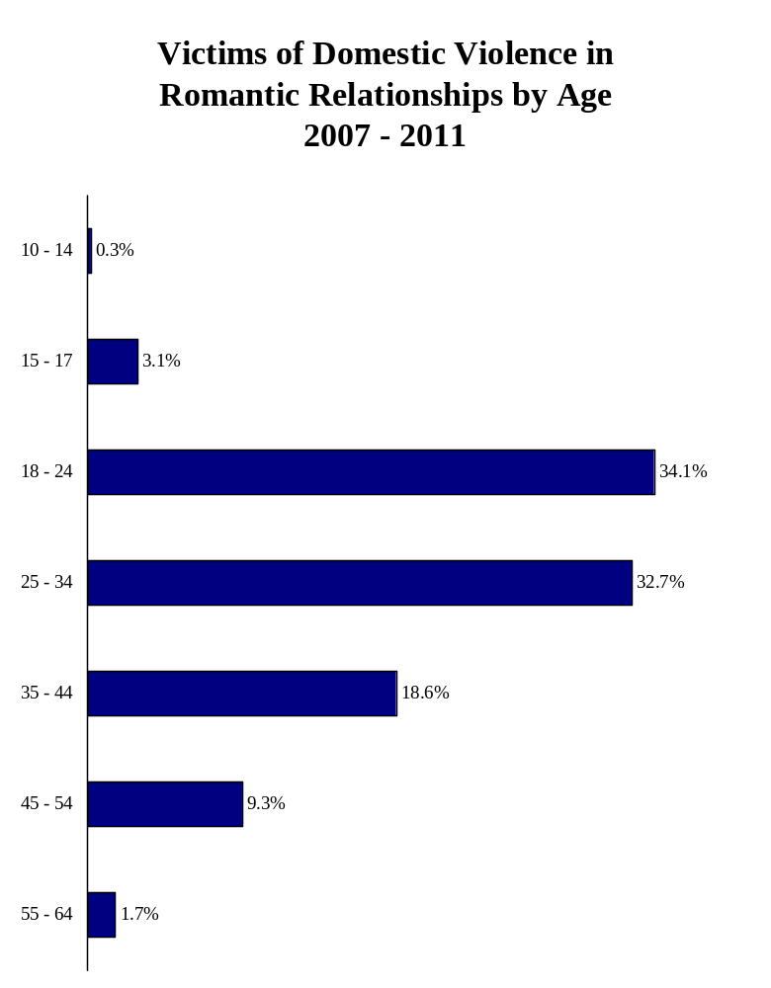
Blank page

STATEWIDE FIVE YEAR TRENDS
IN DOMESTIC VIOLENCE
The domestic violence victimization rate has decreased each of the past four years. The domestic violence victimization rate decreased 10.8% from 2007 to 2011.

DOMESTIC VIOLENCE
FIVE YEAR STATEWIDE TREND
2007 – 2011

Number of Victimization Change from
Year Victims Rate Previous Year

2007 53,727 121.9
2008 51,713 115.4 -5.3%
2009 52,023 114.1 -1.1%
2010 50,829 109.9 -3.7%
2011 50,848 108.7 -1.1%

Notes: Change from previous year represents the change in the victimization rate. Victimization rate is expressed per 10,000.
Sources: SCIBRS, SLED; population estimates, ORS.

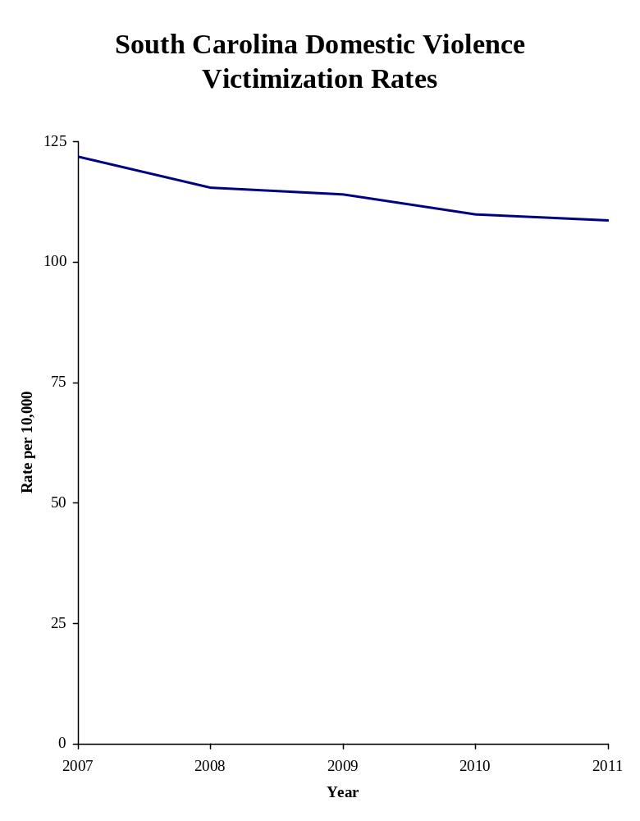
The domestic homicide victimization rate increased 29.4% from 2007 to 2011.

DOMESTIC HOMICIDE: Domestic homicide consists of the offenses of murder and negligent manslaughter where the victim and offender was or had been married, had a familial relationship or was romantically involved.

DOMESTIC HOMICIDE
FIVE YEAR STATEWIDE TREND
2007 – 2011

Number of Victimization Change from
Year Victims Rate Previous Year

2007 73 0.17
2008 87 0.19 +5.9%
2009 78 0.17 -5.6%
2010 71 0.15 -11.8%
2011 103 0.22 +46.7%

Notes: Change from previous year represents the change in the victimization rate. Victimization rate is expressed per 10,000.
Sources: SCIBRS, SLED; population estimates, ORS.

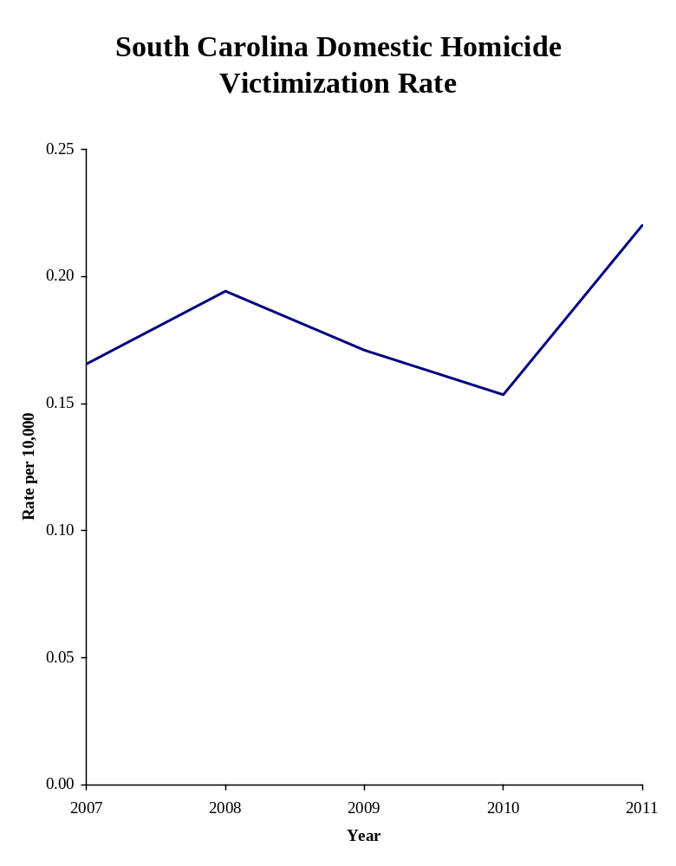
The domestic sexual violence victimization rate decreased 4.4% from 2007 to 2011.

DOMESTIC SEXUAL VIOLENCE: Domestic sexual violence consists of the offenses of rape, forcible sodomy, sexual assault with an object, or forcible fondling, where the victim and offender was or had been married, had a familial relationship or was romantically involved.

DOMESTIC SEXUAL VIOLENCE
FIVE YEAR STATEWIDE TREND
2007 – 2011

Number of Victimization Change from
Year Victims Rate Previous Year

2007 1,207 2.74
2008 1,183 2.64 -3.6%
2009 1,294 2.84 +7.6%
2010 1,202 2.60 -8.5%
2011 1,225 2.62 +0.8%

Notes: Change from previous year represents the change in the victimization rate. Victimization rate is expressed per 10,000.
Sources: SCIBRS, SLED; population estimates, ORS.
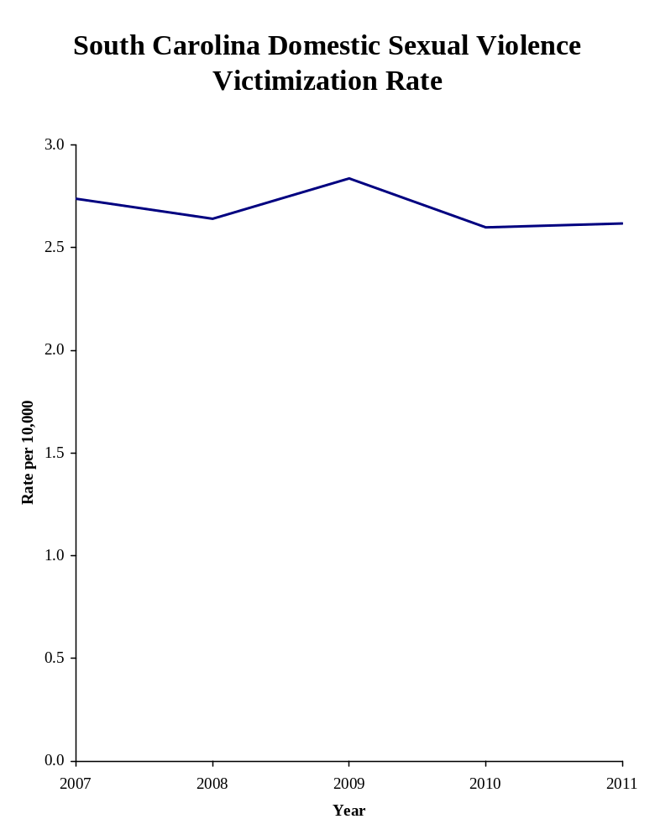

The domestic robbery victimization rate decreased 20% from 2007 to 2011.

DOMESTIC ROBBERY: Domestic robbery consists of the taking or attempted taking of anything of value from the custody, care or control of a person or persons by force or the threat of force, by violence or by putting the victim in fear, where the victim and offender was or had been married, had a familial relationship or was romantically involved.

DOMESTIC ROBBERY
FIVE YEAR STATEWIDE TREND
2007 – 2011

Number of Victimization Change from
Year Victims Rate Previous Year

2007 133 0.30
2008 107 0.24 -20.0%
2009 123 0.27 +12.5%
2010 119 0.26 -3.7%
2011 113 0.24 -7.7%

Notes: Change from previous year represents the change in the victimization rate. Victimization rate is expressed per 10,000.
Sources: SCIBRS, SLED; population estimates, ORS.

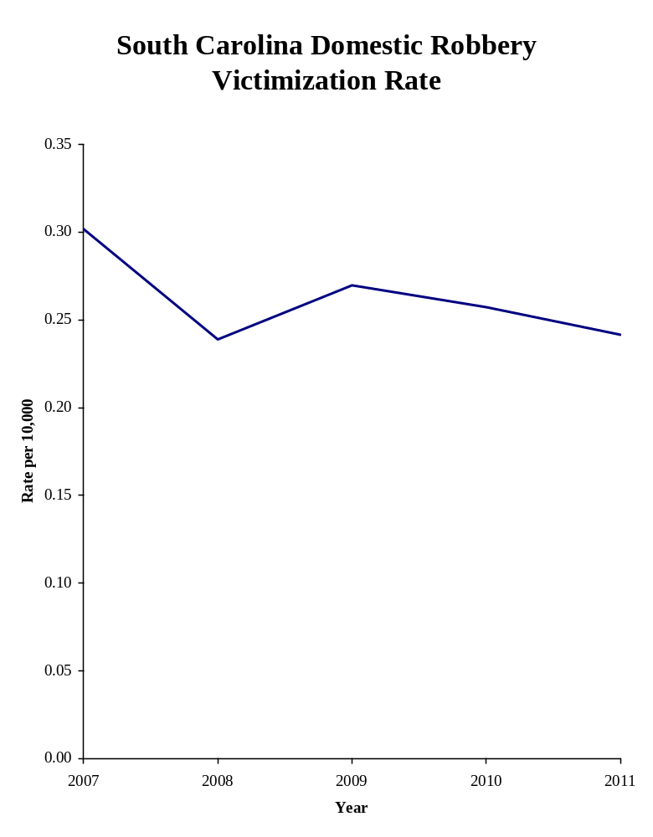
The domestic aggravated assault victimization rate decreased 20% from 2007 to 2011.

DOMESTIC AGGRAVATED ASSAULT: Domestic aggravated assault is an unlawful attack for the purpose of inflicting serious bodily injury where the victim and offender was or had been married, had a familial relationship or was romantically involved

DOMESTIC AGGRAVATED ASSAULT
FIVE YEAR STATEWIDE TREND
2007 – 2011

Number of Victimization Change from
Year Victims Rate Previous Year

2007 9,459 21.5
2008 8,591 19.2 -10.7%
2009 8,504 18.6 -3.1%
2010 8,091 17.5 -5.9%
2011 8,054 17.2 -1.7%

Notes: Change from previous year represents the change in the victimization rate. Victimization rate is expressed per 10,000.
Sources: SCIBRS, SLED; population estimates, ORS.
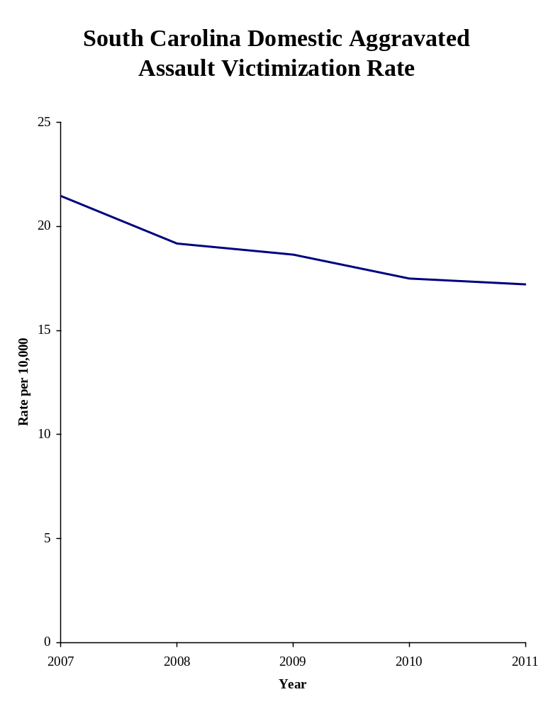
The domestic simple assault victimization rate decreased 5.7% from 2007 to 2011.

DOMESTIC SIMPLE ASSAULT: Domestic simple assault is an unlawful attack upon a person where the offender does not display a weapon, where the victim does not suffer severe bodily injury, and where the victim and offender was or had been married, had a familial relationship or was romantically involved

DOMESTIC SIMPLE ASSAULT
FIVE YEAR STATEWIDE TREND
2007 – 2011

Number of Victimization Change from
Year Victims Rate Previous Year

2007 35,352 80.2
2008 35,087 78.3 -2.4%
2009 35,979 78.9 +0.8%
2010 35,342 76.4 -3.2%
2011 35,397 75.6 -1.0%

Notes: Change from previous year represents the change in the victimization rate. Victimization rate is expressed per 10,000.
Sources: SCIBRS, SLED; population estimates, ORS.
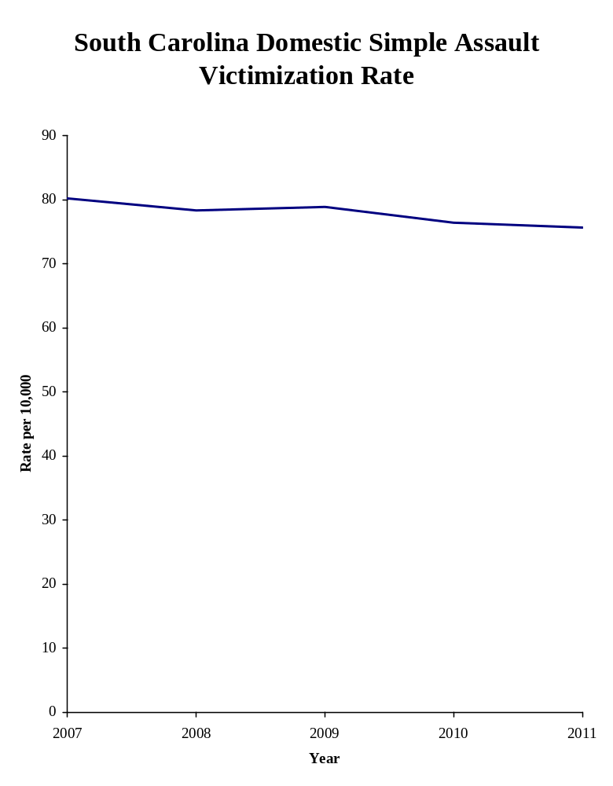
The domestic intimidation victimization rate decreased 25.3% from 2007 to 2011.

DOMESTIC INTIMIDATION: Domestic intimidation consists of unlawfully placing a person in reasonable fear of bodily harm through the use of threatening words or conduct, but without displaying a weapon or subjecting the victim to actual physical attack where the victim and offender was or had been married, had a familial relationship or were romantically involved

DOMESTIC INTIMIDATION
FIVE YEAR STATEWIDE TREND
2007 – 2011

Number of Victimization Change from
Year Victims Rate Previous Year

2007 7,511 17.0
2008 6,666 14.9 -12.4%
2009 6,051 13.3 -10.7%
2010 6,007 13.0 -2.3%
2011 5,961 12.7 -2.3%

Notes: Change from previous year represents the change in the victimization rate. Victimization rate is expressed per 10,000.
Sources: SCIBRS, SLED; population estimates, ORS.
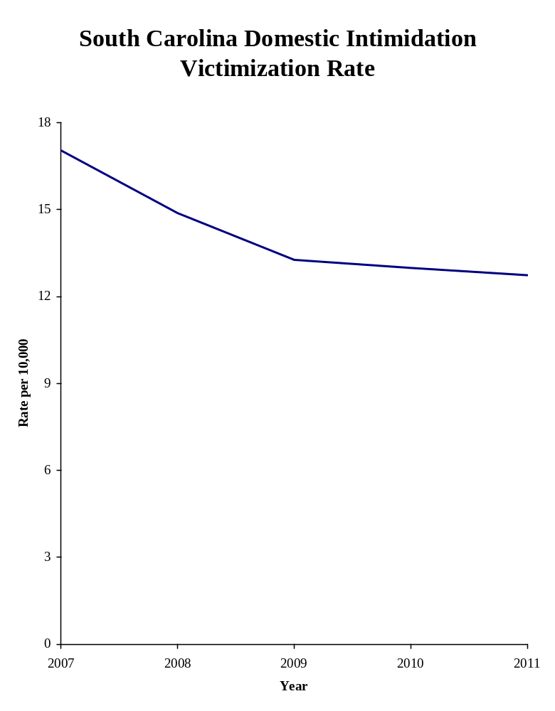
The criminal domestic violence victimization rate proxy indicator decreased 22.1% from 2007 to 2011.

CRIMINAL DOMESTIC VIOLENCE PROXY: Criminal domestic violence (CDV) is defined in South Carolina state law as situations involving a spouse, a former spouse, persons who have a child in common or a male and female who are currently or have formerly cohabitated where one causes physical harm or injury or offers or attempts to cause physical harm or injury under circumstances reasonably creating fear of imminent peril. SCIBRS does not include sufficiently detailed data to completely replicate that definition; however it does contain enough detail to identify a subset of that population to serve as proxy indicator for CDV victims. For the purpose of this report, a CDV proxy indicator was constructed which includes victims of aggravated assault, simple assault or intimidation where the victim was the spouse, common-law spouse or ex-spouse of the offender. SCIBRS does not identify situations where the offender and victim have a child in common, neither does it identify situations where the victim and offender were currently cohabiting or had previously cohabitated.

CRIMINAL DOMESTIC VIOLENCE PROXY
FIVE YEAR STATEWIDE TREND
2007 – 2011

Number of Victimization Change from
Year Victims Rate Previous Year

2007 16,548 37.5
2008 15,378 34.3 -8.5%
2009 14,880 32.6 -5.0%
2010 14,161 30.6 -6.1%
2011 13,671 29.2 -4.6%

Notes: Change from previous year represents the change in the victimization rate. Victimization rate is expressed per 10,000.
Sources: SCIBRS, SLED; population estimates, ORS.
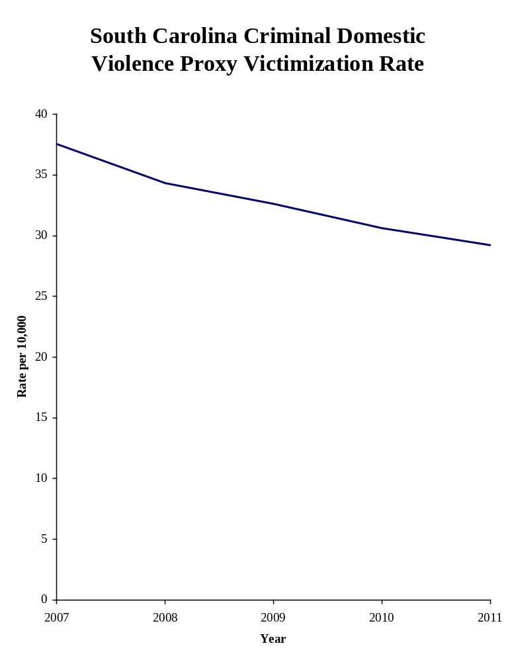

The ex-spouse violent victimization rate decreased 1.4% from 2007 to 2011.

EX-SPOUSE VIOLENCE: Violence against ex-spouses consists of homicide, sexual violence, robbery, aggravated assault, simple assault or intimidation where the victim once was, but is no longer, the spouse or common law spouse of the offender.

EX-SPOUSE VIOLENCE
FIVE YEAR STATEWIDE TREND
2007 – 2011

Number of Victimization Change from
Year Victims Rate Previous Year

2007 1,243 2.82
2008 1,303 2.91 +3.2%
2009 1,242 2.72 -6.5%
2010 1,266 2.74 +0.7%
2011 1,299 2.78 +1.5%

Notes: Change from previous year represents the change in the victimization rate. Victimization rate is expressed per 10,000.
Sources: SCIBRS, SLED; population estimates, ORS.

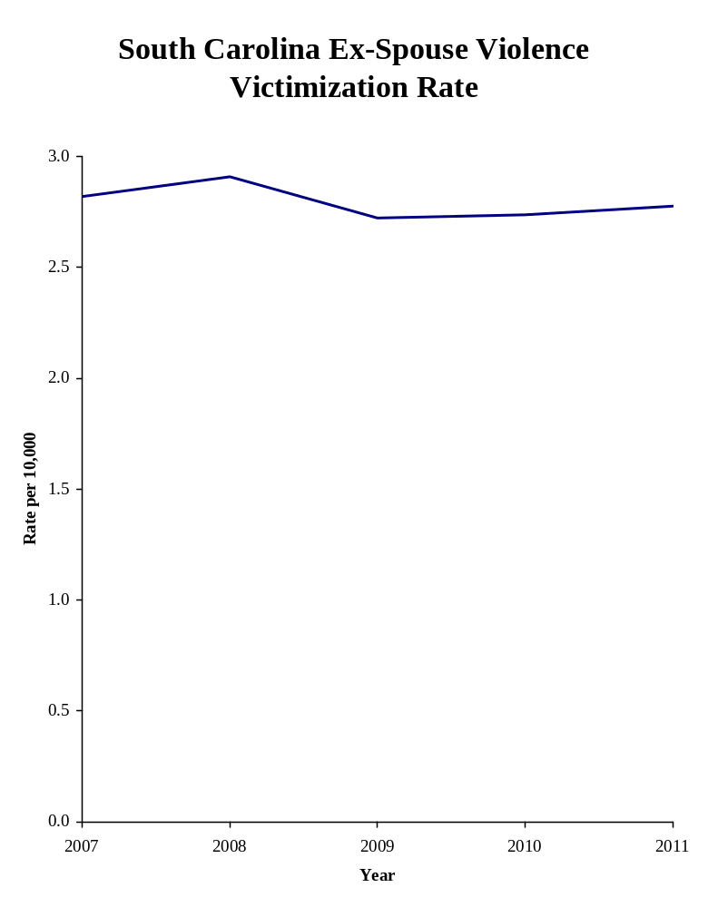
The family violence victimization rate decreased 9.7% from 2007 to 2011.

FAMILY VIOLENCE: Family violence consists of homicide, sexual violence, robbery, aggravated assault, simple assault or intimidation where the offender has a family relationship other than as a spouse, common law spouse or ex-spouse of the offender.

FAMILY VIOLENCE
FIVE YEAR STATEWIDE TREND
2007 – 2011

Number of Victimization Change from
Year Victims Rate Previous Year

2007 17,713 40.2
2008 17,126 38.2 -5.0%
2009 17,101 37.5 -1.8%
2010 16,940 36.6 -2.4%
2011 17,005 36.3 -0.8%

Notes: Change from previous year represents the change in the victimization rate. Victimization rate is expressed per 10,000.
Sources: SCIBRS, SLED; population estimates, ORS.

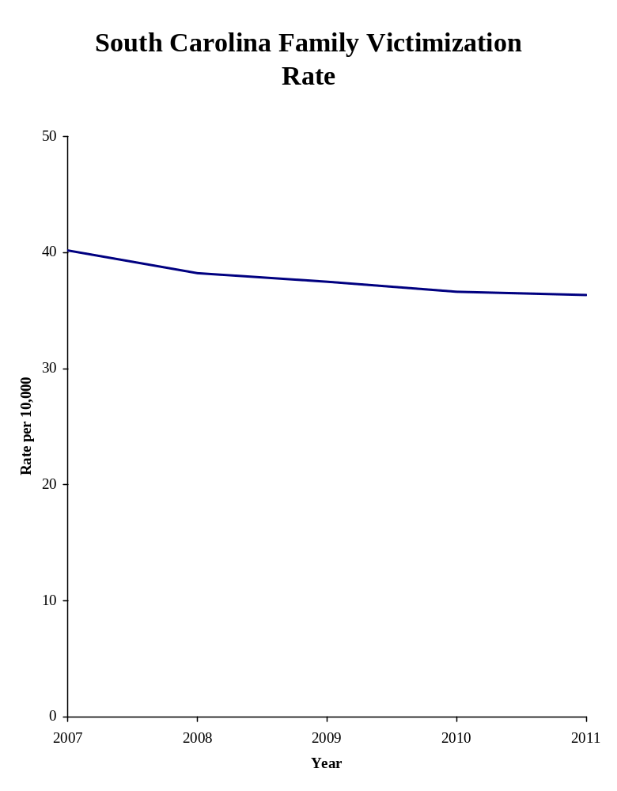
The marital violence victimization rate decreased 24% from 2007 to 2011.

MARTIAL VIOLENCE: Marital violence consists of homicide, sexual violence, robbery, aggravated assault, simple assault or intimidation where the victim is the spouse or common law spouse of the offender.

MARITAL VIOLENCE
FIVE YEAR STATEWIDE TREND
2007 – 2011

Number of Victimization Change from
Year Victims Rate Previous Year

2007 15,427 35.0
2008 14,183 31.7 -9.4%
2009 13,742 30.1 -5.0%
2010 12,994 28.1 -6.6%
2011 12,467 26.6 -5.3%

Notes: Change from previous year represents the change in the victimization rate. Victimization rate is expressed per 10,000.
Sources: SCIBRS, SLED; population estimates, ORS.

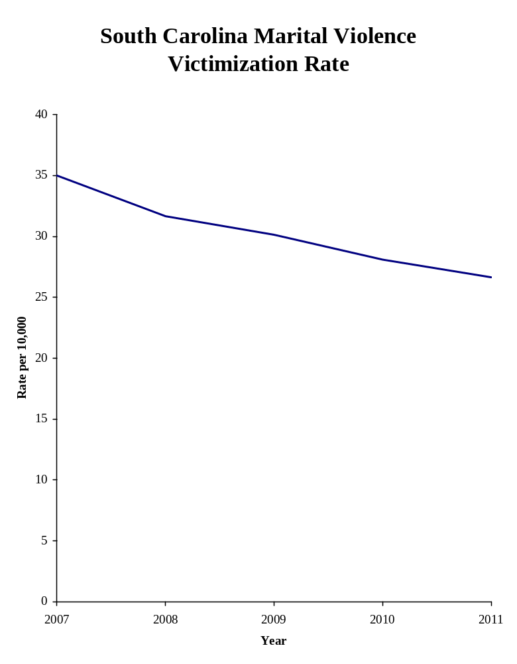
The violent victimization rate in romantic relationships decreased 2.5% from 2007 to 2011.

VIOLENCE IN ROMANTIC RELATIONSHIPS: Violence in romantic relationships consists of homicide, sexual violence, robbery, aggravated assault, simple assault or intimidation where the victim is the boyfriend or girlfriend of the offender.

VIOLENCE IN ROMANTIC RELATIONSHIPS
FIVE YEAR STATEWIDE TREND
2007 – 2011

Number of Victimization Change from
Year Victims Rate Previous Year

2007 19,694 44.7
2008 19,420 43.4 -2.9%
2009 20,281 44.5 +2.5%
2010 20,000 43.2 -2.9%
2011 20,423 43.6 +0.9%

Notes: Change from previous year represents the change in the victimization rate. Victimization rate is expressed per 10,000.
Sources: SCIBRS, SLED; population estimates, ORS.

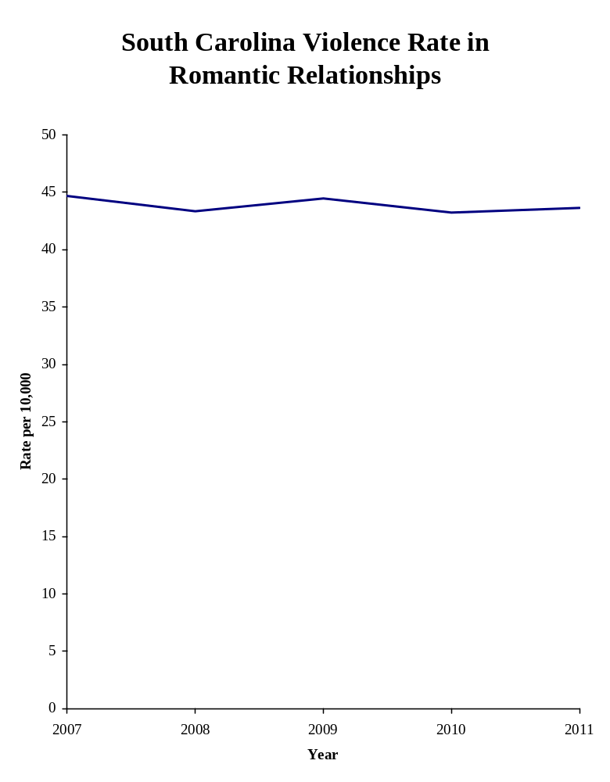
Blank page

COUNTY RANKINGS
FOR DOMESTIC VIOLENCE
2011

Greenville County reported 4,369 domestic violence victims in 2011, the most among South Carolina counties.

DOMESTIC VIOLENCE VICTIMIZATION
COUNTY RANKINGS
2011

County Number Rank County Number Rank

Abbeville 166 43 Greenwood 1,367 14
Aiken 1,439 13 Hampton 219 37
Allendale 103 45 Horry 3,587 2
Anderson 2,821 6 Jasper 219 37
Bamberg 170 42 Kershaw 664 23
Barnwell 396 32 Lancaster 736 21
Beaufort 1,673 10 Laurens 1,229 16
Berkeley 2,092 8 Lee 176 41
Calhoun 200 39 Lexington 2,695 7
Charleston 3,454 3 McCormick 54 46
Cherokee 425 31 Marion 486 27
Chester 589 25 Marlboro 470 29
Chesterfield 476 28 Newberry 328 34
Clarendon 460 30 Oconee 652 24
Colleton 717 22 Orangeburg 1,325 15
Darlington 1,228 17 Pickens 1,052 19
Dillon 516 26 Richland 3,359 4
Dorchester 1,509 12 Saluda 133 44
Edgefield 183 40 Spartanburg 1,781 9
Fairfield 313 35 Sumter 1,126 18
Florence 1,620 11 Union 357 33
Georgetown 764 20 Williamsburg 299 36
Greenville 4,369 1 York 2,851 5

Source: SCIBRS, SLED.

Greenwood County’s domestic violence victimization rate of 195.7 per 10,000 was the highest among South Carolina counties in 2011.

DOMESTIC VIOLENCE VICTIMIZATION RATE
COUNTY RANKINGS
2011

County Rate Rank County Rate Rank

Abbeville 66.0 44 Greenwood 195.7 1
Aiken 89.6 34 Hampton 105.2 24
Allendale 101.2 28 Horry 129.8 15
Anderson 149.7 9 Jasper 86.9 39
Bamberg 106.4 23 Kershaw 106.6 22
Barnwell 177.1 6 Lancaster 94.5 32
Beaufort 101.6 27 Laurens 184.7 3
Berkeley 114.0 20 Lee 92.7 33
Calhoun 132.1 14 Lexington 100.9 29
Charleston 96.6 30 McCormick 53.8 46
Cherokee 76.5 41 Marion 148.0 10
Chester 178.9 5 Marlboro 164.9 7
Chesterfield 102.2 26 Newberry 87.0 38
Clarendon 132.5 13 Oconee 87.6 37
Colleton 185.7 2 Orangeburg 144.2 11
Darlington 179.8 4 Pickens 88.0 35
Dillon 162.5 8 Richland 86.3 40
Dorchester 107.1 21 Saluda 66.9 43
Edgefield 68.6 42 Spartanburg 62.1 45
Fairfield 132.8 12 Sumter 104.8 25
Florence 117.5 19 Union 124.5 17
Georgetown 127.4 16 Williamsburg 87.7 36
Greenville 94.7 31 York 123.7 18

Note: Victimization rate is expressed per 10,000.
Sources: SCIBRS, SLED; population estimates, ORS.

Horry County reported 12 domestic homicide victims in 2011, the most among South Carolina counties.

DOMESTIC HOMICIDE VICTIMIZATION
COUNTY RANKINGS
2011

County Number Rank County Number Rank

Abbeville 1 18 Greenwood 3 12
Aiken 6 5 Hampton 0 30
Allendale 1 18 Horry 12 1
Anderson 8 3 Jasper 1 18
Bamberg 0 30 Kershaw 1 18
Barnwell 0 30 Lancaster 1 18
Beaufort 0 30 Laurens 0 30
Berkeley 3 12 Lee 0 30
Calhoun 0 30 Lexington 6 5
Charleston 4 10 McCormick 0 30
Cherokee 0 30 Marion 0 30
Chester 0 30 Marlboro 1 18
Chesterfield 0 30 Newberry 0 30
Clarendon 1 18 Oconee 0 30
Colleton 1 18 Orangeburg 1 18
Darlington 1 18 Pickens 5 7
Dillon 1 18 Richland 8 3
Dorchester 0 30 Saluda 2 14
Edgefield 2 14 Spartanburg 4 10
Fairfield 0 30 Sumter 0 30
Florence 5 7 Union 2 14
Georgetown 1 18 Williamsburg 2 14
Greenville 11 2 York 5 7

Notes: Due to the small number of domestic homicides reported, there were numerous ties in terms of county rank. The lowest rank is 30, since only 29 counties reported domestic homicides during 2011.
Source: SCIBRS, SLED.

Saluda County’s domestic homicide victimization rate of 1.01 per 10,000 was the highest among South Carolina counties in 2011.

DOMESTIC HOMICIDE VICTIMIZATION RATE
COUNTY RANKINGS
2011

County Rate Rank County Rate Rank

Abbeville 0.40 10 Greenwood 0.43 6
Aiken 0.37 12 Hampton 0.00 30
Allendale 0.98 2 Horry 0.43 6
Anderson 0.42 8 Jasper 0.40 10
Bamberg 0.00 30 Kershaw 0.16 23
Barnwell 0.00 30 Lancaster 0.13 27
Beaufort 0.00 30 Laurens 0.00 30
Berkeley 0.16 23 Lee 0.00 30
Calhoun 0.00 30 Lexington 0.22 19
Charleston 0.11 28 McCormick 0.00 30
Cherokee 0.00 30 Marion 0.00 30
Chester 0.00 30 Marlboro 0.35 14
Chesterfield 0.00 30 Newberry 0.00 30
Clarendon 0.29 16 Oconee 0.00 30
Colleton 0.26 17 Orangeburg 0.11 28
Darlington 0.15 25 Pickens 0.42 8
Dillon 0.31 15 Richland 0.21 21
Dorchester 0.00 30 Saluda 1.01 1
Edgefield 0.75 3 Spartanburg 0.14 26
Fairfield 0.00 30 Sumter 0.00 30
Florence 0.36 13 Union 0.70 4
Georgetown 0.17 22 Williamsburg 0.59 5
Greenville 0.24 18 York 0.22 19

Notes: Due to the small number of domestic homicides reported, there were numerous ties in terms of county rank. The lowest rank is 30, since only 29 counties reported domestic homicides during 2011.
Source: SCIBRS, SLED.
Greenville County reported 173 victims of domestic sexual violence in 2011, the most among South Carolina’s counties.

DOMESTIC SEXUAL VIOLENCE VICTIMIZATION
COUNTY RANKINGS
2011

County Number Rank County Number Rank

Abbeville 2 43 Greenwood 21 18
Aiken 55 7 Hampton 4 40
Allendale 0 46 Horry 64 6
Anderson 43 9 Jasper 11 29
Bamberg 4 40 Kershaw 23 17
Barnwell 6 38 Lancaster 20 19
Beaufort 17 21 Laurens 29 13
Berkeley 37 10 Lee 7 36
Calhoun 2 43 Lexington 87 2
Charleston 65 5 McCormick 2 43
Cherokee 13 27 Marion 8 34
Chester 18 20 Marlboro 14 24
Chesterfield 17 21 Newberry 6 38
Clarendon 11 29 Oconee 30 12
Colleton 17 21 Orangeburg 14 24
Darlington 29 13 Pickens 43 9
Dillon 9 33 Richland 78 3
Dorchester 25 16 Saluda 3 42
Edgefield 8 34 Spartanburg 53 8
Fairfield 7 36 Sumter 11 29
Florence 29 13 Union 14 24
Georgetown 10 32 Williamsburg 13 27
Greenville 173 1 York 73 4

Source: SCIBRS, SLED.

Chester County’s domestic sexual violence victimization rate of 5.47 per 10,000 was the highest among South Carolina counties in 2011.

DOMESTIC SEXUAL VIOLENCE VICTIMIZATION RATE
COUNTY RANKINGS
2011

County Rate Rank County Rate Rank

Abbeville 0.79 45 Greenwood 3.01 19
Aiken 3.42 15 Hampton 1.92 34
Allendale 0.00 46 Horry 2.32 28
Anderson 2.28 29 Jasper 4.37 5
Bamberg 2.50 25 Kershaw 3.69 11
Barnwell 2.68 23 Lancaster 2.57 24
Beaufort 1.03 43 Laurens 4.36 6
Berkeley 2.02 31 Lee 3.69 12
Calhoun 1.32 42 Lexington 3.26 16
Charleston 1.82 36 McCormick 1.99 33
Cherokee 2.34 27 Marion 2.44 26
Chester 5.47 1 Marlboro 4.91 2
Chesterfield 3.65 13 Newberry 1.59 39
Clarendon 3.17 17 Oconee 4.03 8
Colleton 4.40 4 Orangeburg 1.52 40
Darlington 4.25 7 Pickens 3.60 14
Dillon 2.83 22 Richland 2.00 32
Dorchester 1.77 37 Saluda 1.51 41
Edgefield 3.00 20 Spartanburg 1.85 35
Fairfield 2.97 21 Sumter 1.02 44
Florence 2.10 30 Union 4.88 3
Georgetown 1.67 38 Williamsburg 3.81 9
Greenville 3.75 10 York 3.17 17

Note: Victimization rate is expressed per 10,000.
Sources: SCIBRS, SLED; population estimates, ORS.

Richland County reported 14 domestic robbery victims in 2011, the most among South Carolina counties.

DOMESTIC ROBBERY VICTIMIZATION
COUNTY RANKINGS
2011

County Number Rank County Number Rank

Abbeville 2 16 Greenwood 2 16
Aiken 0 28 Hampton 0 28
Allendale 0 28 Horry 6 7
Anderson 5 8 Jasper 1 22
Bamberg 0 28 Kershaw 0 28
Barnwell 1 22 Lancaster 2 16
Beaufort 4 9 Laurens 3 11
Berkeley 0 28 Lee 1 22
Calhoun 0 28 Lexington 8 5
Charleston 10 2 McCormick 0 28
Cherokee 0 28 Marion 3 11
Chester 3 11 Marlboro 3 11
Chesterfield 0 28 Newberry 1 22
Clarendon 2 16 Oconee 0 28
Colleton 0 28 Orangeburg 1 22
Darlington 4 9 Pickens 2 16
Dillon 0 28 Richland 14 1
Dorchester 0 28 Saluda 1 22
Edgefield 0 28 Spartanburg 9 3
Fairfield 0 28 Sumter 3 11
Florence 2 16 Union 0 28
Georgetown 0 28 Williamsburg 0 28
Greenville 9 3 York 7 6

Notes: Due to the small number of domestic robberies reported, there were numerous ties in terms of county rank. The lowest rank is 28, since only 27 counties reported domestic robberies during 2011.
Source: SCIBRS, SLED.
Marlboro County’s domestic robbery victimization rate of 1.05 per 10,000 was the highest among South Carolina counties in 2011.

DOMESTIC ROBBERY VICTIMIZATION RATE
COUNTY RANKINGS
2011

County Rate Rank County Rate Rank

Abbeville 0.79 4 Greenwood 0.29 16
Aiken 0.00 28 Hampton 0.00 28
Allendale 0.00 28 Horry 0.22 23
Anderson 0.27 19 Jasper 0.40 11
Bamberg 0.00 28 Kershaw 0.00 28
Barnwell 0.45 9 Lancaster 0.26 21
Beaufort 0.24 22 Laurens 0.45 9
Berkeley 0.00 28 Lee 0.53 7
Calhoun 0.00 28 Lexington 0.30 14
Charleston 0.28 17 McCormick 0.00 28
Cherokee 0.00 28 Marion 0.91 2
Chester 0.91 2 Marlboro 1.05 1
Chesterfield 0.00 28 Newberry 0.27 19
Clarendon 0.58 6 Oconee 0.00 28
Colleton 0.00 28 Orangeburg 0.11 27
Darlington 0.59 5 Pickens 0.17 25
Dillon 0.00 28 Richland 0.36 12
Dorchester 0.00 28 Saluda 0.50 8
Edgefield 0.00 28 Spartanburg 0.31 13
Fairfield 0.00 28 Sumter 0.28 17
Florence 0.15 26 Union 0.00 28
Georgetown 0.00 28 Williamsburg 0.00 28
Greenville 0.20 24 York 0.30 14

Notes: Due to the small number of domestic robberies reported, there were numerous ties in terms of county rank. The lowest rank is 28, since only 29 counties reported domestic robberies during 2011.
Source: SCIBRS, SLED.
Richland County reported 924 victims of domestic aggravated assault in 2011, the most among South Carolina’s counties.

DOMESTIC AGGRAVATED ASSAULT VICTIMIZATION
COUNTY RANKINGS
2011

County Number Rank County Number Rank

Abbeville 61 30 Greenwood 583 3
Aiken 150 17 Hampton 57 31
Allendale 44 35 Horry 384 6
Anderson 319 8 Jasper 12 45
Bamberg 25 43 Kershaw 95 23
Barnwell 51 33 Lancaster 90 24
Beaufort 247 11 Laurens 169 16
Berkeley 179 14 Lee 29 42
Calhoun 32 40 Lexington 293 10
Charleston 492 5 McCormick 17 44
Cherokee 30 41 Marion 64 29
Chester 66 28 Marlboro 80 25
Chesterfield 72 26 Newberry 34 38
Clarendon 70 27 Oconee 171 15
Colleton 57 31 Orangeburg 115 20
Darlington 208 12 Pickens 122 18
Dillon 102 22 Richland 924 1
Dorchester 119 19 Saluda 34 38
Edgefield 12 45 Spartanburg 382 7
Fairfield 44 35 Sumter 537 4
Florence 198 13 Union 42 37
Georgetown 112 21 Williamsburg 50 34
Greenville 776 2 York 304 9

Source: SCIBRS, SLED.

Greenwood County’s domestic aggravated assault victimization rate of 83.5 per 10,000 was the highest among South Carolina counties in 2011.

DOMESTIC AGGRAVATED ASSAULT VICTIMIZATION RATE
COUNTY RANKINGS
2011

County Rate Rank County Rate Rank

Abbeville 24.2 9 Greenwood 83.5 1
Aiken 9.3 41 Hampton 27.4 7
Allendale 43.2 3 Horry 13.9 32
Anderson 16.9 20 Jasper 4.8 45
Bamberg 15.6 23 Kershaw 15.3 25
Barnwell 22.8 12 Lancaster 11.6 37
Beaufort 15.0 27 Laurens 25.4 8
Berkeley 9.8 40 Lee 15.3 25
Calhoun 21.1 13 Lexington 11.0 38
Charleston 13.8 33 McCormick 16.9 20
Cherokee 5.4 44 Marion 19.5 16
Chester 20.1 15 Marlboro 28.1 6
Chesterfield 15.5 24 Newberry 9.0 42
Clarendon 20.2 14 Oconee 23.0 11
Colleton 14.8 28 Orangeburg 12.5 36
Darlington 30.5 5 Pickens 10.2 39
Dillon 32.1 4 Richland 23.7 10
Dorchester 8.4 43 Saluda 17.1 19
Edgefield 4.5 46 Spartanburg 13.3 34
Fairfield 18.7 17 Sumter 50.0 2
Florence 14.4 31 Union 14.6 30
Georgetown 18.7 17 Williamsburg 14.7 29
Greenville 16.8 22 York 13.2 35

Note: Victimization rate is expressed per 10,000.
Sources: SCIBRS, SLED; population estimates, ORS.

Greenville County reported 3,046 victims of domestic simple assault in 2011, the most among South Carolina’s counties.

DOMESTIC SIMPLE ASSAULT VICTIMIZATION
COUNTY RANKINGS
2011

County Number Rank County Number Rank

Abbeville 84 44 Greenwood 687 18
Aiken 1,158 10 Hampton 114 42
Allendale 51 45 Horry 2,586 2
Anderson 2,211 4 Jasper 182 37
Bamberg 124 40 Kershaw 471 23
Barnwell 323 29 Lancaster 541 19
Beaufort 1,149 11 Laurens 768 17
Berkeley 1,528 8 Lee 117 41
Calhoun 161 38 Lexington 2,064 5
Charleston 2,579 3 McCormick 31 46
Cherokee 332 27 Marion 326 28
Chester 415 24 Marlboro 289 31
Chesterfield 323 29 Newberry 274 33
Clarendon 288 32 Oconee 409 25
Colleton 517 21 Orangeburg 1,130 12
Darlington 769 16 Pickens 812 15
Dillon 360 26 Richland 1,981 6
Dorchester 1,123 13 Saluda 88 43
Edgefield 149 39 Spartanburg 1,228 9
Fairfield 213 35 Sumter 473 22
Florence 1,085 14 Union 259 34
Georgetown 521 20 Williamsburg 202 36
Greenville 3,046 1 York 1,856 7

Source: SCIBRS, SLED.

Barnwell County’s domestic simple assault victimization rate of 144.5 per 10,000 was the highest among South Carolina counties in 2011.

DOMESTIC SIMPLE ASSAULT VICTIMIZATION RATE
COUNTY RANKINGS
2011

County Rate Rank County Rate Rank

Abbeville 33.4 45 Greenwood 98.4 12
Aiken 72.1 27 Hampton 54.8 39
Allendale 50.1 41 Horry 93.6 13
Anderson 117.3 5 Jasper 72.2 26
Bamberg 77.6 22 Kershaw 75.6 24
Barnwell 144.5 1 Lancaster 69.4 30
Beaufort 69.8 29 Laurens 115.4 6
Berkeley 83.3 17 Lee 61.7 34
Calhoun 106.3 9 Lexington 77.3 23
Charleston 72.1 27 McCormick 30.9 46
Cherokee 59.8 35 Marion 99.3 11
Chester 126.1 3 Marlboro 101.4 10
Chesterfield 69.4 30 Newberry 72.6 25
Clarendon 82.9 18 Oconee 55.0 38
Colleton 133.9 2 Orangeburg 122.9 4
Darlington 112.6 8 Pickens 67.9 32
Dillon 113.4 7 Richland 50.9 40
Dorchester 79.7 20 Saluda 44.3 42
Edgefield 55.9 37 Spartanburg 42.8 44
Fairfield 90.4 14 Sumter 44.0 43
Florence 78.7 21 Union 90.3 15
Georgetown 86.8 16 Williamsburg 59.3 36
Greenville 66.0 33 York 80.5 19

Note: Victimization rate is expressed per 10,000.
Sources: SCIBRS, SLED; population estimates, ORS.

York County reported 606 victims of domestic intimidation in 2011, the most among South Carolina’s counties.

DOMESTIC INTIMIDATION VICTIMIZATION
COUNTY RANKINGS
2011

County Number Rank County Number Rank

Abbeville 17 37 Greenwood 71 24
Aiken 70 25 Hampton 44 31
Allendale 7 43 Horry 535 2
Anderson 236 12 Jasper 12 41
Bamberg 17 37 Kershaw 74 23
Barnwell 15 39 Lancaster 82 22
Beaufort 256 9 Laurens 260 8
Berkeley 342 5 Lee 22 36
Calhoun 5 44 Lexington 237 11
Charleston 305 6 McCormick 4 46
Cherokee 50 29 Marion 85 20
Chester 87 19 Marlboro 83 21
Chesterfield 61 28 Newberry 13 40
Clarendon 88 18 Oconee 42 33
Colleton 125 14 Orangeburg 64 27
Darlington 217 13 Pickens 68 26
Dillon 44 31 Richland 355 3
Dorchester 242 10 Saluda 5 44
Edgefield 12 41 Spartanburg 105 16
Fairfield 49 30 Sumter 102 17
Florence 301 7 Union 40 34
Georgetown 120 15 Williamsburg 32 35
Greenville 354 4 York 606 1

Source: SCIBRS, SLED.

Laurens County’s domestic intimidation victimization rate of 39.1 per 10,000 was the highest among South Carolina counties in 2011.

DOMESTIC INTIMIDATION VICTIMIZATION RATE
COUNTY RANKINGS
2011

County Rate Rank County Rate Rank

Abbeville 6.8 35 Greenwood 10.2 25
Aiken 4.4 41 Hampton 21.1 10
Allendale 6.9 34 Horry 19.4 13
Anderson 12.5 20 Jasper 4.8 39
Bamberg 10.6 23 Kershaw 11.9 21
Barnwell 6.7 36 Lancaster 10.5 24
Beaufort 15.5 16 Laurens 39.1 1
Berkeley 18.6 14 Lee 11.6 22
Calhoun 3.3 45 Lexington 8.9 30
Charleston 8.5 31 McCormick 4.0 42
Cherokee 9.0 29 Marion 25.9 7
Chester 26.4 5 Marlboro 29.1 4
Chesterfield 13.1 19 Newberry 3.4 44
Clarendon 25.3 8 Oconee 5.6 38
Colleton 32.4 2 Orangeburg 7.0 33
Darlington 31.8 3 Pickens 5.7 37
Dillon 13.9 17 Richland 9.1 28
Dorchester 17.2 15 Saluda 2.5 46
Edgefield 4.5 40 Spartanburg 3.7 43
Fairfield 20.8 11 Sumter 9.5 26
Florence 21.8 9 Union 13.9 17
Georgetown 20.0 12 Williamsburg 9.4 27
Greenville 7.7 32 York 26.3 6

Note: Victimization rate is expressed per 10,000.
Sources: SCIBRS, SLED; population estimates, ORS.

Using a proxy indicator for criminal domestic violence, Greenville County reported 1,077 victims in 2011, the most among South Carolina’s counties.

CRIMINAL DOMESTIC VIOLENCE PROXY VICTIMIZATION
COUNTY RANKINGS
2011

County Number Rank County Number Rank

Abbeville 45 40 Greenwood 448 12
Aiken 586 9 Hampton 54 38
Allendale 27 45 Horry 1,002 2
Anderson 917 3 Jasper 97 28
Bamberg 29 44 Kershaw 222 21
Barnwell 72 35 Lancaster 162 24
Beaufort 412 13 Laurens 307 17
Berkeley 601 8 Lee 44 41
Calhoun 51 39 Lexington 669 7
Charleston 904 4 McCormick 18 46
Cherokee 125 26 Marion 90 31
Chester 102 27 Marlboro 86 32
Chesterfield 81 34 Newberry 140 25
Clarendon 96 29 Oconee 241 19
Colleton 205 22 Orangeburg 238 20
Darlington 265 18 Pickens 312 16
Dillon 94 30 Richland 816 6
Dorchester 544 10 Saluda 32 43
Edgefield 42 42 Spartanburg 474 11
Fairfield 56 36 Sumter 326 15
Florence 386 14 Union 85 33
Georgetown 204 23 Williamsburg 56 36
Greenville 1,077 1 York 831 5

Source: SCIBRS, SLED.

Using a proxy indicator for criminal domestic violence, Greenwood County’s rate of 64.2 per 10,000 was the highest among South Carolina counties in 2011.

CRIMINAL DOMESTIC VIOLENCE PROXY
VICTIMIZATION RATE
COUNTY RANKINGS
2011

County Rate Rank County Rate Rank

Abbeville 17.9 41 Greenwood 64.2 1
Aiken 36.5 9 Hampton 25.9 28
Allendale 26.5 26 Horry 36.3 10
Anderson 48.7 3 Jasper 38.5 7
Bamberg 18.2 39 Kershaw 35.6 12
Barnwell 32.2 17 Lancaster 20.8 38
Beaufort 25.0 32 Laurens 46.1 4
Berkeley 32.7 15 Lee 23.2 35
Calhoun 33.7 14 Lexington 25.0 31
Charleston 25.3 30 McCormick 17.9 40
Cherokee 22.5 36 Marion 27.4 25
Chester 31.0 18 Marlboro 30.2 20
Chesterfield 17.4 42 Newberry 37.1 8
Clarendon 27.6 24 Oconee 32.4 16
Colleton 53.1 2 Orangeburg 25.9 29
Darlington 38.8 5 Pickens 26.1 27
Dillon 29.6 22 Richland 21.0 37
Dorchester 38.6 6 Saluda 16.1 45
Edgefield 15.7 46 Spartanburg 16.5 43
Fairfield 23.8 33 Sumter 30.3 19
Florence 28.0 23 Union 29.6 21
Georgetown 34.0 13 Williamsburg 16.4 44
Greenville 23.3 34 York 36.0 11

Note: Victimization rate is expressed per 10,000.
Sources: SCIBRS, SLED; population estimates, ORS.

York County reported 133 victims of violence between ex-spouses in 2011, the most among South Carolina’s counties.

EX-SPOUSE VIOLENCE VICTIMIZATION
COUNTY RANKINGS
2011

County Number Rank County Number Rank

Abbeville 4 40 Greenwood 30 16
Aiken 25 17 Hampton 4 40
Allendale 5 36 Horry 88 5
Anderson 74 6 Jasper 7 33
Bamberg 3 42 Kershaw 25 17
Barnwell 6 35 Lancaster 13 24
Beaufort 20 21 Laurens 18 22
Berkeley 42 9 Lee 9 32
Calhoun 1 43 Lexington 51 7
Charleston 105 2 McCormick 1 43
Cherokee 25 17 Marion 12 27
Chester 13 24 Marlboro 5 36
Chesterfield 13 24 Newberry 12 27
Clarendon 11 29 Oconee 14 23
Colleton 21 20 Orangeburg 10 30
Darlington 38 13 Pickens 38 13
Dillon 10 30 Richland 103 3
Dorchester 39 11 Saluda 1 43
Edgefield 1 43 Spartanburg 49 8
Fairfield 7 33 Sumter 39 11
Florence 40 10 Union 5 36
Georgetown 32 15 Williamsburg 5 36
Greenville 92 4 York 133 1

Source: SCIBRS, SLED.

York County’s ex-spouse violence victimization rate of 5.8 per 10,000 was the highest among South Carolina counties in 2011.

EX-SPOUSE VIOLENCE VICTIMIZATION RATE
COUNTY RANKINGS
2011

County Rate Rank County Rate Rank

Abbeville 1.6 38 Greenwood 4.3 8
Aiken 1.6 38 Hampton 1.9 30
Allendale 4.9 5 Horry 3.2 14
Anderson 3.9 10 Jasper 2.8 22
Bamberg 1.9 30 Kershaw 4.0 9
Barnwell 2.7 25 Lancaster 1.7 35
Beaufort 1.2 41 Laurens 2.7 25
Berkeley 2.3 28 Lee 4.7 6
Calhoun 0.7 44 Lexington 1.9 30
Charleston 2.9 20 McCormick 1.0 43
Cherokee 4.5 7 Marion 3.7 12
Chester 3.9 10 Marlboro 1.8 34
Chesterfield 2.8 22 Newberry 3.2 14
Clarendon 3.2 14 Oconee 1.9 30
Colleton 5.4 3 Orangeburg 1.1 42
Darlington 5.6 2 Pickens 3.2 14
Dillon 3.1 18 Richland 2.6 27
Dorchester 2.8 22 Saluda 0.5 45
Edgefield 0.4 46 Spartanburg 1.7 35
Fairfield 3.0 19 Sumter 3.6 13
Florence 2.9 20 Union 1.7 35
Georgetown 5.3 4 Williamsburg 1.5 40
Greenville 2.0 29 York 5.8 1

Note: Victimization rate is expressed per 10,000.
Sources: SCIBRS, SLED; population estimates, ORS.

Greenville County reported 1,436 victims of family violence in 2011, the most among South Carolina’s counties.

FAMILY VIOLENCE VICTIMIZATION
COUNTY RANKINGS
2011

County Number Rank County Number Rank

Abbeville 79 41 Greenwood 473 14
Aiken 493 12 Hampton 87 38
Allendale 25 45 Horry 828 7
Anderson 1,144 2 Jasper 38 44
Bamberg 80 40 Kershaw 252 23
Barnwell 144 32 Lancaster 276 21
Beaufort 611 9 Laurens 385 18
Berkeley 800 8 Lee 71 42
Calhoun 90 37 Lexington 848 6
Charleston 1,074 3 McCormick 23 46
Cherokee 149 31 Marion 174 29
Chester 239 24 Marlboro 197 25
Chesterfield 194 28 Newberry 96 36
Clarendon 195 27 Oconee 196 26
Colleton 263 22 Orangeburg 523 11
Darlington 473 14 Pickens 441 17
Dillon 171 30 Richland 904 5
Dorchester 443 16 Saluda 54 43
Edgefield 81 39 Spartanburg 540 10
Fairfield 110 35 Sumter 353 19
Florence 476 13 Union 126 34
Georgetown 283 20 Williamsburg 133 33
Greenville 1,436 1 York 934 4

Source: SCIBRS, SLED.

Chester County’s family violence victimization rate of 72.6 per 10,000 was the highest among South Carolina counties in 2011.

FAMILY VIOLENCE VICTIMIZATION RATE
COUNTY RANKINGS
2011

County Rate Rank County Rate Rank

Abbeville 31.4 32 Greenwood 67.7 5
Aiken 30.7 34 Hampton 41.8 19
Allendale 24.6 42 Horry 30.0 37
Anderson 60.7 7 Jasper 15.1 46
Bamberg 50.1 14 Kershaw 40.5 22
Barnwell 64.4 6 Lancaster 35.4 27
Beaufort 37.1 25 Laurens 57.9 9
Berkeley 43.6 18 Lee 37.4 24
Calhoun 59.4 8 Lexington 31.7 30
Charleston 30.0 36 McCormick 22.9 44
Cherokee 26.8 39 Marion 53.0 13
Chester 72.6 1 Marlboro 69.1 3
Chesterfield 41.7 20 Newberry 25.5 41
Clarendon 56.2 11 Oconee 26.3 40
Colleton 68.1 4 Orangeburg 56.9 10
Darlington 69.3 2 Pickens 36.9 26
Dillon 53.8 12 Richland 23.2 43
Dorchester 31.4 31 Saluda 27.2 38
Edgefield 30.4 35 Spartanburg 18.8 45
Fairfield 46.7 16 Sumter 32.8 29
Florence 34.5 28 Union 43.9 17
Georgetown 47.2 15 Williamsburg 39.0 23
Greenville 31.1 33 York 40.5 21

Note: Victimization rate is expressed per 10,000.
Sources: SCIBRS, SLED; population estimates, ORS.

Greenville County reported 993 victims of marital violence in 2011, the most among South Carolina’s counties.

MARITAL VIOLENCE VICTIMIZATION
COUNTY RANKINGS
2011

County Number Rank County Number Rank

Abbeville 41 40 Greenwood 420 12
Aiken 566 8 Hampton 50 37
Allendale 23 45 Horry 924 2
Anderson 844 3 Jasper 91 27
Bamberg 26 44 Kershaw 199 21
Barnwell 66 35 Lancaster 150 24
Beaufort 393 13 Laurens 292 15
Berkeley 561 9 Lee 35 42
Calhoun 50 37 Lexington 624 7
Charleston 804 4 McCormick 17 46
Cherokee 101 26 Marion 80 33
Chester 91 27 Marlboro 81 32
Chesterfield 70 34 Newberry 130 25
Clarendon 87 29 Oconee 228 19
Colleton 185 22 Orangeburg 230 18
Darlington 227 20 Pickens 279 17
Dillon 84 30 Richland 722 5
Dorchester 506 10 Saluda 32 43
Edgefield 41 40 Spartanburg 430 11
Fairfield 49 39 Sumter 290 16
Florence 349 14 Union 82 31
Georgetown 172 23 Williamsburg 51 36
Greenville 993 1 York 701 6

Source: SCIBRS, SLED.

Greenwood County’s marital violence victimization rate of 60.1 per 10,000 was the highest among South Carolina counties in 2011.

MARITAL VIOLENCE VICTIMIZATION RATE
COUNTY RANKINGS
2011

County Rate Rank County Rate Rank

Abbeville 16.3 40 Greenwood 60.1 1
Aiken 35.2 7 Hampton 24.0 27
Allendale 22.6 31 Horry 33.4 9
Anderson 44.8 3 Jasper 36.1 5
Bamberg 16.3 40 Kershaw 32.0 11
Barnwell 29.5 16 Lancaster 19.3 35
Beaufort 23.9 28 Laurens 43.9 4
Berkeley 30.6 13 Lee 18.4 37
Calhoun 33.0 11 Lexington 23.4 29
Charleston 22.5 32 McCormick 16.9 39
Cherokee 18.2 38 Marion 24.4 26
Chester 27.6 20 Marlboro 28.4 19
Chesterfield 15.0 44 Newberry 34.5 8
Clarendon 25.1 24 Oconee 30.6 13
Colleton 47.9 2 Orangeburg 25.0 25
Darlington 33.2 10 Pickens 23.3 30
Dillon 26.5 22 Richland 18.6 36
Dorchester 35.9 6 Saluda 16.1 42
Edgefield 15.4 43 Spartanburg 15.0 44
Fairfield 20.8 34 Sumter 27.0 21
Florence 25.3 23 Union 28.6 18
Georgetown 28.7 17 Williamsburg 15.0 44
Greenville 21.5 33 York 30.4 15

Note: Victimization rate is expressed per 10,000.
Sources: SCIBRS, SLED; population estimates, ORS.

Greenville County reported 1,869 victims of violence in romantic relationships in 2011, the most among South Carolina’s counties.

VIOLENT VICTIMIZATION IN ROMANTIC RELATIONSHIPS
COUNTY RANKINGS
2011

County Number Rank County Number Rank

Abbeville 45 45 Greenwood 453 17
Aiken 366 18 Hampton 80 38
Allendale 50 43 Horry 1,769 2
Anderson 788 7 Jasper 84 37
Bamberg 61 39 Kershaw 189 28
Barnwell 181 30 Lancaster 305 19
Beaufort 668 11 Laurens 550 13
Berkeley 702 10 Lee 61 39
Calhoun 59 42 Lexington 1,180 5
Charleston 1,488 4 McCormick 13 46
Cherokee 150 32 Marion 224 25
Chester 252 23 Marlboro 189 28
Chesterfield 201 27 Newberry 93 36
Clarendon 168 31 Oconee 218 26
Colleton 250 24 Orangeburg 570 12
Darlington 503 15 Pickens 301 20
Dillon 253 22 Richland 1,640 3
Dorchester 530 14 Saluda 46 44
Edgefield 60 41 Spartanburg 774 8
Fairfield 150 32 Sumter 466 16
Florence 764 9 Union 145 34
Georgetown 281 21 Williamsburg 111 35
Greenville 1,869 1 York 1,123 6

Source: SCIBRS, SLED.

Laurens County’s rate of 82.7 per 10,000 violent victimizations in romantic relationships was the highest among South Carolina’s counties in 2011.

RATE OF VIOLENT VICTIMIZATION
IN ROMANTIC RELATIONSHIPS
COUNTY RANKINGS
2011

County Rate Rank County Rate Rank

Abbeville 17.9 45 Greenwood 64.9 8
Aiken 22.8 43 Hampton 38.4 29
Allendale 49.1 15 Horry 64.0 10
Anderson 41.8 23 Jasper 33.3 33
Bamberg 38.2 31 Kershaw 30.4 36
Barnwell 81.0 2 Lancaster 39.1 27
Beaufort 40.6 25 Laurens 82.7 1
Berkeley 38.3 30 Lee 32.1 35
Calhoun 39.0 28 Lexington 44.2 19
Charleston 41.6 24 McCormick 13.0 46
Cherokee 27.0 38 Marion 68.2 6
Chester 76.6 4 Marlboro 66.3 7
Chesterfield 43.2 21 Newberry 24.7 41
Clarendon 48.4 17 Oconee 29.3 37
Colleton 64.7 9 Orangeburg 62.0 12
Darlington 73.6 5 Pickens 25.2 40
Dillon 79.7 3 Richland 42.1 22
Dorchester 37.6 32 Saluda 23.1 42
Edgefield 22.5 44 Spartanburg 27.0 38
Fairfield 63.6 11 Sumter 43.4 20
Florence 55.4 13 Union 50.6 14
Georgetown 46.8 18 Williamsburg 32.6 34
Greenville 40.5 26 York 48.7 16

Note: Victimization rate is expressed per 10,000.
Sources: SCIBRS, SLED; population estimates, ORS.

Blank page

COUNTY
FIVE YEAR PROFILES

ABBEVILLE COUNTY

Five Year Trends

Criminal Domestic Violence Proxy

Year Number Rate Change

2007 78 30.7
2008 60 23.6 -22.9%
2009 52 20.7 -12.3%
2010 60 23.7 +14.2%
2011 45 17.9 -24.4%

Domestic Violence Victimization Trend

Year Number Rate Change

2007 225 88.4
2008 224 88.2 -0.3%
2009 208 82.9 -6.0%
2010 185 73.0 -12.0%
2011 166 66.0 -9.6%

Ex-Spouse Violence Victimization Trend

Year Number Rate Change

2007 2 0.8
2008 11 4.3 +450.9%
2009 7 2.8 -35.6%
2010 8 3.2 +13.1%
2011 4 1.6 -49.6%

Notes: Victimization rate is expressed per 10,000. Change represents the change in victimization rate from one year to the next.
Sources: SCIBRS, SLED; population estimates, ORS.

Family Violence Victimization Trend

Year Number Rate Change

2007 86 33.8
2008 112 44.1 +30.4%
2009 100 39.8 -9.6%
2010 84 33.1 -16.8%
2011 79 31.4 -5.2%

Marital Violence Victimization Trend

Year Number Rate Change

2007 76 29.9
2008 49 19.3 -35.4%
2009 45 17.9 -7.0%
2010 52 20.5 +14.4%
2011 41 16.3 -20.5%

Violence in Romantic Relationships

Year Number Rate Change

2007 63 24.8
2008 53 20.9 -15.7%
2009 58 23.1 +10.8%
2010 43 17.0 -26.6%
2011 45 17.9 +5.5%

Notes: Victimization rate is expressed per 10,000. Change represents the change in victimization rate from one year to the next.
Sources: SCIBRS, SLED; population estimates, ORS.

Victim Characteristics

Domestic Violence Victims by Sex

Sex Number Percent

Female 691 68.6%
Male 317 31.4%
Total 1,008 100.0%

Domestic Violence Victims by Race

Race Number Percent

Black 438 43.5%
Unknown 3 0.3%
White 567 56.3%
Total 1,008 100.0%

Domestic Violence Victims by Ethnicity

Ethnicity Number Percent

Hispanic 10 1.0%
Non-Hispanic 997 98.9%
Unknown 1 0.1%
Total 1,008 100.0%

Domestic Violence Victims by Victim Residence

Residence Number Percent

Reporting Jurisdiction 915 90.8%
Out of State 8 0.8%
In State, Not in Jurisdiction 84 8.3%
Unknown 1 0.1%
Total 1,008 100.0%

Source: SCIBRS, SLED.

AIKEN COUNTY

Five Year Trends

Criminal Domestic Violence Proxy

Year Number Rate Change

2007 679 44.6
2008 667 43.3 -2.9%
2009 674 43.2 -0.2%
2010 690 43.0 -0.4%
2011 586 36.5 -15.2%

Domestic Violence Victimization Trend

Year Number Rate Change

2007 1,481 97.2
2008 1,498 97.2 0.0%
2009 1,494 95.8 -1.5%
2010 1,488 92.8 -3.1%
2011 1,439 89.6 -3.5%

Ex-Spouse Violence Victimization Trend

Year Number Rate Change

2007 32 2.1
2008 42 2.7 +29.8%
2009 30 1.9 -29.5%
2010 36 2.2 +16.7%
2011 25 1.6 -30.7%

Notes: Victimization rate is expressed per 10,000. Change represents the change in victimization rate from one year to the next.
Sources: SCIBRS, SLED; population estimates, ORS.

Family Violence Victimization Trend

Year Number Rate Change

2007 514 33.7
2008 536 34.8 +3.1%
2009 515 33.0 -5.1%
2010 469 29.2 -11.4%
2011 493 30.7 +4.9%

Marital Violence Victimization Trend

Year Number Rate Change

2007 657 43.1
2008 627 40.7 -5.6%
2009 645 41.3 +1.6%
2010 659 41.1 -0.6%
2011 566 35.2 -14.3%

Violence in Romantic Relationships

Year Number Rate Change

2007 295 19.4
2008 299 19.4 +0.2%
2009 316 20.3 +4.4%
2010 339 21.1 +4.4%
2011 366 22.8 +7.8%

Notes: Victimization rate is expressed per 10,000. Change represents the change in victimization rate from one year to the next.
Sources: SCIBRS, SLED; population estimates, ORS.

Victim Characteristics

Domestic Violence Victims by Sex

Sex Number Percent

Female 5,258 71.1%
Male 2,137 28.9%
Unknown 5 0.1%
Total 7,400 100.0%

Domestic Violence Victims by Race

Race Number Percent

Asian 10 0.1%
Black 2,914 39.4%
Native American 1 0.0%
Unknown 6 0.1%
White 4,469 60.4%
Total 7,400 100.0%

Domestic Violence Victims by Ethnicity

Ethnicity Number Percent

Hispanic 167 2.3%
Non-Hispanic 7,219 97.6%
Unknown 14 0.2%
Total 7,400 100.0%

Domestic Violence Victims by Victim Residence

Residence Number Percent

Reporting Jurisdiction 6,687 90.4%
Out of State 192 2.6%
In State, Not in Jurisdiction 506 6.8%
Unknown 15 0.2%
Total 7,400 100.0%

Source: SCIBRS, SLED.
ALLENDALE COUNTY

Five Year Trends

Criminal Domestic Violence Proxy

Year Number Rate Change

2007 37 35.4
2008 23 22.0 -37.8%
2009 24 23.5 +6.9%
2010 24 23.2 -1.5%
2011 27 26.5 +14.4%

Domestic Violence Victimization Trend

Year Number Rate Change

2007 133 127.2
2008 103 98.6 -22.5%
2009 100 98.1 -0.5%
2010 118 114.0 +16.2%
2011 103 101.2 -11.3%

Ex-Spouse Violence Victimization Trend

Year Number Rate Change

2007 5 4.8
2008 0 0.0 -100.0%
2009 5 4.9 NA
2010 3 2.9 -40.9%
2011 5 4.9 +69.4%

Notes: Victimization rate is expressed per 10,000. Change represents the change in victimization rate from one year to the next. A percentage increase over zero cannot be calculated.
Sources: SCIBRS, SLED; population estimates, ORS.

Family Violence Victimization Trend

Year Number Rate Change

2007 39 37.3
2008 32 30.6 -17.9%
2009 35 34.3 +12.1%
2010 47 45.4 +32.3%
2011 25 24.6 -45.9%

Marital Violence Victimization Trend

Year Number Rate Change

2007 32 30.6
2008 23 22.0 -28.1%
2009 19 18.6 -15.3%
2010 21 20.3 +8.9%
2011 23 22.6 +11.4%

Violence in Romantic Relationships

Year Number Rate Change

2007 57 54.5
2008 48 45.9 -15.7%
2009 42 41.2 -10.3%
2010 48 46.4 +12.6%
2011 50 49.1 +5.9%

Notes: Victimization rate is expressed per 10,000. Change represents the change in victimization rate from one year to the next.
Sources: SCIBRS, SLED; population estimates, ORS.

Victim Characteristics

Domestic Violence Victims by Sex

Sex Number Percent

Female 451 81.0%
Male 106 19.0%
Total 557 100.0%

Domestic Violence Victims by Race

Race Number Percent

Black 507 91.0%
White 50 9.0%
Total 557 100.0%

Domestic Violence Victims by Ethnicity

Ethnicity Number Percent

Hispanic 7 1.3%
Non-Hispanic 547 98.2%
Unknown 3 0.5%
Total 557 100.0%

Domestic Violence Victims by Victim Residence

Residence Number Percent

Reporting Jurisdiction 491 88.2%
Out of State 6 1.1%
In State, Not in Jurisdiction 60 10.8%
Total 557 100.0%

Source: SCIBRS, SLED.

ANDERSON COUNTY

Five Year Trends

Criminal Domestic Violence Proxy

Year Number Rate Change

2007 896 49.8
2008 820 44.9 -9.9%
2009 948 51.3 +14.3%
2010 896 47.8 -6.7%
2011 917 48.7 +1.7%

Domestic Violence Victimization Trend

Year Number Rate Change

2007 2,346 130.4
2008 2,299 125.7 -3.5%
2009 2,520 136.3 +8.4%
2010 2,677 142.9 +4.9%
2011 2,821 149.7 +4.7%

Ex-Spouse Violence Victimization Trend

Year Number Rate Change

2007 46 2.6
2008 53 2.9 +13.4%
2009 65 3.5 +21.3%
2010 71 3.8 +7.8%
2011 74 3.9 +3.6%

Notes: Victimization rate is expressed per 10,000. Change represents the change in victimization rate from one year to the next.
Sources: SCIBRS, SLED; population estimates, ORS.
Family Violence Victimization Trend

Year Number Rate Change

2007 830 46.1
2008 862 47.1 +2.2%
2009 954 51.6 +9.4%
2010 992 53.0 +2.7%
2011 1,144 60.7 +14.6%

Marital Violence Victimization Trend

Year Number Rate Change

2007 858 47.7
2008 778 42.6 -10.7%
2009 894 48.4 +13.6%
2010 829 44.3 -8.4%
2011 844 44.8 +1.2%

Violence in Romantic Relationships

Year Number Rate Change

2007 635 35.3
2008 619 33.9 -4.0%
2009 623 33.7 -0.5%
2010 816 43.6 +29.3%
2011 788 41.8 -4.0%

Notes: Victimization rate is expressed per 10,000. Change represents the change in victimization rate from one year to the next.
Sources: SCIBRS, SLED; population estimates, ORS.

Victim Characteristics

Domestic Violence Victims by Sex

Sex Number Percent

Female 8,956 70.7%
Male 3,705 29.3%
Unknown 2 <0.1%
Total 12,663 100.0%

Domestic Violence Victims by Race

Race Number Percent

Asian 17 0.1%
Black 3,268 25.8%
Native American 3 <0.1%
Unknown 4 <0.1%
White 9,371 74.0%
Total 12,663 100.0%

Domestic Violence Victims by Ethnicity

Ethnicity Number Percent

Hispanic 193 1.5%
Non-Hispanic 12,406 98.0%
Unknown 64 0.5%
Total 12,663 100.0%

Domestic Violence Victims by Victim Residence

Residence Number Percent

Reporting Jurisdiction 11,722 92.6%
Out of State 109 0.9%
In State, Not in Jurisdiction 823 6.5%
Unknown 9 0.1%
Total 12,663 100.0%

Source: SCIBRS, SLED.
BAMBERG COUNTY

Five Year Trends

Criminal Domestic Violence Proxy

Year Number Rate Change

2007 56 36.2
2008 42 27.4 -24.2%
2009 53 35.3 +28.7%
2010 47 29.4 -16.7%
2011 29 18.2 -38.3%

Domestic Violence Victimization Trend

Year Number Rate Change

2007 177 114.5
2008 185 120.9 +5.6%
2009 227 151.3 +25.2%
2010 223 139.6 -7.8%
2011 170 106.4 -23.7%

Ex-Spouse Violence Victimization Trend

Year Number Rate Change

2007 4 2.6
2008 2 1.3 -49.5%
2009 3 2.0 +53.0%
2010 2 1.3 -37.4%
2011 3 1.9 +46.2%

Notes: Victimization rate is expressed per 10,000. Change represents the change in victimization rate from one year to the next. A percentage increase over zero cannot be calculated.
Sources: SCIBRS, SLED; population estimates, ORS.

Family Violence Victimization Trend

Year Number Rate Change

2007 51 33.0
2008 62 40.5 +22.8%
2009 76 50.6 +25.0%
2010 89 55.7 +10.0%
2011 80 50.1 -10.1%

Marital Violence Victimization Trend

Year Number Rate Change

2007 52 33.6
2008 40 26.1 -22.3%
2009 50 33.3 +27.5%
2010 45 28.2 -15.5%
2011 26 16.3 -42.2%

Violence in Romantic Relationships

Year Number Rate Change

2007 71 45.9
2008 82 53.6 +16.7%
2009 99 66.0 +23.2%
2010 87 54.4 -17.5%
2011 61 38.2 -29.9%

Notes: Victimization rate is expressed per 10,000. Change represents the change in victimization rate from one year to the next.
Sources: SCIBRS, SLED; population estimates, ORS.

Victim Characteristics

Domestic Violence Victims by Sex

Sex Number Percent

Female 729 74.2%
Male 253 25.8%
Total 982 100.0%

Domestic Violence Victims by Race

Race Number Percent

Black 672 68.4%
Unknown 2 0.2%
White 308 31.4%
Total 982 100.0%

Domestic Violence Victims by Ethnicity

Ethnicity Number Percent

Hispanic 18 1.8%
Non-Hispanic 943 96.0%
Unknown 21 2.1%
Total 982 100.0%

Domestic Violence Victims by Victim Residence

Residence Number Percent

Reporting Jurisdiction 807 82.2%
Out of State 5 0.5%
In State, Not in Jurisdiction 170 17.3%
Total 982 100.0%

Source: SCIBRS, SLED.
BARNWELL COUNTY

Five Year Trends

Criminal Domestic Violence Proxy

Year Number Rate Change

2007 88 38.3
2008 94 41.1 +7.2%
2009 71 31.3 -23.9%
2010 74 32.7 +4.6%
2011 72 32.2 -1.6%

Domestic Violence Victimization Trend

Year Number Rate Change

2007 354 154.2
2008 406 177.5 +15.1%
2009 381 167.9 -5.4%
2010 379 167.6 -0.2%
2011 396 177.1 +5.7%

Ex-Spouse Violence Victimization Trend

Year Number Rate Change

2007 10 4.4
2008 7 3.1 -29.7%
2009 9 4.0 +29.6%
2010 10 4.4 +11.5%
2011 6 2.7 -39.3%

Notes: Victimization rate is expressed per 10,000. Change represents the change in victimization rate from one year to the next.
Sources: SCIBRS, SLED; population estimates, ORS.
Family Violence Victimization Trend

Year Number Rate Change

2007 134 58.4
2008 176 76.9 +31.9%
2009 153 67.4 -12.4%
2010 142 62.8 -6.9%
2011 144 64.4 +2.6%

Marital Violence Victimization Trend

Year Number Rate Change

2007 78 34.0
2008 88 38.5 +13.3%
2009 64 28.2 -26.7%
2010 64 28.3 +0.3%
2011 66 29.5 +4.3%

Violence in Romantic Relationships

Year Number Rate Change

2007 132 57.5
2008 137 59.9 +4.2%
2009 155 68.3 +14.1%
2010 163 72.1 +5.5%
2011 181 81.0 +12.3%

Notes: Victimization rate is expressed per 10,000. Change represents the change in victimization rate from one year to the next.
Sources: SCIBRS, SLED; population estimates, ORS.

Victim Characteristics

Domestic Violence Victims by Sex

Sex Number Percent

Female 1,331 69.5%
Male 584 30.5%
Unknown 1 0.1%
Total 1,916 100.0%

Domestic Violence Victims by Race

Race Number Percent

Asian 1 0.1%
Black 1,171 61.1%
Native American 1 0.1%
Unknown 7 0.4%
White 736 38.4%
Total 1,916 100.0%

Domestic Violence Victims by Ethnicity

Ethnicity Number Percent

Hispanic 4 0.2%
Non-Hispanic 1,908 99.6%
Unknown 4 0.2%
Total 1,916 100.0%

Domestic Violence Victims by Victim Residence

Residence Number Percent

Reporting Jurisdiction 1,711 89.3%
Out of State 16 0.8%
In State, Not in Jurisdiction 184 9.6%
Unknown 5 0.3%
Total 1,916 100.0%

Source: SCIBRS, SLED.
BEAUFORT COUNTY

Five Year Trends

Criminal Domestic Violence Proxy

Year Number Rate Change

2007 514 35.0
2008 449 29.9 -14.8%
2009 438 28.2 -5.5%
2010 441 27.1 -4.1%
2011 412 25.0 -7.5%

Domestic Violence Victimization Trend

Year Number Rate Change

2007 1,961 133.7
2008 1,799 119.6 -10.5%
2009 1,861 119.9 +0.2%
2010 1,873 114.9 -4.2%
2011 1,673 101.6 -11.6%

Ex-Spouse Violence Victimization Trend

Year Number Rate Change

2007 29 2.0
2008 35 2.3 +17.7%
2009 34 2.2 -5.9%
2010 32 2.0 -10.4%
2011 20 1.2 -38.1%

Notes: Victimization rate is expressed per 10,000. Change represents the change in victimization rate from one year to the next.
Sources: SCIBRS, SLED; population estimates, ORS.
Family Violence Victimization Trend

Year Number Rate Change

2007 667 45.5
2008 668 44.4 -2.3%
2009 662 42.7 -4.0%
2010 726 44.5 +4.4%
2011 611 37.1 -16.7%

Marital Violence Victimization Trend

Year Number Rate Change

2007 488 33.3
2008 415 27.6 -17.0%
2009 406 26.2 -5.2%
2010 410 25.2 -3.8%
2011 393 23.9 -5.1%

Violence in Romantic Relationships

Year Number Rate Change

2007 789 53.8
2008 699 46.5 -13.6%
2009 773 49.8 +7.2%
2010 725 44.5 -10.7%
2011 668 40.6 -8.8%

Notes: Victimization rate is expressed per 10,000. Change represents the change in victimization rate from one year to the next.
Sources: SCIBRS, SLED; population estimates, ORS.

Victim Characteristics

Domestic Violence Victims by Sex

Sex Number Percent

Female 6,371 69.5%
Male 2,794 30.5%
Unknown 2 <0.1%
Total 9,167 100.0%

Domestic Violence Victims by Race

Race Number Percent

Asian 29 0.3%
Black 4,396 48.0%
Unknown 3 0.0%
White 4,739 51.7%
Total 9,167 100.0%

Domestic Violence Victims by Ethnicity

Ethnicity Number Percent

Hispanic 761 8.3%
Non-Hispanic 8,381 91.4%
Unknown 25 0.3%
Total 9,167 100.0%

Domestic Violence Victims by Victim Residence

Residence Number Percent

Reporting Jurisdiction 8,267 90.2%
Out of State 202 2.2%
In State, Not in Jurisdiction 686 7.5%
Unknown 12 0.1%
Total 9,167 100.0%

Source: SCIBRS, SLED.

BERKELEY COUNTY

Five Year Trends

Criminal Domestic Violence Proxy

Year Number Rate Change

2007 588 36.0
2008 595 35.1 -2.3%
2009 663 38.2 +8.7%
2010 609 34.1 -10.9%
2011 601 32.7 -3.9%

Domestic Violence Victimization Trend

Year Number Rate Change

2007 1,859 113.7
2008 1,760 103.9 -8.6%
2009 2,103 121.2 +16.6%
2010 1,952 109.2 -9.9%
2011 2,092 114.0 +4.4%

Ex-Spouse Violence Victimization Trend

Year Number Rate Change

2007 44 2.7
2008 40 2.4 -12.2%
2009 35 2.0 -14.6%
2010 40 2.2 +10.9%
2011 42 2.3 +2.3%

Notes: Victimization rate is expressed per 10,000. Change represents the change in victimization rate from one year to the next.
Sources: SCIBRS, SLED; population estimates, ORS.
Family Violence Victimization Trend

Year Number Rate Change

2007 730 44.6
2008 652 38.5 -13.7%
2009 790 45.5 +18.3%
2010 762 42.6 -6.4%
2011 800 43.6 +2.3%

Marital Violence Victimization Trend

Year Number Rate Change

2007 549 33.6
2008 560 33.1 -1.5%
2009 632 36.4 +10.1%
2010 570 31.9 -12.5%
2011 561 30.6 -4.1%

Violence in Romantic Relationships

Year Number Rate Change

2007 544 33.3
2008 526 31.1 -6.6%
2009 659 38.0 +22.3%
2010 601 33.6 -11.5%
2011 702 38.3 +13.8%

Notes: Victimization rate is expressed per 10,000. Change represents the change in victimization rate from one year to the next.
Sources: SCIBRS, SLED; population estimates, ORS.

Victim Characteristics

Domestic Violence Victims by Sex

Sex Number Percent

Female 6,926 70.9%
Male 2,840 29.1%
Total 9,766 100.0%

Domestic Violence Victims by Race

Race Number Percent

Asian 49 0.5%
Black 3,366 34.5%
Native American 11 0.1%
Unknown 11 0.1%
White 6,329 64.8%
Total 9,766 100.0%

Domestic Violence Victims by Ethnicity

Ethnicity Number Percent

Hispanic 326 3.3%
Non-Hispanic 9,374 96.0%
Unknown 66 0.7%
Total 9,766 100.0%

Domestic Violence Victims by Victim Residence

Residence Number Percent

Reporting Jurisdiction 8,935 91.5%
Out of State 58 0.6%
In State, Not in Jurisdiction 767 7.9%
Unknown 6 0.1%
Total 9,766 100.0%

Source: SCIBRS, SLED.
CALHOUN COUNTY

Five Year Trends

Criminal Domestic Violence Proxy

Year Number Rate Change

2007 46 31.2
2008 64 43.9 +40.7%
2009 41 28.0 -36.1%
2010 33 21.8 -22.3%
2011 51 33.7 +54.5%

Domestic Violence Victimization Trend

Year Number Rate Change

2007 214 145.1
2008 196 134.4 -7.4%
2009 171 117.0 -13.0%
2010 142 93.8 -19.8%
2011 200 132.1 +40.8%

Ex-Spouse Violence Victimization Trend

Year Number Rate Change

2007 4 2.7
2008 6 4.1 +51.7%
2009 4 2.7 -33.5%
2010 4 2.6 -3.4%
2011 1 0.7 -73.1%

Notes: Victimization rate is expressed per 10,000. Change represents the change in victimization rate from one year to the next.
Sources: SCIBRS, SLED; population estimates, ORS.
Family Violence Victimization Trend

Year Number Rate Change

2007 89 60.4
2008 73 50.1 -17.1%
2009 81 55.4 +10.7%
2010 63 41.6 -24.9%
2011 90 59.4 +42.8%

Marital Violence Victimization Trend

Year Number Rate Change

2007 42 28.5
2008 58 39.8 +39.6%
2009 37 25.3 -36.4%
2010 29 19.2 -24.3%
2011 50 33.0 +72.4%

Violence in Romantic Relationships

Year Number Rate Change

2007 79 53.6
2008 60 41.1 -23.2%
2009 49 33.5 -18.5%
2010 46 30.4 -9.3%
2011 59 39.0 +28.2%

Notes: Victimization rate is expressed per 10,000. Change represents the change in victimization rate from one year to the next.
Sources: SCIBRS, SLED; population estimates, ORS.

Victim Characteristics

Domestic Violence Victims by Sex

Sex Number Percent

Female 661 71.6%
Male 262 28.4%
Total 923 100.0%

Domestic Violence Victims by Race

Race Number Percent

Black 599 64.9%
White 324 35.1%
Total 923 100.0%

Domestic Violence Victims by Ethnicity

Ethnicity Number Percent

Hispanic 2 0.2%
Non-Hispanic 921 99.8%
Total 923 100.0%

Domestic Violence Victims by Victim Residence

Residence Number Percent

Reporting Jurisdiction 830 89.9%
Out of State 5 0.5%
In State, Not in Jurisdiction 88 9.5%
Total 923 100.0%

Source: SCIBRS, SLED.

CHARLESTON COUNTY

Five Year Trends

Criminal Domestic Violence Proxy

Year Number Rate Change

2007 1061 30.9
2008 951 27.3 -11.5%
2009 930 26.2 -4.2%
2010 896 25.5 -2.6%
2011 904 25.3 -0.9%

Domestic Violence Victimization Trend

Year Number Rate Change

2007 3,871 112.7
2008 3,521 101.2 -10.2%
2009 3,678 103.5 +2.3%
2010 3,518 100.1 -3.3%
2011 3,454 96.6 -3.6%

Ex-Spouse Violence Victimization Trend

Year Number Rate Change

2007 64 1.9
2008 94 2.7 +45.0%
2009 100 2.8 +4.2%
2010 90 2.6 -9.0%
2011 105 2.9 +14.6%

Notes: Victimization rate is expressed per 10,000. Change represents the change in victimization rate from one year to the next.
Sources: SCIBRS, SLED; population estimates, ORS.
Family Violence Victimization Trend

Year Number Rate Change

2007 1,240 36.1
2008 1,041 29.9 -17.1%
2009 1,150 32.4 +8.2%
2010 1,132 32.2 -0.5%
2011 1,074 30.0 -6.8%

Marital Violence Victimization Trend

Year Number Rate Change

2007 1,010 29.4
2008 864 24.8 -15.6%
2009 835 23.5 -5.3%
2010 815 23.2 -1.3%
2011 804 22.5 -3.1%

Violence in Romantic Relationships

Year Number Rate Change

2007 1,588 46.2
2008 1,535 44.1 -4.6%
2009 1,613 45.4 +2.9%
2010 1,501 42.7 -5.9%
2011 1,488 41.6 -2.6%

Notes: Victimization rate is expressed per 10,000. Change represents the change in victimization rate from one year to the next.
Sources: SCIBRS, SLED; population estimates, ORS.

Victim Characteristics

Domestic Violence Victims by Sex

Sex Number Percent

Female 13,265 73.5%
Male 4,775 26.5%
Unknown 2 <0.1%
Total 18,042 100.0%

Domestic Violence Victims by Race

Race Number Percent

Asian 74 0.4%
Black 10,238 56.7%
Native American 11 0.1%
Unknown 30 0.2%
White 7,689 42.6%
Total 18,042 100.0%

Domestic Violence Victims by Ethnicity

Ethnicity Number Percent

Hispanic 550 3.0%
Non-Hispanic 17,177 95.2%
Unknown 315 1.7%
Total 18,042 100.0%

Domestic Violence Victims by Victim Residence

Residence Number Percent

Reporting Jurisdiction 15,600 86.5%
Out of State 263 1.5%
In State, Not in Jurisdiction 2,105 11.7%
Unknown 74 0.4%
Total 18,042 100.0%

Source: SCIBRS, SLED.
CHEROKEE COUNTY

Five Year Trends

Criminal Domestic Violence Proxy

Year Number Rate Change

2007 212 39.3
2008 164 30.2 -23.3%
2009 115 21.0 -30.3%
2010 111 20.0 -4.7%
2011 125 22.5 +12.4%

Domestic Violence Victimization Trend

Year Number Rate Change

2007 693 128.5
2008 564 103.7 -19.3%
2009 433 79.1 -23.7%
2010 375 67.7 -14.5%
2011 425 76.5 +13.1%

Ex-Spouse Violence Victimization Trend

Year Number Rate Change

2007 22 4.1
2008 23 4.2 +3.7%
2009 18 3.3 -22.2%
2010 21 3.8 +15.2%
2011 25 4.5 +18.8%

Notes: Victimization rate is expressed per 10,000. Change represents the change in victimization rate from one year to the next.
Sources: SCIBRS, SLED; population estimates, ORS.
Family Violence Victimization Trend

Year Number Rate Change

2007 207 38.4
2008 176 32.4 -15.7%
2009 129 23.6 -27.1%
2010 129 23.3 -1.3%
2011 149 26.8 +15.2%

Marital Violence Victimization Trend

Year Number Rate Change

2007 190 35.2
2008 142 26.1 -25.9%
2009 99 18.1 -30.7%
2010 90 16.2 -10.2%
2011 101 18.2 +12.0%

Violence in Romantic Relationships

Year Number Rate Change

2007 274 50.8
2008 223 41.0 -19.3%
2009 189 34.5 -15.7%
2010 135 24.4 -29.5%
2011 150 27.0 +10.9%

Notes: Victimization rate is expressed per 10,000. Change represents the change in victimization rate from one year to the next.
Sources: SCIBRS, SLED; population estimates, ORS.

Victim Characteristics

Domestic Violence Victims by Sex

Sex Number Percent

Female 1,916 76.9%
Male 573 23.0%
Unknown 1 <0.1%
Total 2,490 100.0%

Domestic Violence Victims by Race

Race Number Percent

Asian 2 0.1%
Black 763 30.6%
Unknown 1 <0.1%
White 1,724 69.2%
Total 2,490 100.0%

Domestic Violence Victims by Ethnicity

Ethnicity Number Percent

Hispanic 16 0.6%
Non-Hispanic 2,471 99.2%
Unknown 3 0.1%
Total 2,490 100.0%

Domestic Violence Victims by Victim Residence

Residence Number Percent

Reporting Jurisdiction 2,231 89.6%
Out of State 50 2.0%
In State, Not in Jurisdiction 204 8.2%
Unknown 5 0.2%
Total 2,490 100.0%

Source: SCIBRS, SLED.
CHESTER COUNTY

Five Year Trends

Criminal Domestic Violence Proxy

Year Number Rate Change

2007 128 39.3
2008 154 47.2 +20.2%
2009 112 34.6 -26.8%
2010 100 30.2 -12.6%
2011 102 31.0 +2.6%

Domestic Violence Victimization Trend

Year Number Rate Change

2007 545 167.3
2008 636 195.0 +16.5%
2009 649 200.2 +2.7%
2010 551 166.4 -16.9%
2011 589 178.9 +7.6%

Ex-Spouse Violence Victimization Trend

Year Number Rate Change

2007 15 4.6
2008 15 4.6 -0.1%
2009 15 4.6 +0.6%
2010 18 5.4 +17.4%
2011 13 3.9 -27.3%

Notes: Victimization rate is expressed per 10,000. Change represents the change in victimization rate from one year to the next.
Sources: SCIBRS, SLED; population estimates, ORS.
Family Violence Victimization Trend

Year Number Rate Change

2007 206 63.2
2008 232 71.1 +2.5%
2009 273 84.2 +8.4%
2010 231 69.7 -17.2%
2011 239 72.6 +4.1%

Marital Violence Victimization Trend

Year Number Rate Change

2007 114 35.0
2008 140 42.9 +22.6%
2009 97 29.9 -30.3%
2010 83 25.1 -16.3%
2011 91 27.6 +10.3%

Violence in Romantic Relationships

Year Number Rate Change

2007 212 65.1
2008 254 77.9 +19.6%
2009 266 82.1 +5.4%
2010 223 67.3 -18.0%
2011 252 76.6 +13.7%

Notes: Victimization rate is expressed per 10,000. Change represents the change in victimization rate from one year to the next.
Sources: SCIBRS, SLED; population estimates, ORS.

Victim Characteristics

Domestic Violence Victims by Sex

Sex Number Percent

Female 2,153 72.5%
Male 816 27.5%
Unknown 1 <0.1%
Total 2,970 100.0%

Domestic Violence Victims by Race

Race Number Percent

Asian 1 <0.1%
Black 1,516 51.0%
Native American 1 <0.1%
Unknown 12 0.4%
White 1,440 48.5%
Total 2,970 100.0%

Domestic Violence Victims by Ethnicity

Ethnicity Number Percent

Hispanic 12 0.4%
Non-Hispanic 2,810 94.6%
Unknown 148 5.0%
Total 2,970 100.0%

Domestic Violence Victims by Victim Residence

Residence Number Percent

Reporting Jurisdiction 2,586 87.1%
Out of State 27 0.9%
In State, Not in Jurisdiction 236 7.9%
Unknown 121 4.1%
Total 2,970 100.0%

Source: SCIBRS, SLED.
CHESTERFIELD COUNTY

Five Year Trends

Criminal Domestic Violence Proxy

Year Number Rate Change

2007 108 25.3
2008 84 19.6 -22.4%
2009 103 23.9 +22.2%
2010 109 23.4 -2.4%
2011 81 17.4 -25.5%

Domestic Violence Victimization Trend

Year Number Rate Change

2007 435 101.7
2008 377 87.9 -13.6%
2009 507 117.8 +34.0%
2010 499 106.9 -9.2%
2011 476 102.2 -4.4%

Ex-Spouse Violence Victimization Trend

Year Number Rate Change

2007 6 1.4
2008 12 2.8 +100.0%
2009 9 2.1 -25.3%
2010 8 1.7 -18.0%
2011 13 2.8 +62.9%

Notes: Victimization rate is expressed per 10,000. Change represents the change in victimization rate from one year to the next.
Sources: SCIBRS, SLED; population estimates, ORS.
Family Violence Victimization Trend

Year Number Rate Change

2007 145 33.9
2008 136 31.7 -6.5%
2009 191 44.4 +39.9%
2010 189 40.5 -8.7%
2011 194 41.7 +2.9%

Marital Violence Victimization Trend

Year Number Rate Change

2007 103 24.1
2008 72 16.8 -30.3%
2009 95 22.1 +31.5%
2010 102 21.9 -1.0%
2011 70 15.0 -31.2%

Violence in Romantic Relationships

Year Number Rate Change

2007 184 43.0
2008 158 36.8 -14.4%
2009 214 49.7 +35.0%
2010 202 43.3 -12.9%
2011 201 43.2 -0.3%

Notes: Victimization rate is expressed per 10,000. Change represents the change in victimization rate from one year to the next.
Sources: SCIBRS, SLED; population estimates, ORS.

Victim Characteristics

Domestic Violence Victims by Sex

Sex Number Percent

Female 1,777 77.5%
Male 514 22.4%
Unknown 3 0.1%
Total 2,294 100.0%

Domestic Violence Victims by Race

Race Number Percent

Asian 4 0.2%
Black 1,114 48.6%
Native American 5 0.2%
Unknown 12 0.5%
White 1,159 50.5%
Total 2,294 100.0%

Domestic Violence Victims by Ethnicity

Ethnicity Number Percent

Hispanic 31 1.4%
Non-Hispanic 2,233 97.3%
Unknown 30 1.3%
Total 2,294 100.0%

Domestic Violence Victims by Victim Residence

Residence Number Percent

Reporting Jurisdiction 1,968 85.8%
Out of State 48 2.1%
In State, Not in Jurisdiction 262 11.4%
Unknown 16 0.7%
Total 2,294 100.0%

Source: SCIBRS, SLED.

CLARENDON COUNTY

Five Year Trends

Criminal Domestic Violence Proxy

Year Number Rate Change

2007 135 41.3
2008 107 32.3 -21.9%
2009 116 35.2 +8.9%
2010 92 26.3 -25.1%
2011 96 27.6 +5.0%

Domestic Violence Victimization Trend

Year Number Rate Change

2007 450 137.7
2008 465 140.3 +1.9%
2009 434 131.6 -6.2%
2010 450 128.8 -2.1%
2011 460 132.5 +2.8%

Ex-Spouse Violence Victimization Trend

Year Number Rate Change

2007 13 4.0
2008 12 3.6 -9.0%
2009 10 3.0 -16.3%
2010 11 3.1 +3.9%
2011 11 3.2 +0.6%

Notes: Victimization rate is expressed per 10,000. Change represents the change in victimization rate from one year to the next.
Sources: SCIBRS, SLED; population estimates, ORS.

Family Violence Victimization Trend

Year Number Rate Change

2007 188 57.5
2008 210 63.4 +10.1%
2009 180 54.6 -13.9%
2010 197 56.4 +3.3%
2011 195 56.2 -0.4%

Marital Violence Victimization Trend

Year Number Rate Change

2007 122 37.3
2008 95 28.7 -23.2%
2009 107 32.4 +13.2%
2010 81 23.2 -28.5%
2011 87 25.1 +8.1%

Violence in Romantic Relationships

Year Number Rate Change

2007 129 39.5
2008 148 44.6 +13.1%
2009 140 42.4 -4.9%
2010 163 46.7 +9.9%
2011 168 48.4 +3.7%

Notes: Victimization rate is expressed per 10,000. Change represents the change in victimization rate from one year to the next.
Sources: SCIBRS, SLED; population estimates, ORS.

Victim Characteristics

Domestic Violence Victims by Sex

Sex Number Percent

Female 1,679 74.3%
Male 579 25.6%
Unknown 1 <0.1%
Total 2,259 100.0%

Domestic Violence Victims by Race

Race Number Percent

Black 1,476 65.3%
Native American 3 0.1%
Unknown 3 0.1%
White 777 34.4%
Total 2,259 100.0%

Domestic Violence Victims by Ethnicity

Ethnicity Number Percent

Hispanic 26 1.2%
Non-Hispanic 2,198 97.3%
Unknown 35 1.5%
Total 2,259 100.0%

Domestic Violence Victims by Victim Residence

Residence Number Percent

Reporting Jurisdiction 1,888 83.6%
Out of State 27 1.2%
In State, Not in Jurisdiction 322 14.3%
Unknown 22 1.0%
Total 2,259 100.0%

Source: SCIBRS, SLED.

COLLETON COUNTY

Five Year Trends

Criminal Domestic Violence Proxy

Year Number Rate Change

2007 299 76.8
2008 254 65.1 -15.3%
2009 243 61.9 -4.9%
2010 225 57.8 -6.6%
2011 205 53.1 -8.2%

Domestic Violence Victimization Trend

Year Number Rate Change

2007 815 209.4
2008 781 200.2 -4.4%
2009 716 182.4 -8.9%
2010 707 181.7 -0.4%
2011 717 185.7 +2.2%

Ex-Spouse Violence Victimization Trend

Year Number Rate Change

2007 21 5.4
2008 20 5.1 -5.0%
2009 18 4.6 -10.5%
2010 21 5.4 +17.7%
2011 21 5.4 +0.8%

Notes: Victimization rate is expressed per 10,000. Change represents the change in victimization rate from one year to the next.
Sources: SCIBRS, SLED; population estimates, ORS.
Family Violence Victimization Trend

Year Number Rate Change

2007 306 78.6
2008 279 71.5 -9.1%
2009 258 65.7 -8.1%
2010 260 66.8 +1.6%
2011 263 68.1 +1.9%

Marital Violence Victimization Trend

Year Number Rate Change

2007 278 71.4
2008 235 60.2 -15.7%
2009 225 57.3 -4.8%
2010 207 53.2 -7.2%
2011 185 47.9 -9.9%

Violence in Romantic Relationships

Year Number Rate Change

2007 218 56.0
2008 250 64.1 +14.4%
2009 220 56.1 -12.5%
2010 221 56.8 +1.3%
2011 250 64.7 +14.0%

Notes: Victimization rate is expressed per 10,000. Change represents the change in victimization rate from one year to the next.
Sources: SCIBRS, SLED; population estimates, ORS.

Victim Characteristics

Domestic Violence Victims by Sex

Sex Number Percent

Female 2,658 71.1%
Male 1,078 28.9%
Total 3,736 100.0%

Domestic Violence Victims by Race

Race Number Percent

Asian 5 0.1%
Black 1,874 50.2%
Native American 19 0.5%
Unknown 11 0.3%
White 1,827 48.9%
Total 3,736 100.0%

Domestic Violence Victims by Ethnicity

Ethnicity Number Percent

Hispanic 54 1.4%
Non-Hispanic 3,523 94.3%
Unknown 159 4.3%
Total 3,736 100.0%

Domestic Violence Victims by Victim Residence

Residence Number Percent

Reporting Jurisdiction 3,349 89.6%
Out of State 57 1.5%
In State, Not in Jurisdiction 322 8.6%
Unknown 8 0.2%
Total 3,736 100.0%

Source: SCIBRS, SLED.
DARLINGTON COUNTY

Five Year Trends

Criminal Domestic Violence Proxy

Year Number Rate Change

2007 303 45.4
2008 306 45.7 +0.7%
2009 292 43.9 -3.7%
2010 251 36.6 -16.8%
2011 265 38.8 +6.1%

Domestic Violence Victimization Trend

Year Number Rate Change

2007 1,190 178.1
2008 1,133 169.0 -5.1%
2009 1,179 177.4 +5.0%
2010 1,090 158.8 -10.5%
2011 1,228 179.8 +13.2%

Ex-Spouse Violence Victimization Trend

Year Number Rate Change

2007 28 4.2
2008 27 4.0 -3.9%
2009 27 4.1 +0.9%
2010 31 4.5 +11.1%
2011 38 5.6 +23.2%

Notes: Victimization rate is expressed per 10,000. Change represents the change in victimization rate from one year to the next.
Sources: SCIBRS, SLED; population estimates, ORS.
Family Violence Victimization Trend

Year Number Rate Change

2007 418 62.6
2008 406 60.6 -3.2%
2009 423 63.7 +5.1%
2010 395 57.5 -9.6%
2011 473 69.3 +20.3%

Marital Violence Victimization Trend

Year Number Rate Change

2007 279 41.8
2008 279 41.6 -0.3%
2009 266 40.0 -3.8%
2010 220 32.1 -19.9%
2011 227 33.2 +3.7%

Violence in Romantic Relationships

Year Number Rate Change

2007 469 70.2
2008 430 64.1 -8.6%
2009 472 71.0 +10.7%
2010 449 65.4 -7.9%
2011 503 73.6 +12.6%

Notes: Victimization rate is expressed per 10,000. Change represents the change in victimization rate from one year to the next.
Sources: SCIBRS, SLED; population estimates, ORS.

Victim Characteristics

Domestic Violence Victims by Sex

Sex Number Percent

Female 4,280 73.5%
Male 1,539 26.4%
Unknown 1 <0.1%
Total 5,820 100.0%

Domestic Violence Victims by Race

Race Number Percent

Asian 9 0.2%
Black 3,172 54.5%
Native American 2 <0.1%
Unknown 6 0.1%
White 2,631 45.2%
Total 5,820 100.0%

Domestic Violence Victims by Ethnicity

Ethnicity Number Percent

Hispanic 25 0.4%
Non-Hispanic 5,740 98.6%
Unknown 55 0.9%
Total 5,820 100.0%

Domestic Violence Victims by Victim Residence

Residence Number Percent

Reporting Jurisdiction 5,136 88.2%
Out of State 34 0.6%
In State, Not in Jurisdiction 613 10.5%
Unknown 37 0.6%
Total 5,820 100.0%

Source: SCIBRS, SLED.
DILLON COUNTY

Five Year Trends

Criminal Domestic Violence Proxy

Year Number Rate Change

2007 108 35.2
2008 98 31.9 -9.3%
2009 104 33.6 +5.4%
2010 120 37.3 +11.0%
2011 94 29.6 -20.7%

Domestic Violence Victimization Trend

Year Number Rate Change

2007 488 159.1
2008 470 153.1 -3.8%
2009 603 195.1 +27.4%
2010 590 183.6 -5.9%
2011 516 162.5 -11.5%

Ex-Spouse Violence Victimization Trend

Year Number Rate Change

2007 7 2.3
2008 6 2.0 -14.4%
2009 11 3.6 +82.1%
2010 12 3.7 +4.9%
2011 10 3.1 -15.7%

Notes: Victimization rate is expressed per 10,000. Change represents the change in victimization rate from one year to the next.
Sources: SCIBRS, SLED; population estimates, ORS.
Family Violence Victimization Trend

Year Number Rate Change

2007 182 59.3
2008 156 50.8 -14.4%
2009 226 73.1 +43.9%
2010 194 60.4 -17.4%
2011 171 53.8 -10.8%

Marital Violence Victimization Trend

Year Number Rate Change

2007 103 33.6
2008 92 30.0 -10.8%
2009 95 30.7 +2.5%
2010 108 33.6 +9.4%
2011 84 26.5 -21.3%

Violence in Romantic Relationships

Year Number Rate Change

2007 199 64.9
2008 218 71.0 +9.4%
2009 278 89.9 +26.6%
2010 283 88.1 -2.1%
2011 253 79.7 -9.5%

Notes: Victimization rate is expressed per 10,000. Change represents the change in victimization rate from one year to the next.
Sources: SCIBRS, SLED; population estimates, ORS.

Victim Characteristics

Domestic Violence Victims by Sex

Sex Number Percent

Female 2,043 76.6%
Male 621 23.3%
Unknown 3 0.1%
Total 2,667 100.0%

Domestic Violence Victims by Race

Race Number Percent

Asian 2 0.1%
Black 1,588 59.5%
Native American 82 3.1%
Unknown 7 0.3%
White 988 37.0%
Total 2,667 100.0%

Domestic Violence Victims by Ethnicity

Ethnicity Number Percent

Hispanic 16 0.6%
Non-Hispanic 2,581 96.8%
Unknown 70 2.6%
Total 2,667 100.0%

Domestic Violence Victims by Victim Residence

Residence Number Percent

Reporting Jurisdiction 2,171 81.4%
Out of State 60 2.2%
In State, Not in Jurisdiction 376 14.1%
Unknown 60 2.2%
Total 2,667 100.0%

Source: SCIBRS, SLED.

DORCHESTER COUNTY

Five Year Trends

Criminal Domestic Violence Proxy

Year Number Rate Change

2007 533 43.2
2008 584 45.9 +6.3%
2009 601 46.1 +0.3%
2010 618 44.9 -2.5%
2011 544 38.6 -14.0%

Domestic Violence Victimization Trend

Year Number Rate Change

2007 1,541 124.9
2008 1,602 126.0 +0.9%
2009 1,596 122.4 -2.9%
2010 1,743 126.7 +3.5%
2011 1,509 107.1 -15.4%

Ex-Spouse Violence Victimization Trend

Year Number Rate Change

2007 37 3.0
2008 42 3.3 +10.0%
2009 44 3.4 +2.1%
2010 54 3.9 +16.3%
2011 39 2.8 -29.5%

Notes: Victimization rate is expressed per 10,000. Change represents the change in victimization rate from one year to the next.
Sources: SCIBRS, SLED; population estimates, ORS.
Family Violence Victimization Trend

Year Number Rate Change

2007 535 43.4
2008 531 41.8 -3.7%
2009 531 40.7 -2.5%
2010 540 39.2 -3.6%
2011 443 31.4 -19.9%

Marital Violence Victimization Trend

Year Number Rate Change

2007 500 40.5
2008 544 42.8 +5.6%
2009 559 42.9 +0.2%
2010 566 41.1 -4.0%
2011 506 35.9 -12.7%

Violence in Romantic Relationships

Year Number Rate Change

2007 481 39.0
2008 504 39.6 +1.7%
2009 482 37.0 -6.8%
2010 598 43.5 +17.6%
2011 530 37.6 -13.4%

Notes: Victimization rate is expressed per 10,000. Change represents the change in victimization rate from one year to the next.
Sources: SCIBRS, SLED; population estimates, ORS.

Victim Characteristics

Domestic Violence Victims by Sex

Sex Number Percent

Female 5,725 71.6%
Male 2,266 28.4%
Total 7,991 100.0%

Domestic Violence Victims by Race

Race Number Percent

Asian 39 0.5%
Black 2,873 36.0%
Native American 43 0.5%
Unknown 19 0.2%
White 5,017 62.8%
Total 7,991 100.0%

Domestic Violence Victims by Ethnicity

Ethnicity Number Percent

Hispanic 143 1.8%
Non-Hispanic 7,761 97.1%
Unknown 87 1.1%
Total 7,991 100.0%

Domestic Violence Victims by Victim Residence

Residence Number Percent

Reporting Jurisdiction 7,235 90.5%
Out of State 58 0.7%
In State, Not in Jurisdiction 691 8.6%
Unknown 7 0.1%
Total 7,991 100.0%

Source: SCIBRS, SLED.
EDGEFIELD COUNTY

Five Year Trends

Criminal Domestic Violence Proxy

Year Number Rate Change

2007 63 24.8
2008 44 17.2 -30.7%
2009 55 21.4 +24.0%
2010 43 16.0 -25.3%
2011 42 15.7 -1.3%

Domestic Violence Victimization Trend

Year Number Rate Change

2007 185 73.0
2008 207 81.0 +11.1%
2009 181 70.3 -13.3%
2010 162 60.1 -14.4%
2011 183 68.6 +14.1%

Ex-Spouse Violence Victimization Trend

Year Number Rate Change

2007 6 2.4
2008 7 2.7 +15.8%
2009 2 0.8 -71.7%
2010 0 0.0 -100.0%
2011 1 0.4 NA

Notes: Victimization rate is expressed per 10,000. Change represents the change in victimization rate from one year to the next. A percent change cannot be calculated from a starting point of zero.
Sources: SCIBRS, SLED; population estimates, ORS.
Family Violence Victimization Trend

Year Number Rate Change

2007 80 31.5
2008 83 32.5 +3.0%
2009 67 26.0 -19.9%
2010 66 24.5 -5.8%
2011 81 30.4 +24.0%

Marital Violence Victimization Trend

Year Number Rate Change

2007 58 22.9
2008 37 14.5 -36.7%
2009 53 20.6 +42.1%
2010 43 16.0 -22.4%
2011 41 15.4 -3.7%

Violence in Romantic Relationships

Year Number Rate Change

2007 43 17.0
2008 80 31.3 +84.7%
2009 59 22.9 -26.8%
2010 56 20.8 -9.3%
2011 60 22.5 +8.2%

Notes: Victimization rate is expressed per 10,000. Change represents the change in victimization rate from one year to the next.
Sources: SCIBRS, SLED; population estimates, ORS.

Victim Characteristics

Domestic Violence Victims by Sex

Sex Number Percent

Female 654 71.2%
Male 263 28.6%
Unknown 1 0.1%
Total 918 100.0%

Domestic Violence Victims by Race

Race Number Percent

Black 498 54.2%
White 420 45.8%
Total 918 100.0%

Domestic Violence Victims by Ethnicity

Ethnicity Number Percent

Hispanic 16 1.7%
Non-Hispanic 899 97.9%
Unknown 3 0.3%
Total 918 100.0%

Domestic Violence Victims by Victim Residence

Residence Number Percent

Reporting Jurisdiction 828 90.2%
Out of State 18 2.0%
In State, Not in Jurisdiction 72 7.8%
Total 918 100.0%

Source: SCIBRS, SLED.
FAIRFIELD COUNTY

Five Year Trends

Criminal Domestic Violence Proxy

Year Number Rate Change

2007 86 36.9
2008 77 32.9 -11.0%
2009 75 32.1 -2.2%
2010 70 29.3 -8.8%
2011 56 23.8 -19.0%

Domestic Violence Victimization Trend

Year Number Rate Change

2007 369 158.5
2008 383 163.4 +3.1%
2009 400 171.4 +4.9%
2010 399 167.1 -2.5%
2011 313 132.8 -20.5%

Ex-Spouse Violence Victimization Trend

Year Number Rate Change

2007 4 1.7
2008 12 5.1 +198.1%
2009 10 4.3 -16.3%
2010 6 2.5 -41.3%
2011 7 3.0 +18.2%

Notes: Victimization rate is expressed per 10,000. Change represents the change in victimization rate from one year to the next.
Sources: SCIBRS, SLED; population estimates, ORS.
Family Violence Victimization Trend

Year Number Rate Change

2007 153 65.7
2008 166 70.8 +7.8%
2009 155 66.4 -6.3%
2010 144 60.3 -9.2%
2011 110 46.7 -22.6%

Marital Violence Victimization Trend

Year Number Rate Change

2007 83 35.6
2008 65 27.7 -22.2%
2009 65 27.8 +0.4%
2010 64 26.8 -3.7%
2011 49 20.8 -22.4%

Violence in Romantic Relationships

Year Number Rate Change

2007 130 55.8
2008 141 60.2 +7.8%
2009 171 73.3 +21.8%
2010 186 77.9 +6.3%
2011 150 63.6 -18.3%

Notes: Victimization rate is expressed per 10,000. Change represents the change in victimization rate from one year to the next.
Sources: SCIBRS, SLED; population estimates, ORS.

Victim Characteristics

Domestic Violence Victims by Sex

Sex Number Percent

Female 1,339 71.8%
Male 524 28.1%
Unknown 1 0.1%
Total 1,864 100.0%

Domestic Violence Victims by Race

Race Number Percent

Asian 2 0.1%
Black 1,391 74.6%
Unknown 3 0.2%
White 468 25.1%
Total 1,864 100.0%

Domestic Violence Victims by Ethnicity

Ethnicity Number Percent

Hispanic 13 0.7%
Non-Hispanic 1,837 98.6%
Unknown 14 0.8%
Total 1,864 100.0%

Domestic Violence Victims by Victim Residence

Residence Number Percent

Reporting Jurisdiction 1,742 93.5%
Out of State 11 0.6%
In State, Not in Jurisdiction 108 5.8%
Unknown 3 0.2%
Total 1,864 100.0%

Source: SCIBRS, SLED.
FLORENCE COUNTY

Five Year Trends

Criminal Domestic Violence Proxy

Year Number Rate Change

2007 627 47.6
2008 498 37.5 -21.2%
2009 415 30.9 -17.5%
2010 406 29.6 -4.2%
2011 386 28.0 -5.5%

Domestic Violence Victimization Trend

Year Number Rate Change

2007 2,216 168.2
2008 1,928 145.2 -13.7%
2009 1,632 121.6 -16.2%
2010 1,518 110.7 -8.9%
2011 1,620 117.5 +6.1%

Ex-Spouse Violence Victimization Trend

Year Number Rate Change

2007 54 4.1
2008 31 2.3 -43.1%
2009 32 2.4 +2.1%
2010 32 2.3 -2.1%
2011 40 2.9 +24.3%

Notes: Victimization rate is expressed per 10,000. Change represents the change in victimization rate from one year to the next.
Sources: SCIBRS, SLED; population estimates, ORS.
Family Violence Victimization Trend

Year Number Rate Change

2007 678 51.5
2008 577 43.4 -15.6%
2009 460 34.3 -21.1%
2010 388 28.3 -17.4%
2011 476 34.5 +22.0%

Marital Violence Victimization Trend

Year Number Rate Change

2007 575 43.6
2008 471 35.5 -18.7%
2009 385 28.7 -19.1%
2010 377 27.5 -4.1%
2011 349 25.3 -8.0%

Violence in Romantic Relationships

Year Number Rate Change

2007 930 70.6
2008 858 64.6 -8.5%
2009 758 56.5 -12.6%
2010 736 53.7 -4.9%
2011 764 55.4 +3.2%

Notes: Victimization rate is expressed per 10,000. Change represents the change in victimization rate from one year to the next.
Sources: SCIBRS, SLED; population estimates, ORS.

Victim Characteristics

Domestic Violence Victims by Sex

Sex Number Percent

Female 6,821 76.5%
Male 2,093 23.5%
Total 8,914 100.0%

Domestic Violence Victims by Race

Race Number Percent

Asian 33 0.4%
Black 5,622 63.1%
Native American 5 0.1%
Unknown 15 0.2%
White 3,239 36.3%
Total 8,914 100.0%

Domestic Violence Victims by Ethnicity

Ethnicity Number Percent

Hispanic 84 0.9%
Non-Hispanic 8,813 98.9%
Unknown 17 0.2%
Total 8,914 100.0%

Domestic Violence Victims by Victim Residence

Residence Number Percent

Reporting Jurisdiction 7,780 87.3%
Out of State 78 0.9%
In State, Not in Jurisdiction 1,019 11.4%
Unknown 37 0.4%
Total 8,914 100.0%

Source: SCIBRS, SLED.

GEORGETOWN COUNTY

Five Year Trends

Criminal Domestic Violence Proxy

Year Number Rate Change

2007 259 42.9
2008 260 42.8 -0.2%
2009 256 42.2 -1.5%
2010 225 37.4 -11.3%
2011 204 34.0 -9.1%

Domestic Violence Victimization Trend

Year Number Rate Change

2007 848 140.4
2008 879 144.7 +3.1%
2009 789 130.0 -10.2%
2010 801 133.2 +2.5%
2011 764 127.4 -4.4%

Ex-Spouse Violence Victimization Trend

Year Number Rate Change

2007 25 4.1
2008 32 5.3 +27.3%
2009 31 5.1 -3.1%
2010 18 3.0 -41.4%
2011 32 5.3 +78.2%

Notes: Victimization rate is expressed per 10,000. Change represents the change in victimization rate from one year to the next.
Sources: SCIBRS, SLED; population estimates, ORS.
Family Violence Victimization Trend

Year Number Rate Change

2007 296 49.0
2008 295 48.6 -0.9%
2009 275 45.3 -6.7%
2010 323 53.7 +18.6%
2011 283 47.2 -12.2%

Marital Violence Victimization Trend

Year Number Rate Change

2007 235 38.9
2008 228 37.5 -3.5%
2009 226 37.2 -0.8%
2010 208 34.6 -7.1%
2011 172 28.7 -17.1%

Violence in Romantic Relationships

Year Number Rate Change

2007 296 49.0
2008 327 53.8 +9.8%
2009 261 43.0 -20.1%
2010 255 42.4 -1.4%
2011 281 46.8 +10.5%

Notes: Victimization rate is expressed per 10,000. Change represents the change in victimization rate from one year to the next.
Sources: SCIBRS, SLED; population estimates, ORS.

Victim Characteristics

Domestic Violence Victims by Sex

Sex Number Percent

Female 2,930 71.8%
Male 1,151 28.2%
Total 4,081 100.0%

Domestic Violence Victims by Race

Race Number Percent

Asian 3 0.1%
Black 1,963 48.1%
Unknown 3 0.1%
White 2,112 51.8%
Total 4,081 100.0%

Domestic Violence Victims by Ethnicity

Ethnicity Number Percent

Hispanic 67 1.6%
Non-Hispanic 3,986 97.7%
Unknown 28 0.7%
Total 4,081 100.0%

Domestic Violence Victims by Victim Residence

Residence Number Percent

Reporting Jurisdiction 3,650 89.4%
Out of State 65 1.6%
In State, Not in Jurisdiction 364 8.9%
Unknown 2 <0.1%
Total 4,081 100.0%
GREENVILLE COUNTY

Five Year Trends

Criminal Domestic Violence Proxy

Year Number Rate Change

2007 1,235 28.9
2008 1,190 27.2 -6.0%
2009 1,208 26.8 -1.5%
2010 1,091 24.1 -10.1%
2011 1,077 23.3 -3.0%

Domestic Violence Victimization Trend

Year Number Rate Change

2007 3,739 87.5
2008 3,915 89.4 +2.2%
2009 4,179 92.6 +3.6%
2010 4,046 89.3 -3.6%
2011 4,369 94.7 +6.1%

Ex-Spouse Violence Victimization Trend

Year Number Rate Change

2007 72 1.7
2008 88 2.0 +19.2%
2009 96 2.1 +5.9%
2010 108 2.4 +12.0%
2011 92 2.0 -16.3%

Notes: Victimization rate is expressed per 10,000. Change represents the change in victimization rate from one year to the next.
Sources: SCIBRS, SLED; population estimates, ORS.
Family Violence Victimization Trend

Year Number Rate Change

2007 1,158 27.1
2008 1,202 27.4 +1.3%
2009 1,324 29.3 +6.9%
2010 1,340 29.6 +0.8%
2011 1,436 31.1 +5.3%

Marital Violence Victimization Trend

Year Number Rate Change

2007 1,172 27.4
2008 1,116 25.5 -7.1%
2009 1,129 25.0 -1.8%
2010 995 22.0 -12.2%
2011 993 21.5 -1.9%

Violence in Romantic Relationships

Year Number Rate Change

2007 1,350 31.6
2008 1,527 34.9 +10.4%
2009 1,656 36.7 +5.3%
2010 1,634 36.0 -1.7%
2011 1,869 40.5 +12.4%

Notes: Victimization rate is expressed per 10,000. Change represents the change in victimization rate from one year to the next.
Sources: SCIBRS, SLED; population estimates, ORS.

Victim Characteristics

Domestic Violence Victims by Sex

Sex Number Percent

Female 14,633 72.3%
Male 5,614 27.7%
Unknown 1 <0.1%
Total 20,248 100.0%

Domestic Violence Victims by Race

Race Number Percent

Asian 82 0.4%
Black 7,528 37.2%
Native American 5 <0.1%
Unknown 42 0.2%
White 12,591 62.2%
Total 20,248 100.0%

Domestic Violence Victims by Ethnicity

Ethnicity Number Percent

Hispanic 1,038 5.1%
Non-Hispanic 18,904 93.4%
Unknown 306 1.5%
Total 20,248 100.0%

Domestic Violence Victims by Victim Residence

Residence Number Percent

Reporting Jurisdiction 18,250 90.1%
Out of State 143 0.7%
In State, Not in Jurisdiction 1,786 8.8%
Unknown 69 0.3%
Total 20,248 100.0%

Source: SCIBRS, SLED.
GREENWOOD COUNTY

Five Year Trends

Criminal Domestic Violence Proxy

Year Number Rate Change

2007 471 69.1
2008 381 55.6 -19.6%
2009 325 46.6 -16.1%
2010 327 46.9 +0.5%
2011 448 64.2 +36.8%

Domestic Violence Victimization Trend

Year Number Rate Change

2007 1,359 199.3
2008 1,234 180.0 -9.7%
2009 1,286 184.6 +2.5%
2010 1,249 179.1 -2.9%
2011 1,367 195.7 +9.3%

Ex-Spouse Violence Victimization Trend

Year Number Rate Change

2007 34 5.0
2008 31 4.5 -9.3%
2009 23 3.3 -27.0%
2010 32 4.6 +39.0%
2011 30 4.3 -6.4%

Notes: Victimization rate is expressed per 10,000. Change represents the change in victimization rate from one year to the next.
Sources: SCIBRS, SLED; population estimates, ORS.
Family Violence Victimization Trend

Year Number Rate Change

2007 428 62.8
2008 416 60.7 -3.3%
2009 439 63.0 +3.8%
2010 430 61.7 -2.1%
2011 473 67.7 +9.8%

Marital Violence Victimization Trend

Year Number Rate Change

2007 441 64.7
2008 352 51.4 -20.6%
2009 303 43.5 -15.3%
2010 296 42.5 -2.4%
2011 420 60.1 +41.7%

Violence in Romantic Relationships

Year Number Rate Change

2007 469 68.8
2008 444 64.8 -5.8%
2009 529 75.9 +17.2%
2010 500 71.7 -5.6%
2011 453 64.9 -9.5%

Notes: Victimization rate is expressed per 10,000. Change represents the change in victimization rate from one year to the next.
Sources: SCIBRS, SLED; population estimates, ORS.

Victim Characteristics

Domestic Violence Victims by Sex

Sex Number Percent

Female 4,661 71.8%
Male 1,833 28.2%
Unknown 1 < 0.1%
Total 6,495 100.0%

Domestic Violence Victims by Race

Race Number Percent

Asian 6 0.1%
Black 3,458 53.2%
Native American 4 0.1%
Unknown 37 0.6%
White 2,990 46.0%
Total 6,495 100.0%

Domestic Violence Victims by Ethnicity

Ethnicity Number Percent

Hispanic 180 2.8%
Non-Hispanic 6,200 95.5%
Unknown 115 1.8%
Total 6,495 100.0%

Domestic Violence Victims by Victim Residence

Residence Number Percent

Reporting Jurisdiction 6,000 92.4%
Out of State 30 0.5%
In State, Not in Jurisdiction 455 7.0%
Unknown 10 0.2%
Total 6,495 100.0%

Source: SCIBRS, SLED.
HAMPTON COUNTY

Five Year Trends

Criminal Domestic Violence Proxy

Year Number Rate Change

2007 86 40.6
2008 85 40.3 -0.7%
2009 48 22.8 -43.4%
2010 48 22.8 -0.2%
2011 54 25.9 +13.8%

Domestic Violence Victimization Trend

Year Number Rate Change

2007 265 125.2
2008 284 134.8 +7.6%
2009 157 74.7 -44.6%
2010 233 110.6 +48.0%
2011 219 105.2 -4.9%

Ex-Spouse Violence Victimization Trend

Year Number Rate Change

2007 2 0.9
2008 2 0.9 +0.4%
2009 3 1.4 +50.4%
2010 0 0.0 -100.0%
2011 4 1.9 NA

Notes: Victimization rate is expressed per 10,000. Change represents the change in victimization rate from one year to the next. A percent change cannot be calculated from a starting point of zero.
Sources: SCIBRS, SLED; population estimates, ORS.
Family Violence Victimization Trend

Year Number Rate Change

2007 112 52.9
2008 122 57.9 +9.4%
2009 77 36.6 -36.7%
2010 115 54.6 +49.0%
2011 87 41.8 -23.5%

Marital Violence Victimization Trend

Year Number Rate Change

2007 84 39.7
2008 84 39.9 +0.4%
2009 46 21.9 -45.1%
2010 48 22.8 +4.1%
2011 50 24.0 +5.4%

Violence in Romantic Relationships

Year Number Rate Change

2007 68 32.1
2008 79 37.5 +16.7%
2009 32 15.2 -59.4%
2010 72 34.2 +124.4%
2011 80 38.4 +12.4%

Notes: Victimization rate is expressed per 10,000. Change represents the change in victimization rate from one year to the next.
Sources: SCIBRS, SLED; population estimates, ORS.

Victim Characteristics

Domestic Violence Victims by Sex

Sex Number Percent

Female 870 75.1%
Male 286 24.7%
Unknown 2 0.2%
Total 1,158 100.0%

Domestic Violence Victims by Race

Race Number Percent

Asian 1 0.1%
Black 755 65.2%
Unknown 2 0.2%
White 400 34.5%
Total 1,158 100.0%

Domestic Violence Victims by Ethnicity

Ethnicity Number Percent

Hispanic 5 0.4%
Non-Hispanic 1,127 97.3%
Unknown 26 2.2%
Total 1,158 100.0%

Domestic Violence Victims by Victim Residence

Residence Number Percent

Reporting Jurisdiction 1,080 93.3%
Out of State 10 0.9%
In State, Not in Jurisdiction 66 5.7%
Unknown 2 0.2%
Total 1,158 100.0%

Source: SCIBRS, SLED.
HORRY COUNTY

Five Year Trends

Criminal Domestic Violence Proxy

Year Number Rate Change

2007 1,417 56.7
2008 1,292 50.2 -11.5%
2009 1,085 41.1 -18.1%
2010 1,233 45.6 +10.8%
2011 1,002 36.3 -20.4%

Domestic Violence Victimization Trend

Year Number Rate Change

2007 4,266 170.8
2008 4,197 163.1 -4.5%
2009 3,579 135.6 -16.8%
2010 4,099 151.5 +11.7%
2011 3,587 129.8 -14.3%

Ex-Spouse Violence Victimization Trend

Year Number Rate Change

2007 109 4.4
2008 159 6.2 +41.5%
2009 84 3.2 -48.5%
2010 103 3.8 +19.5%
2011 88 3.2 -16.3%

Notes: Victimization rate is expressed per 10,000. Change represents the change in victimization rate from one year to the next.
Sources: SCIBRS, SLED; population estimates, ORS.
Family Violence Victimization Trend

Year Number Rate Change

2007 918 36.8
2008 969 37.6 +2.4%
2009 808 30.6 -18.7%
2010 961 35.5 +16.0%
2011 828 30.0 -15.6%

Marital Violence Victimization Trend

Year Number Rate Change

2007 1,313 52.6
2008 1,143 44.4 -15.5%
2009 1,005 38.1 -14.2%
2010 1,140 42.1 +10.6%
2011 924 33.4 -20.6%

Violence in Romantic Relationships

Year Number Rate Change

2007 1,948 78.0
2008 1,952 75.8 -2.8%
2009 1,711 64.8 -14.5%
2010 1,927 71.2 +9.8%
2011 1,769 64.0 -10.1%

Notes: Victimization rate is expressed per 10,000. Change represents the change in victimization rate from one year to the next.
Sources: SCIBRS, SLED; population estimates, ORS.

Victim Characteristics

Domestic Violence Victims by Sex

Sex Number Percent

Female 14,429 73.1%
Male 5,289 26.8%
Unknown 10 0.1%
Total 19,728 100.0%

Domestic Violence Victims by Race

Race Number Percent

Asian 35 0.2%
Black 4,674 23.7%
Native American 19 0.1%
Unknown 63 0.3%
White 14,937 75.7%
Total 19,728 100.0%

Domestic Violence Victims by Ethnicity

Ethnicity Number Percent

Hispanic 635 3.2%
Non-Hispanic 18,991 96.3%
Unknown 102 0.5%
Total 19,728 100.0%

Domestic Violence Victims by Victim Residence

Residence Number Percent

Reporting Jurisdiction 17,746 90.0%
Out of State 976 4.9%
In State, Not in Jurisdiction 976 4.9%
Unknown 30 0.2%
Total 19,728 100.0%

Source: SCIBRS, SLED.
JASPER COUNTY

Five Year Trends

Criminal Domestic Violence Proxy

Year Number Rate Change

2007 125 57.1
2008 114 51.1 -10.6%
2009 92 39.6 -22.4%
2010 93 37.3 -5.9%
2011 97 38.5 +3.3%

Domestic Violence Victimization Trend

Year Number Rate Change

2007 391 178.5
2008 377 168.8 -5.4%
2009 317 136.5 -19.1%
2010 230 92.2 -32.5%
2011 219 86.9 -5.7%

Ex-Spouse Violence Victimization Trend

Year Number Rate Change

2007 9 4.1
2008 15 6.7 +63.5%
2009 5 2.2 -67.9%
2010 5 2.0 -7.0%
2011 7 2.8 +38.7%

Notes: Victimization rate is expressed per 10,000. Change represents the change in victimization rate from one year to the next.
Sources: SCIBRS, SLED; population estimates, ORS.
Family Violence Victimization Trend

Year Number Rate Change

2007 137 62.6
2008 158 70.8 +13.1%
2009 130 56.0 -20.9%
2010 59 23.6 -57.8%
2011 38 15.1 -36.2%

Marital Violence Victimization Trend

Year Number Rate Change

2007 118 53.9
2008 100 44.8 -16.9%
2009 88 37.9 -15.4%
2010 88 35.3 -7.0%
2011 91 36.1 +2.4%

Violence in Romantic Relationships

Year Number Rate Change

2007 133 60.7
2008 110 49.3 -18.9%
2009 95 40.9 -17.0%
2010 78 31.3 -23.6%
2011 84 33.3 +6.7%

Notes: Victimization rate is expressed per 10,000. Change represents the change in victimization rate from one year to the next.
Sources: SCIBRS, SLED; population estimates, ORS.

Victim Characteristics

Domestic Violence Victims by Sex

Sex Number Percent

Female 1,122 73.1%
Male 410 26.7%
Unknown 2 0.1%
Total 1,534 100.0%

Domestic Violence Victims by Race

Race Number Percent

Asian 2 0.1%
Black 971 63.3%
Unknown 11 0.7%
White 550 35.9%
Total 1,534 100.0%

Domestic Violence Victims by Ethnicity

Ethnicity Number Percent

Hispanic 108 7.0%
Non-Hispanic 1,424 92.8%
Unknown 2 0.1%
Total 1,534 100.0%

Domestic Violence Victims by Victim Residence

Residence Number Percent

Reporting Jurisdiction 1,292 84.2%
Out of State 43 2.8%
In State, Not in Jurisdiction 196 12.8%
Unknown 3 0.2%
Total 1,534 100.0%

Source: SCIBRS, SLED.
KERSHAW COUNTY

Five Year Trends

Criminal Domestic Violence Proxy

Year Number Rate Change

2007 127 21.8
2008 178 30.2 +38.3%
2009 220 36.6 +21.2%
2010 176 28.5 -22.3%
2011 222 35.6 +25.3%

Domestic Violence Victimization Trend

Year Number Rate Change

2007 415 71.4
2008 531 90.2 +26.3%
2009 640 106.6 +18.2%
2010 572 92.5 -13.3%
2011 664 106.6 +15.3%

Ex-Spouse Violence Victimization Trend

Year Number Rate Change

2007 16 2.8
2008 11 1.9 -32.1%
2009 13 2.2 +15.9%
2010 14 2.3 +4.5%
2011 25 4.0 +77.4%

Notes: Victimization rate is expressed per 10,000. Change represents the change in victimization rate from one year to the next.
Sources: SCIBRS, SLED; population estimates, ORS.
Family Violence Victimization Trend

Year Number Rate Change

2007 170 29.2
2008 215 36.5 +24.8%
2009 220 36.6 +0.4%
2010 211 34.1 -6.9%
2011 252 40.5 +18.6%

Marital Violence Victimization Trend

Year Number Rate Change

2007 112 19.3
2008 169 28.7 +48.9%
2009 209 34.8 +21.3%
2010 162 26.2 -24.8%
2011 199 32.0 +22.0%

Violence in Romantic Relationships

Year Number Rate Change

2007 121 20.8
2008 145 24.6 +18.3%
2009 201 33.5 +36.0%
2010 192 31.0 -7.3%
2011 189 30.4 -2.2%

Notes: Victimization rate is expressed per 10,000. Change represents the change in victimization rate from one year to the next.
Sources: SCIBRS, SLED; population estimates, ORS.

Victim Characteristics

Domestic Violence Victims by Sex

Sex Number Percent

Female 2,029 71.9%
Male 793 28.1%
Total 2,822 100.0%

Domestic Violence Victims by Race

Race Number Percent

Asian 7 0.2%
Black 981 34.8%
Native American 1 <0.1%
Unknown 14 0.5%
White 1,819 64.5%
Total 2,822 100.0%

Domestic Violence Victims by Ethnicity

Ethnicity Number Percent

Hispanic 29 1.0%
Non-Hispanic 2,770 98.2%
Unknown 23 0.8%
Total 2,822 100.0%

Domestic Violence Victims by Victim Residence

Residence Number Percent

Reporting Jurisdiction 2,405 85.2%
Out of State 51 1.8%
In State, Not in Jurisdiction 360 12.8%
Unknown 6 0.2%
Total 2,822 100.0%

Source: SCIBRS, SLED.
LANCASTER COUNTY

Five Year Trends

Criminal Domestic Violence Proxy

Year Number Rate Change

2007 252 34.3
2008 199 26.2 -23.5%
2009 220 28.3 +7.9%
2010 201 26.1 -7.7%
2011 162 20.8 -20.4%

Domestic Violence Victimization Trend

Year Number Rate Change

2007 933 126.9
2008 833 109.7 -13.5%
2009 883 113.5 +3.5%
2010 735 95.5 -15.9%
2011 736 94.5 -1.1%

Ex-Spouse Violence Victimization Trend

Year Number Rate Change

2007 27 3.7
2008 17 2.2 -39.0%
2009 22 2.8 +26.3%
2010 25 3.2 +14.8%
2011 13 1.7 -48.6%

Notes: Victimization rate is expressed per 10,000. Change represents the change in victimization rate from one year to the next.
Sources: SCIBRS, SLED; population estimates, ORS.
Family Violence Victimization Trend

Year Number Rate Change

2007 343 46.6
2008 302 39.8 -14.7%
2009 342 44.0 +10.5%
2010 277 36.0 -18.2%
2011 276 35.4 -1.6%

Marital Violence Victimization Trend

Year Number Rate Change

2007 226 30.7
2008 183 24.1 -21.6%
2009 199 25.6 +6.2%
2010 178 23.1 -9.6%
2011 150 19.3 -16.8%

Violence in Romantic Relationships

Year Number Rate Change

2007 348 47.3
2008 337 44.4 -6.2%
2009 329 42.3 -4.7%
2010 262 34.0 -19.5%
2011 305 39.1 +15.0%

Notes: Victimization rate is expressed per 10,000. Change represents the change in victimization rate from one year to the next.
Sources: SCIBRS, SLED; population estimates, ORS.

Victim Characteristics

Domestic Violence Victims by Sex

Sex Number Percent

Female 3,059 74.2%
Male 1,061 25.8%
Total 4,120 100.0%

Domestic Violence Victims by Race

Race Number Percent

Asian 5 0.1%
Black 1,546 37.5%
Native American 2 <0.1%
Unknown 7 0.2%
White 2,560 62.1%
Total 4,120 100.0%

Domestic Violence Victims by Ethnicity

Ethnicity Number Percent

Hispanic 59 1.4%
Non-Hispanic 4,055 98.4%
Unknown 6 0.1%
Total 4,120 100.0%

Domestic Violence Victims by Victim Residence

Residence Number Percent

Reporting Jurisdiction 3,717 90.2%
Out of State 58 1.4%
In State, Not in Jurisdiction 343 8.3%
Unknown 2 <0.1%
Total 4,120 100.0%

Source: SCIBRS, SLED.
LAURENS COUNTY

Five Year Trends

Criminal Domestic Violence Proxy

Year Number Rate Change

2007 270 38.8
2008 384 55.1 +41.9%
2009 292 41.7 -24.4%
2010 285 42.8 +2.8%
2011 307 46.1 +7.7%

Domestic Violence Victimization Trend

Year Number Rate Change

2007 954 137.2
2008 1,217 174.7 +27.3%
2009 1,194 170.5 -2.4%
2010 1,161 174.5 +2.4%
2011 1,229 184.7 +5.8%

Ex-Spouse Violence Victimization Trend

Year Number Rate Change

2007 19 2.7
2008 24 3.4 +26.0%
2009 19 2.7 -21.2%
2010 21 3.2 +16.4%
2011 18 2.7 -14.3%

Notes: Victimization rate is expressed per 10,000. Change represents the change in victimization rate from one year to the next.
Sources: SCIBRS, SLED; population estimates, ORS.
Family Violence Victimization Trend

Year Number Rate Change

2007 354 50.9
2008 421 60.4 +18.7%
2009 423 60.4 0.0%
2010 373 56.1 -7.2%
2011 385 57.9 +3.2%

Marital Violence Victimization Trend

Year Number Rate Change

2007 252 36.2
2008 361 51.8 +42.9%
2009 274 39.1 -24.5%
2010 266 40.0 +2.2%
2011 292 43.9 +9.8%

Violence in Romantic Relationships

Year Number Rate Change

2007 339 48.8
2008 423 60.7 +24.5%
2009 486 69.4 +14.3%
2010 506 76.1 +9.6%
2011 550 82.7 +8.7%

Notes: Victimization rate is expressed per 10,000. Change represents the change in victimization rate from one year to the next.
Sources: SCIBRS, SLED; population estimates, ORS.

Victim Characteristics

Domestic Violence Victims by Sex

Sex Number Percent

Female 4,146 72.0%
Male 1,608 27.9%
Unknown 1 <0.1%
Total 5,755 100.0%

Domestic Violence Victims by Race

Race Number Percent

Asian 3 0.1%
Black 2,395 41.6%
Unknown 8 0.1%
White 3,349 58.2%
Total 5,755 100.0%

Domestic Violence Victims by Ethnicity

Ethnicity Number Percent

Hispanic 100 1.7%
Non-Hispanic 5,609 97.5%
Unknown 46 0.8%
Total 5,755 100.0%

Domestic Violence Victims by Victim Residence

Residence Number Percent

Reporting Jurisdiction 4,816 83.7%
Out of State 27 0.5%
In State, Not in Jurisdiction 864 15.0%
Unknown 48 0.8%
Total 5,755 100.0%

Source: SCIBRS, SLED.
LEE COUNTY

Five Year Trends

Criminal Domestic Violence Proxy

Year Number Rate Change

2007 58 29.0
2008 57 28.7 -1.1%
2009 62 31.4 +9.7%
2010 63 32.8 +4.4%
2011 44 23.2 -29.3%

Domestic Violence Victimization Trend

Year Number Rate Change

2007 212 105.9
2008 226 113.6 +7.2%
2009 186 94.3 -17.0%
2010 207 107.8 +14.3%
2011 176 92.7 -14.0%

Ex-Spouse Violence Victimization Trend

Year Number Rate Change

2007 3 1.5
2008 4 2.0 +34.1%
2009 7 3.5 +76.5%
2010 8 4.2 +17.4%
2011 9 4.7 +13.8%

Notes: Victimization rate is expressed per 10,000. Change represents the change in victimization rate from one year to the next.
Sources: SCIBRS, SLED; population estimates, ORS.
Family Violence Victimization Trend

Year Number Rate Change

2007 88 44.0
2008 105 52.8 +20.0%
2009 68 34.5 -34.7%
2010 73 38.0 +10.3%
2011 71 37.4 -1.6%

Marital Violence Victimization Trend

Year Number Rate Change

2007 55 27.5
2008 53 26.6 -3.1%
2009 55 27.9 +4.7%
2010 55 28.6 +2.7%
2011 35 18.4 -35.6%

Violence in Romantic Relationships

Year Number Rate Change

2007 66 33.0
2008 64 32.2 -2.4%
2009 56 28.4 -11.8%
2010 71 37.0 +30.2%
2011 61 32.1 -13.1%

Notes: Victimization rate is expressed per 10,000. Change represents the change in victimization rate from one year to the next.
Sources: SCIBRS, SLED; population estimates, ORS.

Victim Characteristics

Domestic Violence Victims by Sex

Sex Number Percent

Female 757 75.2%
Male 250 24.8%
Total 1,007 100.0%

Domestic Violence Victims by Race

Race Number Percent

Asian 3 0.3%
Black 807 80.1%
Unknown 8 0.8%
White 189 18.8%
Total 1,007 100.0%

Domestic Violence Victims by Ethnicity

Ethnicity Number Percent

Hispanic 11 1.1%
Non-Hispanic 983 97.6%
Unknown 13 1.3%
Total 1,007 100.0%

Domestic Violence Victims by Victim Residence

Residence Number Percent

Reporting Jurisdiction 927 92.1%
Out of State 6 0.6%
In State, Not in Jurisdiction 72 7.1%
Unknown 2 0.2%
Total 1,007 100.0%

Source: SCIBRS, SLED.

LEXINGTON COUNTY

Five Year Trends

Criminal Domestic Violence Proxy

Year Number Rate Change

2007 875 36.0
2008 761 30.6 -15.0%
2009 707 27.7 -9.7%
2010 626 23.8 -14.1%
2011 669 25.0 +5.4%

Domestic Violence Victimization Trend

Year Number Rate Change

2007 2,726 112.3
2008 2,455 98.8 -12.0%
2009 2,604 101.9 +3.1%
2010 2,509 95.2 -6.5%
2011 2,695 100.9 +5.9%

Ex-Spouse Violence Victimization Trend

Year Number Rate Change

2007 56 2.3
2008 59 2.4 +2.9%
2009 58 2.3 -4.4%
2010 41 1.6 -31.4%
2011 51 1.9 +22.7%

Notes: Victimization rate is expressed per 10,000. Change represents the change in victimization rate from one year to the next.
Sources: SCIBRS, SLED; population estimates, ORS.
Family Violence Victimization Trend

Year Number Rate Change

2007 828 34.1
2008 754 30.3 -11.0%
2009 714 27.9 -7.9%
2010 762 28.9 +3.5%
2011 848 31.7 +9.8%

Marital Violence Victimization Trend

Year Number Rate Change

2007 828 34.1
2008 705 28.4 -16.8%
2009 658 25.7 -9.3%
2010 591 22.4 -12.9%
2011 624 23.4 +4.1%

Violence in Romantic Relationships

Year Number Rate Change

2007 1,028 42.3
2008 954 38.4 -9.3%
2009 1,186 46.4 +20.9%
2010 1,129 42.9 -7.6%
2011 1,180 44.2 +3.1%

Notes: Victimization rate is expressed per 10,000. Change represents the change in victimization rate from one year to the next.
Sources: SCIBRS, SLED; population estimates, ORS.

Victim Characteristics

Domestic Violence Victims by Sex

Sex Number Percent

Female 9,518 73.3%
Male 3,470 26.7%
Unknown 1 <0.1%
Total 12,989 100.0%

Domestic Violence Victims by Race

Race Number Percent

Asian 40 0.3%
Black 3,571 27.5%
Native American 6 <0.1%
Unknown 3 <0.1%
White 9,369 72.1%
Total 12,989 100.0%

Domestic Violence Victims by Ethnicity

Ethnicity Number Percent

Hispanic 485 3.7%
Non-Hispanic 12,437 95.8%
Unknown 67 0.5%
Total 12,989 100.0%

Domestic Violence Victims by Victim Residence

Residence Number Percent

Reporting Jurisdiction 10,988 84.6%
Out of State 83 0.6%
In State, Not in Jurisdiction 1,891 14.6%
Unknown 27 0.2%
Total 12,989 100.0%

Source: SCIBRS, SLED.
McCORMICK COUNTY

Five Year Trends

Criminal Domestic Violence Proxy

Year Number Rate Change

2007 12 11.9
2008 23 22.8 +91.3%
2009 12 11.8 -48.1%
2010 16 15.6 +32.1%
2011 18 17.9 +14.8%

Domestic Violence Victimization Trend

Year Number Rate Change

2007 73 72.5
2008 62 61.4 -15.2%
2009 49 48.3 -21.3%
2010 56 54.7 +13.2%
2011 54 53.8 -1.6%

Ex-Spouse Violence Victimization Trend

Year Number Rate Change

2007 1 1.0
2008 4 4.0 +299.2%
2009 0 0.0 -100.0%
2010 3 2.9 NA
2011 1 1.0 -66.0%

Notes: Victimization rate is expressed per 10,000. Change represents the change in victimization rate from one year to the next. A percent change cannot be calculated from a starting point of zero.
Sources: SCIBRS, SLED; population estimates, ORS.
Family Violence Victimization Trend

Year Number Rate Change

2007 40 39.7
2008 21 20.8 -47.6%
2009 11 10.8 -47.9%
2010 23 22.5 +107.1%
2011 23 22.9 +2.0%

Marital Violence Victimization Trend

Year Number Rate Change

2007 11 10.9
2008 20 19.8 +81.5%
2009 12 11.8 -40.3%
2010 13 12.7 +7.3%
2011 17 16.9 +33.4%

Violence in Romantic Relationships

Year Number Rate Change

2007 21 20.8
2008 17 16.8 -19.2%
2009 27 26.6 +58.1%
2010 19 18.6 -30.3%
2011 13 13.0 -30.2%

Notes: Victimization rate is expressed per 10,000. Change represents the change in victimization rate from one year to the next.
Sources: SCIBRS, SLED; population estimates, ORS.

Victim Characteristics

Domestic Violence Victims by Sex

Sex Number Percent

Female 220 74.8%
Male 73 24.8%
Unknown 1 0.3%
Total 294 100.0%

Domestic Violence Victims by Race

Race Number Percent

Asian 1 0.3%
Black 215 73.1%
Native American 1 0.3%
White 77 26.2%
Total 294 100.0%

Domestic Violence Victims by Ethnicity

Ethnicity Number Percent

Hispanic 2 0.7%
Non-Hispanic 288 98.0%
Unknown 4 1.4%
Total 294 100.0%

Domestic Violence Victims by Victim Residence

Residence Number Percent

Reporting Jurisdiction 259 88.1%
Out of State 10 3.4%
In State, Not in Jurisdiction 24 8.2%
Unknown 1 0.3%
Total 294 100.0%

Source: SCIBRS, SLED.
MARION COUNTY

Five Year Trends

Criminal Domestic Violence Proxy

Year Number Rate Change

2007 170 50.2
2008 144 42.5 -15.2%
2009 136 40.6 -4.5%
2010 128 38.8 -4.5%
2011 90 27.4 -29.4%

Domestic Violence Victimization Trend

Year Number Rate Change

2007 679 200.4
2008 616 182.0 -9.2%
2009 629 187.9 +3.3%
2010 560 169.8 -9.7%
2011 486 148.0 -12.8%

Ex-Spouse Violence Victimization Trend

Year Number Rate Change

2007 23 6.8
2008 22 6.5 -4.2%
2009 18 5.4 -17.3%
2010 10 3.0 -43.6%
2011 12 3.7 +20.5%

Notes: Victimization rate is expressed per 10,000. Change represents the change in victimization rate from one year to the next.
Sources: SCIBRS, SLED; population estimates, ORS.
Family Violence Victimization Trend

Year Number Rate Change

2007 298 88.0
2008 241 71.2 -19.0%
2009 237 70.8 -0.6%
2010 210 63.7 -10.1%
2011 174 53.0 -16.8%

Marital Violence Victimization Trend

Year Number Rate Change

2007 147 43.4
2008 123 36.3 -16.2%
2009 119 35.6 -2.2%
2010 121 36.7 +3.2%
2011 80 24.4 -33.6%

Violence in Romantic Relationships

Year Number Rate Change

2007 217 64.1
2008 235 69.4 +8.4%
2009 258 77.1 +11.0%
2010 224 67.9 -11.9%
2011 224 68.2 +0.4%

Notes: Victimization rate is expressed per 10,000. Change represents the change in victimization rate from one year to the next.
Sources: SCIBRS, SLED; population estimates, ORS.

Victim Characteristics

Domestic Violence Victims by Sex

Sex Number Percent

Female 2,210 74.4%
Male 760 25.6%
Total 2,970 100.0%

Domestic Violence Victims by Race

Race Number Percent

Asian 3 0.1%
Black 2,117 71.3%
Native American 7 0.2%
Unknown 7 0.2%
White 836 28.1%
Total 2,970 100.0%

Domestic Violence Victims by Ethnicity

Ethnicity Number Percent

Hispanic 18 0.6%
Non-Hispanic 2,889 97.3%
Unknown 63 2.1%
Total 2,970 100.0%

Domestic Violence Victims by Victim Residence

Residence Number Percent

Reporting Jurisdiction 2,609 87.8%
Out of State 30 1.0%
In State, Not in Jurisdiction 242 8.1%
Unknown 89 3.0%
Total 2,970 100.0%

Source: SCIBRS, SLED.
MARLBORO COUNTY

Five Year Trends

Criminal Domestic Violence Proxy

Year Number Rate Change

2007 95 32.8
2008 78 27.2 -17.1%
2009 97 33.7 +24.0%
2010 98 33.9 +0.7%
2011 86 30.2 -11.1%

Domestic Violence Victimization Trend

Year Number Rate Change

2007 469 138.4
2008 403 119.1 -14.0%
2009 484 144.6 +21.4%
2010 472 143.1 -1.0%
2011 470 143.1 0.0%

Ex-Spouse Violence Victimization Trend

Year Number Rate Change

2007 15 4.4
2008 4 1.2 -73.3%
2009 7 2.1 +77.0%
2010 4 1.2 -42.0%
2011 5 1.5 +25.5%

Notes: Victimization rate is expressed per 10,000. Change represents the change in victimization rate from one year to the next.
Sources: SCIBRS, SLED; population estimates, ORS.
Family Violence Victimization Trend

Year Number Rate Change

2007 165 48.7
2008 154 45.5 -6.6%
2009 187 55.9 +22.8%
2010 181 54.9 -1.8%
2011 197 60.0 +9.3%

Marital Violence Victimization Trend

Year Number Rate Change

2007 80 23.6
2008 76 22.5 -4.9%
2009 93 27.8 +23.7%
2010 94 28.5 +2.6%
2011 81 24.7 -13.5%

Violence in Romantic Relationships

Year Number Rate Change

2007 210 62.0
2008 169 49.9 -19.4%
2009 199 59.5 +19.1%
2010 196 59.4 -0.1%
2011 189 57.5 -3.2%

Notes: Victimization rate is expressed per 10,000. Change represents the change in victimization rate from one year to the next.
Sources: SCIBRS, SLED; population estimates, ORS.

Victim Characteristics

Domestic Violence Victims by Sex

Sex Number Percent

Female 1,734 75.5%
Male 563 24.5%
Unknown 1 <0.1%
Total 2,298 100.0%

Domestic Violence Victims by Race

Race Number Percent

Asian 6 0.3%
Black 1,354 58.9%
Native American 96 4.2%
Unknown 7 0.3%
White 835 36.3%
Total 2,298 100.0%

Domestic Violence Victims by Ethnicity

Ethnicity Number Percent

Hispanic 4 0.2%
Non-Hispanic 2,262 98.4%
Unknown 32 1.4%
Total 2,298 100.0%

Domestic Violence Victims by Victim Residence

Residence Number Percent

Reporting Jurisdiction 1,986 86.4%
Out of State 53 2.3%
In State, Not in Jurisdiction 193 8.4%
Unknown 66 2.9%
Total 2,298 100.0%

Source: SCIBRS, SLED
NEWBERRY COUNTY

Five Year Trends

Criminal Domestic Violence Proxy

Year Number Rate Change

2007 208 55.3
2008 178 47.1 -14.9%
2009 164 42.3 -10.1%
2010 165 43.9 +3.8%
2011 140 37.1 -15.5%

Domestic Violence Victimization Trend

Year Number Rate Change

2007 422 112.2
2008 384 101.5 -9.5%
2009 382 98.5 -2.9%
2010 373 99.2 +0.7%
2011 328 87.0 -12.4%

Ex-Spouse Violence Victimization Trend

Year Number Rate Change

2007 12 3.2
2008 9 2.4 -25.4%
2009 10 2.6 +8.4%
2010 11 2.9 +13.4%
2011 12 3.2 +8.7%

Notes: Victimization rate is expressed per 10,000. Change represents the change in victimization rate from one year to the next.
Sources: SCIBRS, SLED; population estimates, ORS.
Family Violence Victimization Trend

Year Number Rate Change

2007 129 34.3
2008 111 29.3 -14.5%
2009 119 30.7 +4.6%
2010 102 27.1 -11.6%
2011 96 25.5 -6.2%

Marital Violence Victimization Trend

Year Number Rate Change

2007 197 52.4
2008 169 44.7 -14.7%
2009 155 40.0 -10.5%
2010 156 41.5 +3.8%
2011 130 34.5 -17.0%

Violence in Romantic Relationships

Year Number Rate Change

2007 98 26.1
2008 100 26.4 +1.4%
2009 107 27.6 +4.4%
2010 110 29.3 +6.0%
2011 93 24.7 -15.8%

Notes: Victimization rate is expressed per 10,000. Change represents the change in victimization rate from one year to the next.
Sources: SCIBRS, SLED; population estimates, ORS.

Victim Characteristics

Domestic Violence Victims by Sex

Sex Number Percent

Female 1,383 73.2%
Male 506 26.8%
Total 1,889 100.0%

Domestic Violence Victims by Race

Race Number Percent

Asian 1 0.1%
Black 1,014 53.7%
Native American 1 0.1%
White 873 46.2%
Total 1,889 100.0%

Domestic Violence Victims by Ethnicity

Ethnicity Number Percent

Hispanic 97 5.1%
Non-Hispanic 1,787 94.6%
Unknown 5 0.3%
Total 1,889 100.0%

Domestic Violence Victims by Victim Residence

Residence Number Percent

Reporting Jurisdiction 1,562 82.7%
Out of State 9 0.5%
In State, Not in Jurisdiction 306 16.2%
Unknown 12 0.6%
Total 1,889 100.0%

Source: SCIBRS, SLED.
OCONEE COUNTY

Five Year Trends

Criminal Domestic Violence Proxy

Year Number Rate Change

2007 200 28.3
2008 164 23.0 -18.7%
2009 218 30.5 +32.5%
2010 183 24.6 -19.3%
2011 241 32.4 +31.7%

Domestic Violence Victimization Trend

Year Number Rate Change

2007 593 83.9
2008 498 69.9 -16.7%
2009 591 82.6 +18.3%
2010 598 80.4 -2.7%
2011 652 87.6 +9.0%

Ex-Spouse Violence Victimization Trend

Year Number Rate Change

2007 19 2.7
2008 15 2.1 -21.7%
2009 13 1.8 -13.6%
2010 13 1.7 -3.9%
2011 14 1.9 +7.7%

Notes: Victimization rate is expressed per 10,000. Change represents the change in victimization rate from one year to the next.
Sources: SCIBRS, SLED; population estimates, ORS.
Family Violence Victimization Trend

Year Number Rate Change

2007 214 30.3
2008 165 23.2 -23.6%
2009 195 27.3 +17.8%
2010 217 29.2 +7.0%
2011 196 26.3 -9.7%

Marital Violence Victimization Trend

Year Number Rate Change

2007 182 25.8
2008 151 21.2 -17.7%
2009 209 29.2 +37.9%
2010 173 23.3 -20.4%
2011 228 30.6 +31.8%

Violence in Romantic Relationships

Year Number Rate Change

2007 182 25.8
2008 169 23.7 -7.9%
2009 182 25.4 +7.3%
2010 199 26.7 +5.1%
2011 218 29.3 +9.5%

Notes: Victimization rate is expressed per 10,000. Change represents the change in victimization rate from one year to the next.
Sources: SCIBRS, SLED; population estimates, ORS.

Victim Characteristics

Domestic Violence Victims by Sex

Sex Number Percent

Female 2,065 70.4%
Male 858 29.3%
Unknown 9 0.3%
Total 2,932 100.0%

Domestic Violence Victims by Race

Race Number Percent

Asian 1 <0.1%
Black 417 14.2%
Unknown 37 1.3%
White 2,477 84.5%
Total 2,932 100.0%

Domestic Violence Victims by Ethnicity

Ethnicity Number Percent

Hispanic 82 2.8%
Non-Hispanic 2,813 95.9%
Unknown 37 1.3%
Total 2,932 100.0%

Domestic Violence Victims by Victim Residence

Residence Number Percent

Reporting Jurisdiction 2,587 88.2%
Out of State 28 1.0%
In State, Not in Jurisdiction 301 10.3%
Unknown 16 0.5%
Total 2,932 100.0%

Source: SCIBRS, SLED.
ORANGEBURG COUNTY

Five Year Trends

Criminal Domestic Violence Proxy

Year Number Rate Change

2007 387 42.8
2008 396 43.8 +2.3%
2009 399 44.3 +1.0%
2010 303 32.8 -25.9%
2011 238 25.9 -21.1%

Domestic Violence Victimization Trend

Year Number Rate Change

2007 1,575 174.3
2008 1,679 185.9 +6.6%
2009 1,679 186.3 +0.2%
2010 1,485 160.8 -13.7%
2011 1,325 144.2 -10.4%

Ex-Spouse Violence Victimization Trend

Year Number Rate Change

2007 31 3.4
2008 25 2.8 -19.3%
2009 22 2.4 -11.8%
2010 18 1.9 -20.2%
2011 10 1.1 -44.2%

Notes: Victimization rate is expressed per 10,000. Change represents the change in victimization rate from one year to the next.
Sources: SCIBRS, SLED; population estimates, ORS.
Family Violence Victimization Trend

Year Number Rate Change

2007 607 67.2
2008 642 71.1 +5.8%
2009 675 74.9 +5.4%
2010 554 60.0 -19.9%
2011 523 56.9 -5.2%

Marital Violence Victimization Trend

Year Number Rate Change

2007 360 39.8
2008 372 41.2 +3.4%
2009 380 42.2 +2.4%
2010 287 31.1 -26.3%
2011 230 25.0 -19.5%

Violence in Romantic Relationships

Year Number Rate Change

2007 584 64.6
2008 650 72.0 +11.3%
2009 617 68.5 -4.8%
2010 633 68.6 +0.1%
2011 570 62.0 -9.5%

Notes: Victimization rate is expressed per 10,000. Change represents the change in victimization rate from one year to the next.
Sources: SCIBRS, SLED; population estimates, ORS.

Victim Characteristics

Domestic Violence Victims by Sex

Sex Number Percent

Female 5,602 72.3%
Male 2,139 27.6%
Unknown 2 <0.1%
Total 7,743 100.0%

Domestic Violence Victims by Race

Race Number Percent

Asian 2 <0.1%
Black 5,692 73.5%
Native American 2 0.0%
Unknown 6 0.1%
White 2,041 26.4%
Total 7,743 100.0%

Domestic Violence Victims by Ethnicity

Ethnicity Number Percent

Hispanic 35 0.5%
Non-Hispanic 7,697 99.4%
Unknown 11 0.1%
Total 7,743 100.0%

Domestic Violence Victims by Victim Residence

Residence Number Percent

Reporting Jurisdiction 7,455 96.3%
Out of State 13 0.2%
In State, Not in Jurisdiction 268 3.5%
Unknown 7 0.1%
Total 7,743 100.0%

Source: SCIBRS, SLED.
PICKENS COUNTY

Five Year Trends

Criminal Domestic Violence Proxy

Year Number Rate Change

2007 399 34.5
2008 339 29.0 -16.0%
2009 304 25.7 -11.3%
2010 281 23.6 -8.4%
2011 312 26.1 +10.7%

Domestic Violence Victimization Trend

Year Number Rate Change

2007 1,167 100.9
2008 986 84.3 -16.5%
2009 989 83.7 -0.7%
2010 1,041 87.3 +4.3%
2011 1,052 88.0 +0.7%

Ex-Spouse Violence Victimization Trend

Year Number Rate Change

2007 46 4.0
2008 19 1.6 -59.2%
2009 24 2.0 +25.0%
2010 28 2.3 +15.7%
2011 38 3.2 +35.3%

Notes: Victimization rate is expressed per 10,000. Change represents the change in victimization rate from one year to the next.
Sources: SCIBRS, SLED; population estimates, ORS.
Family Violence Victimization Trend

Year Number Rate Change

2007 475 41.1
2008 383 32.8 -20.3%
2009 419 35.5 +8.3%
2010 416 34.9 -1.6%
2011 441 36.9 +5.7%

Marital Violence Victimization Trend

Year Number Rate Change

2007 356 30.8
2008 323 27.6 -10.3%
2009 283 24.0 -13.3%
2010 253 21.2 -11.4%
2011 279 23.3 +9.9%

Violence in Romantic Relationships

Year Number Rate Change

2007 298 25.8
2008 265 22.7 -12.1%
2009 276 23.4 +3.1%
2010 358 30.0 +28.6%
2011 301 25.2 -16.2%

Notes: Victimization rate is expressed per 10,000. Change represents the change in victimization rate from one year to the next.
Sources: SCIBRS, SLED; population estimates, ORS.

Victim Characteristics

Domestic Violence Victims by Sex

Sex Number Percent

Female 3,726 71.2%
Male 1,509 28.8%
Total 5,235 100.0%

Domestic Violence Victims by Race

Race Number Percent

Asian 20 0.4%
Black 442 8.4%
Native American 2 <0.1%
Unknown 27 0.5%
White 4,744 90.6%
Total 5,235 100.0%

Domestic Violence Victims by Ethnicity

Ethnicity Number Percent

Hispanic 75 1.4%
Non-Hispanic 5,123 97.9%
Unknown 37 0.7%
Total 5,235 100.0%

Domestic Violence Victims by Victim Residence

Residence Number Percent

Reporting Jurisdiction 4,648 88.8%
Out of State 43 0.8%
In State, Not in Jurisdiction 533 10.2%
Unknown 11 0.2%
Total 5,235 100.0%

Source: SCIBRS, SLED.
RICHLAND COUNTY

Five Year Trends

Criminal Domestic Violence Proxy

Year Number Rate Change

2007 809 22.6
2008 835 22.9 +1.5%
2009 888 23.9 +4.1%
2010 832 21.6 -9.6%
2011 816 21.0 -2.8%

Domestic Violence Victimization Trend

Year Number Rate Change

2007 3,128 87.4
2008 3,185 87.5 +0.1%
2009 3,644 98.0 +11.9%
2010 3,429 88.9 -9.2%
2011 3,359 86.3 -2.9%

Ex-Spouse Violence Victimization Trend

Year Number Rate Change

2007 66 1.8
2008 77 2.1 +14.7%
2009 100 2.7 +27.1%
2010 112 2.9 +8.0%
2011 103 2.6 -8.8%

Notes: Victimization rate is expressed per 10,000. Change represents the change in victimization rate from one year to the next.
Sources: SCIBRS, SLED; population estimates, ORS.
Family Violence Victimization Trend

Year Number Rate Change

2007 896 25.0
2008 961 26.4 +5.5%
2009 1,043 28.0 +6.2%
2010 1,038 26.9 -4.0%
2011 904 23.2 -13.7%

Marital Violence Victimization Trend

Year Number Rate Change

2007 746 20.8
2008 769 21.1 +1.4%
2009 790 21.2 +0.5%
2010 729 18.9 -11.0%
2011 722 18.6 -1.8%

Violence in Romantic Relationships

Year Number Rate Change

2007 1,424 39.8
2008 1,388 38.1 -4.1%
2009 1,718 46.2 +21.1%
2010 1,570 40.7 -11.9%
2011 1,640 42.1 +3.5%

Notes: Victimization rate is expressed per 10,000. Change represents the change in victimization rate from one year to the next.
Sources: SCIBRS, SLED; population estimates, ORS.

Victim Characteristics

Domestic Violence Victims by Sex

Sex Number Percent

Female 12,931 77.2%
Male 3,811 22.8%
Unknown 3 0.0%
Total 16,745 100.0%

Domestic Violence Victims by Race

Race Number Percent

Asian 108 0.6%
Black 12,476 74.5%
Native American 13 0.1%
Unknown 70 0.4%
White 4,078 24.4%
Total 16,745 100.0%

Domestic Violence Victims by Ethnicity

Ethnicity Number Percent

Hispanic 409 2.4%
Non-Hispanic 16,234 96.9%
Unknown 102 0.6%
Total 16,745 100.0%

Domestic Violence Victims by Victim Residence

Residence Number Percent

Reporting Jurisdiction 15,318 91.5%
Out of State 119 0.7%
In State, Not in Jurisdiction 1,257 7.5%
Unknown 51 0.3%
Total 16,745 100.0%

Source: SCIBRS, SLED.
SALUDA COUNTY

Five Year Trends

Criminal Domestic Violence Proxy

Year Number Rate Change

2007 20 10.7
2008 15 8.1 -24.7%
2009 19 10.0 +23.6%
2010 23 11.5 +16.0%
2011 32 16.1 +39.4%

Domestic Violence Victimization Trend

Year Number Rate Change

2007 117 62.6
2008 108 58.0 -7.4%
2009 111 58.1 +0.3%
2010 94 47.2 -18.9%
2011 133 66.9 +41.8%

Ex-Spouse Violence Victimization Trend

Year Number Rate Change

2007 2 1.1
2008 2 1.1 +0.4%
2009 4 2.1 +95.1%
2010 2 1.0 -52.1%
2011 1 0.5 -49.9%

Notes: Victimization rate is expressed per 10,000. Change represents the change in victimization rate from one year to the next.
Sources: SCIBRS, SLED; population estimates, ORS.
Family Violence Victimization Trend

Year Number Rate Change

2007 53 28.4
2008 58 31.1 +9.8%
2009 55 28.8 -7.5%
2010 45 22.6 -21.6%
2011 54 27.2 +20.3%

Marital Violence Victimization Trend

Year Number Rate Change

2007 18 9.6
2008 13 7.0 -27.5%
2009 15 7.9 +12.6%
2010 21 10.5 +34.2%
2011 32 16.1 +52.7%

Violence in Romantic Relationships

Year Number Rate Change

2007 46 24.6
2008 35 18.8 -23.6%
2009 39 20.4 +8.7%
2010 26 13.0 -36.1%
2011 46 23.1 +77.3%

Notes: Victimization rate is expressed per 10,000. Change represents the change in victimization rate from one year to the next.
Sources: SCIBRS, SLED; population estimates, ORS.

Victim Characteristics

Domestic Violence Victims by Sex

Sex Number Percent

Female 392 69.6%
Male 169 30.0%
Unknown 2 0.4%
Total 563 100.0%

Domestic Violence Victims by Race

Race Number Percent

Black 283 50.3%
Unknown 3 0.5%
White 277 49.2%
Total 563 100.0%

Domestic Violence Victims by Ethnicity

Ethnicity Number Percent

Hispanic 55 9.8%
Non-Hispanic 502 89.2%
Unknown 6 1.1%
Total 563 100.0%

Domestic Violence Victims by Victim Residence

Residence Number Percent

Reporting Jurisdiction 509 90.4%
Out of State 1 0.2%
In State, Not in Jurisdiction 51 9.1%
Unknown 2 0.4%
Total 563 100.0%

Source: SCIBRS, SLED.
SPARTANBURG COUNTY

Five Year Trends

Criminal Domestic Violence Proxy

Year Number Rate Change

2007 833 30.3
2008 814 29.0 -4.2%
2009 815 28.4 -2.0%
2010 562 19.7 -30.6%
2011 474 16.5 -16.3%

Domestic Violence Victimization Trend

Year Number Rate Change

2007 2,652 96.3
2008 2,544 90.6 -5.9%
2009 2,527 88.1 -2.8%
2010 1,879 66.0 -25.1%
2011 1,781 62.1 -5.9%

Ex-Spouse Violence Victimization Trend

Year Number Rate Change

2007 79 2.9
2008 68 2.4 -15.6%
2009 65 2.3 -6.4%
2010 32 1.1 -50.4%
2011 49 1.7 +52.0%

Notes: Victimization rate is expressed per 10,000. Change represents the change in victimization rate from one year to the next.
Sources: SCIBRS, SLED; population estimates, ORS.
Family Violence Victimization Trend

Year Number Rate Change

2007 757 27.5
2008 728 25.9 -5.7%
2009 653 22.8 -12.2%
2010 565 19.8 -12.9%
2011 540 18.8 -5.1%

Marital Violence Victimization Trend

Year Number Rate Change

2007 767 27.9
2008 754 26.9 -3.6%
2009 754 26.3 -2.1%
2010 540 19.0 -27.9%
2011 430 15.0 -20.9%

Violence in Romantic Relationships

Year Number Rate Change

2007 1,066 38.7
2008 1,008 35.9 -7.3%
2009 1,067 37.2 +3.6%
2010 750 26.3 -29.2%
2011 774 27.0 +2.5%

Notes: Victimization rate is expressed per 10,000. Change represents the change in victimization rate from one year to the next.
Sources: SCIBRS, SLED; population estimates, ORS.

Victim Characteristics

Domestic Violence Victims by Sex

Sex Number Percent

Female 8,404 73.8%
Male 2,973 26.1%
Unknown 6 0.1%
Total 11,383 100.0%

Domestic Violence Victims by Race

Race Number Percent

Asian 58 0.5%
Black 4,915 43.2%
Native American 4 <0.1%
Unknown 39 0.3%
White 6,367 55.9%
Total 11,383 100.0%

Domestic Violence Victims by Ethnicity

Ethnicity Number Percent

Hispanic 194 1.7%
Non-Hispanic 11,099 97.5%
Unknown 90 0.8%
Total 11,383 100.0%

Domestic Violence Victims by Victim Residence

Residence Number Percent

Reporting Jurisdiction 10,373 91.1%
Out of State 79 0.7%
In State, Not in Jurisdiction 905 8.0%
Unknown 26 0.2%
Total 11,383 100.0%

Source: SCIBRS, SLED.
SUMTER COUNTY

Five Year Trends

Criminal Domestic Violence Proxy

Year Number Rate Change

2007 541 52.0
2008 401 38.5 -26.0%
2009 357 34.2 -11.3%
2010 285 26.5 -22.4%
2011 326 30.3 +14.5%

Domestic Violence Victimization Trend

Year Number Rate Change

2007 1,601 153.9
2008 1,115 107.1 -30.4%
2009 1,056 101.1 -5.6%
2010 1,019 94.7 -6.2%
2011 1,126 104.8 +10.6%

Ex-Spouse Violence Victimization Trend

Year Number Rate Change

2007 47 4.5
2008 17 1.6 -63.9%
2009 24 2.3 +40.7%
2010 21 2.0 -15.0%
2011 39 3.6 +85.9%

Notes: Victimization rate is expressed per 10,000. Change represents the change in victimization rate from one year to the next.
Sources: SCIBRS, SLED; population estimates, ORS.
Family Violence Victimization Trend

Year Number Rate Change

2007 507 48.7
2008 246 23.6 -51.5%
2009 256 24.5 +3.7%
2010 301 28.0 +14.2%
2011 353 32.8 +17.4%

Marital Violence Victimization Trend

Year Number Rate Change

2007 499 48.0
2008 387 37.2 -22.5%
2009 336 32.2 -13.5%
2010 267 24.8 -22.8%
2011 290 27.0 +8.7%

Violence in Romantic Relationships

Year Number Rate Change

2007 555 53.4
2008 475 45.6 -14.5%
2009 447 42.8 -6.2%
2010 435 40.4 -5.5%
2011 466 43.4 +7.2%

Notes: Victimization rate is expressed per 10,000. Change represents the change in victimization rate from one year to the next.
Sources: SCIBRS, SLED; population estimates, ORS.

Victim Characteristics

Domestic Violence Victims by Sex

Sex Number Percent

Female 4,447 75.2%
Male 1,470 24.8%
Total 5,917 100.0%

Domestic Violence Victims by Race

Race Number Percent

Asian 16 0.3%
Black 4,165 70.4%
Native American 3 0.1%
Unknown 2 <0.1%
White 1,731 29.3%
Total 5,917 100.0%

Domestic Violence Victims by Ethnicity

Ethnicity Number Percent

Hispanic 64 1.1%
Non-Hispanic 5,852 98.9%
Unknown 1 <0.1%
Total 5,917 100.0%

Domestic Violence Victims by Victim Residence

Residence Number Percent

Reporting Jurisdiction 5,756 97.3%
Out of State 40 0.7%
In State, Not in Jurisdiction 117 2.0%
Unknown 4 0.1%
Total 5,917 100.0%

Source: SCIBRS, SLED.
UNION COUNTY

Five Year Trends

Criminal Domestic Violence Proxy

Year Number Rate Change

2007 69 24.8
2008 81 29.3 +17.9%
2009 53 19.4 -33.8%
2010 63 21.8 +12.5%
2011 85 29.6 +36.0%

Domestic Violence Victimization Trend

Year Number Rate Change

2007 278 100.0
2008 270 97.6 -2.5%
2009 218 79.7 -18.3%
2010 270 93.4 +17.3%
2011 357 124.5 +33.2%

Ex-Spouse Violence Victimization Trend

Year Number Rate Change

2007 6 2.2
2008 2 0.7 -66.5%
2009 3 1.1 +51.7%
2010 4 1.4 +26.2%
2011 5 1.7 +26.0%

Notes: Victimization rate is expressed per 10,000. Change represents the change in victimization rate from one year to the next.
Sources: SCIBRS, SLED; population estimates, ORS.
Family Violence Victimization Trend

Year Number Rate Change

2007 100 36.0
2008 88 31.8 -11.6%
2009 84 30.7 -3.5%
2010 91 31.5 +2.6%
2011 126 43.9 +39.5%

Marital Violence Victimization Trend

Year Number Rate Change

2007 64 23.0
2008 79 28.5 +24.0%
2009 50 18.3 -36.0%
2010 60 20.8 +13.6%
2011 82 28.6 +37.7%

Violence in Romantic Relationships

Year Number Rate Change

2007 115 41.4
2008 103 37.2 -10.1%
2009 84 30.7 -17.5%
2010 117 40.5 +31.9%
2011 145 50.6 +24.9%

Notes: Victimization rate is expressed per 10,000. Change represents the change in victimization rate from one year to the next.
Sources: SCIBRS, SLED; population estimates, ORS.

Victim Characteristics

Domestic Violence Victims by Sex

Sex Number Percent

Female 1,006 72.2%
Male 387 27.8%
Total 1,393 100.0%

Domestic Violence Victims by Race

Race Number Percent

Asian 1 0.1%
Black 517 37.1%
Unknown 1 0.1%
White 874 62.7%
Total 1,393 100.0%

Domestic Violence Victims by Ethnicity

Ethnicity Number Percent

Hispanic 2 0.1%
Non-Hispanic 1,358 97.5%
Unknown 33 2.4%
Total 1,393 100.0%

Domestic Violence Victims by Victim Residence

Residence Number Percent

Reporting Jurisdiction 1,233 88.5%
Out of State 7 0.5%
In State, Not in Jurisdiction 147 10.6%
Unknown 6 0.4%
Total 1,393 100.0%

Source: SCIBRS, SLED.
WILLIAMSBURG COUNTY

Five Year Trends

Criminal Domestic Violence Proxy

Year Number Rate Change

2007 79 22.3
2008 62 17.7 -20.9%
2009 50 14.5 -17.8%
2010 69 20.1 +38.4%
2011 56 16.4 -18.2%

Domestic Violence Victimization Trend

Year Number Rate Change

2007 284 80.3
2008 288 82.1 +2.2%
2009 275 79.8 -2.7%
2010 292 85.0 +6.5%
2011 299 87.7 +3.2%

Ex-Spouse Violence Victimization Trend

Year Number Rate Change

2007 6 1.7
2008 5 1.4 -16.0%
2009 5 1.5 +1.9%
2010 7 2.0 +40.4%
2011 5 1.5 -28.0%

Notes: Victimization rate is expressed per 10,000. Change represents the change in victimization rate from one year to the next.
Sources: SCIBRS, SLED; population estimates, ORS.

Family Violence Victimization Trend

Year Number Rate Change

2007 110 31.1
2008 116 33.1 +6.3%
2009 121 35.1 +6.3%
2010 129 37.5 +6.9%
2011 133 39.0 +3.9%

Marital Violence Victimization Trend

Year Number Rate Change

2007 73 20.6
2008 57 16.2 -21.3%
2009 46 13.4 -17.8%
2010 62 18.0 +35.1%
2011 51 15.0 -17.1%

Violence in Romantic Relationships

Year Number Rate Change

2007 95 26.9
2008 110 31.3 +16.7%
2009 103 29.9 -4.6%
2010 96 27.9 -6.6%
2011 111 32.6 +16.5%

Notes: Victimization rate is expressed per 10,000. Change represents the change in victimization rate from one year to the next.
Sources: SCIBRS, SLED; population estimates, ORS.

Victim Characteristics

Domestic Violence Victims by Sex

Sex Number Percent

Female 1,074 74.7%
Male 364 25.3%
Total 1,438 100.0%

Domestic Violence Victims by Race

Race Number Percent

Black 1,143 79.5%
Unknown 2 0.1%
White 293 20.4%
Total 1,438 100.0%

Domestic Violence Victims by Ethnicity

Ethnicity Number Percent

Hispanic 2 0.1%
Non-Hispanic 1,412 98.2%
Unknown 24 1.7%
Total 1,438 100.0%

Domestic Violence Victims by Victim Residence

Residence Number Percent

Total 1,203 83.7%
Out of State 9 0.6%
In State, Not in Jurisdiction 154 10.7%
Unknown 72 5.0%
Total 1,438 100.0%

Source: SCIBRS, SLED.
YORK COUNTY

Five Year Trends

Criminal Domestic Violence Proxy

Year Number Rate Change

2007 906 43.4
2008 812 37.3 -14.0%
2009 728 32.1 -14.1%
2010 870 38.3 +19.5%
2011 831 36.0 -6.0%

Domestic Violence Victimization Trend

Year Number Rate Change

2007 3,033 145.4
2008 2,890 132.9 -8.6%
2009 2,502 110.2 -17.1%
2010 2,780 122.5 +11.1%
2011 2,851 123.7 +1.0%

Ex-Spouse Violence Victimization Trend

Year Number Rate Change

2007 65 3.1
2008 95 4.4 +40.2%
2009 98 4.3 -1.2%
2010 116 5.1 +18.4%
2011 133 5.8 +12.9%

Notes: Victimization rate is expressed per 10,000. Change represents the change in victimization rate from one year to the next.
Sources: SCIBRS, SLED; population estimates, ORS.
Family Violence Victimization Trend

Year Number Rate Change

2007 1,052 50.4
2008 1,087 50.0 -0.9%
2009 817 36.0 -28.0%
2010 905 39.9 +10.8%
2011 934 40.5 +1.6%

Marital Violence Victimization Trend

Year Number Rate Change

2007 844 40.5
2008 722 33.2 -17.9%
2009 635 28.0 -15.8%
2010 756 33.3 +19.1%
2011 701 30.4 -8.7%

Violence in Romantic Relationships

Year Number Rate Change

2007 1,095 52.5
2008 1,012 46.5 -11.4%
2009 979 43.1 -7.3%
2010 1,020 44.9 +4.2%
2011 1,123 48.7 +8.4%

Notes: Victimization rate is expressed per 10,000. Change represents the change in victimization rate from one year to the next.
Sources: SCIBRS, SLED; population estimates, ORS.

Victim Characteristics

Domestic Violence Victims by Sex

Sex Number Percent

Female 9,841 70.0%
Male 4,214 30.0%
Unknown 1 <0.1%
Total 14,056 100.0%

Domestic Violence Victims by Race

Race Number Percent

Asian 37 0.3%
Black 4,568 32.5%
Native American 19 0.1%
Unknown 21 0.1%
White 9,411 67.0%
Total 14,056 100.0%

Domestic Violence Victims by Ethnicity

Ethnicity Number Percent

Hispanic 251 1.8%
Non-Hispanic 13,779 98.0%
Unknown 26 0.2%
Total 14,056 100.0%

Domestic Violence Victims by Victim Residence

Residence Number Percent

Reporting Jurisdiction 13,079 93.0%
Out of State 334 2.4%
In State, Not in Jurisdiction 631 4.5%
Unknown 12 0.1%
Total 14,056 100.0%

Source: SCIBRS, SLED.
Blank page
SUMMARY

Nearly all statewide indicators of domestic violence declined from 2007 to 2011, with some of the indicators declining markedly. The overall domestic violence victimization rate decreased 10.8%. Domestic sexual violence decreased 4.4%, domestic robbery decreased 20%, domestic aggravated assault also decreased 20%, domestic simple assault decreased 5.7%, domestic intimidation decreased 25.3% and the proxy indicator for criminal domestic violence decreased 22.1%. This five year pattern of decreasing domestic violence victimization rates held true for all of the offense categories with the exception of domestic homicide, which increased 29.4% largely as a result of the large increase in the number of domestic homicides reported in 2011. Similarly, victimization rates decreased for each of the domestic victim to offender relationship categories over the five year period. Violence involving marital partners decreased 24%, violence involving ex-spouses decreased 1.4%, violence among family members decreased 9.7% and violence involving romantic partners decreased 2.5%.

Most indicators of domestic violence decreased from 2010 to 2011. During that time, the overall domestic violence victimization rate decreased 1.1%. The domestic robbery victimization rate decreased 7.7%, the victimization rate for domestic aggravated assault decreased 1.7%, the domestic simple assault victimization rate decreased 1%, the domestic intimidation rate decreased 2.3% and the criminal domestic violence proxy indicator decreased 4.6%. The family violence rate decreased 0.8% and the marital violence rate decreased 5.3%. However, some statewide indicators of domestic violence increased from 2010 to 2011. Standing out among the one year increases, the domestic homicide rate increased 46.7%. Other single year increases were more modest. The domestic sexual violence victimization rate increased 0.8%. Single year increases also occurred in the rate of violence involving ex-spouses (1.5%) and the rate of violence in romantic relationships (0.9%).

There were notable differences in domestic violence victimization related to the sex, age, race and ethnicity of the victims. Domestic violence victims were more often female (82.9%) than male (27.1%). Domestic violence victimization was most heavily concentrated among young adults. Young adults from 18 to 24 years of age had the highest rate of domestic violence victimization, closely followed by the 25 to 34 age group. Together, those two age groups accounted for 49.2% of domestic violence victims. The findings related to race and ethnicity in domestic violence were somewhat more complex. Although most (54%) domestic violence victims were White, the domestic violence victimization rate among the Non-White population (which was primarily Black) was 71.5% higher than the domestic violence victimization rate among the White population. Hispanics accounted for only 2.5% of domestic violence victims and the domestic violence victimization rate among Hispanics was 46.1% lower than the rate among the Non-Hispanic population. However, it is important to be aware that the degree to which domestic violence among the state’s Hispanic population is reported may be muddled by linguistic barriers, legal issues and cultural differences. The influence of these factors on victimization rates and reporting patterns, both during the report period and in the future, is uncertain.

The relationship between the victim and the offender is an important factor that beyond providing the basis for defining domestic violence, also provides the basis for better understanding the inter-personal relationships associated with domestic violence victimization. The most frequently reported victim to offender relationship involved partners in a romantic relationship. From 2007 to 2011, 38.3% of reported domestic violence cases involved violence between boyfriends and girlfriends. Women and young adults were the most frequently reported victims of violence involving romantic partners. Girlfriends made up 81.1% of the victims of violence involving romantic partners. Young adults were the most frequently reported victims in romantic relationships with those in the 18 to 24 year old age group accounting for 34.1% of victimizations and 25 to 34 year olds accounting for 32.7% of victimizations. Violence involving family members accounted for 32.9% of domestic violence. The most frequently reported category of victims of family violence was other family members, a category consisting of extended family members such as cousins, aunts, uncles and similar family relationships. Violence involving marital partners accounted for 25.4% of all domestic violence victims. Wives were victimized far more often than husbands, accounting for 77.4% of the victims of marital violence. Violence involving ex-spouses was reported much less frequently than other domestic victim/offender categories and only accounted for 2.4% of domestic violence victimizations. Ex-wives were the most frequent victims of violence among ex-spouses, accounting for 77.4% of ex-spouse victimizations.

The distribution of domestic violence among South Carolina’s counties is difficult to characterize in any meaningful way. Although most counties, like the state as a whole, experienced declines in domestic violence rates, there were some counties that varied from the general pattern of decline from 2007 to 2011. While these counties outside the general pattern of declining domestic violence constitute a legitimate area of concern, more detailed analysis at the local level is required to begin to address those concerns. Similarly, county rankings must be understood in the proper context. Counties differ demographically, economically, socially, in terms of the availability of private and public resources devoted to domestic violence, in terms of how local law enforcement responds to domestic situations and in a number of other ways which might affect the degree to which domestic violence occurs as well as the degree to which it is reported. More useful towards the end of better understanding the situation at the county level are the five year trends and the data tables profiling domestic violence victims. Arguably, the best value provided by the report’s county level information (rankings, victim profiles and five year trends) is as a starting point for more detailed analyses at the local level by those with a better understanding of local practices and conditions.

The findings of this report also serve to highlight the seriousness of the physical consequences of domestic violence. Although the offenses of simple assault (attacks not involving weapons or resulting in serious injury) and intimidation (threats to a person’s safety) together accounted for 80.8% of domestic violence offenses, the physical dangers of domestic violence are nonetheless all too real. To conclude that domestic violence is relatively harmless would require ignoring the 412 domestic homicides and 6,111 domestic sexual violence victimizations that were reported over the five year period. In addition to the deaths and sexual assaults, other serious injuries including broken bones, internal injuries, victims being knocked unconscious, teeth being knocked out, severe lacerations and other major injuries were inflicted. Those categories accounted for a total of 19,405 major injuries over the five year period. Another 104,643 minor injuries resulting from domestic violence were reported over the same five years. Being mindful that the number of reported injuries most likely represents an underestimate of the physical damage inflicted since these they represent an initial assessment of the seriousness of the injury observed by the responding officer, not an official medical diagnosis, these totals serve as a minimal estimate and provide a constant reminder of the potential for serious and even deadly harm in any incident of domestic violence.

Finally, the findings point to the inescapable conclusion that domestic violence is a major contributor to the overall problem of violent crime in South Carolina. Domestic relationships were involved in 41.8% of the violent victimizations reported in the state over the five years examined. Domestic violence was responsible for 52% of the simple assaults, 36.8% of the aggravated assaults, 32.1% of the sexual violence, 30.2% of the intimidations and 24.9% of the homicides; domestic relationships were uncommon only among robbery victimizations (1.6%). However the pervasive scope of domestic violence that marks it as such a daunting concern, also serves to highlight it as a target area of opportunity, one in which the implementation of successful measures could greatly diminish the overall volume of violence in the state.

