1. Create a view named “ATL_CHARTERS_V” that includes the following “For each charter of aircraft to Atlanta (STL), print the charter date, charter hours flown, and the corresponding customer last name, first name, area code, and phone number”.

SQL statement:

CREATE VIEW ATL_CHARTERS_V AS

SELECT CHARTER.CHAR_DATE, CHARTER.CHAR_HOURS_FLOWN, AC_CUSTOMER.CUS_LNAME, AC_CUSTOMER.CUS_FNAME,

AC_CUSTOMER.CUS_AREACODE, AC_CUSTOMER.CUS_PHONE

FROM CHARTER, AC_CUSTOMER

WHERE CHARTER.CUS_CODE = AC_CUSTOMER.CUS_CODE AND CHARTER.CHAR_DESTINATION = 'ATL'

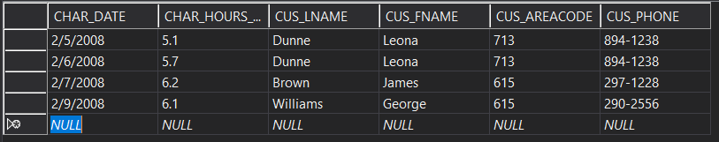

1. Modify the MODEL table to add the following attribute: (Note: use ALTER TABLE and UPDATE commands for this question.)

|  |  |  |
| --- | --- | --- |
| **Attribute name** | **Attribute Description** | **Attribute type** |
| MOD_LIFT_ WEIGHT | Amount of weight each model can lift | Numeric |

Once the attribute has been added, update the values of all rows as per following values:

|  |
| --- |
| **Attribute values for MOD_LIFT_WEIGHT** |
| 10,000 for Mod_code = DC-90A |
| 5,000 for Mod_code = MA23-250 |
| 20,000 for Mod_code = PA31-950 |

SQL statement:

GO

ALTER TABLE MODEL ADD

MOD_LIFT_WEIGHT NUMERIC

GO

UPDATE MODEL SET

MOD_LIFT_WEIGHT = 10000 WHERE MOD_CODE = 'DC-90A'

GO

UPDATE MODEL SET

MOD_LIFT_WEIGHT = 5000 WHERE MOD_CODE = 'MA23-250'

GO

UPDATE MODEL SET

MOD_LIFT_WEIGHT = 20000 WHERE MOD_CODE = 'PA31-950'

1. Create a trigger named trg_charter_hours that will automatically update the AIRCRAFT table after a new CHARTER row is added. Use the CHARTER table’s CHAR_HOURS_FLOWN to update the AIRCRAFT table’s AC_TTAF, AC_TTEL, and AC_TTER values.

SQL statement:

GO

CREATE TRIGGER trg_charter_hours

ON CHARTER

AFTER INSERT

NOT FOR REPLICATION

AS

BEGIN

UPDATE AIRCRAFT SET

AC_TTAF = AC_TTAF + (SELECT CHAR_HOURS_FLOWN FROM inserted) WHERE AIRCRAFT.AC_NUMBER = (SELECT AC_NUMBER FROM inserted)

UPDATE AIRCRAFT SET

AC_TTEL = AC_TTEL + (SELECT CHAR_HOURS_FLOWN FROM inserted) WHERE AIRCRAFT.AC_NUMBER = (SELECT AC_NUMBER FROM inserted)

UPDATE AIRCRAFT SET

AC_TTER = AC_TTER + (SELECT CHAR_HOURS_FLOWN FROM inserted) WHERE AIRCRAFT.AC_NUMBER = (SELECT AC_NUMBER FROM inserted)

END

BEFORE:

CHARTER:

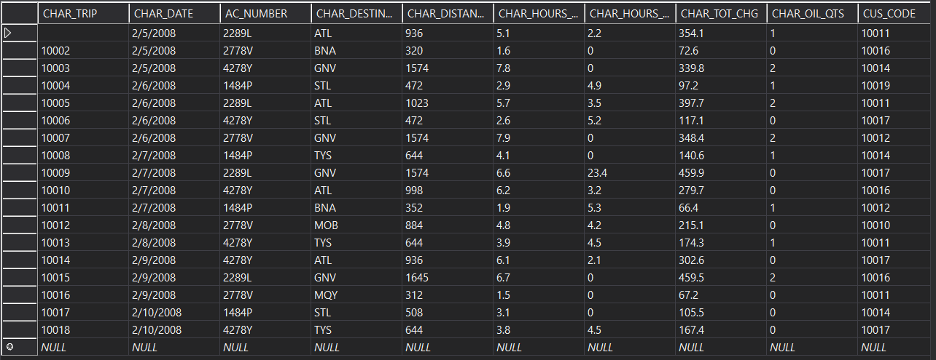

AIRCRAFT:

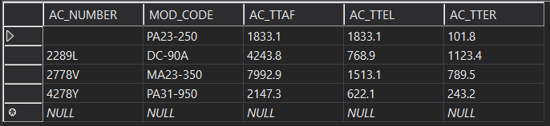

AFTER:

CHARTER:

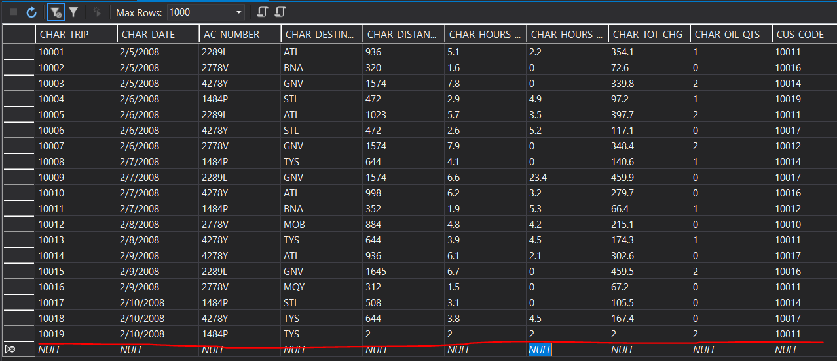

AIRCRAFT:

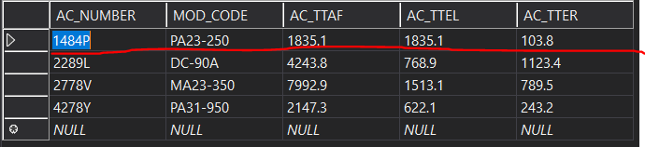

1. Create a trigger named trg_cust_balance that will automatically update the AC_CUSTOMER table’s CUS_BALANCE before a new CHARTER row is added. Use the CHARTER table’s CHAR_TOT_CHG as the update source (Assume that all charter charges are charged to the customer balance.) In addition to the CHAR_TOT_CHG, add $25 for every quart of oil

used on the charter.

SQL statement:

GO

CREATE TRIGGER trg_cust_balance

ON CHARTER

AFTER INSERT

NOT FOR REPLICATION

AS

BEGIN

UPDATE AC_CUSTOMER SET

CUS_BALANCE = (SELECT (CHAR_TOT_CHG + (25*CHAR_OIL_QTS)) FROM inserted)

WHERE AC_CUSTOMER.CUS_CODE = (SELECT CUS_CODE FROM inserted)

END

After adding a row from previous question with cus_number 10011:

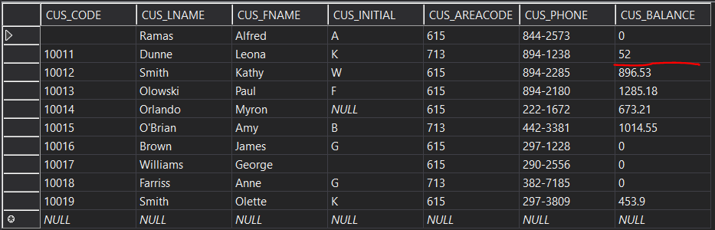

1. Create a stored procedure to update model charge per mile attribute. Procedure takes the model number as a parameter. The procedure increases the charge for this model by 25%.

SQL statement:

GO

CREATE PROCEDURE increase_MODEL_CHG_MILE @MOD_CODE varchar(10)

AS

BEGIN

UPDATE MODEL SET MOD_CHG_MILE = (1.25 * MOD_CHG_MILE) WHERE MODEL.MOD_CODE = @MOD_CODE

END

BEFORE:

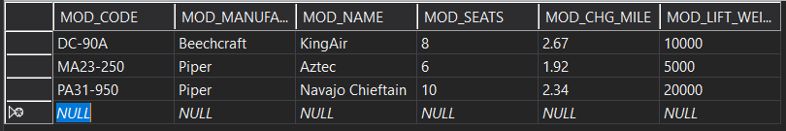

Execution query example:

EXEC increase_MODEL_CHG_MILE 'DC-90A'

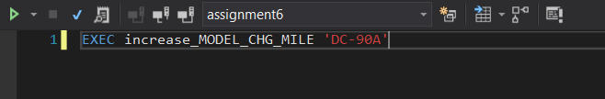

AFTER:

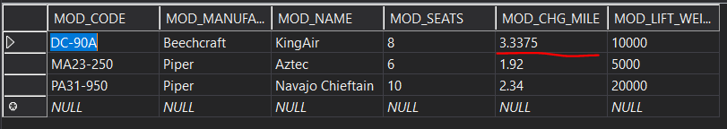

1. Create a stored procedure that will take an Employee number and percentage, then update the corresponding employee’s hourly salary by the input percentage (increase the hourly salary, so you are giving the employee a raise).

**Hint**: A*lter Employee table to add the hourly_salary field, update it with a value of 30 for all rows in the table, before creating the procedure.*

SQL statement:

GO

ALTER TABLE EMPLOYEE ADD

hourly_salary float

GO

UPDATE EMPLOYEE SET hourly_salary = 30

GO

CREATE PROCEDURE increase_EMPLOYEE_hourly_salary @EMP_NUM int, @percentage int

AS

BEGIN

UPDATE EMPLOYEE SET hourly_salary = hourly_salary + (hourly_salary * @percentage /100)

WHERE EMPLOYEE.EMP_NUM = @EMP_NUM

END

BEFORE:

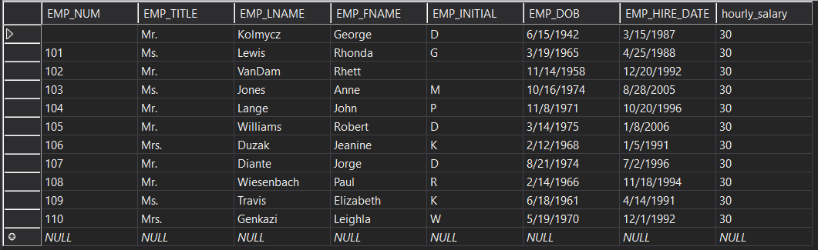

Execution query example:

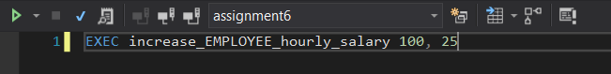

AFTER:

