**Mobile Project.**

For my mobile project I decided to make a game using HTML5, CSS and Javascript. The game is based around an actual game called Shut the box. This idea of the game is as follows: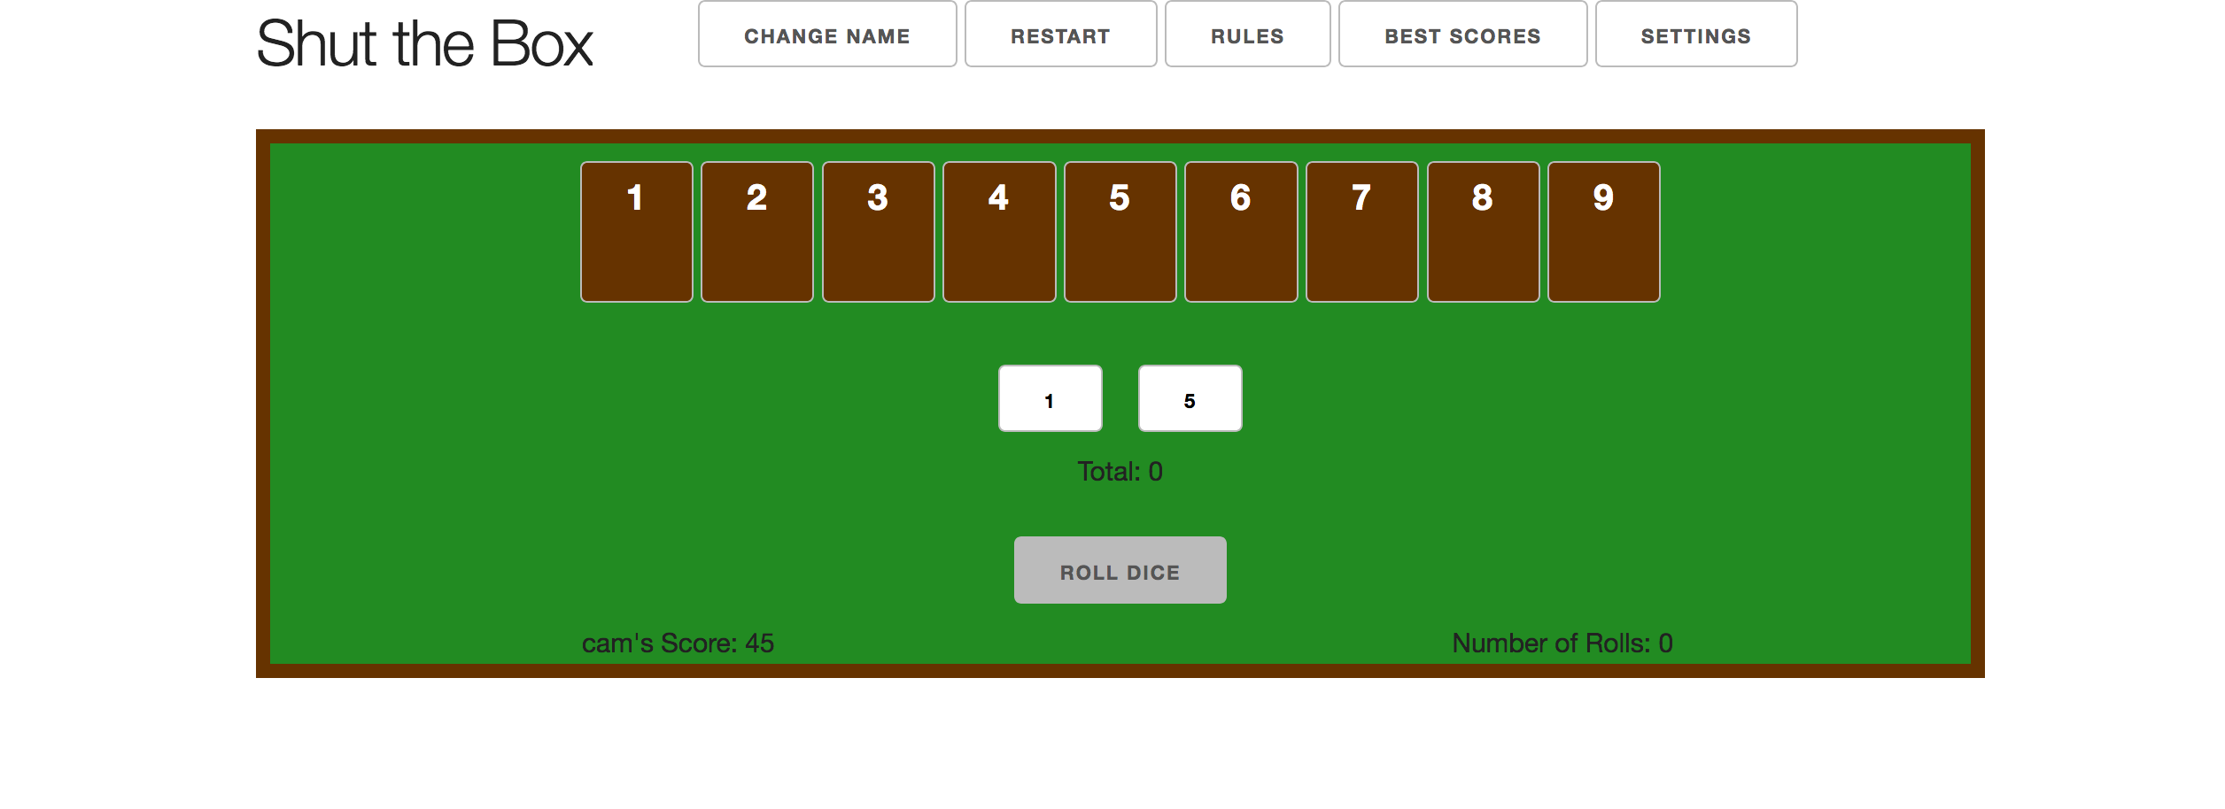

There is a small box with nine flippable tabs located across the top. A player rolls two dice into the box and adds the numbers of the dice together (so could have a total from 2 - 12). The player then must flip over one or two flaps that add up to the total of the dice rolled. For example if a player rolled an 8 and all flaps were still facing up the possible options to flip are:

8

5 and 3

6 and 2

7 and 1

Once a number is flipped it is out of the game. The player then rolls the dice again, aiming to shut more numbers. The player continues throwing the dice and shutting numbers until reaching a point at which, the player cannot shut any more numbers. At that point, the player scores the sum of the numbers that are still uncovered. For example, if the numbers 3, and 5 are still open when the player throws a two, the player's score is 8 (3 + 5 = 8). Play then passes to the next player.

The player with the lowest score or if a player shuts all the flaps (shuts the box) is deemed the winner.

**Game Menu:**

The menu across the top of the game provides the following functionality:

Menu symbol: clicking the menu symbol will both hide and show the menu helping to give the user more screen space if needed.

Change Name: the change name button allows the player to enter a different name from the one entered when the game started. This allows their name to be added to the best scores leader board (if they are good enough).

Restart: the restart button simply restarts the current game - resets roll count back to zero, sets score to 45 and and resets all numbers face up.

Rules: shows a page explaining the rules for the game. The page can be closed by either clicking the “x” in the top right hand corner or by simply clicking any where off the page.

Best scores: shows a list (10 names) of the current lowest scores ordered from lowest to highest. If two scores are the same the score with the lowest amount of rolls is deemed the better score. There is also a button on the page that allows all the best scores to be cleared. The page can be closed by either clicking the “x” in the top right hand corner or by simply clicking any where off the page.

Settings: The settings page allows the user to adjust the text of the game bigger or smaller. They can also change the colour of the back ground. The page can be closed by either clicking the “x” in the top right hand corner or by simply clicking any where off the page.

**Application Discussion:**

One major issue I had with my project was trying to meet the requirement to Persist data using eXtensible markup language (XML) serialisation. There was no material supplied that covered this and for all my searching I could not find a solution to store information to a local xml file using javascript, most information showed how to do it to an online server. So in the end I used the local storage feature of html5 to store the players best scores. Even this proved difficult with it only working reliably within google Chrome.

One thing that is lacking from my game (which I hope to add down the track as I ran out of time) is actual images of dice that change with each roll.