AURORA POSTGRESQL 17.5 — GLOBAL DATABASE
Database Activity Streams
AWS Console Guide — Screenshots + Full Parameter Reference
KMS · S3 · Kinesis Data Streams · DAS · Kinesis Firehose · Lambda · SNS · Athena

Document Type | Technical Implementation Guide — AWS Console (click-by-click)
Target Audience | Database Engineers & Cloud Administrators
Aurora Version | Amazon Aurora PostgreSQL 17.5
Cluster Type | Global Database (Primary + Secondary Regions)
Setup Time | 45–60 minutes (primary region); 15 minutes per additional region
Services Covered | KMS → Kinesis → DAS → Firehose → S3 → Lambda → SNS → Athena

ℹ About the Screenshots in This Document
Every screenshot in this guide is a high-fidelity recreation of the exact AWS Console screen you
will encounter — same navigation bars, field labels, dropdown options, radio buttons, checkboxes,
and button placement. Minor cosmetic differences may exist as AWS periodically updates its UI,
but every field name, option, and navigation path is accurate for the current console.

0. Architecture & Service Setup Order
Before touching any AWS service, understand the complete flow and the mandatory setup sequence. Each service depends on the one before it.

┌─────────────────────────────────────────────────────────────────────────────┐
│ DATABASE ACTIVITY STREAMS — END-TO-END PIPELINE │
└─────────────────────────────────────────────────────────────────────────────┘

SETUP ORDER (follow strictly):
1. KMS CMK → 2. S3 Bucket → 3. Enable DAS (auto-creates Kinesis)
→ 4. Tune Kinesis → 5. Firehose → 6. SNS → 7. Lambda

┌──────────────────────────────────────────────────────────────────────┐
│ Aurora PostgreSQL 17.5 (Writer & Reader instances) │
│ Every SQL event encrypted with KMS CMK ──────────────────────┐ │
└──────────────────────────────────────────────────────────────── │ ──┘
▼
┌─────────────────────────────────────────┐
│ Kinesis Data Stream │
│ aws-rds-das-cluster-XXXXXXXX │
│ (auto-created by Aurora when DAS │
│ is started) │
└────────────────┬────────────────────────┘
│
┌────────────────────┴─────────────────────┐
│ │
▼ ▼
┌───────────────────────┐ ┌───────────────────────┐
│ AWS Lambda │ │ Kinesis Firehose │
│ (Real-time alerting) │ │ (Batch → S3 archive) │
└──────────┬────────────┘ └────────────┬──────────┘
│ │
┌────▼────┐ ┌──────▼──────┐
│ SNS │ │ S3 Bucket │
└────┬────┘ └──────┬──────┘
│ │
Email / Slack / PagerDuty ┌──────▼──────┐
│ Athena │
│ SQL Audit │
└─────────────┘

Service | What It Does in DAS | Setup Section
AWS KMS CMK | Encrypts every DAS record (envelope encryption) before leaving Aurora engine | Section 1
Amazon S3 | Long-term tamper-proof archive for all DAS records (via Firehose) | Section 2
Aurora DAS | Captures every SQL event and streams it encrypted to Kinesis | Section 3
Amazon Kinesis | Managed stream that buffers DAS records for consumers (Lambda + Firehose) | Section 4
Kinesis Firehose | Reads Kinesis stream, batches records, delivers GZIP to S3 every 5 min | Section 5
Amazon SNS | Notification hub — fans out CRITICAL alerts to email / Slack / PagerDuty | Section 6
AWS Lambda | Real-time consumer: decrypts DAS records, detects DROP/TRUNCATE, publishes to SNS | Section 6
Amazon Athena | SQL engine for compliance queries over the S3 DAS archive | Section 7 (Testing)

1. AWS KMS — Create the Customer-Managed Key
DAS requires a Customer-Managed Key (CMK) to encrypt activity records before they are written to Kinesis. This is mandatory — the default AWS-managed aws/rds key is explicitly rejected by DAS.

🧭 AWS Console Path: AWS Console → Search bar: 'KMS' → Key Management Service → Customer managed keys → Create key

🚨 Create this key FIRST — every other service depends on it
The KMS key must exist in the SAME AWS region as your Aurora cluster.
For a Global Database with clusters in multiple regions, you must create
a separate CMK in EACH region before enabling DAS there.

1.1 Step 1 of 5 — Configure Key Type

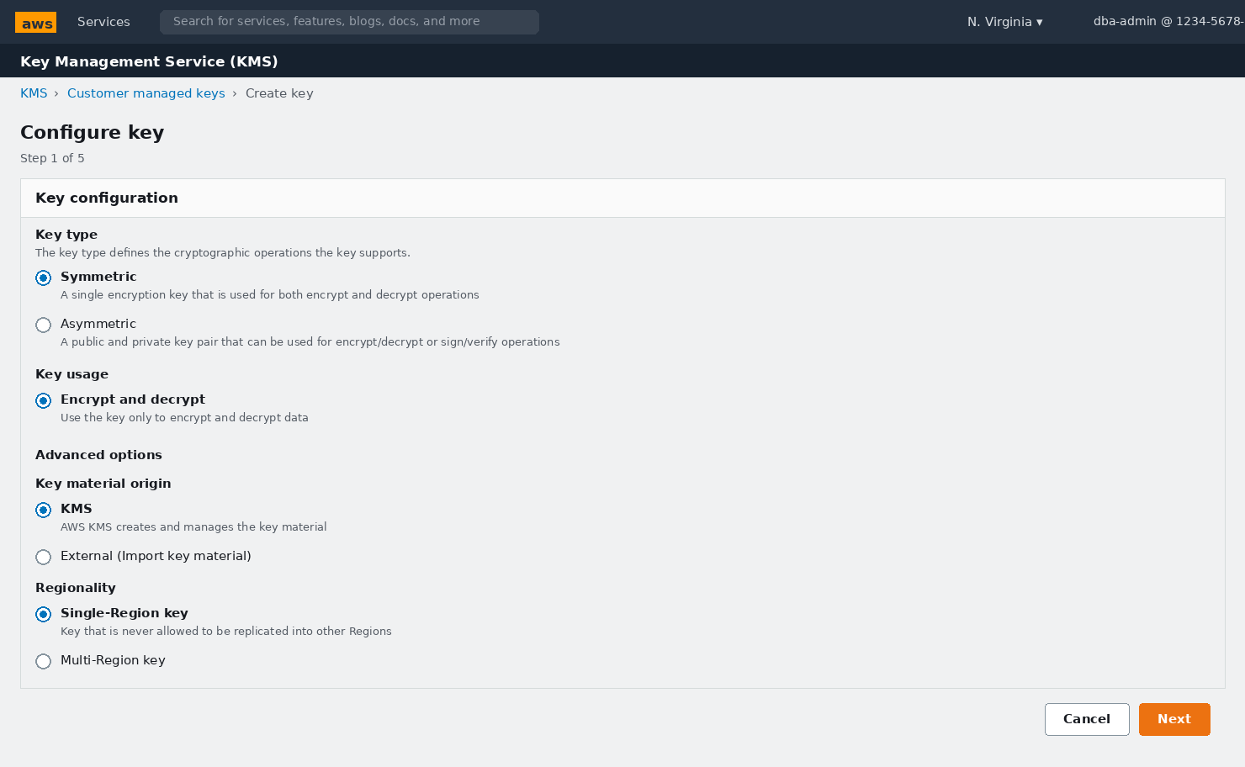
📸 Screenshot: KMS Console — Step 1: Key type (Symmetric), Key usage, Material origin, Regionality

KMS Key Configuration — Full Parameter Reference
Parameter | What It Controls | Why It Matters / Usage | Recommended Value
Key type → Symmetric | Whether the key uses one key (symmetric) or a public/private key pair (asymmetric) | DAS uses KMS GenerateDataKey (symmetric API). Asymmetric keys do not support this API and will cause DAS to fail at startup | Always Symmetric
Key usage → Encrypt and decrypt | Which cryptographic operations the key permits | Aurora calls both GenerateDataKey (encrypt) and Decrypt during DAS record processing. Both directions must be allowed | Always Encrypt and decrypt
Key material origin → KMS | Where the raw key bytes are generated: AWS KMS, externally imported, or AWS CloudHSM | KMS-generated material is hardware-backed, automatically replicated for durability, and supports automatic annual rotation. Import only if your policy mandates BYOK | KMS for most organisations; External only for BYOK compliance
Regionality → Single-Region key | Single-Region keys never leave their home region. Multi-Region keys can be replicated | For a Global DB, create one independent Single-Region key per cluster region. This limits the blast radius if a key is compromised — a compromised key in us-east-1 does not affect ap-southeast-1 | Single-Region key (one per Aurora region)

1.2 Step 2 of 5 — Add Alias, Description & Tags

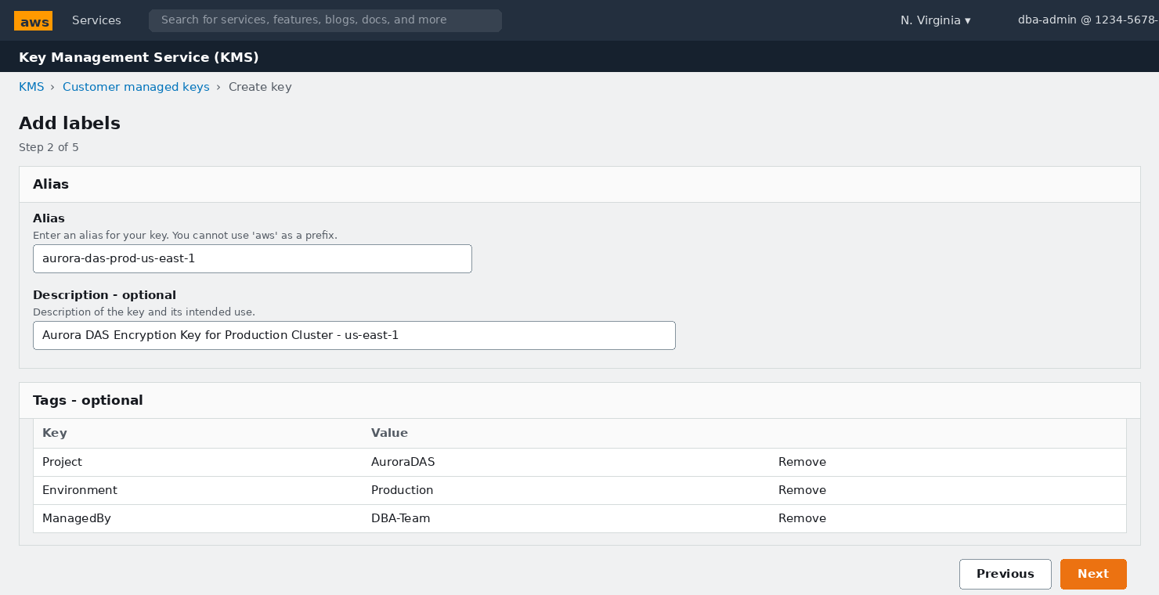
📸 Screenshot: KMS Console — Step 2: Alias name, description, and tagging for cost allocation

KMS Alias & Tag Parameters
Parameter | What It Controls | Why It Matters / Usage | Recommended Value
Alias | A human-readable name that maps to the underlying Key ID (format: alias/<name>) | Used in all downstream configuration (DAS dialog, S3, Firehose). Encode: purpose + environment + region so the alias is self-documenting in IAM policies and cost reports | alias/aurora-das-prod-us-east-1
Description | Free-text annotation shown in the key list and audit logs | Mandatory for SOC 2 / ISO 27001 key inventories. Include cluster identifier and intended service | e.g. Aurora DAS CMK — apg-prod-cluster-use1 — us-east-1
Tag: Project | Cost-allocation tag for billing separation | AWS Cost Explorer breaks down KMS API charges by tag. DAS on a busy cluster can generate millions of KMS calls/month | Key=Project Value=AuroraDAS
Tag: Environment | Distinguishes prod vs non-prod keys in policies and reports | Allows IAM SCPs to prevent prod keys being used in dev workloads | Key=Environment Value=Production
Tag: ManagedBy | Identifies the team responsible for the key | Streamlines incident response — who to call when a key is near expiry or pending deletion | Key=ManagedBy Value=DBA-Team

1.3 Steps 3 & 4 — Key Administrators and Users

STEP 1 Assign administrators and add Aurora as a key user
1. | Step 3 (Key administrators): Check your DBA/Admin IAM role — these principals can manage but not necessarily USE the key
2. | Keep ☑ 'Allow key administrators to delete this key' — this is needed for decommissioning
3. | Step 4 (Key usage): Optionally add the Lambda execution role here now, or via inline policy later (§6.7)
4. | Click Next to reach the Review page

1.4 Step 5 — Edit Key Policy to Allow Aurora Service
On the Review page, click 'Edit' under the key policy section to open the JSON editor. The Aurora (RDS) service principal must be granted Decrypt and GenerateDataKey permissions or DAS will fail with a KMS exception.

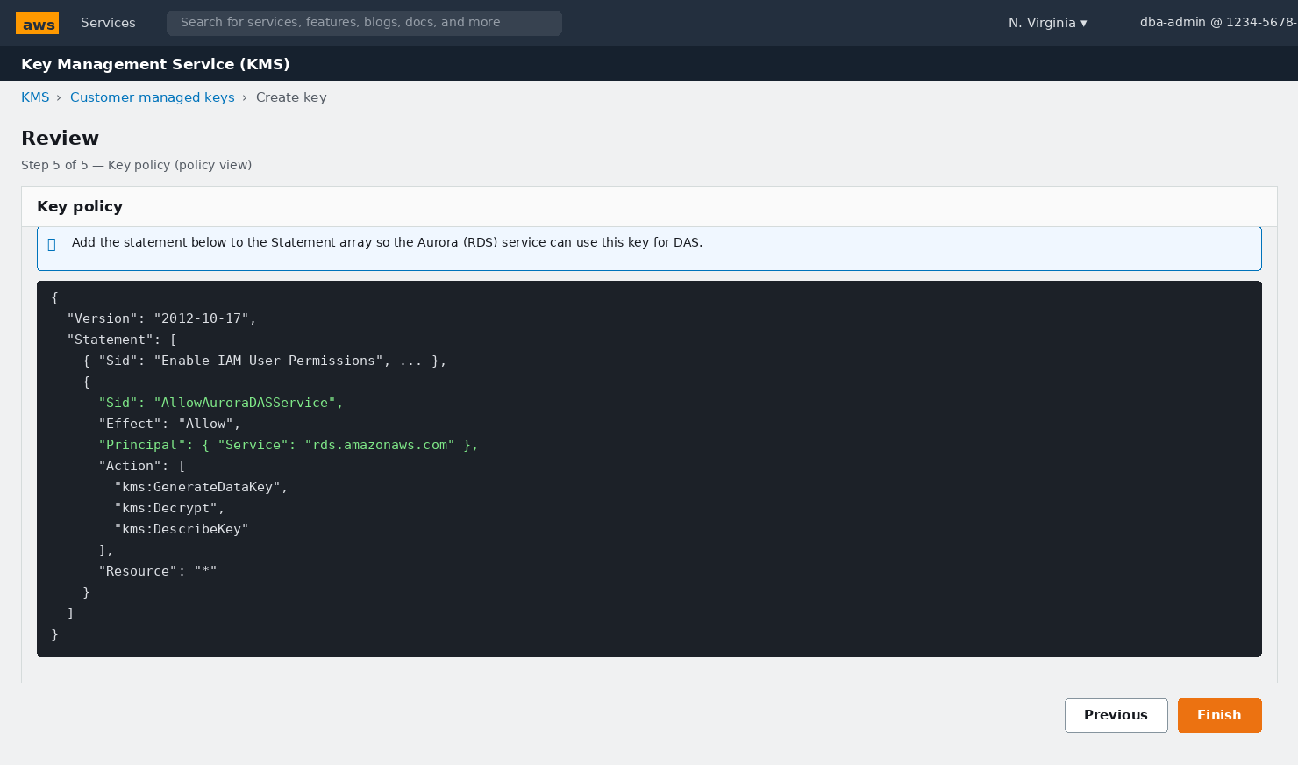
📸 Screenshot: KMS Review — Key policy JSON editor with the AllowAuroraDASService statement added
⚠ Exact statement to add inside the Statement array
{ "Sid": "AllowAuroraDASService",
"Effect": "Allow",
"Principal": { "Service": "rds.amazonaws.com" },
"Action": ["kms:GenerateDataKey","kms:Decrypt","kms:DescribeKey"],
"Resource": "*" }
Paste this before the final ] of the Statement array, separated by a comma.

1.5 Key Created — Record the Key ARN

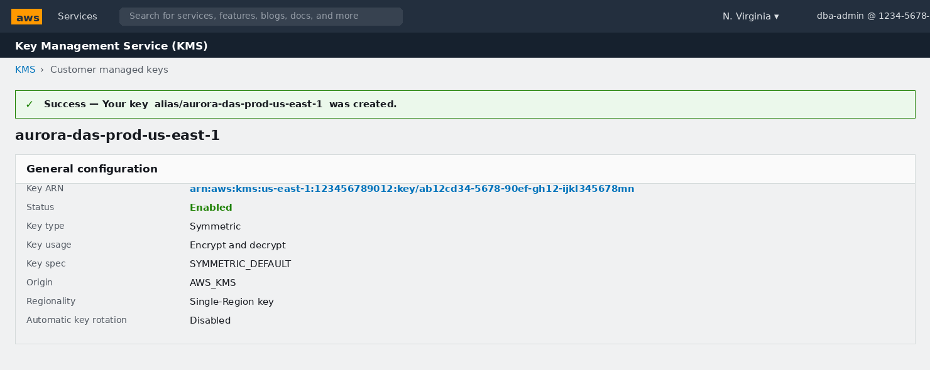
📸 Screenshot: KMS — Key created successfully. Copy the Key ARN from this page

STEP 2 Record and verify the new key
1. | Green banner confirms creation. Note the Status: Enabled — any other status blocks DAS
2. | COPY the full Key ARN (format: arn:aws:kms:us-east-1:ACCOUNT:key/UUID) — needed in §3 DAS dialog
3. | Optional but recommended: go to the Key rotation tab → enable Automatic key rotation (yearly rotation, transparent to DAS)

2. Amazon S3 — Create the Audit Archive Bucket
Firehose delivers batched DAS records to this bucket. We configure it as a hardened, immutable audit store: no public access, versioning on, SSE-KMS encryption, and a lifecycle policy to manage long-term retention costs.
🧭 AWS Console Path: AWS Console → Search bar: 'S3' → Amazon S3 → Buckets → Create bucket

2.1 Bucket Name, Region & Ownership

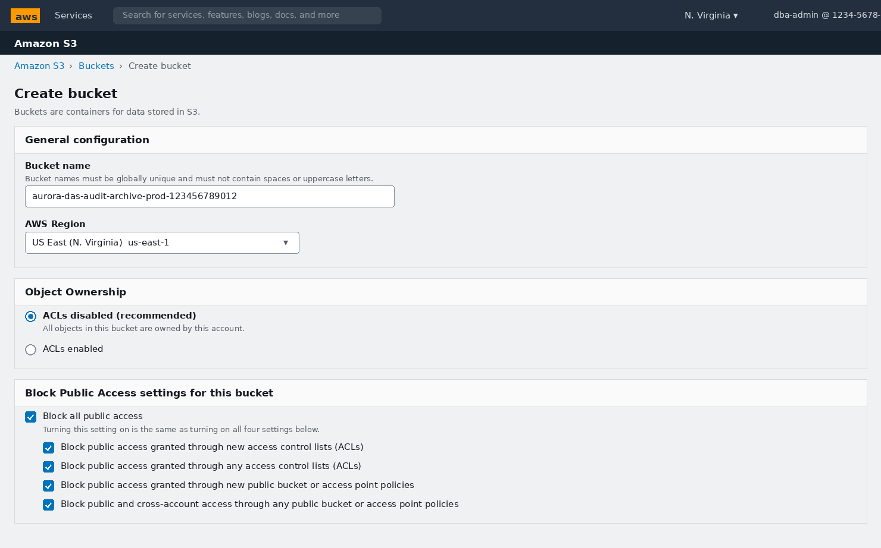
📸 Screenshot: S3 Create Bucket — Bucket name, region, ACLs disabled, Block Public Access all four checked

S3 General Configuration Parameters
Parameter | What It Controls | Why It Matters / Usage | Recommended Value
Bucket name | Globally unique, DNS-compatible name across all AWS accounts worldwide | Appending your 12-digit Account ID makes the name globally unique AND ties it to your account for cross-account audit policies. No uppercase, no spaces, 3-63 characters | aurora-das-audit-archive-prod-<ACCOUNT-ID>
AWS Region | Physical location of the bucket | Must match the Kinesis stream region to avoid inter-region Firehose data transfer charges (~$0.02/GB). For multi-region Global DB, each region needs its own bucket | Same region as the Aurora primary cluster
Object Ownership → ACLs disabled | Controls whether object-level ACLs are active | ACLs are a legacy access model. Modern S3 uses bucket policies exclusively. Disabling ACLs enforces bucket-owner-enforced mode — all objects are owned by the account, no cross-account ACL confusion | ACLs disabled (recommended)
Block all public access | Master switch that overrides all public-facing policies and ACLs | Audit data MUST never be public. Leaving even one sub-checkbox unchecked creates a potential compliance finding in AWS Security Hub and GuardDuty. Always check all four. | All 4 sub-checkboxes Checked

2.2 Versioning & Default Encryption

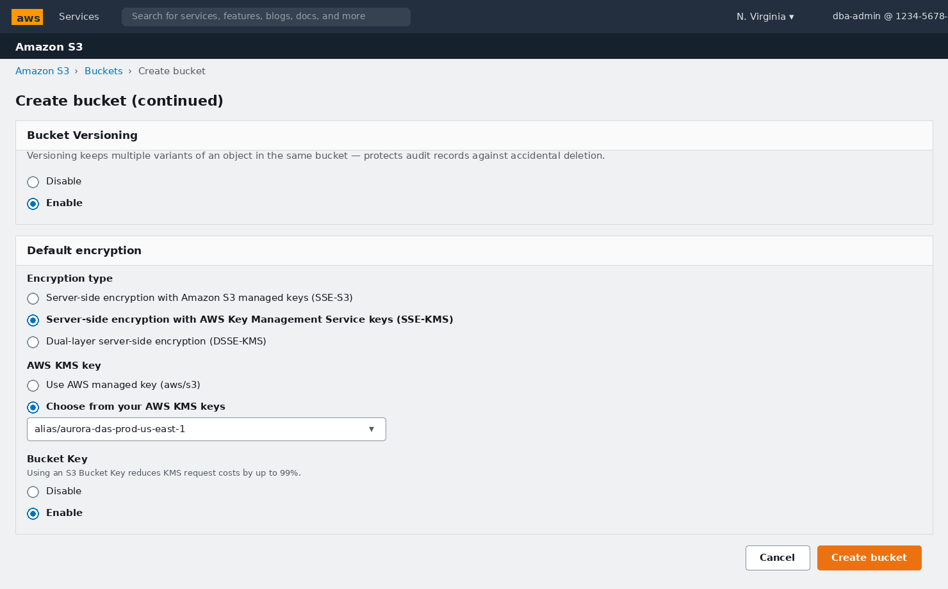
📸 Screenshot: S3 Create Bucket — Bucket Versioning enabled, SSE-KMS with your DAS CMK, Bucket Key enabled

S3 Protection & Encryption Parameters
Parameter | What It Controls | Why It Matters / Usage | Recommended Value
Bucket Versioning → Enable | Keeps every historical version of every object — deletes become delete-markers, not permanent erasures | Protects the audit record archive from accidental or malicious deletion. Also a prerequisite for S3 Object Lock (WORM). Once enabled it cannot be disabled, only suspended | Enable (irreversible — choose deliberately)
Encryption type → SSE-KMS | Server-side encryption mode: S3-managed keys (SSE-S3), customer-managed KMS keys (SSE-KMS), or double-layer (DSSE-KMS) | SSE-KMS gives you: (1) key-level access control — even AWS Support cannot read objects without your CMK; (2) CloudTrail log of every decrypt event for audit-of-audit; (3) ability to revoke access instantly by disabling the key | SSE-KMS
AWS KMS key → alias/aurora-das-prod-us-east-1 | Which CMK encrypts objects written to the bucket | Reusing the DAS CMK gives a single key to govern for the entire audit domain. If your policy mandates key separation (separate keys for streaming vs storage), create a second CMK | Select alias/aurora-das-prod-us-east-1 from the dropdown
Bucket Key → Enable | Generates a bucket-level data key, cached for a period, so most PutObject calls hit S3 instead of KMS | Firehose writes many small objects. Without Bucket Key, every PUT calls KMS — at $0.03 per 10k requests this adds up fast. Bucket Key reduces KMS cost by up to 99% with no security trade-off | Enable (always recommended for high-write buckets)
Object Lock (Advanced — set at creation) | WORM compliance mode preventing any deletion within the retention period | Required by PCI-DSS 10.5.5 and financial-services regulations that demand a tamper-proof audit trail. MUST be enabled at bucket creation time — cannot be added later. Use Governance mode in test, Compliance mode in prod | Governance mode, 7 years for PCI-DSS / financial; adjust for your framework

STEP 1 Create the bucket and add a lifecycle rule for cost management
1. | Click Create bucket — green success banner confirms creation
2. | Open the bucket → click the Management tab → Create lifecycle rule
3. | Rule name: das-audit-tiering | Apply to: All objects in bucket (check the acknowledgment box)
4. | Lifecycle rule actions: ☑ 'Transition current versions between storage classes'
5. | Add transition 1: After 90 days → S3 Glacier Instant Retrieval (hot-ish archive, ms retrieval)
6. | Add transition 2: After 365 days → S3 Glacier Deep Archive (rarely accessed, cheapest)
7. | Click Create rule

3. Amazon RDS — Enable Database Activity Streams
DAS is enabled per-cluster from the RDS console Actions menu. Aurora then automatically creates the Kinesis Data Stream and begins encrypting and streaming every activity event immediately.
🧭 AWS Console Path: AWS Console → Search 'RDS' → Amazon RDS → Databases → click your PRIMARY cluster identifier

🚨 Pre-flight checklist before enabling DAS
✅ KMS CMK Status = Enabled in the SAME region as the cluster (Section 1 done)
✅ Aurora cluster Status = Available (not in Modifying or Maintenance state)
✅ Your IAM identity has rds:StartActivityStream permission
✅ Console region selector (top-right) matches the cluster region

3.1 Locate the Cluster in the RDS Database List

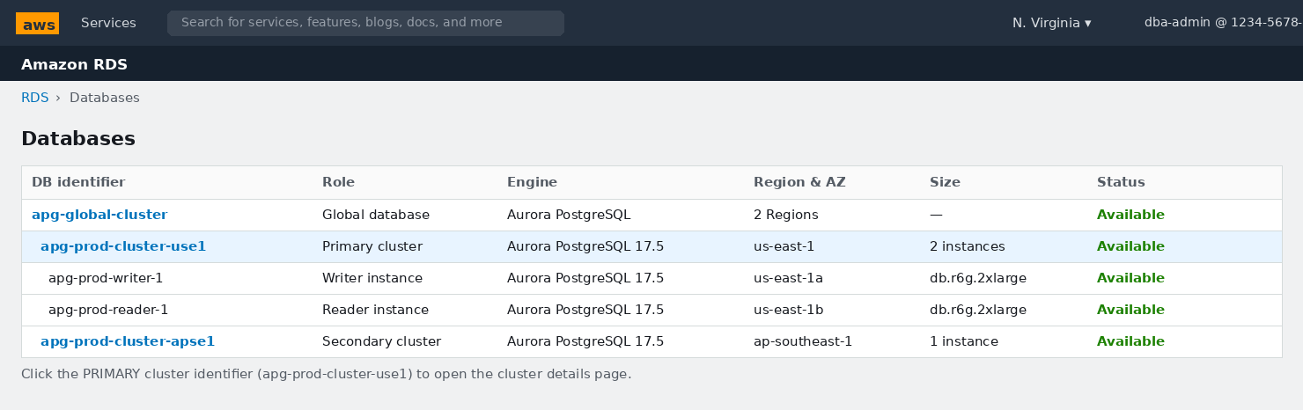
📸 Screenshot: RDS Databases — Global database with Primary cluster (apg-prod-cluster-use1) and Secondary. Click the PRIMARY cluster link
ℹ Global Database — click the REGIONAL cluster, not the Global row
The Global database row (Role = 'Global database') is a metadata container — you cannot enable DAS on it.
Click the regional PRIMARY cluster identifier (Role = 'Regional cluster' or 'Primary cluster').
After enabling on the primary, switch regions and repeat for each secondary cluster.

3.2 Open the Actions Menu

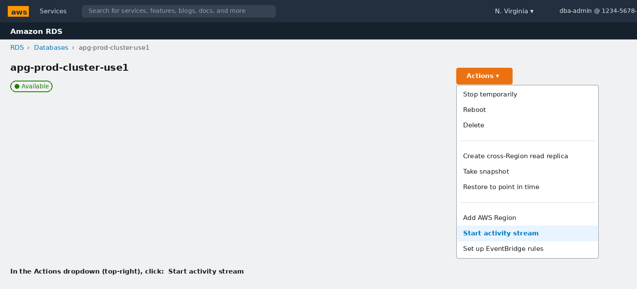
📸 Screenshot: RDS Cluster page — Actions dropdown open, 'Start activity stream' highlighted

STEP 1 Open the DAS configuration dialog
1. | On the cluster details page: click the orange Actions button (top-right)
2. | In the dropdown: scroll to find Start activity stream (near the bottom of the list)
3. | Click it — a modal dialog titled 'Start database activity stream: <cluster>' opens

3.3 The Start Activity Stream Dialog — Every Parameter

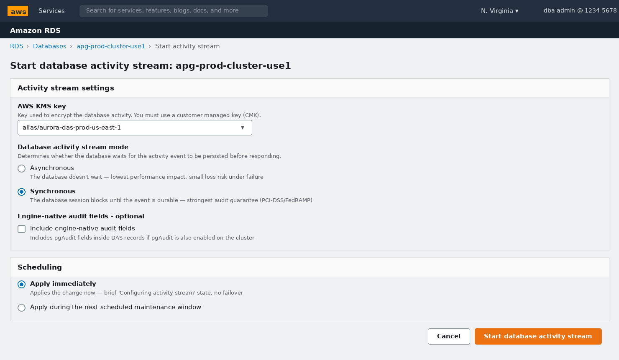
📸 Screenshot: Start database activity stream dialog — KMS key, Mode (Synchronous selected), Engine-native audit fields, Apply immediately

Database Activity Streams — Configuration Parameters
Parameter | What It Controls | Why It Matters / Usage | Recommended Value
AWS KMS key | The CMK used to envelope-encrypt every activity record before it leaves the database engine | DAS uses AES-256-GCM with a per-record data key that is itself encrypted with your CMK (envelope encryption). Without a valid CMK the Start operation is rejected. If the alias does not appear in the dropdown, paste the full Key ARN copied in §1.5 | Select alias/aurora-das-prod-us-east-1 or paste the full Key ARN
Mode → Asynchronous | The database session returns to the application immediately; DAS persists the record in the background | Zero measurable latency impact on query response time. Under an engine crash or Kinesis outage, the tiny window of in-flight events can be lost. Acceptable for SOC 2, HIPAA, and internal security auditing where a sub-second gap is tolerable | Use only when p99 latency SLA is critical AND compliance framework accepts async
Mode → Synchronous ← RECOMMENDED | The database session BLOCKS until the activity record is confirmed durable in Kinesis before returning the query result | Guarantees zero event loss — the audit trail is complete even across engine crashes or Kinesis partial outages. Adds roughly 1–2 ms per statement. MANDATORY for PCI-DSS 3.2.1, FedRAMP-High, and most financial-services audit frameworks | Synchronous for all compliance-mandated workloads
Engine-native audit fields → Unchecked | When checked, pgAudit-generated fields are embedded inside each DAS record | Only relevant if pgAudit is ALSO configured on the cluster. Increases per-record size by 20-40%. Leave unchecked unless you explicitly need both audit systems and want to correlate their events inside the DAS stream | Unchecked unless running pgAudit simultaneously
Apply immediately | Start DAS now (immediate) vs defer to the next maintenance window | Enabling DAS does NOT restart the cluster or cause a failover. The cluster shows 'Configuring activity stream' for 2–3 minutes and then returns to Available — safe in production during business hours. Only defer if change-control policy requires a maintenance window | Apply immediately (no downtime risk)

🚨 Mode cannot be changed without stopping and restarting DAS
Once DAS is started, mode (sync/async) and KMS key are immutable.
To change either: Actions → Stop activity stream (2-3 min gap) → Start activity stream with new settings.
There is a brief audit gap during the stop/start window — schedule it, document it, and note it in your audit log.

3.4 Verify DAS Has Started

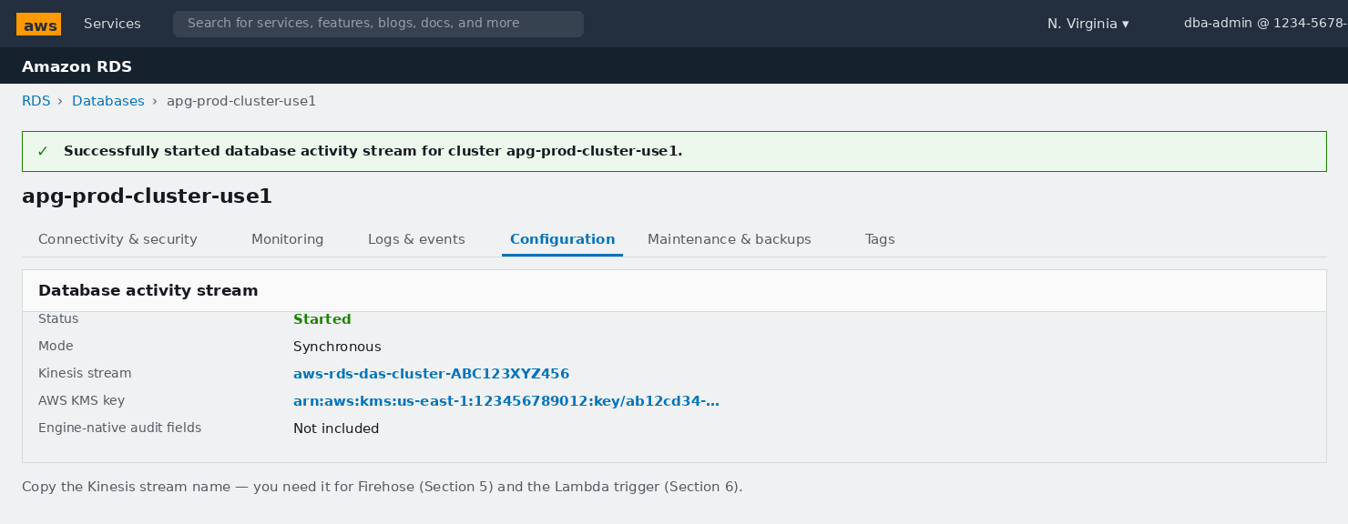
📸 Screenshot: Cluster Configuration tab — Activity stream section showing Status=Started, Mode=Synchronous, Kinesis stream name

STEP 2 Post-start verification and Global DB steps
1. | Cluster status goes: Available → Configuring activity stream (~2-3 min) → Available
2. | Click the Configuration tab → scroll to 'Database activity stream' section
3. | Verify: Status = Started | Mode = Synchronous | Kinesis stream name is populated
4. | COPY the Kinesis stream name (format: aws-rds-das-cluster-XXXXXXXXXXXX) — needed in §4 and §5
5. | For Global DB secondary clusters: switch Console region → create new KMS key (§1) → repeat §3.1–3.3

4. Amazon Kinesis Data Streams — Tune the Auto-Created Stream
Aurora creates the Kinesis stream automatically when DAS is enabled. The defaults (1 shard, 24-hour retention) are suitable only for very low-throughput clusters. Tune them now before Firehose and Lambda are attached.
🧭 AWS Console Path: AWS Console → Search 'Kinesis' → Amazon Kinesis → Data streams → aws-rds-das-cluster-XXXXXXXX

4.1 Stream Configuration Overview

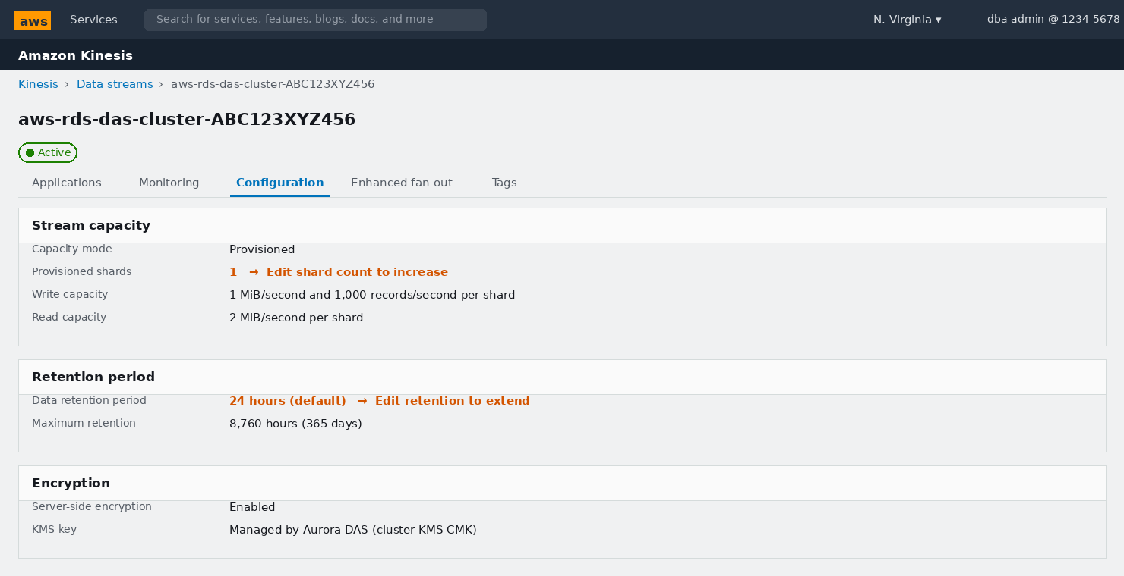
📸 Screenshot: Kinesis stream Configuration tab — capacity mode, shard count (1), retention (24h) — both need updating

4.2 Increase Shard Count

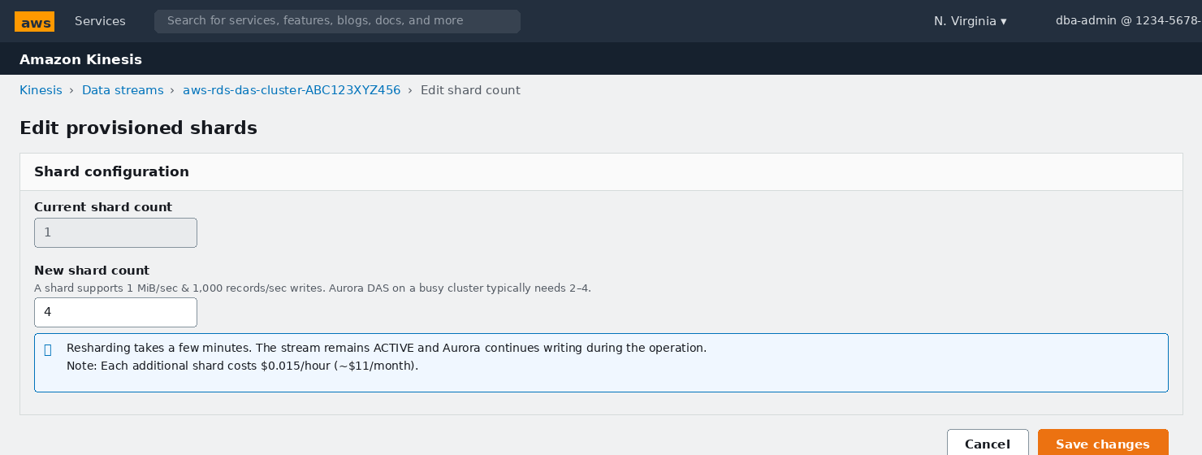
📸 Screenshot: Kinesis Edit Shard Count dialog — increasing from 1 to 4 shards

4.3 Extend Retention Period

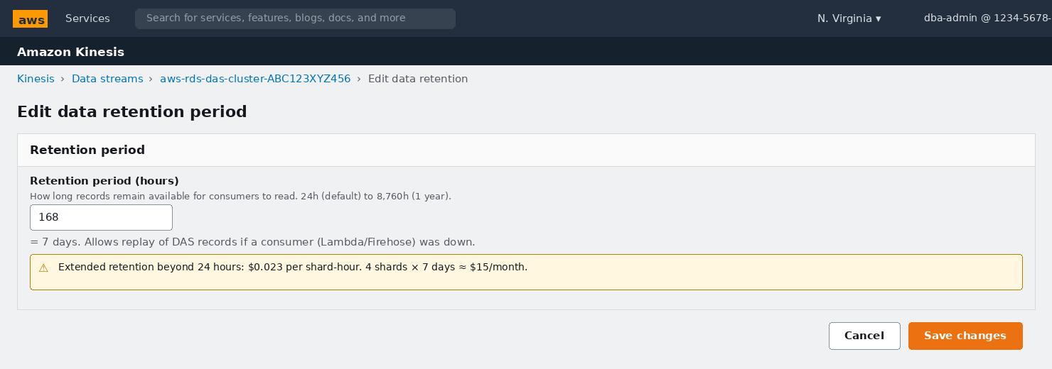
📸 Screenshot: Kinesis Edit Retention — extending from 24 hours to 168 hours (7 days)

Kinesis Data Stream — All Tuneable Parameters
Parameter | What It Controls | Why It Matters / Usage | Recommended Value
Capacity mode → Provisioned | Provisioned: you specify shard count. On-demand: AWS auto-scales (up to 200 shards) | Aurora creates the stream in Provisioned mode. On-demand costs ~2-3x more at steady throughput but needs zero shard management. Switching modes is allowed twice per 24 hours — useful during peak events | Provisioned with right-sized shards for predictable cost; consider On-demand for highly variable workloads
Shard count → 4 | Each shard supports 1 MiB/s and 1,000 records/s writes; 2 MiB/s reads | DAS generates approximately 1 Kinesis record per SQL statement plus metadata. An OLTP cluster at 2,000 stmt/s needs at least 2 shards. Use 4 for headroom — undersized shards throw ProvisionedThroughputExceeded and cause DAS to back-pressure (in sync mode: query latency spike; in async mode: event loss) | 4 for production OLTP; 1-2 for dev/test; scale up if iterator age climbs
Retention period → 168 hours | How long records remain available for consumer GetRecords calls (24h to 8,760h) | If Lambda or Firehose goes down, any DAS records older than the retention period are permanently lost. 7 days provides a comfortable recovery window for most incidents. Extended retention costs $0.023/shard-hr above 24h — about $3.50 per shard per week | 168 hours (7 days) for production; 24 hours acceptable for dev
Server-side encryption | KMS encryption of records at rest inside Kinesis | Aurora configures this automatically with your DAS CMK when DAS is started. Do not change this setting — altering it could break the EncryptionContext expected by the Lambda decryption code | Leave as configured by Aurora — do NOT modify
Enhanced fan-out consumer | Registers a named consumer with a dedicated 2 MiB/s read pipe and ~70ms push latency | Standard consumers share the 2 MiB/s shard read limit across ALL consumers. If both Lambda AND Firehose read the same shard concurrently, they share bandwidth and can throttle. Enhanced fan-out gives each registered consumer its own 2 MiB/s regardless of other consumers. Costs $0.015/consumer-shard-hr | Optional — register Lambda as an enhanced fan-out consumer if alert latency SLA is < 5 seconds

5. Amazon Data Firehose — DAS Records to S3
Firehose reads from the Kinesis DAS stream, buffers records into batches, compresses them with GZIP, and delivers them to S3 on a configurable schedule. This creates the long-term, queryable audit archive.
🧭 AWS Console Path: AWS Console → Search 'Firehose' → Amazon Data Firehose → Create Firehose stream

5.1 Source, Destination and Stream Name

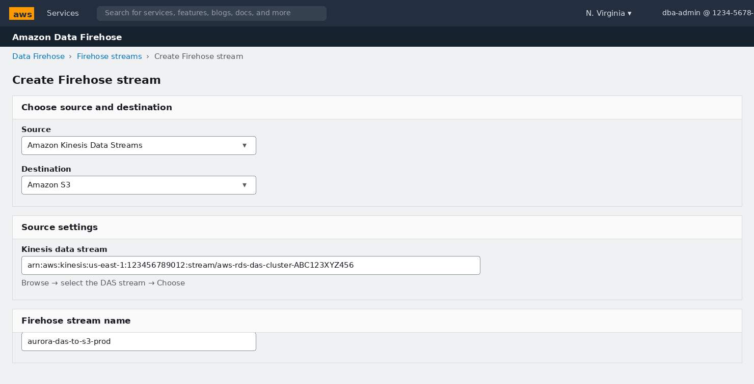
📸 Screenshot: Firehose Create stream — Source = Kinesis Data Streams, Destination = Amazon S3, stream name field

5.2 S3 Prefix, Buffer Hints, Compression & Encryption

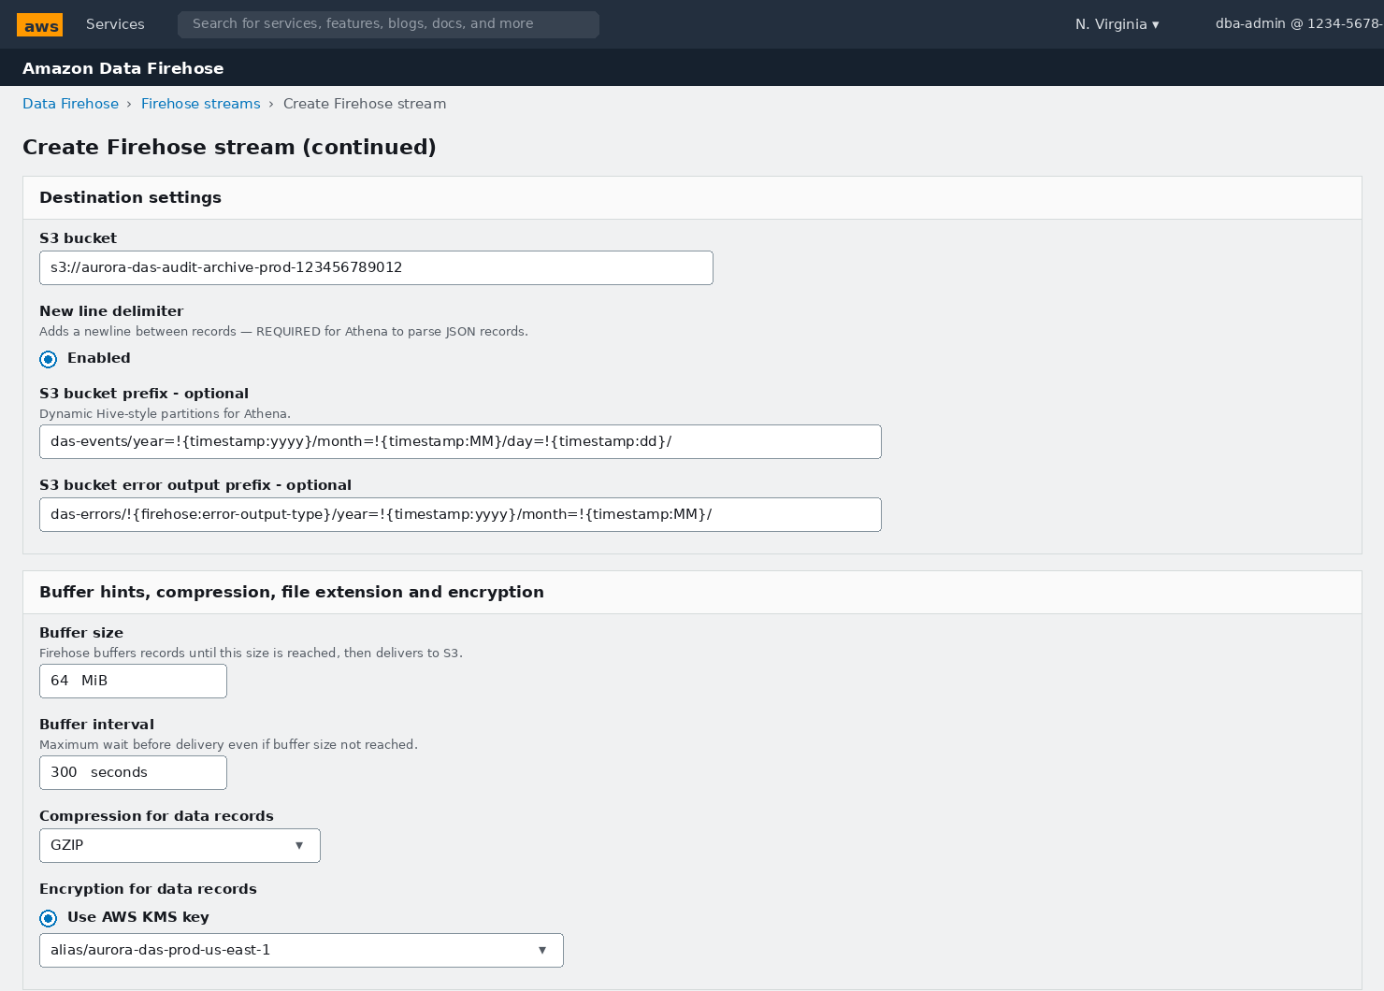
📸 Screenshot: Firehose destination settings — S3 bucket, dynamic partitioning prefix, 64 MiB buffer, 300s interval, GZIP, KMS

5.3 IAM Role for Firehose

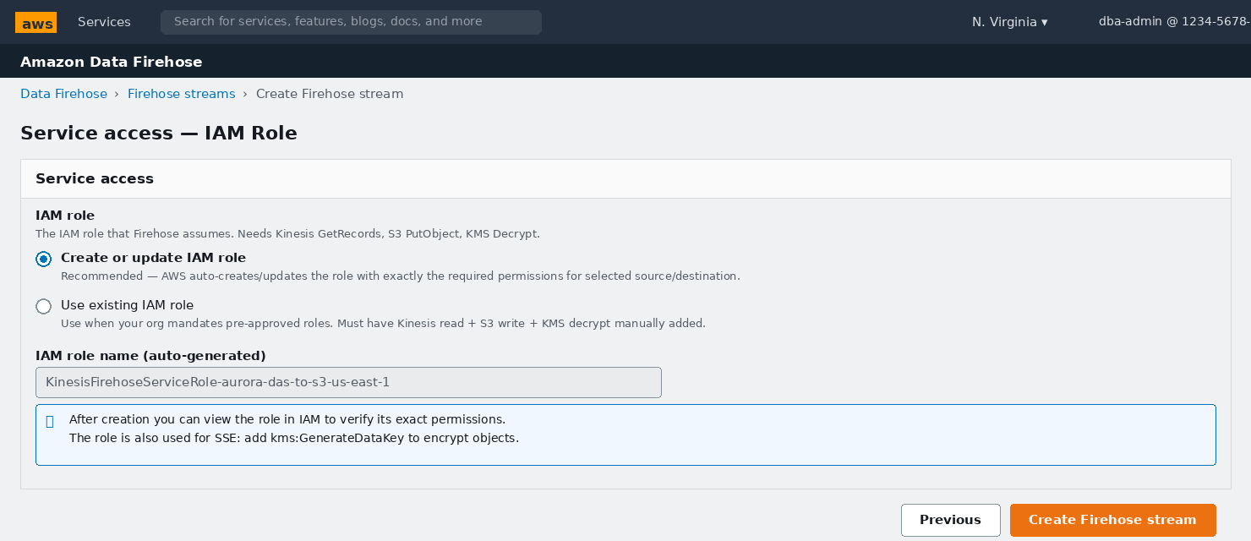
📸 Screenshot: Firehose Service access — Create or update IAM role (auto-generates all needed permissions)

5.4 Firehose Monitoring Tab

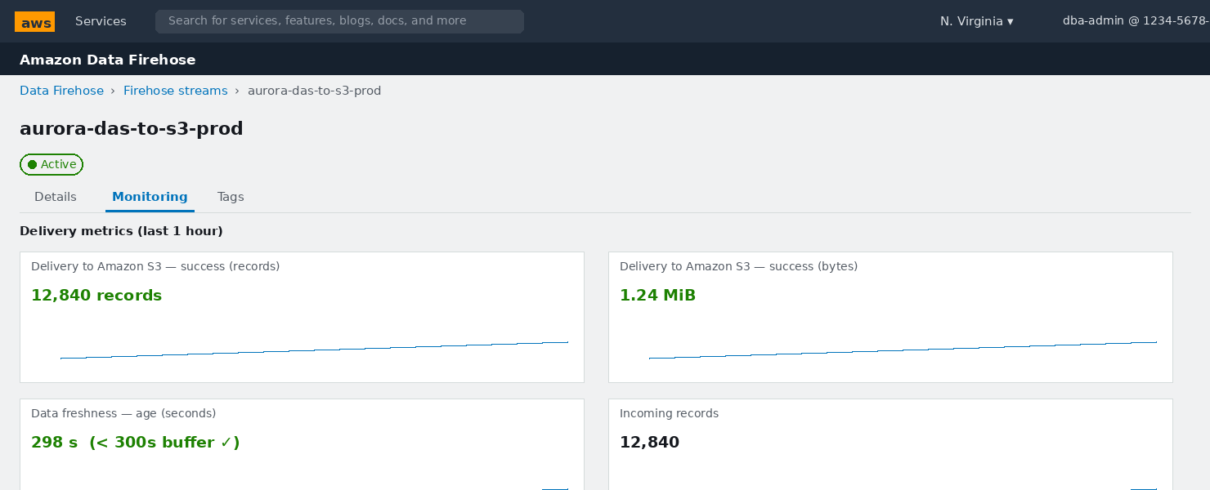
📸 Screenshot: Firehose Monitoring — Delivery to S3 success metrics confirming records are flowing

Kinesis Firehose — All Configuration Parameters
Parameter | What It Controls | Why It Matters / Usage | Recommended Value
Source → Amazon Kinesis Data Streams | Where Firehose reads records from: Direct PUT (apps push directly) or a Kinesis Data Stream | DAS writes to Kinesis, not directly to Firehose. Source must be Kinesis — never change this to Direct PUT for the DAS stream | Amazon Kinesis Data Streams → select the DAS stream
Destination → Amazon S3 | Where batched records are delivered | S3 is the standard audit archive. You can create a second Firehose stream pointing to Amazon OpenSearch if you also want a live search dashboard — but do S3 first as the primary compliance store | Amazon S3
Firehose stream name | Identifier for this delivery pipeline (appears in CloudWatch metrics and billing) | Encode: service + destination + environment. Immutable after creation | aurora-das-to-s3-prod
Transform records (Lambda) | Optionally invoke a Lambda to modify records in-flight before S3 delivery | Storing the raw ENCRYPTED records in S3 is the stronger compliance posture — no in-flight transformation means no chance of accidentally stripping sensitive fields. Decrypt at query time in Lambda/Athena instead | Disabled (keep encrypted records in the archive)
New line delimiter → Enabled | Appends a \n character between consecutive JSON records within one S3 object | CRITICAL — without \n, Firehose concatenates multiple JSON records on a single line, creating unparseable objects. Athena's JSON SerDe, jq, and most JSON parsers all require newline-delimited JSON (NDJSON) | Enabled (always, no exceptions)
S3 bucket prefix | Folder path template using !{timestamp:} and !{firehose:} dynamic substitution variables | Hive-style partitioning (year=/month=/day=) enables Athena partition pruning — queries with a date filter scan only the relevant partitions, cutting scanned data (and cost) by 100x or more vs a flat prefix | das-events/year=!{timestamp:yyyy}/month=!{timestamp:MM}/day=!{timestamp:dd}/
S3 error output prefix | Where failed delivery records land (separate prefix) | Failed deliveries silently vanish without this. Monitor it: any objects here represent audit gaps. Set a CloudWatch alarm on new objects appearing under this prefix | das-errors/!{firehose:error-output-type}/year=!{timestamp:yyyy}/month=!{timestamp:MM}/
Buffer size → 64 MiB | Deliver when the in-memory buffer reaches this size (1–128 MiB) | Larger buffers mean fewer, larger S3 objects — fewer S3 PUT requests (cheaper) and better GZIP compression ratios (objects compresses better in bulk). 64 MiB is a good balance; increase to 128 MiB for very high-throughput clusters | 64 MiB
Buffer interval → 300 seconds | Force delivery after this many seconds even if buffer size not reached (0–900s) | Caps archive latency — records are guaranteed to be in S3 within Buffer Interval seconds. 300s (5 min) is fine for archive; Lambda handles real-time alerting so Firehose latency is not critical | 300 seconds (5 minutes)
Compression → GZIP | Compress S3 objects: GZIP, Snappy, ZIP, HADOOP_SNAPPY, or none | DAS records are verbose JSON. GZIP typically achieves 75-85% compression — 1 GB of raw DAS events becomes ~150-250 MB in S3. GZIP is natively readable by Athena, EMR, and Glue without any decompressor configuration | GZIP
S3 encryption → SSE-KMS | Encrypt S3 objects using the specified KMS key | Ensures records are encrypted at rest in S3 using the same CMK that encrypts them in Kinesis — one key to manage for the entire audit domain. Also satisfies requirements for encryption at rest in PCI-DSS, HIPAA, and SOC 2 | AWS KMS → alias/aurora-das-prod-us-east-1
IAM role → Create or update | The role Firehose assumes to read Kinesis, write S3, and use KMS | Auto-creation generates a role with exactly the minimum required permissions. Review it in IAM after creation. The role needs: kinesis:GetRecords + GetShardIterator + DescribeStream, s3:PutObject on the bucket, kms:Decrypt (for Kinesis) and kms:GenerateDataKey (for S3 SSE) | Create or update IAM role — verify permissions in IAM after creation

6. Amazon SNS + AWS Lambda — Real-Time Alerting
SNS is the notification hub. Lambda is the real-time consumer that decrypts DAS records, evaluates them for critical events (DROP, TRUNCATE, DELETE without WHERE), and publishes alerts to SNS within seconds.

6.1 Create the SNS Topic
🧭 AWS Console Path: AWS Console → Search 'SNS' → Simple Notification Service → Topics → Create topic

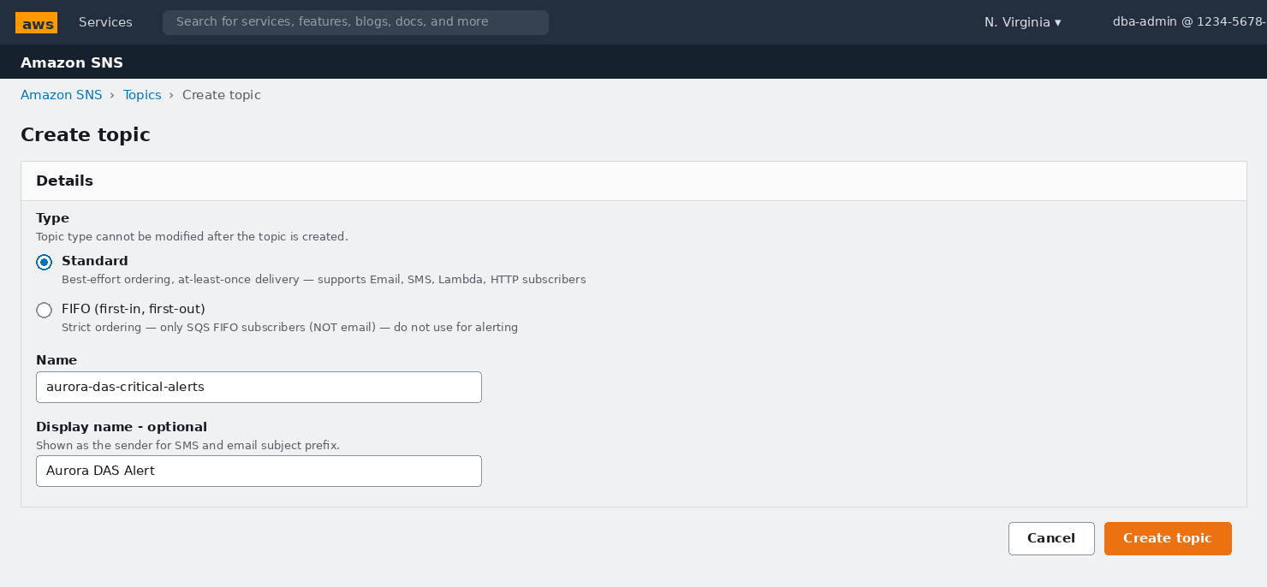
📸 Screenshot: SNS Create topic — Standard type, name 'aurora-das-critical-alerts', display name 'Aurora DAS Alert'

Amazon SNS Topic Parameters
Parameter | What It Controls | Why It Matters / Usage | Recommended Value
Type → Standard | Message delivery semantics: Standard (best-effort ordering, at-least-once) vs FIFO (strict ordering) | FIFO topics only support SQS FIFO subscribers — they CANNOT deliver to Email, SMS, Lambda, or HTTPS endpoints. For alerting to humans and ChatOps tools, Standard is the only valid choice | Always Standard for alert notifications
Name | Topic identifier — immutable after creation, forms part of the ARN | Keep it short and descriptive. The ARN is embedded in Lambda env vars and IAM policies, so changing it requires updates across multiple services | aurora-das-critical-alerts
Display name | The sender name shown in SMS messages and email subject prefix | Appears as the From: display name in email clients. Makes alerts immediately recognisable in a crowded inbox | Aurora DAS Alert

6.2 Subscribe the DBA Team Email

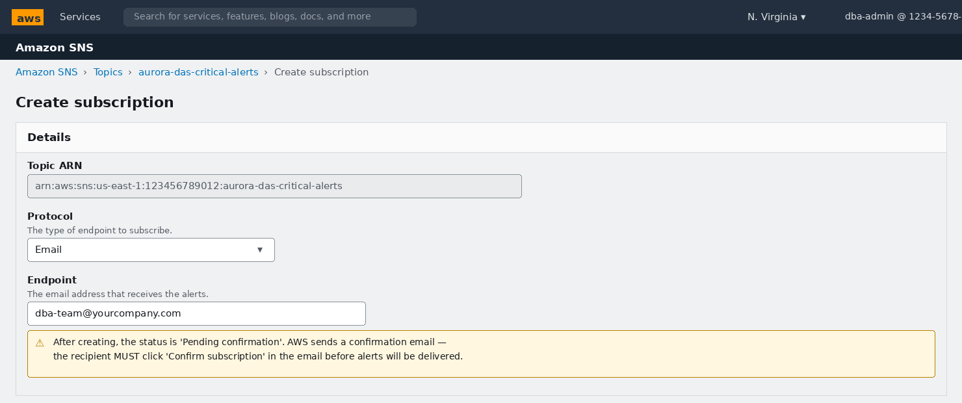
📸 Screenshot: SNS Create subscription — Email protocol, DBA team address, note PendingConfirmation status warning

SNS Subscription Parameters
Parameter | What It Controls | Why It Matters / Usage | Recommended Value
Protocol → Email | The subscriber type: Email, Email-JSON, SMS, Lambda, SQS, HTTPS, Amazon Data Firehose | Email is the starting point — always verify it works before adding more complex subscribers (Lambda for Slack/PagerDuty). Add a Lambda subscriber after Email is confirmed and tested | Email first; add Lambda for ChatOps fan-out
Endpoint | The address that receives alert notifications | Use a distribution list or group email, not an individual address — ensures coverage during vacations and reduces single-points-of-failure in the alert chain | dba-team@yourcompany.com or a team alias
Subscription confirmation | AWS sends a confirmation email; the recipient MUST click the link before alerts are delivered | The #1 cause of 'I set up DAS but never received an alert' is a subscription stuck in PendingConfirmation. Check SNS → Topic → Subscriptions tab — status MUST show Confirmed (green) before testing | Check email, click 'Confirm subscription' link within 3 days or it expires

6.3 Create the Lambda Function
🧭 AWS Console Path: AWS Console → Search 'Lambda' → Functions → Create function

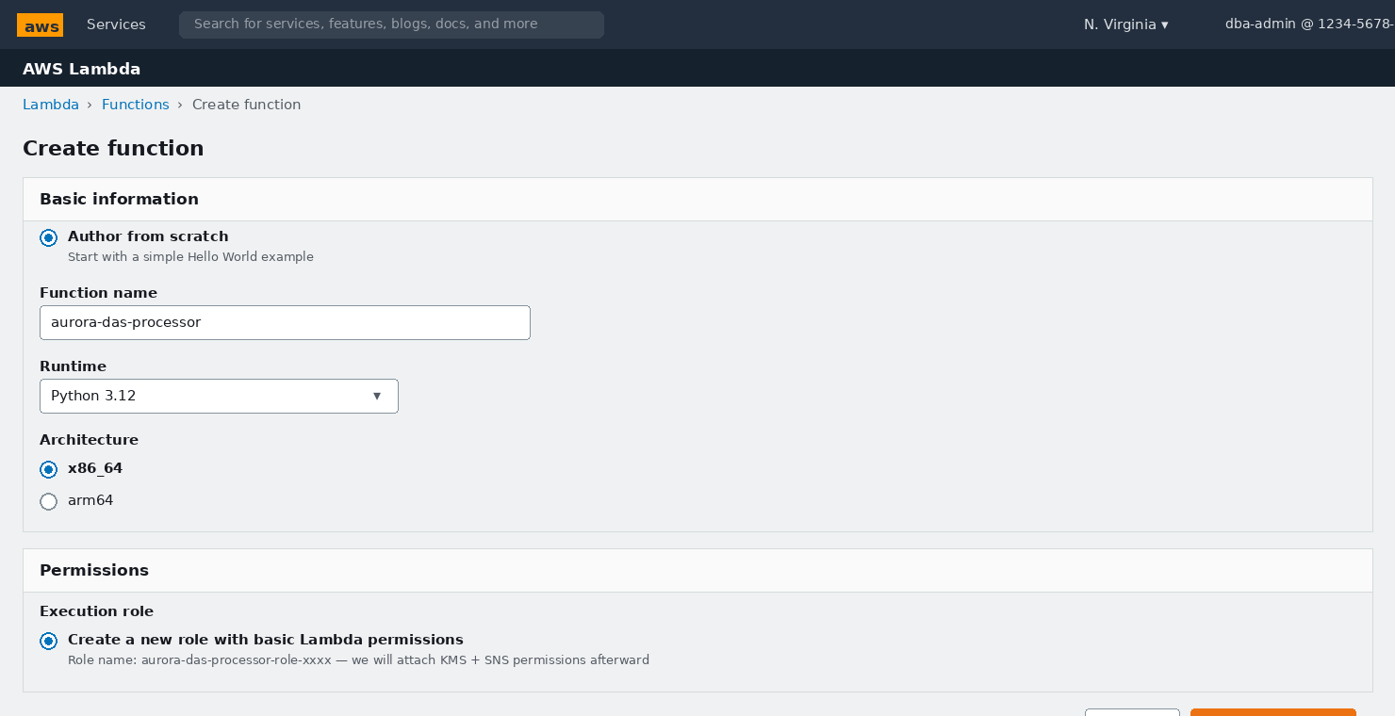
📸 Screenshot: Lambda Create function — Author from scratch, Python 3.12, x86_64, new execution role

Lambda Function Creation Parameters
Parameter | What It Controls | Why It Matters / Usage | Recommended Value
Author option → Author from scratch | Starting point: blank, a blueprint, or a container image | Start blank — the DAS processor code is provided below and does not match any existing blueprint | Author from scratch
Function name | Identifier for the function — used in CloudWatch log group names, ARNs, and IAM policies | Encode purpose. Log group will be /aws/lambda/aurora-das-processor | aurora-das-processor
Runtime → Python 3.12 | Language runtime environment | Python 3.12 is the latest stable supported runtime with the cryptography package available via Lambda Layers. Avoid Python 3.8/3.9 (approaching end-of-support) | Python 3.12
Architecture | CPU instruction set: x86_64 or arm64 (Graviton) | arm64 is ~20% cheaper and faster for CPU-bound workloads. However, the cryptography package wheel must be compiled for arm64 — use x86_64 unless your Lambda Layer already targets arm64 | x86_64 (safest for binary wheel compatibility)
Execution role | IAM role the function assumes at runtime | Create new — we will attach the additional KMS Decrypt and SNS Publish permissions in §6.7 | Create a new role with basic Lambda permissions

6.4 Paste the Processor Code

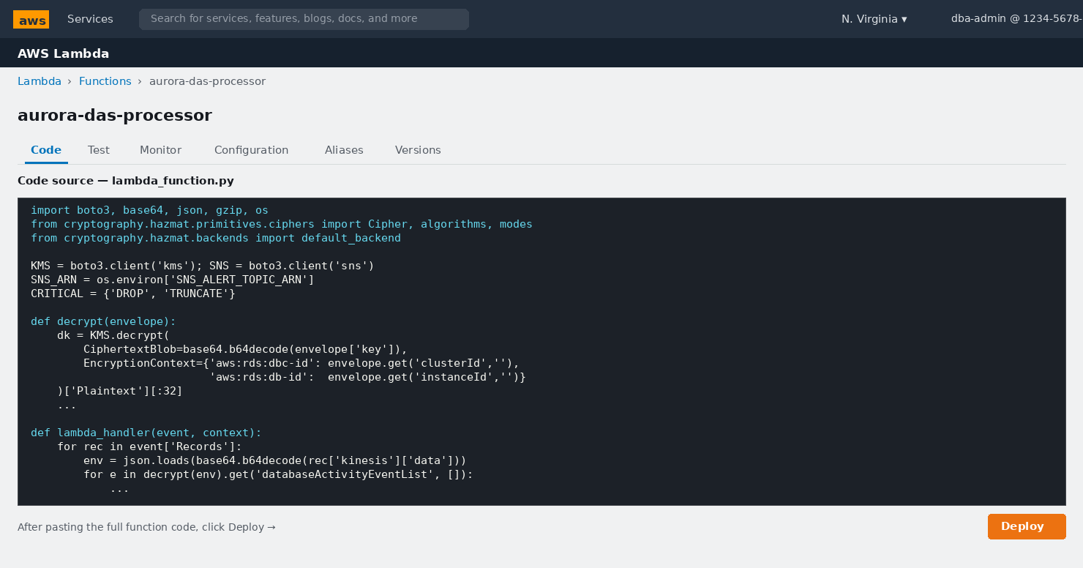
📸 Screenshot: Lambda Code tab — DAS processor function. Select All in lambda_function.py, paste, then click Deploy
import boto3, base64, json, gzip, os
from cryptography.hazmat.primitives.ciphers import Cipher, algorithms, modes
from cryptography.hazmat.backends import default_backend

KMS = boto3.client('kms')
SNS = boto3.client('sns')
SNS_ARN = os.environ['SNS_ALERT_TOPIC_ARN']
CRITICAL = {'DROP', 'TRUNCATE'}

def decrypt(envelope):
# Step 1: KMS decrypts the per-record data key using your CMK
dk = KMS.decrypt(
CiphertextBlob=base64.b64decode(envelope['key']),
EncryptionContext={
'aws:rds:dbc-id': envelope.get('clusterId', ''),
'aws:rds:db-id': envelope.get('instanceId', '')
}
)['Plaintext'][:32]
# Step 2: Decrypt the activity payload with AES-256-GCM
raw = base64.b64decode(envelope['databaseActivityEvents'])
iv, ct, tag = raw[:12], raw[12:-16], raw[-16:]
dec = Cipher(algorithms.AES(dk), modes.GCM(iv, tag),
backend=default_backend()).decryptor()
# Step 3: Decompress (gzip) and parse JSON
return json.loads(gzip.decompress(dec.update(ct) + dec.finalize()))

def lambda_handler(event, context):
for rec in event['Records']:
envelope = json.loads(base64.b64decode(rec['kinesis']['data']))
payload = decrypt(envelope)
for e in payload.get('databaseActivityEventList', []):
cmd = (e.get('command') or '').upper()
sql = (e.get('commandText') or '').upper()
obj = e.get('objectName', '')
usr = e.get('dbUserName', '')
ip = e.get('remoteHost', '')
print('Decrypted event:', json.dumps(
{k: e.get(k) for k in ('command','objectName',
'dbUserName','remoteHost','sessionId')}))
# Critical event detection
fire = cmd in CRITICAL
fire |= (cmd == 'DELETE' and 'WHERE' not in sql)
fire |= (cmd in ('GRANT','ALTER ROLE') and 'SUPERUSER' in sql)
if fire:
reason = f'{cmd} on {obj} by {usr} from {ip}'
print('ALERT PUBLISHED ->', reason)
SNS.publish(
TopicArn=SNS_ARN,
Subject=f'[Aurora DAS CRITICAL] {reason}'[:99],
Message=json.dumps({
'severity': 'CRITICAL',
'reason': reason,
'event': e
}, indent=2, default=str)
)
return {'statusCode': 200}
⚠ The cryptography package must be available at runtime
AWS Lambda Python 3.12 does NOT include the cryptography package by default.
Solution A (recommended): Create a Lambda Layer containing the package.
→ pip install cryptography --target python/lib/python3.12/site-packages
→ zip -r cryptography-layer.zip python/
→ Lambda → Layers → Create layer → upload the zip → attach to your function.
Solution B: Package the function code together with the cryptography wheel in a zip file.

6.5 Configure Timeout and Memory

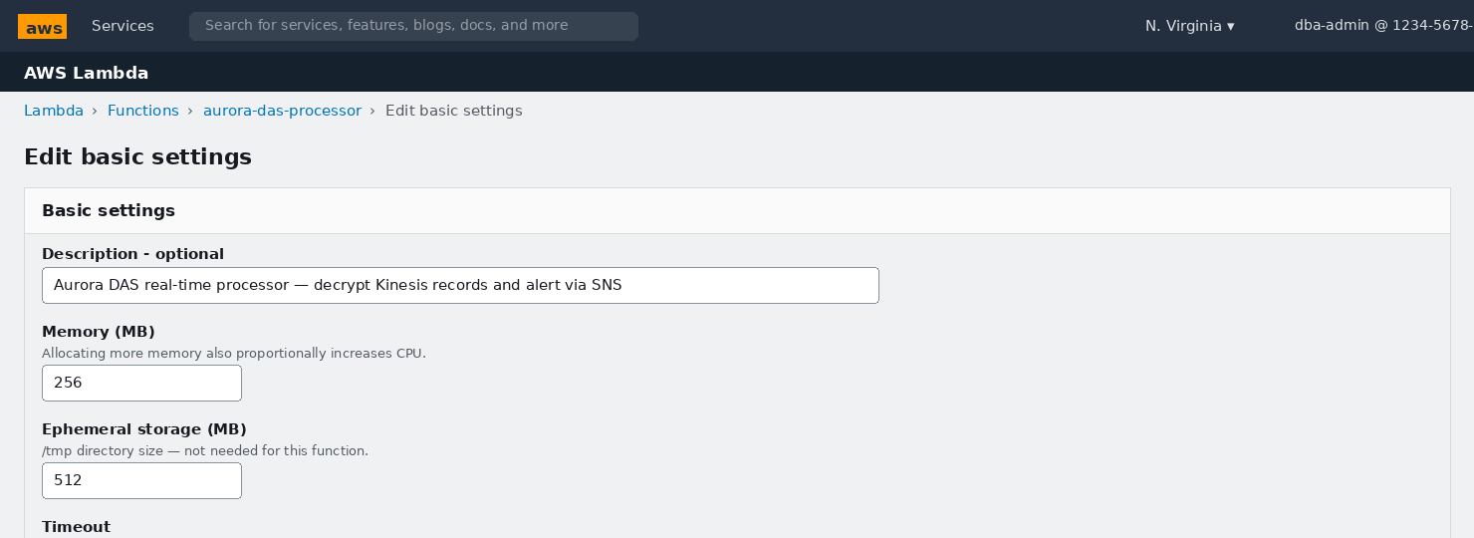
📸 Screenshot: Lambda Edit basic settings — Timeout 60s, Memory 256 MB

Lambda Function Execution Parameters
Parameter | What It Controls | Why It Matters / Usage | Recommended Value
Memory → 256 MB | RAM allocation. CPU is allocated proportionally to memory | AES-256-GCM decryption of a full 100-record batch typically completes in < 2 seconds with 256 MB. The default 128 MB can cause CPU-starved timeouts under busy batches | 256 MB
Timeout → 60 seconds | Maximum execution time per invocation. Lambda terminates after this | A batch of 100 DAS records with KMS decrypt typically takes 1-3 seconds. 60s provides a 20x safety margin while preventing runaway invocations from blocking the Kinesis consumer | 60 seconds
Ephemeral storage | /tmp directory available to the function | DAS processor streams records in memory — no disk required | Default 512 MB is fine

6.6 Set the SNS Environment Variable

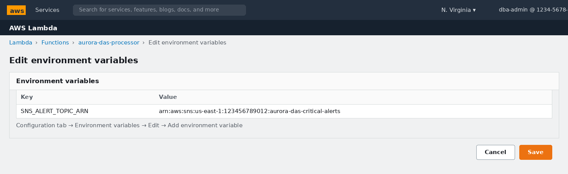
📸 Screenshot: Lambda Configuration → Environment variables — SNS_ALERT_TOPIC_ARN key and value

Lambda Environment Variables
Parameter | What It Controls | Why It Matters / Usage | Recommended Value
SNS_ALERT_TOPIC_ARN | The ARN of the SNS topic to which CRITICAL alerts are published | Hard-coding the ARN in source code makes the function unusable in other environments. Using an env var allows the same code to be deployed to dev/staging/prod by changing only this variable | arn:aws:sns:us-east-1:ACCOUNT:aurora-das-critical-alerts

6.7 Add the Kinesis Trigger

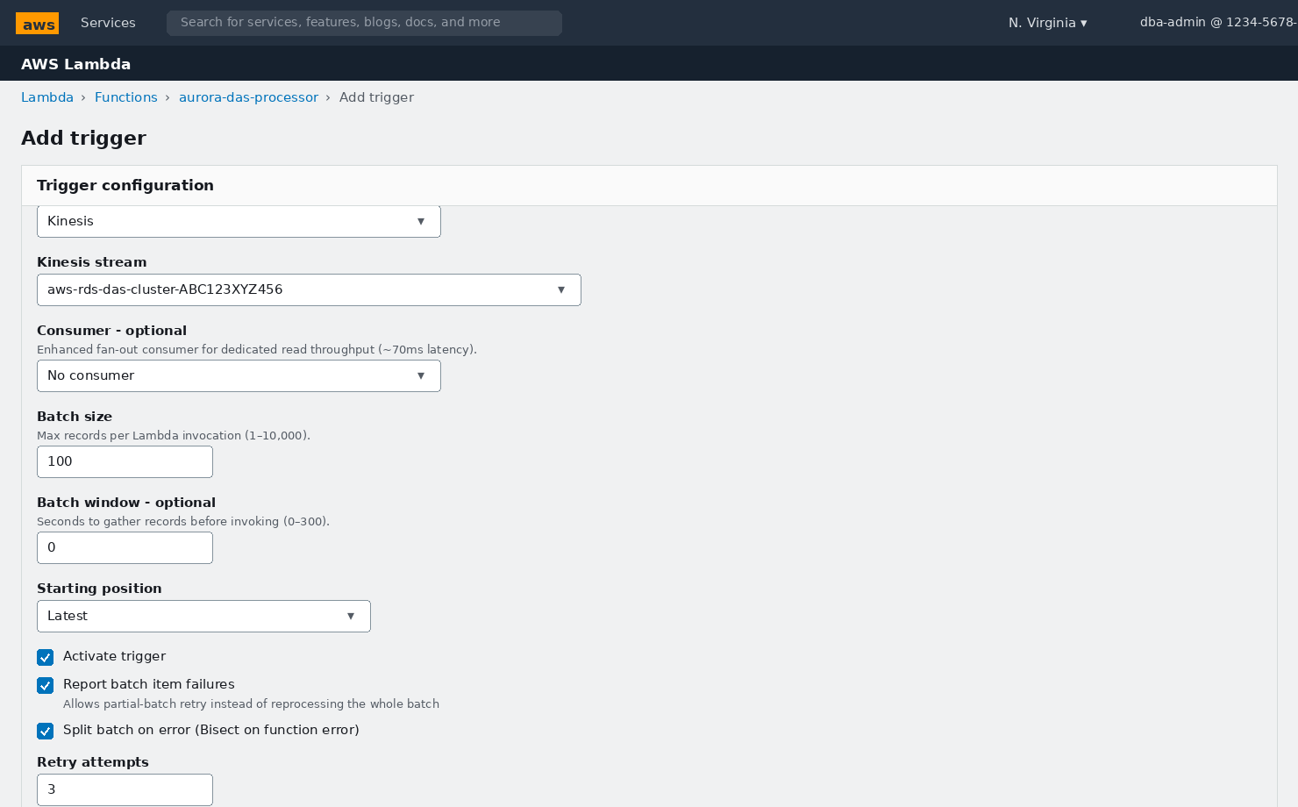
📸 Screenshot: Lambda Add trigger — Kinesis source, batch 100, window 0, Latest, Report batch item failures, Bisect on error enabled

Lambda Kinesis Trigger Parameters
Parameter | What It Controls | Why It Matters / Usage | Recommended Value
Kinesis stream | The source stream that invokes the function | Must point to the DAS stream. Verify the stream name suffix matches what Aurora showed in §3.4 | aws-rds-das-cluster-XXXXXXXX
Consumer | Standard (shared read) vs Enhanced fan-out (dedicated pipe per consumer) | If you registered an enhanced fan-out consumer in §4 (Kinesis), select it here for ~70ms alert latency. Otherwise leave No consumer for standard polling | No consumer unless enhanced fan-out registered; then select it
Batch size → 100 | Maximum records delivered per Lambda invocation (1–10,000) | Larger batches = fewer invocations (cheaper) but slower per-record alert latency and larger blast radius if a poison record causes a failure. 100 balances cost and isolation | 100
Batch window → 0 seconds | Seconds to accumulate records before invoking, even if batch size not reached (0–300s) | 0 means: invoke as soon as ANY records are available — minimises alert latency. Non-zero values trade latency for cost when the stream is bursty | 0 (minimum latency for real-time alerting)
Starting position → Latest | Where in the stream to begin reading: Latest (new records), Trim Horizon (oldest retained), or At Timestamp | Trim Horizon on first attach replays up to 7 days of history — 168 hours of production DAS events will overwhelm Lambda with thousands of redundant alerts. Use Latest for normal operation; Trim Horizon only when replaying a specific gap | Latest
Report batch item failures → Enabled | Lambda can return a partial-failure response listing which record identifiers failed, so only those records are retried | Without this, one corrupted record causes the ENTIRE batch to retry until it expires — blocking the shard. With it, only the failing record retries | Enabled (always)
Bisect on function error → Enabled | On invocation failure, splits the batch in half and retries each half independently | Combined with Report batch item failures, this isolates a poison record in log₂(100) = 7 retries rather than retrying the full batch hundreds of times | Enabled (always)
Retry attempts → 3 | Number of times to retry a failing batch (0–10,000) | Bounded retries prevent a permanently unprocessable record from stalling the shard indefinitely. After 3 retries, send to a dead-letter SQS queue for manual investigation | 3 + add an SQS on-failure destination

6.8 Grant Lambda the Required IAM Permissions

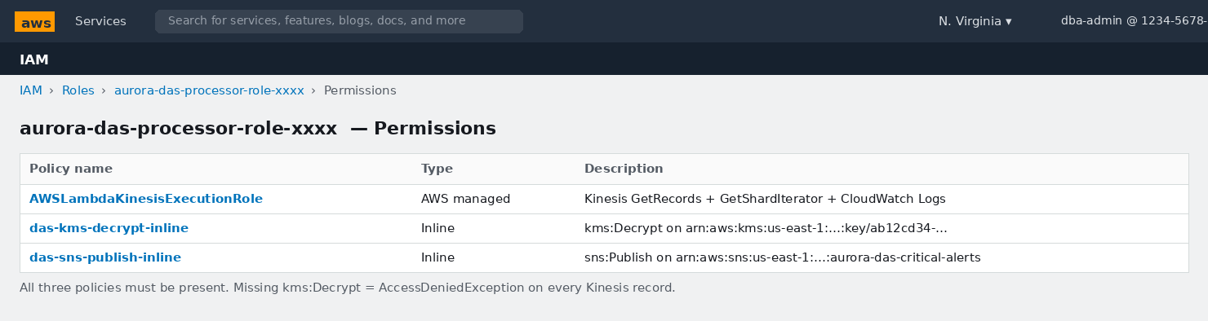
📸 Screenshot: IAM Role for Lambda — three policies: AWSLambdaKinesisExecutionRole + two inline policies for KMS Decrypt and SNS Publish

STEP 2 Attach KMS Decrypt and SNS Publish to the Lambda role
1. | Lambda → Configuration → Permissions → click the Execution role link (opens IAM in new tab)
2. | Verify AWSLambdaKinesisExecutionRole is already attached (Kinesis read + CloudWatch Logs)
3. | Click Add permissions → Create inline policy
4. | Inline policy 1 — KMS: Service=KMS, Action=kms:Decrypt, Resource=your KMS key ARN
5. | Name: das-kms-decrypt-policy → Click Create policy
6. | Click Add permissions → Create inline policy
7. | Inline policy 2 — SNS: Service=SNS, Action=sns:Publish, Resource=your SNS topic ARN
8. | Name: das-sns-publish-policy → Click Create policy
9. | Final state: 3 policies attached (as shown in the screenshot above)

7. End-to-End Audit Testing
Trace real SQL statements through every layer: Aurora → Kinesis → Lambda CloudWatch Logs → SNS Email → S3 Archive → Athena Query.

ℹ Test environment — connect to your Aurora writer endpoint
psql -h apg-prod-cluster-use1.cluster-xxxx.us-east-1.rds.amazonaws.com -U postgres -d postgres
Use a test schema. DO NOT run DROP tests on production data — the DROP is real.

7.1 Test 1 — Baseline: Confirm Kinesis is Receiving DAS Records
SELECT current_timestamp, current_user, version();

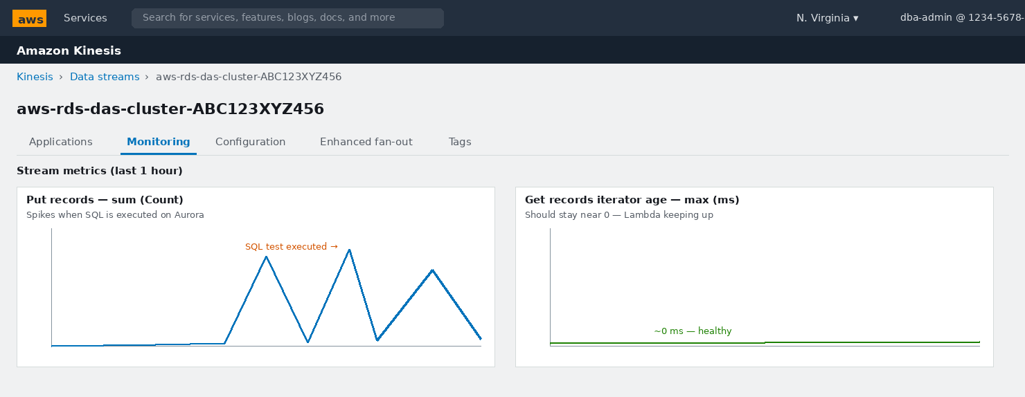
📸 Screenshot: Kinesis Monitoring tab — Put Records spike after SQL execution; Get Records iterator age ≈ 0 ms (Lambda keeping up)

STEP 1 Interpret the Kinesis monitoring charts
1. | Navigate to Kinesis → your DAS stream → Monitoring tab
2. | Put Records — sum (Count): each spike = SQL activity on Aurora. Confirms DAS → Kinesis flow
3. | GetRecords Iterator Age — max (ms): how far behind consumers are. Near 0 ms = healthy; sustained climb means Lambda is erroring or shards are undersized
4. | No spike after 60 seconds? → Recheck §3.4: DAS Status must be Started in this exact region

7.2 Test 2 — DDL and DML Capture
CREATE SCHEMA das_test;
CREATE TABLE das_test.customers (
customer_id SERIAL PRIMARY KEY,
name VARCHAR(100) NOT NULL,
email VARCHAR(200) UNIQUE,
account_balance NUMERIC(15,2) DEFAULT 0
);
INSERT INTO das_test.customers (name, email, account_balance)
VALUES ('Alice Johnson', 'alice@example.com', 50000),
('Bob Smith', 'bob@example.com', 25000),
('Carol White', 'carol@example.com', 75000);

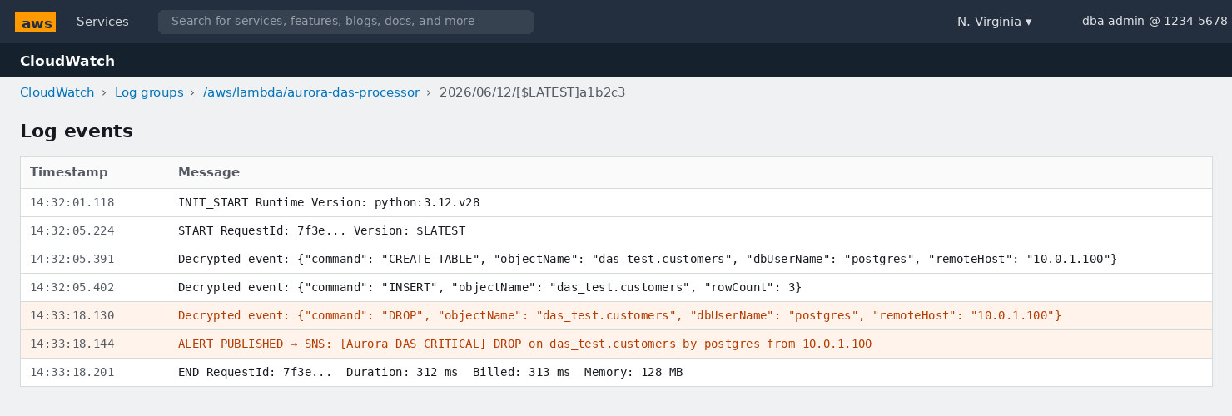
📸 Screenshot: CloudWatch Logs — Lambda log stream showing decrypted CREATE TABLE and INSERT events, then the DROP ALERT line

STEP 2 Check Lambda logs for CREATE and INSERT events
1. | Lambda → aurora-das-processor → Monitor tab → Click View CloudWatch logs
2. | Click the latest log stream (today's date and time)
3. | Look for lines: Decrypted event: {"command": "CREATE TABLE", "objectName": "das_test.customers"...}
4. | Also see INSERT events — these confirm DAS captures DML, not just DDL
5. | Timestamp in the log should be within 5–30 seconds of the SQL execution time

7.3 Test 3 — DROP TABLE: Triggers CRITICAL Email Alert
🚨 Alert test in progress — watch your email inbox
The DROP command below WILL trigger Lambda → SNS → email within 30-60 seconds.
Have your email client open. If nothing arrives in 2 minutes:
(1) SNS → Topic → Subscriptions → Status must be Confirmed
(2) Lambda → Monitor → Error count must be 0
(3) IAM → Lambda role → verify kms:Decrypt and sns:Publish are present
-- This DROP fires the CRITICAL alert pipeline
DROP TABLE das_test.customers;

-- Also test DROP SCHEMA
DROP SCHEMA das_test;

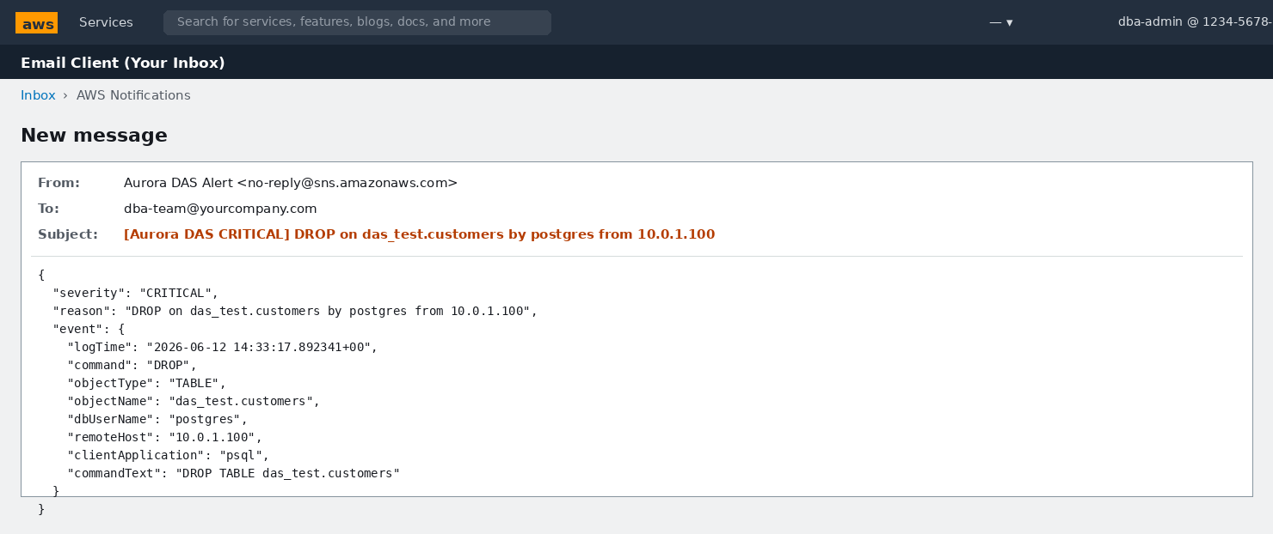
📸 Screenshot: CRITICAL alert email — subject line names the command, object, user and source IP; body carries full DAS event JSON

7.4 Test 4 — TRUNCATE and DELETE-without-WHERE
-- TRUNCATE → CRITICAL alert
CREATE TABLE das_test_trunc (id INT, val TEXT);
INSERT INTO das_test_trunc VALUES (1,'a'),(2,'b'),(3,'c');
TRUNCATE das_test_trunc;

-- DELETE without WHERE → CRITICAL alert (insider-threat pattern)
DELETE FROM das_test_trunc;

-- DELETE WITH WHERE → captured by DAS but NO alert (correct — expected)
INSERT INTO das_test_trunc VALUES (9,'x');
DELETE FROM das_test_trunc WHERE id = 9;

DROP TABLE das_test_trunc;

7.5 Test 5 — Verify S3 Archive via Firehose

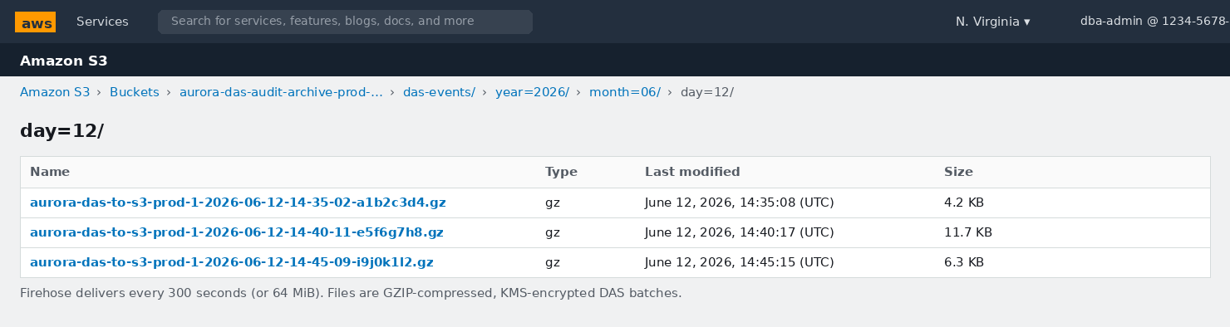
📸 Screenshot: S3 — Firehose-delivered GZIP batches in the year=/month=/day= partition structure (within 5 minutes of SQL execution)

STEP 3 Verify S3 delivery
1. | S3 → your bucket → das-events/year=2026/month=06/day=12/
2. | Objects appear within the buffer interval — up to 5 minutes after SQL execution
3. | File format: aurora-das-to-s3-prod-1-<timestamp>-<guid>.gz
4. | Nothing after 10 minutes? Check Firehose → Monitoring → DeliveryToS3 success metric, and look in the das-errors/ prefix for failed deliveries

7.6 Test 6 — Athena: SQL Queries Over the S3 Archive

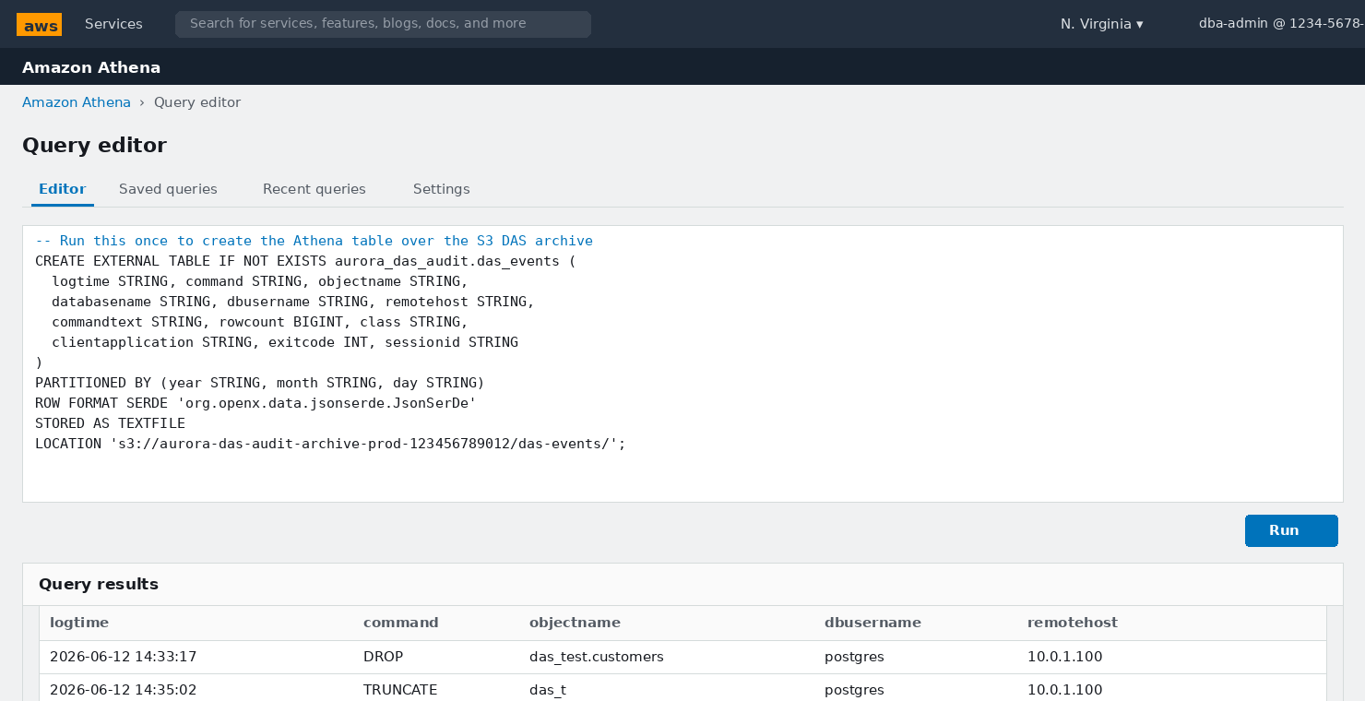
📸 Screenshot: Athena Query editor — CREATE TABLE DDL over S3 archive, then SELECT results showing DROP and TRUNCATE events

STEP 4 Create the Athena table and run compliance queries
1. | Navigate to Athena → Query editor → Settings → set query results S3 location
2. | Run the CREATE DATABASE and CREATE EXTERNAL TABLE statements (in the screenshot)
3. | Run: MSCK REPAIR TABLE aurora_das_audit.das_events; to load partitions
4. | Then run the queries below to validate the archive

-- Query 1: All DROP events — for the audit report
SELECT logtime, dbusername, command, objectname, remotehost, commandtext
FROM aurora_das_audit.das_events
WHERE command = 'DROP'
AND year = '2026' AND month = '06'
ORDER BY logtime DESC;

-- Query 2: All privilege changes (GRANT/REVOKE/ALTER ROLE)
SELECT logtime, dbusername, command, commandtext, remotehost
FROM aurora_das_audit.das_events
WHERE class = 'ROLE' AND year = '2026'
ORDER BY logtime DESC;

-- Query 3: All activity from a specific IP (forensic investigation)
SELECT logtime, dbusername, command, objectname, rowcount
FROM aurora_das_audit.das_events
WHERE remotehost = '10.0.1.100' AND year = '2026' AND month = '06'
ORDER BY logtime;

-- Query 4: Failed login attempts — brute force detection
SELECT remotehost, dbusername, COUNT(*) AS failed_attempts
FROM aurora_das_audit.das_events
WHERE class = 'AUTH' AND exitcode != 0 AND year = '2026'
GROUP BY remotehost, dbusername
HAVING COUNT(*) > 5
ORDER BY failed_attempts DESC;

8. Complete Validation Checklist
# | Validation Test | Where to Check / Expected State | Result
1 | KMS key Status = Enabled | KMS → Key → General configuration: Status = Enabled (green) | [ ] Pass [ ] Fail
2 | KMS key policy has rds.amazonaws.com principal | KMS → Key → Key policy → AllowAuroraDASService Sid present | [ ] Pass [ ] Fail
3 | S3 bucket: all 4 public-access blocks enabled | S3 → Bucket → Permissions → Block public access: all Yes | [ ] Pass [ ] Fail
4 | S3 bucket versioning = Enabled | S3 → Bucket → Properties → Bucket Versioning: Enabled | [ ] Pass [ ] Fail
5 | S3 default encryption = SSE-KMS with DAS key | S3 → Bucket → Properties → Default encryption: SSE-KMS | [ ] Pass [ ] Fail
6 | DAS Status = Started, Mode = Synchronous | RDS → Cluster → Configuration tab → Activity stream section | [ ] Pass [ ] Fail
7 | Kinesis stream Status = ACTIVE, 4 shards, 168h retention | Kinesis → stream → Configuration tab | [ ] Pass [ ] Fail
8 | Firehose stream Status = Active, new-line delimiter = Enabled | Firehose → stream → Details | [ ] Pass [ ] Fail
9 | SNS subscription Status = Confirmed | SNS → Topic → Subscriptions tab | [ ] Pass [ ] Fail
10 | Lambda trigger State = Enabled, batch = 100, window = 0 | Lambda → Configuration → Triggers | [ ] Pass [ ] Fail
11 | Lambda: timeout = 60s, memory = 256 MB | Lambda → Configuration → General configuration | [ ] Pass [ ] Fail
12 | Lambda IAM role: all 3 policies attached | IAM → role → Permissions: 3 policies listed | [ ] Pass [ ] Fail
13 | SELECT → Put Records spike in Kinesis Monitoring | Kinesis → Monitoring → Put Records > 0 | [ ] Pass [ ] Fail
14 | CREATE TABLE event in Lambda CloudWatch Logs | CW Logs → log stream → command: CREATE TABLE | [ ] Pass [ ] Fail
15 | DROP TABLE → CRITICAL email within 60 seconds | Email inbox: subject [Aurora DAS CRITICAL] DROP | [ ] Pass [ ] Fail
16 | TRUNCATE → CRITICAL email within 60 seconds | Email inbox: subject [Aurora DAS CRITICAL] TRUNCATE | [ ] Pass [ ] Fail
17 | DELETE-without-WHERE → CRITICAL email | Email inbox: CRITICAL DELETE without WHERE | [ ] Pass [ ] Fail
18 | Firehose objects in S3 within 5 minutes | S3 → das-events/year/month/day/ → .gz files present | [ ] Pass [ ] Fail
19 | Athena SELECT returns rows from archive | Athena: SELECT COUNT(*) FROM das_events > 0 | [ ] Pass [ ] Fail
20 | Iterator age stays ≈ 0 ms under load | Kinesis → Monitoring → Iterator age | [ ] Pass [ ] Fail
21 | Secondary region: own KMS key, DAS Started | Switch region → RDS → cluster → Activity stream: Started | [ ] Pass [ ] Fail

9. Troubleshooting Reference
Symptom / Error | Root Cause | Console Fix (exact path)
DAS fails to start — KMS error | Key policy missing rds.amazonaws.com principal, or key is in the wrong region | KMS → your key → Key policy → switch to policy view → add AllowAuroraDASService statement (§1.4)
KMS alias missing from DAS dropdown | Key not in same region as cluster | Create a new CMK in the cluster's region. Paste the full Key ARN if alias still missing
Lambda: AccessDeniedException on kms:Decrypt | Lambda execution role lacks kms:Decrypt, or EncryptionContext keys are wrong | IAM → Lambda role → add inline policy: kms:Decrypt on the exact key ARN. Verify clusterId/instanceId in EncryptionContext
Lambda: ModuleNotFoundError: cryptography | Package not bundled with the function | Lambda → Layers → Create layer with cryptography wheel → attach to function (see §6.4 callout)
No email despite 'ALERT PUBLISHED' in logs | SNS subscription is PendingConfirmation | SNS → Topic → Subscriptions → find subscription → Status must be Confirmed. Re-send confirmation email if expired
Kinesis iterator age climbing steadily | Lambda invocations failing silently or shards undersized | Lambda → Monitor → fix all errors first. Then Kinesis → Edit shard count → increase by 2
ProvisionedThroughputExceededException | Statement rate > 1,000/s per shard | Kinesis → Edit shard count. Rule: ceil(peak_stmt_per_sec / 1000) shards minimum
No objects in S3 after 10+ minutes | Buffer interval not elapsed, Firehose IAM role issue, or Kinesis stream mismatch | Firehose → Monitoring → check Delivery to S3 success. Check das-errors/ prefix. Verify Firehose source ARN matches DAS stream
Athena: HIVE_PARTITION_SCHEMA_MISMATCH | Table DDL does not match S3 object schema | Run MSCK REPAIR TABLE after adding new partitions. Verify JSON SerDe property ignore.malformed.json=true
Secondary region DAS not capturing events | DAS not enabled on secondary cluster, or Console region selector is wrong | Switch Console region → RDS → secondary cluster → Actions → Start activity stream (with THAT region's KMS key)

This completes the end-to-end AWS Console implementation guide for Aurora PostgreSQL Database Activity Streams — from KMS key creation through real-time alerting, long-term archiving, and compliance querying, with every service parameter documented and explained.

