E-commerce Database Schema Reference
Models, fields, relations and backend notes
Prisma schema | 19 models | 2 enums

1. Overview
This document explains every model in the Prisma schema for the store backend: what each field is for, how the models connect, what happens on delete, and what a backend developer should watch out for when reading or writing the data. Section 12 lists schema issues worth fixing.

The schema at a glance
Domain | Models | What it covers
Customer & Account | Customer, Address | Storefront shoppers and their delivery addresses.
Product Catalog | Products, ProductImage, Attributes, ProductAttributes, Category, subCategory, productCategory_SubCat | What is sold, its media, specs and categorisation.
Cart, Wishlist & Orders | Carts, Wishlists, Order, OrderItem, Payment | Shopping intent, purchases and payments.
Audit | AuditLog | Append-only history of business events.
Admin Access (RBAC) | Useraccount, UserProfile, Roles, permission | Back-office staff login, roles and permissions.

Model to table name map
Prisma client accessors use the model name with a lowercase first letter (for example prisma.carts, prisma.orderItem, prisma.productCategory_SubCat). The database tables use the @@map names below.
Prisma model | Table | Prisma model | Table
Customer | customers | Order | orders
Address | address | OrderItem | order_items
Category | categories | Payment | payments
subCategory | sub_categories | AuditLog | audit_logs
Attributes | attributes | Roles | roles
Products | products | permission | permission
ProductImage | productImage | Useraccount | user_accounts
ProductAttributes | product_attributes | UserProfile | user_profile
productCategory_SubCat | product_category_subcat | Wishlists | wishlist
Carts | carts

Conventions used across the schema
- Primary keys are auto-increment integers named id.
- Most models have createdAt (default now()) and updatedAt (@updatedAt, set by Prisma on every update). ProductImage has neither, and AuditLog has only createdAt because audit rows are never updated.
- Money columns use Decimal(10,2). Prisma returns these as Prisma.Decimal objects, not JavaScript numbers.
- A trailing ? means the column is nullable.
- Fields that hold another model (for example Customer.Orders) are virtual back-relations. They create no column; they exist so you can use include or select in queries. The foreign key column lives on the other model.
- If onDelete is not written on a required relation, Prisma uses Restrict: the database refuses to delete a parent row while child rows exist.

2. Entity-relationship diagram
The diagram shows all 19 models grouped by colour. Each line is a relation; the symbol at each end tells you how many rows can sit on that side.
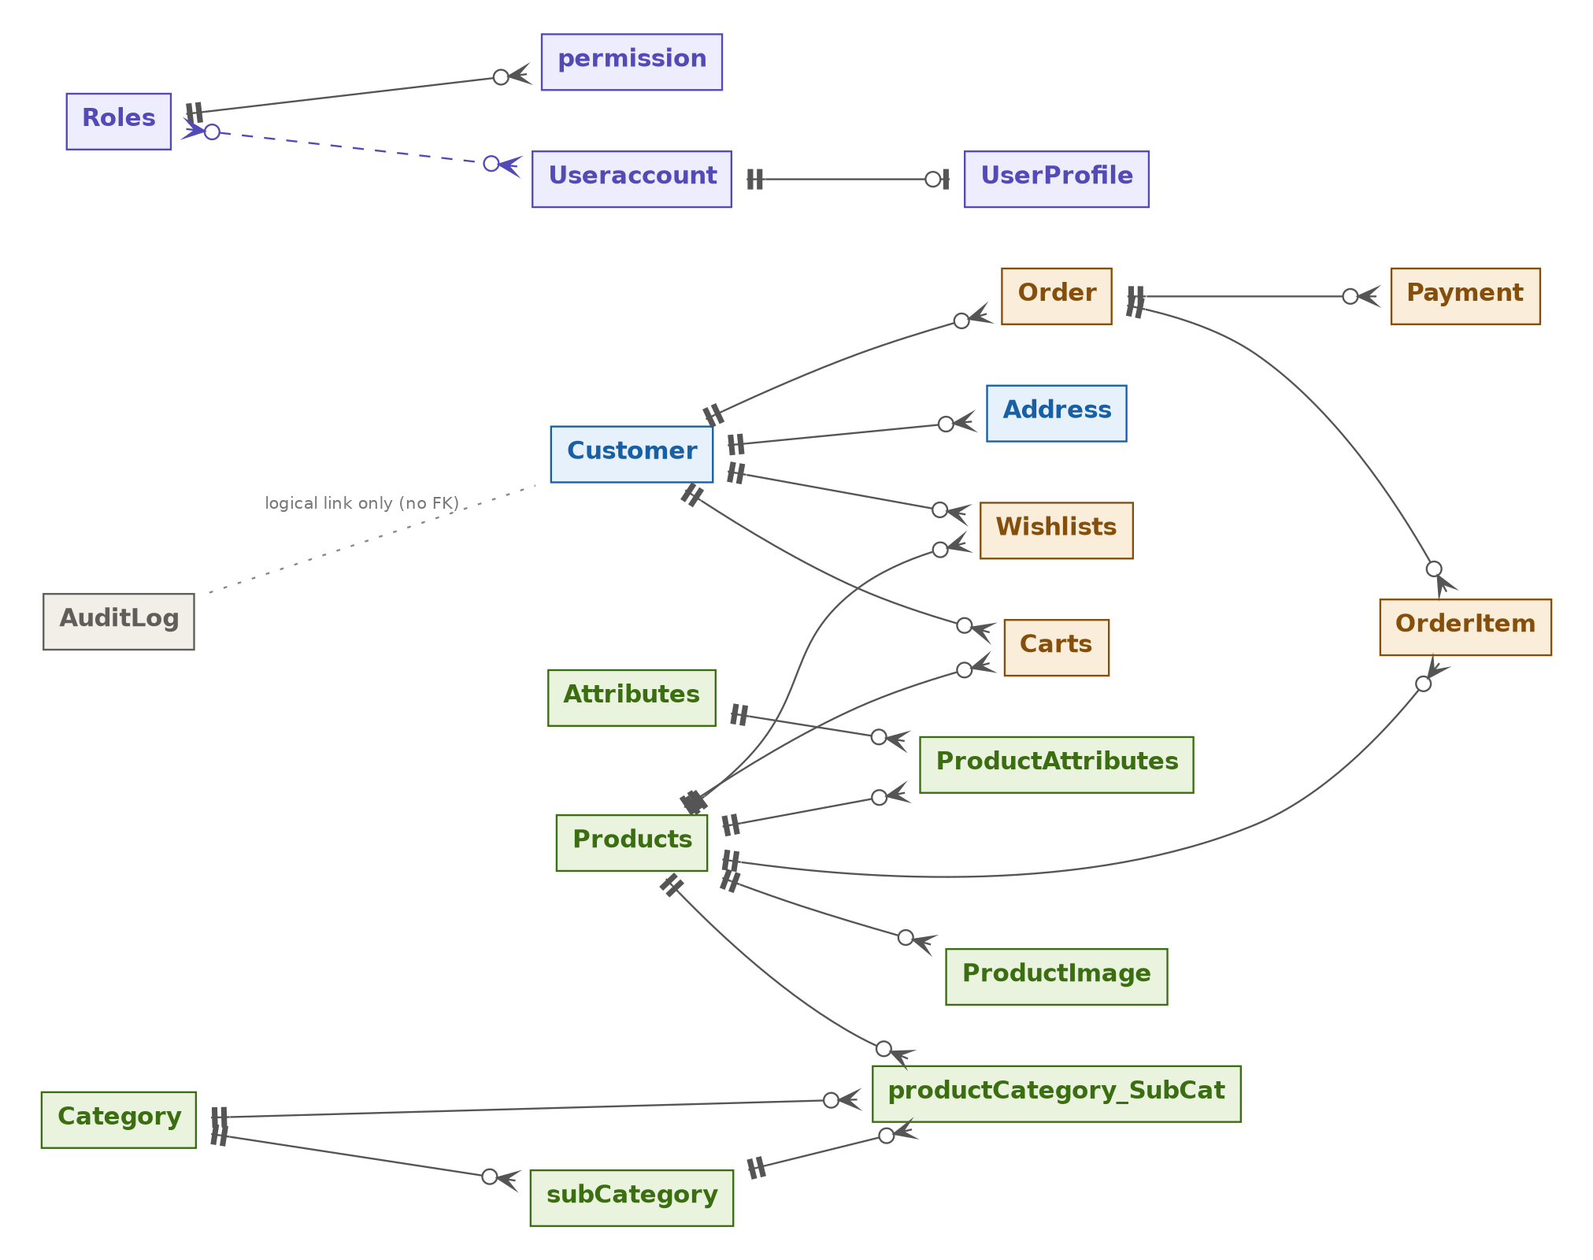

How to read the symbols
Symbol | Meaning
Double bar || | Exactly one. Example: an Order belongs to exactly one Customer.
Circle with crow foot o< | Zero or many. Example: a Customer can have zero or many Order rows.
Circle with bar o| | Zero or one. Example: a Useraccount has zero or one UserProfile.
Dashed purple line | Many-to-many through a Prisma-managed join table (Roles and Useraccount).
Dotted grey line | Logical link only, with no foreign key in the database (AuditLog.customerId).

Colour key: blue = Customer & Account, green = Product Catalog, orange = Cart, Wishlist & Orders, grey = Audit, purple = Admin Access.

3. Relations reference
Every relation in one table. "FK holder" is the model whose table stores the foreign key column. Delete rules marked (default) were not written in the schema; Prisma applies Restrict.
Relation | Type | FK holder | On delete | Meaning
Customer to Address | One to many | Address.customerId | Cascade | Deleting a customer deletes their addresses.
Customer to Carts | One to many | Carts.customerId | Cascade | Deleting a customer empties their cart.
Customer to Wishlists | One to many | Wishlists.customerId | Cascade | Deleting a customer removes their wishlist.
Customer to Order | One to many | Order.customerId | Restrict (default) | A customer who has orders cannot be deleted.
Order to OrderItem | One to many | OrderItem.orderID | Cascade | Deleting an order deletes its line items.
Order to Payment | One to many | Payment.orderID | Restrict | An order with payments cannot be deleted.
Products to OrderItem | One to many | OrderItem.productId | Restrict | A product that was ever ordered cannot be deleted.
Products to Carts | One to many | Carts.productId | Restrict (default) | A product in any cart cannot be deleted.
Products to Wishlists | One to many | Wishlists.productId | Restrict (default) | A wishlisted product cannot be deleted.
Products to ProductImage | One to many | ProductImage.productId | Cascade | Deleting a product deletes its media rows.
Products to ProductAttributes | One to many | ProductAttributes.product_id | Restrict (default) | Remove attribute values before deleting a product.
Attributes to ProductAttributes | One to many | ProductAttributes.attributes_id | Restrict (default) | An attribute in use cannot be deleted.
Category to subCategory | One to many | subCategory.categoryId | Cascade | Deleting a category deletes its sub-categories.
Products and Category / subCategory | Many to many (explicit join) | productCategory_SubCat | Restrict (default) | Join rows must be removed first.
Roles to permission | One to many | permission.rolesId | Restrict (default) | A role that owns permissions cannot be deleted.
Roles and Useraccount | Many to many (implicit join) | _RolesToUseraccount | Cascade (join rows) | Prisma manages the join table.
Useraccount to UserProfile | One to one | UserProfile.account_id (unique) | Cascade | Deleting an account deletes its profile.
AuditLog to Customer | None (logical) | No foreign key | Not applicable | customerId is a plain nullable integer.

4. Customer and Address
A Customer is a shopper on the storefront. It is separate from Useraccount, which is for staff who log in to the back office. A customer owns addresses, a cart, a wishlist and orders.
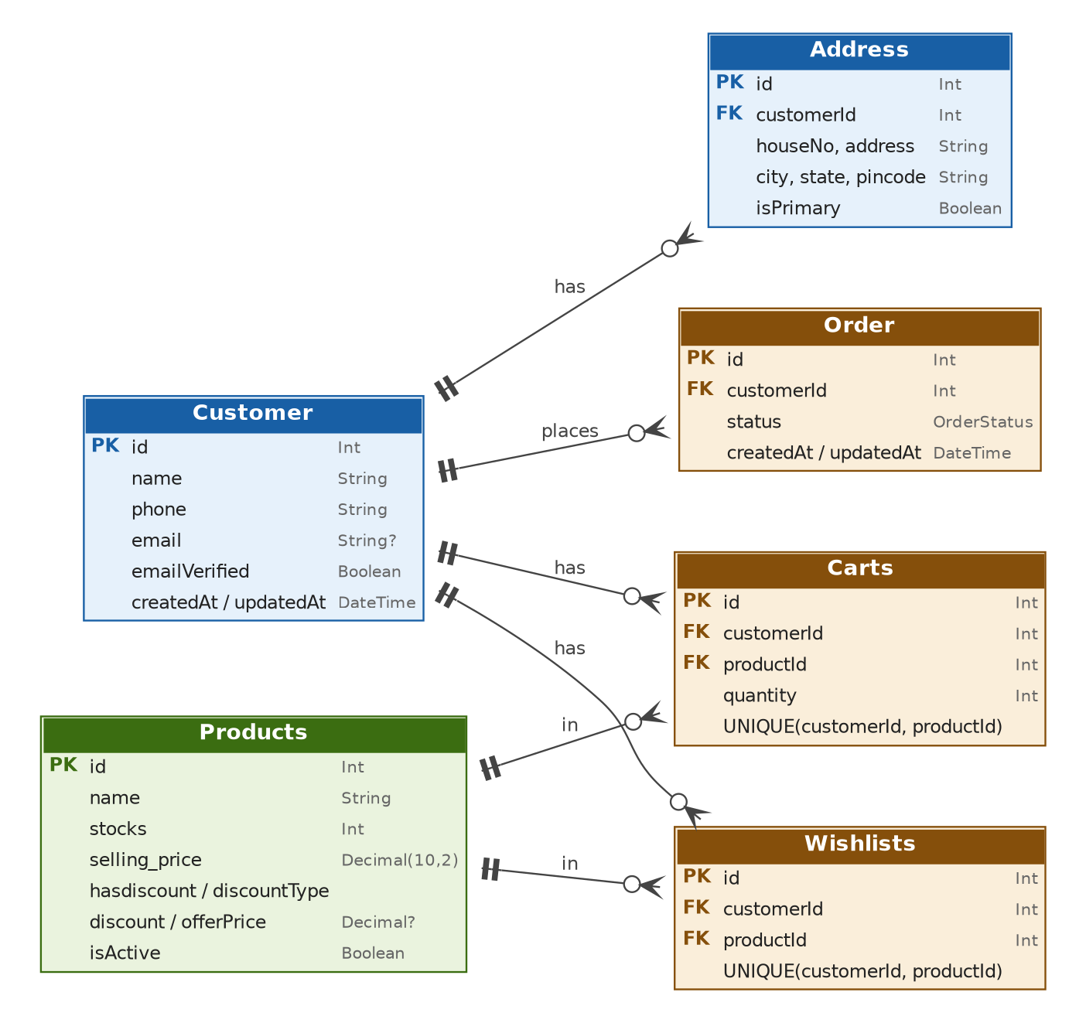

Customer
Table: customers | Domain: Customer & Account
One row per registered shopper. Every cart line, wishlist entry, address and order points back to a customer.

What each field does
Field | Type | Purpose
id | Int, PK | Unique customer ID.
name | String | Full name shown on orders and the account page.
phone | String | Contact number. Likely the login or OTP identifier. Not unique at database level.
email | String? | Optional email address. Nullable because a customer may register with only a phone number.
emailVerified | Boolean, default false | Becomes true once the customer confirms the email. Reset it to false when the email changes.
address | Address[] (virtual) | Back-relation to the customer's saved addresses. No column.
Carts | Carts[] (virtual) | Back-relation to cart lines. No column.
wishlist | Wishlists[] (virtual) | Back-relation to wishlist entries. No column.
Orders | Order[] (virtual) | Back-relation to the customer's orders. No column.
createdAt | DateTime, default now() | When the customer registered.
updatedAt | DateTime, @updatedAt | Set automatically by Prisma on every update.

Indexes and constraints
- Composite index on (phone, email). It helps queries that filter by phone, or by phone and email together. It does not help a lookup by email alone.

Relations
- One customer, many addresses. Foreign key on Address.customerId; Cascade.
- One customer, many cart lines. Foreign key on Carts.customerId; Cascade.
- One customer, many wishlist entries. Foreign key on Wishlists.customerId; Cascade.
- One customer, many orders. Foreign key on Order.customerId; Restrict.
- AuditLog.customerId refers to a customer by value only. There is no foreign key.

Backend notes
- phone and email are not unique. If you log in by phone or email, enforce uniqueness in the service layer or add @unique, otherwise duplicate accounts can be created.
- A customer who has orders cannot be hard-deleted (Restrict). For deletion or privacy requests, anonymise the row (blank the name, phone and email) instead.
- To load a customer with related data, use include: { address: true, Orders: true }. Field names are case-sensitive: Carts and Orders start with a capital letter, address and wishlist do not.

Address
Table: address | Domain: Customer & Account
A delivery address saved by a customer. A customer can keep several and mark one as the default.

What each field does
Field | Type | Purpose
id | Int, PK | Unique address ID.
houseNo | String | House, flat or building number.
address | String | Street, area and landmark line.
city | String | City or town.
pincode | String | Postal PIN code. Stored as a string to keep leading zeros; validate the format in code.
state | String | State or region.
isPrimary | Boolean, default false | Marks the default delivery address for checkout.
customerId | Int, FK | Owner of this address. References customers.id.
customer | Customer (virtual) | The owning customer. No column.
createdAt | DateTime, default now() | When the address was saved.
updatedAt | DateTime, @updatedAt | Last change time.

Indexes and constraints
- Index on customerId for "all addresses of this customer" queries.

Relations
- Many addresses belong to one customer. Foreign key customerId; Cascade, so deleting the customer deletes the addresses.

Backend notes
- Only one primary address per customer is not enforced by the database. When setting a new primary, run one transaction: updateMany to set isPrimary = false for the customer, then update the chosen address to true.
- Order has no address column, so the delivery address is not frozen at purchase time. If the customer edits or deletes an address later, past orders lose their shipping details. Consider adding an address snapshot to Order (see section 12).

5. Product catalog
Products are organised in a two-level category tree (Category then subCategory). A product is linked to categories through the explicit join model productCategory_SubCat. Specs such as colour or RAM use an attribute/value design: Attributes defines the spec type and ProductAttributes stores the value for each product.
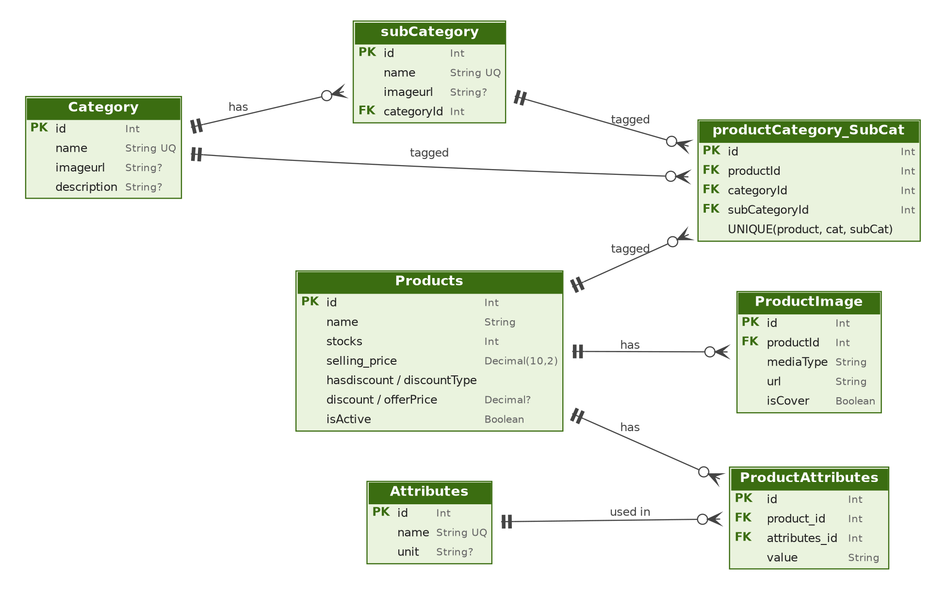

Products
Table: products | Domain: Product Catalog
The sellable item. It holds price, stock and discount data. Media, specs and categories hang off it through related tables.

What each field does
Field | Type | Purpose
id | Int, PK | Unique product ID.
name | String | Product title shown in listings and search.
description | String? | Optional long description.
stocks | Int, default 0 | Units currently available to sell.
selling_price | Decimal(10,2) | Regular price before any discount.
hasdiscount | Boolean, default false | True when a discount is active on this product.
discountType | String? | How discount is applied, for example PERCENTAGE or FLAT. Free text, no enum.
discount | Decimal(10,2)? | Discount value. Its meaning depends on discountType.
offerPrice | Decimal(10,2)? | Final price after discount. This is what the customer pays when hasdiscount is true.
attributes | ProductAttributes[] (virtual) | Spec values for this product.
carts | Carts[] (virtual) | Cart lines that contain this product.
Wishlists | Wishlists[] (virtual) | Wishlist entries for this product.
mediafile | ProductImage[] (virtual) | Images and videos for this product.
categories | productCategory_SubCat[] (virtual) | Join rows linking the product to categories.
orderItems | OrderItem[] (virtual) | Order lines that sold this product.
isActive | Boolean, default true | Visibility switch. Use it to hide or retire a product instead of deleting it.
createdAt | DateTime, default now() | When the product was created.
updatedAt | DateTime, @updatedAt | Last change time.

Indexes and constraints
- Index on name (search and sorting by name).
- Composite index on (stocks, selling_price) (in-stock and price-range filters).
- Index on hasdiscount (offers page).

Relations
- One product, many images. ProductImage.productId; Cascade.
- One product, many attribute values. ProductAttributes.product_id; Restrict.
- One product, many category links. productCategory_SubCat.productId; Restrict.
- One product, many cart lines, wishlist entries and order lines. Foreign keys on Carts, Wishlists and OrderItem; all Restrict.

Backend notes
- Effective price. Use one helper everywhere: price = hasdiscount && offerPrice !== null ? offerPrice : selling_price. offerPrice is a stored, derived value, so recompute it whenever selling_price, discount or discountType changes or it will drift.
- Money handling. Prisma returns Decimal objects. Convert to strings in API responses and avoid floating-point maths for totals.
- Stock. Decrement stock inside the order transaction with a guarded update (updateMany with stocks: { gte: qty }) so two simultaneous checkouts cannot oversell.
- No hard deletes. A product that appears in any OrderItem, cart or wishlist cannot be deleted (Restrict). Set isActive = false and filter on it in every storefront query.
- Relation field names differ from the model names: images are mediafile, category links are categories. Use these in include.

ProductImage
Table: productImage | Domain: Product Catalog
A media file attached to a product. Only the URL is stored; the file itself lives in object storage or a CDN.

What each field does
Field | Type | Purpose
id | Int, PK | Unique media ID.
mediaType | String | Kind of media, for example IMAGE or VIDEO. Free text.
url | String | Public URL of the file.
isCover | Boolean, default false | Marks the main image shown in listings.
productId | Int, FK | Product this media belongs to.
product | Products (virtual) | The owning product. No column.

Indexes and constraints
- Index on productId.

Relations
- Many media rows belong to one product. Foreign key productId; Cascade.

Backend notes
- The schema does not enforce a single cover image per product. Switch the cover inside a transaction (clear all, then set one).
- There is no sort-order column and no timestamps. Add position if the gallery order matters.
- Deleting a row removes only the database record. Delete the stored file separately.

Attributes
Table: attributes | Domain: Product Catalog
The definition of a specification type, such as Colour, RAM or Weight. It is created once and reused by many products.

What each field does
Field | Type | Purpose
id | Int, PK | Unique attribute ID.
name | String, unique | Attribute name, for example RAM.
unit | String? | Optional unit, for example GB or kg. Null for unit-less attributes such as colour.
Products | ProductAttributes[] (virtual) | Values of this attribute across products.
createdAt | DateTime, default now() | Creation time.
updatedAt | DateTime, @updatedAt | Last change time.

Relations
- One attribute, many product values. Foreign key ProductAttributes.attributes_id; Restrict.

Backend notes
- The unit belongs to the attribute, not to each value. The value 16 plus the unit GB from Attributes is displayed as "16 GB".

ProductAttributes
Table: product_attributes | Domain: Product Catalog
Stores the value of one attribute for one product, for example "Product 12: RAM = 16". It is the link between Products and Attributes.

What each field does
Field | Type | Purpose
id | Int, PK | Unique row ID.
value | String | The attribute value for this product. Numbers are stored as text.
product_id | Int, FK | Product the value belongs to.
attributes_id | Int, FK | Attribute definition this value is for.
product | Products (virtual) | The product. No column.
attributes | Attributes (virtual) | The attribute definition. No column.
createdAt | DateTime, default now() | Creation time.
updatedAt | DateTime, @updatedAt | Last change time.

Indexes and constraints
- Composite index on (attributes_id, product_id). It serves "all products with attribute X" better than "all attributes of product Y", because attributes_id comes first.

Relations
- Many values belong to one product. Foreign key product_id; Restrict.
- Many values belong to one attribute. Foreign key attributes_id; Restrict.

Backend notes
- There is no unique constraint on (product_id, attributes_id), so the same attribute can be saved twice for one product. Add @@unique([product_id, attributes_id]) or validate before insert.
- Because value is a string, numeric filtering (for example RAM above 8) needs a cast or parsing in code.
- Field names here use snake_case (product_id, attributes_id) while most other models use camelCase. Use the exact names in queries.

Category
Table: categories | Domain: Product Catalog
A top-level grouping such as Electronics or Fashion.

What each field does
Field | Type | Purpose
id | Int, PK | Unique category ID.
name | String, unique | Category name.
imageurl | String? | Optional banner or icon URL.
description | String? | Optional description for the category page.
subCategories | subCategory[] (virtual) | Child sub-categories.
product | productCategory_SubCat[] (virtual) | Join rows linking products to this category.
createdAt | DateTime, default now() | Creation time.
updatedAt | DateTime, @updatedAt | Last change time.

Relations
- One category, many sub-categories. Foreign key subCategory.categoryId; Cascade.
- Many products, many categories through productCategory_SubCat; Restrict.

Backend notes
- Deleting a category cascades to its sub-categories, but the delete then fails if any product join rows still reference the category or its sub-categories (Restrict). Unlink the products first.
- The field imageurl is all lowercase; keep that spelling in code.

subCategory
Table: sub_categories | Domain: Product Catalog
A second-level grouping inside a category, such as Mobiles under Electronics.

What each field does
Field | Type | Purpose
id | Int, PK | Unique sub-category ID.
name | String, unique | Sub-category name.
imageurl | String? | Optional image URL.
categoryId | Int, FK | Parent category.
product | productCategory_SubCat[] (virtual) | Join rows linking products to this sub-category.
category | Category (virtual) | The parent category. No column.
createdAt | DateTime, default now() | Creation time.
updatedAt | DateTime, @updatedAt | Last change time.

Indexes and constraints
- Index on categoryId.

Relations
- Many sub-categories belong to one category. Foreign key categoryId; Cascade.
- Many products, many sub-categories through productCategory_SubCat; Restrict.

Backend notes
- name is unique across the whole table, not per parent. "Accessories" cannot exist under both Mobiles and Laptops. If you need that, replace it with @@unique([categoryId, name]).

productCategory_SubCat
Table: product_category_subcat | Domain: Product Catalog
Explicit join table. One row means "this product is listed under Category X, Sub-category Y". A product can have many such rows.

What each field does
Field | Type | Purpose
id | Int, PK | Unique row ID.
productId | Int, FK | The product being categorised.
categoryId | Int, FK | The category it is listed under.
subCategoryId | Int, FK | The sub-category it is listed under.
category | Category (virtual) | Category record. No column.
subCategory | subCategory (virtual) | Sub-category record. No column.
product | Products (virtual) | Product record. No column.
createdAt | DateTime, default now() | Creation time.
updatedAt | DateTime, @updatedAt | Last change time.

Indexes and constraints
- Unique on (productId, categoryId, subCategoryId), so the same placement cannot be inserted twice.

Relations
- Many rows belong to one product, one category and one sub-category. All three foreign keys use Restrict.
- Together these make Products and Category / subCategory many-to-many.

Backend notes
- The database does not check that subCategoryId actually belongs to categoryId. Validate this in the service layer, or derive categoryId from the sub-category before inserting.
- The only index is the unique constraint, which starts with productId. Category pages filter by categoryId or subCategoryId, which are not covered. Add @@index([categoryId]) and @@index([subCategoryId]). PostgreSQL does not index foreign key columns automatically.
- To list products in a category: prisma.products.findMany({ where: { isActive: true, categories: { some: { categoryId } } } }).

6. Cart, wishlist, orders and payments
The shopping flow is: customer adds products to a cart, checkout turns the cart into an order with order items, and one or more payments are recorded against the order. The wishlist is a separate "saved for later" list.
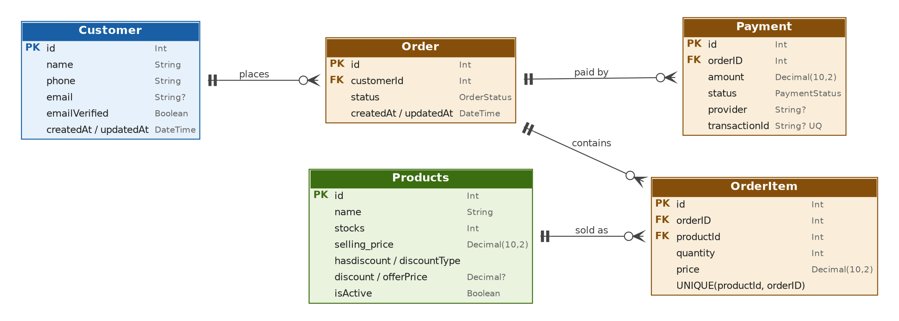

Carts
Table: carts | Domain: Cart, Wishlist & Orders
One row is one product line in a customer's cart. There is no cart header table: the "cart" is simply all rows for a customer.

What each field does
Field | Type | Purpose
id | Int, PK | Unique cart line ID.
customerId | Int, FK | Customer who owns the cart.
productId | Int, FK | Product in the cart.
quantity | Int | Number of units wanted.
customer | Customer (virtual) | Owning customer. No column.
product | Products (virtual) | The product. No column.
createdAt | DateTime, default now() | When the product was first added.
updatedAt | DateTime, @updatedAt | Last quantity change.

Indexes and constraints
- Unique on (customerId, productId). A product appears once per customer; adding it again must change the quantity.

Relations
- Many cart lines belong to one customer. Foreign key customerId; Cascade.
- Many cart lines reference one product. Foreign key productId; Restrict.

Backend notes
- Add to cart is an upsert on the compound key (Prisma names it customerId_productId). See section 11.
- No price is stored. Always read the current price from Products, then copy it into OrderItem.price at checkout.
- Validate quantity against Products.stocks and isActive when adding and again at checkout.
- At checkout, create the order and then deleteMany the customer's cart rows in the same transaction.

Wishlists
Table: wishlist | Domain: Cart, Wishlist & Orders
A product a customer has saved for later.

What each field does
Field | Type | Purpose
id | Int, PK | Unique wishlist entry ID.
customerId | Int, FK | Customer who saved the product.
productId | Int, FK | Saved product.
customer | Customer (virtual) | Owning customer. No column.
product | Products (virtual) | The product. No column.
createdAt | DateTime, default now() | When it was saved.
updatedAt | DateTime, @updatedAt | Last change time.

Indexes and constraints
- Unique on (customerId, productId): a product can be saved only once per customer.
- Index on (productId, customerId): supports "how many customers wishlisted this product".

Relations
- Many entries belong to one customer. Foreign key customerId; Cascade.
- Many entries reference one product. Foreign key productId; Restrict.

Backend notes
- A wishlist toggle endpoint can look up the compound unique key, delete the row if found and create it otherwise. Handle the unique-constraint error (P2002) in case two requests race.

Order
Table: orders | Domain: Cart, Wishlist & Orders
A purchase made by a customer. The order is the header; the products bought are in OrderItem, and the money received is in Payment.

What each field does
Field | Type | Purpose
id | Int, PK | Unique order ID.
customerId | Int, FK | Customer who placed the order.
status | OrderStatus, default PENDING | Fulfilment state. See section 9 for values.
customer | Customer (virtual) | The customer. No column.
items | OrderItem[] (virtual) | Line items of the order.
payments | Payment[] (virtual) | Payment attempts and refunds for the order.
createdAt | DateTime, default now() | When the order was placed.
updatedAt | DateTime, @updatedAt | Last status or data change.

Indexes and constraints
- Composite index on (customerId, createdAt): "my orders, newest first".

Relations
- Many orders belong to one customer. Foreign key customerId; Restrict.
- One order, many items. Foreign key OrderItem.orderID; Cascade.
- One order, many payments. Foreign key Payment.orderID; Restrict.

Backend notes
- The table has no total amount, shipping address or public order number. Compute the total as the sum of OrderItem.price * quantity, or add a totalAmount snapshot column. The auto-increment id is guessable, so consider a separate public order number.
- Enforce valid status changes in the service layer, for example PENDING to CONFIRMED to PROCESSING to SHIPPED to DELIVERED, and CANCELLED only from early states. Write an AuditLog row for every change.
- Create the order and its items in one nested create inside a transaction (section 11).

OrderItem
Table: order_items | Domain: Cart, Wishlist & Orders
One product line inside an order, with the quantity and the unit price at the time of purchase.

What each field does
Field | Type | Purpose
id | Int, PK | Unique line item ID.
orderID | Int, FK | Order this line belongs to.
productId | Int, FK | Product that was bought.
quantity | Int | Units bought.
price | Decimal(10,2) | Unit price at purchase time. This is a snapshot and does not change when the product price changes.
order | Order (virtual) | The parent order. No column.
product | Products (virtual) | The product. No column.
createdAt | DateTime, default now() | Creation time.
updatedAt | DateTime, @updatedAt | Last change time.

Indexes and constraints
- Unique on (productId, orderID): a product can appear only once per order. Merge duplicate quantities before inserting.

Relations
- Many items belong to one order. Foreign key orderID; Cascade.
- Many items reference one product. Foreign key productId; Restrict, so sold products cannot be deleted.

Backend notes
- Line total = price * quantity. Order total = sum of line totals. Never recalculate history from Products.selling_price.
- The column is spelled orderID (capital D) while others use productId. Prisma is case-sensitive.

Payment
Table: payments | Domain: Cart, Wishlist & Orders
One payment attempt or refund for an order. An order can have several payments, for example a failed attempt followed by a successful retry.

What each field does
Field | Type | Purpose
id | Int, PK | Unique payment ID.
orderID | Int, FK | Order being paid.
amount | Decimal(10,2) | Amount of this payment attempt.
status | PaymentStatus, default PENDING | Outcome of the attempt. See section 9.
provider | String? | Gateway or method, for example Razorpay, Stripe or COD.
transactionId | String?, unique | Reference from the payment gateway. Unique, so it can be used to make webhook handling idempotent.
order | Order (virtual) | The order. No column.
createdAt | DateTime, default now() | When the attempt was created.
updatedAt | DateTime, @updatedAt | Last status change.

Indexes and constraints
- Unique on transactionId. Nullable, so several rows may have no transaction ID (for example pending cash-on-delivery rows).
- Index on orderID.

Relations
- Many payments belong to one order. Foreign key orderID; Restrict, so an order with payments cannot be deleted.

Backend notes
- Treat an order as paid when it has a SUCCESS payment whose amount matches the order total.
- Handle gateway webhooks with an upsert on transactionId so retried webhooks do not create duplicates. Update the order status in the same transaction.
- Write PAYMENT_FAILED, PAYMENT_SUCCESS and PAYMENT_REFUNDED events to AuditLog.
- Never store card numbers or secrets here. Keep only the gateway reference.

7. Audit log

AuditLog
Table: audit_logs | Domain: Audit
An append-only record of important business events, such as an order being created or a payment failing. It answers "what happened, to what, and when".

What each field does
Field | Type | Purpose
id | Int, PK | Unique audit record ID.
customerId | Int? | Customer associated with the event; null for system-generated events.
action | String | The event, such as ORDER_CREATED or PAYMENT_FAILED.
entity | String | Resource type, such as Order or Payment.
entityId | String | ID of the affected order or payment. A string so it can hold integers, UUIDs or composite keys.
details | Json? | Optional JSON with event information, for example old and new status, amount or error message.
createdAt | DateTime, default now() | Timestamp when the audit event was recorded.

Indexes and constraints
- Index on (customerId, createdAt): a customer's activity timeline.
- Index on (entity, entityId, createdAt): history of one order or payment.
- Index on (action, createdAt): all events of one type in a time range.

Relations
- None by design. customerId is a plain nullable integer with no foreign key, so audit rows survive customer deletion and a log write can never fail because of a missing customer.

Backend notes
- Only insert. Never update or delete audit rows. That is why there is no updatedAt.
- entityId is a string but order and payment IDs are integers, so write String(order.id) and query with a string.
- When possible, write the audit row inside the same transaction as the change it describes.
- Keep action names in one shared constants file or enum in code to avoid typos such as ORDER_CREATED versus ORDER_CREATE.
- Do not store passwords, tokens or card data in details.
- There is no admin or staff actor column. For actions done by a Useraccount, put actorId and actorType inside details, or add a column.
- Example: order history = prisma.auditLog.findMany({ where: { entity: "Order", entityId: "42" }, orderBy: { createdAt: "asc" } }).

8. Admin users, roles and permissions
These four models handle login and access control for back-office users. They are unrelated to Customer. A user has one profile and any number of roles; a role owns a set of permissions.
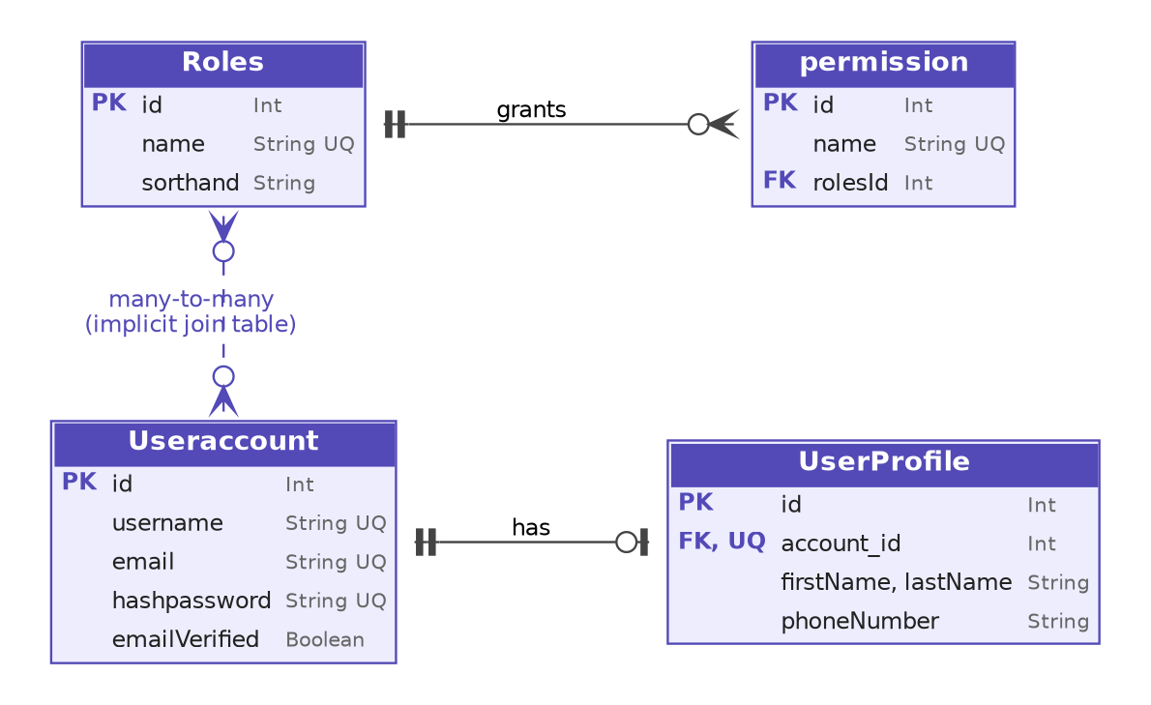

Useraccount
Table: user_accounts | Domain: Admin Access (RBAC)
The login identity of a staff or admin user. Personal details are in UserProfile.

What each field does
Field | Type | Purpose
id | Int, PK | Unique account ID.
username | String, unique | Login name.
hashpassword | String, unique | Password hash (bcrypt or argon2). Never store or return the plain password.
email | String, unique | Account email.
emailVerified | Boolean, default false | True after the email is confirmed.
profile | UserProfile? (virtual) | The one-to-one profile. No column.
roles | Roles[] (virtual) | Roles assigned to this account (many-to-many).
createdAt | DateTime, default now() | Account creation time.
updatedAt | DateTime, @updatedAt | Last change time.

Relations
- One account, zero or one profile. Foreign key UserProfile.account_id; Cascade.
- Many accounts, many roles. Implicit many-to-many. Prisma creates a hidden table _RolesToUseraccount with columns A (Roles.id) and B (Useraccount.id). You assign roles with roles: { connect: [{ id: 1 }] }.

Backend notes
- hashpassword is marked @unique. A unique hash gives no benefit and an accidental collision would block a signup; remove the constraint.
- Never return hashpassword in API responses. Use select or omit explicitly on every query that returns accounts.
- The comment in the schema says "one account contains many roles"; together with Roles.useracounts this is a many-to-many relation, not one-to-many.

UserProfile
Table: user_profile | Domain: Admin Access (RBAC)
Personal details of a staff user, kept apart from the login credentials.

What each field does
Field | Type | Purpose
id | Int, PK | Unique profile ID.
account_id | Int, FK, unique | The account this profile belongs to. The unique constraint makes the relation one-to-one.
firstName | String | First name.
lastName | String | Last name.
phoneNumber | String | Contact number.
accounts | Useraccount (virtual) | The owning account. No column.
createdAt | DateTime, default now() | Creation time.
updatedAt | DateTime, @updatedAt | Last change time.

Relations
- One profile belongs to exactly one account. Foreign key account_id (unique); Cascade, so deleting the account deletes the profile.

Backend notes
- On the account side the profile is optional (UserProfile?), so an account can exist without one. Create both together with a nested write: useraccount.create({ data: { ..., profile: { create: { ... } } } }).
- The relation field is named accounts (plural) even though it points to one account.

Roles
Table: roles | Domain: Admin Access (RBAC)
A named job function such as ADMIN, MANAGER or SUPPORT. A role groups permissions, and users are assigned roles.

What each field does
Field | Type | Purpose
id | Int, PK | Unique role ID.
name | String, unique | Role name, for example ADMIN.
sorthand | String | Short code for the role. Likely a typo for "shorthand"; keep the spelling in code.
permissions | permission[] (virtual) | Permissions owned by this role.
useracounts | Useraccount[] (virtual) | Accounts holding this role. Note the spelling.
createdAt | DateTime, default now() | Creation time.
updatedAt | DateTime, @updatedAt | Last change time.

Relations
- One role, many permissions. Foreign key permission.rolesId; Restrict.
- Many roles, many accounts (implicit join table).

Backend notes
- Load permissions for authorisation with include: { permissions: true }, then cache them or put them in the token so you do not query on every request.

permission
Table: permission | Domain: Admin Access (RBAC)
A single right, such as product:create or order:refund, owned by one role.

What each field does
Field | Type | Purpose
id | Int, PK | Unique permission ID.
name | String, unique | Permission key, for example product:create.
rolesId | Int, FK | The role that owns this permission.
roles | Roles (virtual) | The owning role. No column.
createdAt | DateTime, default now() | Creation time.
updatedAt | DateTime, @updatedAt | Last change time.

Relations
- Many permissions belong to one role. Foreign key rolesId; Restrict.

Backend notes
- Because rolesId is a single foreign key and name is unique, one permission can belong to only one role. You cannot give order:view to both ADMIN and SUPPORT without inventing a second name. Most systems model permissions as a shared list with a many-to-many link to roles (section 12).
- Check access by collecting the permission names of all of a user's roles and testing the required key.

9. Enums

OrderStatus (used by Order.status)
Value | Meaning | Typical next state
PENDING | Order created, not yet confirmed (default). | CONFIRMED or CANCELLED
CONFIRMED | Accepted, usually after successful payment or COD approval. | PROCESSING or CANCELLED
PROCESSING | Being picked and packed. | SHIPPED or CANCELLED
SHIPPED | Handed to the courier. | DELIVERED
DELIVERED | Received by the customer. Final. | None
CANCELLED | Cancelled. Final. Restore stock and refund if paid. | None

The schema does not stop invalid jumps (for example PENDING straight to DELIVERED). Keep an allowed-transitions map in the service layer.

PaymentStatus (used by Payment.status)
Value | Meaning | Typical next state
PENDING | Attempt created, waiting for the gateway (default). | SUCCESS or FAILED
SUCCESS | Money received. | REFUNDED
FAILED | Attempt failed. The customer can retry with a new Payment row. | None
REFUNDED | Money returned to the customer. | None

10. Indexes and unique constraints
Model | Constraint or index | What it supports
Customer | Index (phone, email) | Lookup by phone, or phone and email.
Address | Index (customerId) | Addresses of a customer.
Category | Unique name | No duplicate category names.
subCategory | Unique name; index (categoryId) | No duplicate names; children of a category.
Attributes | Unique name | No duplicate attribute names.
Products | Index (name), (stocks, selling_price), (hasdiscount) | Search, stock and price filters, offers.
ProductImage | Index (productId) | Media of a product.
ProductAttributes | Index (attributes_id, product_id) | Products by attribute.
productCategory_SubCat | Unique (productId, categoryId, subCategoryId) | No duplicate placements.
Carts | Unique (customerId, productId) | One cart line per product per customer.
Wishlists | Unique (customerId, productId); index (productId, customerId) | No duplicates; wishlist counts per product.
Order | Index (customerId, createdAt) | Order history of a customer.
OrderItem | Unique (productId, orderID) | One line per product per order.
Payment | Unique transactionId; index (orderID) | Idempotent webhooks; payments of an order.
AuditLog | Index (customerId, createdAt), (entity, entityId, createdAt), (action, createdAt) | Timeline per customer, per record and per action.
Roles | Unique name | No duplicate roles.
permission | Unique name | No duplicate permissions.
Useraccount | Unique username, hashpassword, email | No duplicate logins.
UserProfile | Unique account_id | Enforces one profile per account.

11. Common backend patterns
Prisma examples for the main flows. Adjust names and error handling to your project.

Add to cart (create or increase quantity)
await prisma.carts.upsert({
where: { customerId_productId: { customerId, productId } },
update: { quantity: { increment: qty } },
create: { customerId, productId, quantity: qty },
});

Place an order from the cart
Everything runs in one transaction. If any step throws, stock, order and cart are all rolled back.
const order = await prisma.$transaction(async (tx) => {
const cart = await tx.carts.findMany({
where: { customerId },
include: { product: true },
});
if (cart.length === 0) throw new Error("Cart is empty");

for (const line of cart) {
// guarded update prevents overselling
const res = await tx.products.updateMany({
where: { id: line.productId, isActive: true, stocks: { gte: line.quantity } },
data: { stocks: { decrement: line.quantity } },
});
if (res.count === 0) throw new Error("Out of stock: " + line.product.name);
}

const created = await tx.order.create({
data: {
customerId,
items: {
create: cart.map((l) => ({
productId: l.productId,
quantity: l.quantity,
price: l.product.hasdiscount && l.product.offerPrice !== null
? l.product.offerPrice
: l.product.selling_price,
})),
},
},
include: { items: true },
});

await tx.carts.deleteMany({ where: { customerId } });
await tx.auditLog.create({
data: { customerId, action: "ORDER_CREATED", entity: "Order", entityId: String(created.id) },
});
return created;
});

Record a payment from a gateway webhook
await prisma.$transaction(async (tx) => {
await tx.payment.upsert({
where: { transactionId: txnId },
update: { status: "SUCCESS" },
create: { orderID: orderId, amount, status: "SUCCESS", provider, transactionId: txnId },
});
await tx.order.update({ where: { id: orderId }, data: { status: "CONFIRMED" } });
await tx.auditLog.create({
data: { customerId, action: "PAYMENT_SUCCESS", entity: "Payment", entityId: txnId },
});
});

Load an order with everything attached
const order = await prisma.order.findUnique({
where: { id },
include: {
customer: true,
items: { include: { product: { include: { mediafile: true } } } },
payments: true,
},
});

12. Schema review: points to watch
These are not errors that stop the app from running, but each one can cause a bug, a data problem or confusion later. They are ordered roughly by how much they matter.
# | Where | Observation | Suggestion
1 | permission | A permission has a single rolesId and a unique name, so it can belong to only one role. | Make permission a shared list and link it to Roles many-to-many (implicit or an explicit RolePermission model).
2 | Order | No total amount, no shipping address, no public order number. | Add totalAmount, an address snapshot (JSON or an addressId), and an orderNumber.
3 | Useraccount.hashpassword | Marked unique, which has no purpose for a salted hash. | Remove @unique.
4 | Customer | phone and email are not unique, so duplicate customers are possible. | Add @unique to the identifier you log in with, or enforce it in code.
5 | ProductAttributes | The same attribute can be stored twice for one product. | Add @@unique([product_id, attributes_id]).
6 | productCategory_SubCat | No check that the sub-category belongs to the category; no index on the category columns. | Validate in code; add @@index([categoryId]) and @@index([subCategoryId]).
7 | subCategory.name | Unique across all categories. | Use @@unique([categoryId, name]) if names may repeat under different parents.
8 | Address.isPrimary, ProductImage.isCover | More than one row per owner can be true. | Enforce in a transaction, or use a partial unique index in SQL.
9 | discountType, mediaType, AuditLog.action | Free-text strings that act like enums. | Convert to Prisma enums, or keep constants in one shared file.
10 | AuditLog | No actor for staff actions. | Add actorId / actorType, or store them in details.
11 | Customer deletion | Restrict on orders makes hard deletion impossible once a customer has ordered. | Add a soft-delete or anonymise flow.
12 | Naming | Mixed styles: orderID vs productId, product_id, sorthand, useracounts, imageurl, Products (plural) vs Order (singular), lower-case subCategory and permission. | Keep as is if the code already depends on it; otherwise standardise with @map so the database names stay stable.

