# Long Island University Post

# College of Management

## **MDA 525-1 Business Analytics Summer 2019**

## **Instructor: Dr. Jiamin Wang**

# Quiz 2 Due August 12

|  |  |
| --- | --- |
| **Student's Name** |  |

Section I. True/False Questions (6 points)

1. Consider two distributions: (A) 5, 15, 23; (B) -5, 20, 30. The variance of distribution (A) is larger. ( )

2. If a sample variance is zero, then the population variance is also zero.   ( )

3. By the definitions of quartiles *Q*1, *Q*2 and *Q*3, the equation *Q*1 – the smallest observation = the largest observation – *Q*3 always holds. ( )

4. All symmetric histograms have single peaks. ( )

5. The range of the sample data set is never greater than the range of the population. ( )

6. The *p*th percentile is a value such that (100 – *p*) percent of the measurements fall at or below the value.  ( )

Section II. Multiple-choice Questions (6 points)

1. Which of the following distributions is more likely to be skewed to the left than skewed to the right? ( )

|  |  |
| --- | --- |
| A | Household incomes |
| B | Home prices |
| C | Ages of teenage drivers |
| D | Heights of adult males |

2. Below are some summary statistics for a numerical variable. Which of the following is true? ( )

|  |  |  |  |  |  |  |  |  |
| --- | --- | --- | --- | --- | --- | --- | --- | --- |
| Min | Q1 | Median | Q3 | Max | Mean | Standard Deviation | n | Missing |
| 30 | 57 | 69.5 | 77 | 96 | 65.12 | 16.09 | 200 | 0 |

|  |  |
| --- | --- |
| A | There is evidence that the distribution is right-skewed. |
| B | The minimum value of 30 would be identified as an outlier in a box plot. |
| C | There are more values less than 57 than values greater than 77. |
| D | None of the above is true. |

3. Which of the following statements is true?  ( )

|  |  |
| --- | --- |
| A | The variance must be non-negative, but the standard deviation can be negative. |
| B | *µ* denotes a sample mean. |
| C | *s* denotes a sample standard deviation. |
| D | The mean is always larger than the first quartile, but smaller than the third quartile. |

4. Refer to the side-by-side box plots below that present the distributions of two variables X and Y, respectively. Which of the following statements is **NOT** true? ( )

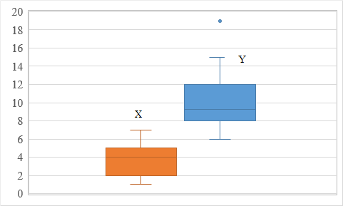

|  |  |
| --- | --- |
| A | Variable Y has an outlier. |
| B | The first quartile of variable X is 2. |
| C | The IQR of variable X is 4. |
| D | All values of variable Y are larger than the third quartile of variable X. |

5. Which type of plot would be most useful for visualizing the relationship between two numerical variables? ( )

|  |  |
| --- | --- |
| A | Histogram |
| B | Stacked dot plot |
| C | Box plot |
| D | Scatter plot |

6. Every value in a data set is increased by 10. Which of the following summary measures will not change? Select all that apply. ( )

|  |  |
| --- | --- |
| A | Mode |
| B | Median |
| C | Standard deviation |
| D | IQR |
| E | Mean |

Section III. Fill-in-the-Blank Questions (3 points)

A business school has 270 male students and 230 female students in total. The students in the MBA Program and the Undergraduate Program account for 30% and 70% of the student population, respectively. Suppose that there are 80 female students in the MBA Program.

There are _______ undergraduate students, ________ male students in the MBA Program, and ________ female students in the Undergraduate Program.