|  |
| --- |
| Software Solutions© |
| MJ Logistics Gaming CRM Solution |
| CRM Design Template |

|  |
| --- |
| Joshua Touchstone  [Date]  [Version 1.1] |

Contents

A. Introduction 3

A1. Introduction and Purpose Statement 3

A2. Overview of the Problems 3

A3. Goals and Objectives 3

A4. Prerequisites 3

A5. Scope 3

A6. Environment 3

B. Requirements 4

Business Requirements 4

User Requirements 4

Functional Requirements 4

Non-Functional Requirements 4

C. Software Development Methodology 4

C1. Advantages and Disadvantages 4

Advantages of the Agile Method 4

Disadvantages of the Agile Method 4

Advantages of {A Different Method} 4

Disadvantages of {A Different Method} 4

C2. Best suited 5

D. Create Two Representations of the Software Solution 5

Representation 1 5

Representation 2 5

E. Testing 6

Test Name 1 6

Test Name 2 7

Test Name 3 8

F. Sources 8

# Introduction

# A1. Introduction and Purpose Statement

Software Solutions© is proposing a CRM software solution for MJ Logistics Gaming Company. The purpose of this document is to provide a design template to streamline the development process, enabling software designers, developers, and stakeholders to collaboratively design a robust CRM system tailored to meet the unique needs of MJ Logistics Gaming. The details of the proposed solution are in sections A-E of this proposal.

# A2. Overview of the Problems

The current system is experiencing a range of challenges, including the absence of a unified system for data sharing and business processes, as well as lack of access control and security. Consequently, it lacks effective management of client contacts and activity maintenance and lacks the capability to efficiently generate reports or monitor sales. The proposed CRM solution will solve all the problems listed above by creating a singular database that allows data from all business clients and processes to interact with each other securely under one roof, so to speak.

# A3. Goals and Objectives

Software Solutions© goal is to deliver a seamless and intuitive CRM system that optimizes customer interactions, enhances organizational productivity, and drives business growth through elevated customer engagement for MJ Logistics Gaming.

The objectives of the CRM solution are as follows:

consolidate all contacts and business information

provide the ability to report the company’s activities and interactions with contacts

provide access control for features based on roles and permissions for the company’s users, both onsite and off-site

provide the ability to manage activities and track sales

provide the ability to integrate with other systems to allow for sharing of data

provide robust security

maintain the ability to be enhanced and scaled.

# A4. Prerequisites

|  |  |  |  |
| --- | --- | --- | --- |
| Number | Prerequisite | Description | Completion Date |
| 1 | Setup Oracle Database | Software Solutions© will create and setup the new Oracle database that will be housing all CRM data. | 09/28/2023 |
| 2 | Import Current Business Data | Software Solutions© will import all current business data into the new database, preferably on a weekend where no changes will be made during the process. | 10/01/2023 |
| 3 | Install Client CRM Software | Each computer and device utilizing the new CRM software will need to have the software installed by MJ Logistics Gaming. | 10/01/2023 |
| 4 | Connect Clients to Database and Test | Software Solutions © will connect all client software to the new database remotely or over the phone and then have end-users run tests to make sure everything is in working order. This should take place ideally over a weekend. | 10/01/2023 |

# A5. Scope

Aspects this solution **WILL** cover:

* Initial Oracle Database Design and Setup
* CRM software design and agreed upon modules, and creation of an installation tutorial
* 2000 software licenses, and an agreement on future licenses and pricing
* CRM to Database initial link setup for all devices and creation of a database link tutorial for future devices
* Free Customer Service for the CRM software for 2 years and scheduled maintenance every 6 months
* Proposed upgrade and enhancement meetings every 6 months

Aspects this solution **WILL NOT** cover:

* Software Solutions © will not be installing the CRM software on all of MJ Logistics Gaming Devices, that will be the responsibility of MJ Logistics Gaming as part of the integration process.
* Software Solutions© will not handle database customer service **not** pertaining to the initial database design or software linking. MJ Logistics Gaming will have to contact Oracle through its subscription.
* Addition of future CRM upgrades and enhancements, unless through new sub-contracts

# A6. Environment

**Back-End:** The CRM database will be designed by Software Solutions © and then initialized and setup on the cloud, hosted by Oracle database services. It will be a RDBMS (Relational Database Management System) using MySQL, hosted in the United States. It will be a subscription mainly priced on usage metrics and service level. By using top of the line database services like Oracle, the database architecture will always be up-to-date, scalable, protected by top tier security protocols, and maintain top-of-the-line backup solutions. The architecture includes redundant and reliable network connectivity to minimize connectivity outages. In the case of rare connectivity outages however, Oracle has solutions, including database relocation. Comprehensive Service Level Agreements (SLAs) will be established with Oracle to guarantee agreed levels of uptime, performance, and support responsiveness. Oracle provides all the necessary tutorials, tools, and customer service to upgrade, maintain, and further custom develop the database as part of its subscription. As a matter of fact, one of the reasons we propose Oracle over other cloud database solutions is because of its highly reviewed and rated customer service. MJ Logistics Gaming also maintains the ability to refuse database upgrades if comfortable with the current version. Oracle does also include many pre-deployment and testing services including an Oracle Real Application Testing option, a SQL Performance Analyzer, and Database Replay.

**Front-End:** On the front-end, each user will have the CRM software installed on their computer or device. The CRM will be linked to the cloud database over the internet. Clients devices will never have any vital information stored on them through the CRM software and will only push and pull data from and to the server on the cloud. The software will incorporate essential components such as GUI, dashboards, navigational menus, buttons, forms for data entry, as well as search and filtering tools. Additionally, it will encompass customer profiles, task and activity management, reporting and analytics, and necessary security features. These elements are vital for seamless interaction with the database on the backend, ultimately delivering the required CRM solution.

# Requirements

## Business Requirements

**Reporting**: The CRM solution will allow users to seamlessly generate a wide array of database reports. It will feature a main program dashboard and a dedicated sub-dashboard for report generation. Users will be able to save and export reports, apply various filters, save the filters for future use, and format reports as needed. Although users will be able to save their reports, the CRM will also automatically record all reports in the database for historical viewing or auditing purposes. Reporting will also be tied into the User Access Control so users will only be able to see data that is relevant to them only.

## User Requirements

**Users:** The CRM client software will only have user limitations with regards to the number of licenses purchased and being used. As far as the database, Oracle’s architecture will never have limits to the number of concurrent or separate users or bandwidth and will always be customizable and scalable to any degree. MJ Logistics Gaming will have to make sure to adjust their Oracle subscription based on usage metrics and performance and scalability requirements.

## Functional Requirements

**Opportunity Management:** The CRM solution will have a sub-dashboard for pipelining that will allow users to define and customize sales workflows and associated activities. It will implement a pipeline management feature to enable users to visualize, track, and manage opportunities at various stages of the sales cycle. The system will provide a clear overview of opportunities, their status, and progression through the pipeline. There will be analytical tools to perform comprehensive win/loss analysis, competitive analysis, competitive product analysis, and discount approval and analysis. These tools will offer insights into sales performance, competitor positioning, and discount efficacy.

## Non-Functional Requirements

**Data Types:** The CRM solution will have a few different entity data types, including but not limited to; business, stakeholder, and contact. When adding a business entity, users will be able to define many different types of information about the business including but not limited to; address(es) and phone number(s), offices, and subcompanies. The CRM will also detect duplicate business entry and prevent it. When adding a new contact, users will be able to establish if the contact is part of a pre-defined business entity, and end-user, a regular contact, etc. A user may also establish contact rules for each added contact. The CRM will detect and prevent duplicate contact entry. If the contact is part of a business, users will have the ability to add pertinent information such as which office or subcompany the contact of that business is a part of and what role, if multiple, they perform. If contact information is entered only partially, the addition will be accepted, but will be flagged in the system.

# Software Development Methodology

# C1. Advantages and Disadvantages

## Advantages of the Agile Method

**#1. Frequent Customer Feedback, Involvement, and Communication**: MJ Logistics Gaming mentions multiple times in their requirements form of sitting down after choosing a proposal to go over specific parts of the CRM in more detail with the chosen company before development. It would seem as though MJ Logistics Gaming would likely want to be a part of the design of the software solution frequently, or at a minimum, a lot in the beginning.

**#2. Contant Testing Promotes Easier Integration:** In order for a seamless transition into the new CRM software, this project will require a hefty integration plan. All current data entities must be entered into a new database and many currently disconnected processes must be re-designed and/or re-implemented in order to integrate nicely into the new CRM software. An agile method would have much more testing involved, assuring that the new processes and data will integrate efficiently.

**#3 Development Risk Mitigation:** In the Agile Method, before each software iteration, potential new development risks are found and handled before development starts on the next iteration. This can save time and money.

## Disadvantages of the Agile Method

**#1. Doesn’t handle large systems well**: An entire CRM system with all of the requirements that MJ Logistics Gaming has requested is quite a project. The Agile Method builds projects in small increments, all while adjusting the requirements along the way. This means that big projects can easily stray off the wanted path, which is not what MJ Logistics Gaming seems to need. Their requirements are noticeably clear.

**#2. Sometimes results in less than optimal design:** Although in some aspects of the project, MJ Logistics Gaming is open-minded about multiple options or ways of doing things, most of their needs are already established. This suggests that they would not be satisfied with any less-than-optimal piece of software, and are not really open to new and creative ways of doing CRM or too much additional shaping of the application through its development. They seem to just need a software that works and does what they need it to do for them efficiently.

**#3. Used more for Unpredictable and/or changing Requirements**

MJ Logistics Gaming has a pretty clear requirements form and for the most part does not seem open to much change. If a project has stable, unchanging requirements and the end goal is clear and agreed upon, the nonlinear and non-sequential nature of the agile model can provide an unpredictable timeline and budget.

## Advantages of THE Waterfall Method

**#1. Cost saving:** Since the requirements for this software are essentially set in stone, there shouldn’t be any development paths that lead to dead ends thus costing more money and time backtracking and starting over.

**#2. Better Documentation:** Since requirements are mostly set, much documentation will be created before design starts. When developing in a fast-paced incremental agile environment, developers tend to slack or forget to keep up with proper documentation, or they just don’t have the time. More documentation is best for MJ Logistics Gaming, considering they are not CRM software experts.

**#. Known Software and Methods**: CRM software is not something new. Predictive methods like the Waterfall method can be used for software that is tried and true and has a known development process. Agile methodologies are mostly used for newer, ever-changing requirements software, and MJ Logistics Gaming doesn’t seem to want to design any never-before-used type of CRM. This also means that developers for this project could be chosen based on prior CRM development experience. This saves tons of money and time and promises a better implementation and integration.

## Disadvantages of The Waterfall method

**#1. Doesn’t allow for software discovery:** MJ Logistics Gaming seems to know exactly what type of software they need. However, if they were to change their minds along the way of the development process and wanted to try any new development paths or approaches, it would be difficult to backtrack, modify requirements, and could potentially incur significant time and cost.

**#2. Doesn’t involve frequent customer/stakeholder involvement:** The Waterfall method tends to not focus as much on the end-user or clients that are involved in the project. Its main objective is focusing on efficiently developing the pre-defined software at hand and helping its teams move smoothly across the project. MJ Logistics Gaming mentions multiple times in their requirements form of sitting down after choosing a proposal to go over specific parts of the CRM in more detail with the chosen company. This suggests they may want to be a part of the process the entire way through, and not just in the beginning.

**#3 Late Release and Feedback:** In the waterfall method**,** stakeholders typically see the product only towards the end of the development cycle, which means feedback is provided late in the process. This can sometimes result in substantial rework and corrections, which further extends the project time. No company wants to be told their software is finished, then when it is presented to them it is not what they had in mind.

# C2. Best suited

I believe the Waterfall method would be the most suitable approach for this project, primarily because of its well-defined scope, clear requirements, and the project's scale. The sequential flow of the Waterfall method allows for better control and predictability in terms of timelines, budgets, and resource allocation, which can be particularly important for large-scale CRM software projects. A downfall of this method for this project would be the potential lack of frequent communication between stakeholders and developers. However, this issue could be somewhat alleviated by ensuring a thorough and detailed planning stage after a proposal is selected to avoid any omissions. Another possible downfall would be late release and feedback considering stakeholders wouldn’t typically see the software until late in development. One way to alleviate this problem is to use a solid prototype in the beginning during the planning stages.

# Create Two Representations of the Software Solution

## Representation 1

The following diagram represents an activity flow of the particular action of adding a new contact into the CRM Database. (Non-Functional Requirement)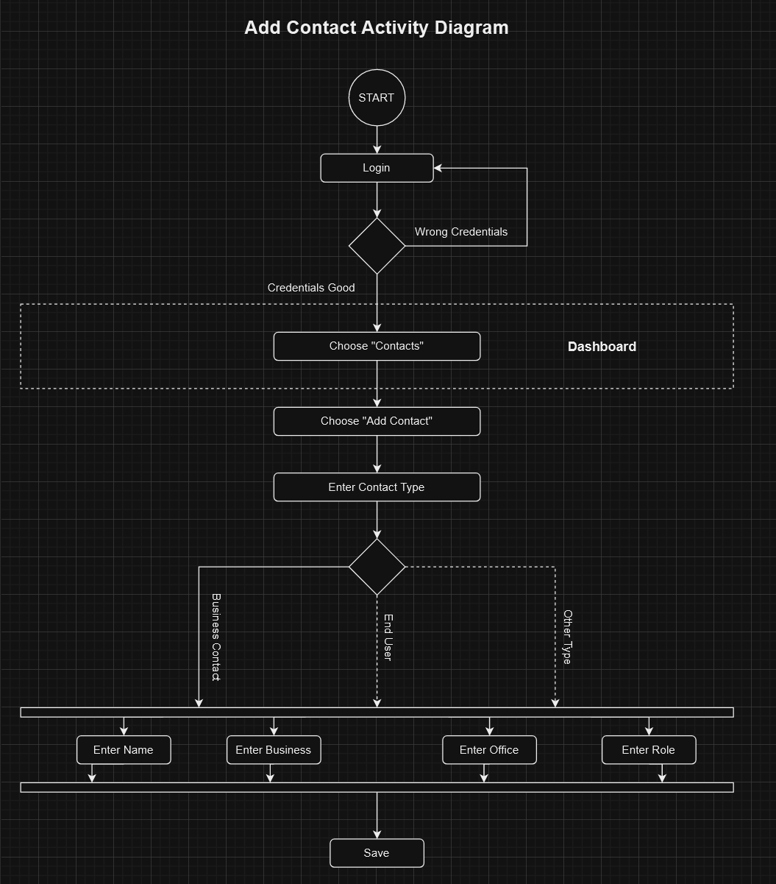

## Representation 2

The following diagram shows an activity flow of the particular action of generating and exporting a report of any sort. (Business Requirement)

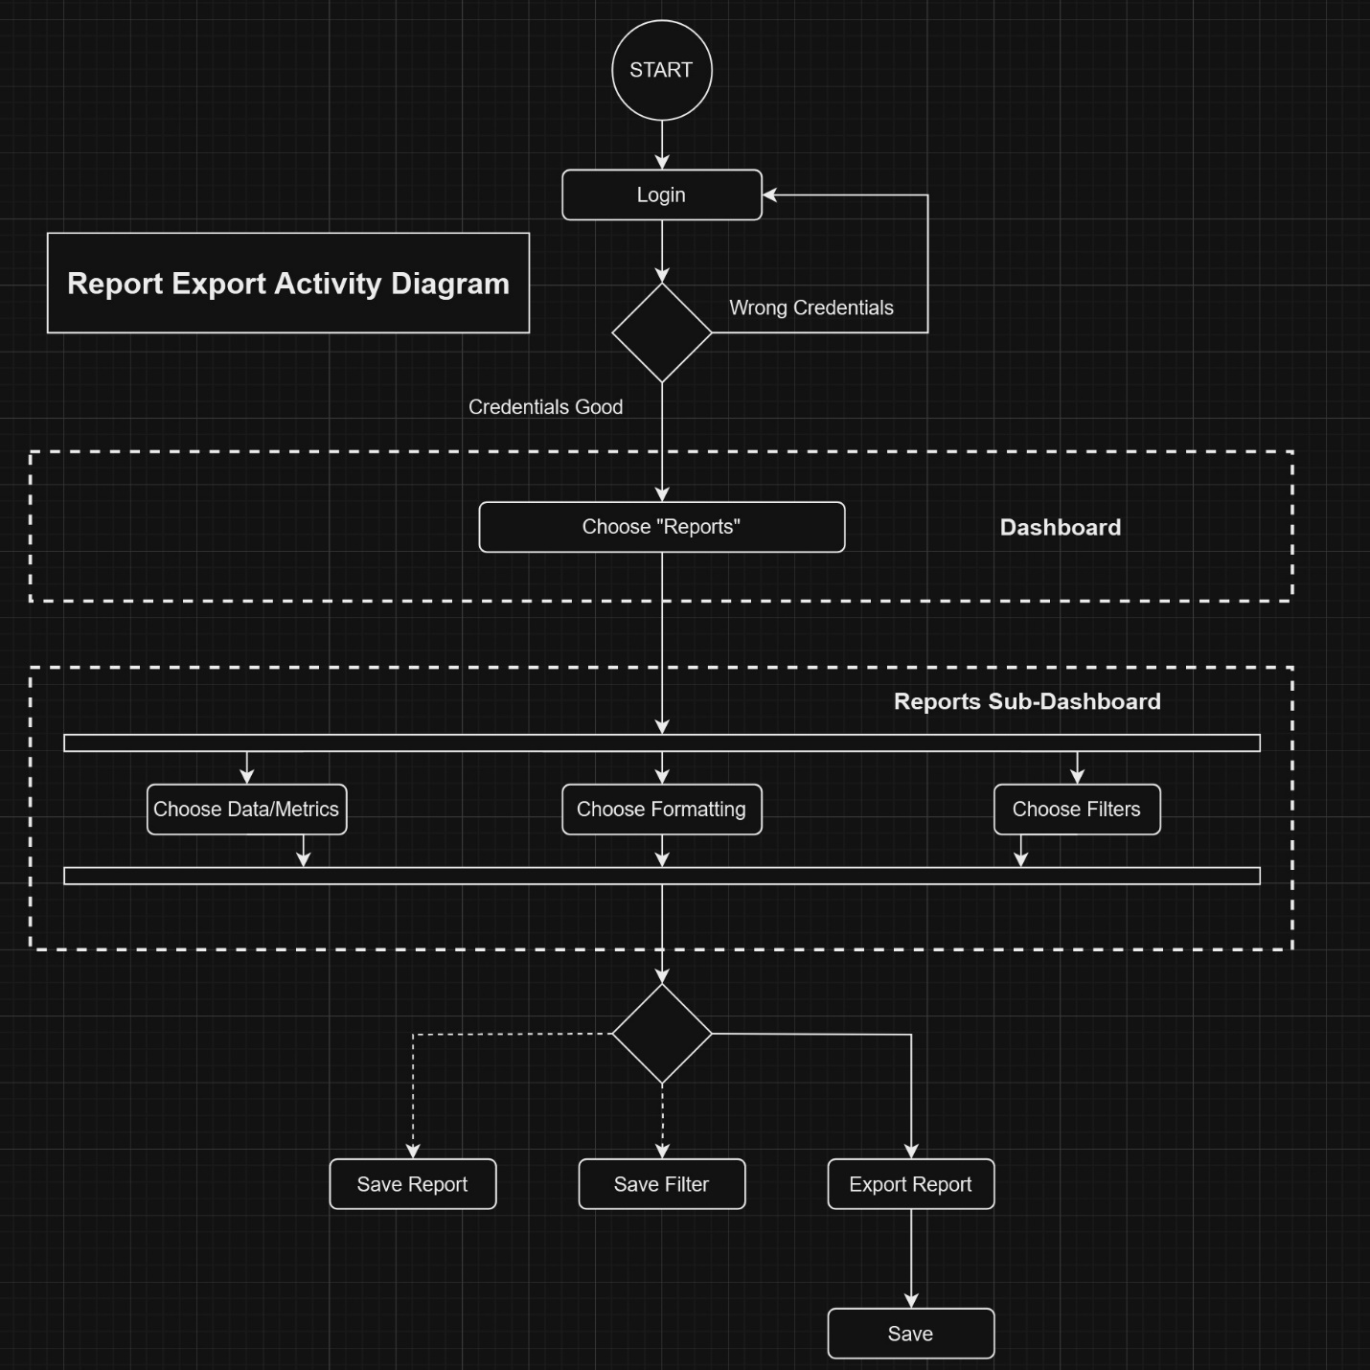

# Testing

# Add Contact Functional Test

|  |
| --- |
| **Requirement to be tested**: A functional test of the functionality of adding a new contact to the database using the CRM software and ensuring that the data saves properly to the cloud database by requesting the same contact data after entry. |
| **Preconditions**: For this test to work, the cloud database must be initialized and functioning, the CRM software must be installed and linked to the database on the device being used, and a test account must be created and login tested and working. |
| **Steps**: The steps the tester must execute to test the feature.   1. Login to the CRM software 2. Open the “Contacts” sub-dashboard and add a new contact 3. Return to the CRM dashboard 4. Open the “Contacts” sub-dashboard 5. Open the specific contact that was just added 6. Verify the data pulled is the same data that was added and is properly formatted and categorized. |
| **Expected results**:  1. There are no server or client-side errors when saving the data that was entered.  2. There are no errors or problems when querying the database for the contact information.  3. The data pulled is exactly the same data that was entered and retains its format. |
| **Pass/Fail**: Pass. Considering database setup and initialization was pretty straightforward, this test case is an easy one to pass as it is just testing whether the entered data was saved properly over the cloud or not. No advanced functions were ran or data reported or aggregated in any way. The possibility of failure is plenty though if the CRM software did not relay the data to the database properly or the database did not relay the data properly back to the CRM software from formatting or possible network or connectivity issues. |

# CRM Software mobile INSTALLATION TEst

|  |
| --- |
| **Requirement to be tested**: An installation test of the new CRM software on a mobile device by installing and verifying proper working order of the software. |
| **Preconditions**: In order for this test to work, the CRM software and installation configuration for mobile devices specifically must be completed. |
| **Steps**: The steps the tester must execute to test the feature.   1. Make sure device is powered on. 2. Download software onto device 3. Commence software installation 4. Open newly installed software to verify installation was successful 5. Navigate through the software’s different windows and dashboards to verify proper installation |
| **Expected results**: Considering the usage of the waterfall method, the completed software should be in a semi-final stage before deployment testing. The expected results are as follows:  1. Software installs onto the device with no errors.  2. Software opens with no errors.  3. Navigation to different windows and dashboards results in completion with no errors or graphical artifacts. |
| **Pass/Fail**: Fail. The software installed correctly with no errors, however there was one or two windows that the GUI was not properly formatted for mobile viewing. Even though this software will be used mainly on Personal Computer devices, I would say it is not quite ready for deployment as GUI adjustments for mobile devices should not take too long to fix. |

# CRM Software Security test

|  |
| --- |
| **Requirement to be tested**: A security test of the login process of the client-side CRM software by trying correct and incorrect login credentials. |
| **Preconditions**: For this test to work, the cloud database must be initialized and functioning, the CRM software must be installed and linked to the database on the device being used, and a test account must be created with login credentials. |
| **Steps**: The steps the tester must execute to test the feature.   1. Open the CRM software 2. Login using the test credentials 3. If login was not successful, test is completed unsuccessfully 4. If login was successful, log back out 5. Attempt to log back in using deliberately incorrect credentials 6. If login was successful, test is completed unsuccessfully 7. If login was not successful, test is completed successfully |
| **Expected results**:  1. The login credentials given should bring the user to the main dashboard after the login attempt  2. If logging in with incorrect credentials, the program should let the user know the credentials were wrong, and **not** move them forward to the main dashboard |
| **Pass/Fail**: Pass. The test account was created properly and credentials stored correctly on the cloud server. This allowed the credentials to successfully allow the user to enter and open the CRM software. This security must be present to stop unauthorized users from gaining access to the CRM database. |

# Sources

Stephens, Rod. *Beginning Software Engineering*, John Wiley & Sons, Incorporated, 2015. *ProQuest Ebook Central*, <https://ebookcentral.proquest.com/lib/westerngovernors-ebooks/detail.action?docID=1895174>.

Oracle. "Oracle Database Technologies." Oracle, Accessed 09/24/2023, <https://www.oracle.com/database/technologies/>.