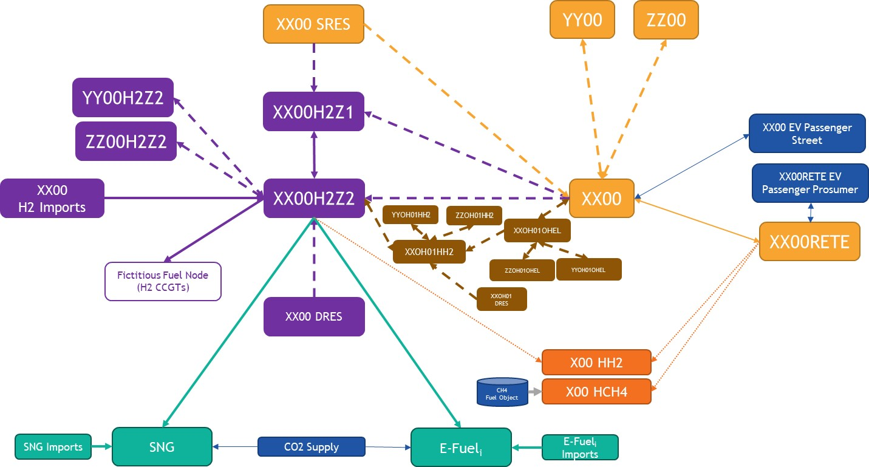

- MMStandardOutputFile_DE2050_Plexos_CY2009_v11: Electricity results

Nodes:
XX00 | XX00 EV Passenger Prosumer | XX00 EV Passenger Street | XX00 SRES | XX00RETE
Emarket node | EV node charging in Prosumer node | EV node charging in emarket | Shared RES node | Prosumer node

Technologies:
Nuclear [MW]
Lignite old 1 [MW]
Lignite old 2 [MW]
Lignite new [MW]
Lignite CCS [MW]
Hard coal old 1 [MW]
Hard coal old 2 [MW]
Hard coal new [MW]
Hard coal CCS [MW]
Gas conventional old 1 [MW]
Gas conventional old 2 [MW]
Gas CCGT old 1 [MW]
Gas CCGT old 2 [MW]
Gas CCGT new [MW]
Gas CCGT CCS [MW]
Gas OCGT old [MW]
Gas OCGT new [MW]
Gas CCGT present 1 [MW]
Gas CCGT present 2 [MW]
Light oil [MW]
Heavy oil old 1 [MW]
Heavy oil old 2 [MW]
Oil shale old [MW]
Oil shale new [MW]
Run-of-River [MW]
Reservoir [MW]
Pump Storage - Open Loop (turbine) [MW]
Pump Storage - Open Loop (pump) [MW]
Pump Storage - Closed Loop (turbine) [MW]
Pump Storage - Closed Loop (pump) [MW]
Pondage [MW]
Wind Onshore [MW] | Generation potential (real generation + energy curtailed)
Wind Offshore [MW] | Generation potential (real generation + energy curtailed)
Solar (Photovoltaic) [MW] | Generation potential (real generation + energy curtailed)
Solar (Thermal) [MW] | Generation potential (real generation + energy curtailed)
Others renewable [MW] | Generation potential (real generation + energy curtailed)
Others non-renewable [MW]
Lignite biofuel [MW]
Hard Coal biofuel [MW]
Gas biofuel [MW]
Light oil biofuel [MW]
Heavy oil biofuel [MW]
Oil shale biofuel [MW]
Battery Storage discharge (gen.) [MW]
Battery Storage charge (load) [MW]
Electrolyser (load) [MW] | XX00 node: emarket-to-H2Z1 and emarket-to-H2Z2 electrolysers (electricity demand)  SRES node: SRES-to-H2Z1 electrolyser (electricity demand)
Hydrogen Fuel Cell [MW]
Hydrogen CCGT [MW]
Demand Side Response [MW]
CH4 Heat Pump (load) [MW] | Electricity for CH4 Hybrid Heat Pump
H2 Heat Pump (load) [MW] | Electricity for H2 Hybrid Heat Pump
Demand [MW]  (losses included) | Includes Native Demand, Fixed Exchanges (with extra-EU countries), some DSR in DE00  (electricity load)
Balance [MW] | Emarket: includes Prosumer and SRES connections, crossborder interconnections and electricity for/from EV (<0: injection in Emarket node)  Prosumer: includes emarket connection and electricity for/from EV (<0: injection in Prosumer node)  EV: includes emarket/Prosumer connections (<0: injection in EV node)
Dumped Energy [MW]
Energy Not Served [MW]
Marginal Cost [€]

Lines (‘Node From – Node To’)
XX00-YY00 (“”/”Real”/”Concept”) | “”: Reference grid interconnection  “Real”: Real candidate  “Concept”: Conceptual candidate
XX00-XX00RETE | Emarket - Prosumer connection
XX00-XX00EV | Electricity for EV in emarket node
XX00EV-XX00 | V2G in emarket node (injection in emarket node)
XX00RETE-XX00EV | Electricity for EV in Prosumer node
XX00EV-XX00RETE | V2G in Prosumer node (injection in Prosumer node)
XX00 SRES - XX00 | SRES-to-emarket connection

- MMStandardOutputFile_DE2050_Plexos_CY2009_H2_v11: Hydrogen results

Nodes:
XX00 DRES | XX00 SRES | XXH2Z1 | XXH2Z2
Dedicated RES node | Shared RES node | H2Z1 node | H2Z2 node

Technologies:
H2 storage discharge (gen.) [MWH2]
H2 storage charge (load) [MWH2]
Steam methane reformer [MWH2]
DRES Solar PV [MW]
DRES Wind Onshore [MW]
DRES Wind Offshore [MW]
H2 Boiler (load) [MWH2] | H2 for H2 Hybrid Heat Pump Boiler (H2 demand)
H2 for power generation (load) [MWH2] | H2 for H2 CCGTs and fuel cells (H2 demand)
Demand [MWH2]
(losses included)
Balance [MWH2] | Includes electrolysers, interconnections, imports, H2 for synfuel (see detail in the crossborder sheet)
Dumped Hydrogen [MWH2]
Hydrogen Not Served [MWH2]
Marginal Cost [€/MWH2h]

Lines:
XX00 EL H2Z1 | emarket-to-H2Z1 electrolyser (H2 injection in H2Z1 node) – ref.grid
XX00 EL H2Z1 Expansion 2035/2040/2045/2050 | emarket-to-H2Z1 electrolyser (H2 injection in H2Z1 node) – expansion candidates
XX00 EL H2Z2 | emarket-to-H2Z2 electrolyser (H2 injection in H2Z2 node) – ref.grid
XX00 EL H2Z2 Expansion 2035/2040/2045/2050 | emarket-to-H2Z2 electrolyser (H2 injection in H2Z2 node) – expansion candidates
XX00 SRES EL H2Z1 Expansion 2035/2040/2045/2050 | SRES-to-H2Z1 electrolyser (H2 injection in H2Z1 node)  – expansion candidates
XX00 DRES EL H2Z2 Expansion 2035/2040/2045/2050 | DRES-to-H2Z2 electrolyser (H2 injection in H2Z2 node)  – expansion candidates
XX-YY (“” / “Expansion”) | “”: Reference grid crossborder interconnection  “Expansion”: Expansion candidate
XXH2Z1-XXH2Z2 | H2Z1-to-H2Z2 connection
XXH2Z2-e-diesel | H2 for e-diesel (H2 demand)
XXH2Z2-e-kerosene | H2 for e-kerosene (H2 demand)
XXH2Z2-sng | H2 for sng (H2 demand)

- MMStandardOutputFile_DE2050_Plexos_CY2009_Heat_SynthFuels_v11: Heat and Synthetic Fuel results

Heat:
Nodes:
XX00 HCH4 | XX00 HH2
CH4 Hybrid Heat Pump node | H2 Hybrid Heat Pump node

Technologies:
H2 Boiler [GJ] | H2 Boiler Heat production
CH4 Boiler [GJ] | CH4 Boiler Heat production
Electric Heat Pump [GJ] | Electric Heat Pump Heat production
Heat Demand [GJ]
H2 Boiler H2 usage [MWH2] | H2 for H2 Hybrid Heat Pump Boiler
CH4 Boiler CH4 Offtake [GJ] | CH4 for CH4 Hybrid Heat Pump Boiler
Electric Heat Electrical Usage [MW] | Electricity for H2/CH4 Hybrid Heat Pump
Heat Not Served [GJ]

Synthetic Fuels:
Nodes:
e-diesel | e-kerosene | sng
Node with ediesel demand | Node with ekerosene demand | Node with sng demand

Domestic/import synfuel production:
Domestic production [MWSynfuel]
Imports [MWSynfuel]
Demand [MWSynfuel]
Demand Not Served [MWSynfuel]
CO2 [tons]

Lines:
XXH2Z2-e-diesel | H2 injection in e-diesel node (≠ H2Z2 H2 demand for e-diesel)
XXH2Z2-e-kerosene | H2 injection in e-kerosene node (≠ H2Z2 H2 demand for e- kerosene)
XXH2Z2-sng | H2 injection in sng node (≠ H2Z2 H2 demand for sng)

- MMStandardOutputFile_DE2050_Plexos_CY2009_offshore_v11: Offshore hubs results

