Introduction
This analysis focuses on applying logistic regression to develop a classifier that determines whether an online shopping session results in a purchase, using the Online Shoppers Purchasing Intention dataset from the UCI Machine Learning Repository. This dataset, from the year 2018, consists of 12,330 records over approximately 18 variables, with Revenue as the target response variable.
The primary objective is to develop a classifier by identifying critical behavioral and contextual variables that can be leveraged to predict whether a user session will generate revenue. With the complexity of online consumer behavior and the multitude of factors influencing purchase decisions (such as browsing patterns, visitor characteristics, and temporal factors), the results of this analysis are intended to provide evidence-based insights for e-commerce optimization rather than a definitive predictive model.

Problem Statements
- What are the key behavioural characteristics associated with revenue-generating sessions?
- How strongly do conversion rates differ across categorical groups such as VisitorType, Weekend, and Month?
- Can we build a reliable model to predict purchase conversion in e-commerce sessions?
- How reliable is our model in classifying sessions as revenue-generating or non-revenue-generating?
- Is there a relationship between the month of the year and whether an online shopping session generates revenue?

Analysis

Task 1: Exploratory Data Analysis
This task provides a comprehensive statistical overview of the online shopping session data. This serves as the foundation for understanding the distribution, scale, and variability of numerical variables, to identify patterns and trends that justify subsequent logistic regression analysis.
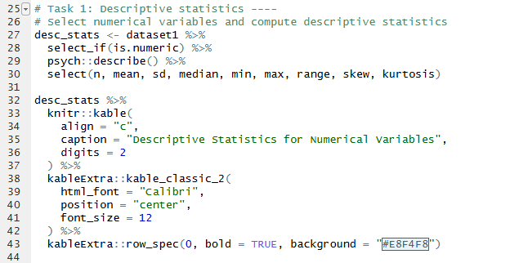

Observation of Results
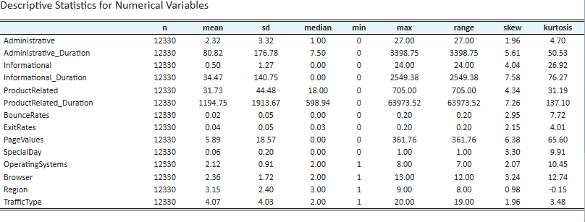
The Online Shoppers dataset is complete with no missing values and contains 12,330 observations collected over 18 variables, with Revenue as the binary response variable. There is relatively larger spread and high skewness for duration variables (Administrative_Duration, Informational_Duration, ProductRelated_Duration) as compared to rate metrics (BounceRates, ExitRates), which appear to be more restricted between 0 and 0.20. The extremely high kurtosis values (ranging from 4.01 to 137.10) indicate the presence of extreme outliers and heavy-tailed distributions, particularly in the duration variables. The response variable, Revenue, is a categorical binary variable, which confirms that logistic regression modeling is the appropriate analytical approach rather than general linear modeling.
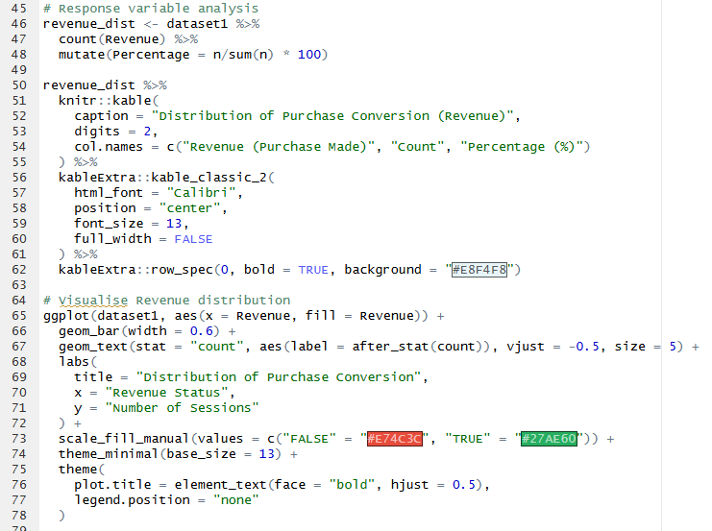

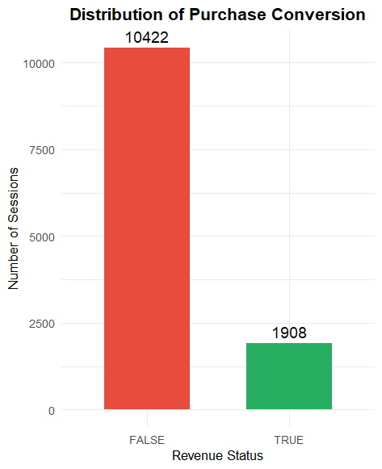 | 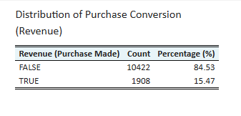

As evidenced by the response variable distribution, 84.53% of sessions did not result in a purchase, while only 15.47% generated revenue. This substantial class imbalance; where non-converting sessions outnumber converting sessions by approximately 5.5 to 1, has critical implications for model evaluation. Traditional accuracy metrics may be misleading, and the model may be biased toward predicting the majority class. Therefore, evaluation metrics such as precision, recall, F1-score, and area under the ROC curve (AUC) will be prioritised to account for this imbalance. Additionally, this imbalance suggests the cost of misclassifying revenue-generating sessions as non-revenue (false negatives) may be particularly critical for business decision-making.
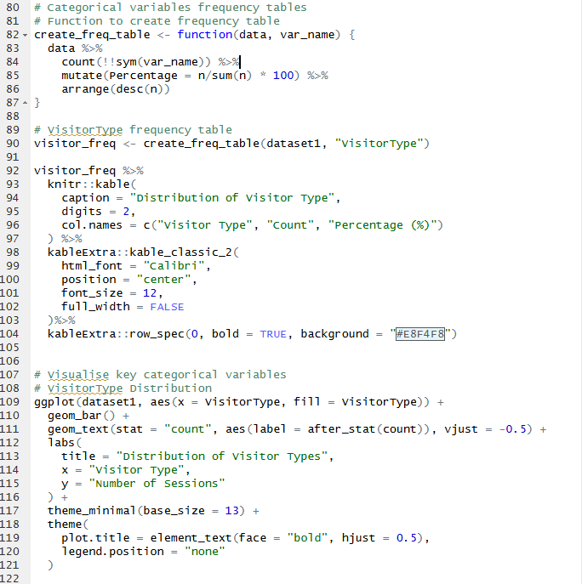

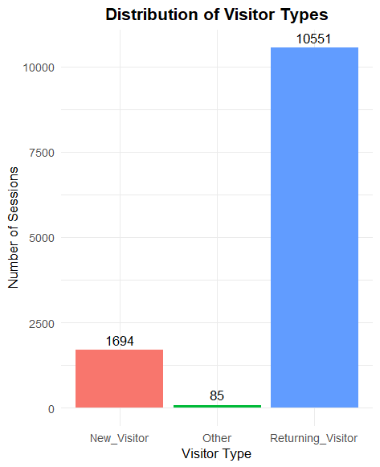 | 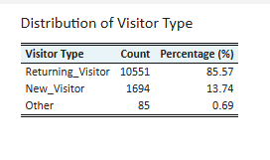

Examining the VisitorType distribution reveals that Returning Visitors dominate the dataset at 85.57% followed by New Visitors at 13.74% and a small proportion of Other visitors at 0.69%. This distribution suggests that visitor loyalty and familiarity with the e-commerce platform are common characteristics in the dataset. The extremely small proportion of "Other" visitors may warrant grouping this category with another or excluding it from certain analyses to avoid statistical inconsistencies.
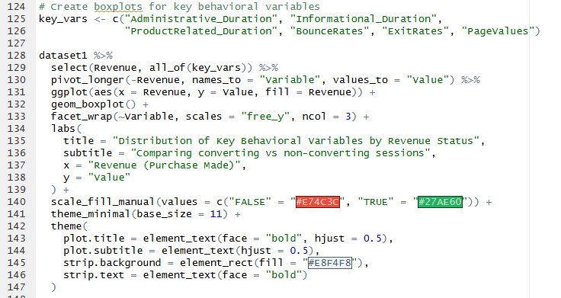
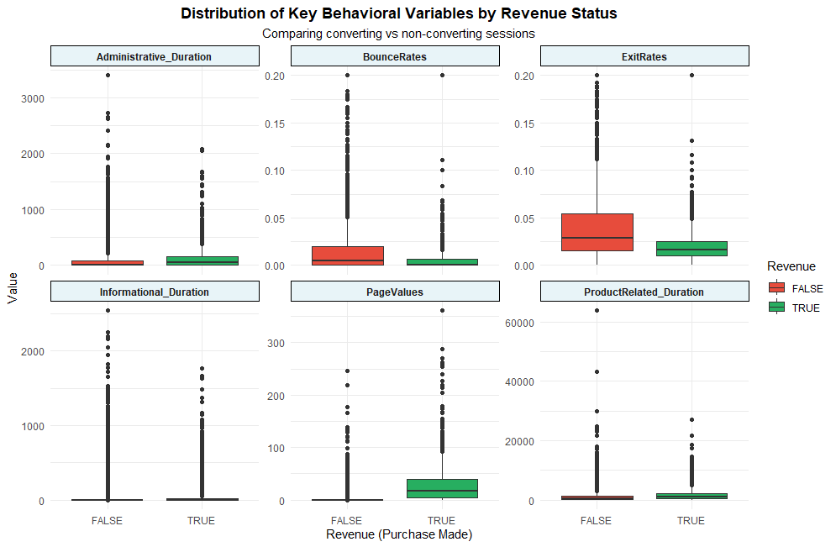
The boxplots comparing key behavioural variables by Revenue status reveal distinct patterns between converting and non-converting sessions. Notably, the distributions show that converting sessions (Revenue = TRUE) exhibit:
- Higher PageValues: The median PageValues for converting sessions is substantially elevated compared to non-converting sessions, which cluster near zero. This strong separation suggests PageValues is a powerful discriminator for purchase conversion.
- Longer ProductRelated_Duration: Converting sessions show higher median time spent on product-related pages, indicating greater engagement with merchandise before purchase.
- Lower BounceRates and ExitRates: Converting sessions demonstrate lower abandonment metrics, suggesting sustained engagement throughout the session.

The distributions for Administrative_Duration and Informational_Duration show less pronounced differences between groups, with both revenue categories displaying considerable overlap. This suggests these variables may be weaker predictors of conversion compared to product-related engagement metrics.
Most importantly, several distributions show minimal between converting and non-converting sessions (particularly PageValues and BounceRates), making these variables prime candidates as strong classifiers. This means that the Revenue variable can potentially be classified into each category (TRUE/FALSE) using a rule formulated from the combination of these behavioural metrics. The clear separation in certain variables provides optimism for building an effective logistic regression model, despite the challenges posed by class imbalance.

The highly right-skewed distributions (skewness values ranging from 1.96 to 7.58) across most numerical variables indicate that log transformations may be necessary to normalize distributions and improve model performance. This is particularly relevant for duration variables and PageValues, where the majority of sessions have low values, but extreme outliers pull the distribution's tail.

Task2: Train-test split
The dataset is partitioned into training and test sets using an 80/20 stratified split. The training set is used to compute classification rules through model fiting and the test set is used to evaluate our model reliability.
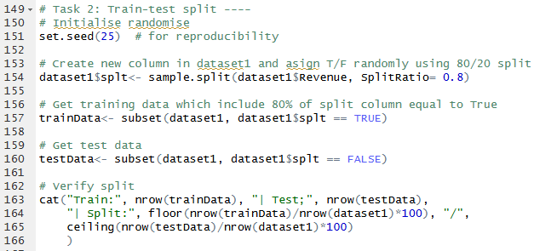

Observation of results
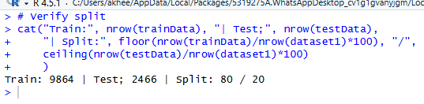
The split assigned 9864 sessions into the training set and the remaining 2466 sessions to the test set, maintaining the 80/20 split ratio.

Task 3: Model fitting
A logistic regression model is fit using 5 behavioural predictors selected based on explanatory analysis. Given the binary nature of the Revenue response variable, binomial family is used together with the logit link function to model a classifier.
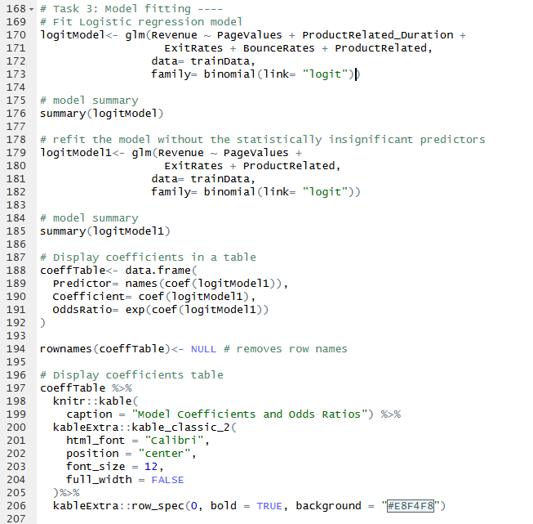

Observation of results
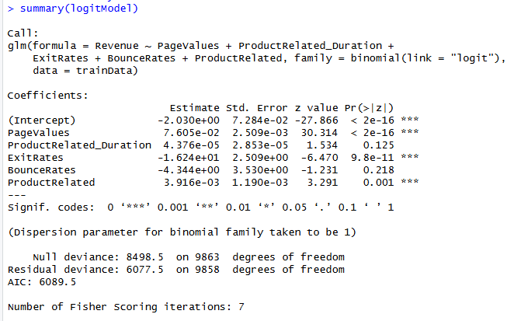 | 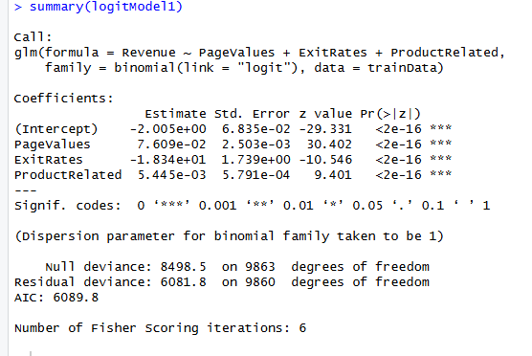

The initial model summary revealed ProductRelated_Duration with p-value 0.125 and BounceRates with p-value 0.218 were not statistically significant in classifying the response variable Revenue. The model was refined to include only statistically significant predictors, PageValues, ExitRates and ProductRelated.
Refined model coefficients
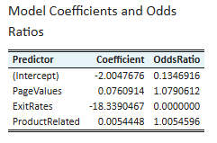
The intercept represents the baseline log—odds of a session generating revenue when all presictors are equal to zero. This however has limited practical interpretation as zero values for the predictors are uncommon in actual browsing sessions.
PageValue coefficient indicates that for every marginal increase in PageValues, the odds of generating revenue increase by 7.9%. This means that as the average value of pages visited increase (greater engagement), the probability of the user purchasing the items browsed also increases.
ExitRates shows a strong negative relationship with purchase conversion. For every marginal increase in ExitRates, the odds of conversion decrease at an increasing rate. This aligns with behavioural expectations as higher exit rates signal premature session abandonment, suggesting highly unlike purchase conversion.
ProductRelated demonstrates that each additional product-related page visited increases conversion odds by 0.55%. This effect appears modest per page, but it compounds across multiple page views.

Task 4: Confusion Matrix for Training Set
Classifier performance on the training data is evaluated by constructing confusion matrix that compared predicted sessions against the actual Revenue values.
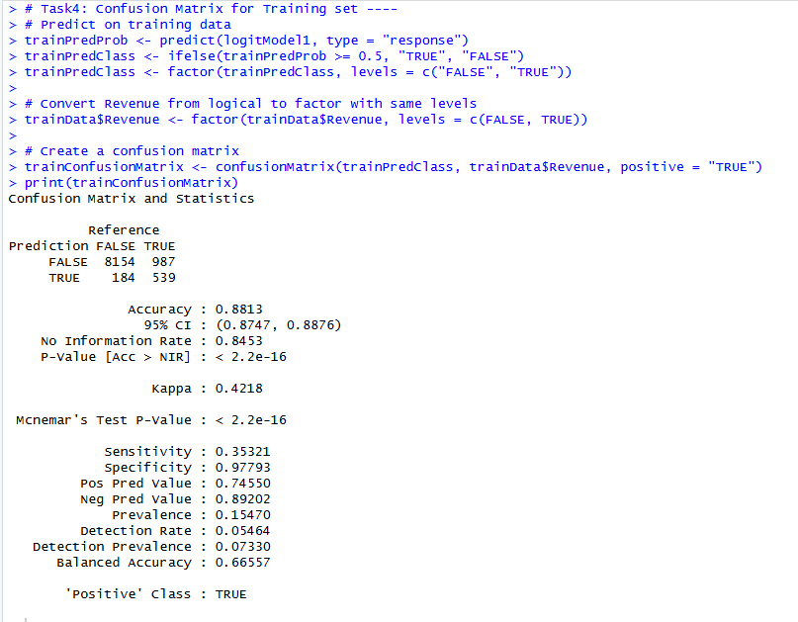

Observation of results
The classifier correctly distinguished 8693 of 9864 sessions, achieving 88.1% overall accuracy on the training data. This exceeds the 84,5% baseline accuracy that utilises chance in classification. The model demonstrates particularly strong performance in identifying non-revenue sessions, classifying 8154 of 8338 actual non-revenue sessions, that is 97.8% specificity. This suggests that the model effectively recognises behavioural patterns traits of sessions that will not convert.
However, the model shoes weaker performance on revenue generating sessions, achieving only 35.3% sensitivity. This means the classifier correctly identified 539 of 1526 actual converting sessions, missing 987 revenue generating sessions (false negatives). This disparity in performance reflects the inherent challenge of severe class imbalance, where non-revenue sessions out number revenue sessions by 5.5 to 1. The model learnt patterns predominantly from the majority class which made it conservative in predicting revenue generation
Precision of 74.6% indicates that when the model predicts a session will generate revenue, it is correct approximately three-quarters of the time. Conversely, only 184 non-revenue sessions were incorrectly classified as revenue generating, representing 2.2% of actual non-revenue sessions. In the context of our business domain, the False Negatives are substantially more damaging that False Positives. This neglect potential customers showing purchase intent through their behavioural patterns.

Task 5: Confusion Matrix for the test set
The trained model’s classification capabilities are evaluated using an independent test dataset.
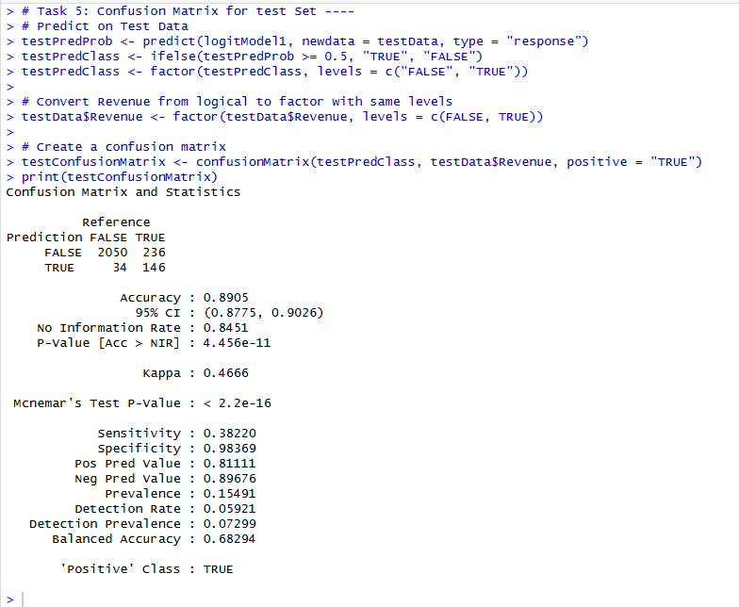

Observation of results
Accuracy (89.1%): The model classified 2196 of 2466 test session correctly. This slightly exceeds training accuracy by a percentage point
Precision (81.1%): The model is correct 81.1% of the time when predicting revenue generation in the test set, and this shows a 6.5% improvement over training precision.
Sensitivity (38.2%): The model identified 146 of 382 actual revenue-generating sessions, capturing 32.2% of converters. This shows a 2.9% improvement over the training recall.
Specificity (98.4%): The model correctly identified 2050 of 2084 non-revenue session, maintaining an excellent performance of 98.4% specificity.
Conclusively, the test set performance demonstrates excellent generalization and it shows marginal improvements across all metrics when compared to training performance. This indicates that the model is a good fit that avoids overfitting. The consistence between training and test specificity confirms that the model reliability recognizes non converting sessions patterns across different data samples. In addition to that, the modest improvement in sensitivity suggests that the model’s conservative approach to predicting revenue generation is a genuine trait rather than a training flaw.

Task 6: ROC Curve
ROC Curve is plotted to visualize the classifier’s performance across all possible decision thresholds.
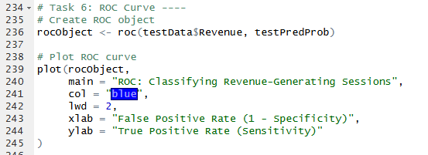

Observation of results
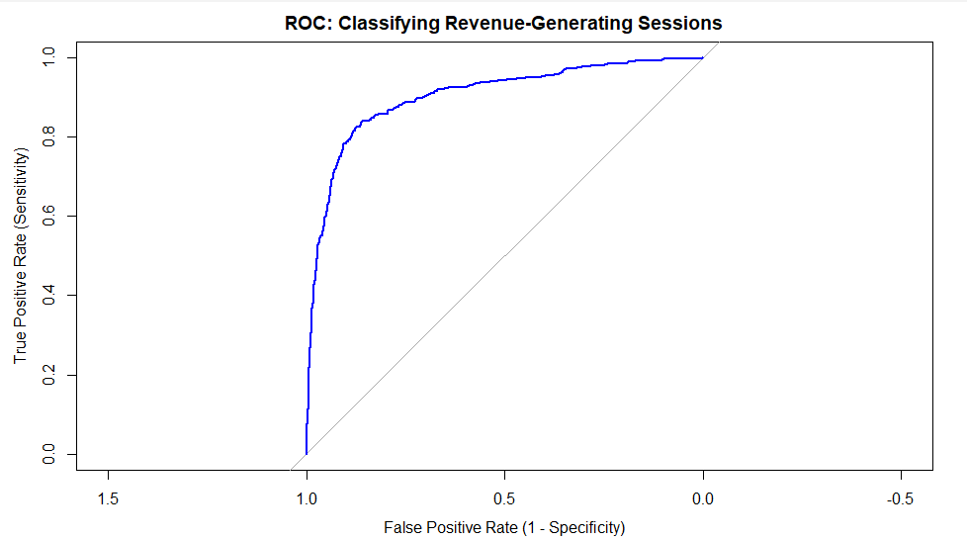
The ROC curve shows a strong discerning ability, with the curve positioned well above the no-skill line. The curve’s pronounces bow towards the upper-left corner indicates the model’s effectiveness in separating revenue-generating sessions from non-revenue generating sessions across a wide range of probability thresholds.

Task 7: AUC
The probability that the model assigns a higher conversion probability to a randomly selected revenue-generating session than to a randomly selected non-revenue session, the AUC is computed.
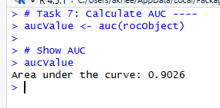

Observation of results
The model achieves an AUC of 0.9026 which indicates an excellent discriminative performance. This means that if one revenue generating session and one non-revenue generating session are selected randomly, there is a 90.3% probability that the model will correctly assign a higher conversion probability to the actual revenue session. This high AUC validated the feature selection process and model refinement strategy

Task 8: Hypothesis testing
The relationship between revenue generation trends and the time of the year is evaluated to check if they are dependent on each other, using the chi-square test of independence. All assumptions for the chi-square test are assumed to be met
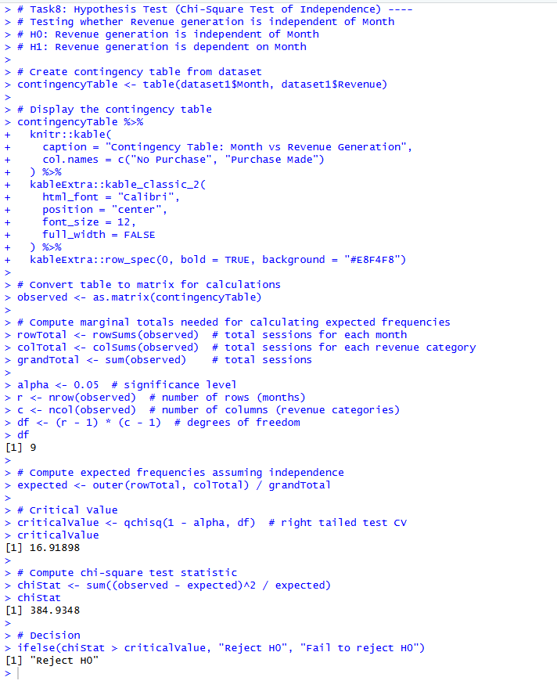

Observation of results
Hypothesis:
H0: Revenue generation is independent of month
H1: Revenue generation id dependent on month
Degrees of freedom: 9
Significance level: 0.05
Critical value: 16.919
Chi-square value: 384.935
Decision: Since 384.935 > 16.919, we reject the null hypothesis and conclude that revenue is dependent on the month. This suggests that certain months exhibit substantially different conversion rates than others, likely reflecting seasonal shopping patterns, holidays purchasing behaviour (November’s Black Frids/ Cyber Mondey) or month-specific promotional activities. Ecommerce platforms should account for these temporal variations when allocating marketing resources, adjusting inventory, and forecasting revenue.

Conclusion
The logistic regression model achieves excellent discrimination (AUC= 90.3%) using three behavioural predictors. The classifier successfully identified non-converting sessions with 98.4% specificity whilst demonstrating reliable generalization across both the training and test sets. The Chi-square test revealed significant monthly variation in conversion rates which confirms the seasonal effect that warrant strategic consideration in e-commerce operation.
However, the final writeup will address the model’s conservative prediction tendency through threshold adjustment or sampling techniques to improve the 38% recall for revenue-generating sessions. Additionally, the chi-square assumptions will be verified in the final report to confirm the validity of the independence test conclusions.

