武汉纺织大学

Web应用开发课程设计

**Web应用开发——查询显示**

**学 院： 数学与计算机学院**

**班 级： 软件11802班**

**姓 名： 刘颖**

**学 号： 1801230203**

**指导老师： 聂刚**

**成 绩：**

**完成日期： 2020年12月15日**

目 录

1 需求分析 1

1.1主菜单 1

1.3各项功能 1

1.3.1 数据查询 1

1.3.2 查询统计 1

1.3.3 模糊查询 1

1.3.4 分页显示 2

2 系统设计 2

2.1用户用例图 2

2.2 ER图 3

2.5 UML活动图（Activity Diagram） 3

3 系统实现 4

3.1 项目结构 4

3.2 配置文件 5

3.2.1 application.xml文件 5

3.2.2 dispatcherServlet-servlet.xml 6

3.2.3 web.xml文件 7

3.2.4 mybatis-config.xml 8

3.3 bean类 9

3.3.1Goods.java 9

3.3.2 GoodsExample.java 12

3.4 DAO接口类GoodsMapper.java 37

3.5 GoodsService.java 38

3.6 GoodsController.java 39

4 系统测试 39

5 系统总结 40

# 1 需求分析

设计一个查询显示页面，实现网页的数据来自于数据库、可进行组合查询、某些字段支持模糊查询、分页显示功能，具体要求如下：

## 1.1主菜单

打开项目进入主页面，如下：

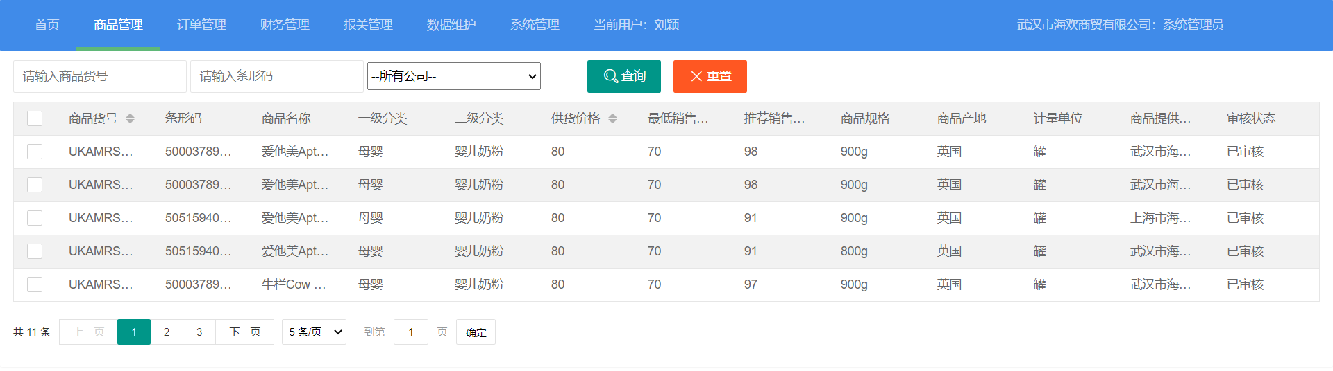

## 1.3各项功能

### 1.3.1 数据查询

将数据库中的数据导入table中显示

### 1.3.2 查询统计

可根据商品编号、条形码、所有公司三个条件任意组合对数据库中的数据进行查询。输出显示如下：

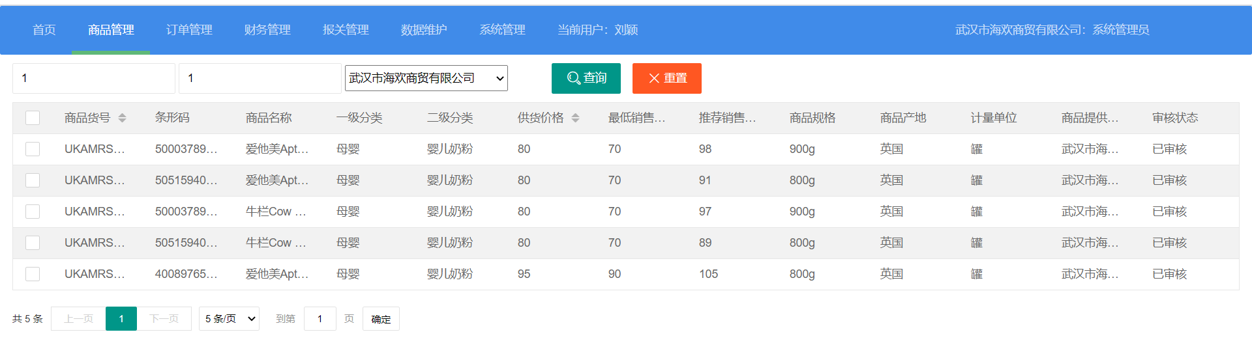

### 1.3.3 模糊查询

当用户通过input框进行查询时，可显示所有含有输入信息的记录，即可以只输入部分信息。

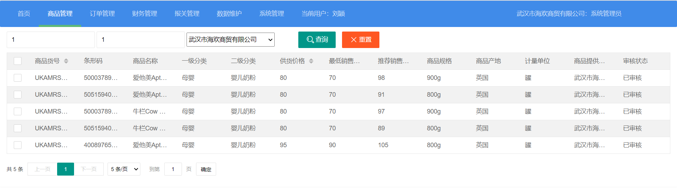

### 1.3.4 分页显示

当数据库中的数据记录很多时，将记录分成很多页，用户可通过分页导航读取显示需要的某页数据。也可选择每页显示多少条数据。

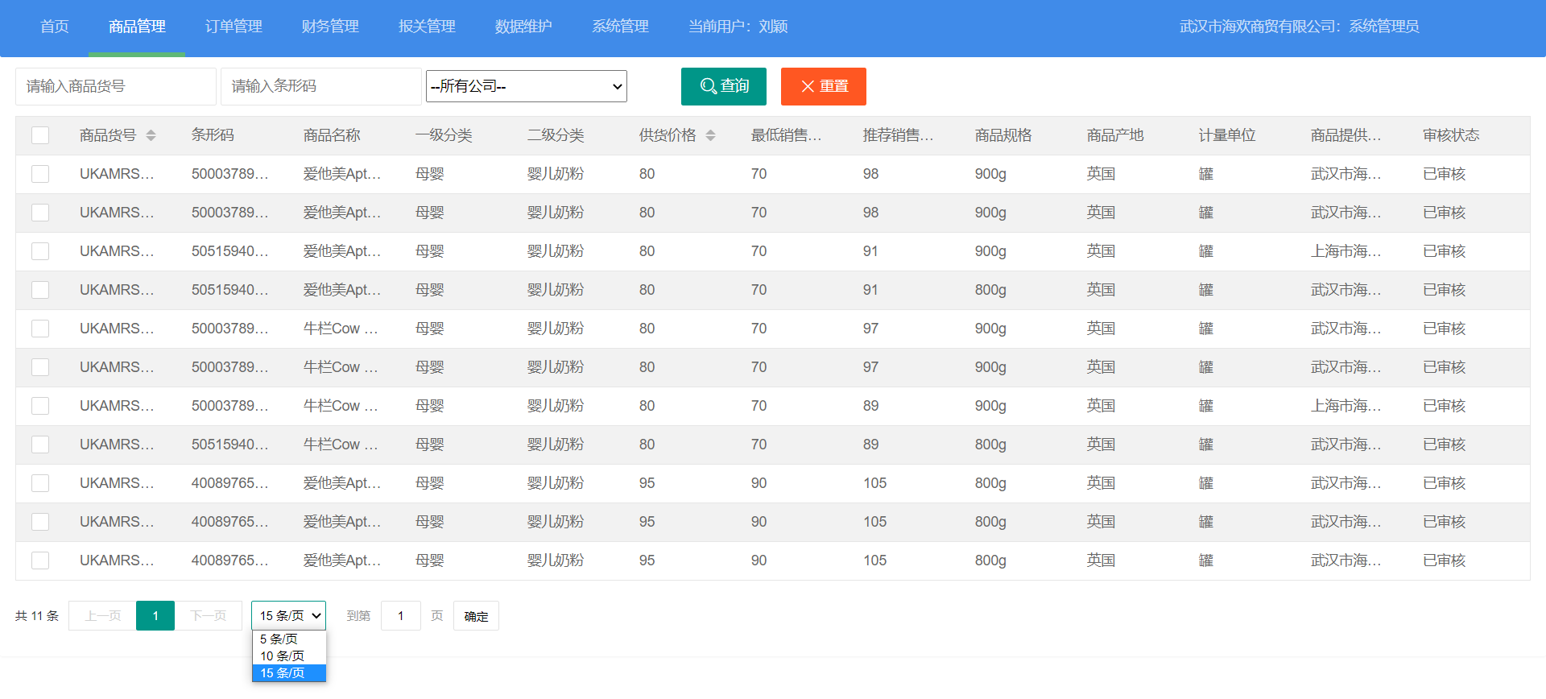

# 2 系统设计

## 2.1用户用例图

页面有普通用户和系统管理员两个觉得，各角色的用户用例如下图2-1所示：

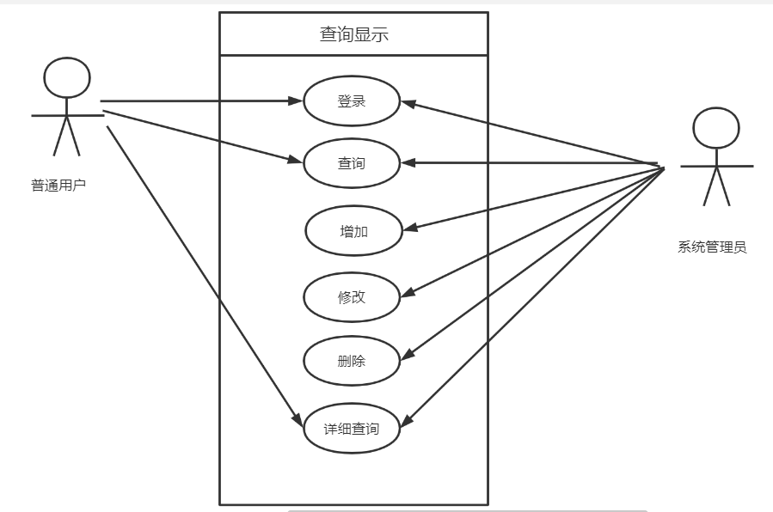

图2-1 用户用例图

## 2.2 ER图

数据库设计1张表，商品表，表对应的ER图如图3-1所示。

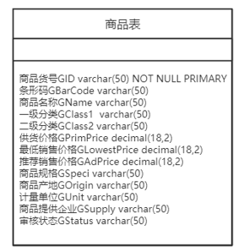

图3-1 数据库ER图

## 2.5 UML活动图（Activity Diagram）

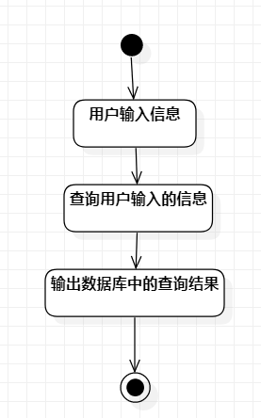

图2-2 查询

# 3 系统实现

## 3.1 项目结构

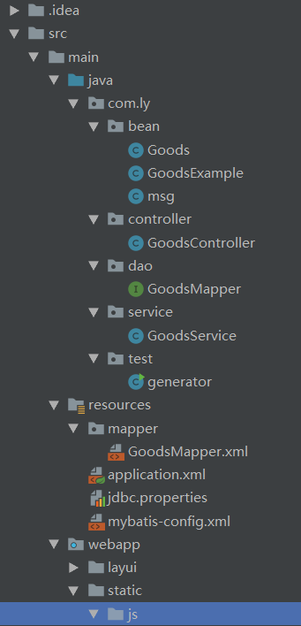

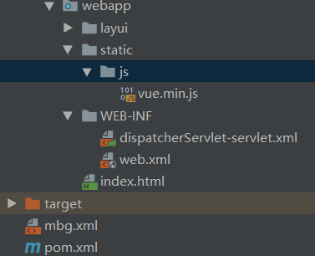

## 3.2 配置文件

### 3.2.1 application.xml文件

连接数据库，配置spring

<?xml version="1.0" encoding="UTF-8"?>

<beans xmlns="http://www.springframework.org/schema/beans"

xmlns:xsi="http://www.w3.org/2001/XMLSchema-instance"

xmlns:context="http://www.springframework.org/schema/context"

xmlns:aop="http://www.springframework.org/schema/aop"

xmlns:tx="http://www.springframework.org/schema/tx"

xmlns:p="http://www.springframework.org/schema/p"

xsi:schemaLocation="http://www.springframework.org/schema/beans http://www.springframework.org/schema/beans/spring-beans.xsd

http://www.springframework.org/schema/context http://www.springframework.org/schema/context/spring-context.xsd

http://www.springframework.org/schema/aop http://www.springframework.org/schema/aop/spring-aop.xsd

http://www.springframework.org/schema/tx http://www.springframework.org/schema/tx/spring-tx.xsd

">

<context:component-scan base-package="com.ly">

<context:exclude-filter type="annotation" expression="org.springframework.stereotype.Controller"/>

</context:component-scan>

<context:property-placeholder location="classpath:jdbc.properties"/>

<!-- 配置连接池-->

<bean class="com.mchange.v2.c3p0.ComboPooledDataSource" id="pooledDataSource">

<property name="jdbcUrl" value="${jdbc.url}"></property>

<property name="driverClass" value="${jdbc.className}"></property>

<property name="user" value="${jdbc.username}"/>

<property name="password" value="${jdbc.password}"></property>

<property name="maxPoolSize" value="15"/>

<property name="minPoolSize" value="2"/>

<!--关闭连接后不自动commit-->

<property name="autoCommitOnClose" value="false"/>

<!--获取连接超时时间-->

<property name="checkoutTimeout" value="10000"/>

<!--当获取连接失败重试次数-->

<property name="acquireRetryAttempts" value="2"/>

<!-- 连接超时-->

<property name="testConnectionOnCheckout" value="false"/>

<property name="testConnectionOnCheckin" value="true"/>

<property name="idleConnectionTestPeriod" value="30"/>

</bean>

<!-- 配置sqlsessionfactory-->

<bean class="org.mybatis.spring.SqlSessionFactoryBean" id="sqlSessionFactory">

<property name="configLocation" value="classpath:mybatis-config.xml"/>

<property name="dataSource" ref="pooledDataSource"/>

<property name="mapperLocations" value="classpath:mapper/*.xml"/>

</bean>

<!-- 扫描mapper文件-->

<bean class="org.mybatis.spring.mapper.MapperScannerConfigurer">

<property name="basePackage" value="com.ly.dao"/>

</bean>

<!-- 配置事务-->

<bean class="org.springframework.jdbc.datasource.DataSourceTransactionManager" id="transactionManager">

<property name="dataSource" ref="pooledDataSource"/>

</bean>

<aop:config>

<aop:pointcut id="txPoint" expression="execution(* com.ly.service..*(..))"/>

<aop:advisor advice-ref="txAdvice" pointcut-ref="txPoint"/>

</aop:config>

<tx:advice id="txAdvice">

<tx:attributes>

<tx:method name="*"/>

<tx:method name="get*"/>

</tx:attributes>

</tx:advice>

</beans>

### 3.2.2 dispatcherServlet-servlet.xml

数据上传，spring配置文件

<?xml version="1.0" encoding="UTF-8"?>

<beans xmlns="http://www.springframework.org/schema/beans"

xmlns:xsi="http://www.w3.org/2001/XMLSchema-instance"

xmlns:context="http://www.springframework.org/schema/context"

xmlns:aop="http://www.springframework.org/schema/aop" xmlns:tx="http://www.springframework.org/schema/tx"

xmlns:mvc="http://www.springframework.org/schema/mvc"

xsi:schemaLocation="http://www.springframework.org/schema/beans http://www.springframework.org/schema/beans/spring-beans.xsd http://www.springframework.org/schema/context https://www.springframework.org/schema/context/spring-context.xsd http://www.springframework.org/schema/aop https://www.springframework.org/schema/aop/spring-aop.xsd http://www.springframework.org/schema/tx http://www.springframework.org/schema/tx/spring-tx.xsd http://www.springframework.org/schema/mvc http://www.springframework.org/schema/mvc/spring-mvc.xsd">

<context:component-scan base-package="com.ly" use-default-filters="false">

<context:include-filter type="annotation" expression="org.springframework.stereotype.Controller"/>

</context:component-scan>

<bean class="org.springframework.web.servlet.view.InternalResourceViewResolver">

<property name="prefix" value="/pages/manager/"/>

<property name="suffix" value=".jsp"/>

</bean>

<bean id="multipartResolver"

class="org.springframework.web.multipart.commons.CommonsMultipartResolver">

<!-- 上传文件大小上限，单位为字节（10MB） -->

<property name="maxUploadSize">

<value>10485760</value>

</property>

<!-- 请求的编码格式，必须和jSP的pageEncoding属性一致，以便正确读取表单的内容，默认为ISO-8859-1 -->

<property name="defaultEncoding">

<value>UTF-8</value>

</property>

</bean>

<mvc:default-servlet-handler></mvc:default-servlet-handler>

<mvc:annotation-driven></mvc:annotation-driven>

</beans>

### 3.2.3 web.xml文件

配置路径，spring配置文件

<?xml version="1.0" encoding="UTF-8"?>

<web-app xmlns="http://xmlns.jcp.org/xml/ns/javaee"

xmlns:xsi="http://www.w3.org/2001/XMLSchema-instance"

xsi:schemaLocation="http://xmlns.jcp.org/xml/ns/javaee http://xmlns.jcp.org/xml/ns/javaee/web-app_4_0.xsd"

version="4.0">

<display-name>Archetype Created Web Application</display-name>

<listener>

<listener-class>org.springframework.web.context.ContextLoaderListener</listener-class>

</listener>

<context-param>

<param-name>contextConfigLocation</param-name>

<param-value>classpath:application.xml</param-value>

</context-param>

<servlet>

<servlet-name>dispatcherServlet</servlet-name>

<servlet-class>org.springframework.web.servlet.DispatcherServlet</servlet-class>

<load-on-startup>1</load-on-startup>

</servlet>

<servlet-mapping>

<servlet-name>dispatcherServlet</servlet-name>

<url-pattern>/</url-pattern>

</servlet-mapping>

<!-- 字符编码过滤器-->

<filter>

<filter-name>CharacterEncodingFilter</filter-name>

<filter-class>org.springframework.web.filter.CharacterEncodingFilter</filter-class>

<init-param>

<param-name>encoding</param-name>

<param-value>utf-8</param-value>

</init-param>

<init-param>

<param-name>forceEncoding</param-name>

<param-value>true</param-value>

</init-param>

</filter>

<filter-mapping>

<filter-name>CharacterEncodingFilter</filter-name>

<url-pattern>/*</url-pattern>

</filter-mapping>

<filter>

<filter-name>HiddenHttpMethodFilter</filter-name>

<filter-class>org.springframework.web.filter.HiddenHttpMethodFilter</filter-class>

</filter>

<filter-mapping>

<filter-name>HiddenHttpMethodFilter</filter-name>

<url-pattern>/*</url-pattern>

</filter-mapping>

<filter>

<filter-name>FormContentFilter</filter-name>

<filter-class>org.springframework.web.filter.HttpPutFormContentFilter</filter-class>

</filter>

<filter-mapping>

<filter-name>FormContentFilter</filter-name>

<url-pattern>/*</url-pattern>

</filter-mapping>

</web-app>

### 3.2.4 mybatis-config.xml

Mybatis配置文件

<?xml version="1.0" encoding="UTF-8" ?>

<!DOCTYPE configuration

PUBLIC "-//mybatis.org//DTD Config 3.0//EN"

"http://mybatis.org/dtd/mybatis-3-config.dtd">

<configuration>

<settings>

<setting name="mapUnderscoreToCamelCase" value="true"/>

<setting name="logImpl" value="STDOUT_LOGGING"/>

</settings>

<typeAliases>

<package name="com.ly.bean"/>

</typeAliases>

<!-- 分页插件--><plugins>

<plugin interceptor="com.github.pagehelper.PageInterceptor">

<property name="reasonable" value="true"/>

</plugin>

</plugins>

</configuration>

## 3.3 bean类

### 3.3.1Goods.java

package com.ly.bean;

import java.io.Serializable;

import java.math.BigDecimal;

public class Goods implements Serializable {

private String gid;

private String gbarcode;

private String gname;

private String gclass1;

private String gclass2;

private BigDecimal gprimprice;

private BigDecimal glowestprice;

private BigDecimal gadprice;

private String gspeci;

private String gorigin;

private String gunit;

private String gsupply;

private String gstatus;

//自定义UID默认UID在反序列化的时候容易出现异常

private static final long serialVersionUID = 1L;

public String getGid() {

return gid;

}

public void setGid(String gid) {

this.gid = gid == null ? null : gid.trim();

}

public String getGbarcode() {

return gbarcode;

}

public void setGbarcode(String gbarcode) {

this.gbarcode = gbarcode == null ? null : gbarcode.trim();

}

public String getGname() {

return gname;

}

public void setGname(String gname) {

this.gname = gname == null ? null : gname.trim();

}

public String getGclass1() {

return gclass1;

}

public void setGclass1(String gclass1) {

this.gclass1 = gclass1 == null ? null : gclass1.trim();

}

public String getGclass2() {

return gclass2;

}

public void setGclass2(String gclass2) {

this.gclass2 = gclass2 == null ? null : gclass2.trim();

}

public BigDecimal getGprimprice() {

return gprimprice;

}

public void setGprimprice(BigDecimal gprimprice) {

this.gprimprice = gprimprice;

}

public BigDecimal getGlowestprice() {

return glowestprice;

}

public void setGlowestprice(BigDecimal glowestprice) {

this.glowestprice = glowestprice;

}

public BigDecimal getGadprice() {

return gadprice;

}

public void setGadprice(BigDecimal gadprice) {

this.gadprice = gadprice;

}

public String getGspeci() {

return gspeci;

}

public void setGspeci(String gspeci) {

this.gspeci = gspeci == null ? null : gspeci.trim();

}

public String getGorigin() {

return gorigin;

}

public void setGorigin(String gorigin) {

this.gorigin = gorigin == null ? null : gorigin.trim();

}

public String getGunit() {

return gunit;

}

public void setGunit(String gunit) {

this.gunit = gunit == null ? null : gunit.trim();

}

public String getGsupply() {

return gsupply;

}

public void setGsupply(String gsupply) {

this.gsupply = gsupply == null ? null : gsupply.trim();

}

public String getGstatus() {

return gstatus;

}

public void setGstatus(String gstatus) {

this.gstatus = gstatus == null ? null : gstatus.trim();

}

}

### 3.3.2 GoodsExample.java

package com.ly.bean;

import java.math.BigDecimal;

import java.util.ArrayList;

import java.util.List;

public class GoodsExample {

protected String orderByClause;

protected boolean distinct;

protected List<Criteria> oredCriteria;

public GoodsExample() {

oredCriteria = new ArrayList<>();

}

public void setOrderByClause(String orderByClause) {

this.orderByClause = orderByClause;

}

public String getOrderByClause() {

return orderByClause;

}

public void setDistinct(boolean distinct) {

this.distinct = distinct;

}

public boolean isDistinct() {

return distinct;

}

public List<Criteria> getOredCriteria() {

return oredCriteria;

}

public void or(Criteria criteria) {

oredCriteria.add(criteria);

}

public Criteria or() {

Criteria criteria = createCriteriaInternal();

oredCriteria.add(criteria);

return criteria;

}

public Criteria createCriteria() {

Criteria criteria = createCriteriaInternal();

if (oredCriteria.size() == 0) {

oredCriteria.add(criteria);

}

return criteria;

}

protected Criteria createCriteriaInternal() {

Criteria criteria = new Criteria();

return criteria;

}

public void clear() {

oredCriteria.clear();

orderByClause = null;

distinct = false;

}

protected abstract static class GeneratedCriteria {

protected List<Criterion> criteria;

protected GeneratedCriteria() {

super();

criteria = new ArrayList<>();

}

public boolean isValid() {

return criteria.size() > 0;

}

public List<Criterion> getAllCriteria() {

return criteria;

}

public List<Criterion> getCriteria() {

return criteria;

}

protected void addCriterion(String condition) {

if (condition == null) {

throw new RuntimeException("Value for condition cannot be null");

}

criteria.add(new Criterion(condition));

}

protected void addCriterion(String condition, Object value, String property) {

if (value == null) {

throw new RuntimeException("Value for " + property + " cannot be null");

}

criteria.add(new Criterion(condition, value));

}

protected void addCriterion(String condition, Object value1, Object value2, String property) {

if (value1 == null || value2 == null) {

throw new RuntimeException("Between values for " + property + " cannot be null");

}

criteria.add(new Criterion(condition, value1, value2));

}

public Criteria andGidIsNull() {

addCriterion("GID is null");

return (Criteria) this;

}

public Criteria andGidIsNotNull() {

addCriterion("GID is not null");

return (Criteria) this;

}

public Criteria andGidEqualTo(String value) {

addCriterion("GID =", value, "gid");

return (Criteria) this;

}

public Criteria andGidNotEqualTo(String value) {

addCriterion("GID <>", value, "gid");

return (Criteria) this;

}

public Criteria andGidGreaterThan(String value) {

addCriterion("GID >", value, "gid");

return (Criteria) this;

}

public Criteria andGidGreaterThanOrEqualTo(String value) {

addCriterion("GID >=", value, "gid");

return (Criteria) this;

}

public Criteria andGidLessThan(String value) {

addCriterion("GID <", value, "gid");

return (Criteria) this;

}

public Criteria andGidLessThanOrEqualTo(String value) {

addCriterion("GID <=", value, "gid");

return (Criteria) this;

}

public Criteria andGidLike(String value) {

addCriterion("GID like", value, "gid");

return (Criteria) this;

}

public Criteria andGidNotLike(String value) {

addCriterion("GID not like", value, "gid");

return (Criteria) this;

}

public Criteria andGidIn(List<String> values) {

addCriterion("GID in", values, "gid");

return (Criteria) this;

}

public Criteria andGidNotIn(List<String> values) {

addCriterion("GID not in", values, "gid");

return (Criteria) this;

}

public Criteria andGidBetween(String value1, String value2) {

addCriterion("GID between", value1, value2, "gid");

return (Criteria) this;

}

public Criteria andGidNotBetween(String value1, String value2) {

addCriterion("GID not between", value1, value2, "gid");

return (Criteria) this;

}

public Criteria andGbarcodeIsNull() {

addCriterion("GBarCode is null");

return (Criteria) this;

}

public Criteria andGbarcodeIsNotNull() {

addCriterion("GBarCode is not null");

return (Criteria) this;

}

public Criteria andGbarcodeEqualTo(String value) {

addCriterion("GBarCode =", value, "gbarcode");

return (Criteria) this;

}

public Criteria andGbarcodeNotEqualTo(String value) {

addCriterion("GBarCode <>", value, "gbarcode");

return (Criteria) this;

}

public Criteria andGbarcodeGreaterThan(String value) {

addCriterion("GBarCode >", value, "gbarcode");

return (Criteria) this;

}

public Criteria andGbarcodeGreaterThanOrEqualTo(String value) {

addCriterion("GBarCode >=", value, "gbarcode");

return (Criteria) this;

}

public Criteria andGbarcodeLessThan(String value) {

addCriterion("GBarCode <", value, "gbarcode");

return (Criteria) this;

}

public Criteria andGbarcodeLessThanOrEqualTo(String value) {

addCriterion("GBarCode <=", value, "gbarcode");

return (Criteria) this;

}

public Criteria andGbarcodeLike(String value) {

addCriterion("GBarCode like", value, "gbarcode");

return (Criteria) this;

}

public Criteria andGbarcodeNotLike(String value) {

addCriterion("GBarCode not like", value, "gbarcode");

return (Criteria) this;

}

public Criteria andGbarcodeIn(List<String> values) {

addCriterion("GBarCode in", values, "gbarcode");

return (Criteria) this;

}

public Criteria andGbarcodeNotIn(List<String> values) {

addCriterion("GBarCode not in", values, "gbarcode");

return (Criteria) this;

}

public Criteria andGbarcodeBetween(String value1, String value2) {

addCriterion("GBarCode between", value1, value2, "gbarcode");

return (Criteria) this;

}

public Criteria andGbarcodeNotBetween(String value1, String value2) {

addCriterion("GBarCode not between", value1, value2, "gbarcode");

return (Criteria) this;

}

public Criteria andGnameIsNull() {

addCriterion("GName is null");

return (Criteria) this;

}

public Criteria andGnameIsNotNull() {

addCriterion("GName is not null");

return (Criteria) this;

}

public Criteria andGnameEqualTo(String value) {

addCriterion("GName =", value, "gname");

return (Criteria) this;

}

public Criteria andGnameNotEqualTo(String value) {

addCriterion("GName <>", value, "gname");

return (Criteria) this;

}

public Criteria andGnameGreaterThan(String value) {

addCriterion("GName >", value, "gname");

return (Criteria) this;

}

public Criteria andGnameGreaterThanOrEqualTo(String value) {

addCriterion("GName >=", value, "gname");

return (Criteria) this;

}

public Criteria andGnameLessThan(String value) {

addCriterion("GName <", value, "gname");

return (Criteria) this;

}

public Criteria andGnameLessThanOrEqualTo(String value) {

addCriterion("GName <=", value, "gname");

return (Criteria) this;

}

public Criteria andGnameLike(String value) {

addCriterion("GName like", value, "gname");

return (Criteria) this;

}

public Criteria andGnameNotLike(String value) {

addCriterion("GName not like", value, "gname");

return (Criteria) this;

}

public Criteria andGnameIn(List<String> values) {

addCriterion("GName in", values, "gname");

return (Criteria) this;

}

public Criteria andGnameNotIn(List<String> values) {

addCriterion("GName not in", values, "gname");

return (Criteria) this;

}

public Criteria andGnameBetween(String value1, String value2) {

addCriterion("GName between", value1, value2, "gname");

return (Criteria) this;

}

public Criteria andGnameNotBetween(String value1, String value2) {

addCriterion("GName not between", value1, value2, "gname");

return (Criteria) this;

}

public Criteria andGclass1IsNull() {

addCriterion("GClass1 is null");

return (Criteria) this;

}

public Criteria andGclass1IsNotNull() {

addCriterion("GClass1 is not null");

return (Criteria) this;

}

public Criteria andGclass1EqualTo(String value) {

addCriterion("GClass1 =", value, "gclass1");

return (Criteria) this;

}

public Criteria andGclass1NotEqualTo(String value) {

addCriterion("GClass1 <>", value, "gclass1");

return (Criteria) this;

}

public Criteria andGclass1GreaterThan(String value) {

addCriterion("GClass1 >", value, "gclass1");

return (Criteria) this;

}

public Criteria andGclass1GreaterThanOrEqualTo(String value) {

addCriterion("GClass1 >=", value, "gclass1");

return (Criteria) this;

}

public Criteria andGclass1LessThan(String value) {

addCriterion("GClass1 <", value, "gclass1");

return (Criteria) this;

}

public Criteria andGclass1LessThanOrEqualTo(String value) {

addCriterion("GClass1 <=", value, "gclass1");

return (Criteria) this;

}

public Criteria andGclass1Like(String value) {

addCriterion("GClass1 like", value, "gclass1");

return (Criteria) this;

}

public Criteria andGclass1NotLike(String value) {

addCriterion("GClass1 not like", value, "gclass1");

return (Criteria) this;

}

public Criteria andGclass1In(List<String> values) {

addCriterion("GClass1 in", values, "gclass1");

return (Criteria) this;

}

public Criteria andGclass1NotIn(List<String> values) {

addCriterion("GClass1 not in", values, "gclass1");

return (Criteria) this;

}

public Criteria andGclass1Between(String value1, String value2) {

addCriterion("GClass1 between", value1, value2, "gclass1");

return (Criteria) this;

}

public Criteria andGclass1NotBetween(String value1, String value2) {

addCriterion("GClass1 not between", value1, value2, "gclass1");

return (Criteria) this;

}

public Criteria andGclass2IsNull() {

addCriterion("GClass2 is null");

return (Criteria) this;

}

public Criteria andGclass2IsNotNull() {

addCriterion("GClass2 is not null");

return (Criteria) this;

}

public Criteria andGclass2EqualTo(String value) {

addCriterion("GClass2 =", value, "gclass2");

return (Criteria) this;

}

public Criteria andGclass2NotEqualTo(String value) {

addCriterion("GClass2 <>", value, "gclass2");

return (Criteria) this;

}

public Criteria andGclass2GreaterThan(String value) {

addCriterion("GClass2 >", value, "gclass2");

return (Criteria) this;

}

public Criteria andGclass2GreaterThanOrEqualTo(String value) {

addCriterion("GClass2 >=", value, "gclass2");

return (Criteria) this;

}

public Criteria andGclass2LessThan(String value) {

addCriterion("GClass2 <", value, "gclass2");

return (Criteria) this;

}

public Criteria andGclass2LessThanOrEqualTo(String value) {

addCriterion("GClass2 <=", value, "gclass2");

return (Criteria) this;

}

public Criteria andGclass2Like(String value) {

addCriterion("GClass2 like", value, "gclass2");

return (Criteria) this;

}

public Criteria andGclass2NotLike(String value) {

addCriterion("GClass2 not like", value, "gclass2");

return (Criteria) this;

}

public Criteria andGclass2In(List<String> values) {

addCriterion("GClass2 in", values, "gclass2");

return (Criteria) this;

}

public Criteria andGclass2NotIn(List<String> values) {

addCriterion("GClass2 not in", values, "gclass2");

return (Criteria) this;

}

public Criteria andGclass2Between(String value1, String value2) {

addCriterion("GClass2 between", value1, value2, "gclass2");

return (Criteria) this;

}

public Criteria andGclass2NotBetween(String value1, String value2) {

addCriterion("GClass2 not between", value1, value2, "gclass2");

return (Criteria) this;

}

public Criteria andGprimpriceIsNull() {

addCriterion("GPrimPrice is null");

return (Criteria) this;

}

public Criteria andGprimpriceIsNotNull() {

addCriterion("GPrimPrice is not null");

return (Criteria) this;

}

public Criteria andGprimpriceEqualTo(BigDecimal value) {

addCriterion("GPrimPrice =", value, "gprimprice");

return (Criteria) this;

}

public Criteria andGprimpriceNotEqualTo(BigDecimal value) {

addCriterion("GPrimPrice <>", value, "gprimprice");

return (Criteria) this;

}

public Criteria andGprimpriceGreaterThan(BigDecimal value) {

addCriterion("GPrimPrice >", value, "gprimprice");

return (Criteria) this;

}

public Criteria andGprimpriceGreaterThanOrEqualTo(BigDecimal value) {

addCriterion("GPrimPrice >=", value, "gprimprice");

return (Criteria) this;

}

public Criteria andGprimpriceLessThan(BigDecimal value) {

addCriterion("GPrimPrice <", value, "gprimprice");

return (Criteria) this;

}

public Criteria andGprimpriceLessThanOrEqualTo(BigDecimal value) {

addCriterion("GPrimPrice <=", value, "gprimprice");

return (Criteria) this;

}

public Criteria andGprimpriceIn(List<BigDecimal> values) {

addCriterion("GPrimPrice in", values, "gprimprice");

return (Criteria) this;

}

public Criteria andGprimpriceNotIn(List<BigDecimal> values) {

addCriterion("GPrimPrice not in", values, "gprimprice");

return (Criteria) this;

}

public Criteria andGprimpriceBetween(BigDecimal value1, BigDecimal value2) {

addCriterion("GPrimPrice between", value1, value2, "gprimprice");

return (Criteria) this;

}

public Criteria andGprimpriceNotBetween(BigDecimal value1, BigDecimal value2) {

addCriterion("GPrimPrice not between", value1, value2, "gprimprice");

return (Criteria) this;

}

public Criteria andGlowestpriceIsNull() {

addCriterion("GLowestPrice is null");

return (Criteria) this;

}

public Criteria andGlowestpriceIsNotNull() {

addCriterion("GLowestPrice is not null");

return (Criteria) this;

}

public Criteria andGlowestpriceEqualTo(BigDecimal value) {

addCriterion("GLowestPrice =", value, "glowestprice");

return (Criteria) this;

}

public Criteria andGlowestpriceNotEqualTo(BigDecimal value) {

addCriterion("GLowestPrice <>", value, "glowestprice");

return (Criteria) this;

}

public Criteria andGlowestpriceGreaterThan(BigDecimal value) {

addCriterion("GLowestPrice >", value, "glowestprice");

return (Criteria) this;

}

public Criteria andGlowestpriceGreaterThanOrEqualTo(BigDecimal value) {

addCriterion("GLowestPrice >=", value, "glowestprice");

return (Criteria) this;

}

public Criteria andGlowestpriceLessThan(BigDecimal value) {

addCriterion("GLowestPrice <", value, "glowestprice");

return (Criteria) this;

}

public Criteria andGlowestpriceLessThanOrEqualTo(BigDecimal value) {

addCriterion("GLowestPrice <=", value, "glowestprice");

return (Criteria) this;

}

public Criteria andGlowestpriceIn(List<BigDecimal> values) {

addCriterion("GLowestPrice in", values, "glowestprice");

return (Criteria) this;

}

public Criteria andGlowestpriceNotIn(List<BigDecimal> values) {

addCriterion("GLowestPrice not in", values, "glowestprice");

return (Criteria) this;

}

public Criteria andGlowestpriceBetween(BigDecimal value1, BigDecimal value2) {

addCriterion("GLowestPrice between", value1, value2, "glowestprice");

return (Criteria) this;

}

public Criteria andGlowestpriceNotBetween(BigDecimal value1, BigDecimal value2) {

addCriterion("GLowestPrice not between", value1, value2, "glowestprice");

return (Criteria) this;

}

public Criteria andGadpriceIsNull() {

addCriterion("GAdPrice is null");

return (Criteria) this;

}

public Criteria andGadpriceIsNotNull() {

addCriterion("GAdPrice is not null");

return (Criteria) this;

}

public Criteria andGadpriceEqualTo(BigDecimal value) {

addCriterion("GAdPrice =", value, "gadprice");

return (Criteria) this;

}

public Criteria andGadpriceNotEqualTo(BigDecimal value) {

addCriterion("GAdPrice <>", value, "gadprice");

return (Criteria) this;

}

public Criteria andGadpriceGreaterThan(BigDecimal value) {

addCriterion("GAdPrice >", value, "gadprice");

return (Criteria) this;

}

public Criteria andGadpriceGreaterThanOrEqualTo(BigDecimal value) {

addCriterion("GAdPrice >=", value, "gadprice");

return (Criteria) this;

}

public Criteria andGadpriceLessThan(BigDecimal value) {

addCriterion("GAdPrice <", value, "gadprice");

return (Criteria) this;

}

public Criteria andGadpriceLessThanOrEqualTo(BigDecimal value) {

addCriterion("GAdPrice <=", value, "gadprice");

return (Criteria) this;

}

public Criteria andGadpriceIn(List<BigDecimal> values) {

addCriterion("GAdPrice in", values, "gadprice");

return (Criteria) this;

}

public Criteria andGadpriceNotIn(List<BigDecimal> values) {

addCriterion("GAdPrice not in", values, "gadprice");

return (Criteria) this;

}

public Criteria andGadpriceBetween(BigDecimal value1, BigDecimal value2) {

addCriterion("GAdPrice between", value1, value2, "gadprice");

return (Criteria) this;

}

public Criteria andGadpriceNotBetween(BigDecimal value1, BigDecimal value2) {

addCriterion("GAdPrice not between", value1, value2, "gadprice");

return (Criteria) this;

}

public Criteria andGspeciIsNull() {

addCriterion("GSpeci is null");

return (Criteria) this;

}

public Criteria andGspeciIsNotNull() {

addCriterion("GSpeci is not null");

return (Criteria) this;

}

public Criteria andGspeciEqualTo(String value) {

addCriterion("GSpeci =", value, "gspeci");

return (Criteria) this;

}

public Criteria andGspeciNotEqualTo(String value) {

addCriterion("GSpeci <>", value, "gspeci");

return (Criteria) this;

}

public Criteria andGspeciGreaterThan(String value) {

addCriterion("GSpeci >", value, "gspeci");

return (Criteria) this;

}

public Criteria andGspeciGreaterThanOrEqualTo(String value) {

addCriterion("GSpeci >=", value, "gspeci");

return (Criteria) this;

}

public Criteria andGspeciLessThan(String value) {

addCriterion("GSpeci <", value, "gspeci");

return (Criteria) this;

}

public Criteria andGspeciLessThanOrEqualTo(String value) {

addCriterion("GSpeci <=", value, "gspeci");

return (Criteria) this;

}

public Criteria andGspeciLike(String value) {

addCriterion("GSpeci like", value, "gspeci");

return (Criteria) this;

}

public Criteria andGspeciNotLike(String value) {

addCriterion("GSpeci not like", value, "gspeci");

return (Criteria) this;

}

public Criteria andGspeciIn(List<String> values) {

addCriterion("GSpeci in", values, "gspeci");

return (Criteria) this;

}

public Criteria andGspeciNotIn(List<String> values) {

addCriterion("GSpeci not in", values, "gspeci");

return (Criteria) this;

}

public Criteria andGspeciBetween(String value1, String value2) {

addCriterion("GSpeci between", value1, value2, "gspeci");

return (Criteria) this;

}

public Criteria andGspeciNotBetween(String value1, String value2) {

addCriterion("GSpeci not between", value1, value2, "gspeci");

return (Criteria) this;

}

public Criteria andGoriginIsNull() {

addCriterion("GOrigin is null");

return (Criteria) this;

}

public Criteria andGoriginIsNotNull() {

addCriterion("GOrigin is not null");

return (Criteria) this;

}

public Criteria andGoriginEqualTo(String value) {

addCriterion("GOrigin =", value, "gorigin");

return (Criteria) this;

}

public Criteria andGoriginNotEqualTo(String value) {

addCriterion("GOrigin <>", value, "gorigin");

return (Criteria) this;

}

public Criteria andGoriginGreaterThan(String value) {

addCriterion("GOrigin >", value, "gorigin");

return (Criteria) this;

}

public Criteria andGoriginGreaterThanOrEqualTo(String value) {

addCriterion("GOrigin >=", value, "gorigin");

return (Criteria) this;

}

public Criteria andGoriginLessThan(String value) {

addCriterion("GOrigin <", value, "gorigin");

return (Criteria) this;

}

public Criteria andGoriginLessThanOrEqualTo(String value) {

addCriterion("GOrigin <=", value, "gorigin");

return (Criteria) this;

}

public Criteria andGoriginLike(String value) {

addCriterion("GOrigin like", value, "gorigin");

return (Criteria) this;

}

public Criteria andGoriginNotLike(String value) {

addCriterion("GOrigin not like", value, "gorigin");

return (Criteria) this;

}

public Criteria andGoriginIn(List<String> values) {

addCriterion("GOrigin in", values, "gorigin");

return (Criteria) this;

}

public Criteria andGoriginNotIn(List<String> values) {

addCriterion("GOrigin not in", values, "gorigin");

return (Criteria) this;

}

public Criteria andGoriginBetween(String value1, String value2) {

addCriterion("GOrigin between", value1, value2, "gorigin");

return (Criteria) this;

}

public Criteria andGoriginNotBetween(String value1, String value2) {

addCriterion("GOrigin not between", value1, value2, "gorigin");

return (Criteria) this;

}

public Criteria andGunitIsNull() {

addCriterion("GUnit is null");

return (Criteria) this;

}

public Criteria andGunitIsNotNull() {

addCriterion("GUnit is not null");

return (Criteria) this;

}

public Criteria andGunitEqualTo(String value) {

addCriterion("GUnit =", value, "gunit");

return (Criteria) this;

}

public Criteria andGunitNotEqualTo(String value) {

addCriterion("GUnit <>", value, "gunit");

return (Criteria) this;

}

public Criteria andGunitGreaterThan(String value) {

addCriterion("GUnit >", value, "gunit");

return (Criteria) this;

}

public Criteria andGunitGreaterThanOrEqualTo(String value) {

addCriterion("GUnit >=", value, "gunit");

return (Criteria) this;

}

public Criteria andGunitLessThan(String value) {

addCriterion("GUnit <", value, "gunit");

return (Criteria) this;

}

public Criteria andGunitLessThanOrEqualTo(String value) {

addCriterion("GUnit <=", value, "gunit");

return (Criteria) this;

}

public Criteria andGunitLike(String value) {

addCriterion("GUnit like", value, "gunit");

return (Criteria) this;

}

public Criteria andGunitNotLike(String value) {

addCriterion("GUnit not like", value, "gunit");

return (Criteria) this;

}

public Criteria andGunitIn(List<String> values) {

addCriterion("GUnit in", values, "gunit");

return (Criteria) this;

}

public Criteria andGunitNotIn(List<String> values) {

addCriterion("GUnit not in", values, "gunit");

return (Criteria) this;

}

public Criteria andGunitBetween(String value1, String value2) {

addCriterion("GUnit between", value1, value2, "gunit");

return (Criteria) this;

}

public Criteria andGunitNotBetween(String value1, String value2) {

addCriterion("GUnit not between", value1, value2, "gunit");

return (Criteria) this;

}

public Criteria andGsupplyIsNull() {

addCriterion("GSupply is null");

return (Criteria) this;

}

public Criteria andGsupplyIsNotNull() {

addCriterion("GSupply is not null");

return (Criteria) this;

}

public Criteria andGsupplyEqualTo(String value) {

addCriterion("GSupply =", value, "gsupply");

return (Criteria) this;

}

public Criteria andGsupplyNotEqualTo(String value) {

addCriterion("GSupply <>", value, "gsupply");

return (Criteria) this;

}

public Criteria andGsupplyGreaterThan(String value) {

addCriterion("GSupply >", value, "gsupply");

return (Criteria) this;

}

public Criteria andGsupplyGreaterThanOrEqualTo(String value) {

addCriterion("GSupply >=", value, "gsupply");

return (Criteria) this;

}

public Criteria andGsupplyLessThan(String value) {

addCriterion("GSupply <", value, "gsupply");

return (Criteria) this;

}

public Criteria andGsupplyLessThanOrEqualTo(String value) {

addCriterion("GSupply <=", value, "gsupply");

return (Criteria) this;

}

public Criteria andGsupplyLike(String value) {

addCriterion("GSupply like", value, "gsupply");

return (Criteria) this;

}

public Criteria andGsupplyNotLike(String value) {

addCriterion("GSupply not like", value, "gsupply");

return (Criteria) this;

}

public Criteria andGsupplyIn(List<String> values) {

addCriterion("GSupply in", values, "gsupply");

return (Criteria) this;

}

public Criteria andGsupplyNotIn(List<String> values) {

addCriterion("GSupply not in", values, "gsupply");

return (Criteria) this;

}

public Criteria andGsupplyBetween(String value1, String value2) {

addCriterion("GSupply between", value1, value2, "gsupply");

return (Criteria) this;

}

public Criteria andGsupplyNotBetween(String value1, String value2) {

addCriterion("GSupply not between", value1, value2, "gsupply");

return (Criteria) this;

}

public Criteria andGstatusIsNull() {

addCriterion("GStatus is null");

return (Criteria) this;

}

public Criteria andGstatusIsNotNull() {

addCriterion("GStatus is not null");

return (Criteria) this;

}

public Criteria andGstatusEqualTo(String value) {

addCriterion("GStatus =", value, "gstatus");

return (Criteria) this;

}

public Criteria andGstatusNotEqualTo(String value) {

addCriterion("GStatus <>", value, "gstatus");

return (Criteria) this;

}

public Criteria andGstatusGreaterThan(String value) {

addCriterion("GStatus >", value, "gstatus");

return (Criteria) this;

}

public Criteria andGstatusGreaterThanOrEqualTo(String value) {

addCriterion("GStatus >=", value, "gstatus");

return (Criteria) this;

}

public Criteria andGstatusLessThan(String value) {

addCriterion("GStatus <", value, "gstatus");

return (Criteria) this;

}

public Criteria andGstatusLessThanOrEqualTo(String value) {

addCriterion("GStatus <=", value, "gstatus");

return (Criteria) this;

}

public Criteria andGstatusLike(String value) {

addCriterion("GStatus like", value, "gstatus");

return (Criteria) this;

}

public Criteria andGstatusNotLike(String value) {

addCriterion("GStatus not like", value, "gstatus");

return (Criteria) this;

}

public Criteria andGstatusIn(List<String> values) {

addCriterion("GStatus in", values, "gstatus");

return (Criteria) this;

}

public Criteria andGstatusNotIn(List<String> values) {

addCriterion("GStatus not in", values, "gstatus");

return (Criteria) this;

}

public Criteria andGstatusBetween(String value1, String value2) {

addCriterion("GStatus between", value1, value2, "gstatus");

return (Criteria) this;

}

public Criteria andGstatusNotBetween(String value1, String value2) {

addCriterion("GStatus not between", value1, value2, "gstatus");

return (Criteria) this;

}

}

public static class Criteria extends GeneratedCriteria {

protected Criteria() {

super();

}

}

public static class Criterion {

private String condition;

private Object value;

private Object secondValue;

private boolean noValue;

private boolean singleValue;

private boolean betweenValue;

private boolean listValue;

private String typeHandler;

public String getCondition() {

return condition;

}

public Object getValue() {

return value;

}

public Object getSecondValue() {

return secondValue;

}

public boolean isNoValue() {

return noValue;

}

public boolean isSingleValue() {

return singleValue;

}

public boolean isBetweenValue() {

return betweenValue;

}

public boolean isListValue() {

return listValue;

}

public String getTypeHandler() {

return typeHandler;

}

protected Criterion(String condition) {

super();

this.condition = condition;

this.typeHandler = null;

this.noValue = true;

}

protected Criterion(String condition, Object value, String typeHandler) {

super();

this.condition = condition;

this.value = value;

this.typeHandler = typeHandler;

if (value instanceof List<?>) {

this.listValue = true;

} else {

this.singleValue = true;

}

}

protected Criterion(String condition, Object value) {

this(condition, value, null);

}

protected Criterion(String condition, Object value, Object secondValue, String typeHandler) {

super();

this.condition = condition;

this.value = value;

this.secondValue = secondValue;

this.typeHandler = typeHandler;

this.betweenValue = true;

}

protected Criterion(String condition, Object value, Object secondValue) {

this(condition, value, secondValue, null);

}

}

}

## 3.4 DAO接口类GoodsMapper.java

package com.ly.dao;

import com.ly.bean.Goods;

import com.ly.bean.GoodsExample;

import java.util.List;

import org.apache.ibatis.annotations.Param;

public interface GoodsMapper {

long countByExample(GoodsExample example);

int deleteByExample(GoodsExample example);

int deleteByPrimaryKey(String gid);

int insert(Goods record);

int insertSelective(Goods record);

List<Goods> selectByExample(GoodsExample example);

Goods selectByPrimaryKey(String gid);

int updateByExampleSelective(@Param("record") Goods record, @Param("example") GoodsExample example);

int updateByExample(@Param("record") Goods record, @Param("example") GoodsExample example);

int updateByPrimaryKeySelective(Goods record);

int updateByPrimaryKey(Goods record);

}

## 3.5 GoodsService.java

package com.ly.service;

import com.github.pagehelper.PageHelper;

import com.github.pagehelper.PageInfo;

import com.ly.bean.Goods;

import com.ly.bean.GoodsExample;

import com.ly.dao.GoodsMapper;

import org.springframework.beans.factory.annotation.Autowired;

import org.springframework.stereotype.Service;

import java.util.List;

@Service

public class GoodsService {

@Autowired

GoodsMapper goodsMapper;

public PageInfo getGoods(int pageNum, int pageSize, Goods goods){

GoodsExample example = new GoodsExample();

GoodsExample.Criteria criteria = example.createCriteria();

if (goods.getGbarcode()!=null){

criteria.andGbarcodeLike('%'+goods.getGbarcode()+'%');

}

if (goods.getGid()!=null){

criteria.andGidLike('%'+goods.getGid()+'%');

}

if (goods.getGsupply()!=null&&goods.getGsupply()!=""){

criteria.andGsupplyEqualTo(goods.getGsupply());

}

//获取当前页的所有条记录

PageHelper.startPage(pageNum,pageSize);

List<Goods> goodsList = goodsMapper.selectByExample(example);

//PageInfo对结果进行包装并返回

PageInfo pageInfo = new PageInfo(goodsList);

return pageInfo;

}

}

## 3.6 GoodsController.java

package com.ly.controller;

import com.ly.bean.Goods;

import com.ly.bean.msg;

import com.ly.service.GoodsService;

import org.springframework.beans.factory.annotation.Autowired;

import org.springframework.web.bind.annotation.PostMapping;

import org.springframework.web.bind.annotation.RequestBody;

import org.springframework.web.bind.annotation.RestController;

@RestController

public class GoodsController {

@Autowired

GoodsService goodsService;

@PostMapping("getGoods.do")

public msg getGoods(int pageNum, int pageSize,@RequestBody Goods goods){

return msg.success().add("goodsList",goodsService.getGoods(pageNum,pageSize,goods));

}

}

# 4 系统测试

4.1数据来源于数据库

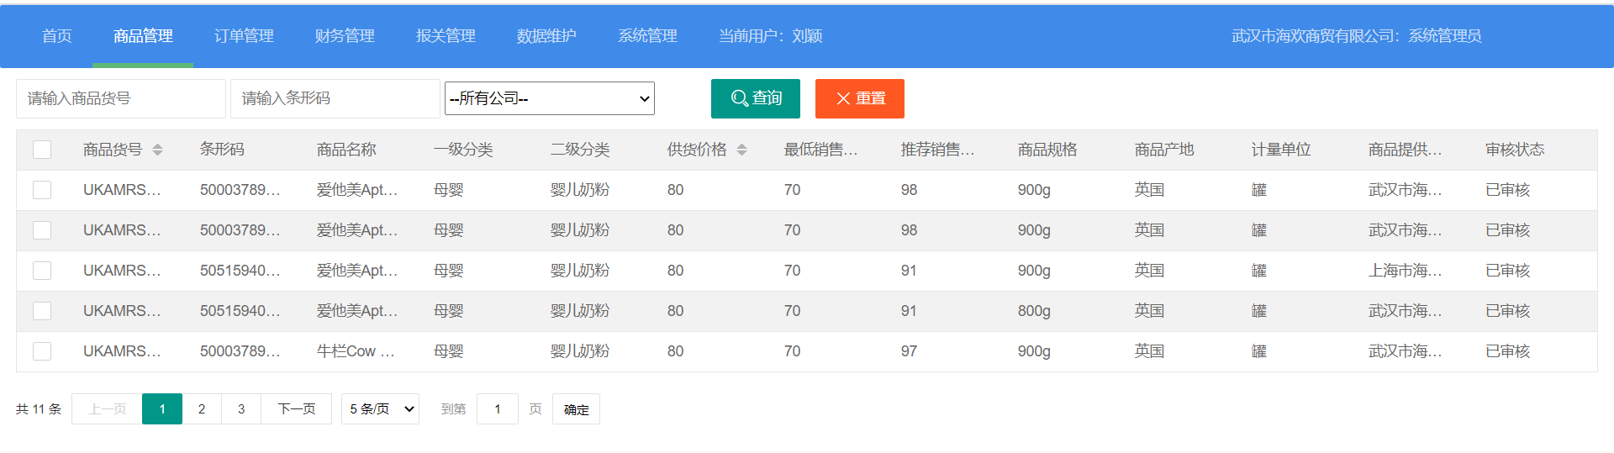

4.2组合查询

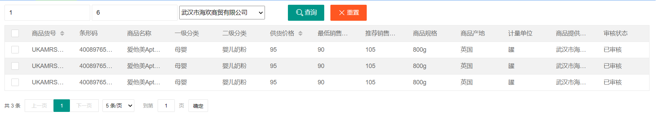

4.3模糊查询



4.4分页显示

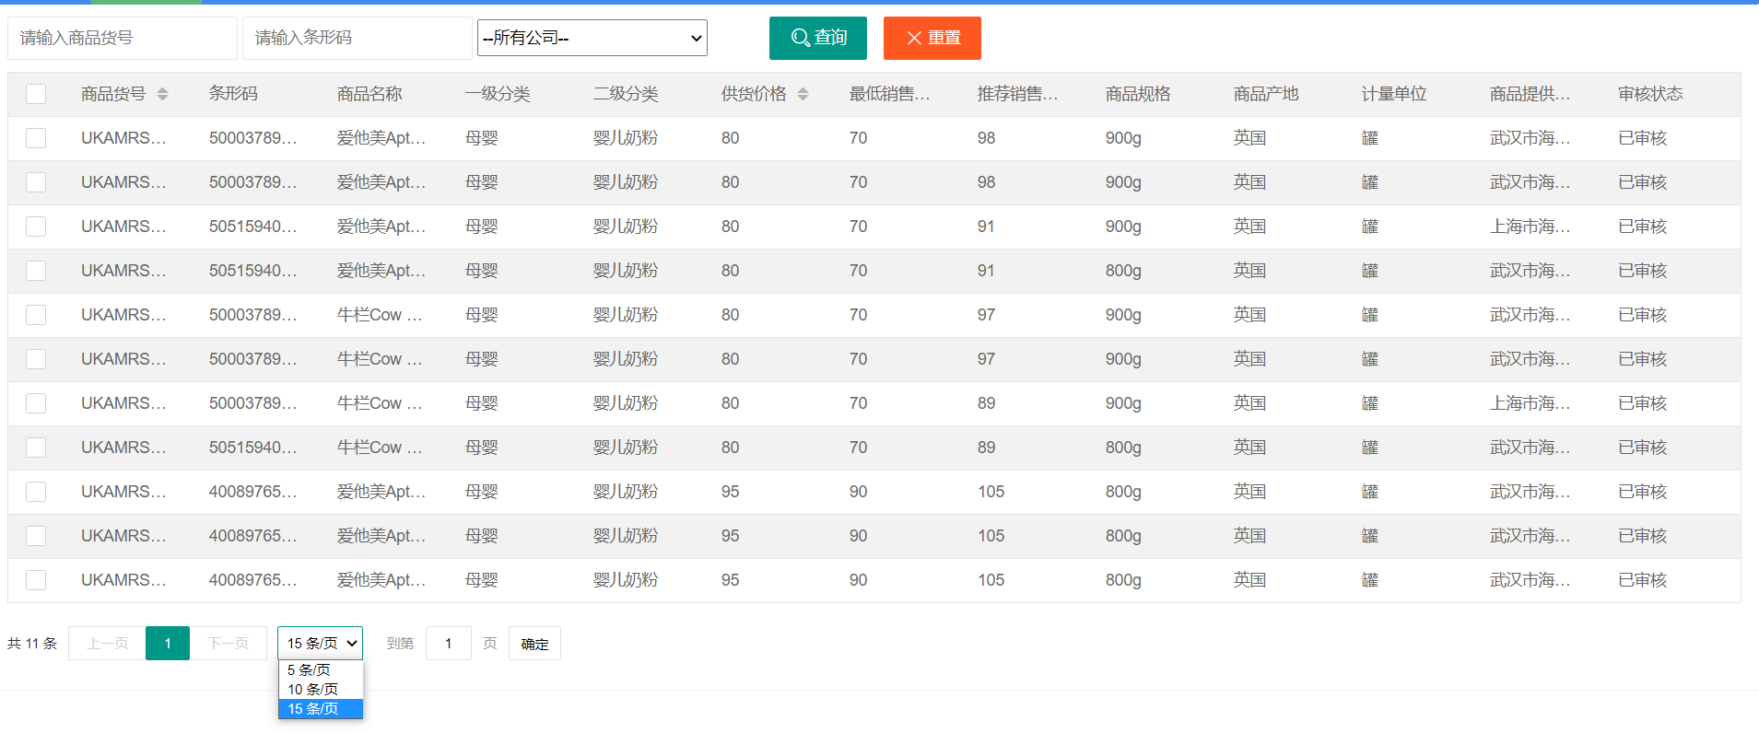

# 5 系统总结

本次作业我最开始使用的是bootstrap框架，但是由于之前没有使用过这个框架，所以对框架的组件和组件的功能不是很熟悉，使用的时候往往达不到预期的效果，页面的布局也写得比较混乱，加上bootstrap是英文文档，我学习起来也有一定的困难，所以最后我选择使用layui和vue实现页面效果。

后端的代码使用mybatis generator生成bean、dao、mapper包，controller类使用get方法获取数据，service中用%实现模糊查询。

在完成作业的时候经常出现一些错误信息，我一般通过查看相关博客的方式来解决，有时也会请教同学。在请教同学的过程中，我不仅解决了问题，也学习到了这些优秀同学的学习方法，也通过他们我知道了一些我之前没有了解过的技术。在前端开发方面我还有很多需要学习的地方，也还有很大的进步空间。未来我会利用课余时间通过文档、视频等方式继续学习前端开发，开拓自己的眼界，增强自己的实践能力和技术知识。