KNOWN app: build outline and flowchart
Oct 2, 2026 · @Rhidaya

Summary
Build KNOWN as one React Native (Expo) app for iOS and Android, with every Moment stored only on her phone and no accounts. The current KNOWN Design Lab prototype becomes the spec: its flow, copy, Scripture and matrix move into the app as bundled content files, and the judge panel becomes a developer-only build.
What the app carries over from the Design Lab build:
- Five languages: English, Burmese, Simplified Chinese, Japanese and Arabic (right-to-left), each with its own public-domain Bible (WEBBE, 和合本, 口語訳, Judson, Van Dyck).
- Four steps: Feel → Scripture → Pray → After (keep, reach out, sit longer, finish).
- Two ways in: four pictures (internal keys S, F, A, J, never shown) or her own words, matched to one of 11 reviewed stories.
- Safety layer: a crisis check on her words, a Help screen (findahelpline.com, local emergency number, message my guide) and paused moments that delete themselves after 3 days.
One decision changes with the move to a real app: matching her own words and translating her message need an AI service. On a phone that means a small KNOWN server that passes her words to the model and stores nothing. Pictures, Scripture, prayer and Moments all work offline.

User journey flowchart
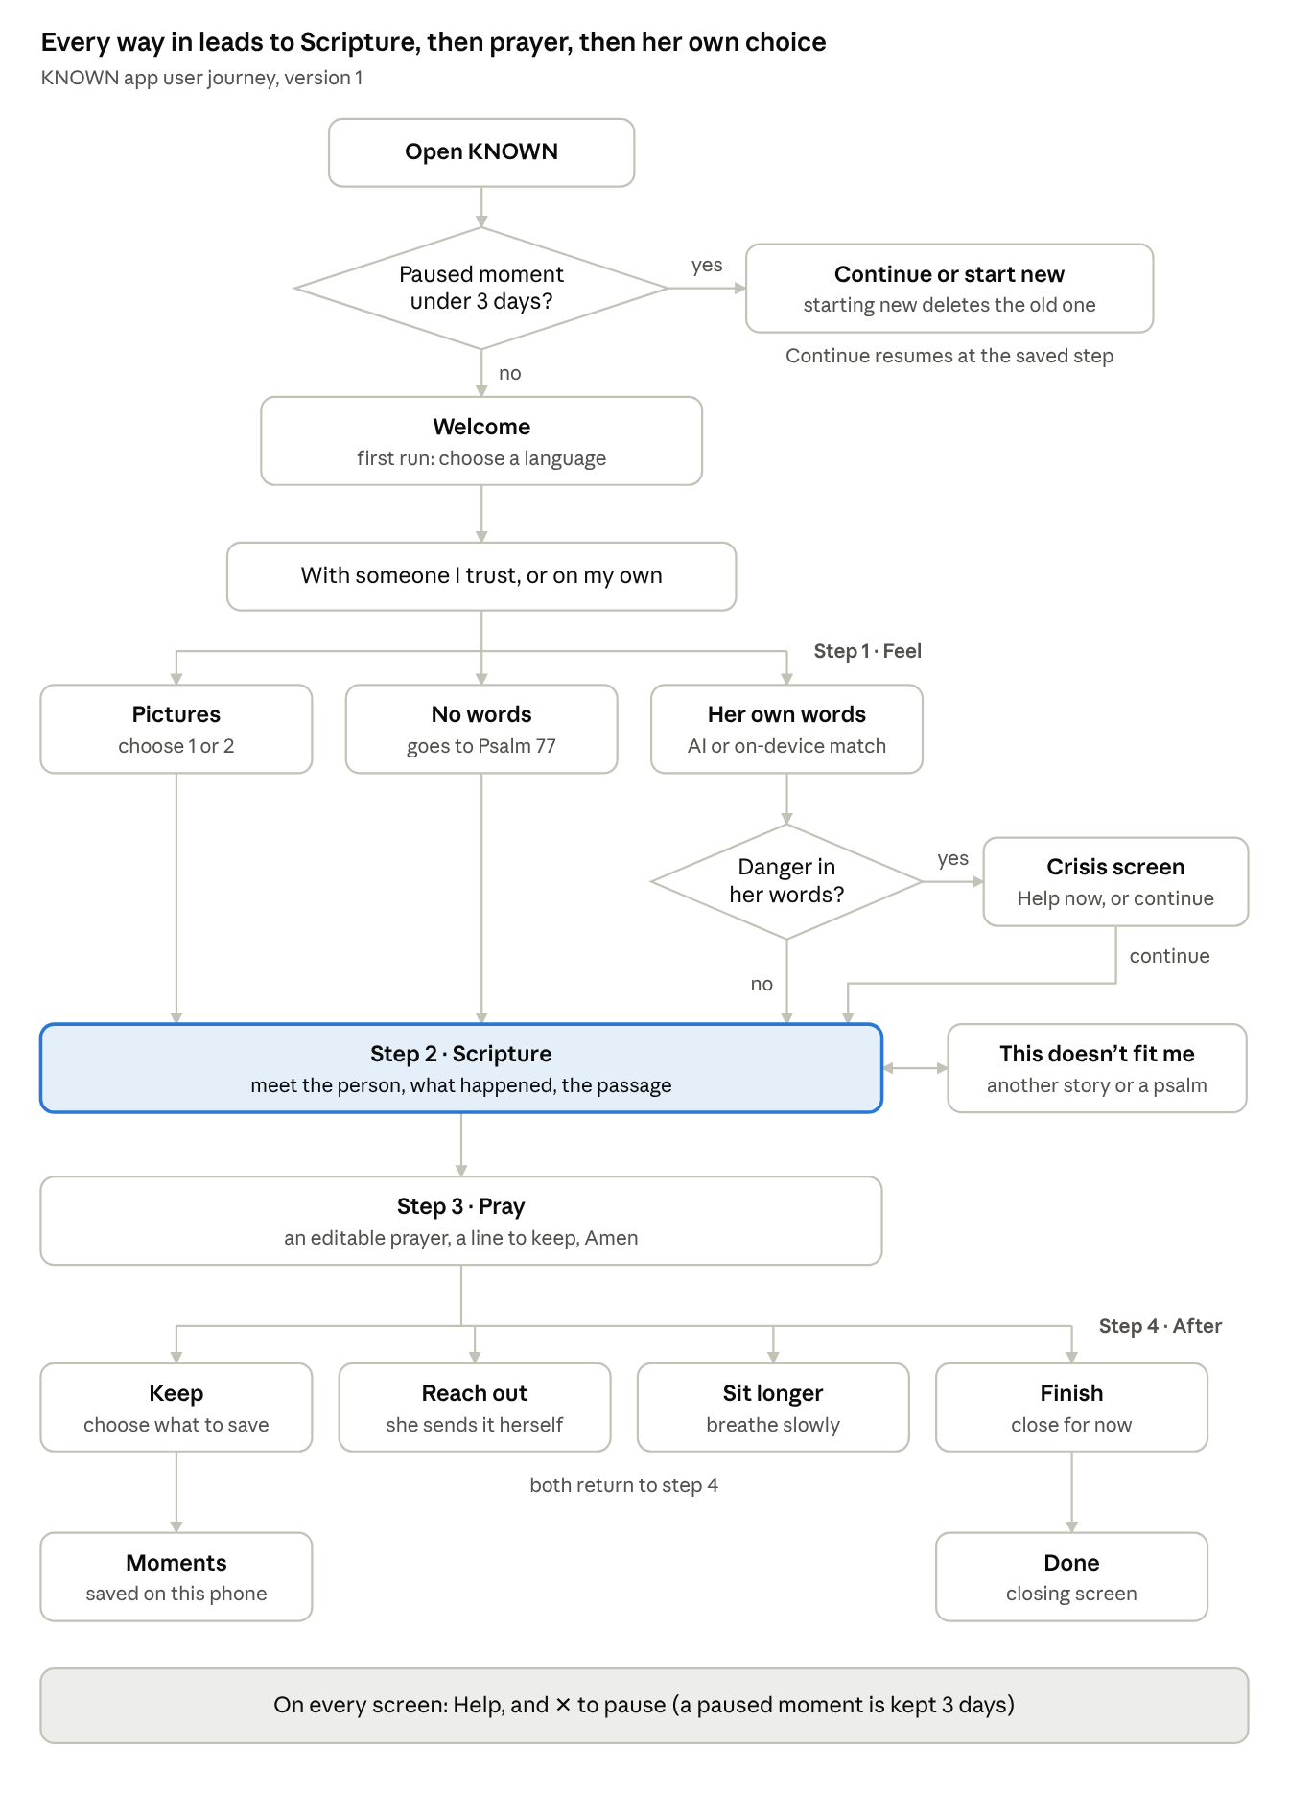
user journey · 4 steps, 3 ways in, 2 checks
Pictures, no words and her own words all land on Scripture; only her own words pass through the danger check, and Help is one tap away throughout.

Development flowchart
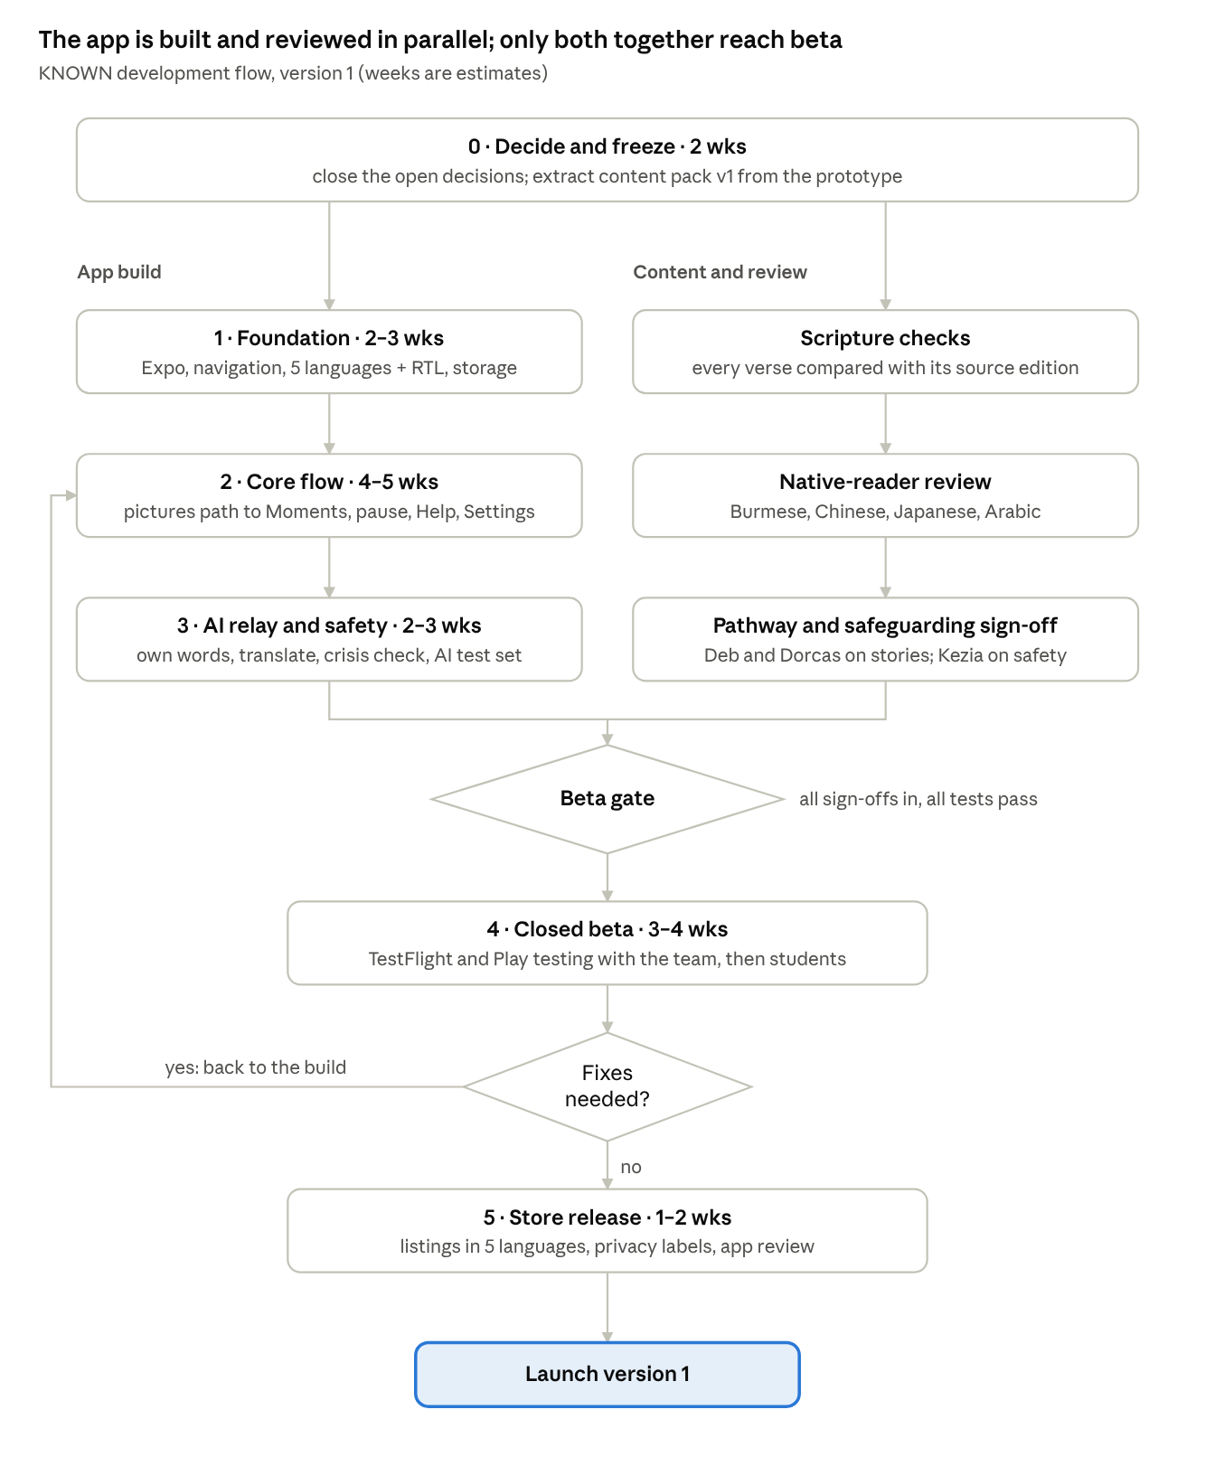
development flow · 6 phases, 2 parallel tracks, 1 gate
Content review runs beside the build from week 3, so native readers and Kezia are not a queue at the end; beta fixes loop back into the build until none remain.

Tech stack and architecture
The app is three parts: the phone app, a bundled content pack, and one stateless AI relay.
Layer | Choice | Why
App framework | React Native + Expo, TypeScript, Expo Router | One codebase for iOS and Android; the prototype's JS logic ports almost directly
On-device storage | Encrypted SQLite (op-sqlite with SQLCipher), key in iOS Keychain / Android Keystore | Moments hold her own words; encrypted at rest, never synced
Preferences | MMKV | Language and theme only
Content pack | Versioned JSON: Scripture, stories, prayers, breath lines, matrix, UI strings | Reviewed content ships with the app and works offline
Languages | i18next + I18nManager for Arabic RTL; Noto fonts bundled | No network fonts; Burmese and Arabic render correctly
AI relay | One serverless function (e.g. Cloudflare Workers) calling the Claude API | Keeps the API key off the phone; no logging of request bodies
App integrity | Apple App Attest / Google Play Integrity + rate limits on the relay | Only the real app can call the relay
Crash reports | Sentry with all text fields scrubbed, or none in v1 | Find bugs without collecting her words
Builds | EAS Build and EAS Submit | Store builds without a Mac for every developer
The AI relay accepts two calls only: match (her words → one library key, a one-line reason, a risk flag) and translate (her message → translation + back-translation). The app accepts only keys that exist in its bundled content pack, so the AI can never send her to a passage the team has not reviewed. If the relay is unreachable, the on-device keyword matcher from the prototype runs instead, and translation shows the copy-only fallback.

Screens and features (version 1)
Version 1 ships the Design Lab flow as it stands; nothing new is added until the team signs off.
# | Screen | What it does | Notes for the build
1 | Language | First-run choice of 5 languages | Switching to Arabic flips layout (RTL)
2 | Welcome | Title, privacy line, Begin, Your Moments, Help | Shows recovery prompt if a paused moment exists
3 | Using KNOWN with someone? | With someone I trust / On my own | Trusted mode adds one orientation screen
4 | Feel (step 1) | Tabs: Pictures (choose 1–2) or My own words | "I don't have the words" → Psalm 77
5 | Thinking | Shown while the relay matches her words | Timeout after ~8 s → on-device matcher
6 | Crisis | Shown if her words suggest danger | Help now, or continue to Scripture
7 | Scripture (step 2) | Scene art, Meet, What happened, passage, Why this story | Doesn't-fit sheet: alternate story or a lament psalm; YouVersion link
8 | Pray (step 3) | Editable prayer, a line to keep, Amen | Breath prayer lines per story
9 | After (step 4) | Keep / Reach out / Sit longer / Finish
10 | Reach out | To, what would help, editable message, translate + back-check, copy or share sheet | KNOWN never sends; uses the phone's share sheet
11 | Sit longer | Breathing timer with the story's two lines | Respects reduce-motion
12 | Keep | Checkboxes for what to save | Saves only what she ticks
13 | Done | Closing
14 | Moments | List, open, resume paused, delete | Translate-on-open prompt for other languages
15 | Help | findahelpline.com, local emergency number, message my guide | Reachable from every screen
16 | Settings | Language, appearance, delete everything
Pause (✕ on any session screen) saves the step; a paused moment is deleted after 3 days or when she starts a new one.

Data model and privacy
Everything she writes stays in an encrypted database on her phone; the relay sees her words only for the seconds a match or translation takes.
Table | Fields | Kept until
prefs | language, theme, first-run done | She changes or deletes them
session | started at, language, step, selection or words, path, prayer, message draft | 3 days, or she starts a new moment
moments | id, kind (moment / prayer / paused), saved at, language, path key, chosen line, her words, prayer, message | She deletes it, or "Delete everything"
content_meta | content pack version | Next app update
Rules the build must keep:
- No account, no sync, no analytics on her content; the app works fully in airplane mode except own-words matching and translation.
- Before her words leave the phone, the screen says so (the prototype's AI note); she can always use pictures instead.
- The relay keeps no request bodies, logs only counts and errors, and the Claude API is used under zero data retention.
- Moments are excluded from iCloud and Google backups, so deleting the app deletes them.
- Paused-moment cleanup runs at launch and when Moments opens, using the device clock.
Open privacy question: the brief says personal words aren't kept, but paused moments keep her words for 3 days. Kezia and Dorcas need to confirm that rule before build.

Content pipeline
Content moves out of the code into a reviewed content pack, so Deb and Dorcas can change words without a developer.
- Extract: pull PASSAGES, BOOKS, VERSIONS, PATHS, MATRIX, BREATH, LAMENTS and UI strings out of the prototype into one JSON file per language.
- Source of truth: keep the pack in a shared spreadsheet or a Git repo; each row carries a status (draft, in review, approved) and a reviewer.
- Check Scripture: an automated test compares every verse with its public-domain source file and fails on any difference, missing verse or cut-off final verse.
- Review: Deb signs off each pathway; native readers sign off Burmese, Chinese, Japanese and Arabic copy; Kezia signs off anything touching crisis or Help.
- Build: a script validates the pack (every key in all 5 languages, no emotion words shown to users, story text never labelled as Scripture) and bundles it into the app.
Items already waiting for review carry straight into this pipeline:
- ☐ Native Burmese reader for Judson text, UI copy and book names
- ☐ Native Arabic reader for Van Dyck text, UI copy and RTL layout
- ☐ Deb's review of the lament psalms (61, 13, 62, 56, 139) and the breath prayer lines
- ☐ Deb and Dorcas sign-off on the pathways not from Deb's research
- ☐ Confirm CUV Habakkuk 1:2's leading 他说： against print
- ☐ Confirm the YouVersion links: Burmese JBMLE and Japanese 1819 are not the editions shown in the app

Safeguarding, accessibility and QA
The AI is the riskiest part of the app, so it gets the strictest guardrails and its own test set.
Safeguarding
- The crisis check runs on the phone first (the prototype's keyword list in 5 languages), then the relay's risk flag; either one shows the Crisis screen.
- The AI picks a story and writes one sentence; it never quotes or interprets Scripture and never names her feelings to her. The prototype's prompt also asks for a feelings field, which should be dropped or kept internal only, to hold the "AI never determines her emotions" boundary.
- A test set of 200+ real-style sentences in all 5 languages, including crisis phrasing, is run against every prompt change; Kezia reviews the results.
- Help numbers and links are checked before each release; findahelpline.com must work in every language.
Accessibility
- VoiceOver and TalkBack labels on every control; picture choices described in words.
- Dynamic Type up to the largest size without clipping; RTL mirroring checked in Arabic.
- Reduce Motion turns off the breathing animation and transitions.
QA
- Port the 34-check smoke test to Jest + React Native Testing Library, and add Maestro end-to-end flows for all 10 selections, no-words, own-words and pause-and-resume.
- A test clock replaces the judge panel's time travel, so the 3-day cleanup can be tested.
- TestFlight and Play internal testing with the team, then a small closed beta with students.

Phases, owners and open decisions
With one or two developers, version 1 is roughly 14–18 weeks from content freeze to both stores; the weeks below are estimates to adjust once a developer is in place.
Phase | Weeks (est.) | Delivers | Owners
0. Decide and freeze | 2 | Signed-off flow, open decisions closed, content pack v1 extracted | Dorcas, Ben, Deb, Kezia
1. Foundation | 2–3 | Expo project, navigation, theming, 5 languages + RTL, encrypted storage | Developer
2. Core flow | 4–5 | Pictures path, Scripture, Pray, After, Keep, Moments, pause and recovery, Help, Settings | Developer, Ben
3. AI relay and safety | 2–3 | Relay, App Attest / Play Integrity, own-words, translate, crisis screen, AI test set | Developer, Kezia
4. Review and beta | 3–4 | Native-reader and safeguarding sign-off, accessibility pass, TestFlight and Play closed beta | Whole team
5. Store release | 1–2 | Store listings in 5 languages, privacy labels, age rating, submission | Dorcas, Developer
Decisions to close in phase 0:
- ☐ Who builds it: in-house developer, contractor or agency
- ☐ Keep own-words matching in v1, or ship pictures-only first and add AI in v1.1
- ☐ Paused moments: keep her words for 3 days, or delete on pause
- ☐ Figma flow vs. Design Lab flow: the feeling-word layer and choose-who-to-meet step in Figma are not in this build
- ☐ The 6 dropped features from the comparison doc (reminders, companion invite and others)
- ☐ Which organisation publishes the app (developer accounts: Apple $99/yr, Google $25 once)
- ☐ Name collision: the Figma companion "Hannah" and the biblical Hannah pathway

