Institution’s Innovation Council IIC-CARE
REPORT ON
AUTOMATION PROGRAMMING WORKSHOP
Date & Time : 30-01-2026 & 01.30 am to 5 pm | VENUE : CSE LAB – 1

The Automation Programming Workshop was organized to introduce students to automation concepts and programming techniques.
The session covered fundamental concepts, practical demonstrations and real-world applications of automation programming.
Students actively participated in the session and gained practical exposure through demonstrations and interactive activities.
Poster:
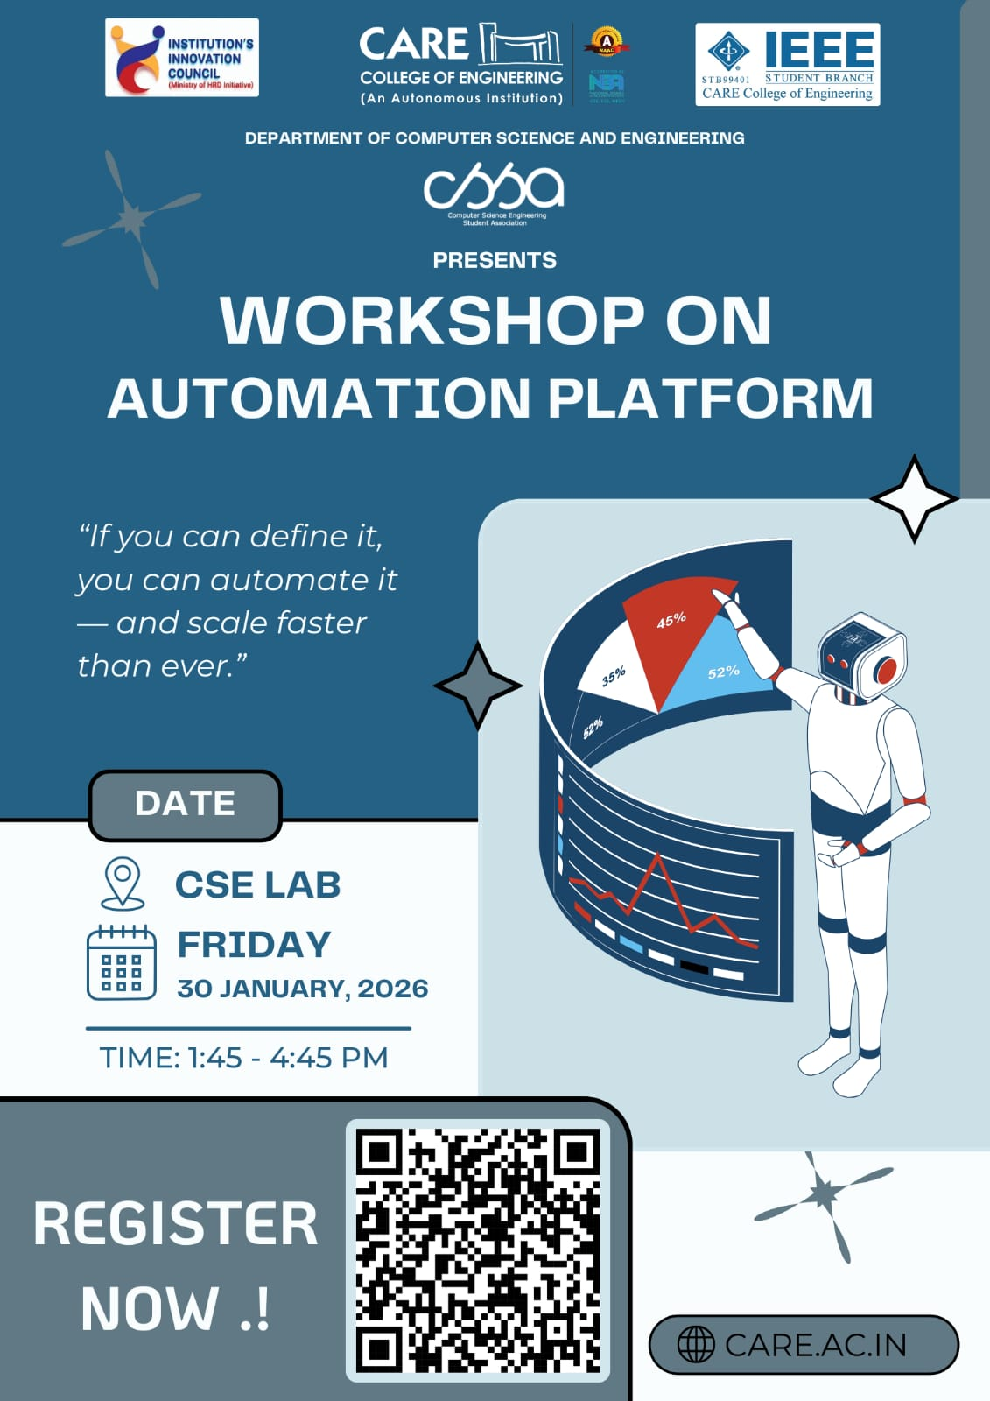
Figure 1: Poster
Photos



Principal



