Quan Zhou
Large Language Models for Reading Passage Generation:
A Closed-Loop Approach to Difficulty Adaptation

Master’s Thesis
Faculty of Information Technology and Communication Sciences
Mika Saari
April 2026

ABSTRACT
Quan Zhou: Large Language Models for Reading Passage Generation: A Closed-Loop Approach to Difficulty Adaptation
Master’s Thesis
Tampere University
Faculty of Information Technology and Communication Sciences
April 2026

This thesis investigates how large language models can be used to generate reading materials that are usable, controllable, and analysable for graded English reading practice. Traditional approaches to reading material preparation are costly and slow to update, making them ill-suited to personalised learning and dynamic difficulty adaptation. Although large language models demonstrate strong capabilities in text generation and rewriting, direct prompting often fails to satisfy target length, target difficulty, and content fidelity constraints in a stable manner. To address this problem, this thesis designs and implements a closed-loop system for reading passage generation and difficulty adaptation, integrating passage generation, readability evaluation, iterative rewriting, result archival, and statistical analysis into a unified workflow.
Methodologically, the thesis operationalises reading difficulty as a calculable metric target and models closed-loop adaptation as an iterative Generate-Evaluate-Adjust-Archive-Analyse process. The system first generates an English reading passage according to a specified topic, target level, and target word count. It then evaluates target difficulty using a composite difficulty signal, referred to in this thesis as the grade-family mean, which consists of Flesch-Kincaid Grade, Automated Readability Index, Coleman-Liau Index, and Gunning Fog, while retaining Flesch Reading Ease as a monitoring signal. During the difficulty adaptation stage, the system employs a constrained replacement-only rewriting strategy and constructs a Content Fidelity score from the recall of entities, numbers, and keywords in order to balance difficulty alignment against semantic preservation. In addition, the system supports local data archival, batch experiment logging, and multidimensional statistical analysis, thereby providing a basis for later reproduction and academic evaluation.
Two categories of experiments were conducted around the system: direct passage generation and closed-loop difficulty adaptation. The results show that direct prompting can produce broadly usable reading passages, but its difficulty control remains unstable; in the final reporting subset, the maximum hit rate of the direct-generation task was 31.6%. By contrast, closed-loop difficulty adaptation substantially improved target alignment, achieving hit rates from 92.5% to 98.8% within the final experimental scope while maintaining fidelity at approximately 0.92 to 0.93. These findings indicate that, in graded reading scenarios, difficulty control is more effective when reformulated as a feedback-driven iterative optimisation problem rather than a one-shot prompting problem. The principal contributions of this thesis are fourfold: it proposes a closed-loop difficulty adaptation framework for educational text generation; develops an adaptation mechanism that jointly considers difficulty alignment and content fidelity; implements a dynamic reading-material system that is operational, archivable, and analysable; and empirically validates the effectiveness of the proposed approach in the context of reading passage generation.

Keywords: large language models; reading passage generation; readability control; closed-loop difficulty adaptation; graded English reading

The originality of this thesis has been verified using the Turnitin Originality Check service.

USE OF AI IN THESIS

I have utilised AI tools in my thesis:

☐ No
☑ Yes

The AI tools utilised in my thesis and their purposes are described below:

Names and versions of AI tools: OpenAI Codex

Purpose of using AI tools: text editing during the thesis process, including code writing, code revision, and language polishing.

Sections where AI tools were used: AI was applied in implementation-related work, scripting, and the editing of thesis text.

I acknowledge that I am fully responsible for the entire content of my thesis, including the parts generated by AI, and accept accountability for any violations of ethical standards in publications.

Preface
This thesis was written as part of my research on the use of large language models for reading passage generation and difficulty adaptation. During this work, I also had the opportunity to witness the rapid development of AI technologies, which made the study not only academically meaningful but also personally inspiring. The speed of recent progress has been remarkable, and it has been exciting to explore how these technologies may contribute to language education in practical and responsible ways.
I would like to express my sincere gratitude to my supervisor for the valuable guidance, patience, and support provided throughout the completion of this thesis.

Tampere, 28 April 2026
Quan Zhou
CONTENTS
1 Introduction 1
1.1 Research Background 1
1.2 Research Objectives and Research Questions 2
1.3 Research Methods and Technical Route 3
1.4 Thesis Structure 4
2 Background 5
2.1 Graded Reading and Educational Content Generation 5
2.2 Related Research on LLM-Based Educational Text Generation and Difficulty Adaptation 5
2.3 Readability Theory 7
2.4 Research Gap and Positioning of This Study 9
3 Methodological Design 10
3.1 Research Paradigm and Overall Approach 10
3.2 Definition of the Closed-Loop Workflow 10
3.2.1 Difficulty Definition and Hit Rules 11
3.2.2 Length Control and Length Compensation 12
3.2.3 Closed-Loop Difficulty Adaptation Strategy 13
3.2.4 Content Fidelity Constraints 14
3.3 Experimental Task Design and Evaluation Metrics 15
4 System Design and Implementation 18
4.1 Overall System Architecture 18
4.2 Module Design 18
4.2.1 Passage Generation Module 19
4.2.2 Difficulty Adaptation Module 22
4.2.3 Experimental Support Module 25
4.3 Data Archival and Analysis 27
4.4 Front-End Interaction and User Workflow 28
5 Experimental Results and Discussion 30
5.1 Overview of Experimental Settings 30
5.2 Task A: Direct Generation 30
5.2.1 Performance Across Different Models 30
5.2.2 Analysis of Level Drift in Task A 31
5.3 Task B: Closed-Loop Difficulty Adaptation 32
5.3.1 Performance Across Different Models 32
5.3.2 Cost and Residual-Drift Analysis 33
5.4 Discussion 35
6 Conclusion 37
6.1 Research Conclusions 37
6.2 Limitations and Threats to Validity 38
6.3 Future Work 39
REFERENCES 41

List of Figures
Figure 1. Closed-loop workflow for passage generation and difficulty adaptation 11
Figure 2. Request validation schema 19
Figure 3. Structured response schema 20
Figure 4. Prompt for article generation 20
Figure 5. Core generation and candidate selection logic 21
Figure 6. Prompt for difficulty adaptation 23
Figure 7. Iterative Difficulty Adjustment Algorithm 24
Figure 8. Code for job builder 26
Figure 9. Difficulty drift across target levels in Task A. 32
Figure 10. Hit rate and fidelity after closed-loop adjustment. 33
Figure 11. Residual drift after closed-loop adjustment. 34
Figure 12. Average token cost across models. 35

List of Tables
Table 1. Overall performance of direct generation in Task A 31
Table 2. Overall results of closed-loop difficulty adaptation in Task B 33

List of Symbols and abbreviations
AI Artificial Intelligence
API Application Programming Interface
ARI Automated Readability Index
ASL Average Sentence Length
ASW Average Syllables per Word
$C$ Number of characters
CLI Coleman-Liau Index
$CP$ Percentage of complex words
$D$ Normalized distance between observed difficulty and target center
EFL English as a Foreign Language
FK Flesch-Kincaid Grade
FRE Flesch Reading Ease
GF Gunning Fog
$h$ Half-width of the target interval
IELTS International English Language Testing System
JSON JavaScript Object Notation
$L$ Average number of letters per 100 words
LLM Large Language Model
$M_{grade}$ Grade-family mean
$P$ Average number of sentences per 100 words
RQ Research Question
$W$ Number of words
a Lower bound of the target interval
b Upper bound of the target interval
c Center of the target interval

Introduction
  - Research Background
In English reading instruction, graded reading practice, and personalised learning scenarios, teachers and content designers must continuously provide reading materials that vary in topic, length, and difficulty level. For the same topic, different learners often require multiple versions at different difficulty levels to match their current reading ability and instructional goals. Traditional manual writing methods retain advantages in content quality and pedagogical appropriateness, but they are usually expensive, slow to update, and difficult to scale in batch production. Consequently, they are poorly suited to high-frequency, dynamic, and stratified content supply.
With the rapid development of large language models in text generation, rewriting, and style control, the automatic generation of reading materials has become a practically viable direction [1][2]. Existing studies indicate that large language models can produce educational texts approximating a target style under prompt constraints and can also perform a degree of graded rewriting and readability control [1][2]. However, within educational applications, generating fluent text is not equivalent to generating reading materials that are directly usable for instruction. At a minimum, a system for graded reading practice should satisfy the following requirements simultaneously: first, output difficulty should be stably controllable; second, text length should remain close to pedagogical requirements; third, rewriting should preserve original content and key information as much as possible; and fourth, results should be archivable, comparable, and analysable so as to support later replication and continuous optimisation.
Accordingly, this study is not concerned with the general question of whether large language models can generate reading texts. Rather, it addresses a more specific engineering and research problem: how to construct an operational, verifiable, and reproducible closed-loop system that enables large language models to achieve stronger controllability and practical usability in the context of reading-material generation.
Analysis of system development and pilot data revealed two prominent problems. First, although direct prompting usually produces grammatically correct and topically relevant passages, control over length and difficulty remains unstable, and lower-level texts tend to be systematically shorter than intended. Second, when adapting an existing text to a specified target difficulty, prompts such as "rewrite it to be simpler" or "rewrite it to be more difficult" often produce only directional change rather than stable convergence into the desired target range, while also introducing risks of factual drift or the loss of key information.
These observations suggest that difficulty control in graded reading-material generation should not be treated merely as a prompt-design problem, but also as a text adaptation problem related to simplification and controlled rewriting [6][7]. It is more appropriately formulated as a control problem with feedback [3]. In other words, the system should first produce candidate texts and then evaluate and iteratively refine them using readability metrics, content fidelity signals, and engineering constraints, rather than accepting the result after a single model call. Motivated by this view, the thesis focuses on closed-loop difficulty adaptation and its systematic implementation.
  - Research Objectives and Research Questions
This thesis designs and implements a dynamic reading-material system for graded English reading practice that includes passage generation, difficulty adaptation, result archival, and statistical analysis, and it evaluates the system experimentally with respect to controllability and usability. The specific research questions are as follows:
RQ1. Can direct prompting satisfy both length and difficulty constraints for reading passage generation at the same time?
This question examines the practical reliability of one-shot generation. Its purpose is not merely to test whether LLMs can generate readable passages, but whether they can generate passages that simultaneously satisfy two concrete instructional requirements: approximate target length and acceptable target difficulty.
RQ2. Can a closed-loop feedback mechanism significantly improve the hit rate for target difficulty?
This question investigates whether iterative evaluation and adjustment can outperform direct prompting as a control strategy. It focuses on the extent to which feedback-based adaptation can increase the proportion of outputs that fall within the predefined target difficulty bands.
RQ3. Can improved difficulty control be achieved without substantially damaging content fidelity?
This question evaluates whether the gains produced by closed-loop adaptation remain educationally acceptable. It addresses the trade-off between metric alignment and semantic preservation, asking whether the system can improve difficulty accuracy while still retaining the key information and meaning of the source text.
These research questions together define the central problem of the thesis: how to transform LLM-based reading material generation from a loosely guided prompting task into a measurable, controllable, and reproducible educational text-production process.
In response to these questions, the study pursues four closely related objectives. First, it seeks to build an operational system for reading-material generation and difficulty adaptation rather than offering only a conceptual framework. This means implementing a complete workflow in which reading passages can be generated, evaluated, adjusted, archived, and later analysed within a unified platform. Second, the study aims to represent reading difficulty as a calculable and comparable target so that the system can move beyond vague prompt labels such as “easy” or “difficult” and instead rely on explicit metric-based judgement. Third, it seeks to design a closed-loop adaptation strategy in which generated outputs are iteratively evaluated and revised toward the target difficulty range while preserving the semantic integrity of the source content as far as possible. Finally, the thesis aims to validate experimentally whether such a system can provide meaningful advantages for the controlled production of educational texts by examining its performance in terms of target hit rate, deviation, fidelity, and related indicators. Taken together, these objectives define the broader purpose of the study: to transform LLM-based reading-material generation from a loosely guided text-generation task into a measurable, controllable, and reproducible process for educational use.
  - Research Methods and Technical Route
The thesis adopts a research route that combines system construction with experimental validation. On the one hand, a fully operational platform is implemented by integrating front-end interaction, back-end business logic, model adaptation, archival management, and statistical analysis. On the other hand, batch experiments are conducted to evaluate both direct passage generation and closed-loop difficulty adaptation, using automatic metrics to analyse hit rate, deviation, fidelity, and cost.
Technically, the system treats large language models as the core text-generation engine and uses readability indicators together with content fidelity scoring as feedback signals, in line with recent iterative refinement approaches that combine generation with subsequent feedback-based revision [3] .Task execution and logging are organised through a five-stage Generate-Evaluate-Adjust-Archive-Analyse workflow. At the evaluation level, the thesis focuses on hit rate, length deviation, average rounds, fidelity, residual drift, and token cost as key indicators of system performance, and the implications and limitations of these results are discussed later.
  - Thesis Structure
The remainder of the thesis is organised as follows.
Chapter 2 introduces the research background and theoretical foundations, including educational content generation, graded reading, readability theory, and prior work on LLM-driven text difficulty adaptation.
Chapter 3 presents the methodological design, including the research workflow, the definition of difficulty, fidelity constraints, experimental tasks, and evaluation metrics.
Chapter 4 describes system design and implementation, focusing on the system architecture, the passage-generation module, the difficulty-adaptation module, the archival and statistical-analysis modules, and the front-end interaction flow.
Chapter 5 reports and discusses the experimental results, analysing system performance in both direct-generation and closed-loop adaptation tasks and examining strengths, limitations, and threats to validity.
Chapter 6 concludes the thesis, reviews the extent to which the research objectives were achieved, and outlines directions for future improvement.

Background
  - Graded Reading and Educational Content Generation
Graded reading emphasises the provision of texts whose difficulty is aligned with learners' reading ability, to balance comprehension burden, lexical challenge, and training effectiveness. In English teaching and EFL contexts, reading materials function not only as language input but also as vehicles for vocabulary learning, discourse comprehension, and assessment practice. Accordingly, the difficulty, length, topic, and pedagogical suitability of materials all affect their educational usefulness.
Traditional construction of reading resources relies primarily on manual writing, selection, or rewriting. Such methods are dependable in terms of quality control, but when a scenario demands the continuous production of materials across multiple topics, levels, and versions, manual approaches struggle to scale. The emergence of generative artificial intelligence provides a new technical pathway for reading-resource supply and gives practical plausibility to the idea of a dynamic reading-material engine.
  - Related Research on LLM-Based Educational Text Generation and Difficulty Adaptation
In recent years, large language models have been increasingly applied to educational text generation, reading-exercise design, automated feedback, and instructional support systems. Their value in education lies not only in their ability to produce fluent and contextually coherent text, but also in their potential to reduce the cost of content production, expand topic coverage, and support more flexible forms of personalised learning. For reading instruction, LLMs appear promising because they can generate passages on demand, rewrite existing materials for different learner groups, and potentially provide multiple versions of similar content under different difficulty requirements. These capabilities make them attractive for educational scenarios in which teachers or system designers need scalable production of reading materials that vary in length, style, and complexity.
Early work has already demonstrated the feasibility of applying large language models to reading-related educational tasks. Bezirhan and von Davier [4] showed that GPT-3 could be used to generate assessment-like reading passages, suggesting that prompt-based generation can produce texts that resemble target educational genres. Xiao et al. [5], from the perspective of reading-comprehension exercise generation, further indicated that the usefulness of LLMs in educational settings depends not only on the quality of generated text itself, but also on how such text is embedded into a broader pedagogical workflow. These studies collectively suggest that LLMs can produce educationally relevant material, but they also imply that generation quality alone does not guarantee instructional usability.
At the same time, research on LLM-supported text simplification, graded rewriting, and readability-controlled generation points to a more specific issue: controllability. In many educational scenarios, the task is not merely to generate a new passage, but to generate or revise a passage so that it aligns with a desired level of readability while preserving the essential meaning of the original content. Huang et al. [9] proposed a graded educational text-generation task and found that large language models could move outputs toward different readability levels, but that target mismatch and semantic distortion remained common challenges. Hsu et al. [10], in the related task of readability-controlled rationale generation, likewise reported that prompt-based level control often produced directional shifts rather than stable convergence to a target range. Kew et al. [11], through the BLESS benchmark on sentence simplification, further showed that different models vary substantially in simplification behaviour and editing strategies, which suggests that rewriting performance is model-dependent and often unstable [8].
These findings are important because they show that text difficulty adaptation is not equivalent to general text generation. Generating fluent passages is relatively easy for modern LLMs but generating passages that consistently satisfy explicit difficulty constraints is much harder. This distinction becomes even more significant in educational applications, where readability is tied to learner appropriateness and pedagogical effectiveness. A passage that isotopically relevant and grammatically correct may still be educationally unsuitable if it overshoots the learner’s reading level, undershoots the intended challenge, or changes important factual content during rewriting.
Another important line of literature concerns the evaluation of readability itself. Marulli et al. [12] argued that the readability of LLM-generated output should not be reduced to a single numerical score, because different formulas capture different aspects of surface-level textual complexity. This is especially relevant for educational text adaptation, where difficulty is inherently multidimensional and cannot be fully represented by one metric alone. The implication is that systems seeking to control educational text difficulty should avoid simplistic one-formula optimisation and instead adopt a more robust multi-indicator approach. This insight directly supports the methodological choice in the present thesis to use a composite grade-family signal rather than relying exclusively on a single readability index.
Related educational AI research also reinforces the need for stronger evaluation and control mechanisms. Scaria et al. [13], in the context of automated question generation across Bloom’s levels, concluded that LLM outputs can be pedagogically useful but still require careful assessment before use. A similar lesson emerges from reading-material generation studies: although model outputs may appear plausible at first glance, educational deployment requires filtering, revision, and validation.
Taken together, the literature reveals three broad patterns. First, LLMs have demonstrated clear potential for educational text production and adaptation. Second, existing studies consistently show that one-shot prompting is often insufficient for stable control over readability and level alignment. Third, semantic fidelity remains a major concern whenever models are asked to simplify, complicate, or otherwise rewrite text to alter its measured difficulty. As a result, the central unresolved issue is not whether LLMs can generate reading materials, but how such generation can be transformed into a measurable, controllable, and educationally reliable process.
Against this background, the present study positions itself at the intersection of educational text generation, readability control, and system-level design. Rather than focusing only on the generation quality of a single model or on isolated prompt performance, this thesis addresses the broader problem of how to integrate generation, evaluation, difficulty adjustment, fidelity protection, archival, and analysis into a unified closed-loop workflow. In this sense, the study extends prior work by treating difficulty adaptation as a feedback-driven control problem rather than as a single-step prompting task, and by examining controllability and semantic preservation together within an operational system for graded reading-material production.
  - Readability Theory
Reading difficulty is a multidimensional concept. It includes textual properties such as syntactic complexity, lexical difficulty, and information density, while also being influenced by reader background knowledge, task objectives, and context. Because reading difficulty in authentic instructional settings cannot be fully captured by a single indicator [20][21], readability formulas are commonly used in both research and engineering practice as approximate estimates of text complexity [14].
Flesch Reading Ease (FRE) [15] is one of the earliest and most widely used readability formulas and estimates reading ease through sentence length and syllable density. Flesch-Kincaid Grade (FK) [16] translates a similar logic into an approximate grade-level representation. The Coleman-Liau Index (CLI) [17] is based on character counts rather than syllables and is therefore more suitable for machine computation. Gunning Fog [18] places greater emphasis on the role of complex words in reading difficulty, while the Automated Readability Index (ARI) [19] provides another grade-like estimate using character counts and sentence length.
In the present system, readability computation is implemented consistently with the source code, and the core variables are defined as follows:
- Let $W$ denote the number of words, $S$ the number of sentences, $Y$ the total number of syllables, $C$ the total number of characters, and $CW$ the number of complex words.
- Let average sentence length be $ASL=W/S$.
- Let average syllables per word be $ASW = Y/W$.
- Let characters per 100 words be $L=100· C W$.
- Let sentences per 100 words be $P= 100 · S/W$.
- Let the percentage of complex words be $CP = 100 · CW/W$.
On this basis, the principal readability formulas used in this thesis are:
$$FRE = 206.835 - 1.015· ASL - 84.6· ASW$$
$$FK = 0.39· ASL + 11.8· ASW - 15.59$$
$$ARI = 4.71· \frac{C}{W}+ 0.5· ASL - 21.43$$
$$CLI = 0.0588· L - 0.296· P - 15.8$$
$$GF = 0.4· (ASL + CP)$$
Among these measures, a higher FRE value indicates that a text is easier to read, whereas higher FK, ARI, CLI, and Gunning Fog values indicate greater complexity. In the specific implementation, complex words are approximated as words whose syllable count exceeds three after simple suffix normalisation, and sentences are segmented through punctuation-based splitting.
These indicators are strongly related but not identical in the surface properties they capture. For educational text generation systems, relying on a single formula often leads to representational insufficiency, whereas requiring all formulas to fall within an extremely narrow target range risks making the objective unattainable. Accordingly, this thesis combines multiple indicators by taking the mean of FK, ARI, CLI, and Gunning Fog as the principal basis for difficulty judgement, while retaining FRE as an auxiliary interpretive signal.
  - Research Gap and Positioning of This Study
Despite the growing use of large language models in educational text generation and readability-related rewriting, a clear gap remains in controllable reading-material production for graded practice.
Existing research has shown that LLMs can generate or adapt texts, but the reported evidence also suggests that stable level alignment is still difficult to achieve through prompting alone. Prior studies have not sufficiently established a framework in which target difficulty is treated as an explicit and measurable control objective rather than as a loose prompt instruction.
A second gap concerns the control process itself. Although readability-related adaptation has been explored in prior work, difficulty change is often treated as a single-step generation or rewriting outcome rather than as the result of iterative evaluation and correction. This limits the practical reliability of the approach when outputs initially miss the desired target range.
A third gap concerns semantic preservation during adaptation. For educational reading materials, difficulty improvement is only meaningful if key content remains substantially intact. However, prior work has not adequately integrated fidelity protection into the difficulty-control process as a formal constraint on acceptance.
Accordingly, the present study is positioned at the system level. It addresses the above gaps by proposing a closed-loop framework for reading passage generation and difficulty adaptation in which difficulty is operationalised as a calculable target, adaptation is performed iteratively toward that target, and semantic fidelity is explicitly constrained throughout the adjustment process. In this way, the study seeks to transform LLM-based reading-material generation from a loosely guided text-generation task into a more measurable, controllable, and reproducible educational workflow.

Methodological Design
  - Research Paradigm and Overall Approach
This thesis adopts a methodology that combines system construction with experimental evaluation. The study first identifies system objectives based on actual instructional needs and literature review, then completes the design and implementation of a dynamic reading-material generation system and finally validates the system through batch experiments on direct generation and closed-loop adaptation tasks. This approach combines engineering practicality with research verifiability and is appropriate for addressing the questions of whether the system is usable, whether control is effective, and whether rewriting preserves content.
Overall, the study follows the process below:
- Clarify the application requirements of reading-material generation and difficulty adaptation.
- Review the relevant literature and determine the methodological entry point of the present study.
- Design and implement a reading-material generation and difficulty-adaptation system.
- Conduct direct-generation and closed-loop adaptation experiments.
- Analyse the experimental results and discuss system strengths, limitations, and future directions.
  - Definition of the Closed-Loop Workflow
The system follows a five-stage Generate-Evaluate-Adjust-Archive-Analyse workflow.
In the Generate stage, the system produces an initial passage according to the topic, target level, target word count, and model configuration.
In the Evaluate stage, the system computes word count, sentence count, readability metrics, and related statistical features to determine whether the current output satisfies the target constraints.
In the Adjust stage, the system performs difficulty adaptation, when necessary, iteratively rewriting the text toward the target difficulty and recalculating metrics after each round.
In the Archive stage, the text, metadata, experiment identifiers, hit status, token consumption, and adjustment history are written to local storage to support reproduction and later analysis.
In the Analyse stage, the archival results are aggregated into summary tables, statistical files, and figures for task comparison and thesis writing.
The key to this workflow is not the quality of a single generation result, but the transformation of text generation into a feedback-driven controllable process through which the system can continuously revise outputs based on measured indicators.
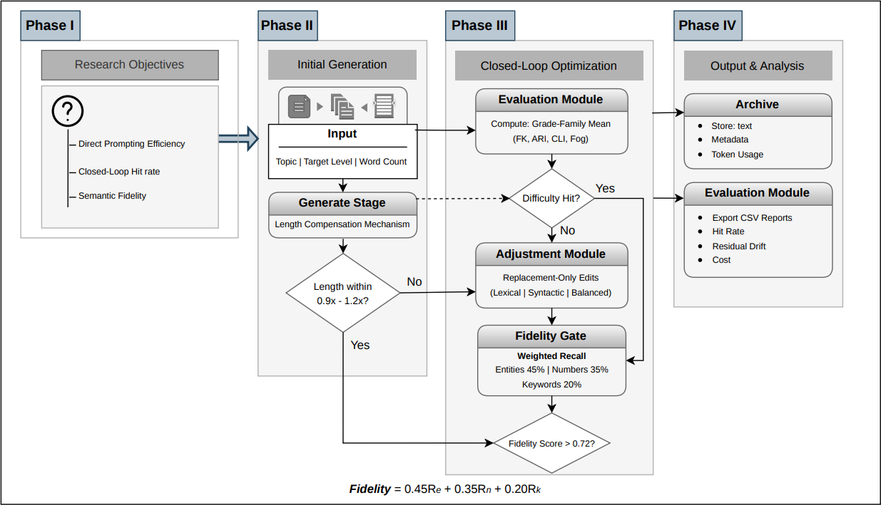
- Closed-loop workflow for passage generation and difficulty adaptation
The figure illustrates the core logic of the proposed method: the system does not treat model output as an endpoint, but as the starting point for subsequent measurement, filtering, and archival. The figure clarifies the layered logic of the framework and highlights the central role of feedback in improving controllability.
    - Difficulty Definition and Hit Rules
This thesis represents reading difficulty as a target range defined over multiple indicators rather than relying directly on natural-language labels such as "easy", "medium", or "difficult". For each target level, the system specifies a difficulty profile and uses the grade-family mean as the principal decision signal. The grade-family mean is the arithmetic mean of the following four metrics:
- Flesch-Kincaid Grade
- Automated Readability Index
- Coleman-Liau Index
- Gunning Fog
If these four indicators are denoted by $FK$, $ARI$, $CLI$, and $GF$, respectively, then the principal decision quantity is defined as:
$$M_{grade}=\frac{FK + ARI + CLI + GF}{4}$$
When the grade-family mean of a candidate text falls within the target interval corresponding to the requested level, the system counts it as a difficulty hit. At the same time, Flesch Reading Ease is retained as an auxiliary monitoring signal to help explain why a text has shifted toward greater ease or greater difficulty. The reason for using an interval rather than a point value is that authentic reading materials rarely correspond to one exact numerical value; rather, they occupy an acceptable band of complexity.
In the present system, the mean targets for the five levels are defined as follows: Level 1 corresponds to 6-8, Level 2 to 8-10, Level 3 to 10-12, Level 4 to 12-14, and Level 5 to 14-20. These intervals were calibrated with reference to common grade-band representations for English reading materials and the readability distributions observed in pilot data. Importantly, the final hit judgement does not require all four-component metrics to fall individually into the same narrow interval. Instead, the system requires only that their mean enter the corresponding level band. This design reduces the risk that the objective becomes unattainable through excessive multi-metric tightening.
    - Length Control and Length Compensation
Pilot experiments revealed a systematic under-length tendency in lower-level texts. A likely reason is that, unlike human writers, large language models do not complete a passage by continuously checking whether the output has already reached a required word count through an explicit hard constraint. Instead, the length instruction in a prompt is processed as part of the textual input through the model’s attention mechanism, together with topic, style, and difficulty instructions. As a result, the requested word count does not function as a strict stopping rule, but only as one conditioning signal among others. In practice, the observed pattern in this study was that LLM outputs tended to fall short of the word count requested in the prompt, especially when the target level was lower. To reduce this bias, the system introduces a level-specific length compensation strategy during generation.
If the target word count specified by the user is $W_{t}$, the requested level is $l$, and the level-specific compensation factor is $α_{l}$, then the effective target word count $W_{eff}$ used internally by the prompt is:
$$W_{eff}= max(80, round(W_{t}· α_{l}))$$
The compensation factors used by the system are:

- Level 1:$α_{1} = 1.40$
- Level 2: $α_{2} = 1.30$
- Level 3: $α_{3} = 1.05$
- Level 4: $α_{4} = 1.00$
- Level 5: $α_{5} = 1.00$
Compensated candidates are still evaluated against the user's original target word count. The system uses an acceptable range to filter candidates; when a result lies outside this range, the system retries and retains the candidate closest to the requested length. The essential nature of this strategy is engineering calibration rather than ex post relaxation of the evaluation standard.
More specifically, the acceptable range is defined as:
$$W_{low}= 0.9⋅W_{t}$$
$$W_{high}= 1.2⋅W_{t}$$
If a candidate falls outside this interval, the system enters a retry or candidate-selection process. This design ensures that length-control improvement is treated explicitly as a generation-stage calibration problem rather than as a post hoc adjustment of standards.
    - Closed-Loop Difficulty Adaptation Strategy
In the difficulty-adaptation task, the system first computes the current readability metrics of the input text and determines the adaptation direction based on its deviation from the target interval. It then invokes the large language model to perform one round of constrained rewriting and recalculates the metrics of the candidate text. If the candidate hits the target, the process terminates early. If it does not hit the target but is closer to the goal than the current text, the candidate can be retained as the input to the next round.
To reduce the high variance and semantic drift associated with full rewriting, this thesis adopts a replacement-only strategy, seeking to move the text toward the target through local substitutions and local structural adjustments. The system supports three principal rewriting variants:
1. A lexical variant dominated by lexical substitutions.
2. A sentence variant dominated by syntactic restructuring.
3. A balanced variant that combines lexical and syntactic modifications.
The purpose of this design is to narrow the scope of each single-round rewrite, improve control precision, and reduce both token cost and the risk of semantic distortion.
To quantify the condition of being closer to the target, the system evaluates not only whether the target is hit but also the normalised distance between the candidate and the centre of the target interval. If the target interval is $[a,b]$, its centre is $c=(a+b)/2$, its half-width is $h=(b-a)/2$, and the candidate's grade-family mean is $M_{grade}$, then distance is defined as:
$$D = \frac{\left|M_{\left\{grade\right\}}- c\right|}{h}$$
When $D$ decreases, the candidate is numerically closer to the centre of the target interval. This quantity functions as a local-improvement criterion in the closed loop, allowing the system to compare candidates even when none has yet reached the target band.
    - Content Fidelity Constraints
Difficulty adaptation should not come at the cost of substantial alteration of facts or core meaning. For this reason, the thesis introduces a fidelity-validation mechanism into candidate filtering. The system extracts entities, numbers, and keywords from the source text and computes their recall in the candidate text. Overall fidelity is obtained as a weighted combination of these three components: Entity recall, Number recall and Keyword recall.
If the three recalls are denoted by $R_{e}$, $R_{n}$, and $R_{k}$, then the overall fidelity score is defined as:
$$F = 0.45R_{e}+ 0.35R_{n}+ 0.20R_{k}$$
In the main workflow, a candidate must reach a predefined minimum fidelity threshold before it becomes eligible for acceptance. Some local heuristic acceptance rules apply a stricter threshold. Through this mechanism, the system prevents candidates with superficially improved readability metrics but severe information loss from entering the result.
The default threshold in the main workflow is $F ≥ 0.72$, while some stricter local acceptance rules require approximately $F ≥ 0.85$. These weights reflect the priority of factual reliability in educational texts: entities and numbers are more directly related to factual correctness and are therefore assigned higher weights, whereas keyword recall functions mainly as a supplementary signal of semantic coverage. Consequently, the system does not automatically accept a candidate simply because its difficulty metrics improve. Only candidates that satisfy the minimum fidelity requirement are allowed to continue competing in later rounds.
  - Experimental Task Design and Evaluation Metrics
To answer the research questions, the thesis organises two core experimental tasks.
Task A is a direct-generation task intended to examine the baseline performance of one-shot prompting in terms of length control and difficulty control. This task does not employ closed-loop correction; it considers only the usability and stability of the first-pass output.
Task B is a closed-loop difficulty-adaptation task designed to evaluate whether the introduction of feedback and fidelity constraints can significantly improve the target-difficulty hit rate while maintaining high semantic fidelity.
The core experimental results of the thesis are organised around these two tasks. Content related to comparison with reference corpora, extended statistical analysis, and certain pilot observations can be treated as supplementary analysis rather than being mixed into the principal results.
To assess the effectiveness of the proposed system, this study uses a set of evaluation metrics designed to reflect both control performance and practical usability. Since the purpose of the system is not merely to generate fluent text, but to generate or adapt passages in a controllable and reproducible way, the evaluation must consider whether outputs reach the desired target, how far they deviate when they miss, how much rewriting is required, whether meaning is preserved, and what cost is incurred during the process. Accordingly, the evaluation framework combines target- alignment metrics, process-efficiency metrics, fidelity-related metrics, and cost-related metrics.
The first core metric is hit rate. Hit rate measures the proportion of samples whose final difficulty falls within the predefined target interval for the requested level. In this study, the hit condition is determined primarily by the grade-family mean, that is, the arithmetic mean of Flesch-Kincaid Grade, Automated Readability Index, Coleman-Liau Index, and Gunning Fog. If the final value of this mean lies within the target band corresponding to the requested level, the sample is counted as a hit. Hit rate is the most direct indicator of whether the system can achieve reliable level control, because it reflects not just directional movement, but successful arrival within the acceptable target range.
A second important metric is length deviation. This metric is used mainly in the direct-generation task to examine how closely the generated passage matches the requested word count. In practical educational use, difficulty alone is not sufficient; passages must also remain reasonably close to the intended length so that they fit classroom tasks, exercise design, and reading-time expectations. Length deviation therefore measures the relative difference between the actual word count and the user-specified target word count. Lower deviation indicates better control of passage length and stronger adherence to instructional requirements.
To further describe target alignment, the study also uses residual drift. Residual drift refers to the remaining distance between the final grade-family mean and the target interval after the adjustment process. If a sample hits the target band, the residual drift is zero. If it falls below or above the band, the drift is measured as the distance from the nearest boundary of the target interval. This metric is useful because hit rate alone is binary: it distinguishes only between success and failure. Residual drift, by contrast, shows how close non-hit samples are to the target and therefore provides a more fine-grained view of control quality.
Another important metric is average rounds used. This metric records how many rounds of iterative adjustment are required before the process terminates. It reflects the operational efficiency of the closed-loop mechanism. A lower average number of rounds indicates that the system can reach the target more quickly, whereas a higher value suggests that more correction steps are needed. This metric is particularly relevant for comparing the practical behaviour of different models under the same adaptation framework, because it captures how efficiently each model responds to feedback.
Because readability improvement alone is not sufficient for educational usability, the study also evaluates content fidelity. Fidelity is intended to measure how well the adapted text preserves key information from the source passage. In the present system, the overall fidelity score is constructed from three recall-based components: entity recall, number recall, and keyword recall. Entity recall reflects whether named entities and core content items from the source text are retained. Number recall captures whether quantitative information, dates, and other numerical details are preserved. Keyword recall reflects whether the main topical vocabulary of the source passage remains present in the adapted version. These three components are combined into a weighted overall score, with higher weights assigned to entities and numbers because factual consistency is especially important in educational reading materials. A higher fidelity score indicates stronger semantic preservation during difficulty adaptation.
In addition to output quality, the study also considers token consumption as a cost-related metric. Since closed-loop adaptation may require multiple model calls, practical deployment depends not only on whether the system works, but also on how much computational cost is incurred in reaching a satisfactory result. Token consumption therefore records the total number of tokens used during generation or adjustment. This metric is especially useful when comparing models that may achieve similar hit rates but require very different levels of cost to do so.
For Task A, which evaluates direct generation without closed-loop correction, the main metrics are hit rate, length deviation, and average attempts. Here, hit rate indicates whether one-shot prompting can directly satisfy the target difficulty requirement, length deviation indicates whether the generated text remains close to the requested size, and average attempts reflects how many retries are needed to obtain an acceptable candidate under the generation-stage filtering strategy.
For Task B, which evaluates iterative difficulty adaptation, the main metrics are hit rate, residual drift, average rounds used, fidelity score, and token consumption. In this task, hit rate remains the central indicator of target achievement, residual drift shows the remaining degree of mismatch when target bands are not reached, average rounds indicate adaptation efficiency, fidelity reflects semantic preservation, and token consumption captures practical cost. Taken together, these metrics provide a multidimensional basis for evaluating whether the proposed closed-loop system is not only effective in moving texts toward the target level, but also usable as a controlled educational text-production workflow.

System Design and Implementation
  - Overall System Architecture
The dynamic reading-material system designed in this thesis consists of a front-end interaction layer, a back-end service layer, a model-adaptation layer, a data-archival layer, and a statistical-analysis layer. The front end is responsible for parameter input, result presentation, local-data browsing, and statistical pages. The back end orchestrates business logic, including passage generation, basic rewriting, difficulty adaptation, and local file reading. The model-adaptation layer provides a unified abstraction over different model providers. The data layer archives generation results, adaptation results, and experiment logs. The statistical-analysis layer supports result aggregation and figure preparation through offline scripts and front-end visualisation.
Functionally, the central value of this architecture lies in connecting generation, adaptation, archival, and analysis into one unified workflow. Compared with a prototype that merely outputs text once, this design is more suitable for thesis experiments and later iterative development.
At the implementation level, the back end adopts a route-based service architecture built with Express. It receives requests through unified interfaces and delegates passage generation, basic rewriting, difficulty adaptation, and question generation to independent service modules. The ‘generate-article’ endpoint corresponds to the passage-generation service, ‘simplify-article’ to the basic-rewriting service, and ‘adjust-difficulty’ to the closed-loop adaptation service. Before entering the business logic, all requests undergo structured schema validation via Zod. The advantage of this design is that input constraints, service logic, and archival logic remain separated, which facilitates both testing and later expansion to additional task types.
At the directory level, generated passages, adapted passages, and question-generation outputs are written into separate locations. This directory-level separation of responsibilities prevents outputs from different experimental phases from being confused during post-processing and allows statistical scripts to read data by source in a stable manner.
  - Module Design
    - Passage Generation Module
The passage generation module is responsible for producing the initial reading passage according to user-specified parameters, including topic, target difficulty level, target word count, language, and model selection. In the implemented system, this function is exposed through the ‘/api/generate-article’ endpoint and is executed by the ‘generateArticle’ service. The module does not treat the LLM response as a final answer immediately. Instead, it validates the request, constructs a controlled prompt, asks the model to return structured output, evaluates the generated candidate, and archives the accepted result with its metadata and readability metrics.
At the API level, the generation request is checked before it enters the service layer. The following fragment shows the structured validation used for this endpoint. The system requires four core fields, namely ‘topic’, ‘level’, ‘target_words’, and ‘lang’; the selected model and experiment metadata are optional. The level is restricted to the range from 1 to 5, the target word count is restricted to 80-1200 words, and the language is fixed to English in the current implementation.
1  2  3  4  5  6  7  8 | const requestSchema = z.object({  topic: z.string().min(1),  level: z.number().int().min(1).max(5),  target_words: z.number().int().min(80).max(1200),  lang: z.literal("en"),  model: z.enum(OPENROUTER_MODEL_OPTIONS).optional(),  experiment: experimentMetaSchema,  });
- Request validation schema
The model response is also constrained by a structured schema. Rather than allowing the model to return free-form text, the system expects a JSON object with only two fields: `title` and `article`. This design reduces parsing ambiguity and makes later metric calculation and archival more stable.
01  02  03  04  05  06  07  08  09  10  11  12 | const ARTICLE_RESPONSE_SCHEMA = {  name: "article_generation_response",  schema: {  type: "object",  additionalProperties: false,  properties: {  title: { type: "string" },  article: { type: "string" },  },  required: ["title", "article"],  },  } as const;
- Structured response schema
The prompt is constructed from the topic, effective word target, acceptable word-count range, difficulty profile, language requirement, and output constraints. A representative prompt generated by the system is shown below. In this example, the user requests a 600-word level 2 passage about rainforest ecosystems. Because level 2 applies length compensation, the effective target becomes 780 words, and the preferred range becomes 702-936 words.
You are an assistant that writes short reading passages.
Topic: Rainforest ecosystems
Target length: around 780 words.
Preferred range: 702-936 words.
Difficulty level: 2 (Grade Mean 8-10).
Difficulty targets: Mean readability target (FK/ARI/CLI/GF): 8-10; Flesch-Kincaid grade: 8-10; ARI: 8-10; Coleman-Liau: 8-10; Gunning Fog: 8-10.
Difficulty guidance: Push readability-grade metrics toward the 8-10 band with moderately complex wording and sentence structures.
Language: English.
Write in the style of an IELTS Academic Reading passage.
Write 3 to 5 coherent paragraphs.
No markdown, no lists, no headings.
Provide a concise title and the full passage content.
Use blank lines between paragraphs in the passage content.
- Prompt for article generation
This prompt combines task content, measurable difficulty targets, genre expectations, and formatting requirements in one instruction sequence. The topic and language lines define the content scope. The target length and preferred range make the task measurable instead of relying on a vague request for a short or long article. The difficulty profile links the natural-language level to explicit readability-grade bands, which makes the generated passage comparable with later evaluation metrics. The IELTS-style instruction gives the passage a stable educational genre, while the formatting constraints prevent the model from returning markdown, lists, or explanatory comments that would interfere with automatic parsing and archival.
The core service logic is shown in simplified form below. The service first resolves the compensated target length and constructs the prompt. It then calls the model with the structured response schema, extracts the JSON result, verifies that the result contains the expected fields, computes readability metrics, and keeps the best candidate according to word-count distance. The service performs at most three attempts and accepts a candidate when it falls within the preferred word-count range; otherwise, it retains the closest candidate available within the limited call budget.
01  02  03  04  05  06  07  08  09  10  11  12  13  14  15  16  17  18  19  20  21  22  23  24  25  26  27  28 | for (let attempt = 0; attempt < MAX_GENERATION_ATTEMPTS; attempt += 1) {  const llmResponse = await getLlmResponseWithMeta(prompt, {  model: request.model,  structured_output: ARTICLE_RESPONSE_SCHEMA,  });  const parsed = extractJson(llmResponse.content);  if (!isModelResponse(parsed)) {  throw new JsonExtractError("JSON missing title or article");  }  const title = parsed.title.trim();  const article = parsed.article.trim();  const metrics = computeMetrics(article);  const distanceToTarget =  Math.abs(metrics.word_count - request.target_words);  const isWithinPreferredRange =  metrics.word_count >= bounds.lowerBound &&  metrics.word_count <= bounds.upperBound;  if (!bestCandidate || distanceToTarget < bestCandi-date.distanceToTarget) {  bestCandidate = { title, article, metrics, distanceToTarget };  }  if (isWithinPreferredRange) {  break;  }  }
- Core generation and candidate selection logic
Through this design, passage generation becomes a reproducible system operation rather than a single prompt response. Each output can be traced back to its request parameters, prompt constraints, model configuration, generated metrics, and archival record. This traceability is important for the experiments in Chapter 5, because generated passages are compared not only by visible text quality but also by length control, readability alignment, and token cost.
    - Difficulty Adaptation Module
The difficulty adaptation module is the core implementation of the closed-loop mechanism in this thesis. Unlike the basic rewriting function, which only performs directional operations such as simplification, hardening, or sentence shortening, this module attempts to move an existing passage toward a target difficulty band defined by the system's difficulty profile. Its objective is therefore not merely to make a text "easier" or "harder", but to repeatedly evaluate, adjust, and select candidates until the passage either reaches the target range or the maximum number of rounds is reached.
The module starts by computing the readability metrics of the input passage and retrieving the difficulty profile corresponding to the target level. The target level is represented as a grade-family interval. For example, level 2 corresponds to the mean readability range of 8-10, while level 5 corresponds to 14-20. In each round, the system compares the current readability mean with the target interval and decides whether the next operation should simplify or harden the passage. If the current mean is above the target interval, the direction is set to `simpler`; if it is below the interval, the direction is set to `harder`. If the mean already falls inside the interval, the system uses the interval centre to decide a small corrective direction.
The prompt used in the adaptation module is different from the prompt used in the passage generation module. The system does not ask the model to return a complete rewritten article. Instead, it asks the model to provide three groups of replacement edits: a lexical variant, a syntactic variant, and a balanced variant. Each edit must specify whether it is a word-level or sentence-level replacement, the exact source substring, and the replacement text. The model output is constrained by the same structured-output mechanism as the passage generation module, but the structure here is based on candidate variants and replacement operations rather than `{title, article}`.
A representative adaptation prompt is shown below. This example assumes that the current passage is above the target level, so the next direction is `simpler`.
You are an expert reading-text editor.
Task: rewrite the article to match difficulty level 2 (Grade Mean 8-10).
Round 1 of 5.
Direction: simpler.
Guidance: Push readability-grade metrics toward the 8-10 band with moderately complex wording and sentence structures.
Reduce lexical and syntactic complexity by using more common words and shorter sentences.
Distance tier: MEDIUM (distance_to_target=1.4200, 1.0-2.0).
This round use WORD-ONLY adjustment.
- Replace words to increase/decrease lexical complexity according to direction.
- Replace approximately 12 words (integer budget).
- CRITICAL: DO NOT split or merge sentences. Keep the sentence count and basic structure fixed.
- Focus on swapping high-frequency vs. academic-frequency synonyms.
Output Requirements:
- Provide EXACTLY 3 different variants in the JSON array.
- Variant 1: Focus primarily on LEXICAL changes (word substitutions).
- Variant 2: Focus primarily on SYNTACTIC changes (sentence replacements/splits/merges).
- Variant 3: A BALANCED approach combining both strategies.
- DO NOT return full rewritten article text.
- Return only replacement edits with this schema for each variant: {"strategy_applied":"...","replacements":[{"kind":"word|sentence","from":"exact old text","to":"exact new text"}]}
- Every `from` value MUST be an exact substring from the original article.
Hard constraints:
- Preserve all facts and factual relations.
- Preserve all named entities, dates, numbers, and units.
- Keep the same paragraph breaks and overall order of ideas.
- Do not add new facts.
- Do not remove key facts.
Article:
[current passage text]
- Prompt for difficulty adaptation
This prompt reflects the control logic of the module. It gives the model a target level, a round number, a direction, and a concrete editing mode. The distance tier determines whether the system should use broader changes or smaller local edits. The prompt also separates lexical, syntactic, and balanced variants, which allows the system to compare different editing strategies within the same round. Most importantly, the model is required to return replacement operations instead of a complete passage. This makes the adjustment process more interpretable because the system can record which edits were proposed, which edits were actually applied, and which candidate was finally accepted.
After receiving the model response, the system applies the proposed replacements locally. A word replacement is only applied when the source substring can be found in the current article, and sentence replacements are handled in the same exact-substring manner. This prevents the system from accepting a rewritten passage whose relationship to the source text is unclear.
The main closed-loop algorithm evaluates every candidate generated in a round. For each candidate, the system recalculates readability metrics, computes its distance to the target profile, calculates content fidelity relative to the original article, and checks whether the target has been hit. A candidate is eligible only if it satisfies the fidelity threshold and either improves the distance to the target, newly hits the target band, or produces a useful lexical or syntactic improvement under high fidelity. The best eligible candidate becomes the current best article for the next round.
01  02  03  04  05  06  07  08  09  10  11  12  13  14  15  16  17  18  19  20  21  22  23  24  25  26  27  28  29  30  31  32 | export const adjustArticleDifficulty = async (  input: AdjustDifficultyInput  ) => {  const profile = getDifficultyProfile(input.target_level);  const original = input.article.trim();  let current = initCandidate(original, profile);  let best = current;  for (let round = 1; round <= 5; round++) {  const variants = await requestVariants(  current.article,  profile,  input.model  );  const candidate = selectBestVariant(  original,  current,  variants,  profile  );  if (!candidate) continue;  current = candidate;  if (better(candidate, best)) best = candidate;  if (candidate.isHit) break;  }  return buildResult(original, best, profile);  };
- Iterative Difficulty Adjustment Algorithm
The code above is a simplified representation of the implemented service. The full implementation additionally records round-by-round history, token usage, provider and model metadata, adaptive word and sentence budgets, direction-switch guards, and stopping conditions related to zero adaptive budget. These details support later experimental analysis, but the essential algorithm remains the same: compute the current distance, choose a direction, ask the model for structured replacement candidates, apply them locally, evaluate readability and fidelity, and keep the best candidate observed across all rounds.
The fidelity score is based on recall of named entities, numbers, and high-frequency keywords from the original article. This constraint is important because a candidate that reaches the target readability band is not necessarily acceptable if it loses key information. By combining readability distance with fidelity filtering, the adaptation module treats difficulty control as a constrained optimisation problem rather than a free rewriting task. The final output is therefore not simply the last generated candidate, but the globally best candidate encountered during the iterative process.
    - Experimental Support Module
The experimental support module connects the interactive system functions with the batch experiments reported later in the thesis. Its purpose is to make passage generation and difficulty adaptation reproducible at scale. Instead of manually invoking the front-end interface for each sample, the system uses configuration-driven scripts to construct experiment jobs, call the back-end API, record execution outcomes, and prepare batch-level records for later analysis.
The module supports two main experimental task types. The first is direct passage generation, corresponding to Task A in the thesis. In this task, the script enumerates combinations of topics, target levels, target word counts, models, and repeated runs. Each combination becomes one generation job and is sent to the passage-generation endpoint. The second task type is difficulty adaptation, corresponding to Task B. In that case, the script loads source passages from previously generated records, applies optional filters such as model or source level, and constructs adaptation jobs for one or more target levels.
The most representative part of the experimental module is the job-construction logic, because it determines how an experimental configuration is transformed into reproducible API requests. The following simplified example shows how a direct generation configuration is expanded into individual jobs.
01  02  03  04  05  06  07  08  09  10  11  12  13  14  15  16  17  18  19  20  21  22  23  24  25  26  27  28  29 | const buildJobs = (config) => {  const jobs = [];  const repeats = Math.max(1, Number(config.repeats || 1));  for (const topic of config.topics || []) {  for (const level of config.levels || []) {  for (const targetWords of config.target_words || []) {  for (let r = 1; r <= repeats; r += 1) {  jobs.push({  topic,  level,  target_words: targetWords,  lang: "en",  model: config.model,  experiment: {  experiment_id: config.experiment_id,  run_tag: config.run_tag,  batch_id: config.batch_id,  sample_id:  `${topic.replace(/\s+/g, "_")}_l${level}_w${targetWords}_r${r}`,  },  });  }  }  }  }  return jobs;  };
- Code for job builder
This job builder ensures that experimental samples are not generated in an ad hoc manner. Each sample receives a stable identifier, and each request carries batch-level metadata. The adaptation procedure follows the same principle, but each job additionally includes the source passage, target level, maximum number of rounds, fidelity threshold, and source metadata. This is necessary because adaptation experiments depend on both the original source text and the target difficulty level.
For each job, the script calls the corresponding back-end API and records whether the request succeeded or failed. This design separates experiment execution from final analysis. During execution, the script can continue running after individual failures, while the resulting logs preserve enough information to diagnose failed model calls, timeout cases, invalid structured outputs, or samples that did not reach the target difficulty.
After a batch finishes, the script writes a batch summary. The summary acts as the bridge between execution and analysis: it identifies which samples were successfully produced and provides a stable input list for downstream statistical scripts.
For larger adaptation experiments, the system also provides a master parallel runner. This script divides all jobs into micro-batches, controls the batch size and parallelism level, and writes both an execution plan and a final report. The plan records how many jobs and micro-batches will be executed, while the report aggregates the results from all selected micro-batches. This design makes long-running experiments easier to resume, inspect, and partially rerun.

Overall, the experimental support module provides the operational bridge between the implemented system and the empirical results. It ensures that generation and adaptation experiments are repeatable, that the same configuration can be rerun, and that batch execution can be inspected without relying on manual operation. The concrete data structures produced by this process are described in the next section.
  - Data Archival and Analysis
The system saves experiment outputs as local JSON records rather than treating the front-end display as the only result. This design makes the generated passages, adapted passages, question sets, execution logs, and batch summaries available for later inspection and statistical processing. The archival layer is therefore not only a storage mechanism, but also the basis for reproducibility: every numerical result in the later experimental chapter should be traceable to saved records.
The first major archive type is the generated-passage record. Each generated article is saved as an individual structured record. The saved schema contains the article identity, request parameters, passage content, readability metrics, model information, generation metadata, token usage, and timestamp.
This schema separates the requested target from the actual generated result. The original length request is stored separately from the internally compensated target and the accepted length range. The actual output length and remaining deviation are also preserved. This makes it possible to analyse length-control performance without rereading the original prompt or reconstructing the generation process manually.
The second major archive type is the difficulty-adaptation record. This record contains both the original passage and the final adapted passage, together with the target profile, before-and-after metrics, hit status, number of rounds, fidelity score, and round-level history.
The most important feature of the adaptation schema is that it preserves both final outcomes and process information. The before-and-after metric groups support comparison between the source passage and the adapted passage. The target profile and hit status support target-hit analysis. The fidelity section records whether content preservation remained acceptable. The round history records direction, acceptance status, distance values, fidelity values, and failure reasons. This allows later analysis to distinguish between different failure modes, such as insufficient model movement, low fidelity, structured-output problems, or failure to improve distance.
The third archive type is the generated-question record. Although question generation is not the central experimental focus of Chapter 5, it is part of the implemented system and follows the same archival principle. The saved record includes the source article, generated title, judgement questions, single-choice questions, validation results, repair rounds, and timestamp. This makes the generated exercise material inspectable and separates validated question output from temporary model responses.
In addition to article-level records, the experiment scripts write two higher-level record types: chronological execution logs and batch summaries. Logs preserve both successful and failed API calls. Batch summaries list successfully produced samples and provide stable input for later analysis. In large experiments, the master runner also writes execution plans and final reports, recording micro-batch settings, selected batches, success counts, and failure counts.
Together, these saved schemas support the data flow from system execution to thesis analysis. The generated-passage schema supports length and readability analysis for Task A. The adaptation schema supports hit-rate, fidelity, round-count, and token-cost analysis for Task B. The execution logs and batch summaries support reproducibility by linking every analysed sample to its execution batch and source configuration.
  - Front-End Interaction and User Workflow
The system also includes a lightweight web interface for interactive use. The front end provides form controls for entering a topic, target level, target word count, and model selection, and it sends the request to the corresponding back-end API. After a passage is generated, the page displays the article content and basic readability indicators. It also provides controls for basic rewriting, difficulty adjustment, and question generation, so that individual samples can be inspected through the browser.
The front-end workflow follows the same service boundaries as the back-end implementation. Passage generation, difficulty adjustment, and question generation are not implemented inside the front end itself; the page only collects parameters, sends requests to the API layer, and renders the returned results. This separation keeps the experimental logic inside the service and script layers rather than inside the visual interface.
The interface also includes a local browsing function for previously saved records. Users can select a saved source, load an article or generated question set, and view its text, metrics, or questions in the browser. A separate statistics page reads precomputed statistical records and displays summary values and simple distributions. These pages are useful for manual inspection, debugging, and small-scale demonstrations.
However, the main experiments reported in this thesis are not conducted through repeated manual front-end operations. They are executed primarily by batch scripts that call the same API endpoints directly. This design avoids browser-side manual variability and ensures that experimental samples are generated under controlled configurations. The front end should therefore be understood as an auxiliary interaction and inspection layer, while the experiment scripts and saved records form the main path for producing and analysing the research data.

Experimental Results and Discussion
  - Overview of Experimental Settings
The experiments in this thesis consist of two main tasks: a direct-generation task and a closed-loop difficulty-adaptation task. These two tasks correspond to different stages of the system workflow. Task A evaluates the baseline controllability of one-shot passage generation, while Task B evaluates whether iterative feedback and candidate selection can improve difficulty alignment after an initial text has already been produced or selected.
Task A is designed to test whether direct prompting can satisfy length and difficulty constraints at the same time. The task uses four topic prompts: climate adaptation, public transportation, ancient trade routes, and marine ecosystems. For each topic, the system generates passages at five target difficulty levels and two target lengths, namely 300 and 600 words. This gives 40 planned generation jobs for each model. Three models are included in the reported comparison: GPT-5-mini, Grok-4.1-fast, and Gemini-3-flash-preview. After filtering invalid or incomplete samples, the reporting subset contains 38 valid samples per model. The main evaluation indicators for Task A are target hit rate, length deviation, average attempts, and difficulty drift by target level.
Task B is designed to test whether the closed-loop adaptation mechanism can move passages toward specified difficulty bands while maintaining content fidelity. In this task, the system takes existing passages as source texts and attempts to adapt them to target levels from 1 to 5. Each adaptation run is limited to a maximum of five rounds, and the fidelity threshold is set to 0.72. The final reporting scope contains 240 samples in total, with 80 samples for each of three models: GPT-5-mini, Grok-4.1-fast, and DeepSeek-V3.2. The main evaluation indicators for Task B are target hit rate, average rounds, average fidelity, residual difficulty drift, and token consumption.
  - Task A: Direct Generation
    - Performance Across Different Models
Task A addresses Research Question 1, namely whether direct prompting can stably satisfy both length and difficulty constraints. The results show that direct prompting can generate English reading passages that are topically relevant and structurally usable, but that its difficulty control remains unstable. Across the statistical subset, the three models achieved hit rates of 31.6%, 21.1%, and 31.6%, respectively; average attempts ranged from 1.84 to 2.05; and length deviation ranged from 7.46% to 11.89%.
- Overall performance of direct generation in Task A
Model | Length deviation (%) | Hit rate (%) | Average attempts
openai/gpt-5-mini | 8.11 | 31.6 | 1.84
x-ai/grok-4.1-fast | 7.46 | 21.1 | 2.05
google/gemini-3-flash-preview | 11.89 | 31.6 | 1.97
These findings indicate that even when engineering measures improve structural output and length control, one-shot prompting still does not provide reliable target-difficulty control. Direct generation can therefore serve as an entry point to the system, but it is insufficient as the final control mechanism for a graded reading-material system.
    - Analysis of Level Drift in Task A
When drift is analysed by target level, direct generation does not fail uniformly across all levels. Lower-level samples show some degree of negative drift, whereas from Level 3 onward multiple models exhibit pronounced positive drift, meaning that the generated texts are harder than intended. The results show that overshoot for Levels 3 to 5 falls roughly within the range of +5 to +12 FK grade points.
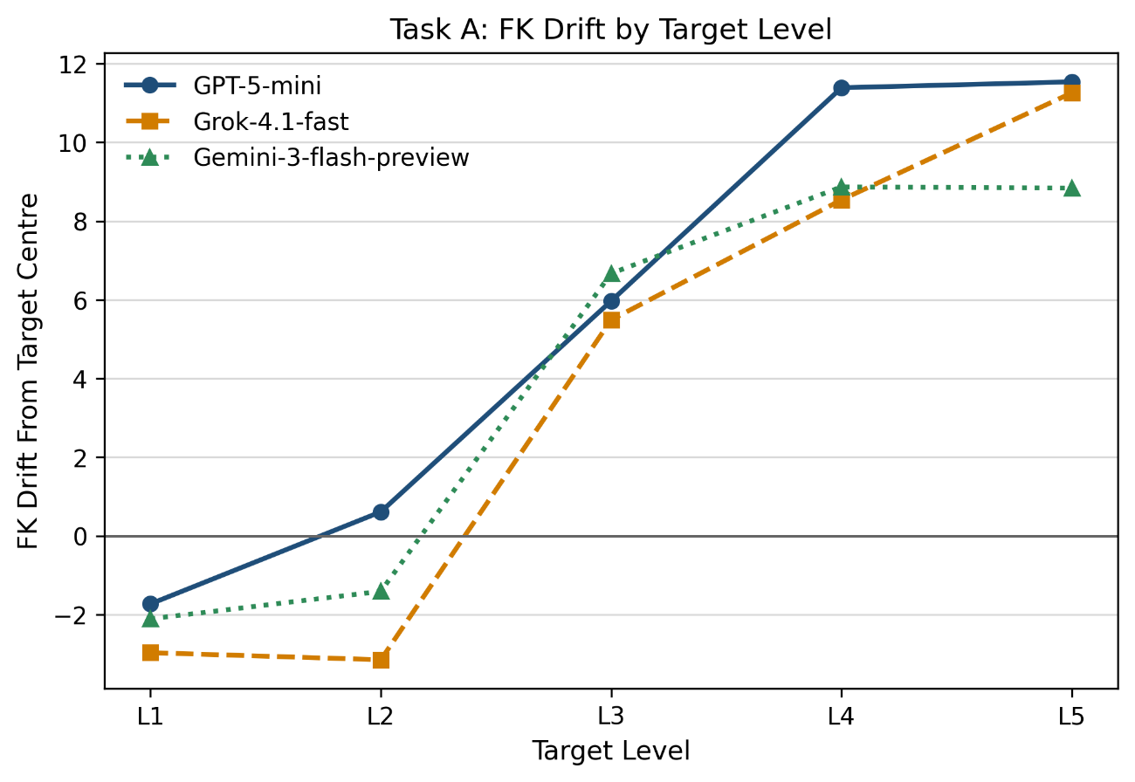
- Difficulty drift across target levels in Task A.
This pattern has important pedagogical implications. In a graded reading system, even if an output is fluent and topically relevant, it cannot be regarded as genuinely controllable instructional material if it systematically deviates from the target level. The results of Task A therefore provide direct justification for introducing a closed-loop feedback mechanism.
Figure 9 offers an intuitive view of the structural bias in direct prompting. Its main significance is not that a given model occasionally fails, but that such failure exhibits a clear level-specific pattern: lower levels are under-shot, while higher levels are substantially over-shot. This is precisely why the thesis turns to closed-loop adaptation rather than attempting only further refinement of a single prompt.
  - Task B: Closed-Loop Difficulty Adaptation
    - Performance Across Different Models
Task B addresses Research Questions 2 and 3, namely whether a closed-loop feedback mechanism can significantly improve hit rate and whether such improvement can be achieved without sacrificing content fidelity. The results show that within the final scope of 240 samples, closed-loop adaptation substantially improves target alignment: the three models achieved hit rates of 92.5%, 98.8%, and 95.0%, respectively; the average number of rounds was approximately 1.68 to 1.78; and average fidelity remained between 0.92 and 0.93.
- Overall results of closed-loop difficulty adaptation in Task B
Model | Hit rate (%) | Average rounds | Average fidelity
openai/gpt-5-mini | 92.5 | 1.78 | 0.92
x-ai/grok-4.1-fast | 98.8 | 1.74 | 0.93
deepseek/deepseek-v3.2 | 95.0 | 1.68 | 0.92
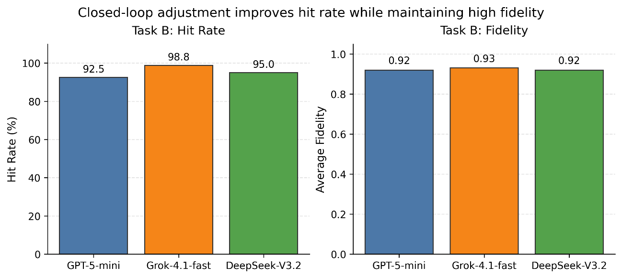
- Hit rate and fidelity after closed-loop adjustment.
Compared with Task A, the results of Task B support the central claim of the thesis: target-difficulty control is more effectively treated as an iterative optimisation problem than as a one-shot generation problem. By recalculating metrics after each round, filtering candidates, and imposing fidelity constraints, the system progressively moves texts toward the target difficulty while avoiding major loss of source information.
Figure 10 further demonstrates the balance achieved by the system between improving hit rate and maintaining content fidelity. The results indicate that the increase in difficulty alignment is not obtained by severely sacrificing text content, but rather under comparatively high fidelity.
    - Cost and Residual-Drift Analysis
From the perspective of token cost, different models exhibit different trade-offs between control precision and deployment cost. The results show that DeepSeek-V3.2 has the lowest average token consumption, at approximately 8,754 tokens; Grok-4.1-fast occupies the middle range at around 15,949 tokens; and GPT-5-mini has the highest average cost, at approximately 19,605 tokens. This indicates that model selection should not be based on hit rate alone but should also be informed by cost budgets and deployment scenarios.
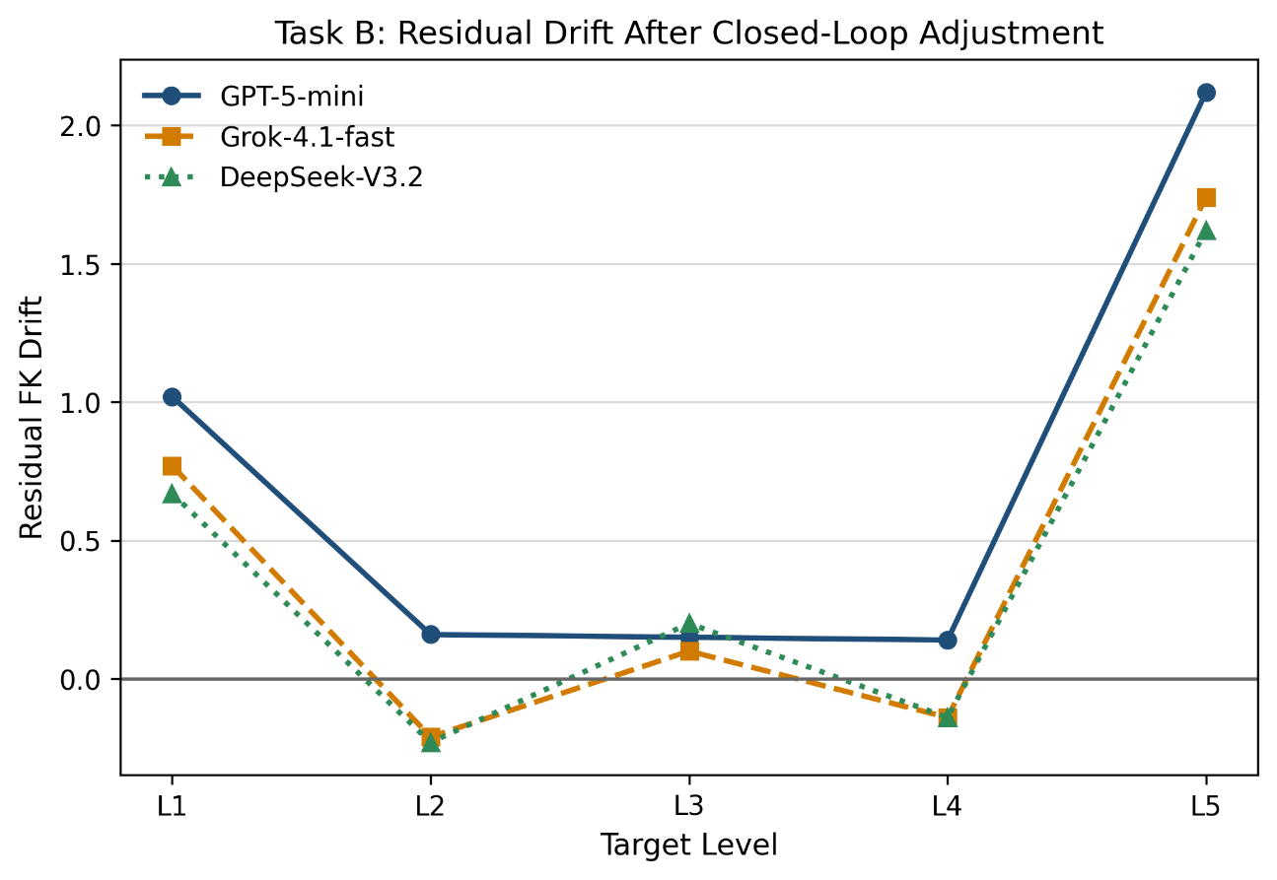
- Residual drift after closed-loop adjustment.
Residual-drift analysis shows that the closed-loop method performs relatively stably for Levels 2 to 4, where residual bias is close to zero, but that positive drift remains at Level 5. This suggests that control near the upper end of the difficulty scale is more sensitive: even a small amount of lexical upgrading or syntactic expansion can have a substantial effect on grade-family metrics. It also indicates that the replacement-only strategy provides relatively limited operating space in the highest difficulty band.
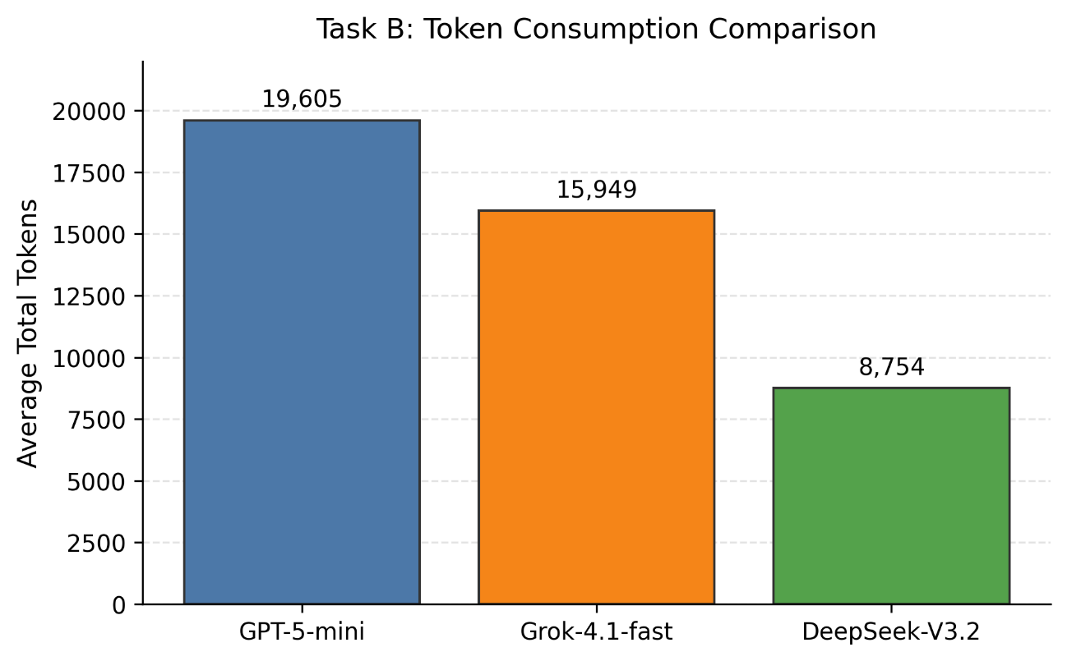
- Average token cost across models.
Figure 11 shows that the closed-loop method does not work equally well at all levels: it is most stable in the middle difficulty bands, while overshoot remains at the highest level. Figure 12 complements this finding by adding an engineering perspective: a high hit rate does not automatically imply high cost-effectiveness. Model selection is, in practice, a combined trade-off among precision, fidelity, and cost.
  - Discussion
Taken together, the results of Task A and Task B support several observations.
First, direct prompting is not entirely ineffective. It can generate passages that are topically relevant and structurally usable, and it can achieve a basically acceptable level of length control. Therefore, direct generation still has practical value in low-requirement or rapid-prototyping scenarios.
Second, once the system objective shifts from generating a readable article to generating a pedagogically usable text that is accurate in difficulty, reproducible, and analysable, direct prompting is no longer sufficient. The results of this thesis show that prompt-level difficulty labels do not correspond linearly and stably to measured readability indicators, making later feedback and correction necessary.
Third, the effectiveness of the closed-loop method does not derive merely from invoking the model multiple times. It depends more fundamentally on explicit decision criteria and candidate-selection logic. Without grade-family targets, fidelity constraints, and acceptance rules, simply increasing the number of rounds would not naturally produce stable improvement. In that sense, the core of the closed loop lies in the control logic rather than in repeated model calls themselves.
Finally, from an application perspective, the system proposed here is not intended to replace teachers or content experts completely. Instead, it is intended to reduce repetitive labour in reading-material preparation while providing a clear production trace and an interpretable basis for review. For instructional support and training-corpus construction, this combination of controllable generation and traceable analysis has clear practical value.

Conclusion
  - Research Conclusions
This thesis addressed the demand for controllable English reading-material generation by designing and implementing a dynamic reading-material system based on large language models, with particular emphasis on closed-loop difficulty adaptation. The study did not treat LLM generation as a purely prompt-level task, but as a system process involving generation, measurement, feedback, archival, and analysis. The answers to the research questions are as follows.
RQ1: Can direct prompting satisfy both length and difficulty constraints for reading passage generation at the same time?
Direct prompting can produce basically usable reading passages, but it cannot satisfy both constraints with sufficient stability. As discussed in Chapter 5, the direct-generation task achieved only 31.6%, 21.1%, and 31.6% target-hit rates across the three tested models, even though average length deviation remained within a comparatively moderate range of 7.46% to 11.89%. This means that the system-level length compensation and retry mechanism help with length control, but prompt-only generation still fails to provide reliable difficulty alignment. Direct prompting is therefore useful as an initial generation mechanism, but it is not sufficient as the main control method for graded reading-material production.
RQ2: Can a closed-loop feedback mechanism significantly improve the hit rate for target difficulty?
The closed-loop mechanism substantially improves difficulty alignment because it turns generation into an iterative evaluation-and-selection process. In Task B, the three models reached target-hit rates of 92.5%, 98.8%, and 95.0%, with average rounds between 1.68 and 1.78. These figures show that the improvement is not simply the result of unlimited repeated generation; rather, the system usually reaches an acceptable candidate within a small number of rounds. Instead of accepting the first model response, the system recalculates readability metrics, compares candidates with the target profile, and updates the current best text according to explicit acceptance rules. This supports the conclusion that difficulty control is more appropriately formulated as a feedback-driven optimisation problem than as a one-shot prompting problem.
RQ3: Can improved difficulty control be achieved without substantially damaging content fidelity?
The results indicate that improved difficulty control can be achieved while preserving the source content to a substantial degree. In Task B, average fidelity remained between 0.92 and 0.93 while the target-hit rate stayed above 92% for all three models. This supports the claim that the improvement in difficulty alignment was not achieved by freely rewriting away the source content. The adaptation module introduces fidelity constraints based on entity, number, and keyword recall, which prevents candidates with severe information loss from being accepted even if their readability metrics improve. This design shows that difficulty alignment and content preservation can be jointly considered within the same adaptation process.
Beyond these direct answers, the thesis makes several broader contributions. It proposes a closed-loop control framework for English reading-material generation, represents reading difficulty as a calculable grade-family target rather than relying only on natural-language level labels, and implements an adaptation mechanism that combines readability alignment with content-preservation constraints. It also develops an operational system that supports generation, adaptation, archival, and statistical analysis. The value of the system lies not only in producing texts, but also in making the production process traceable and reproducible.
These conclusions suggest that educational text generation should not be understood merely as a matter of asking a model to write at a given level. In practice, the model output must be measured, compared with explicit targets, and revised under constraints. The significance of the proposed framework is therefore systemic: it reduces the instability of unconstrained generation and provides an auditable basis for later review, replication, and refinement.
  - Limitations and Threats to Validity
Although the results support the effectiveness of the closed-loop method, several limitations must be acknowledged.
First, the final reporting subset for Task A remains relatively small, with only \(n=38\) samples per model. Accordingly, comparisons among different models in direct generation should be interpreted with caution.

Second, the evaluation in this thesis relies primarily on automatic metrics [22]. Although readability formulas and fidelity recall provide a calculable and reproducible observational basis, they cannot fully replace human pedagogical evaluation, nor can they fully capture discourse quality, instructional suitability, or actual learner comprehension outcomes [23].
Third, the residual bias observed at Level 5 indicates that precise control at the upper boundary of difficulty remains challenging. Future work should continue exploring finer-grained step control, alternative profile designs, or editing strategies better suited to highly complex texts.
Fourth, the model sets used in Task A and Task B are not completely identical. Therefore, the interpretation of the results should distinguish between conclusions about methodological effectiveness and conclusions about cross-model horizontal comparison.
  - Future Work
Future work should first introduce more systematic human evaluation [24]. Previous studies on LLM-based educational text generation, such as the work of Bezirhan and von Davier [4] and Xiao et al. [5], have shown that generated educational texts need to be judged not only by surface fluency but also by their pedagogical usefulness. This thesis mainly verifies controllability through automatic readability and fidelity indicators. A natural next step is to involve teachers or learners in evaluating whether the adapted passages are appropriate for classroom use, assessment preparation, or independent reading practice.
Another direction is to improve the modelling of difficulty itself [22]. Prior work on readability-controlled generation and simplification, including Huang et al. [9], Hsu et al. [10], and Kew et al. [11], indicates that LLMs can move text toward easier or harder levels, but that target mismatch and semantic distortion remain persistent problems. The present thesis addresses this issue through grade-family profiles and feedback-based candidate selection. Future versions of the system could extend this representation by incorporating discourse structure, information density, cohesion, background knowledge, and task-specific comprehension demand, rather than relying mainly on grade-like readability formulas [22].
The highest difficulty band also requires more refined control. The current replacement-based strategy is interpretable and helps preserve source content, but it gives the system limited room when the target requires very high complexity. Future work could explore adaptive step-size control, explicit overshoot penalties, or separate policies for lexical and syntactic adjustment. This would build on the current feedback framework while reducing the risk that high-level adaptation moves too far beyond the intended target range.
Cost-aware control is another important extension. This thesis records token usage and shows that model choice involves a trade-off among precision, fidelity, and cost. Future work could make this trade-off part of the control policy itself. For example, the system could select cheaper models for easier cases, reserve stronger models for difficult or failed cases, or stop earlier when further improvement is unlikely to justify the additional cost.
Finally, the system should be tested in more authentic educational contexts. The present work implements a reproducible research platform and validates the closed-loop method experimentally, but it does not yet integrate deeply with a real teaching platform or learner-facing exercise system. Future research could connect the generator with reading-comprehension tasks, learner profiles, teacher review workflows, or adaptive assignment systems. In that setting, the contribution of the system would no longer be limited to producing controlled passages; it could also support a broader cycle of material creation, learner response, evaluation, and instructional adjustment.

REFERENCES
- M. M. Ali, A. M. Alaa, W. Alharbi, and I. AlQurashi. Investigating the impact of ChatGPT on reading proficiency in EFL context. International Journal of Technology in Education, 8(4):1222-1244, 2025. doi: 10.46328/ijte.1563.
- Y. Ding. Research on generative artificial intelligence in senior high schools' English reading teaching. SHS Web of Conferences, 222:01001, 2025. doi: 10.1051/shsconf/202522201001.
- A. Madaan, N. Tandon, P. Clark, Y. Yang, A. Majumder, P. P. Liang, M. Bansal, and S. Gupta. Self-Refine: Iterative refinement with self-feedback. In Thirty-seventh Conference on Neural Information Processing Systems, 2023. Available: https://openreview.net/forum?id=S37hOerQLB
- U. Bezirhan and M. von Davier. Automated reading passage generation with OpenAI's large language model. Computers and Education: Artificial Intelligence, 5:100161, 2023. doi: 10.1016/j.caeai.2023.100161.
- C. Xiao, S. X. Xu, K. Zhang, Y. Wang, and L. Xia. Evaluating reading comprehension exercises generated by LLMs: A showcase of ChatGPT in education applications. In Proceedings of the 18th Workshop on Innovative Use of NLP for Building Educational Applications (BEA 2023), pages 610-625, 2023. doi: 10.18653/v1/2023.bea-1.52.
- A. Siddharthan. A survey of research on text simplification. ITL - International Journal of Applied Linguistics, 165(2):259-298, 2014.
- H. Saggion. Automatic Text Simplification. Morgan & Claypool Publishers, 2017. Available: https://www.morganclaypool.com/doi/abs/10.2200/S00700ED1V01Y201602HLT032
- S. Stajner. Automatic text simplification for social good: Progress and challenges. In Findings of the Association for Computational Linguistics: ACL-IJCNLP 2021, pages 2637-2652, 2021. Available: https://aclanthology.org/2021.findings-acl.233/
- C. Huang, J. Wei, and T. H. K. Huang. Generating educational materials with different levels of readability using LLMs. In In2Writing '24: Proceedings of the Third Workshop on Intelligent and Interactive Writing Assistants, pages 16-22, 2024. doi: 10.1145/3690712.3690718.
- Y.-S. Hsu, N. Feldhus, and S. Hakimov. Free-text rationale generation under readability level control. Proceedings of the Fourth Workshop on Generation, Evaluation and Metrics (GEM 2025), pages 129-150, 2025. Available: https://aclanthology.org/2025.gem-1.11/
- T. Kew, A. Chi, L. Vasquez-Rodriguez, S. Agrawal, D. Aumiller, F. Alva-Manchego, and M. Shardlow. BLESS: Benchmarking large language models on sentence simplification. In Proceedings of the 2023 Conference on Empirical Methods in Natural Language Processing, pages 13291-13309, 2023. doi: 10.18653/v1/2023.emnlp-main.821.
- F. Marulli, L. Campanile, M. S. de Biase, S. Marrone, L. Verde, and M. Bifulco. Understanding readability of large language models output: An empirical analysis. Procedia Computer Science, 246:5273-5282, 2024. doi: 10.1016/j.procs.2024.09.636.
- N. Scaria, S. Dharani Chenna, and D. Subramani. Automated educational question generation at different Bloom's skill levels using large language models: Strategies and evaluation. In A. M. Olney, I. A. Chounta, Z. Liu, O. C. Santos, and I. I. Bittencourt, editors, Artificial Intelligence in Education, volume 14830 of Lecture Notes in Computer Science, pages 165-179. Springer, 2024. doi: 10.1007/978-3-031-64299-9_12.
- W. H. DuBay. The Principles of Readability. Impact Information, Costa Mesa, CA, 2004.
- R. Flesch. A new readability yardstick. Journal of Applied Psychology, 32(3):221-233, 1948.
- J. P. Kincaid, R. P. Fishburne, R. L. Rogers, and B. S. Chissom. Derivation of new readability formulas for navy enlisted personnel. Technical Report Research Branch Report 8-75, Naval Technical Training Command, 1975.
- M. Coleman and T. L. Liau. A computer readability formula designed for machine scoring. Journal of Applied Psychology, 60(2):283-284, 1975.
- R. Gunning. The Technique of Clear Writing. McGraw-Hill, 1952.
- E. A. Smith and R. J. Senter. Automated readability index. Technical Report AMRL-TR-66-220, Aerospace Medical Research Laboratories, 1967.
- A. Bailin and A. Grafstein. The linguistic assumptions underlying readability formulae: A critique. Language & Communication, 21(3):285-301, 2001. doi: 10.1016/S0271-5309(01)00005-2.
- S. A. Crossley, S. Skalicky, M. Dascalu, D. S. McNamara, and K. Kyle. Predicting text comprehension, processing, and familiarity in adult readers: New approaches to readability formulas. Discourse Processes, 54(5-6):340-359, 2017. doi: 10.1080/0163853X.2017.1296264.
- A. Celikyilmaz, E. Clark, and J. Gao. Evaluation of text generation: A survey. arXiv preprint arXiv:2006.14799, 2020. Available: https://arxiv.org/abs/2006.14799
- E. Sulem, O. Abend, and A. Rappoport. BLEU is not suitable for the evaluation of text simplification. In Proceedings of the 2018 Conference on Empirical Methods in Natural Language Processing, pages 738-744, 2018. doi: 10.18653/v1/D18-1081.
- E. Clark, T. August, S. Serrano, N. Haduong, S. Gururangan, and N. A. Smith. All That's "Human" Is Not Gold: Evaluating human evaluation of generated text. In Proceedings of the 59th Annual Meeting of the Association for Computational Linguistics and the 11th International Joint Conference on Natural Language Processing (Volume 1: Long Papers), pages 7282-7296, 2021. doi: 10.18653/v1/2021.acl-long.565.

Appendix A: Supplementary Materials for System Configuration and Experimental Outputs
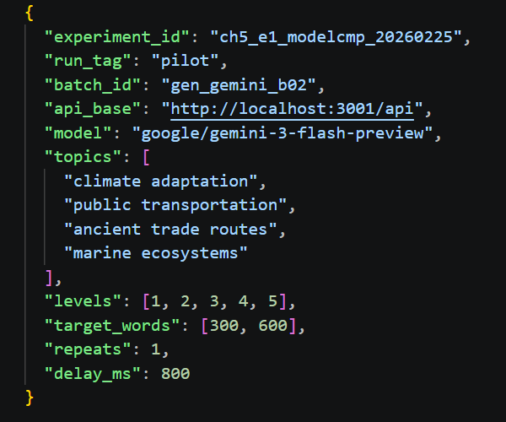
Figure A1. Example configuration for a passage-generation batch experiment.

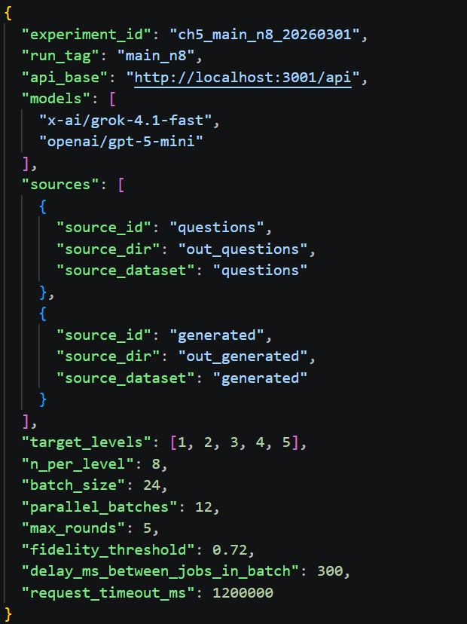
Figure A2. Example configuration for a difficulty-adjustment batch experiment.
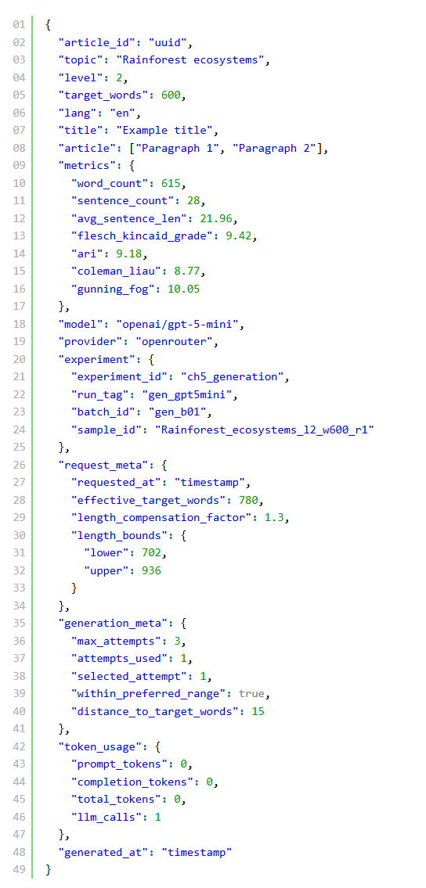
Figure A3. Example archived JSON record for a generated passage.
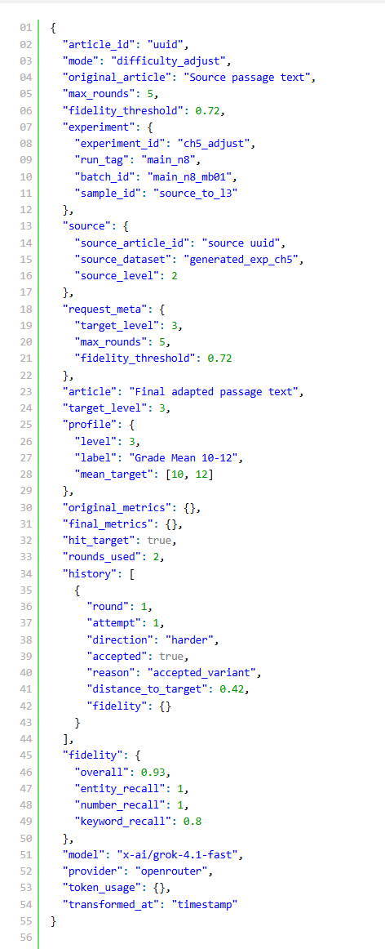
Figure A4. Example archived JSON record for a difficulty-adjusted passage.
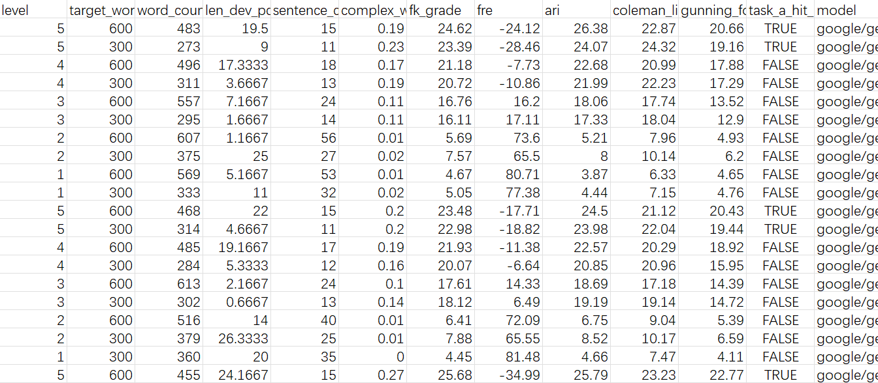

Figure A5. Example excerpt of TaskA experimental results.

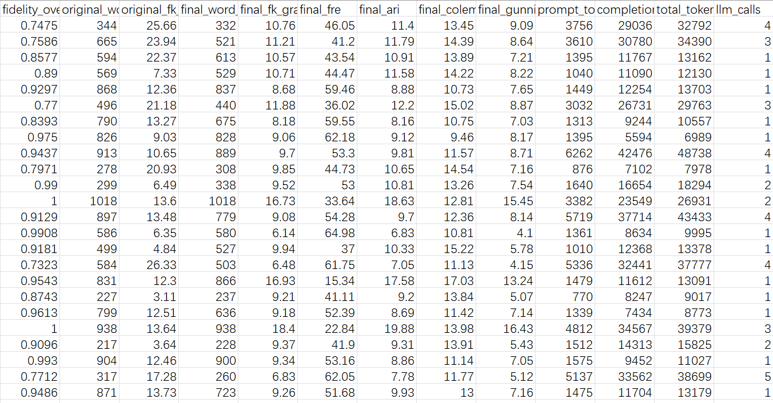

Figure A6. Example excerpt of TaskB experimental results, including fidelity and token usage.

Figure A7. Example screenshot of the front-end interface of the LLM reading system.

