A Closed-Loop LLM System for Reading Passage Generation and Difficulty Adaptation

Initials Last name ª, Initials Last name ^{b}, Initials Last name ^{c},
Initials Last name ^{d}, Initials Last name ^{e}
ª Affiliation, Town, Country, ORCID
^{b} Affiliation, Town, Country, ORCID
^{c} Affiliation, Town, Country, ORCID
^{d} Affiliation, Town, Country, ORCID
^{e} Affiliation, Town, Country, ORCID

Conference Key Areas: Digital tools and AI in engineering education, Engineering skills, professional skills, and transversal skills
Keywords: large language models; reading passage generation; readability control; closed-loop adaptation; English reading practice
Abstract
English reading instruction requires large amounts of level-appropriate material, yet manual preparation is slow, difficult to scale, and hard to adapt to learner differences. Large language models (LLMs) offer a promising way to generate reading passages on demand, but direct prompting alone often fails to achieve stable control over both passage length and reading difficulty. This paper presents a closed-loop LLM system for reading passage generation and difficulty adaptation for English reading practice. The system follows a Generate-Evaluate-Adjust-Archive-Analyze pipeline. In the generation stage, a length compensation mechanism is used to reduce systematic under-generation at lower levels. In the adjustment stage, difficulty is operationalised through a grade-family readability mean computed from Flesch-Kincaid Grade, Automated Readability Index, Coleman-Liau Index, and Gunning Fog, while Flesch Reading Ease is retained as a monitoring signal. A replacement-only adjustment strategy is applied under semantic fidelity constraints based on weighted recall of entities, numbers, and keywords. Two experimental tasks were conducted. Task A evaluated direct generation without closed-loop correction, and Task B evaluated iterative difficulty adjustment with fidelity validation. The results show that direct prompting was usable but unstable, with a maximum hit rate of 31.6%. In contrast, closed-loop adjustment increased hit rates to 92.5%-98.8% while maintaining fidelity around 0.92-0.93. The study contributes a measurable and reproducible framework for level-specific educational text control and demonstrates its practical value for scalable reading material preparation.

- Introduction
Preparing reading materials for English reading practice is repetitive and difficult to scale. Teachers and content developers often need multiple passages on similar topics but at different difficulty levels and lengths. Static reading banks are costly to maintain and usually offer only coarse-grained level distinctions. Recent education-focused studies suggest that generative AI can enrich reading resources and support learner adaptation, but also that pedagogical value depends on careful system design rather than raw generation ability alone (Ali et al., 2025; Ding, 2025).
Large language models (LLMs) make dynamic reading material generation feasible, but educational usability requires more than fluent text. Reading materials intended for level-specific practice should approximately match the requested difficulty, preserve semantic content, and remain reproducible enough for later analysis. These requirements expose a practical limitation of one-shot prompting: a model may produce a readable article yet still fail to satisfy both length and difficulty constraints in a stable way.
This study addresses that control problem by designing and evaluating a closed-loop LLM system for reading passages generation and difficulty adaptation. The system generates an initial passage, evaluates it with readability metrics, applies iterative edits under fidelity constraints, archives outputs, and exports reproducible analysis results. Rather than treating difficulty as a descriptive label, the study models it as a calculable target that can be monitored and improved iteratively.
- Related Work and Research Gap
Research on educational text generation has shown that LLMs can support reading materials, exercises, and related language learning tasks. Bezirhan and von Davier (2023) demonstrated that GPT-3 could generate assessment-like reading passages, while Xiao et al. (2023) reported promising classroom-oriented results for reading comprehension materials. However, both lines of work still depended on external quality control rather than explicit closed-loop difficulty control.
Readability-controlled generation studies point to the same limitation from another angle. Huang et al. (2024) found that LLMs can move educational materials toward different readability levels, but target mismatch and semantic distortion remained common. Hsu et al. (2025) likewise showed that readability-controlled rationale generation produced trend-level shifts without stable alignment, and Kew et al. (2023) showed through BLESS that simplification behaviour varies substantially across models. Marulli et al. (2024) further argued that readability assessment of LLM output should not be reduced to a single score.
Taken together, these studies suggest that one-shot prompting is often insufficient for reliable level targeting and that evaluation should be multi-dimensional. Scaria et al. (2024) reached a similar conclusion in automated educational question generation, where LLM outputs could be educationally relevant but still required careful evaluation. The gap addressed in the present study is therefore system-level: a measurable, reproducible, closed-loop framework for level-specific educational text control.
- Methodology
3.1 Research Questions
The study is organised around three research questions:
RQ1. How Can direct prompting satisfy both length and difficulty constraints for reading passage generation?
Objective of this RQ is to evaluate whether direct prompting can generate reading passages that satisfy both the requested length and the requested difficulty level with sufficient reliability for educational use.
RQ2. Can closed-loop feedback significantly improve difficulty hit rate?
Objective of this RQ to determine whether a closed-loop feedback mechanism can significantly improve difficulty alignment, as measured by the readability-based hit rate.
RQ3. Can difficulty control be improved without substantially damaging semantic fidelity?
Objective of this RQ to examine whether improved difficulty control can be achieved without substantially reducing semantic fidelity to the source passage.
The corresponding hypotheses are pragmatic: direct prompting is expected to be usable but unstable; closed- loop adjustment is expected to improve hit rate above 90%; and this improvement is expected to remain compatible with high semantic fidelity. The paper contributes a closed-loop control method, a grade-family difficulty definition, a replacement-only adjustment strategy, and a reproducible pipeline for generation, archival, and analysis.
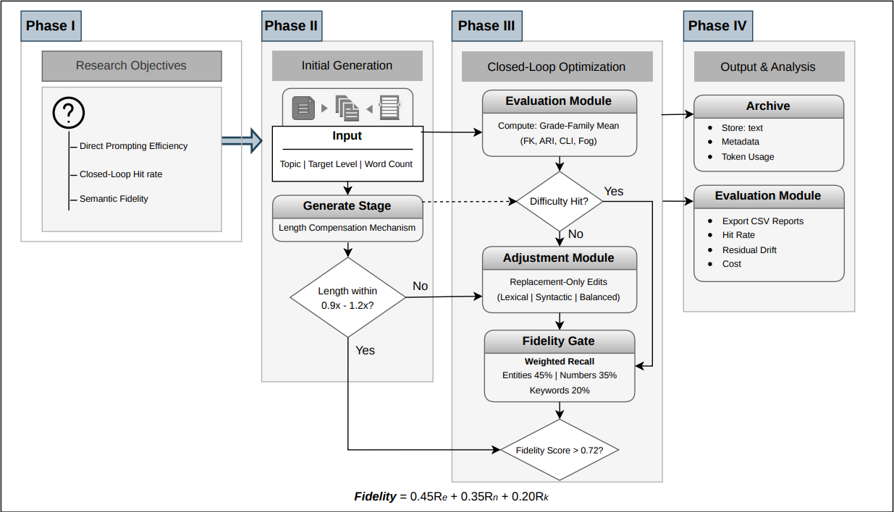
Figure 1: Visual representation of the research methodology implemented in this study
3.2 Pipeline
The system follows a five-stage pipeline: Generate, Evaluate, Adjust, Archive, and Analyze. In the Generate stage, the user provides a topic, target level, target word count, and model selection. The system produces an initial reading passage using a structured prompt. In the Evaluate stage, readability metrics are computed automatically. In the Adjust stage, the system iteratively edits the passage toward the target profile. In the Archive stage, the system stores all relevant outputs and metadata. In the Analyze stage, archived records are aggregated into CSV-based reports for later comparison.
This workflow is designed so that each stage produces data that can be reused by the next stage and traced in the archive. Figure 1 summarises the relationship between generation, metric evaluation, iterative adjustment, fidelity validation, archival, and downstream analysis.
3.2.1 Generate Stage and Length Compensation
An important engineering issue observed in pilot generation was that raw prompts often under-produced length at lower difficulty levels. To address this, the system uses a level-specific length compensation mechanism. The effective generation target is computed by multiplying the requested target words by a level-specific factor. Lower levels therefore use larger compensation factors than upper levels in order to counter systematic under-generation.
After generation, the system applies an acceptance range around the compensated target, using a preferred interval of 0.9x to 1.2x. If a candidate falls outside this range, the system retries generation and retains the candidate whose length is closest to the original requested target.
3.2.2 Difficulty Definition and Hit Condition
Difficulty is defined using a grade-family readability target instead of a single formula. For each level, the system specifies a target band over the mean of four readability indicators: Flesch-Kincaid Grade (FK), Automated Readability Index (ARI), Coleman-Liau Index (CLI), and Gunning Fog. A sample is counted as a hit when this grade-family mean falls within the predefined profile range for the requested level.
This design choice was made because readability metrics are coupled but not identical. Flesch Reading Ease is one of the earliest widely adopted readability formulas and estimates ease through sentence length and syllable density (Flesch, 1948). Flesch-Kincaid Grade converts a similar logic into an approximate grade-level interpretation (Kincaid et al., 1975). Coleman-Liau was designed for machine scoring by using character counts rather than syllables (Coleman and Liau, 1975). Gunning Fog emphasises the contribution of complex words to reading difficulty (Gunning, 1952), while ARI provides another automated grade-like estimate using characters and sentence length (Smith and Senter, 1967). Because these metrics capture overlapping but non-identical surface properties, requiring all of them to independently satisfy narrow target bands can become mathematically unrealistic. Therefore, the grade-family mean functions as the main decision target, while FRE is retained as an important monitoring signal for interpretation.
The use of a profile range rather than a single target value reflects the practical nature of educational text control: real reading materials occupy bands of acceptable complexity rather than exact point values.
3.2.3 Closed-Loop Adjustment Strategy
Instead of rewriting the full article from scratch in every round, the system applies a replacement-only adjustment strategy. Three variants are used. Variant 1 focuses on lexical substitutions. Variant 2 focuses on sentence-structure operations such as splitting or merging. Variant 3 combines lexical and sentence-level changes. This design seeks to reduce unnecessary rewriting and improve controllability.
The adjustment process is iterative. After each candidate edit is generated, the system recalculates the readability metrics, checks whether the target has been hit, and determines whether the new candidate should be accepted. The controller uses lexical-only editing when the dominant mismatch is lexical difficulty, sentence-only editing when the dominant mismatch is sentence structure, and a balanced variant when both dimensions need stronger movement. By constraining the scope of edits, the system aims to improve precision and cost-efficiency while reducing semantic risk.
3.2.4 Fidelity Validation
A readability improvement is not acceptable if it damages semantic integrity. For this reason, every adjustment candidate passes through a fidelity gate before acceptance. The system extracts source entities, numbers, and top keywords from the original article and computes their recall in the candidate text.
The overall fidelity score is a weighted combination of three recall signals: entity recall (45%), number recall (35%), and keyword recall (20%). Entities and numbers are weighted more heavily because factual consistency is critical in reading materials. In the main adjustment workflow, a candidate must reach at least 0.72 overall fidelity to remain eligible for acceptance; in addition, some local heuristic acceptances for lexical or syntactic improvement require fidelity above 0.85. Only candidates above the active fidelity threshold are considered for acceptance into the adjustment history.
This gate prevents candidates that improve readability metrics while losing key source information.
3.2.5 Archive and Analysis Layer
The archive layer stores the generated or adjusted text together with readability metrics, experiment identifiers, request metadata, generation metadata, hit status, adjustment history, and token usage. The analysis layer exports landed CSV files for both Task A and Task B, enabling repeatable comparison across models and tasks.
3.3 Experimental Design and Evaluation Metrics
Two tasks were used in the evaluation. Task A measured direct generation performance without closed-loop correction. Its purpose was to determine whether one-shot prompting could satisfy both length and difficulty constraints. Task B measured closed-loop difficulty adjustment under fidelity validation. Its purpose was to test whether iterative control could substantially improve level alignment while preserving semantic fidelity. The Task A generation design used four topics, five levels, and two target lengths (300 and 600 words), yielding 40 planned jobs per model. The final reporting subset used landed samples marked for the report, resulting in n = 38 per model. Task B used the final closed-loop evaluation scope of 240 samples, with 80 samples per model in the final set. The final model set for Task B included openai/gpt-5-mini, x-ai/grok-4.1-fast, and deepseek/deepseek-v3.2.
Task A was evaluated using hit rate, length deviation, and average attempts. Task B was evaluated using hit rate, residual drift, average rounds used, fidelity score, and token consumption.
- Results
4.1 RQ1: Can Direct Prompting Satisfy Both Length and Difficulty Constraints?
Task A evaluated direct passage generation without closed-loop correction, using the final report subset of n = 38 per model. The overall pattern was clear: direct prompting was usable, but not reliable as a level-control mechanism. Table 1 summarises the overall Task A results.
Table 1: Overall performance of direct generation in Task A.
Model | Length deviation (%) | Hit rate (%) | Average attempts
Gpt-5-mini | 8.11 | 31.6 | 1.84
Grok-4.1-fast | 7.46 | 21.1 | 2.05
Gemini-3-flash-preview | 11.89 | 31.6 | 1.97
These results show that acceptable length alone did not imply acceptable difficulty control. The main limitation of direct generation was unstable difficulty alignment, even after engineering adjustments for length. Therefore, the answer to RQ1 is that direct prompting can produce usable passages, but it cannot reliably satisfy both length and difficulty constraints for level-specific reading practice.
A more detailed view of Task A shows that failure was not evenly distributed across levels. At lower target levels, models tended to undershoot, while from Level 3 onward all three models showed large positive drift. Figure 2 shows this clearly: lower bands were missed on the low side, whereas Levels 3–5 were frequently overshot by roughly +5 to +12 grade points.
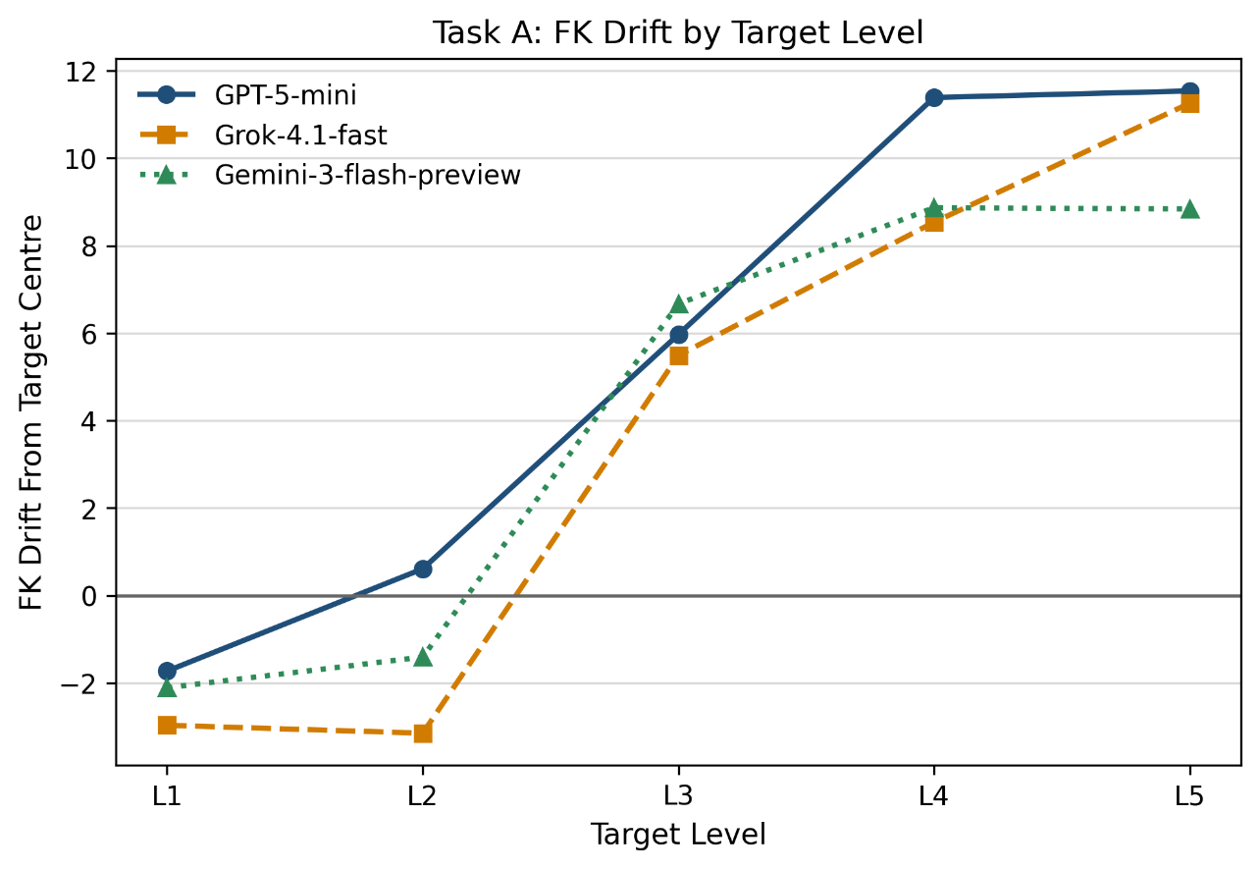
Figure 2: Direct prompting undershoots lower levels and strongly overshoots Levels 3–5 in Task A.
This finding is important for educational use. A system that consistently overshoots or undershoots at certain levels cannot be trusted to produce appropriate training material, even if it appears broadly coherent. The Task A results therefore confirm the practical need for a feedback-based control method.
Key Takeaways from RQ1
Direct prompting can generate readable and usable passages, but it does not provide dependable control over both length and difficulty at the same time. Its main weakness is unstable difficulty alignment across target levels, especially the tendency to undershoot lower levels and overshoot Levels 3 to 5. This means that direct prompting alone is not sufficient for reliable level-specific reading material generation.
4.2 RQ2: Can Closed-Loop Feedback Significantly Improve Difficulty Hit Rate?
Task B applied iterative feedback and fidelity constraints over a final scope of 240 samples. The results show a sharp improvement over direct generation. Table 2 summarises the overall closed-loop outcomes across the final model set.
Table 2: Closed-loop outcomes in Task B.
Model | Hit rate (%) | Average rounds | Average fidelity
gpt-5-mini | 92.5 | 1.78 | 0.92
Grok-4.1-fast | 98.8 | 1.74 | 0.93
Deepseek-v3.2 | 95.0 | 1.68 | 0.92
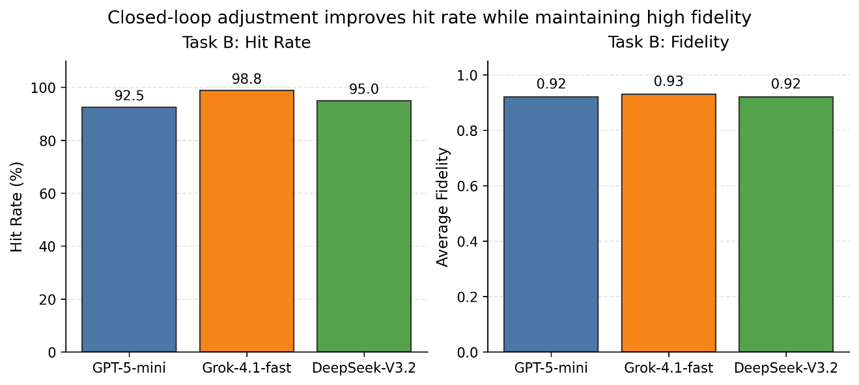
Figure 3: Closed-loop adjustment improves hit rate while maintaining high fidelity across final models.
The answer to RQ2 is yes: closed-loop feedback significantly improved difficulty hit rate. Final performance ranged from 92.5% to 98.8%, which is substantially higher than the Task A results and consistent with the hypothesis that the closed-loop method would push hit rate above 90%.
Key Takeaways from RQ2
Closed-loop feedback substantially improves difficulty control. Across the final model set, hit rates increased to 92.5%–98.8%, clearly outperforming direct prompting and supporting the usefulness of iterative evaluation and adjustment. This shows that feedback-based control is effective for achieving stable level alignment in generated reading passages.
4.3 RQ3: Can Difficulty Control Be Improved Without Substantially Damaging Semantic Fidelity?
The Task B results also address semantic preservation. Across the final model set, average fidelity remained high at 0.92–0.93 while hit rate improved substantially. This indicates that the gains in difficulty control were not achieved through major semantic distortion.
The answer to RQ3 is therefore yes: difficulty control can be improved without substantially damaging semantic fidelity. The closed-loop mechanism achieved high precision while preserving the meaning of the source passages to a high degree.
Key Takeaways from RQ3
The improvement in difficulty control was achieved without major loss of meaning. Average fidelity remained high at 0.92–0.93, indicating that the closed-loop system was able to modify readability while preserving the core semantic content of the source passages. This confirms that precise difficulty adaptation and semantic preservation can be achieved together within the proposed framework.
4.4 Token Consumption Comparison
Control quality is only one part of deployment readiness. The cost of obtaining that control also matters. In the final model comparison, DeepSeek-V3.2 showed the lowest average token consumption per final-scope sample, at approximately 8,754 tokens. Grok-4.1-fast occupied the middle range at about 15,949 tokens, while GPT-5-mini consumed the most, at approximately 19,605 tokens.
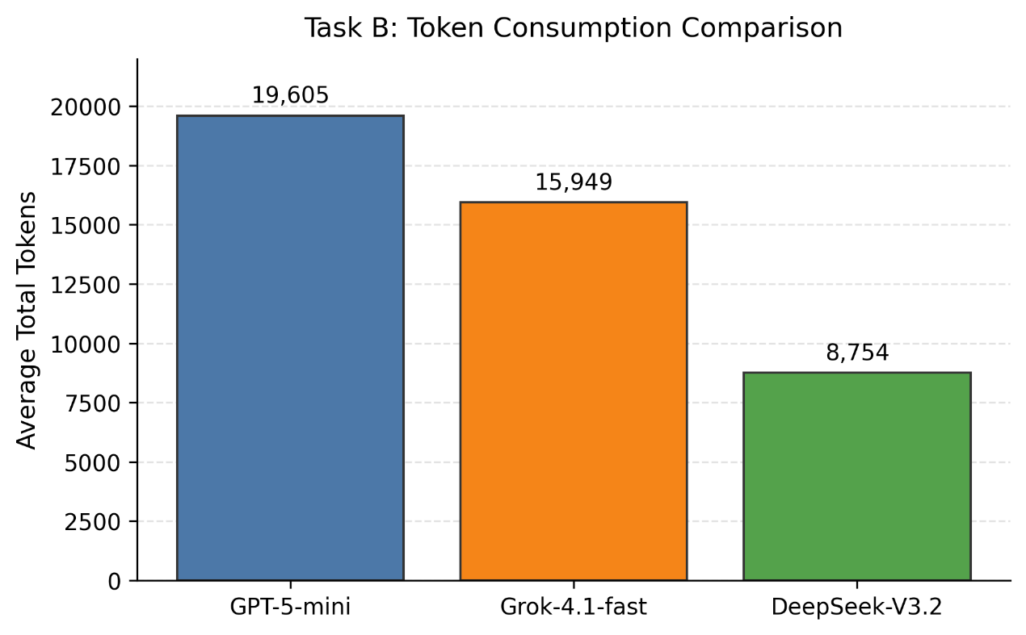
Figure 4: Model choice reflects a precision-fidelity-cost trade-off rather than hit rate alone.
This result suggests that model choice should be scenario-dependent rather than based on hit rate alone. If maximal hit rate is the priority, Grok performs best in the present study. If efficiency is more important, DeepSeek is the more economical option while still maintaining high hit rate and fidelity.
4.5 Residual Drift After Adjustment
Residual drift after adjustment was generally low for Levels 2 to 4, where all final models converged close to zero. This indicates that the closed-loop method is especially effective in the middle difficulty bands. However, Level 5 remained more difficult to centre precisely, with positive residual drift across models.
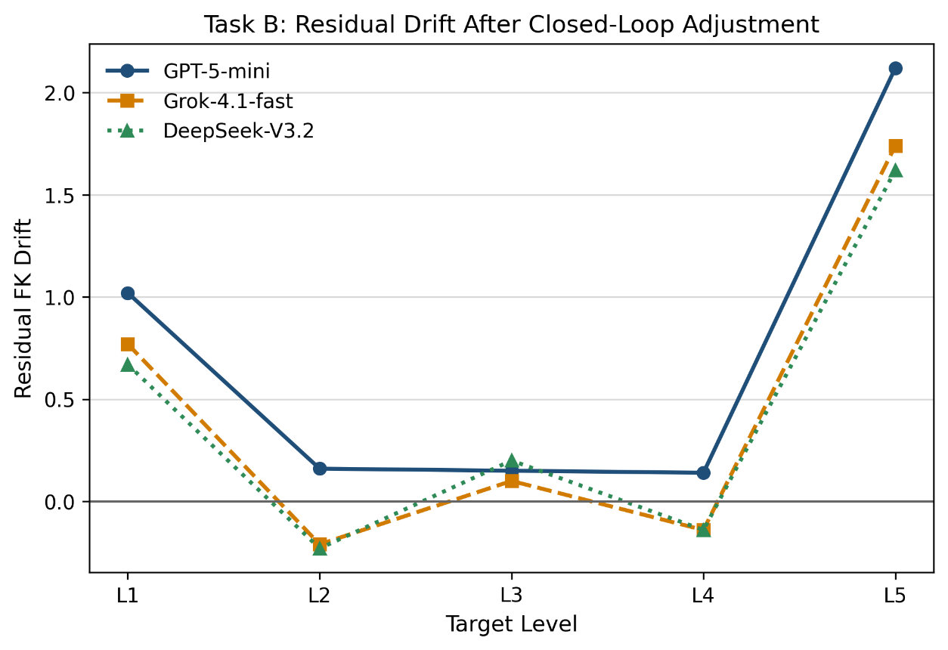
Figure 5: Residual drift is near zero for Levels 2–4, but Level 5 remains positively biased after adjustment.
One plausible explanation is that Level 5 pushes the controller toward an upper-end academic style where even a few lexical upgrades or sentence expansions can cause disproportionate movement in grade-family metrics. A second explanation is methodological: replacement-only control is intentionally conservative and may have less manoeuvring space when the target requires a highly advanced but still precisely centred output. In other words, the method can overshoot because the remaining edit space at the top band is narrow, while the readability formulas react strongly to denser vocabulary and clause structure.
- Discussion
The findings indicate that direct prompting alone is insufficient when educational applications require stable level targeting. Prompt labels such as “level 2” or “advanced” do not map consistently onto measurable readability outcomes. As a result, one-shot generation may appear acceptable in individual examples while still producing unstable difficulty alignment at scale.
The results suggest that difficulty control is more effectively treated as an iterative optimisation process rather than a single prompting step. Once difficulty is defined as a measurable target band, the system can evaluate whether a candidate moves closer to the target, whether the target has been reached, and whether the modification remains acceptable under semantic constraints.
The replacement-only strategy contributes to stability by limiting unnecessary rewriting. Constraining edits reduces semantic drift, improves interpretability of changes, and helps control token usage. Lexical-only replacement is most effective when deviations are small and primarily vocabulary-based. Sentence-level modification is more suitable for structural mismatches. The balanced strategy is most useful when the gap between the generated text and the target level is larger.
From a practical perspective, the framework connects generation, control logic, fidelity protection, and archival analysis into a reproducible pipeline. For teachers and content developers, the system does not replace expert judgement, but it can reduce preparation effort while preserving a transparent and auditable production process.
Several limitations should also be acknowledged. The direct-generation comparison in Task A was relatively small (n = 38 per model), which limits statistical power when comparing one-shot performance across models. The evaluation relies primarily on automatic readability metrics, which capture lexical and structural properties but cannot fully represent pedagogical suitability. In addition, the overshoot effect observed at Level 5 indicates that upper-band difficulty remains more sensitive to small linguistic changes. Replacement-only control reduces semantic risk but also limits the available adjustment space for very high difficulty targets.
- Threats to Validity
Several threats to validity should be considered.
Construct validity is influenced by the choice of readability formulas. Grade-family metrics approximate linguistic complexity through surface features such as sentence length and word difficulty. These indicators do not fully capture discourse structure, conceptual density, or reader background knowledge. As a result, measured difficulty may not always perfectly correspond to perceived difficulty in authentic learning contexts.
Conclusion validity is influenced by sample size and metric sensitivity. While the observed improvements in hit rate are substantial, larger datasets and additional human evaluation would further strengthen the robustness of the findings.
- Conclusion
The study demonstrates that direct prompting alone is not sufficiently stable for precise control of educational difficulty, even when length constraints are satisfied. A closed-loop control mechanism substantially improves hit rate while maintaining high semantic fidelity, showing that difficulty adjustment can be treated as an iterative optimisation task rather than a single prompting problem.
The proposed framework integrates difficulty measurement, constrained editing, fidelity protection, and reproducible evaluation into a unified pipeline. This supports scalable production of level-specific reading materials while preserving the transparency and interpretability of the generation process.
Future work may extend the framework through stronger human evaluation, improved control strategies for upper difficulty bands, and further optimisation of cost-aware generation policies.
- Use of AI Tools
Generative AI tools were used as technical assistance during this study. Codex 5.3 was used to support code generation for the experimental pipeline and to assist with implementation of the closed-loop control system. Codex was also used to assist with experiment scripting and data analysis procedures.
All AI-generated content was critically reviewed and modified where necessary. The author is solely responsible for the research design, experimental results, interpretations, and conclusions presented in this paper.
References
M. M. Ali, A. M. Alaa, W. Alharbi, and I. AlQurashi. Investigating the impact of ChatGPT on reading proficiency in EFL context. International Journal of Technology in Education, 8(4):1222–1244, 2025. doi: 10.46328/ijte.1563.
U. Bezirhan and M. von Davier. Automated reading passage generation with OpenAI’s large language model. Computers and Education: Artificial Intelligence, 5:100161, 2023. doi: 10.1016/j.caeai.2023.100161.
M. Coleman and T. L. Liau. A computer readability formula designed for machine scoring. Journal of Applied Psychology, 60(2):283–284, 1975.
Y. Ding. Research on generative artificial intelligence in senior high schools’ english reading teaching. SHS Web of Conferences, 222:01001, 2025. doi: 10.1051/shsconf/202522201001.
R. Flesch. A new readability yardstick. Journal of Applied Psychology, 32(3):221–233, 1948.
R. Gunning. The Technique of Clear Writing. McGraw-Hill, 1952. 9
Y.-S. Hsu, N. Feldhus, and S. Hakimov. Free-text rationale generation under readability level control. In Proceedings of the Fourth Workshop on Generation, Evaluation and Metrics (GEM22025), pages 129–150, 2025. URL https://aclanthology.org/2025.gem-1.11/.
C. Huang, J. Wei, and T. H. K. Huang. Generating educational materials with different levels of readability using LLMs. InIn2Writing ’24: Proceedings of the Third Workshop on Intelligent and Interactive Writing Assistants, pages 16–22, 2024. doi: 10.1145/3690712.3690718.
T. Kew, A. Chi, L. Vásquez-Rodríguez, S. Agrawal, D. Aumiller, F. Alva-Manchego, and M. Shardlow. BLESS: Benchmarking large language models on sentence simplification. In Proceedings of the 2023 Conference on Empirical Methods in Natural Language Processing, pages 13291–13309, 2023. doi: 10.18653/v1/2023.emnlp- main.821.
J. P. Kincaid, R. P. Fishburne, R. L. Rogers, and B. S. Chissom. Derivation of new readability formulas for navy enlisted personnel. Technical Report Research Branch Report 8-75, Naval Technical Training Command, 1975.
F. Marulli, L. Campanile, M. S. de Biase, S. Marrone, L. Verde, and M. Bifulco. Understanding readability of large language models output: An empirical analysis. Procedia Computer Science, 246:5273–5282, 2024. doi: 10.1016/j.procs.2024.09.636.
N. Scaria, S. Dharani Chenna, and D. Subramani. Automated educational question generation at different Bloom’s skill levels using large language models: Strategies and evaluation. In A. M. Olney, I. A. Chounta, Z. Liu, O. C. Santos, and I. I. Bittencourt, editors, Artificial Intelligence in Education, volume 14830 of Lecture Notes in Computer Science, pages 165–179. Springer, 2024. doi: 10.1007/978-3-031-64299-9_12.
E. A. Smith and R. J. Senter. Automated readability index. Technical Report AMRL-TR-66-220, Aerospace Medical Research Laboratories, 1967.
C. Xiao, S. X. Xu, K. Zhang, Y. Wang, and L. Xia. Evaluating reading comprehension exercises generated by LLMs: A showcase of ChatGPT in education applications. In Proceedings of the 18th Workshop on Innovative Use of NLP for Building Educational Applications (BEA 2023), pages 610–625, 2023. doi: 10.18653/v1/2023.bea-1.52.

