**Task:**

You have to design and implement a chip component that looks like below  
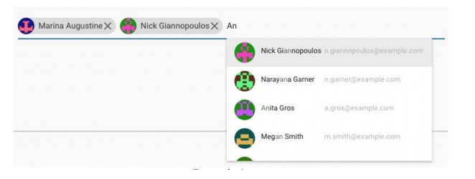

**Video Example**

<https://drive.google.com/file/d/1sy-YAhX1FYFImjLj1uXNilb7DHlbuveh/view?usp=sharing>

**Specifications**

1. When you click on the input field, a list of items will appear.
2. As you type, the list should show only items that match what you're typing.
3. Clicking on an item should turn it into a chip at the top, and the input field should adjust automatically.
4. Once an item becomes a chip, it should no longer be in the list.
5. Each chip has an "X" icon. Clicking it removes the chip and adds the item back to the list.

**Bonus Task**

1. Clean code.
2. TypeScript
3. When the input is blank and the user presses backspace, the last chip (for example, Nick Giannopoulos) should get highlighted and on again pressing backspace it should get deleted

**Notes**

1. Make sure you code your solution in React (CRA/NextJS).
2. Make sure you build the component from scratch and do not use any component based library like MUI, Chakra UI etc.
3. You are free to use CSS solutions like TailwindCss/SCSS.

**Deadline:** 16th Jan, 2024 (EOD)

**Result:**

1. Show List

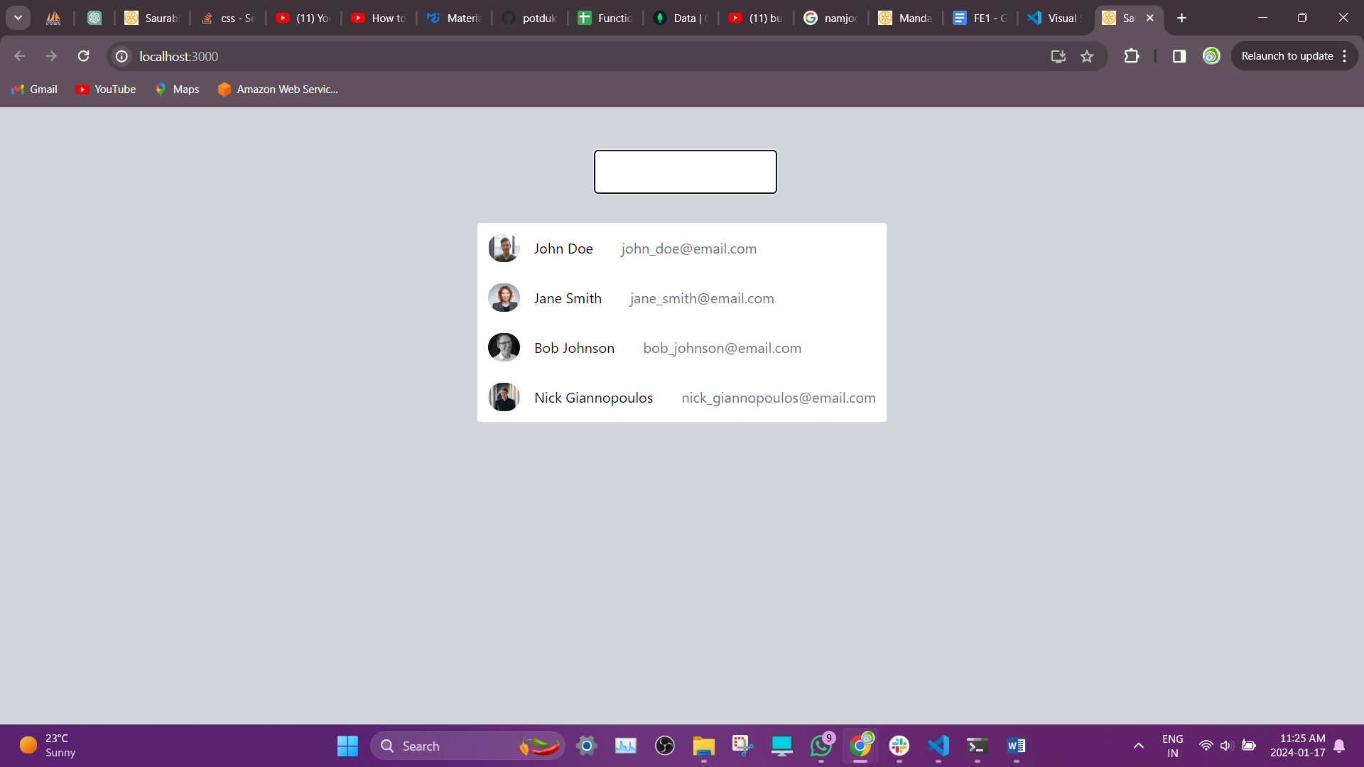

1. Select from list

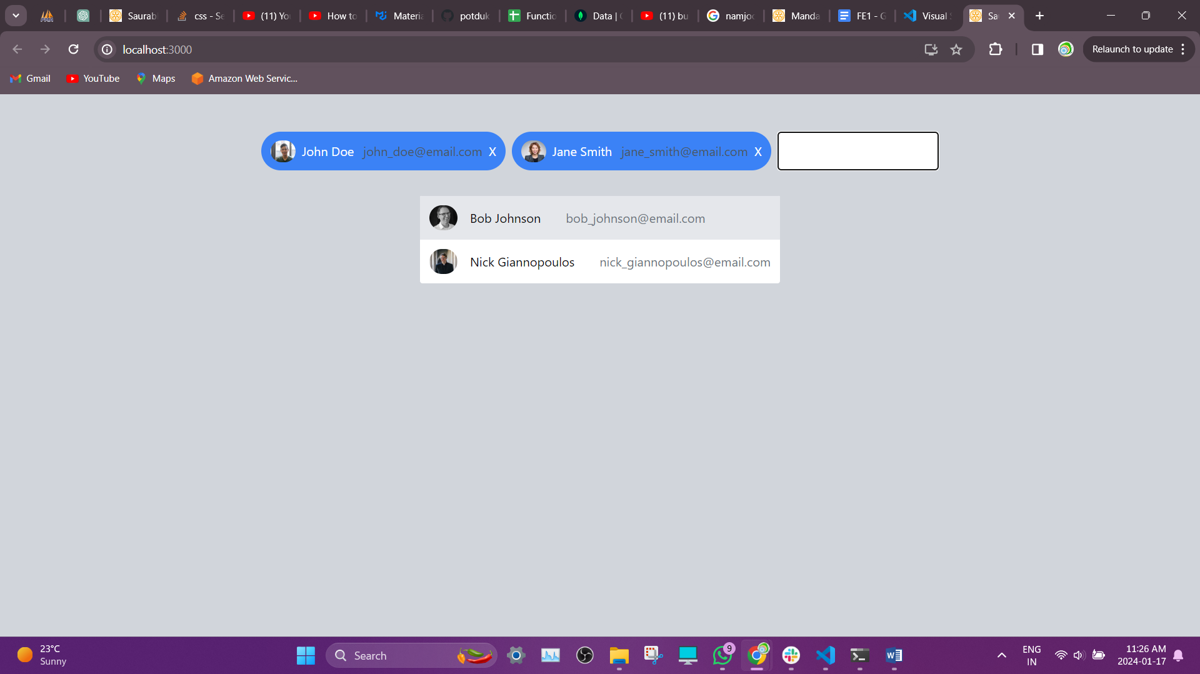

1. Highlight when ‘Backspace’ is pressed

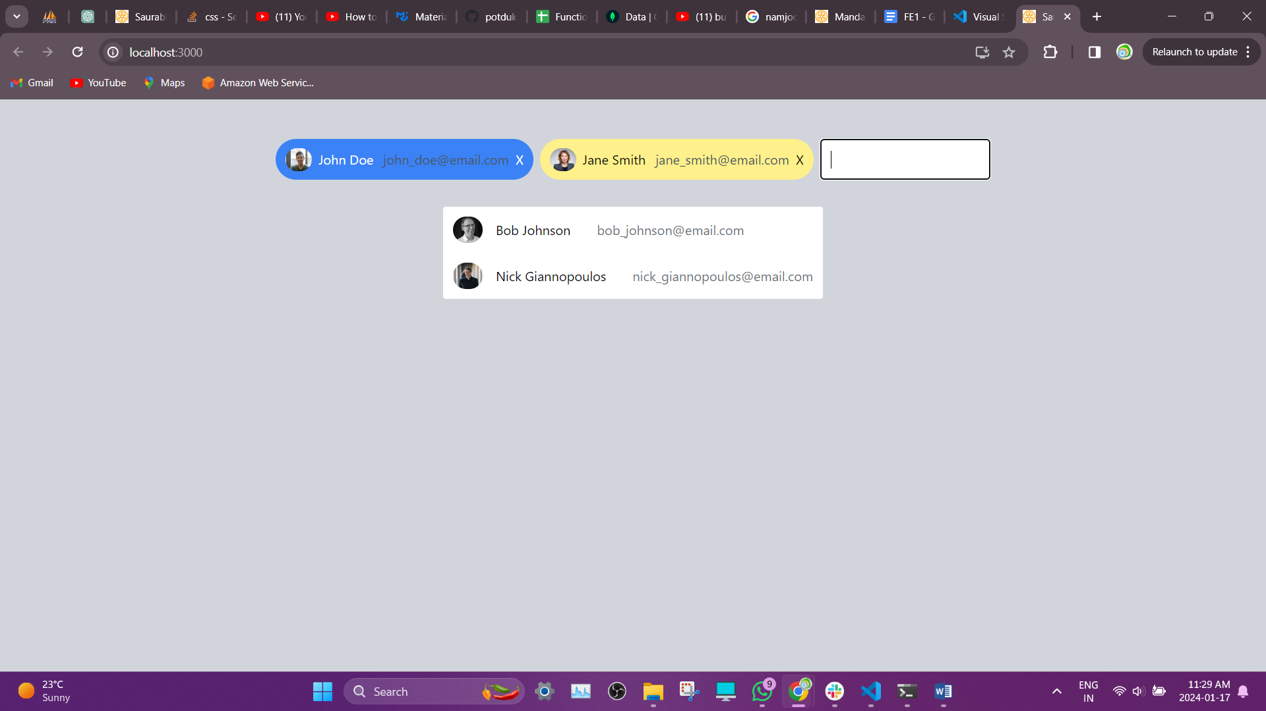

1. Run remove command when ‘Backspace’ is pressed again

