**Python Script for Router Interaction To access the Internet history**

Objective:

The Python script aims to interact with a router's web-based administration interface using the requests library. It logs in to the router, navigates to a hypothetical browsing history page, and extracts information about the most viewed website.

Dependencies:

## **Code Explanation:**

### **1. Import Necessary Libraries:**

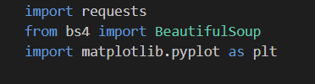

requests: A Python library for making HTTP requests.

BeautifulSoup: A Python library for pulling data out of HTML and XML files.

### **2. Define Router and Login Credentials:**

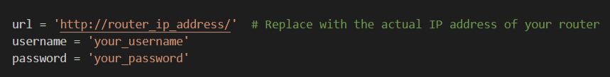

url: The URL of the router's web-based administration interface.

username and password: Login credentials for accessing the router.

### **3. Create a Session and Log In:**

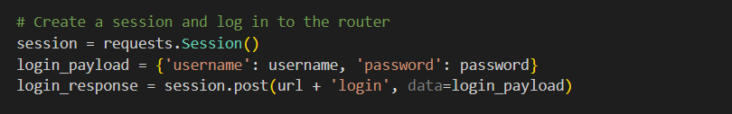

session: A persistent session object to maintain state across multiple requests.

login_payload: A dictionary containing login credentials.

session.post(): Sends a POST request to the router's login endpoint.

### **4. Check Login Status:**

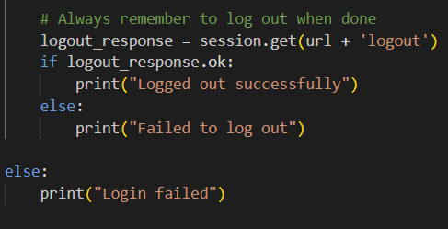

Checks if the login was successful based on the HTTP response.

### **5. Navigate to Browsing History Page (Hypothetical):**

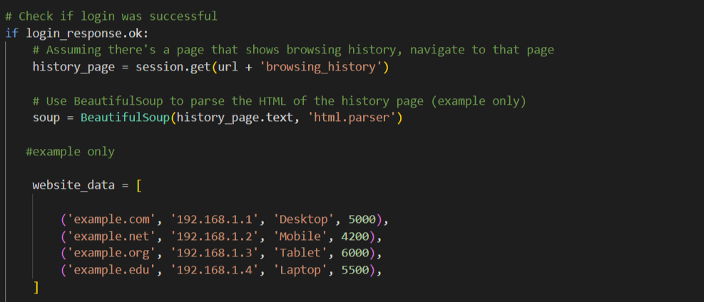

Sends a GET request to a hypothetical browsing history page.

Creates a BeautifulSoup object to parse the HTML content of the history page.

Replace with Actual Implementation: This is a placeholder for actual website data retrieved from the router.

### **8. Find the Most Viewed Website:**

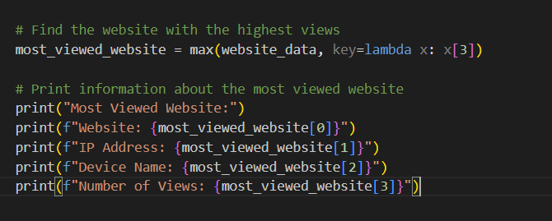

Finds the website with the highest number of views based on the fourth element in the tuple (views).

Prints information about the most viewed website, including its name, IP address, device name, and number of views.

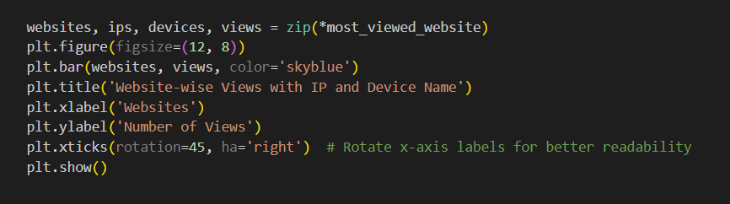

### **10. Logout (Hypothetical):**

Sends a GET request to a hypothetical logout endpoint.

Check Logout Status:



Checks if the logout was successful based on the HTTP response.

Ensure that the script is used responsibly, with proper authorization and adherence to privacy and security guidelines.

Unauthorized access to network devices is both unethical and may be illegal. Always act within legal and ethical boundaries.