Agile Development Process
Devops

Lab Assessment :5(Mid-Term):

Reg.No:23MIS0614
Name: Pothiprajan K
Faculty Name:Balaganesh N
Due Date: 08/04/2025

Dynamic Discount System for E-commerce

Problem Statement:
Ensure product discounts are dynamically applied based on user behavior, season, and inventory levels before release

Tasks
1.Develop dynamic discount calculation logic
2.write Junit tests for regular discounts
3.implement Ci/cd pipeline with automated testing
4.deploy micoservice on Docker and Kubernetes

1.Creating File Structure:
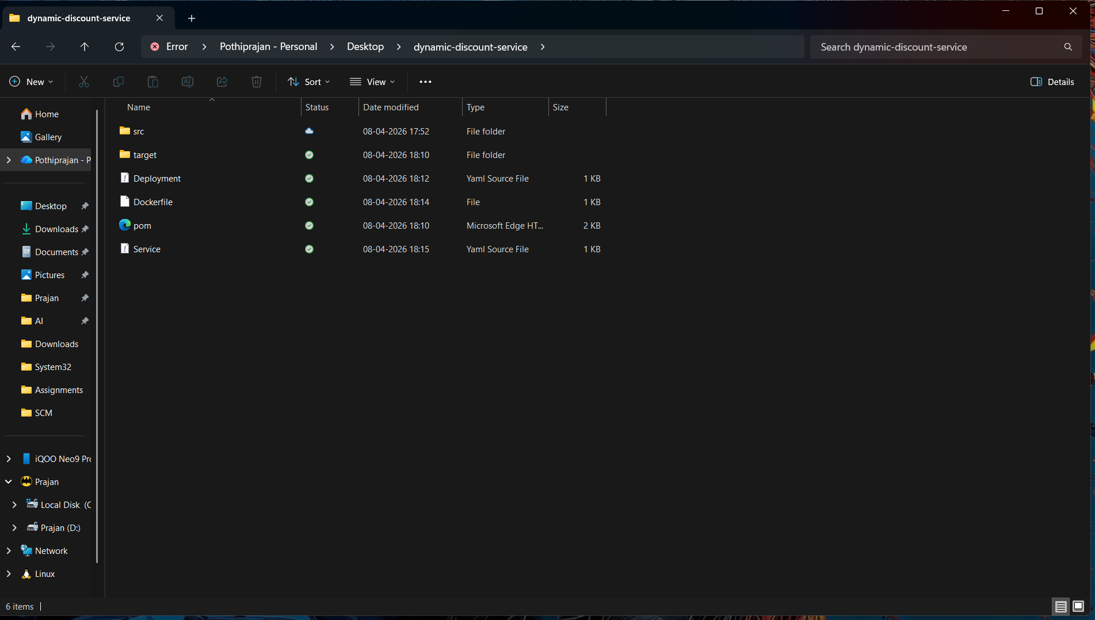

2.Code:
Discount Service.java
public class DiscountService {

public double calculateDiscount(double price, int stock, boolean festive, int purchases) {

double discount = 0;

if (festive) discount += 10;
if (stock > 100) discount += 5;
if (purchases > 10) discount += 7;

return price - (price * discount / 100);
}
}

Main.java:
public class Main {
public static void main(String[] args) {

DiscountService service = new DiscountService();

double finalPrice = service.calculateDiscount(1000, 150, true, 20);

System.out.println("Final Price: " + finalPrice);
}
}

DiscountServiceTest.java:

import org.junit.jupiter.api.Test;
import static org.junit.jupiter.api.Assertions.*;

public class DiscountServiceTest {

DiscountService service = new DiscountService();

@Test
void testNoDiscount() {
assertEquals(1000, service.calculateDiscount(1000, 50, false, 0));
}

@Test
void testFestiveDiscount() {
assertEquals(900, service.calculateDiscount(1000, 50, true, 0));
}

@Test
void testAllDiscounts() {
double result = service.calculateDiscount(1000, 200, true, 20);
assertTrue(result < 900);
}
}
Pom.xml:
<project xmlns="http://maven.apache.org/POM/4.0.0">
<modelVersion>4.0.0</modelVersion>

<groupId>com.discount</groupId>
<artifactId>discount-app</artifactId>
<version>1.0</version>

<dependencies>
<!-- JUnit -->
<dependency>
<groupId>org.junit.jupiter</groupId>
<artifactId>junit-jupiter</artifactId>
<version>5.10.0</version>
<scope>test</scope>
</dependency>
</dependencies>

<build>
<plugins>
<!-- Compiler -->
<plugin>
<groupId>org.apache.maven.plugins</groupId>
<artifactId>maven-compiler-plugin</artifactId>
<version>3.11.0</version>
<configuration>
<source>21</source>
<target>21</target>
</configuration>
</plugin>

<!-- Jar -->
<plugin>
<groupId>org.apache.maven.plugins</groupId>
<artifactId>maven-jar-plugin</artifactId>
<version>3.3.0</version>
<configuration>
<archive>
<manifest>
<mainClass>Main</mainClass>
</manifest>
</archive>
</configuration>
</plugin>
</plugins>
</build>
</project>

Maven: mvn clean test:
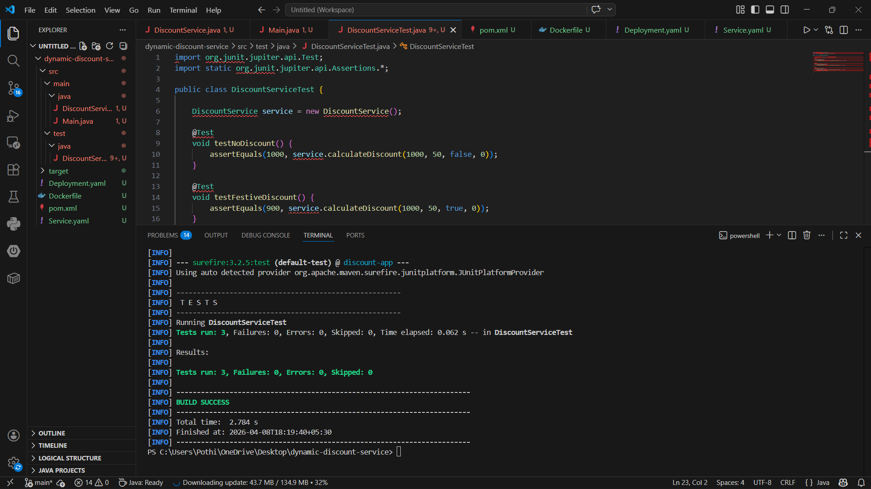

mvn clean package:
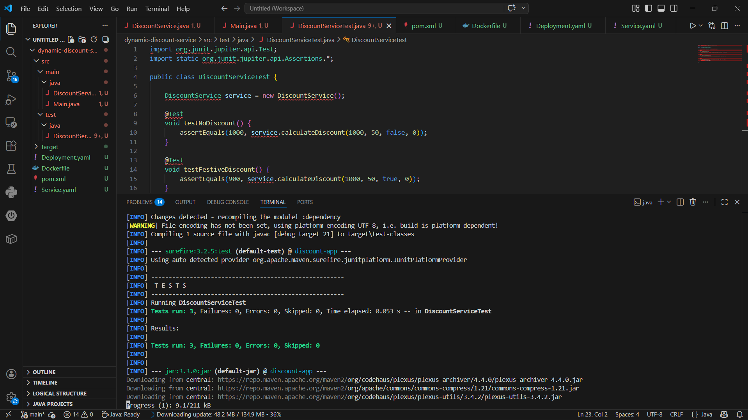
Docker:
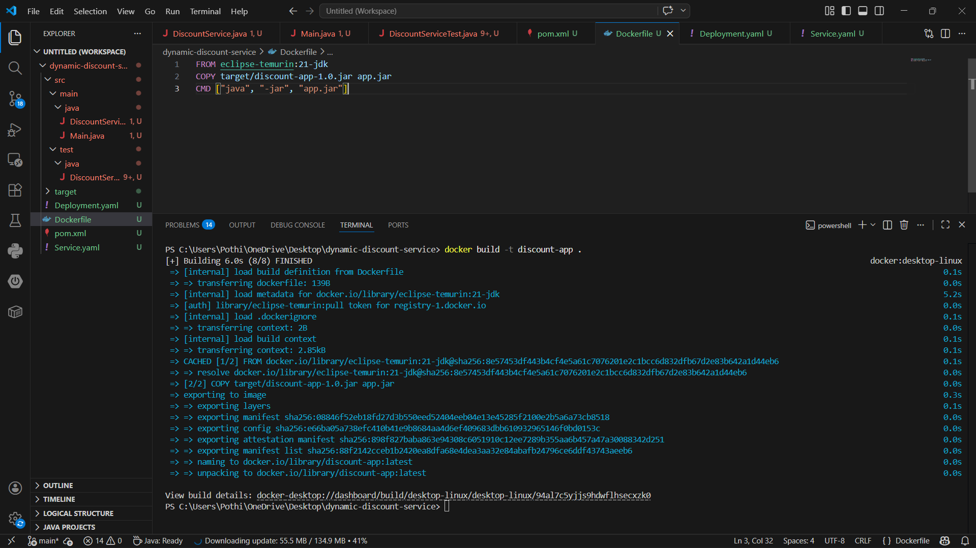

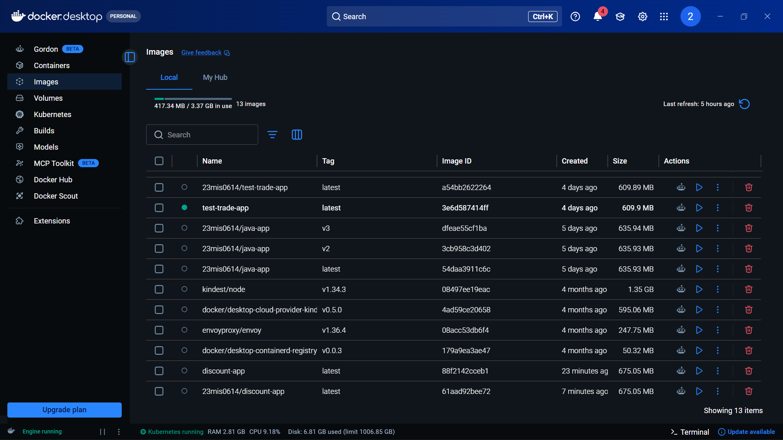

Git repository(after pushing the Code):
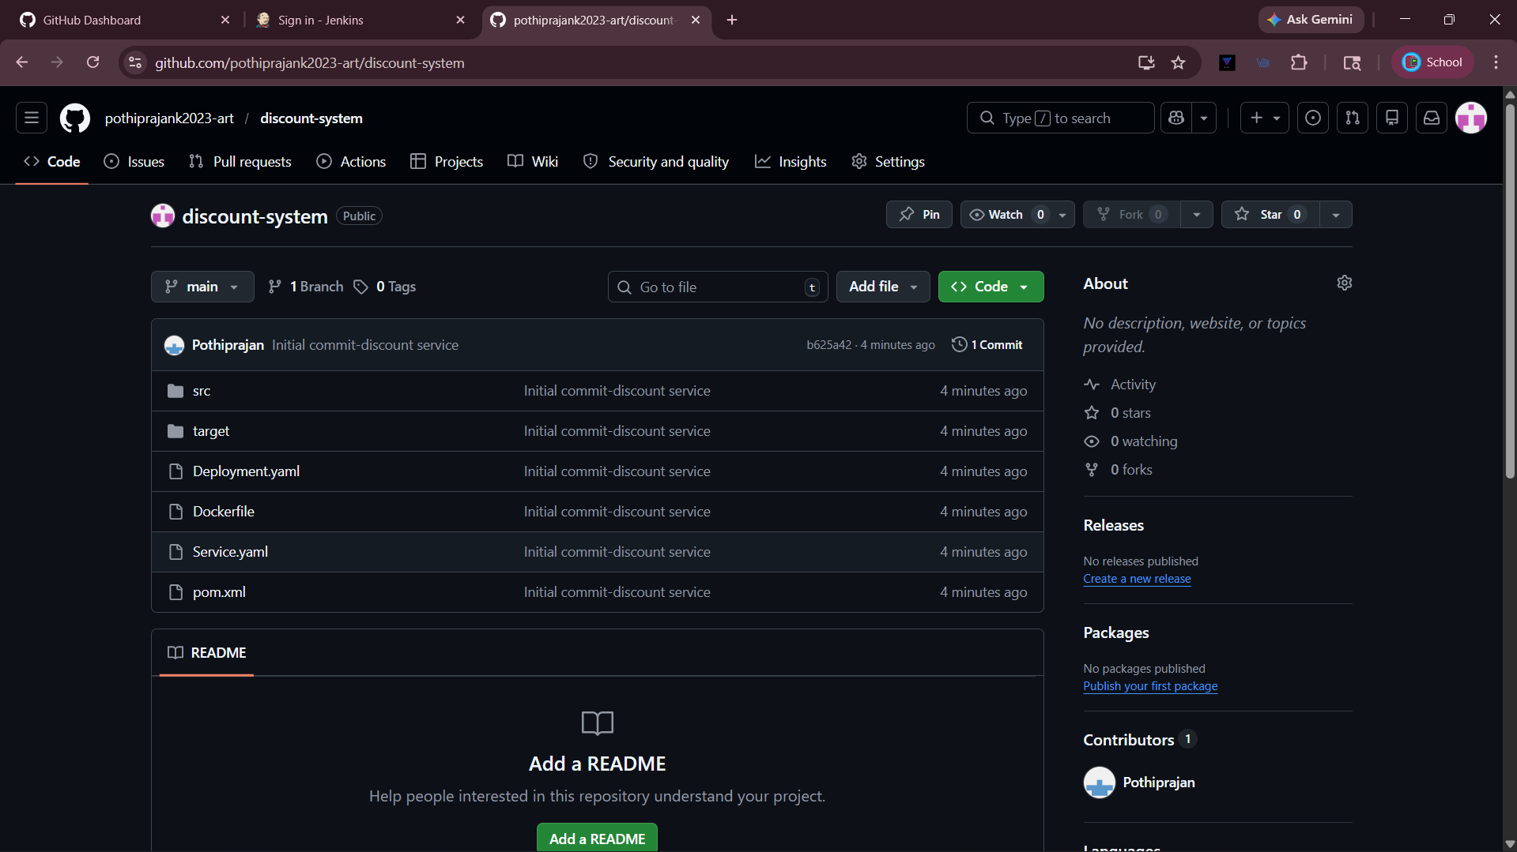

Jenkins:
Pipeline script:
pipeline {
agent any

environment {
DOCKER_IMAGE = "23mis0614/discount-app:latest"
}

stages {

stage('Clone Repository') {
steps {
git branch: 'main',
url: 'https://github.com/pothiprajank2023-art/discount-system.git'
}
}

stage('Build with Maven') {
steps {
bat 'mvn clean package'
}
}

stage('Run Tests') {
steps {
bat 'mvn test'
}
}

stage('Build Docker Image') {
steps {
bat "docker build -t %DOCKER_IMAGE% ."
}
}

stage('Push to DockerHub') {
steps {
withCredentials([usernamePassword(
credentialsId: 'dockerhub-creds',
usernameVariable: 'DOCKER_USER',
passwordVariable: 'DOCKER_PASS'
)]) {
bat """
docker login -u %DOCKER_USER% -p %DOCKER_PASS%
docker push %DOCKER_IMAGE%
"""
}
}
}

stage('Deploy to Kubernetes') {
steps {
bat 'kubectl apply -f deployment.yaml'
bat 'kubectl apply -f service.yaml'
}
}
}

post {
success {
echo 'CI/CD Pipeline executed successfully!'
}
failure {
echo 'Pipeline failed. Please check logs.'
}
}
}

Output:
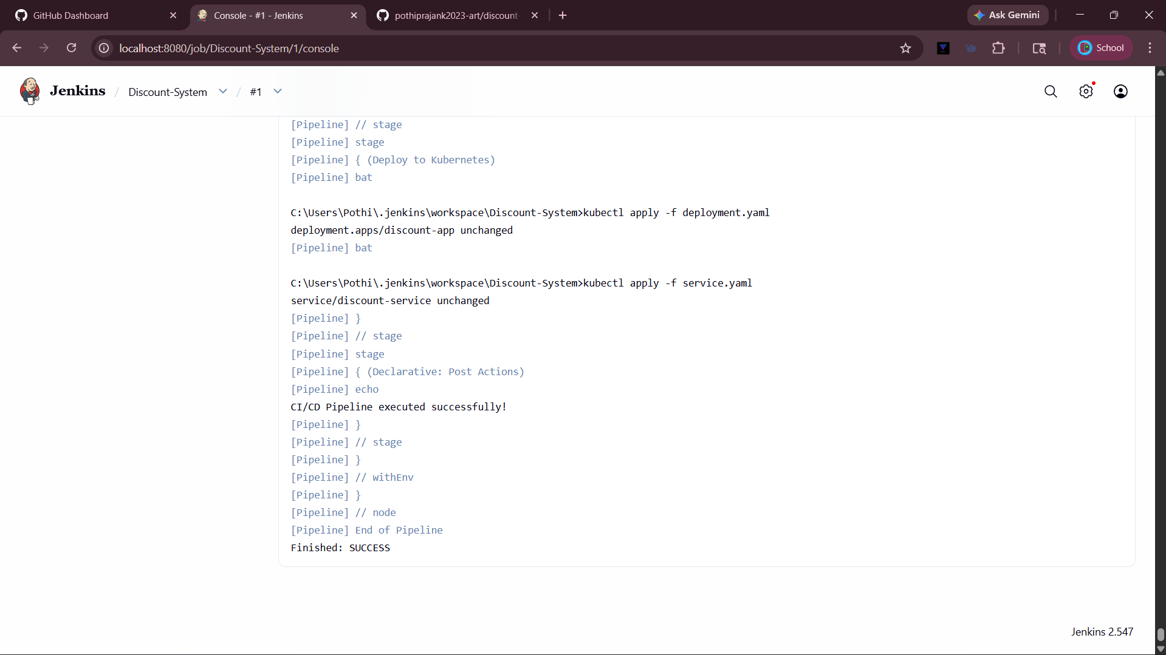

Kubernetes:
Deployment.yaml:
apiVersion: apps/v1
kind: Deployment
metadata:
name: discount-app

spec:
replicas: 2
selector:
matchLabels:
app: discount

template:
metadata:
labels:
app: discount

spec:
containers:
- name: discount-container
image: discount-app

Service.yaml:
apiVersion: v1
kind: Service
metadata:
name: discount-service

spec:
type: NodePort
selector:
app: discount

ports:
- port: 80
targetPort: 8080
nodePort: 30007
Output:
