

SCHOOL OF ENGINEERING
Department of Artificial Intelligence and Machine Learning

CERTIFICATE

This is to certify that the Cornerstone project work entitled “DIGITAL ADDICTION EARLY WARNING SYSTEM” is submitted by
N.D.S.S MADHAVI (24B11AI282)
HASANA POTHULA (24B11AI354)
ROKHIYA BEGUM (24B11AI371)
S LEELA PAVANI (24B11AI409)

in partial fulfillment of the requirements for the award of the B.Tech. degree in Artificial Intelligence and Machine Learning for the academic year 2025-2026.

Project Guide Head of the Department
Dr. N.S.L.Kumar Kurumeti, M.Tech, Ph.D., Dr. M. Venkatesh, M.Tech., Ph.D. Assistant Professor, Assistant Professor,
Department of AIML Department of AIML

DECLARATION

We hereby declare that the Cornerstone project entitled “DIGITAL ADDICTION EARLY WARNING SYSTEM” is original and is submitted to ADITYA UNIVERSITY, Surampalem, in partial fulfillment of the requirements for the award of the B.Tech. degree in Artificial Intelligence and Machine Learning. We further declare that this project work has not been submitted, either in full or in part, for the award of any degree in this or any other institution. We also confirm that this work complies with the Institutional Academic Integrity and AI Usage Policy

Place: Surampalem Date:
By
N.D.S.S MADHAVI (24B11AI282) HASANA POTHULA (24B11AI354) ROKHIYA BEGUM (24B11AI371)
S LEELA PAVANI (24B11AI409)

ACKNOWLEDGEMENT

It is with immense pleasure that we would like to express us indebted gratitude to our project Guide Dr. N.S.L.Kumar Kurumeti, M.Tech, Ph.D, Assistant Professor., who has guided us a lot and encourage in every step of the project work, his valuable moral support and guidance throughout the project helped us a greater extent.
We would like to thank our Deputy Heads of the Department,Dr. R. Sunitha, Assistant Professor and Dr.A.Phani Sridhar,Assistant Professor, Department of AI&ML, for their support andvaluable suggestions.
Our deepest thanks to our Head of the Department Dr.M.Venkatesh, Associate Professor,for his inspiration and for providing all the necessary facilities and resources required for this project.
We also extend our sincere thanks to Dr. M.V. Rajesh, Associate Dean, School of Engineering for their encouragement and support during the course of our project.
We would like to express our sincere gratitude to Dr.G.Suresh,Registrar, Dr. A Ramesh, ProVice-Chancellor (Engineering & Sciences), Dr.S.RamaSree,ProVice-Chancellor(Academics),Dr.M.B.Srinivas,ViceChancellor,Dr.M.SreenivasaReddy,DeputyProChancellorandManagement,AdityaUniversity for providing excellent infrastructure and state-of-the-art laboratories.
Finally, we would like to thank the faculty members, lab technicians, non-teaching staff, and our friends who have directly or indirectly supported us in completing this Cornerstone project successfully.

ABSTRACT

Digital addiction has emerged as a growing concern among students, affecting academic performance, social interactions, and overall well-being. Traditional methods of monitoring, such as surveys, manual observations, and basic screen-time tracking, are limited in scope and fail to provide deeper insights into behavioral patterns. To address these challenges, the Digital Addiction Early Warning System (DAEWS) leverages data mining and machine learning techniques to analyze student digital usage and predict addiction risks.
The system collects data from multiple sources including screen time logs, app usage statistics, browsing behavior, and study activity. Through preprocessing and automated analysis, the data is transformed into meaningful features that reflect digital habits. Classification algorithms such as Decision Tree and Random Forest are applied to categorize students into risk levels: Safe, AtRisk, and HighRisk.
Visualization tools such as charts and dashboards make the results easy to interpret for teachers, parents, and administrators. By identifying key factors like late-night usage, social media dependency, and reduced study hours, the system enables timely interventions such as counseling, awareness programs, or personalized guidance.
The proposed system minimizes manual effort, reduces human error, and provides scalable solutions for large datasets. It supports data-driven decision-making in educational institutions, ensuring early detection and prevention of digital addiction. Overall, DAEWS demonstrates how integrating technology with student well- being can create a proactive, intelligent, and impactful solution for healthier academic environments.

Keywords:
- Digital Addiction Early Warning System
- Data Mining
- Machine Learning
- Risk Prediction
- Student Behavior Analysis

LIST OF CONTENTS
CONTENTS | Page No
LIST OF FIGURES |  | i
CHAPTER 1: INTRODUCTION | 1
1.1 Introduction | 2
1.2 Problem Statement | 3
1.3 Objectives of the Project | 4
1.4 Scope of the Project | 6
CHAPTER 2: SYSTEM OVERVIEW | 11
2.1 Existing System | 12
2.2 Limitations of Existing System | 12
2.3 Proposed System | 12
2.4 Software Requirements | 12
2.5 Hardware Requirements | 12
CHAPTER 3: DATA SET | 13
3.1 Dimentions | 194
3.2 Attribute Information | 19
CHAPTER 4: DATA PREPROCESSING | 29
4.1: Introduction | 30
4.2. Need for Data Preprocessing | 30
4.3. Data Preprocessing Steps | 31
4.3.1. Data Cleaning | 31
4.3.2. Handling Missing Values | 32
4.3.3. Duplicates Removal | 33
4.3.4. Handling Outliers | 34
4.3.5. Data Normalization | 35
4.3.6. Data Splitting | 35

  - Benefits of Data Preprocessing 35
  - Conclusion 36
CHAPTER 5: CLASSIFICATION 37
  - Introduction to Classification 38
  - Need for Classification in This Project 38
  - Classification Algorithm Used – Decision Tree (J48) 38
  - Implementation in Weka 39
  - Evaluation Method 40
  - Results of Classification 42
  - Advantages of Classification 43
  - Applications in This Project 44
  - Conclusion 44
CHAPTER 6: ASSOCIATION 45
  - Introduction: 46
  - Why Association: 46
  - Algorithm Used- Apriori Algorithm 46
  - Implementation in Weka 47
CHAPTER 7: CLUSTERING 49
  - Introduction: 50
  - Need for Clustering in This Project: 50
  - Clustering Algorithm Used – SimpleKmeans 50
    - How it works 50
  - Implementation in Weka 51
  - Results of Clustering 53
CHAPTER 8: CONCLUSION 54
CHAPTER 9: FUTURE SCOPE 56
CHAPTER 10: WEBLINKS & REFERENCES 58

LIST OF FIGURES

Figure No. | Name of the Figure | Page No.
1 | Digital Addiction | 03
2 | Digital Addiction & Social Network addiction | 06
3 | Dimension- User & Time Identifiers | 15
4 | Dimension- Basic Phone Usage Metrics | 15
5 | Dimension- App Usage & Interaction Patterns | 16
6 | Dimension- Emotional & Psychological Signals | 16
7 | Dimension- Temporal & Contextual Usage Patterns | 17
8 | Dimension- Dependency & Control Signals | 18
9 | Dimension- Lifestyle & Balance Indicators | 18
10 | Dimension- Derived & Label Columns | 19
11 | Selecting String TO Nominal for Data Cleaning | 31
12 | After applying the String TO Nominal Result | 32
13 | Selecting ReplaeMissingValuesWithUserConstant | 33
14 | Selecting RemoveDuplicates to remove duplicates | 33
15 | After the removal of duplicates | 34
16 | Selecting RemoveWithValues to handle outliers | 34
17 | Selecting Normalization | 35
18 | Selecting Tree– J48 for decision tree | 40
19 | Selecting Evaluation Method as Cross Validation | 41
19.1 | Cross Validation (10 folds) | 41
20 | Result after selecting Cross Validation (10 folds) | 42
21 | Digital Addiction Descision Tree | 43
22 | Selecting Apriori Algorithm | 47
23 | Results of Association Rule Mining | 48
24 | Selecting SimpleKMeans algorithm | 51
25 | Selecting number of clusters | 52
26  27  28 | Result of SimpleKMeans  Selecting Visualization of Clustering  Cluster Visualization | 52  53  53

CHAPTER 1 : INTRODUCTION

  - Introduction
Digital technology has become an inseparable part of modern life. Smartphones, social media platforms, online gaming, streaming services, and other digital applications have transformed how people communicate, learn, work, and entertain themselves. While these innovations have brought undeniable benefits, they have also introduced new challenges, particularly the phenomenon of digital addiction. Digital addiction refers to the excessive and compulsive use of digital devices and applications, often leading to negative impacts on mental health, productivity, social relationships, and overall well-being.
The Digital Addiction Early Warning System is a data mining–based application designed to monitor, analyze, and predict patterns of digital usage that may indicate the onset of addictive behavior. By leveraging advanced techniques such as clustering, classification, association rule mining, and predictive analytics, the system identifies hidden patterns in user behavior and provides timely alerts. These alerts act as early warnings, enabling individuals, families, educators, and organizations to take preventive measures before digital usage escalates into harmful addiction.
This system is required because traditional monitoring methods are either too simplistic (e.g., screen-time counters) or too reactive (e.g., interventions only after addiction is severe). A proactive, data-driven approach ensures that risks are detected early, allowing for healthier digital habits and reducing long-term consequences. The application not only supports individual well-being but also contributes to broader societal goals such as improving academic performance, workplace productivity, and mental health outcomes.


Figure 1: Digital Addiction
The introduction of such a system is timely and necessary in an era where digital engagement is unavoidable. By combining data mining techniques with behavioral analytics, the project bridges the gap between raw data and actionable insights, transforming digital footprints into meaningful indicators of well-being.
  - Problem Statement
The current landscape of digital usage presents several pressing problems. Existing systems for monitoring digital behavior are limited in scope and effectiveness. Most tools focus on surface-level metrics such as screen time, app usage duration, or number of notifications received. While these metrics provide some information, they fail to capture the deeper behavioral patterns that signify addiction, such as compulsive checking, inability to disengage, or emotional dependence on digital platforms.
Key problems in the current system include:

    - Lack of predictive capability: Current monitoring tools can only report usage statistics but cannot predict whether a user is at risk of developing addiction.
    - Fragmented data sources: Digital behavior is spread across multiple devices and applications, making it difficult to obtain a holistic view of user activity.

    - Reactive interventions: Most solutions are implemented only after addiction has already taken hold, which reduces their effectiveness.
    - Absence of personalization: Existing systems often apply generic thresholds (e.g., “more than 4 hours of screen time is bad”), ignoring individual differences in lifestyle, work requirements, and personal resilience.
    - Limited awareness: Users often underestimate the seriousness of their digital habits until negative consequences manifest, such as poor academic performance, workplace inefficiency, or deteriorating mental health.
A computerized data mining system is needed to solve these problems because manual observation or simplistic monitoring cannot handle the complexity and scale of digital behavior. Data mining techniques allow for:
    - Pattern discovery: Identifying hidden correlations between usage behaviors and addiction risk.
    - Clustering and segmentation: Grouping users into categories such as “healthy users,” “at-risk users,” and “addicted users.”
    - Predictive modeling: Forecasting future addiction tendencies based on current and historical data.
    - Real-time alerts: Providing early warnings before addiction escalates.

    - Personalized insights: Tailoring recommendations to individual usage patterns rather than applying one-size-fits-all solutions.
Without such a system, society risks facing increasing levels of digital dependency, with consequences ranging from reduced productivity to mental health crises. The Digital Addiction Early Warning System addresses these gaps by offering a proactive, intelligent, and scalable solution.
  - Objectives of the Project
The objectives of the Digital Addiction Early Warning System are comprehensive, reflecting both technical goals and societal impact. The project aims to:
- Develop a data mining–based application that systematically analyzes digital usage data to detect early signs of addiction.

- Collect and preprocess user data from multiple sources such as mobile apps, social media platforms, browsing history, and device logs.
- Apply clustering techniques to categorize users into different risk levels based on their digital behavior.
- Implement classification algorithms to predict whether a user’s current behavior is likely to lead to addiction.
- Use association rule mining to uncover hidden relationships between specific digital activities (e.g., late-night usage, frequent app switching) and addiction tendencies.
- Provide real-time alerts and notifications to users, parents, or administrators when risky patterns are detected.
- Promote awareness and education about digital addiction by providing insights into its causes, symptoms, and preventive strategies.
- Support mental health initiatives by offering data-driven evidence to counselors, educators, and healthcare professionals.
- Integrate predictive analytics to forecast future risks and provide long-term monitoring.
- Enhance security and privacy by ensuring that user data is anonymized and protected against misuse.
- Contribute to academic research by providing a framework for studying digital addiction patterns using real-world data.
- Bridge the gap between technology and psychology by combining computational methods with behavioral science insights.

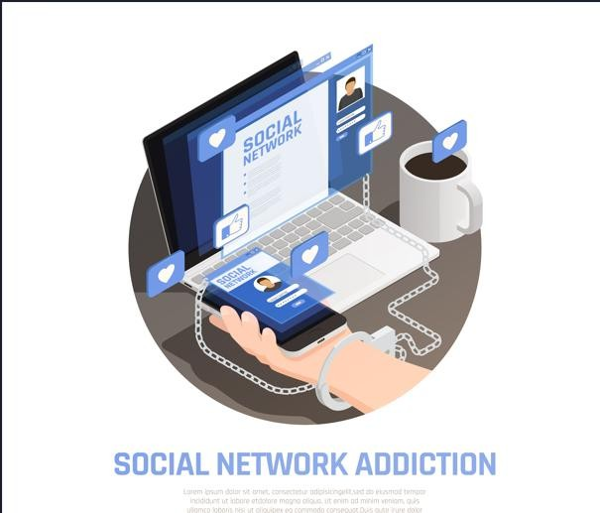
Figure 2: Digital Addiction & Social Network addiction

Ultimately, the project seeks to create a holistic solution that not only detects digital addiction but also empowers individuals and communities to take proactive steps toward healthier digital engagement.
  - Scope of the Project
The scope of the Digital Addiction Early Warning System defines the environments in which the system can be applied and the range of operations it supports. This ensures clarity about its applicability, functionality, and limitations, while also highlighting its potential impact across different domains.
Where the System Can Be Used

- Educational Institutions

  - Schools, colleges, and universities can deploy the system to monitor students’ digital habits.

  - Helps identify early signs of excessive gaming, social media use, or late- night device activity that may affect academic performance.
  - Provides teachers and administrators with reports to guide awareness programs and counseling.
- Workplaces and Organizations

  - Employers can use the system to track employee digital engagement during working hours.
  - Detects patterns of distraction caused by non-work-related digital activities.
  - Supports HR and management in promoting productivity and digital wellness initiatives.
- Healthcare and Counseling Centers

  - Mental health professionals can integrate the system into diagnostic processes.
  - Provides data-driven evidence of digital dependency for early intervention.
  - Assists counselors in tailoring therapy sessions with personalized insights.
- Families and Individual Users

  - Parents can monitor children’s device usage to ensure healthy digital habits.
  - Individuals can self-assess their own risk levels and receive personalized recommendations.
  - Encourages responsible digital engagement at home.

- Government and Policy Making

  - Public health departments can use aggregated data to study digital addiction trends.

  - Supports policymaking for awareness campaigns and preventive strategies.
  - Provides insights into demographic and regional variations in digital dependency.
- Research and Academia

  - Researchers can use the system as a framework for studying digital addiction patterns.
  - Offers datasets for academic projects, theses, and behavioral studies.

  - Contributes to the growing body of knowledge on digital well-being.

Objectives:

- Data Collection and Integration

  - Collects usage logs from mobile devices, social media platforms, browsing histories, and gaming applications.
  - Integrates data from multiple sources to provide a holistic view of digital behavior.
- Data Preprocessing

  - Cleans and normalizes raw data to remove inconsistencies.

  - Transforms data into structured formats suitable for mining and analysis.

- Pattern Discovery

  - Applies clustering techniques to group users based on digital habits.

  - Uses classification algorithms to predict addiction risk levels.

  - Employs association rule mining to uncover hidden correlations between activities.
- Risk Categorization

  - Segments users into categories such as healthy usage, at-risk usage, and
addicted usage.

  - Provides clear indicators for each category to guide interventions.

- Prediction and Forecasting

  - Uses predictive analytics to forecast future addiction tendencies.

  - Helps anticipate risks before they escalate into severe dependency.

- Early Warning Alerts

  - Alerts can be sent to individuals, parents, educators, or administrators.

- Visualization and Reporting

  - Provides dashboards, charts, and reports for easy interpretation of digital behavior.
  - Supports customized views for different stakeholders (students, employees, parents, counselors).
- Personalized Recommendations

  - Suggests corrective measures such as screen breaks, app usage limits, or mindfulness practices.
  - Tailors recommendations to individual behavior rather than applying generic thresholds.
- Security and Privacy Operations

  - Ensures user data is anonymized and encrypted.

  - Provides secure access controls to prevent misuse of sensitive information.
- Scalability and Adaptability

  - Supports deployment across diverse domains and demographics.

  - Can be scaled to handle large datasets in organizations or educational institutions.
The Digital Addiction Early Warning System has a wide scope, spanning educational, professional, healthcare, family, and research domains. It supports a comprehensive set of operations, from data collection and mining to prediction, alert generation, and personalized recommendations. By combining technical robustness with practical applicability, the system ensures that digital addiction can be detected early, managed effectively, and prevented proactively.

CHAPTER 2: SYSTEM OVERVIEW

  - Existing System
Digital addiction is currently tracked through:
    - Surveys and questionnaires
    - Teacher/parent observations
    - Basic screen-time statistics
These methods are manual, subjective, and lack deeper analysis.
  - Limitations of Existing System
    - Time-consuming and error-prone
    - No prediction of future risk
    - Limited analysis beyond surface metrics
    - Hidden patterns not detected
    - Not scalable for large student datasets
  - Proposed System
The Digital Addiction Early Warning System applies data mining and machine learning to student digital behavior.
Key Features:
    - Automated data collection and processing
    - Student risk classification (low, medium, high)
    - Prediction of future performance decline
    - Clear visual dashboards and reports
    - Identification of critical addiction factor
  - Software Requirements

    - WEKA → WEKA is used for performing data mining and applying various analytical techniques.
  - Hardware Requirements

    - Processor: Intel i3 or above

    - RAM: 4GB or more

    - Storage: 10GB free space

CHAPTER 3: DATA SET

The dataset used in this project consists of multiple attributes that describe different aspects of student participation in campus activities. These attributes are essential for analyzing student behavior, identifying patterns, and applying data mining techniques such as clustering and classification. Each attribute is categorized based on its data type, including nominal, ordinal, and numerical attributes. Understanding the nature and role of each attribute is crucial for effective data preprocessing and model building.
Number of Instances: 870 Dimensions: 8

3.1. DIMENTIONS
- User & Time Identifiers

This dimension captures the unique identifiers of each user along with temporal markers such as date, time, and session duration. It ensures that digital behavior is linked to specific individuals while maintaining chronological order. By tracking time stamps, the system can analyze daily, weekly, and monthly trends in usage. It also helps identify peak hours of device engagement, such as late-night activity or continuous daytime sessions. These identifiers are crucial for distinguishing between different users in multi-user environments. They also allow longitudinal studies of digital habits over extended periods. In predictive modeling, time-based identifiers provide context for detecting recurring patterns. Overall, this dimension forms the backbone of data organization and analysis.

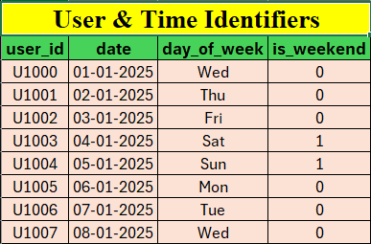
Figure 3: Dimension- User & Time Identifiers

- Basic Phone Usage Metrics

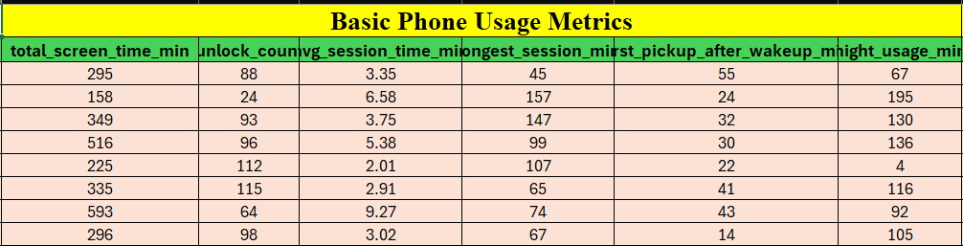
This dimension includes fundamental measures such as total screen time, number of unlocks, call duration, and text message frequency. These metrics provide a baseline understanding of how often and how long users interact with their devices. Excessive unlocks or prolonged screen sessions may indicate compulsive checking behavior. Call and text activity can reveal whether digital communication is balanced or excessive. By analyzing these metrics, the system can differentiate between normal and abnormal usage. They also serve as input variables for clustering users into healthy, at-risk, or addicted categories. Basic metrics are easy to collect and interpret, making them essential for early detection. Together, they provide a quantitative foundation for deeper behavioral analysis.

Figure 4: Dimension- Basic Phone Usage Metrics

- App Usage & Interaction Patterns

This dimension focuses on how users engage with specific applications, including frequency, duration, and switching behavior. It tracks social media, gaming, streaming, and productivity apps separately to highlight differences in usage. Frequent switching between apps may indicate restlessness or lack of focus. Extended sessions on

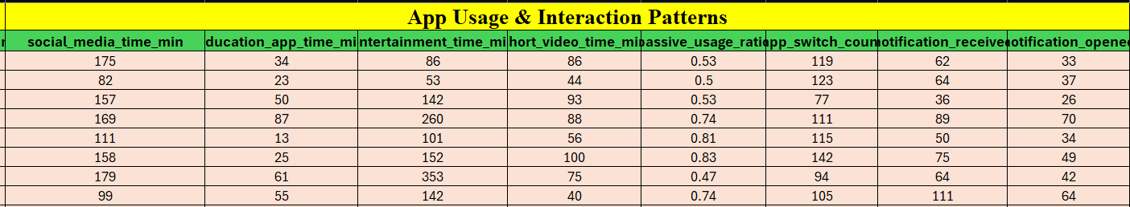
entertainment or social platforms can signal dependency. Interaction patterns also reveal multitasking tendencies and preference hierarchies among apps. By mining these patterns, the system uncovers hidden correlations between app categories and addiction entertainment or social platforms can signal dependency. Interaction patterns also reveal multitasking tendencies and preference hierarchies among apps. By mining these patterns, the system uncovers hidden correlations between app categories and addiction risk. This dimension supports personalized recommendations, such as limiting time on high-risk apps. It also enables clustering users based on dominant app usage types. Ultimately, app interaction patterns provide a nuanced view of digital engagement.

Figure 5: Dimension- App Usage & Interaction Patterns

- Emotional & Psychological Signals

This dimension captures indirect indicators of emotional states, such as frequency of notifications checked, late-night usage, or reliance on digital communication during stressful periods. It may also include self-reported mood logs or sentiment analysis of text interactions. These signals help bridge the gap between raw usage data and psychological well-being. For example, compulsive checking during anxiety episodes can be detected through abnormal notification response times. Emotional signals are critical for identifying dependency that is not purely quantitative. They allow the system to connect behavioral data with mental health outcomes. By integrating psychological cues, the system becomes more holistic and human-centered. This dimension strengthens the predictive power of addiction detection models.
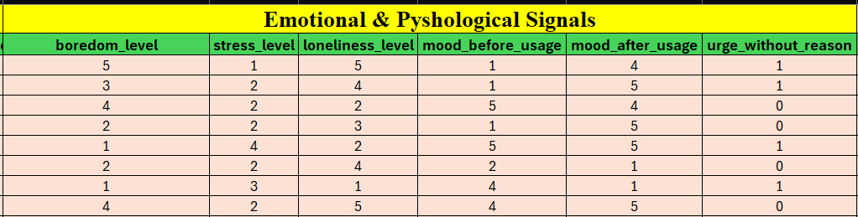

Figure 6: Emotional & Psychological Signals

- Temporal & Contextual Usage Patterns

This dimension examines when and where digital usage occurs, including time of day, day of week, and contextual factors such as location. Late-night or early-morning activity often correlates with sleep disruption and addiction risk. Weekend spikes may indicate recreational overuse, while weekday patterns may reflect work or study demands. Contextual data, such as usage during commuting or in classrooms, adds depth to behavioral analysis. By combining temporal and contextual factors, the system identifies risky scenarios like continuous night-time scrolling. These patterns also support forecasting of future habits based on past cycles. They provide actionable insights for recommending healthier routines. Overall, this dimension highlights the situational aspects of digital engagement.
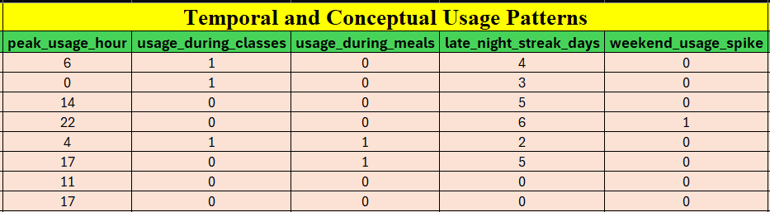

Figure 7: Dimension- Temporal & Contextual Usage Patterns

- Dependency & Control Signals

This dimension measures indicators of dependency, such as inability to reduce usage, frequent app reopens, or ignoring screen-time warnings. It also tracks control signals like attempts to set limits or use digital well-being tools. High dependency signals combined with weak control efforts suggest elevated addiction risk. Conversely, strong control signals may indicate resilience against compulsive behavior. This dimension is crucial for distinguishing between users who are aware of their habits and those who are not. It also helps evaluate the effectiveness of interventions like app timers or parental controls. By analyzing dependency and control together, the system provides a balanced view of digital self-regulation. This dimension directly supports early warning alerts.

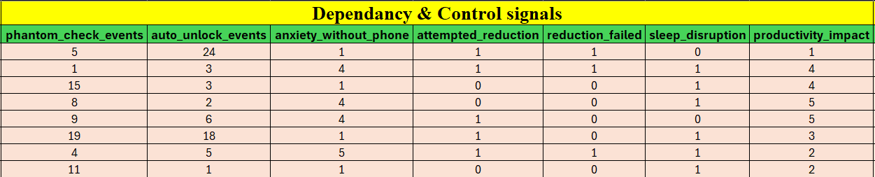

Figure 8: Dimension- Dependency & Control Signals

- Lifestyle & Balance Indicators

This dimension integrates digital usage with lifestyle factors such as sleep duration, physical activity, and offline social interactions. Excessive device use often disrupts sleep cycles, reduces exercise, and limits face-to-face communication. By correlating digital habits with lifestyle metrics, the system assesses overall balance. For example, late-night scrolling linked with reduced sleep hours signals unhealthy patterns. Balanced users show consistent offline engagement alongside digital activity. This dimension highlights the broader impact of digital addiction on well-being. It also supports personalized recommendations that encourage healthier routines. By including lifestyle indicators, the system moves beyond device metrics to holistic wellness. This makes the analysis more comprehensive and actionable.
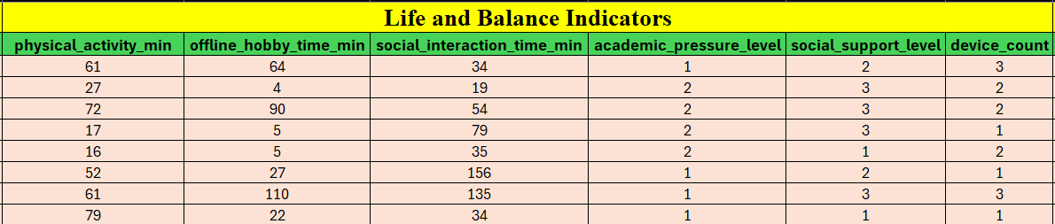

Figure 9: Dimension- Lifestyle & Balance Indicators

- Derived & Label Columns

This dimension includes computed variables and labels generated during data mining, such as risk scores, addiction categories, or predictive outcomes. Derived columns may represent normalized screen time, weighted app usage, or aggregated emotional signals. Label columns classify users into categories like healthy, at-risk, or addicted. These
outputs are essential for supervised learning models and evaluation. They provide the ground truth for training and validating predictive algorithms. Derived metrics also simplify complex raw data into interpretable indicators. By combining multiple dimensions into composite scores, the system enhances accuracy. This dimension

ensures that insights are actionable and easy to communicate. It forms the final stage of the data mining pipeline.
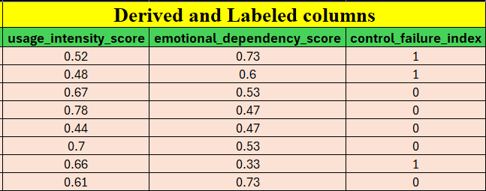

Figure 10: Dimension- Derived & Label Columns

3.2 Attribute Information
- digital_addiction_risk_level

  - Type: Ordinal

  - Description: Represents the final classification of a user’s addiction status (Safe, At Risk, High Risk). It is ordinal because the categories have a meaningful order of severity. This attribute serves as the target variable for supervised learning models. It enables quick identification of users needing intervention. It is the most critical output of the system.
- user_id

  - Type: Nominal

  - Description: Anonymous identifier assigned to each user (U1000–U1118). It is nominal since IDs are labels without inherent order. Ensures privacy while
allowing individual-level tracking. Prevents confusion in multi-user datasets. Forms the foundation for personalized insights.
- date

  - Type: Interval

  - Description: Records the exact date of data collection. Interval because differences between dates are meaningful, but there is no true zero. Allows

temporal analysis of digital behavior trends. Supports forecasting by linking habits to specific dates. Ensures chronological consistency.
- day_of_week

  - Type: Nominal

  - Description: Captures the day (Mon–Sun) of data collection. Nominal since days are categorical labels. Helps identify weekly cycles of digital usage. Weekends may show spikes in entertainment activity. Adds contextual depth to temporal analysis.
- is_weekend

  - Type: Binary (Nominal)

  - Description: Indicator (1/0) specifying whether the record falls on a weekend. Simplifies analysis by distinguishing workdays from leisure days. Weekend usage often correlates with recreational overuse. Helps detect weekend spikes in digital activity. Supports lifestyle pattern analysis.
- total_screen_time_min

  - Type: Ratio

  - Description: Measures total smartphone usage in minutes per day. Ratio because it has a true zero and meaningful comparisons. High screen time often correlates with addiction risk. Supports clustering users into healthy vs. high- usage groups. Foundational for risk scoring.
- unlock_count

  - Type: Ratio
  - Description: Counts the number of times a phone is unlocked daily. Frequent unlocks may indicate compulsive checking behavior. Provides insight into user dependency on digital devices. Complements screen time analysis. Strong predictor of addictive tendencies.
- avg_session_time_min

  - Type: Ratio

  - Description: Measures the average duration of each phone session. Longer

sessions suggest sustained engagement with apps. Short but frequent sessions may indicate compulsive checking. Helps differentiate between focused and fragmented usage. Supports behavioral pattern discovery.
- longest_session_min

  - Type: Ratio

  - Description: Records the maximum continuous usage duration. Extremely long sessions often signal binge behavior. Highlights risks such as gaming or streaming overuse. Long sessions can disrupt sleep and productivity. Vital for detecting extreme cases of addiction.
- first_pickup_after_wakeup_min

  - Type: Ratio

  - Description: Measures time taken to first use the phone after waking. Immediate pickups may indicate dependency. Longer delays suggest healthier habits. Helps assess morning routines and self-control. Adds psychological depth to analysis.
- night_usage_min

  - Type: Ratio

  - Description: Captures usage between 11 PM and 5 AM. Night-time activity often disrupts sleep cycles. High values strongly correlate with addiction risk. Supports detection of late-night streaks and unhealthy routines. Critical for lifestyle impact analysis.
- social_media_time_min

  - Type: Ratio

  - Description: Measures time spent on social networking apps. Excessive social media use is a common addiction driver. Helps identify emotional dependency on online interactions. Supports clustering by app category. Central to behavioral profiling.
- education_app_time_min

  - Type: Ratio

  - Description: Records usage of educational apps. Distinguishes productive digital engagement from recreational use. Higher values may reduce addiction risk classification. Supports positive usage analysis in academic contexts. Highlights constructive habits.
- entertainment_time_min

  - Type: Ratio

  - Description: Measures time spent on gaming and entertainment platforms. Excessive values often indicate recreational overuse. Supports detection of binge gaming or streaming. Strong predictor of high-risk classification. Highlights leisure-driven digital dependency.
- short_video_time_min

  - Type: Ratio

  - Description: Captures time spent on short-form video apps. Such apps often encourage compulsive scrolling. High values indicate passive consumption patterns. Supports detection of addictive micro-content engagement. Crucial for modern digital addiction analysis.
- passive_usage_ratio

  - Type: Ratio

  - Description: Measures the proportion of passive scrolling compared to active interaction. A high ratio indicates mindless consumption of content. It helps differentiate purposeful use from compulsive habits. Passive usage is strongly linked to emotional dependency. This attribute enriches behavioral analysis.
- app_switch_count

  - Type: Ratio

  - Description: Counts the number of app switches per day. Frequent switching suggests restlessness or fragmented attention. It highlights multitasking tendencies and compulsive checking. High values correlate with distracted digital behavior. Supports clustering of users with scattered focus.

- notification_received

  - Type: Ratio

  - Description: Records the total number of notifications received daily. High volumes increase digital engagement pressure. It helps assess external triggers of phone use. Notification load influences compulsive checking behavior. This attribute supports dependency analysis.
- notification_opened

  - Type: Ratio

  - Description: Measures notifications actively opened by the user. Reflects responsiveness to digital stimuli. High values indicate compulsive engagement. Helps assess user control over external triggers. Complements notification received analysis.
- boredom_level

  - Type: Ordinal

  - Description: Self-reported score (1–5) capturing boredom before phone use. High boredom often drives compulsive engagement. Links psychological states with digital habits. Enriches emotional-behavioral correlation analysis. Supports prediction of passive scrolling tendencies.
- stress_level

  - Type: Ordinal
  - Description: Daily stress level rated 1–5. Stress often increases reliance on digital devices. Helps connect emotional states with usage patterns. High stress correlates with compulsive checking. Supports holistic addiction analysis.
- loneliness_level

  - Type: Ordinal

  - Description: Perceived social isolation rated 1–5. Loneliness often drives excessive social media use. Links emotional needs with digital dependency. High values correlate with reliance on devices for connection. Strengthens psychological profiling.

- mood_before_usage

  - Type: Ordinal

  - Description: Emotional state before phone use rated 1–5. Negative moods often trigger compulsive engagement. Helps assess emotional drivers of digital habits. Supports mood-behavior correlation analysis. Enriches predictive modeling.
- mood_after_usage

  - Type: Ordinal

  - Description: Emotional state after phone use rated 1–5. Positive shifts may indicate healthy engagement. Negative shifts suggest emotional dependency or regret. Helps assess the impact of digital activity on well-being. Supports outcome-based analysis.
- urge_without_reason

  - Type: Binary

  - Description: Indicator (0/1) capturing purposeless phone use. Reflects compulsive checking without clear intent. High values strongly correlate with addiction risk. Supports detection of unconscious digital habits. Critical for dependency analysis.
- peak_usage_hour

  - Type: Interval

  - Description: Records the hour (0–23) of highest phone activity. Helps identify daily usage cycles. Late-night peaks often signal unhealthy routines. Supports temporal clustering of digital habits. Adds contextual depth to analysis.
- usage_during_classes

  - Type: Binary

  - Description: Indicator (0/1) capturing phone use during study or class time. Highlights academic distraction risks. High values correlate with reduced productivity. Supports detection of misuse in educational contexts. Vital for student-focused analysis.

- usage_during_meals

  - Type: Binary

  - Description: Indicator (0/1) capturing phone use during meals. Reflects lifestyle imbalance and social disengagement. Frequent values suggest compulsive habits. Supports detection of unhealthy routines. Adds lifestyle context to addiction analysis.
- late_night_streak_days

  - Type: Ratio

  - Description: Counts consecutive days of late-night usage. Longer streaks indicate sustained unhealthy routines. Highlights chronic sleep disruption risks. Supports forecasting of long-term addiction. Critical for lifestyle impact analysis.
- weekend_usage_spike

  - Type: Binary

  - Description: Indicator (0/1) capturing significant weekend usage increases. Reflects recreational overuse patterns. High values suggest dependency during leisure time. Supports detection of lifestyle-driven addiction. Adds temporal balance to analysis.

- phantom_check_events

  - Type: Ratio

  - Description: Counts phone checks without notifications. Reflects compulsive checking behavior driven by habit rather than stimuli. High values strongly correlate with dependency. Supports detection of unconscious digital habits. Crucial for early warning signals
- auto_unlock_events

  - Type: Ratio

  - Description: Records unlocks without conscious intent. Highlights unconscious digital engagement patterns. High values suggest loss of control over device use. Supports dependency and control failure analysis. Strengthens

addiction detection.

- anxiety_without_phone

  - Type: Binary

  - Description: Indicator (0/1) capturing anxiety when unable to access the phone. Reflects emotional dependency on digital devices. High values strongly correlate with addiction risk. Supports psychological profiling of users. Critical for emotional analysis.
- attempted_reduction

  - Type: Binary

  - Description: Indicator (0/1) capturing attempts to reduce phone usage. Reflects user awareness of unhealthy habits. Successful attempts suggest resilience. Failed attempts highlight dependency risks. Supports intervention analysis.
- reduction_failed

  - Type: Binary

  - Description: Indicator (0/1) capturing failure in reducing usage. Reflects loss of control over digital habits. High values strongly correlate with addiction risk.Supports dependency and control failure analysis. Complements attempted reduction.
- sleep_disruption

  - Type: Binary

  - Description: Indicator (0/1) capturing phone usage affecting sleep. Reflects lifestyle imbalance due to late-night activity. Strongly linked to health and productivity decline. Supports detection of chronic digital dependency. Critical for lifestyle impact analysis.
- productivity_impact

  - Type: Ordinal

  - Description: Rated 1–5, measuring impact on academic or work productivity. Higher values indicate severe disruption. Links digital habits with real-world performance outcomes. Supports holistic addiction analysis. Provides

actionable insights for intervention.

- physical_activity_min

  - Type: Ratio

  - Description: Records daily exercise duration in minutes. Low values often correlate with excessive screen time. Helps assess lifestyle balance between digital and physical activity. Supports wellness-oriented recommendations. Adds holistic context to addiction analysis.
- offline_hobby_time_min

  - Type: Ratio

  - Description: Measures time spent on non-screen hobbies. Higher values suggest healthier lifestyle balance. Low values may indicate digital dependency. Supports detection of reduced offline engagement. Adds protective factors to analysis.
- social_interaction_time_min

  - Type: Ratio
  - Description: Records duration of face-to-face social interactions. Low values often correlate with loneliness and digital reliance. Helps assess balance between online and offline relationships. Supports psychological profiling. Adds social context to addiction detection.
- academic_pressure_level

  - Type: Ordinal

  - Description: Rated 1–3, measuring academic or work pressure. Higher values may drive increased digital escapism. Links external stressors with device dependency. Supports contextual analysis of addiction risk. Adds environmental depth to behavioral profiling.
- social_support_level

  - Type: Ordinal

  - Description: Rated 1–3, measuring strength of social support systems. Higher values act as protective factors against addiction. Low values correlate with

loneliness-driven digital dependency. Supports psychological resilience analysis. Adds social context to risk detection.
- device_count

  - Type: Ratio

  - Description: Records the number of digital devices used by a user. Higher counts increase exposure to digital engagement. Supports analysis of multi- device dependency. Helps assess scalability of addiction risk. Adds technological context to profiling.
- usage_intensity_score

  - Type: Ratio

  - Description: Composite indicator (0–1) of overall phone usage intensity. Aggregates multiple behavioral metrics into a single score. Higher values indicate stronger digital engagement. Supports clustering and risk classification. Simplifies complex data into actionable insights.
- emotional_dependency_score
  - Type: Ratio

  - Description: Composite measure (0–1) of emotional reliance on devices. Derived from psychological and behavioral signals. Higher values indicate stronger emotional attachment. Supports prediction of compulsive usage. Adds depth to emotional profiling.
- control_failure_index

  - Type: Binary

  - Description: Indicator (0/1) capturing loss of control over usage. Reflects inability to regulate digital habits. High values strongly correlate with addiction risk. Supports dependency and intervention analysis. Critical for early warning classification.

CHAPTER 4: DATA PREPROCESSING

4.1: Introduction
Data preprocessing is a crucial step in the data mining process that involves transforming raw data into a clean and suitable format for analysis. In real-world scenarios, the data collected from various sources is often incomplete, inconsistent, noisy, and unstructured. Such data cannot be directly used for applying machine learning or data mining algorithms.
Data preprocessing includes a series of techniques such as data cleaning, data transformation, data integration, and data reduction. These techniques ensure that the dataset becomes accurate, consistent, and reliable for further analysis. Without proper preprocessing, the performance of data mining models may be significantly affected, leading to incorrect predictions and poor results.

  - Need for Data Preprocessing

The dataset used in this project contains student participation information, which may include missing values, inconsistencies, and categorical data that cannot be directly processed by machine learning algorithms. Therefore, preprocessing is essential to improve the quality of data and ensure better analysis.
The main reasons for performing data preprocessing are:

- To handle missing or incomplete data

- To remove duplicate or irrelevant records

- To convert categorical data into numerical form

- To normalize or scale numerical values

- To improve the accuracy and efficiency of data mining algorithms

By performing these steps, the dataset becomes more structured and suitable for clustering and classification techniques used in this project.

  - Data Preprocessing Steps
The following preprocessing steps were performed on the dataset:

    - Data Cleaning

Data cleaning is the first and most important step in preprocessing. It involves identifying and correcting errors or inconsistencies in the dataset.
      - Missing values were identified and handled using appropriate methods such as filling with default values or removing records if necessary.
      - Duplicate records were removed to avoid redundancy.

      - Inconsistent data entries were corrected to maintain uniformity.

This step ensures that the dataset is accurate and free from errors.
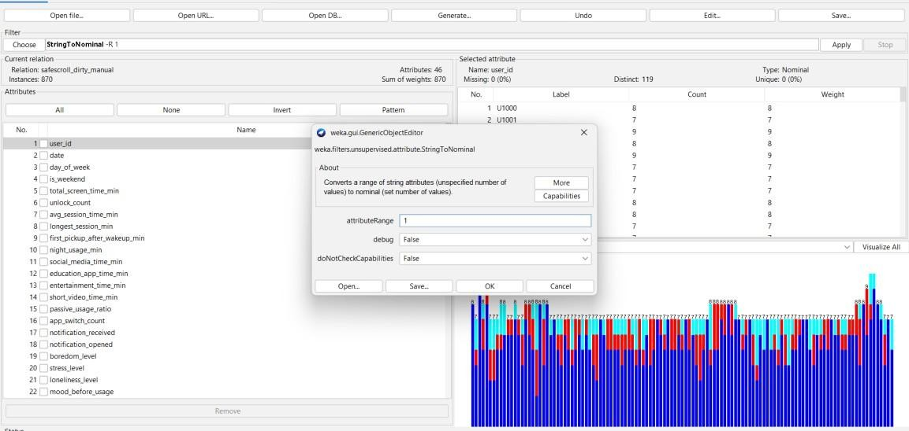

Figure 11: Selecting String TO Nominal for Data Cleaning

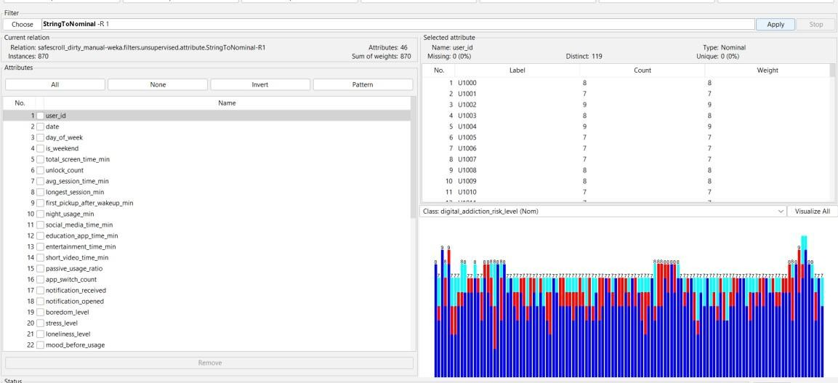

Figure 12: After applying the String TO Nominal Result

    - Handling Missing Values

In real-world datasets, some values may be missing due to incomplete data entry or system errors.
      - Missing values in numerical attributes were replaced using mean or median values.
      - Missing categorical values were filled with the most frequent category or
labeled as “Unknown.”

      - Missing values can be replaced with a user constant.
Handling missing values is important to prevent errors during model training. There are 41 missing values in the data.
We use ‘ReplaceMissingValuesWithUserConstant’ filter which is an attribute filter in unsupervised filters.

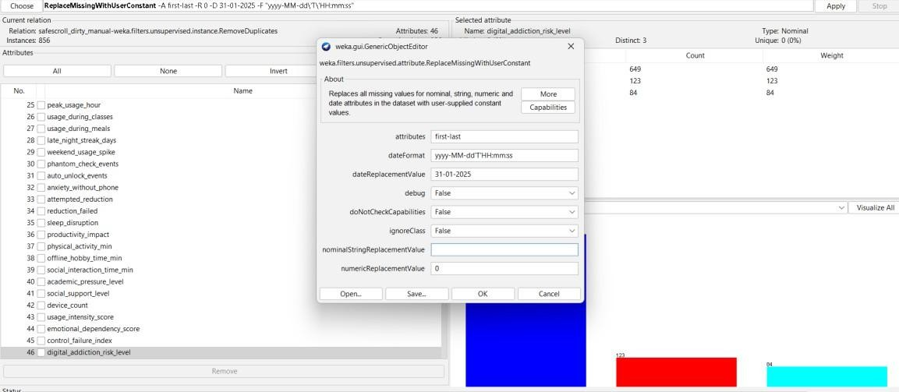

Figure 13: Selecting ReplaeMissingValuesWithUserConstant

    - Duplicates Removal

To remove the duplicate instances from our data we use ‘RemoveDuplicates’ filter which is in unsupervised- instance filters.
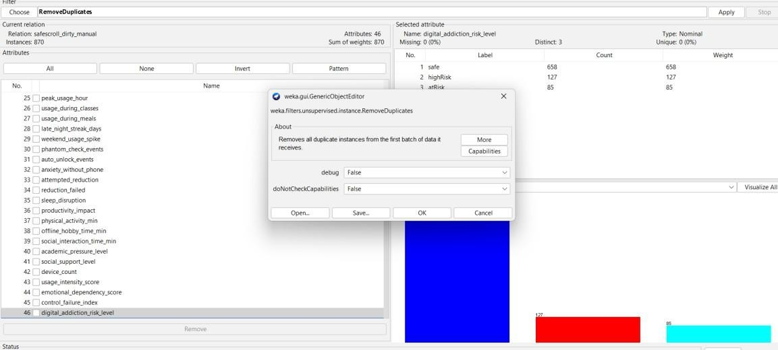

Figure 14 : selecting RemoveDuplicates to remove duplicates

After applying the filter, 14 duplicates are deleted from the data.

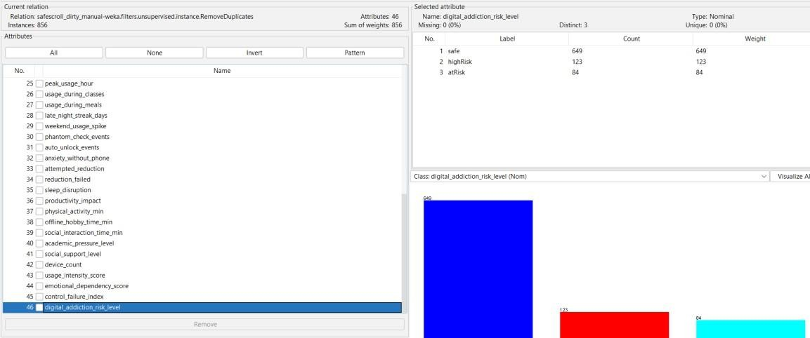

Figure 15: After the removal of duplicates

    - Handling Outliers

In the data some attributes (i.e, 5, 7, 11, 12, 13) contains outliers.

To handle Outliers we use ‘RemoveWithValues’ which is an instance filter in unsupervised filters.
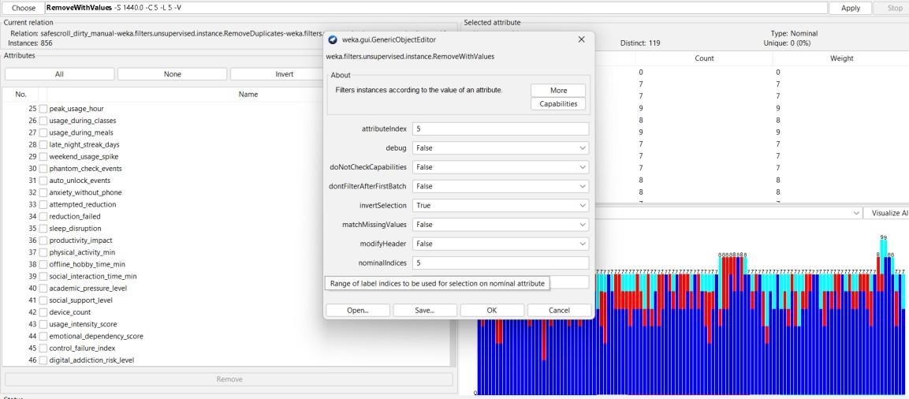
Figure 16: selecting RemoveWithValues to handle outliers
By handling the Outliers in
- 5th attribute : 5 instances
- 7th attribute : 7 instances
- 8th attribute : 1 instances
- 10th attribute : 1 instances
- 11th attribute : 5 instances
- 12th attribute : 3 instances
- 13th attribute : 1 instances are removed.
Then the total instances is 833.

    - Data Normalization

Normalization is the process of scaling numerical values to a common range.

      - Attributes like Participation_Count were normalized to ensure uniformity.

      - This prevents attributes with larger values from dominating the model.

Normalization improves the performance and stability of algorithms such as K-Means clustering.
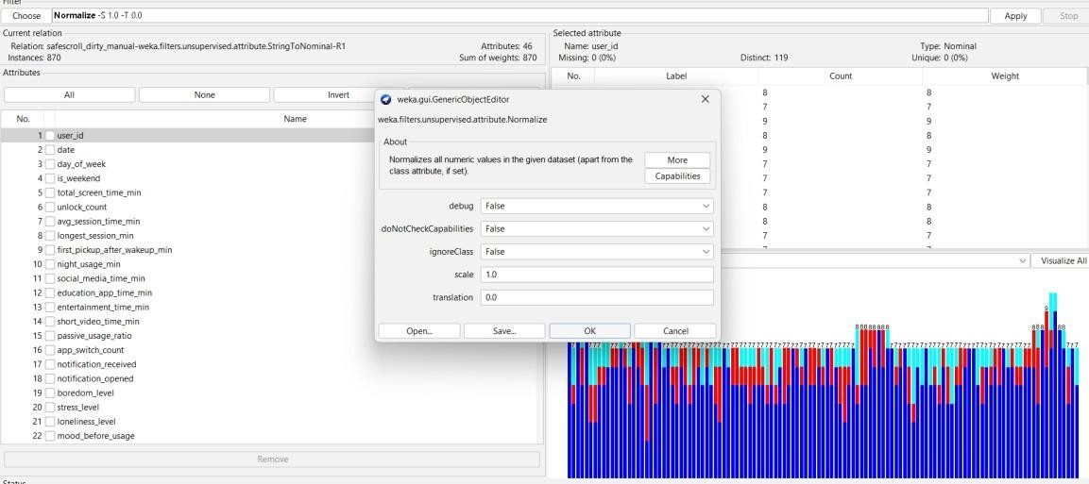

Figure 17: Selecting Normalization

    - Data Splitting

The dataset was divided into training and testing sets.

      - Training data is used to build the model

      - Testing data is used to evaluate the model performance

      - This ensures that the model can generalize well to new data.

Benefits of Data Preprocessing
Data preprocessing provides several advantages:

    - Improves data quality and consistency

    - Enhances accuracy of machine learning models

    - Reduces noise and errors in data

    - Makes data suitable for analysis

    - Helps in better decision-making

Conclusion
Data preprocessing is a fundamental step in the data mining process. In this project, various preprocessing techniques were applied to ensure that the dataset is clean, structured, and ready for analysis. These steps significantly improve the efficiency and accuracy of clustering and classification algorithms used for analyzing student participation.

CHAPTER 5: CLASSIFICATION

Introduction to Classification
Classification is a supervised learning technique in data mining used to assign data into predefined categories or classes based on input features. Unlike clustering, classification requires a target variable (class label) to train the model.
In this project, classification is used to predict the engagement level of students based on their participation in campus activities. The dataset contains attributes such as participation count, event category, and role in events, which are used as input features to classify students into categories such as Low, Moderate, and High engagement.
Classification helps in understanding student behavior and enables institutions to take proactive measures to improve participation.

Need for Classification in This Project
While clustering groups students based on similarity, it does not provide a predictive model. Classification, on the other hand, allows us to predict the engagement level of students based on given data.
The need for classification includes:

    - To predict student engagement levels

    - To categorize students into predefined classes

    - To support decision-making

    - To identify students who require attention

This helps institutions take targeted actions to improve student participation

Classification Algorithm Used – Decision Tree (J48)
In this project, the J48 Decision Tree algorithm is used for classification.

J48 is an implementation of the Decision Tree algorithm in Weka. It creates a tree-like structure where:
    - Each internal node represents an attribute

    - Each branch represents a decision

    - Each leaf node represents a class label

How Decision Tree Works

- Select the best attribute based on information gain

- Split the dataset into subsets

- Repeat the process for each subset

- Continue until all data is classified

The final model is a tree that can be used to make predictions.

Implementation in Weka
The classification was performed using the following steps:

- The preprocessed dataset was loaded into Weka

- The Classify tab was selected

- The J48 algorithm was chosen:
classifiers → trees → J48
- The target attribute (TargetLabel) was set as the class

- The model was trained using the dataset

- The algorithm was executed to generate results

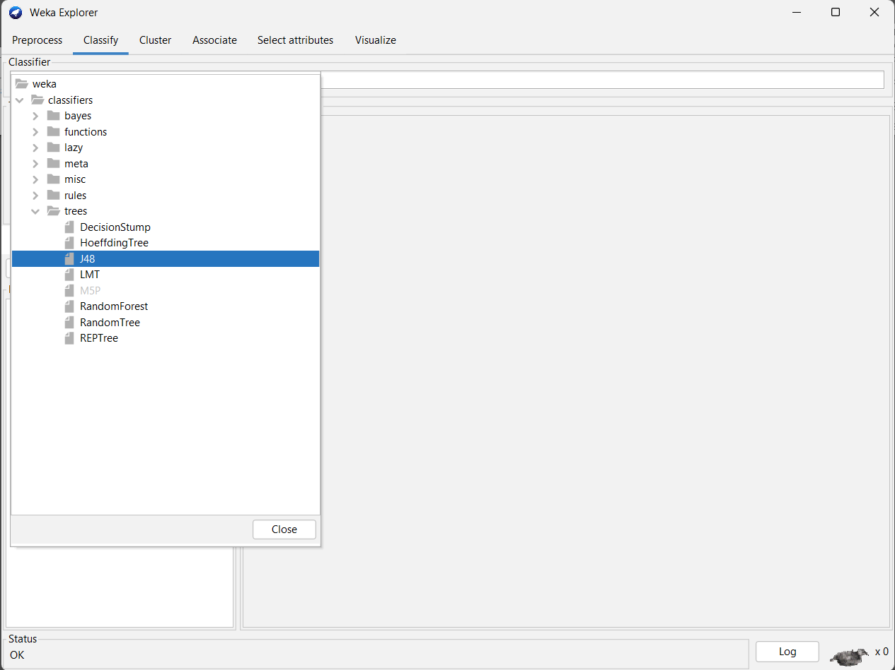
Figure 18: Selecting Trees – J48 for decision tree

Evaluation Method

To evaluate the performance of the model, techniques such as:

    - Train-Test Split

    - Cross-Validation (10-fold)

were used.

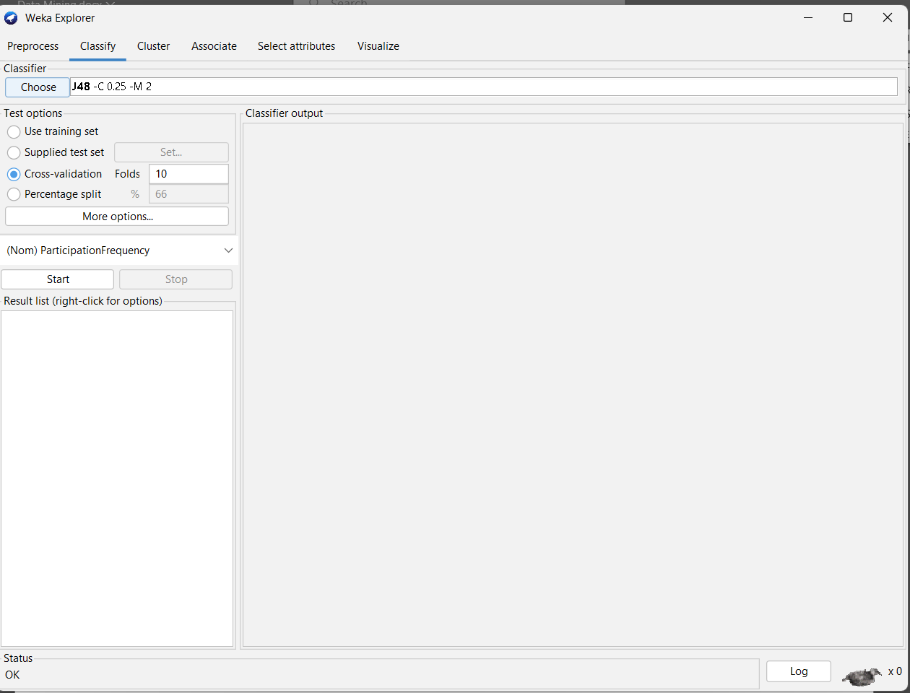

Figure 19: Selecting Evaluation Method as Cross Validation
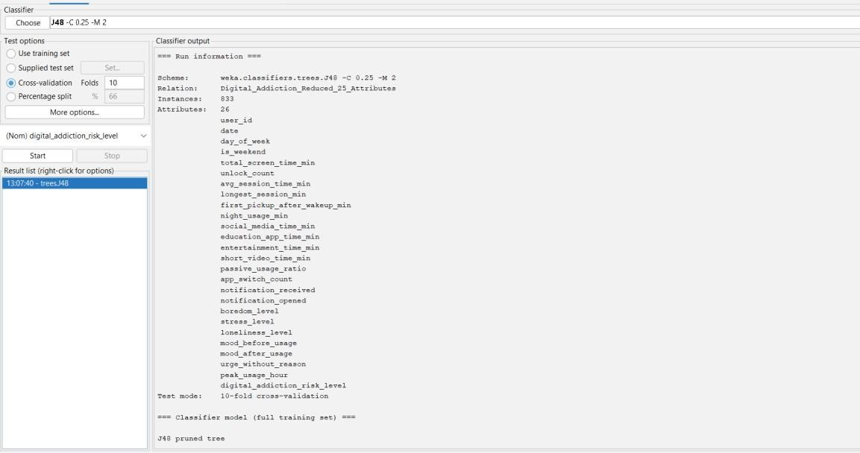

Figure 19.1: Cross Validation (10 folds)

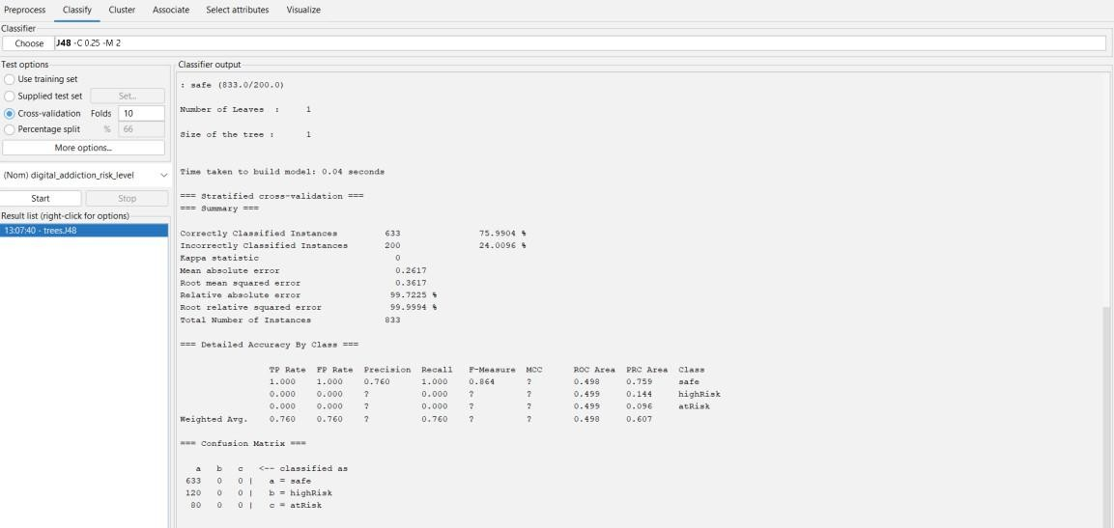

Figure 20: Result after selecting Cross Validation (10 folds)

Results of Classification
The classification model successfully categorized students into:

    - HighRisk

    - AtRisk

    - Safe

The output includes:

    - Accuracy of the model

    - Confusion matrix

    - Decision tree structure

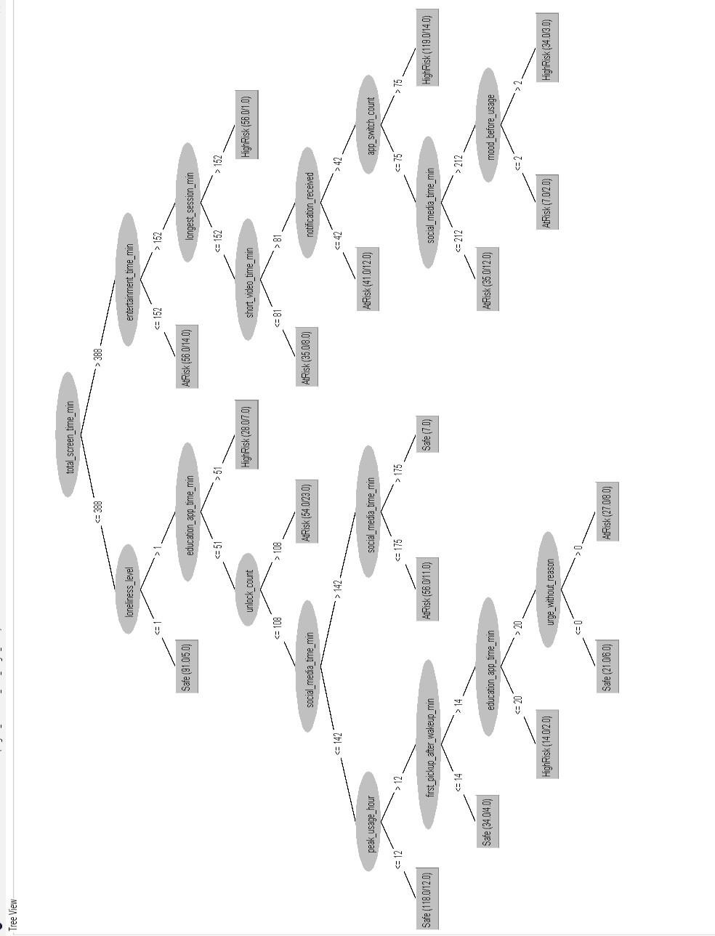

Figure 21:Digital Addiction Level Decision Tree

Advantages of Classification
    - Provides predictive capability

    - Helps in decision-making

    - Easy to interpret (Decision Tree)

    - Identifies important attributes

Applications in This Project
The classification results can be used to:

    - Predict student participation behavior

    - Identify inactive students

    - Provide personalized encouragement

    - Improve planning of activities

Conclusion
Classification is an essential technique used in this project to predict student engagement levels. By using the J48 Decision Tree algorithm, the system is able to classify students accurately based on their participation data. This helps institutions take proactive steps to improve student involvement and create a more engaging campus environment.

CHAPTER 6: ASSOCIATION

Introduction:
Association in data mining is a method for finding relationships between variables, focusing on how certain behaviors or events tend to occur together. It uses rules like “If X occurs, then Y is likely to occur,” measured by support, confidence, and lift. Unlike clustering or classification, association emphasizes co-occurrence patterns rather than grouping or labeling. It does not prove causation but highlights correlations that can guide decisions. Because the rules are interpretable, they provide clear insights that are easy to explain.

Why Association:
In your Digital Addiction Early Warning System, association is vital because addiction often arises from interconnected behaviors. For example, late-night social media use may co-occur with skipping morning tasks, or prolonged gaming may correlate with reduced sleep. Mining these associations helps detect hidden behavioral links that act as early warning signals. The rules are explainable, so parents, educators, or therapists can understand why alerts are triggered. Ultimately, association transforms your system into a predictive, intelligent tool that promotes healthier digital habits.
  - Algorithm Used – Apriori Algorithm
The Apriori algorithm is a classic method for mining frequent itemsets and generating association rules, widely used in market basket analysis to uncover patterns like “customers who buy bread often buy butter.” It was introduced by Agrawal and Srikant in 1994 and remains a foundational algorithm in data mining.
How it Works
    - Step 1: Identify frequent items
Finds items that meet a minimum support threshold (frequency in dataset)
    - Step 2: Generate larger itemsets
. Extends frequent items into larger sets, pruning those that don’t meet support.
• Step 3: Create rules
From frequent itemsets, rules are generated based on confidence (likelihood of co-occurrence).
  - Implementation in Weka
- Go to Associate tab in weka
- Select Apriori Algorithm in Associators
- Click on start to start the association using Apriori Algorithm
- In the Output we can see the Association rules obtained from the dataset using Apriori Algorithm
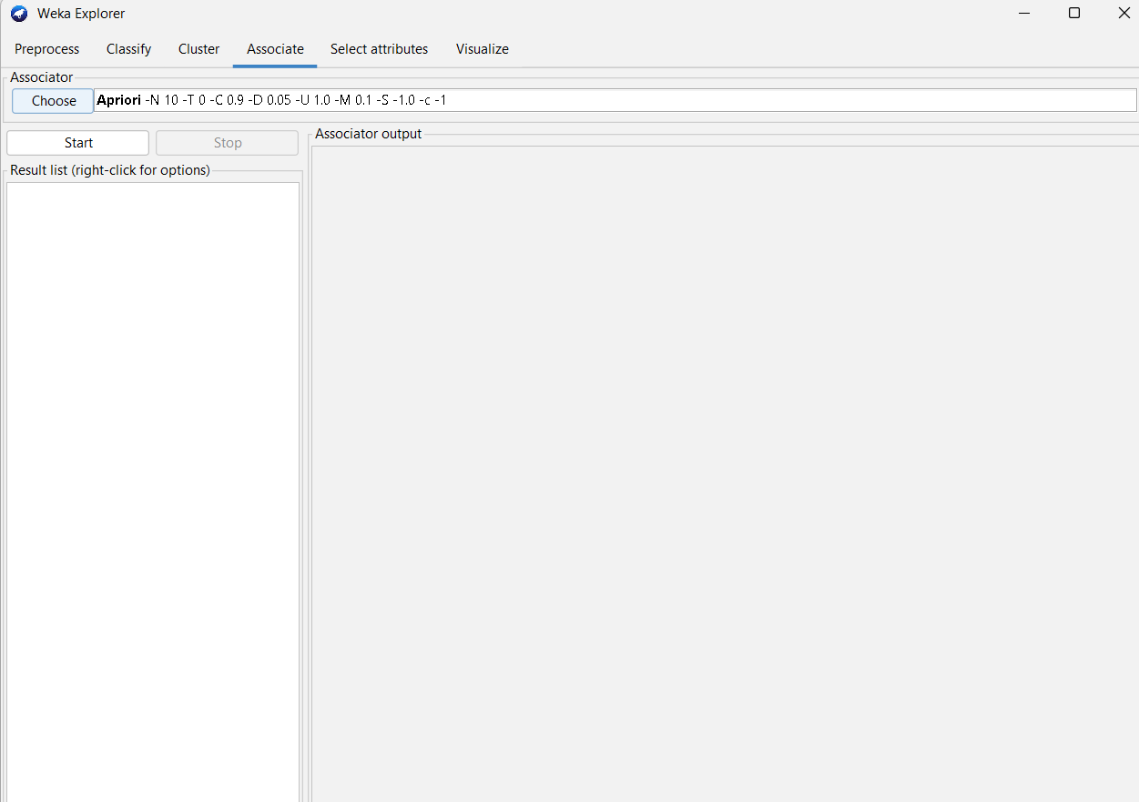
Figure 22 : Selecting Apriori Algorithm
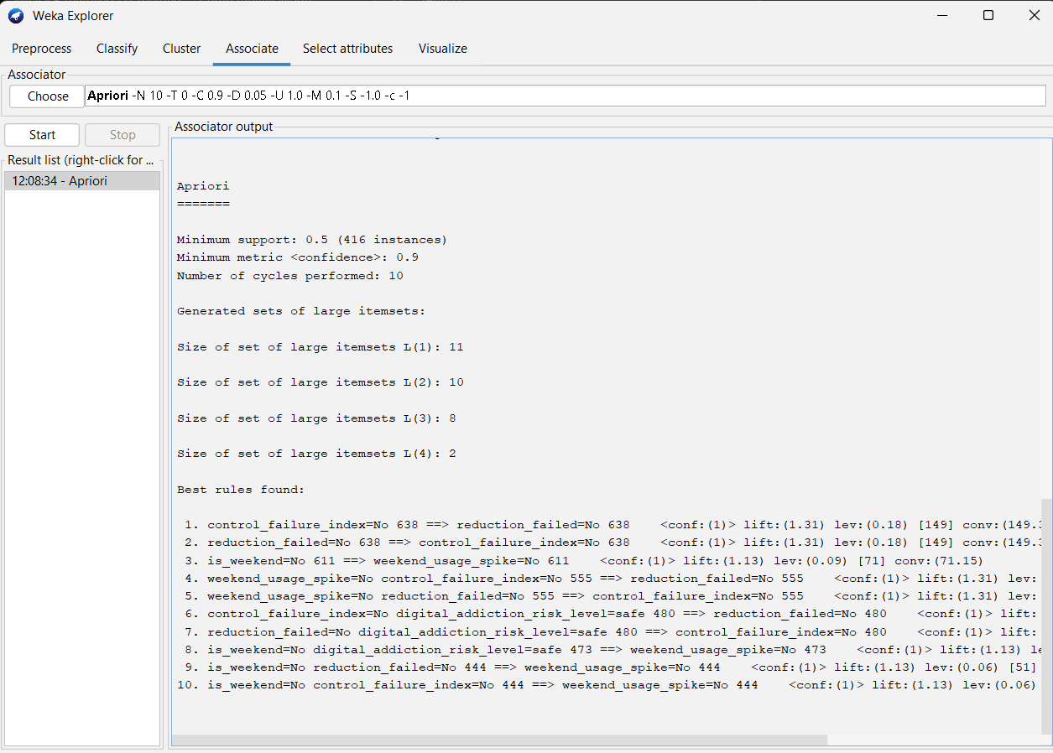
Figure 23 : Results of Association Rule Mining

CHAPTER 7: CLUSTERING

Introduction:
Clustering in data mining is an unsupervised technique that groups similar data objects together without predefined labels, using measures like distance or density to form meaningful clusters. It is widely applied in areas such as customer segmentation, anomaly detection, and behavioral analysis because it uncovers hidden structures in large datasets. In your Digital Addiction Early Warning System, clustering can group users by usage patterns—like heavy social media users or late-night gamers—helping identify risk-prone clusters and enabling targeted interventions.

Need for Clustering in This Project:
- To group students based on similar engagement patterns

- To discover natural groupings without predefined labels

- To identify clusters such as high social media users, late-night gamers, or balanced users
- To support pattern discovery and behavioral analysis

- To highlight groups that may be at higher risk of digital addiction

This helps institutions or systems understand different types of student behaviors, uncover hidden structures in data, and design targeted strategies for improving engagement and preventing addiction.

Clustering Algorithm Used – SimpleKmeans

How it works

      - Choose number of clusters (k): You tell the algorithm how many groups you want (for example, 3 clusters).
      - Pick starting points: It randomly selects k points from your data as the initial
“centers” of the clusters.

      - Assign data to clusters: Each data point is checked for similarity (usually

distance) to these centers, and assigned to the closest one.

      - Recalculate centers: Once points are assigned, the algorithm recalculates the average position (centroid) of each cluster.
      - Repeat the process: Steps 3 and 4 are repeated until the cluster centers stop changing much, meaning the groups have stabilized.
      - Final clusters: At the end, you get k clusters where points inside each cluster are similar, and points in different clusters are less similar

Implementation in Weka
The classification was performed using the following steps:

- The preprocessed dataset was loaded into Weka.

- The Cluster tab was selected.

- The SimpleKmeans algorithm was chosen:

clusterer→ SimpleKMeans.

- Select number of clusters for clustering.

- The algorithm was executed to cluster the data.
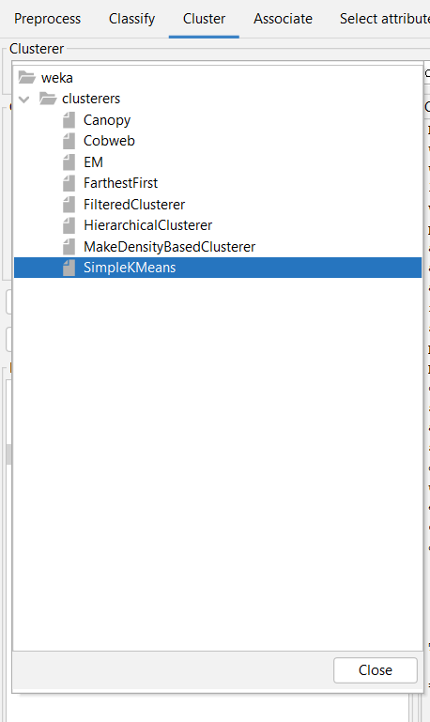

Figure 24: selecting SimpleKMeans algorithm

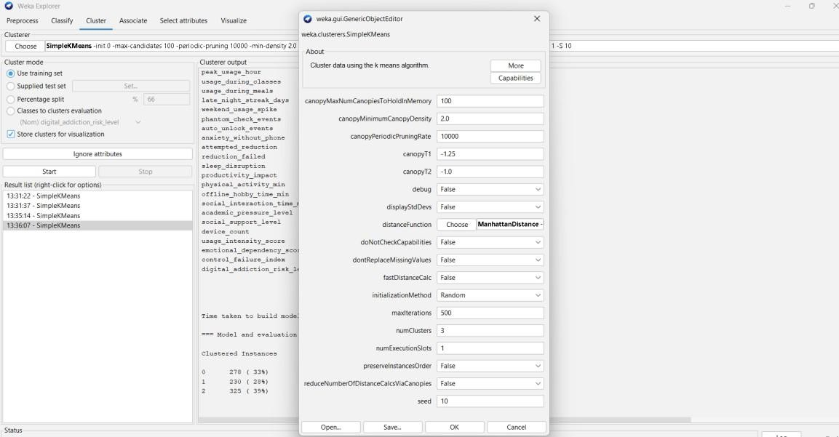

Figure 25: Selecting number of clusters
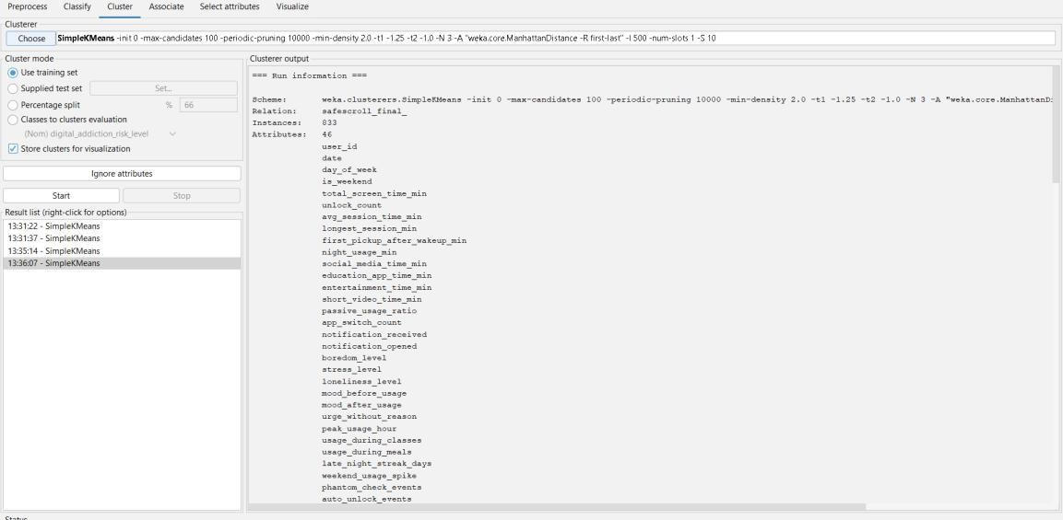

Figure 26: Result of SimpleKMeans

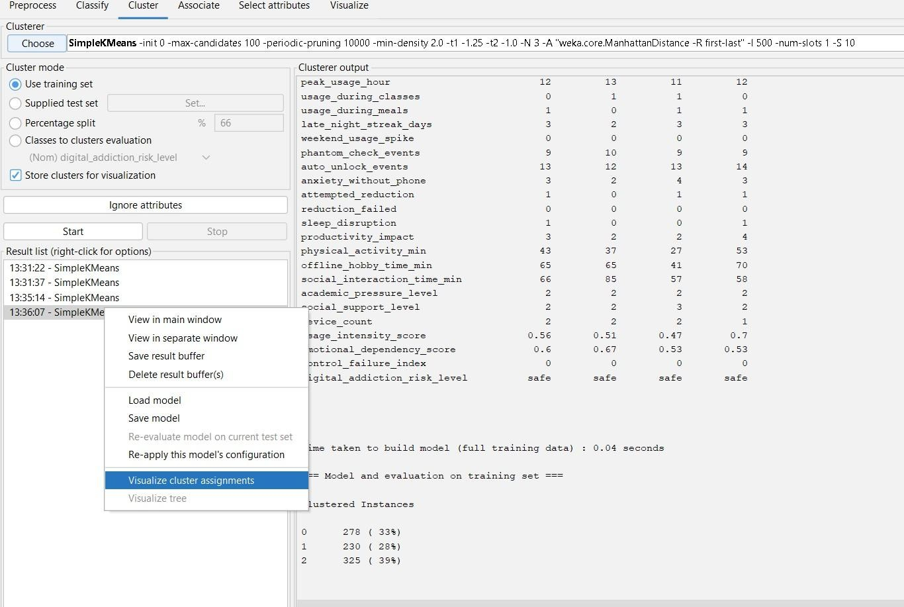
Figure 27: Selecting visualization of clustering

Results of Clustering
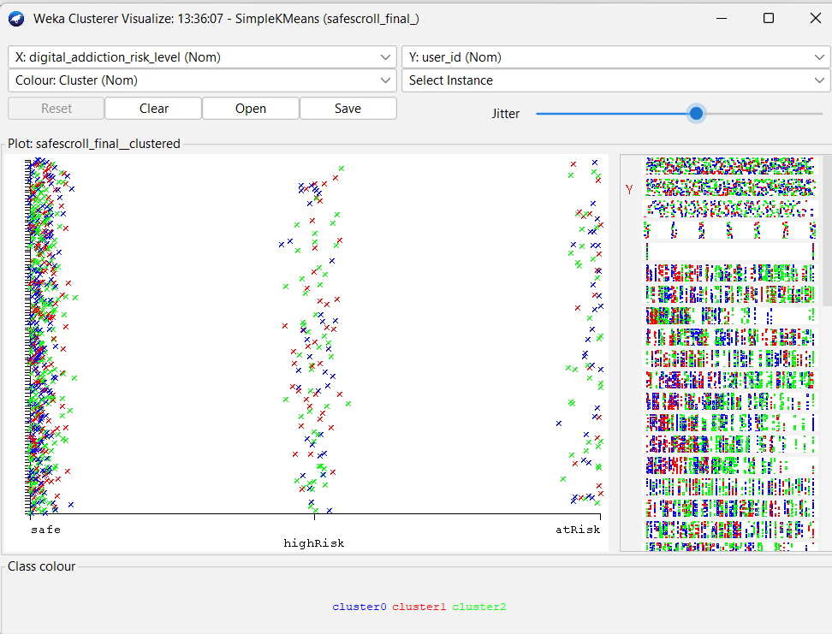
Figure 28: cluster Visualization

CHAPTER 8: CONCLUSION

The Digital Addiction Early Warning System demonstrates the effective use of data mining and machine learning in analyzing student digital behavior and predicting addiction risks. By processing parameters such as screen time, app usage, browsing habits, and study activity, the system provides meaningful insights into early signs of digital dependency.
Algorithms like Decision Tree and Random Forest enable accurate classification of students into risk categories such as Safe, AtRisk, HighRisk. The system automates monitoring, reduces manual effort, and minimizes human error.
The system helps in:

- Identifying at-risk students early

- Preventing academic and social decline

- Providing reliable addiction risk predictions

- Highlighting key behavioral factors

- Supporting data-driven decisions for educators and parents

Visualization techniques such as charts and dashboards make results easy to interpret, enabling timely interventions like counseling or awareness programs.
Overall, this project highlights the importance of integrating technology with student well-being. It provides a scalable, efficient, and intelligent solution for monitoring digital addiction, contributing to healthier academic environments through data-driven approaches.

CHAPTER 9: FUTURE SCOPE

Several enhancements can extend the functionality and usability of the Digital Addiction Early Warning System:
- Web-Based Application → Develop as a web platform for universal access by students, teachers, and parents.
- Real-Time Data Analysis → Enable continuous monitoring of digital usage
patterns and instant risk updates.

- Integration with Institutional Systems → Connect with school/college databases for automatic data collection and seamless reporting.
- Advanced AI Models → Incorporate deep learning and behavioral analytics to improve prediction accuracy.
- Mobile Application → Provide a mobile app for quick access to addiction risk alerts, personalized recommendations, and progress tracking.
These future improvements will make the system more intelligent, scalable, and user- friendly, allowing it to play a significant role in early detection, prevention, and management of digital addiction among students.

CHAPTER 10: WEBLINKS & REFERENCES

- WEKA documentation for data mining tools and techniques

- Online tutorials and resources on machine learning and data analysis

- Chrome for the information about previous systems

- FreePIK.com for the images

