รายงาน Lab 06
Lab 06 — Lamp Emotion and Interaction
1353410 Biological Sensing and Sensorimotor Control
กลุ่ม Minionและผ่องเพื่อน
Busakorn Senpeng 6752500029
Panida Kansrang 6752500169
Thanit Wongsripuek 6752500436
Baramee Sampaotong 6752500380
วันที่ส่ง: ______________________________

Lab 06 — Lamp Emotion and Interaction

Prediction and protocol
Prediction (written in the results report; not a preregistered prediction): C0 without debounce/hysteresis would have more state transitions from button bounce and noisy distance; C1 may respond later because of debounce but should suppress repeated transitions. A fault while already neutral and a touch conflicting with near should not create a new output onset.
All values are from the proposed course simulation model, not a physical robot. Run C0 and C1 on paired input files for seeds 41, 42, and 43; each file has 1,101 samples over 22 s at dt=.02 s. Scheduler delay is .04 s. C1 uses .06 s button/touch debounce, near enter/exit thresholds .20/.28 m, and approach enter/exit .80/.95 m. Active-state timeout is 2 s and normal inactivity timeout is 6 s. Output bounds and slew constraints are held fixed between conditions.
The checker passed 40/40 transition pairs using the baseline contract. student_policy.py preserves safety priority and hold behavior, then maps touch→happy, button/approach→interested, active timeout→normal, and normal idle→sleepy.

FSM and event table
Priority for events recognized in the same tick: fault > near > clear > touch > button > approach > timeout > idle. The first three rules apply from every state. After those rules, afraid holds for every other event. None means hold the current state.

State \ event | fault | near | clear | touch | button | approach | timeout | idle
normal | normal | afraid | normal | happy | interested | interested | hold | sleepy
interested | normal | afraid | normal | happy | interested | interested | normal | hold
happy | normal | afraid | normal | happy | interested | interested | normal | hold
afraid | normal | afraid | normal | hold | hold | hold | hold | hold
sleepy | normal | afraid | normal | happy | interested | interested | hold | hold

C1 uses distance hysteresis/debounce as listed above. Entering afraid takes priority over a simultaneously recognized touch; a touch recognized on a later tick while still afraid is held by the policy. State outputs, joint bounds, and RGB mapping are those defined by the course model; they are simulated commands, not physical measurements.

Results

Condition / seed | All source inputs | Both onset | ≤1 s among observed | No both onset | Max observed latency (s) | State transitions | Primary pass / 7 (missing)
C0 / 41 | 10 | 7 | 7 | 3 | .240 | 67 | 7 (0)
C1 / 41 | 10 | 7 | 7 | 3 | .140 | 9 | 7 (0)
C0 / 42 | 10 | 6 | 6 | 4 | .180 | 72 | 6 (1)
C1 / 42 | 10 | 7 | 7 | 3 | .140 | 10 | 7 (0)
C0 / 43 | 10 | 6 | 6 | 4 | .040 | 63 | 6 (1)
C1 / 43 | 10 | 7 | 7 | 3 | .140 | 9 | 7 (0)
C0 total | 30 | 19 | 19 | 11 | .240 | — | 19 / 21 (2)
C1 total | 30 | 21 | 21 | 9 | .140 | — | 21 / 21 (0)

Across this fixed synthetic input set, C0 produced 63–72 state transitions per run versus 9–10 for C1. This is consistent with the prediction for bounce/noise handling, but three synthetic seeds do not establish general performance. The “≤1 s among observed” column is not an all-input success rate: its denominator excludes missing/no-onset sources. The separately reported primary denominator contains the seven predeclared IDs; C0 missed clear_01 at seed 42 (filtered_not_recognized) and clear_02 at seed 43 (no_state_change).
All 10 source IDs remain in each run's metrics. No-both statuses are:
Seed | C0: no both onset | C1: no both onset
41 | touch_conflict (discarded_priority); invalid_01, stale_01 (no_state_change) | touch_conflict (policy_held); invalid_01, stale_01 (no_state_change)
42 | clear_01 (filtered_not_recognized); touch_conflict (preempted_before_apply); invalid_01, stale_01 (no_state_change) | touch_conflict (policy_held); invalid_01, stale_01 (no_state_change)
43 | touch_conflict (discarded_priority); clear_02, invalid_01, stale_01 (no_state_change) | touch_conflict (policy_held); invalid_01, stale_01 (no_state_change)
discarded_priority means a higher-priority recognized event won; policy_held means the FSM returned no transition; preempted_before_apply means a queued command was replaced before application; filtered_not_recognized means the sensor event did not pass the filter; and no_state_change means the resulting output did not change. None of these missing outcomes is assigned a zero latency.

Event trace and source-data check
For button_01 in C0 seed 41, source=1.00 s, recognized/decision=1.00 s, apply=1.04 s, and motion/RGB onset=1.04 s; 1.04−1.00=.04 s, matching both_latency_s. In C1 seed 41, debounce delays recognition/decision to 1.10 s; apply and both output onsets occur at 1.14 s; 1.14−1.00=.14 s, also matching the event CSV. This is simulated command-onset latency, not physical actuator latency.
The stored re-run was compared against the original result manifest: config, inputs, all raw/event CSVs, metrics, and six traces match byte-for-byte; source snapshot hashes match the manifest. No source/config change explains the results. Re-run artifacts are in rerun/.
Figures and source data:
- C0 seed 41 trace, C1 seed 41 trace
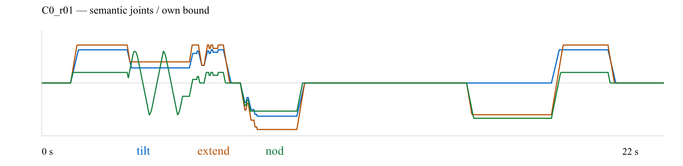
รูปที่ 1: C0 seed 41 trace
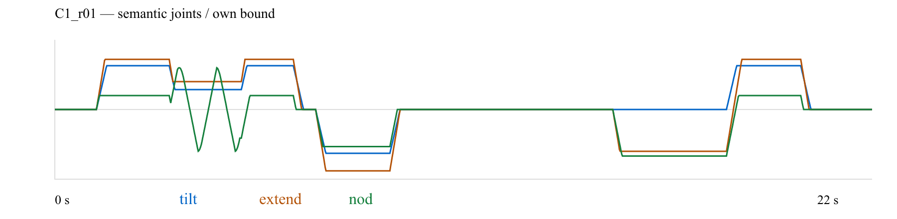
รูปที่ 2: C1 seed 41 trace
- event CSV C0 seed 41, event CSV C1 seed 41
- metrics, HTML report

Discussion and limitations
Results match the prediction that debounce/hysteresis reduces state-transition count in these simulated noisy inputs, while C1 button response is later in the example because of debounce. Fault and stale/invalid inputs while already neutral do not produce a new command onset; this is a negative result, not a zero-latency success. All trials are deterministic course-model simulations with synthetic repetitions. No actuator, LED, torque, linkage, collision, clock/camera calibration, gait, or hardware-safety behavior was tested. The FSM is not learning and does not update persistent parameters.
Reproduce from the lab directory:
python check_submission.py --contract baseline
python lab06.py --policy student --condition all --repeats 3 --output-dir results\lab06_complete_20261111\new_run
The runner requires a new output directory; existing raw data are retained. Data and plot files for all six runs are in results/lab06_complete_20261111/.

