SELF SERVE PORTAL

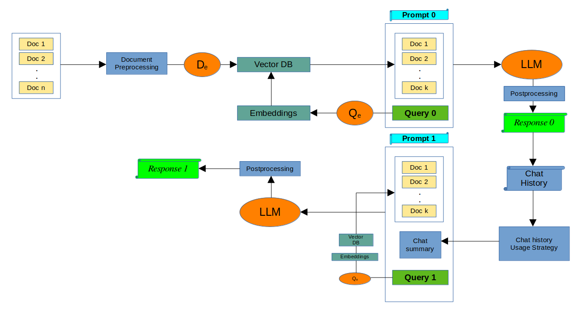
Key Systems :

- Document preprocessing
    - Document types
    - Handling tables/images in the document
    - Chunking
- Vector DB
- Selection of Vector DB (chromaDB, FAISS, LanceDB(search algo available)
- Indexing strategies
- Document Encoder (D_{e}) - stella
- Query Encoder (Q_{e}) -
- Embedding search algorithm
- Reranking
- Prompt Engineering
- Selection of Chat model (Mistral 7B*/4 BIT)
- Reponse post processing

- Chat history
    - Storage
    - Usage strategy in prompts
- Chatbot UI

Problems Identified :

- Parsing pdf for tables and images
- Context switching/Rephrasing query
- Retrieval
- RAG Evaluation strategies

Augmentation Code
- Reasoning
- Iteration drawbacks
- Adding new data for training*
- litigation
- locality specific
- Max sentence length(experiments for )
Training Code

Concerned about Ambiguous

