ThreadsExecutorsawsKubernatesDockerjava11springbatchapachekafkaoauth2

**oauth2**

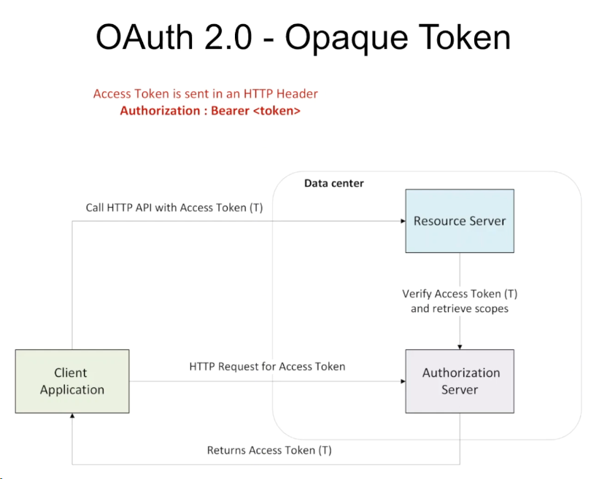

data.

in auth server we are get token through client id secret key

from resource server it allows the access to application methods based on given token.

mana application lo restcontroller lo a method naina access cheyalantee oka token generator cheyali clientid secretkey estene token generate avthadi

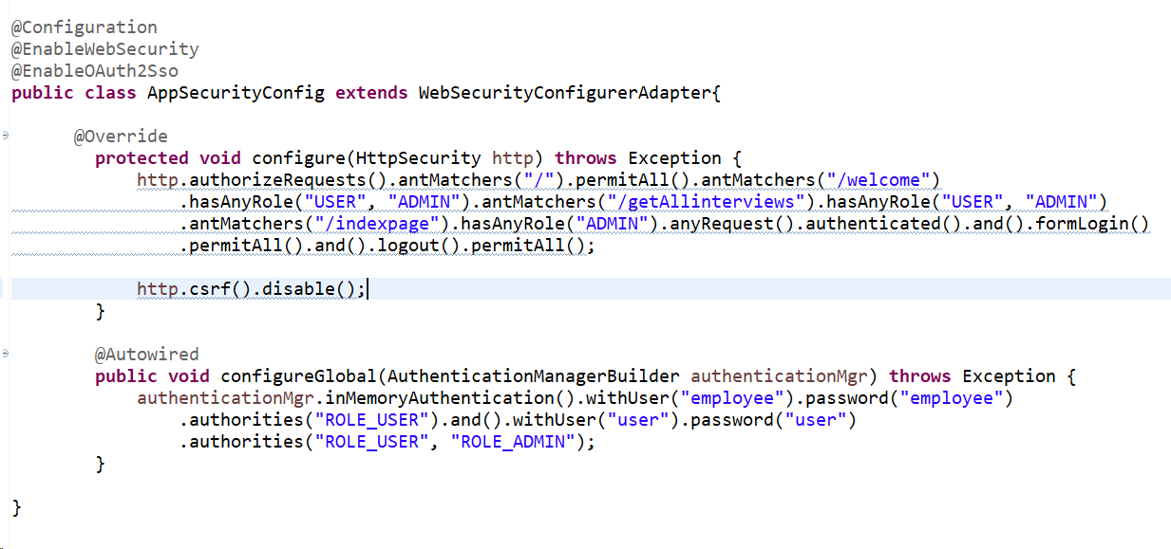

application.properties:

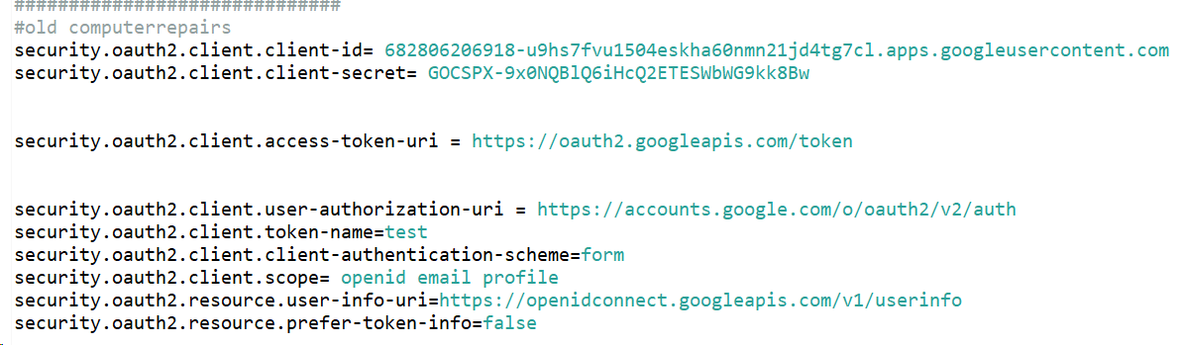

Concept about get clientid and secret key from google cloud:

https://accounts.google.com/.well-known/openid-configuration

create project give any project name after search api and services

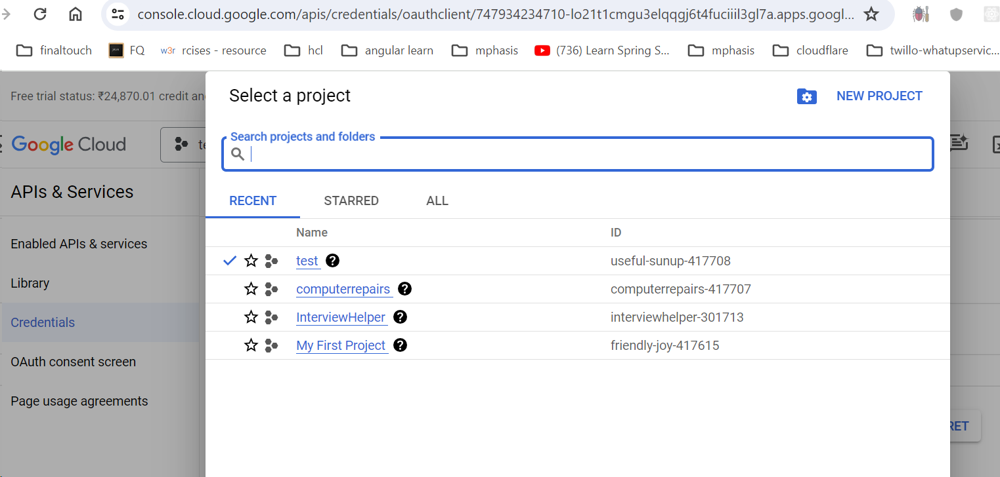

credentials click on create credentials choose oauth

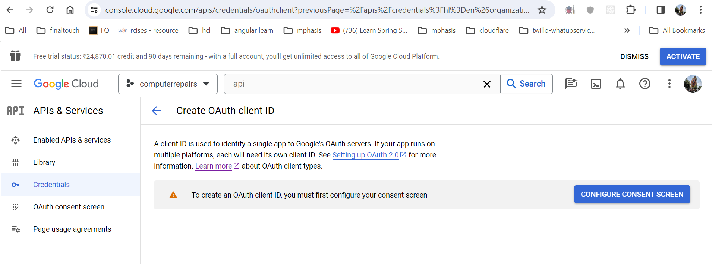

Click on configure consent screen

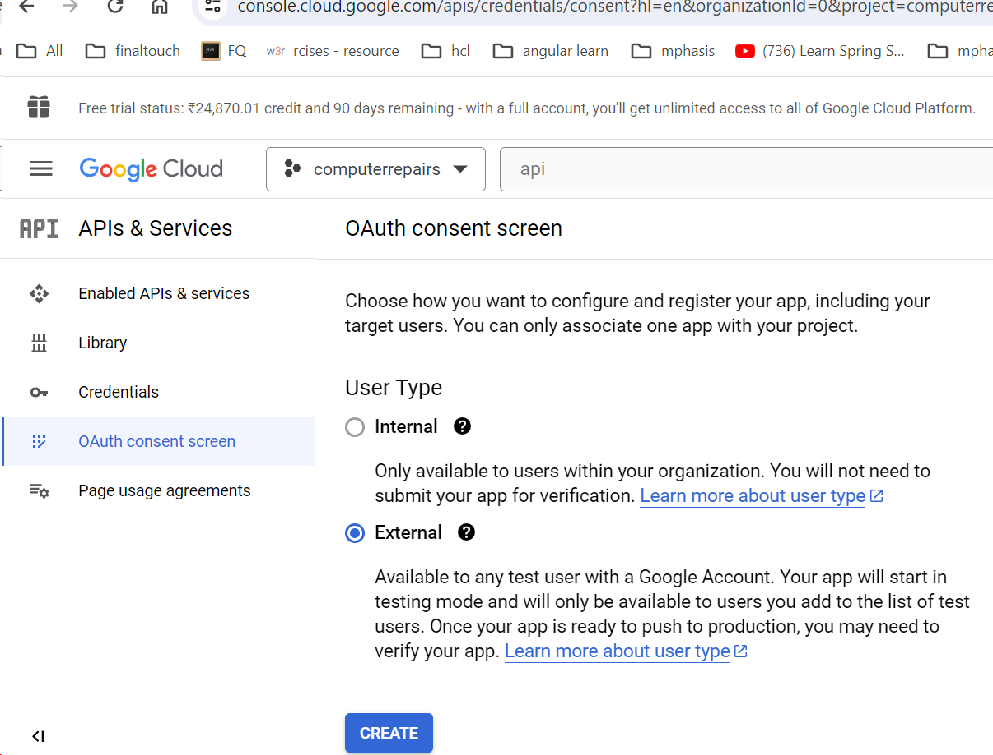

Choose external click on create

Give appname ,supported mail and developer contact info

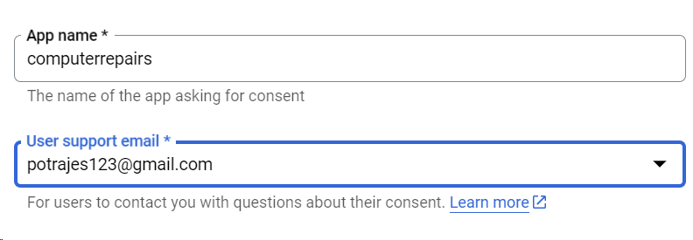

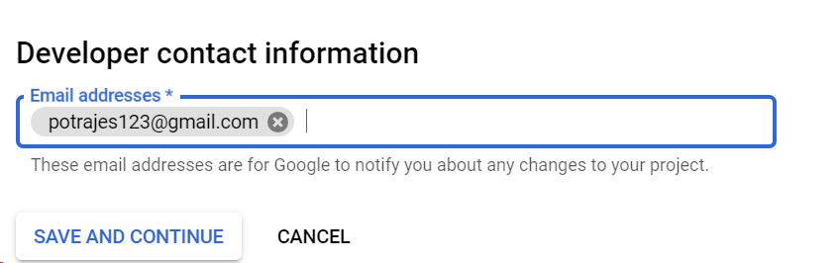

Click on save continue ..scope appear not given anything

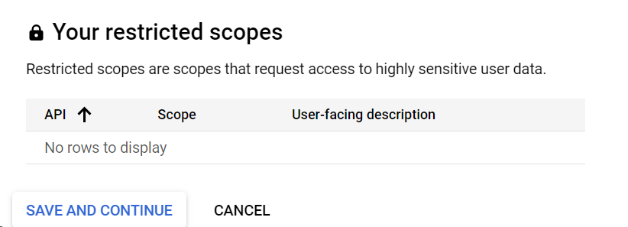

Click on save and continue and add user as potrajes123@gmail.com as a user and continue

Now back to

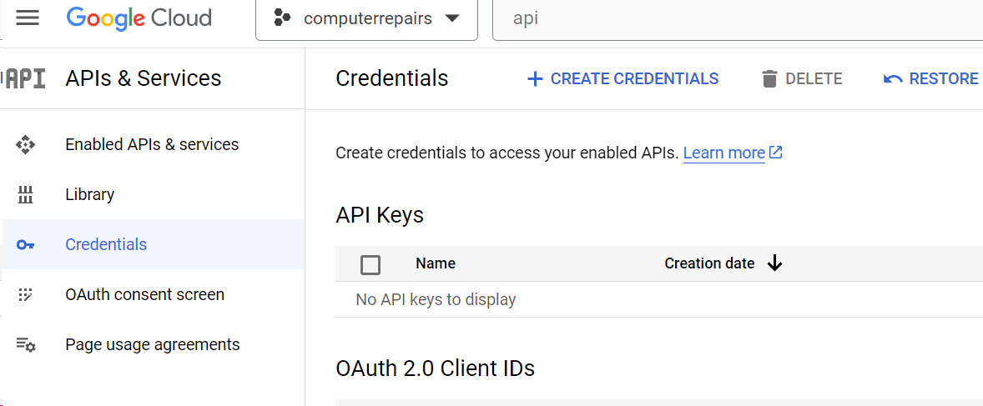

Click on create credentials and choose oauth client id

Give application type as webapplication and application name as computerrepairs

And authrozation redirect uri : http://localhost:8080

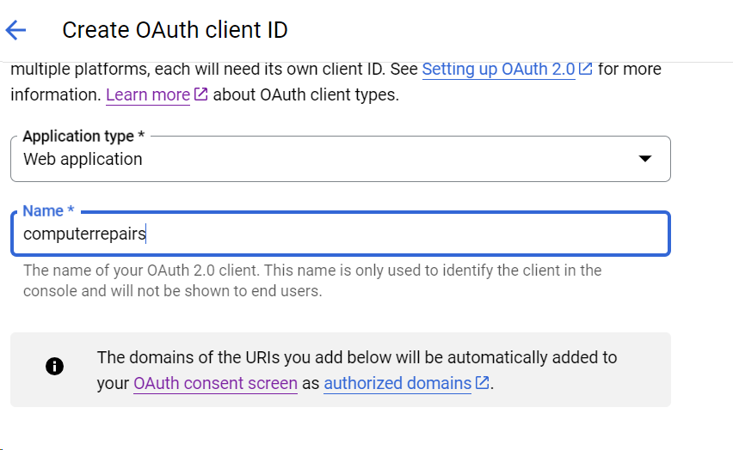

http://localhost:8080

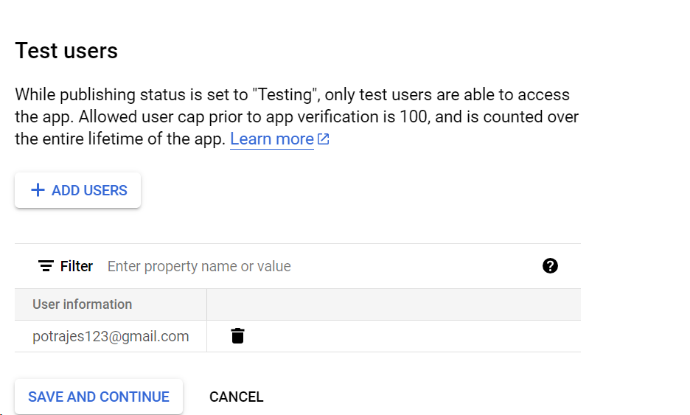

After click on save and continue ..client id and secret key is generated.