Q)About Conditional breakpoint

A) ste p 1: write this code.

**public** **class** ConditionalBreakPoint {

**public** **static** **void** main(String[] args) {

ArrayList<Student> al = **new** ArrayList<Student>();

Subject s = **new** Subject("test");

Subject s1 = **new** Subject("test1");

Subject s2 = **new** Subject("test2");

Subject s3 = **new** Subject("test3");

Subject s4 = **new** Subject("test4");

al.add(**new** Student("sri",s));

al.add(**new** Student("sre1",s1));

al.add(**new** Student("sri2",s2));

al.add(**new** Student("sri3",s3));

al.add(**new** Student("sri4",s4));

**for** (Student std : al) {

System.***out***.println(std);

}

}

}

Step 2: put a breakpoint here

System.***out***.println(std);

Ste p 3: rightclick on breakpoint select conditional breakpoint add below code.

**if**(student.getName().equalsIgnoreCase("sri3"))

**return** **true**;

**else** **return** **false**;

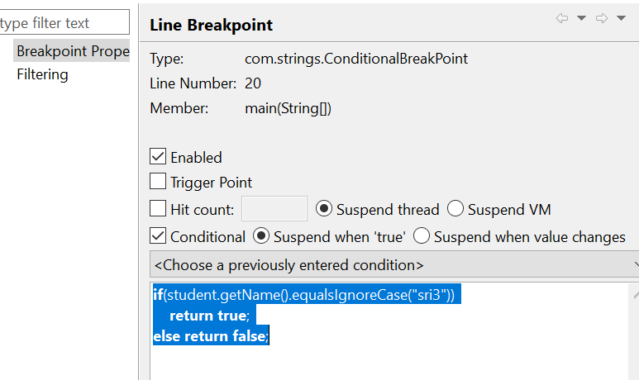

Step 4: debug as application. Then thread is stopped at sri3 value. And click on resume.

===================================================================