解析結果2025/1/22

結論
キャリア位相差(MP)
n = 4
包絡線位相差(MP)
n = 0
キャリア位相差(PMP)
n = 6, 8
包絡線位相差(PMP)
n = 0

キャリア位相差(MP)

nensemble: 20
nfft: 556

y = nxと最も接近するようなnの値はn=4となった。下記のslopeは最小二乗法によって推定した直線の傾き、mean_squareは各点と直線y=nxとの偏差の二乗の和を表す。どちらで推定するべきか分からなかったので両方表示している。どちらの配列もn番目の要素はy = nxのnに対応し、slopeには回帰直線の傾きが、mean_squareには各y=nxとの偏差の二乗がn = 0,1,2,3,4と順に格納されている。↓は異なる基準に対して平均をとった値。

〇最小二乗法
n = 4
slope average = [-0.001089454635940651, 1.1413875828534594, 2.0032935852483913, 2.8557513355132493, 3.9996105216550415]
〇偏差の二乗
n = 4
mean square average = [50.540112031403154, 70.76749269316838, 77.76955608424066, 72.92283919118779, 46.54011203140316]

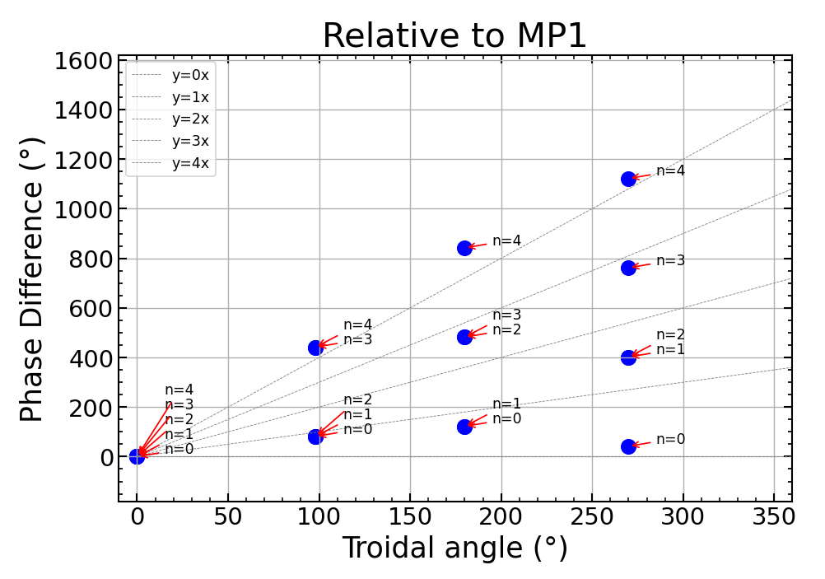
Relative to MP1
y = 3x, slope = [0.35874118312497, 1.2046647367001284, 1.7686137724169007, 2.9215762454378575, 4.331448834729788]:
y = 1x, mean square = [15.329567388612194, 12.886044709009758, 23.42554388291195, 15.858844019466105, 13.32956738861219]:
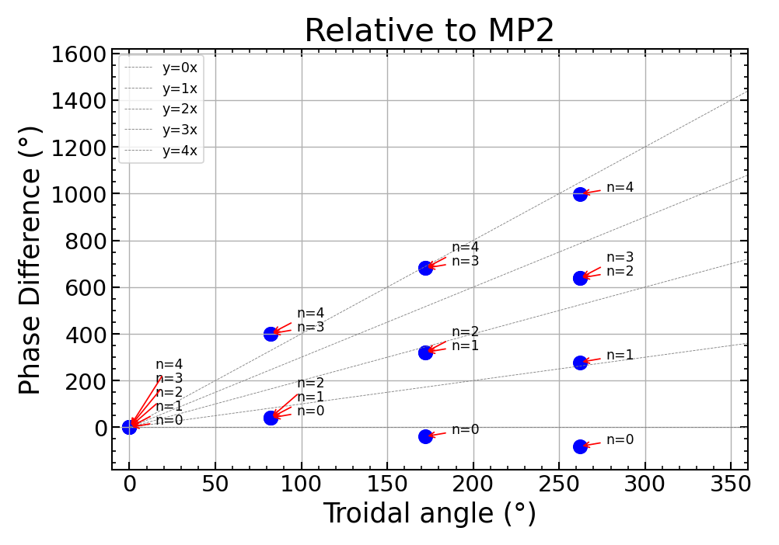
Relative to MP2
y = 3x, slope = [-0.2361906276008784, 1.2524899120744017, 2.1511864590673127, 3.0224418901215087, 3.9211384371144193]:
y = 4x, mean square = [25.39516658740882, 25.82044551021313, 39.7596674704131, 45.024720431964944, 21.395166587408823]:

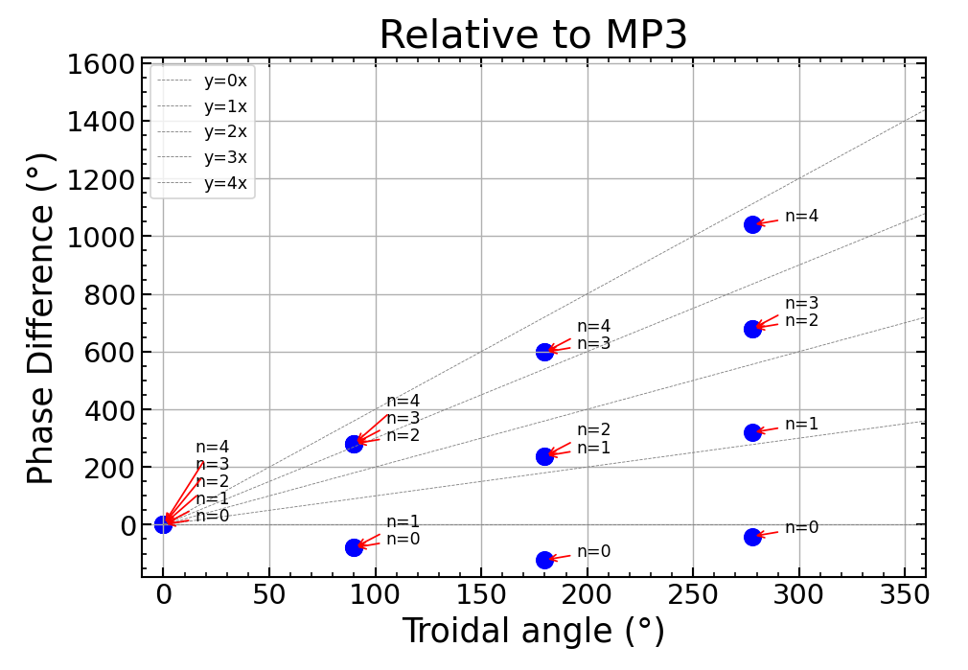
Relative to MP3
y = 1x, slope = [-0.3424797256801239, 1.0573708482518194, 2.182141615079232, 2.7323012292882924, 3.5819921890111757]:
y = 4x, mean square = [40.51334945711139, 42.640452905174385, 61.39659587223466, 58.949601765479564, 38.51334945711139]:

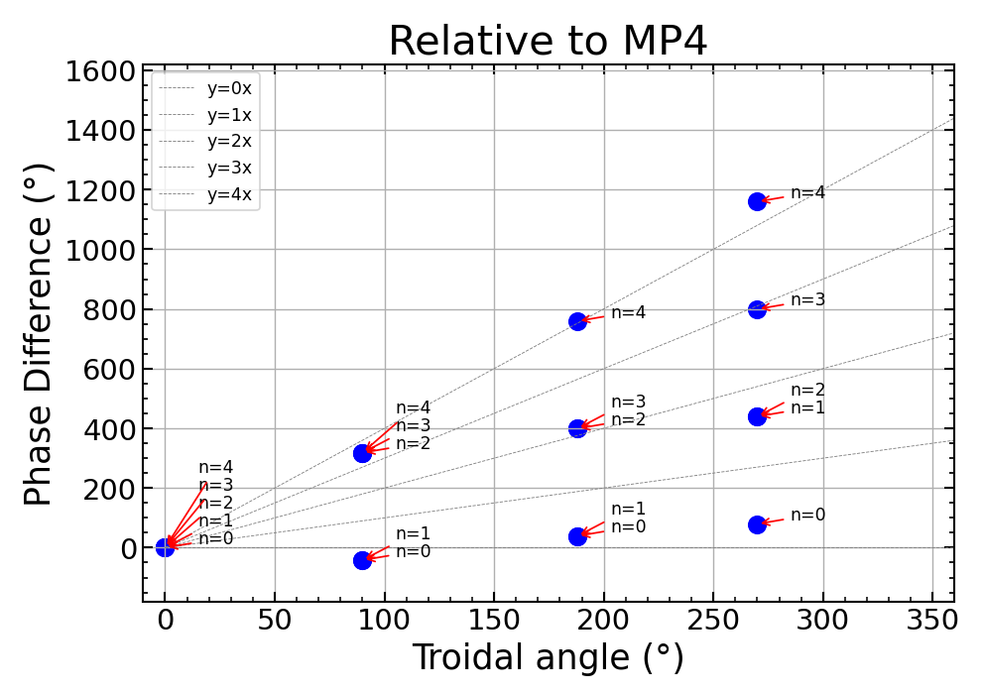

Relative to MP4
y = 1x, slope = [0.2155713516122697, 1.051024834387488, 1.9112324944301204, 2.7466859772053382, 4.163862625764783]:
y = 4x, mean square = [50.540112031403154, 70.76749269316838, 77.76955608424066, 72.92283919118779, 46.54011203140316]:

包絡線位相差(MP)
y = nxと最も接近するようなnの値はn=0となった。下記のslopeは最小二乗法によって推定した直線の傾き、mean_squareは各点と直線y=nxとの偏差の二乗の和を表す。どちらで推定するべきか分からなかったので両方表示している。どちらの配列もn番目の要素はy = nxのnに対応し、slopeには回帰直線の傾きが、mean_squareには各y=nxとの偏差の二乗がn = 0,1,2,3,4と順に格納されている。↓は異なる基準に対して平均をとった値。

〇最小二乗法
n = 0
slope average = [-0.002164514715077851, 1.1404019131603662, 1.9604781486654272, 2.890291885904597, 4.016298571618124, 5.085633986868807, 5.961178124956409]
〇偏差の二乗
n = 0
mean square average = [14.100547431530247, 68.68725661713238, 56.49971749616728, 57.212478455170064, 20.475547431530277, 47.81225661713239, 52.499717496167264]

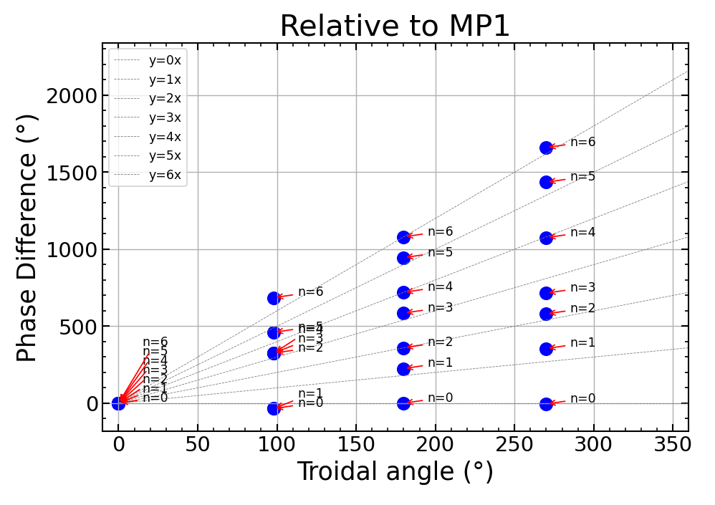
Relative to MP1
y = 0x, slope = [-0.04288912150308077, 1.1555025793950602, 2.2027246082191216, 2.872414088132789, 3.929818530101737, 5.243349825792053, 6.175432259823939]:
y = 0x, mean square = [2.5351742199258678, 16.39324761102567, 10.549982132158062, 10.709096036890386, 4.535174219925864, 9.955747611025672, 8.549982132158057]:

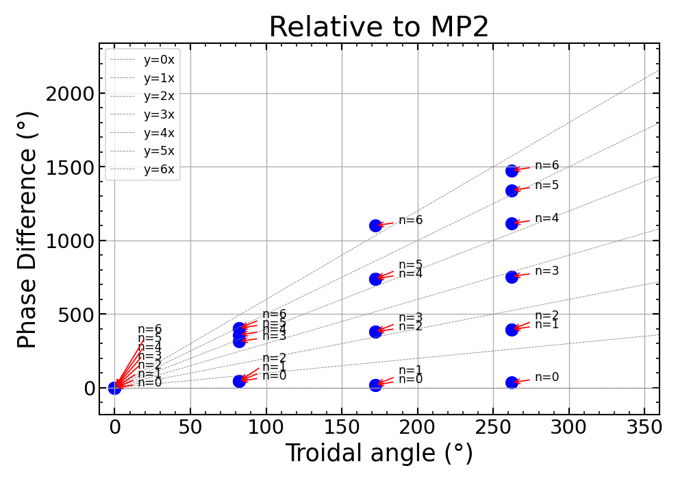
Relative to MP2
y = 1x, slope = [0.15493950081779378, 1.0536360478107047, 1.643620040493074, 2.753270166264855, 4.277109635736614, 4.873953907403662, 5.800949105208372]:
y = 0x, mean square = [8.75049453455101, 36.543849127352075, 28.36213792929776, 25.406018408799145, 13.937994534551013, 19.668849127352072, 24.36213792929774]:

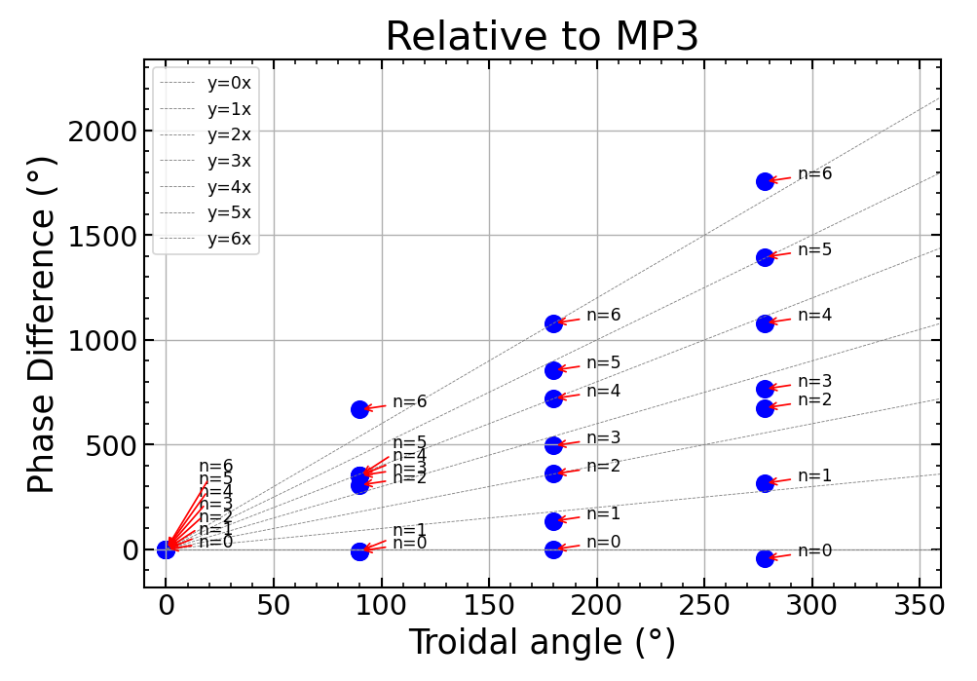
Relative to MP3
y = 1x, slope = [-0.1101792121772394, 0.9458216028740408, 2.38005715269405, 2.833174723841235, 3.92050407247942, 4.870293517565341, 6.30452906738535]:
y = 0x, mean square = [12.013184150549813, 47.80913970473304, 43.80960466538288, 37.61807147933425, 16.38818415054983, 28.934139704733045, 37.80960466538288]:

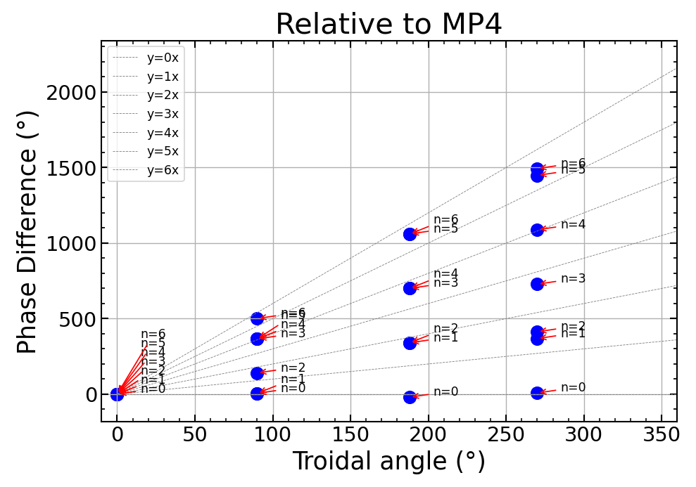
Relative to MP4
y = 0x, slope = [-0.010529225997785012, 1.4066474225616592, 1.6155107932554638, 3.10230856537951, 3.9377620481547284, 5.354938696714173, 5.563802067407978]:
y = 0x, mean square = [14.100547431530247, 68.68725661713238, 56.49971749616728, 57.212478455170064, 20.475547431530277, 47.81225661713239, 52.499717496167264]:

キャリア位相差(PMP)

y = nxと最も接近するようなnの値はn=6,8となった。MPと同様にslopeには回帰直線の傾きが、mean_squareには各y=nxとの偏差の二乗がn = 0,1,2,...,10と順に格納されている。

nensemble: 20
nfft: 556
adopt following PMP signals ['PMP1', 'PMP2', 'PMP3', 'PMP4', 'PMP5', 'PMP6', 'PMP7', 'PMP8', 'PMP10', 'PMP11', 'PMP13']

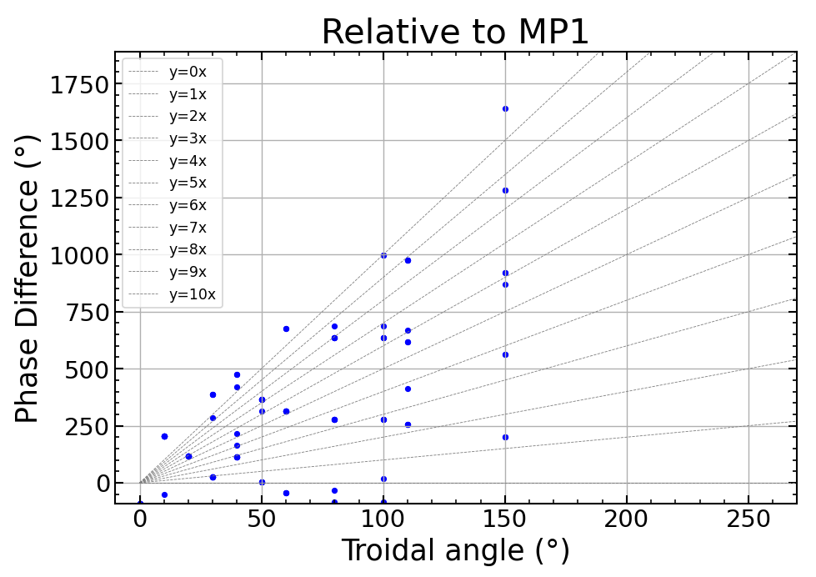
Relative to MP1
〇最小二乗法
y = 8x
slope = [-0.8884714214685289, 1.708822315808444, 2.2584570900869734, 3.200380213066256, 3.4331667057018693, 5.866647725938967, 6.383951042906995, 6.114522231986147, 8.125538876699355, 8.67732908146525, 10.235705323831436]:

〇偏差の二乗
y = 6x
mean square = [8.0955131401456, 8.02422620989099, 7.409032666717481, 7.589395007518514, 7.064325603698901, 8.673814697456827, 6.915376679792963, 7.248416866893614, 8.274625131385774, 8.102101411359245, 8.505064054909473]:

包絡線位相差(PMP)

nensemble: 20
nfft: 556
adopt following PMP signals ['PMP1', 'PMP2', 'PMP13']

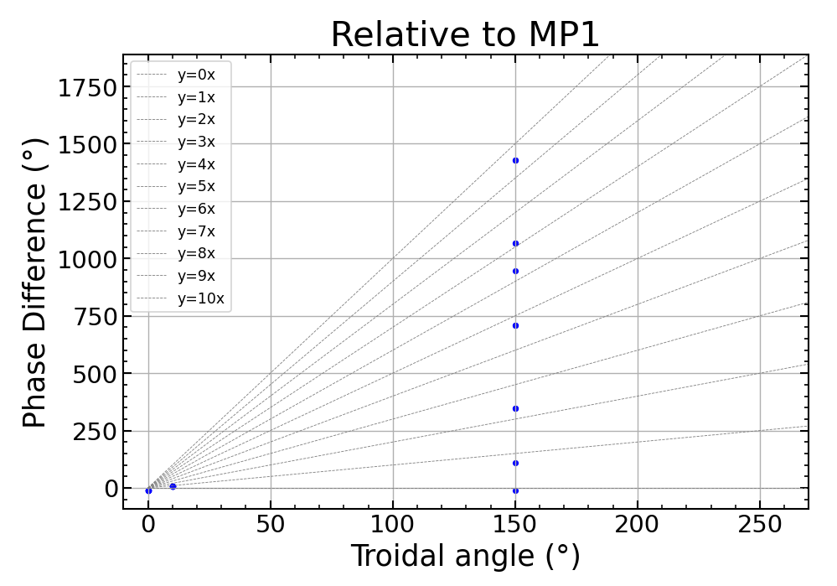
Relative to MP1

〇最小二乗法
y = 0x
slope = [-0.05909097196970442, 0.7655535777933287, 2.414842677319395, 2.414842677319395, 4.888776326608494, 4.888776326608494, 6.538065426134561, 7.362709975897594, 7.362709975897594, 9.836643625186692, 9.836643625186692]:

〇偏差の二乗
y = 0x
mean square = [3.2708843163417844, 6.409062783588671, 8.13793422437342, 15.29795167247756, 17.026823113262303, 10.85350722803312, 12.58237866881786, 10.360156446595637, 24.186840561366452, 19.249045335484524, 19.74239611692201]:

