VDL-1 PC Control Software
Installation and User Guide
Open Source Software for Controlling Variable Delay Line Kit from PC Com-Port

V.1.41 Oct 2016 All OS versions. Project published in https://github.com/potty-dzmeia/DLineController
V.0. 5 Jul 2014 Initial version

VDL-1 can be controlled from a COM port instead of from keyboard. Only TXD output from any PC COM port is used for this purpose. A two wire cable is needed to connect the COM port to J108 of BPI board. The control program is deliberately written in Java in order to work on several operating systems. The program works with any Com port ( also with USB-RS232 adapters with FTDI chip set).

I. Download

The current version can be loaded from http://active-antenna.eu/variable-delay-line-kit-vdl-1a/technical-documentation/ or from design site https://github.com/potty-dzmeia/DLineController where the last version is always available. It is open source.
The program is written in Java and should support the following operating systems: win32, win64, linux_x86, linux_x86_64, linux_ia64, mac_os_x
Tested in: Win XP, 7 (32&64bit) , 8 (32&64bit), Win 10 and Linux Debian.

II. Installation

In any OS:
- Make sure you have installed Java Runtime Environment (JRE) version 1.7 or later. https://www.java.com/en/download/
- Unzip the distribution software in any folder and drive. A new folder is created named dlinecontroller-xxxx where xxxx is the version number.
- To start the program double-click on the file dlinecontroller_xx.jar

III. Operating

Main window

After first start the main window looks like Fig.1:

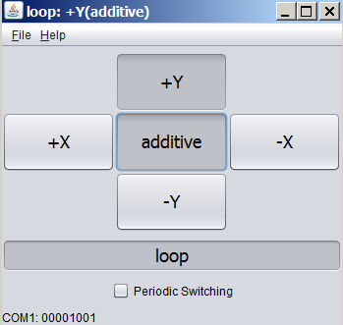 Fig.1 Default display

The operating is very simple and almost duplicates the keyboard behavior. Pushing any of the direction buttons will choose the appropriate direction in Subtractive (directional) mode. The mode can be changed to Additive by pushing the central button. Also Loop or Dipole mode can be set in the case of dual array with AAA-1 active antennas. When clicking on any of the buttons, the transmitted serial code in binary form will appear at the lower edge of the window (the code is described in VDL-1 manual)

File menu Settings Window

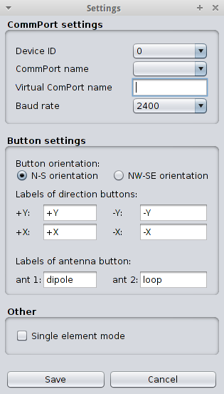 Fig.2 Settings window

- Device ID - set to 0. For other values look at the manual
  - CommPort name - choose the appropriate COM port
  - Virtual CommPort name - File name of a virtual com port (leave empty if you would like to use a standard port specified in the field above)
  - Baud rate - 2400 default
  - Button orientation: Choose N-S (Fig.3) or NW-SE (Fig.4) according to antenna physical direction orientation.

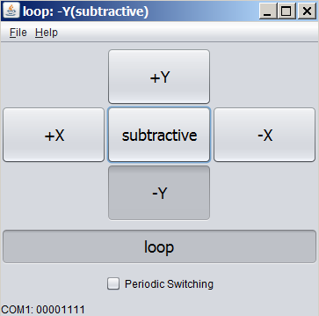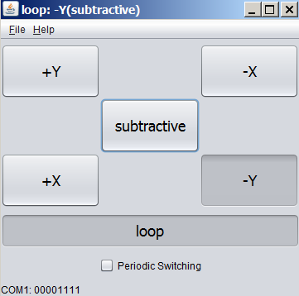
Fig.3 N- S display Fig.4 NW-SE display

- Labels of direction buttons: Any name can be entered but usually use N, S, E, W or NW, SE, NE, SW according to actual antenna directions (Fig.2,3). The default notations (Fig.1) +Y ….. correspond to those of manual keyboard switching and are defined in VDL-1 User Manual.
  - Labels on antenna button Dipole and Loop should be default names when AAA-1 active antennas are used.
  - Single element mode If this mode is checked the delay line processing is excluded and each physical antenna can be checked alone. This mode is effective only if the additional relay is added which duplicates J3,J4 jumper switch on VDL-1 board. See Appendix III for more details. This mode is used for debug purposes only.
  - Save After filling this window push Save button in order to make changes effective.

Automatic periodic switching of directions Fig.5

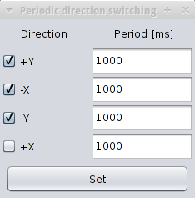 Fig.5 Periodic switching window

In this mode a periodical selection of directions is performed. From the CheckBoxes the user can select which directions are toggled. The time duration of each direction can be set by entering the a millisecond value inside the TextFields. The Periodic Switching window and the Main window can be opened simultaneously and the user can change interactively the periodic switching parameters and modes. Any change in Periodic Switching window values must be followed by pressing the “Set” key in order to make them effective. The automatic switching can be used to test and estimate the antenna performance especially F/B ratio with real sky signals where the fading is very fast. For this purpose an SDR receiver and Linrad program are used. See the article ……

Appendix I
Hardware modification to set the single element mode from the software

Remark: This modification is not essential and does not improve the workings of the array. If the user does not have hardware skills it is better to omit it.

On VDL-1 board we can set J3 = OFF and J4 = ON. In this position, the delay line channel is disconnected and one of the arms of the combiner is terminated with 100 ohms resistor (Fig.1). Now only single antenna is connected to the output. Which antenna element is active depends on which button is pressed and is shown on Table 1 of VDL1 Manual. Push the appropriate push button of the keyboard or in the program window to choose the specific active element.
A hardware modification can be made which enables to switch J2/3 from the software (but not from the keyboard) and change from array mode to single element mode. This might be useful for debugging purposes and for quick check of each active antenna behavior without the need to open the VDL-1 box and set the jumpers J3,J4. For this purpose a relay is added which duplicates the J3,4 jumper settings. The schematics is shown on Fig.6 . Use the same type of 12v relay (DPDT) as those used in VDL-1 board. This type is produced by many manufacturers the original being TQ type from Panasonic. This relay is polarity sensitive. The contacts of the relay must be golden plated!. The software uses AUX unused port to drive the relay. The modification is shown also on the PCB on Fig. 7.The best way to do the mod is to solder two male pins on +12V and AUX points. Then the relay can be connected to these pins and J3,J4 pins by means of female plug pins thus avoiding any additional soldering on the board. Use short leads for RF paths.

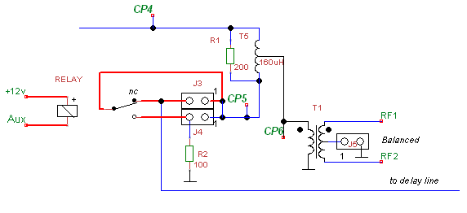 Fig.6

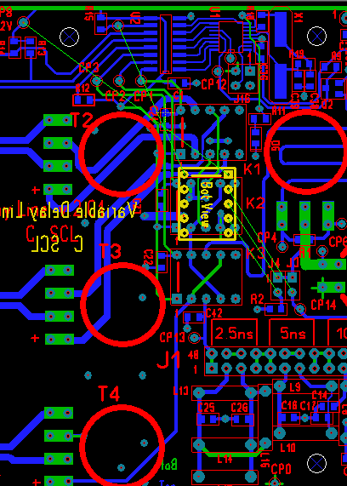 Fig. 7 The additional relay is glued to board with bottom up

Appendix II
Information for programmers

In case of problems[Linux] : If you have started the program but you don't see the comm port in the "Settings" dialog, probably you don't have the permission to access the comm port file (e.g. /dev/ttyS0)
- You need to add your username to the dialout group by writing: sudo gpasswd --add yourusername dialout
  - Then either login and logout or write exec su – $USER

Compilation
For those that want to make changes or custom version clone, download the project from https://github.com/potty-dzmeia/DLineController

IDE Installation
Netbeans [recommended]
- Go to File->Open Project and select the directory where you have downloaded the project
  - Now you are ready to run and debug the project

LZ1ABC 2015 info@active-antenna.eu

