Antenna placement
On Fig. is given the placement of the 3 elements for the case of loop mode. The directions corresponds to those set by the keyboard control. There are 3 antennas : Base antenna (central), X – antenna and Y-antenna. Note that for a loop array there must be 2 orthogonal loops on the base antenna which must be switched when X or Y direction is chosen. By convention, for X-direction loop-B is used and for Y – direction loop-A is used. For dipole array the same dipole in base antenna is used for X and Y directions.

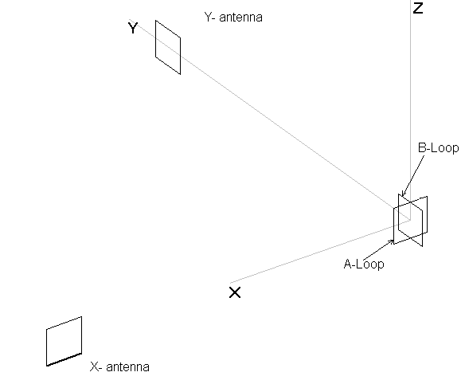 Fig. Antenna directions convention

Serial Interface to Dline controller
It is possible to control the Dline from a PC. There is a standard RS232 asynchronous serial interface for Dline. It is receive only (the board accept commands only and there is no feedback). The bode rate is 4800 bits/sec, no parity, 8 bit word, no handshake. Each command sent to Dline has 2 bytes.
The first byte is always 80 (Hex) and the second byte is the command itself. Each bit in the command byte corresponds to relay or signal. These bits control totally the behaviour of the board. On the following table are given the corresponding lines and their state:

Table 1
Bit pos. | Bit State =1 | Bit State = 0
0 (lsb) | relay K1 is ON, Y direction | relay K1 is OFF, X direction
1 | relay K2 is ON, subtractive (directive) mode | relay K2 is OFF, additive (omndirective) mode
2 | relay K3 is ON, backward direction | relay K3 is OFF, forward direction
3 | Line Lb is in low active level, Loop-B mode | Line Lb is in high inactive level
4 | Line La is in low active level, Loop-A mode | Line La is in high inactive level
5 | Line Dp is in low active level, Dipole mode | Line Dp is in high inactive level
6 | Line Aux is in low level. Reserved | Line Aux is in high level. Reserved
7 | *** must be always 0, reserved | *** must be always 0, reserved

Forward directions means that of + X or +Y direction (Fig.) . In forward mode always the base antenna is connected to the delay line. In backward mode (-X and –Y directions) X or Y-antenna is connected to the delay line.

Bits 0,1,2, 6 and 7 are independent and can be used to set the appropriate combinations of modes.

When using AAA-1 amplifiers bits 3,4 and 5 must be set as shown. Other combinations are not allowed.

bits | 3 | 4 | 5
Loop A | 0 | 1 | 0
Loop B | 1 | 0 | 0
Crossed | 1 | 1 | 0
Dipole | 0 | 0 | 1
Bits 3,4 and 5 truth table

As an examples the following commands set the Dline in certain mode.

Loop mode
0000 1011 , +Y direction, B-loop is used as a base Y-antenna
0000 1111 , - Y direction, B-loop is used as a base Y-antenna
0001 0010 , +X direction, A-loop is used as a base X-antenna
0001 1110 , -X direction, A-loop is used as a base X-antenna
0000 1001 , Y Additive (almost omni directional) , B-loop is used

Dipole mode
0010 0011 , +Y direction, dipole is used
0010 0111 , - Y direction, dipole is used
0010 0010 , +X direction, dipole is used
0010 0110 , -X direction, dipole is used
0010 0001 , Y Additive (almost omni directional) ,
0010 0000 , X additive (almost omni directional) ,

The Keyboard controller (Fig. ) is connected to the Dline trough the same serial interface and the same codes are used. Pushing the appropriate buttuns the corresponding mode can be chosen.

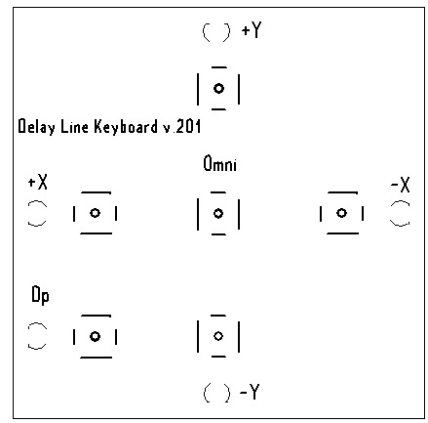 Fig. Keyboard

When Dipole button is pushed the green led is on and the loops are changed with dipoles. All other settings are preserved – e.g. if we were in -Y direction, the same direction will be preserved in dipole mode. Some clarification is needed for additive mode. Pushing the central button all leds are ON and the corresponding additive mode is set. That means that if we were before in –Y direction then we have Y antennas additive mode. There is not great difference between Y or X additive modes – the diagram is almost circular so this mode is named omni-directional.

If J4 on D.Line board is ON, the delay line channel is disconnected and terminated to 100 ohms resistor. Now only single antenna is connected to the output. On the Table are given which antenna is used corresponding to certain mode.

Mode | Antenna
+X | X antenna
-X | Base X antenna (A-loop or dipole)
+Y | Y antenna
-Y | Base Y antenna (B-loop or dipole)

This mode is used to test each antenna alone.

