**PERFORMANCE ANALYSIS OF MOVIE RATING**

**summer Project Report**

*Submitted in partial fulfilment for the award of the degree of*

**MS**

***in***

**Software Engineering**

*by*

**POTUREDDI GOWTHAM RAJEEV SWAROOP (14MSE0070)**

**ABBAVARAM PAVANI (14MSE0085)**

*Under the guidance of*

**Prof. LAWANYA SHRI M**

**SITE**



**School of Information Technology and Engineering**

July 2018



**School Of Information Technology and Engineering**

**DECLARATION BY THE CANDIDATE**

We hereby declare that the summer project report entitled **“****PERFORMANCE ANALYSIS OF MOVIE RATING”** submitted by us to VIT University ,Vellore, in partial fulfillment of the requirement for the award of the degree of **MS (Software Engineering)**  is a record of bonafide project work carried out by me under the supervision of **Prof. LAWANYA SHRI M , Assistant Professor(Senior)** .We further declare that the work reported in this project has not been submitted and will not be submitted, either in part or in full, for the award of any other degree in this institute or any other institute or university.

**Place**: Vellore

**Date**: **Signature of the Candidate(s)**



**School of Information Technology and Engineering**

**BONAFIDE CERTIFICATE**

This is to certify that the project work entitled “ **PERFORMANCE ANALYSIS OF MOVIE RATING”** by **POTUREDDI GOWTHAM (14MSE0070),ABBAVARAM PAVANI (14MSE0085)** to VIT University, Vellore, in partial fulfillment of the requirement for the award of the degree of **MS(Software Engineering)** is a project bonafide work carried out by them under my supervision. The project fulfills the requirements as per the regulations of this Institute and in my opinion meets the necessary standards for submission. The contents of this report have not been submitted and will not be submitted either in part or in full, for the award of any other degree or diploma in this Institute or any other Institute or University.

**Prof. LAWANYA SHRI M**

**Supervisor**

**Assistant Professor(Senior)**

**Internal Examiner(1) InternalExaminer(2)**

**Acknowledgement**

I wish to express our heartfelt gratitude to **Dr.G. Viswanathan**, Chancellor,VIT University, Vellore for providing facilities for the summer semester project.I am highly grateful to our Vice Presidents. **Shri. Shankar Viswanathan, Shri.Sekar Viswanathan, Shri** **G.V.Selvam**, and **Dr. Anand A. Samuel,** Vice chancellor, **Dr.S.Narayanan, Pro-Vice Chancellor** for providing necessary resources.

My sincere gratitude to **Dr. Aswani Kumar Cherukuri**,, Dean, School of Information Technology and Engineering, for giving us the opportunity to undertake the project.

I wish to express my sincere gratitude to **Dr. S.Sree Dharinya**, Head of the Department, **Prof. MAGESH G** and **Prof. JAYA LAKSHMI P**, Summer Project Coordinators, MS(Software Engineering),Department of Software and Systems Engineering, School of information Technology and Engineering for providing me an opportunity to do my project work in the ***VIT University.***

I would like to express my special gratitude and thanks to my internal guide **Prof. LAWANYA SHRI.M, Assistant Professor(Senior).** School of information Technology and Engineering whose esteemed guidance and immense support encouraged to complete the project successfully.

I thank the Management of VIT University for permitting me to use the library resources. I also thank all the faculty members of VIT University for giving me the courage and strength I needed to complete my goals. This acknowledgement would be incomplete without expressing my whole hearted thanks to my family and friends who motivated me during the course of the work.

Place: Vellore

Date:

POTUREDDI GOWTHAM RAJEEV SWAROOP ABBAVRAM PAVANI

**TABLE OF CONTENTS**

|  |  |  |
| --- | --- | --- |
| **CHAPTER NO.** | **TITLE** | **PAGE NO.** |
|  | **ABSTRACT** | vii |
|  | **LIST OF TABLES** | viii |
|  | **LIST OF FIGURES** | ix |
|  | **LIST OF SYMBOLS** | x |
|  |  |  |
| 1. | **INTRODUCTION** |  |
|  | 1.1.Problem Statement | 1 |
|  | 1.2.Motivation | 1 |
|  | 1.2.1.Existing System | 1 |
|  | 1.2.2.Disadvantages of Existing system | 1 |
|  | 1.3.Objective | 2 |
|  | 1.3.1.Proposed System | 2 |
|  | 1.3.2.Advantages of Proposed system | 2 |
|  |  |  |
| 2. | **Literature Survey** |  |
|  | 2.1 Introduction | 2 |
|  | 2.2.Literature | 2-4 |
|  | 2.3 Findings | 5 |
|  |  |  |
| 3 | **SYSTEM DESIGN** |  |
|  | 3.1 System Architecture | 5 |
|  | 3.2 Module description | 6-10 |
|  | 3.3 System Specification | 10 |
|  | 3.3.1 Software Requirements | 10 |
|  | 3..3.2 Hardware Requirements | 10 |
|  | 3.4 Detailed Design | 11 |
|  | 3.4.1 Use case Diagram | 11 |
|  | 3.4.2 Sequence Diagram | 12 |
|  | 3.4.3 Class Diagram | 12 |
|  | 3.4.4 Dataflow diagram | 13 |
|  | 3.4.5 Activity diagram | 14 |
|  |  |  |
| 4 | **IMPLEMENTATION** |  |
|  | 4.1 Implementation details | 16-43 |
|  | 4.2 Unit testing | 44-45 |
| **5** | **TEST RESULTS** |  |
|  | 5.1 Test cases | 45-47 |
|  |  |  |
| **6** | **RESULTS AND DISCUSSIONS** |  |
|  | 6.1 Output/Results | 47-55 |
| **7** | **CONCLUSION AND FUTURE WORK** |  |
|  | 7.1 Conclusion | 55 |
|  | 7.2 Future Work | 56 |
|  |  |  |
| **8** | **REFERENCES** | 56 |

**ABSTRACT**

Data mining has been popularly used in many areas such as marketing, customer relationships, banking, finance, statistics, inventory forecasting, bioinformatics, healthcare etc. The techniques have also been used for many recommender systems in many aspects like classification, clustering, predictions, and performance analysis. It can be combined with many existing areas in the computer and information technology fields such as embedded system design etc. The technique of data mining requires lots of data to be investigated. The data attributes must be studied in details to create an accurate model. The measurement of the accuracy of models can be F-measure, Precision, Recall, True positive/True negative/False positive/False negative etc. In this work, we are interested in the movie rating classification approaches.

Movie rating is one of the most unpredictable thing because different viewers have different opinions. In the old system, very less accurate ratings were predicted which affected the opinions of other users who viewed it. Different reviewers rates the movie based on the genre ,actors ,directors which leads to positive or negative impact on the movie.There are different classification approaches available for the prediction,but there is no true evidence which algorithm suits best for our system. So we apply the performance analysis to get the right accuracies.

We in our system demonstrate the analysis of Internet Movie DataBase(IMDB). In this modern world where the ratings of movie are being dependent on various factors namely content_rating, title,genre, language etc. It becomes difficult for an user to know on which factor it is being mainly dependent. Even though there are many classification algorithms that are being used to know the ratings, the user couldn’t know which one is the best to apply in real world. To avoid this problem , the performance analysis of those algorithms is done. It also contains the information about the techniques used and their usefulness. Between those all algorithms the performance is analyzed and compared.

The algorithms are implemented in the ‘R-studio’ environment using the ‘R – Programing’ language.We have implemented our system in the OS X environment having 2.5 GHZ Intel Core I5 using an Apple Extended Keyboard.

**LIST OF TABLES**

|  |  |  |
| --- | --- | --- |
| **Table No** | **Title** | **Page No** |
| 2.1 | Literature survey | 2-4 |
| 5.1.1 | Test case Generation-1 | 43 |
| 5.1.2 | Test case Generation-2 | 43-44 |
| 5.1.3 | Test case Generation-3 | 44 |

**List of Figures**

|  |  |  |
| --- | --- | --- |
| **Figure No** | **Title** | **Page No** |
| 3.1 | System Architecture | 5 |
| 3.2 | Module-1 usecase,Activity | 6-7 |
| 3.3 | Module-2 Usecase,activity | 8-9 |
| 3.4.1 | Use-case Diagram | 11 |
| 3.4.2 | Sequence Diagram | 12 |
| 3.4.3 | Class Diagram | 12 |
| 3.4.4 | Data flow Diagram | 13 |
| 3.4.5 | Activity Diagram | 14 |

**LIST OF Abbreviations**

|  |  |
| --- | --- |
| **ACRONYM** | **EXPANSION** |
| **IMDB** | Internet Movie DataBase |
| **INEQ** | Inequality Measurement |
| **PARTY** | Recursive partioning |
| **TREE** | Classification and regression tree |
| **GINI** | Gini coefficient |
| **ENTROPY** | Theils entropy coefficient |
| **LC** | Lorenz curve |
| **SVM** | Support vector machine |

1. **INTRODUCTION**
   1. **PROBLEM STATEMENT:**

Movie rating is one of the most unpredictable thing because different viewers have different opinions. In the old system, very less accurate ratings were predicted which affected the opinions of other users who viewed it. The ratings of movie are being dependent on various factors namely content_rating, title, genre, language etc.. (It becomes difficult for an user to know on which factor it is being mainly dependent. Even though there are many classification algorithms that are being used to know the ratings, the user couldn’t know which one is the best to apply in real world. To avoid this problem , the performance analysis of those algorithms is done. It also contains the information about the techniques used and their usefulness. Between those all algorithms the performance is analyzed and compared.

**MOTIVATION:**

To predict the movie ratings with high accuracy using very efficient algorithms like decision tree ,regression , support vector machine,CART etc..

* + 1. **Existing System**

In the existing system the prediction of movie rating is done using different algorithms. For the same system different algorithms are applied and this leads to the confusion in the user to predict the ratings. The user cannot predict which algorithm will give the best accurate ratings. This is the major disadvantage in the existing system. It is difficult for the user to predict on which factor the outcome depends.

* + 1. **Disadvantages of Existing system**
* Leads to confusion for the user to predict the outcome.
* Increase in complexity.
  1. **OBJECTIVE:**
     1. **PROPOSED SYSTEM:**

We in our system demonstrate the analysis of Internet Movie DataBase(IMDB). In this modern world where the ratings of movie are being dependent on various factors namely content_rating, title,genre, language etc. It becomes difficult for an user to know on which factor it is being mainly dependent. Even though there are many classification algorithms that are being used to know the ratings, the user couldn’t know which one is the best to apply in real world. To avoid this problem , the performance analysis of those algorithms is done. It also contains the information about the techniques used and their usefulness. Between those all algorithms the performance is analyzed and compared.

* + 1. **ADVANTAGES OF PROPOSED SYSTEM**

Increase in accuracy

Increase in scalability

Decrease in complexity

1. **LITERATURE SURVEY**
   1. **Literature**

|  |  |  |  |
| --- | --- | --- | --- |
| **SNO** | **PAPER TITLE** | **JOURNAL NAME AND YEAR** | **METHEDOLOGY USED** |
| **1.** | Sentiment analyis of Indian movie review with various feature selection techniques | 2016 IEEE International Conference on Advances in Computer Applications (ICACA), Coimbatore, 2016, pp. 181-185 | 1. A proper analysis and study is done on different approaches that are affecting the sentiment score of a movie review which is having impact on the rating.  2. Classification algorithms are used for the evaluation of performance and accuracy of the approach. Doing this ,they performed random forest technique also which gave highest accurate result. They also found some features that determine the polarity of reviews. |
| **2.** | Predicting Movie Success Based on IMDB Data | International Journal of Data Mining Techniques and Applications ,June 2014. | 1. In the past when they used other techniques none of them has succeeded in advising about the model that can be used to give high polarity level on movie rating. Here they used the IMDB data set to predict it. They performed logistic regression and SVM regression on this IMDB data to predict the rating  2. They had found that by using linear regression it is 51% accurate. Also they got the error tolerance or SVM and Linear techniques is 20%. |
| **3** | Prediction of Movies popularity Using Machine Learning Techniques | International Journal of Computer Science and Network Security, VOL.16 No.8, August 2016 | 1. IMDB is used for performing data analysis and required machine learning approaches are taken here to build the model which will result in predicting the movies popularity very accurately.  2. They found that result achieved through the simple logistic and logistic regression is around 84%, which is highly accurate. But they failed to show more accurate results with the linear regression technique |
| **4** | Sentiment analysis of movie review data using Senti-lexicon algorithm | 2016 2nd International Conference on Applied and Theoretical Computing and Communication Technology (iCATccT), Bangalore, 2016, pp. 592-597. | 1. They used algorithm known as Senti-Lexical is used here to find the polarity of reviews as positive, negative or neutral. They also used a method to handle words which have negation effect on the reviews and the role of their emotions. They obtained a histogram depicting the overall result.  2. This resulted around 70% accuracy which is very good enough to find the simplistic approach of the algorithm taken. But there were many challenges that are identified here such as complex sentences ,spam detection etc. which need to be addressed. |

**2.2 Findings:**

Prediction is a challenging task and that too for movie ratings is even more complex, dynamic and mind- boggling. Movie rating prediction poses a big herculean task, because it depends on various parameters to predict. Movie ratings primarily depends on Imdb score, the number of Facebook likes, content rating, movie Facebook likes, rating of actor, duration of the movie and so on. The present research is focused on improving the accuracy of the ratings with help of different algorithms such as Decision tree, Regression, Random Forest, SupportVectorMachine, and Logistic Regression.

**3**. **SYSTEM DESIGN**

**3.1 System Architecture:**

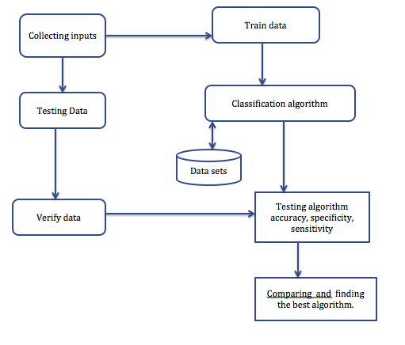

**3.2 Module Description:**

**Module 1: Data Pre-Processing:**

Data pre-processing is a data mining technique that involves transforming raw data into an understandable format. Preparing of dataset before algorithm is applied on it. Here we take different raw data sets and missing values are filtered using the data cleaning process

**Use case Diagram:**

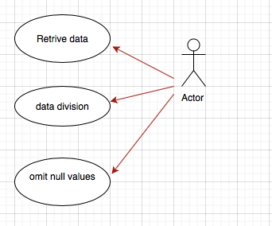

**Activity Diagram:**

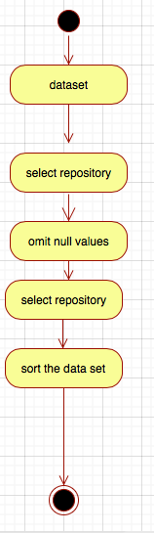

**Module 2: Feature Selection:**

Once initial state is done we analyse the pre-processed data available. It is done to know the common patterns that are affecting the rating like genre, director name, actor name, gross. Information gain of analysed data is done by using the gini index and algorithm for deciding the class label is applied. We plot histogram for clear classification of each attribute based on its frequency and density to this processed dataset. Then, Gini index and entropy are applied to each and every attribute. Next, we plot Lc for each of these Gini and Entropy values. All the values of gini are stored in one variable and entropy is stored in another variable then graph is plotted for these two variables thereby showing the accuracy. When the data is sorted along with its corresponding class labels. Evaluate the interval range

[Interval range = (max – min)/group size]

Based on this interval range, evaluate the split points whenever there is a change in the class label.

[split point= midpoint(changed class labels)].

**Activity Diagram:**

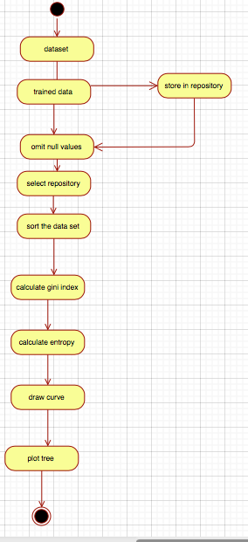

**Use case diagram:**

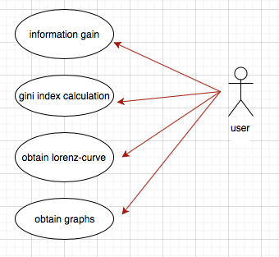

**Module 3: Classification Algorithms**:

1. Logistic Regression: It is one of the highly used regression technique which is useful to predict value of dependent variable. Dependent variable might depend on many independent variables. This prediction can be done using logit function.
2. Decision Tree: It is of two types. One is classical trees and conditional Inference trees. This is a classification technique that helps in predicting the outcome of a variable. The root node is the one with highest information gain or gini index value. After performing the decision tree with training data set ,it is validated with testing set. The prediction is done and an elegant decision tree is formed which gives a crystal clear view of different association rules that can be formed with help of it. These rules help the users or producers to depict the outcome before on hand. In conditional inference tree the features and splits are taken on basis of tests that are performed on the dataset. These tests are known as permutation tests.
3. RandomForest : This contains a group of decision trees. All these trees are grouped into one to make the cases into the groups. It is supervised learning approach. We use randomForest function here to perform it. It is available in the randomForest package. Pruning of tree is done here. It also provides a natural measure to know the importance of feature. Determines the importance of each attribute in the dataset. According to the weight, chooses the best tree. According to the project perspective, the attribute that has higher importance is taken and the bar graph is plotted. According to the plotted graph, the value of highest frequency is taken as reference for accurate prediction. The dataset is divided into training and testing samples where we apply package (random forest) and test this system using the testing sample.
4. Support Vector Machines: It is also called as SVMs. Now these became popular because of improved prediction in showing up accuracy. In this we use the field of mathematics, a mathematical approach that is underlying in this algorithm gives the highly accurate data and focus on binary classification. We can use this SVMs by using function ksvm(). This is the respective function that is used in R programming. And also usage of svm() function available in the e1071 package is done.

**Module 4: Performance Analysis:** Rating is classified as A1,A2 using supervised machine-learning techniques. To know which approach is accurate we calculated the accuracy of each classification classifier. But , accuracy alone is not enough to tell that particulary algorithm is the best.So, we calculated the sensitivity,specificity,positive predictive value, negative predective value and accuracy of each classification technique. This one we performed by including all these in performance function. Once the performance function is executed and the one classifier with highest measures will be treated as the best algorithm in terms of accuracy.

**3.3 SYSTEM SPECIFICATION**

**3.3.1 Software Requirements:**

Operating System: OS X

Software used: R-Studio, programing using R.

**3.3.2 Hardware Requirements:**

Processor: 2.5 GHZ INTEL CORE I5.

Memory: 4GB 1600 MHz DDR3.

Key Board: Apple Extended Keyboard.

**3.4** **Detailed Design:**

**3.4.1 Use-Case Diagram:**

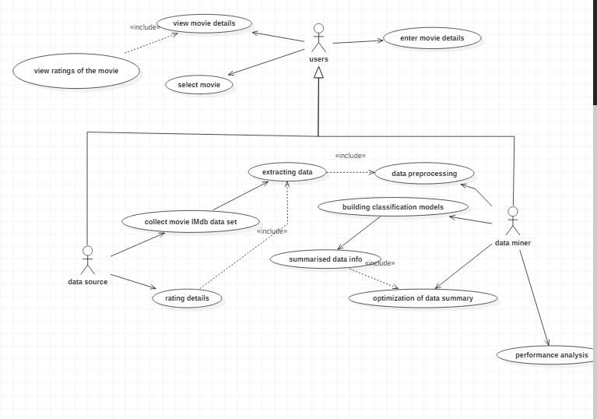

**3.4.2 Sequence Diagram:**

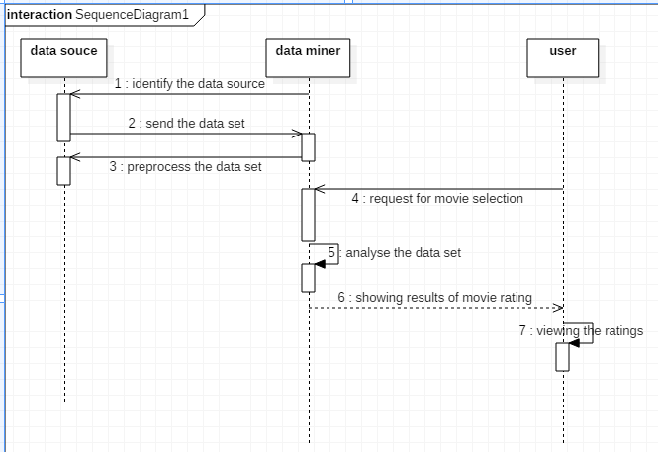

**3.4.3 Class Diagram:**

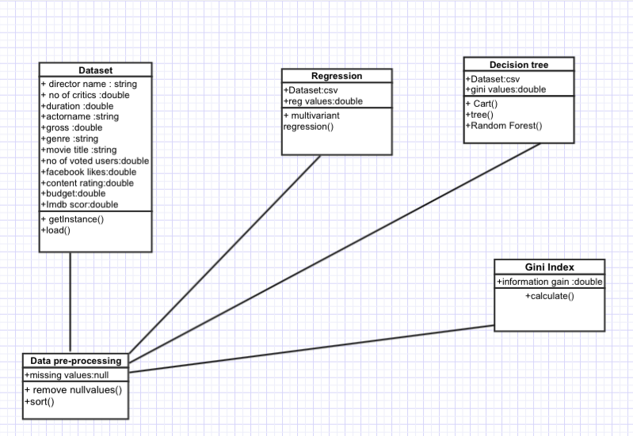

**3.4.4 Data Flow Diagram:**

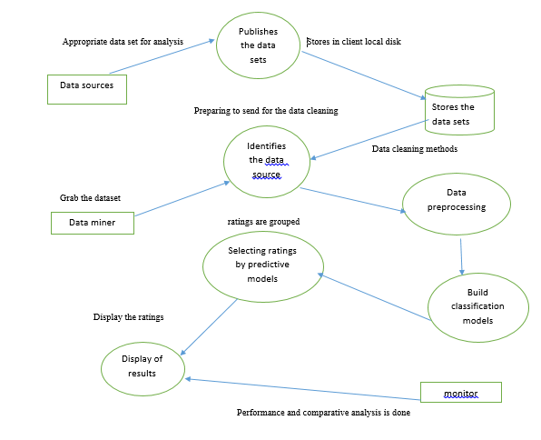

**3.4.5 Activity Diagram**:

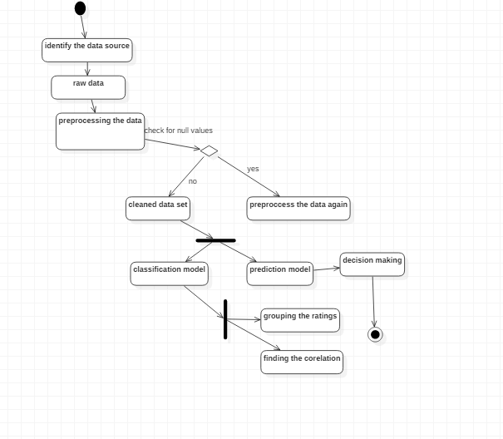

**4. IMPLEMENTATION:**

**4.1 Implementation Details:**

**CODE:**

library("party")

library("rpart")

library("rpart.plot")

library("e1071")

library("randomForest")

library("ineq")

#add file

setwd("C:/Users/Admin/Desktop/summer project/")

play_decision<-play_decision<-read.csv("C:/Users/Admin/Desktop/summer project/Book2.csv" ,header=TRUE, sep=",")

#show table

View(play_decision)

#null all the values

play1<-play_decision[complete.cases(play_decision),]

View(play1)

play1$rating<-cut(play1$rating,breaks=c(0,125,290),labels=paste("A",1:2,sep=""))

play2<-play1[complete.cases(play1),]

set.seed(1234)

play_decision <- play_decision[complete.cases(play_decision),]

summary(play_decision)

#divide values to train=70% and validate=30%

dec<-sample(2, nrow(play2), replace=TRUE, prob=c(0.7,0.3))

train<-play2[dec==1,]

validate<-play2[dec==2,]

table(train$rating)

#glm is used to fit generalized linear models, specified by giving a symbolic description of the linear predictor and a description of the error distribution.

fit.logit<-glm(rating~director_facebook_likes+actor_3_facebook_likes+actor_1_facebook_likes+num_voted_users+facenumber_in_poster+num_user_for_reviews+country+content_rating+actor_2_facebook_likes+imdb_score+aspect_ratio+movie_facebook_likes, data=train , family=binomial())

summary(fit.logit)

prob<- predict(fit.logit ,validate , type="response")

logit.pred<-factor(prob> .5, levels=c(FALSE,TRUE), labels=c("A1","A2"))

logit.perf<- table(validate$rating , logit.pred, dnn=c("Actual","Predicted"))

logit.perf

performance<- function(table,n=2) {

if(!all(dim(table) == c(2,2)))

stop("Must be a 2 X 2 table")

tn = table[1,1]

fp = table[1,2]

fn = table[2,1]

tp = table[2,2]

sensitivity = tp/(tp+fn)

specificity = tn/(tn+fp)

ppp = tp/(tp+fp)

npp = tn/(tn+fn)

hitrate = (tp+tn)/(tp+tn+fp+fn)

result <- paste("sensitivity = ",round(sensitivity, n),

"\nSpecificity = ", round(specificity, n),

"\nPositive Predictive Value = ", round(ppp, n),

"\nNegative Predictive Value = ", round(npp, n),

"\nAccuracy = ", round(hitrate, n), "\n", sep="")

cat(result)

}

#performance analysis of glm

performance(logit.perf)

#Recursive Partitioning And Regression Trees

fit<- rpart(rating~director_facebook_likes+actor_3_facebook_likes+imdb_score+aspect_ratio,data=train, method="class",parms=list(split="information"))

summary(fit)

fit$cptable

plotcp(fit)

#decision tree

dtree.pruned<-prune(fit, cp=.0125)

fit.pruned<-prune(fit, cp=.0125)

prp(fit.pruned, type=2, extra=104, fallen.leaves = TRUE, main="Decision Tree")

dtree.pred<-predict(fit.pruned, validate, type="class")

dtree.perf<-table(validate$rating, dtree.pred, dnn=c("Actual","Predicted"))

dtree.perf

performance(dtree.perf)

#Conditional Inference Trees

#Recursive partitioning for continuous, censored, ordered, nominal and multivariate response variables in a conditional inference framework.

fit.ctree<-ctree(rating~.,data=train)

plot(fit.ctree, main="Conditional Inference Tree")

ctree.pred<-predict(fit.ctree, validate, type="response")

ctree.perf<-table(validate$rating, ctree.pred, dnn=c("Actual","Predicted"))

ctree.perf

performance(ctree.perf)

#histogram

hist(play2$movie_facebook_likes, main="histogram of movie likes", xlab="movie_facebook_likes",border="blue",col="green",xlim=c(36,98),las=0,breaks=10)

hist(play2$aspect_ratio, main="histogram of aspect_ratio", xlab="aspect_ratio",border="red",col="orange",xlim=c(1,2.4),las=0,breaks=10)

hist(play2$imdb_score, main="histogram of imdb_score", xlab="imdb_score",border="blue",col="pink",xlim=c(2,8),las=0,breaks=10)

hist(play2$movie_facebook_likes, main="histogram of movie likes", xlab="movie_facebook_likes",border="blue",col="green",xlim=c(36,98),las=0,breaks=10)

#Random forest

fit.forest<-randomForest(rating~content_rating+aspect_ratio+imdb_score+language+country+director_facebook_likes, data=train, na.action=na.roughfix, importance=TRUE)

➢ fit.forest

plot(fit.forest)

forest.pred<-predict(fit.forest,validate)

forest.perf<-table(validate$rating,forest.pred,dnn=c("Actual","Predicted"))

forest.perf

performance(forest.perf)

#Simple vector machine

fit.svm<-svm(rating~.,data=train)

fit.svm

svm.pred<-predict(fit.svm, na.omit(validate))

svm.perf<-table(na.omit(validate)$rating,svm.pred,dnn=c("Actual","Predicted"))

svm.perf

performance(svm.perf)

# Gini index

g<-ineq(play2$director_facebook_likes, type="Gini")

g

plot(Lc(play2$director_facebook_likes), col="purple", lwd=2)

savehistory("~/C:/Users/Admin/Desktop/summer project/gini.Rhistory")

#green--content_rating

h<-ineq(play2$content_rating, type="Gini")

h

plot(Lc(play2$content_rating), col="green", lwd=2)

#blue--imdb_score

h<-ineq(play2$imdb_score, type="Gini")

h

plot(Lc(play2$imdb_score), col="blue", lwd=2)

#pink--country

i<-ineq(play2$country, type="Gini")

i

plot(Lc(play2$country), col="pink", lwd=2)

#orange--language

j<-ineq(play2$language, type="Gini")

j

plot(Lc(play2$language), col="orange", lwd=2)

#blue--imdb_score

k<-ineq(play2$imdb_score, type="Gini")

k

plot(Lc(play2$imdb_score), col="blue", lwd=2)

#blue--director_facebook_likes

a<-ineq(play2$director_facebook_likes, type="Gini")

a

plot(Lc(play2$director_facebook_likes), col="purple", lwd=2)

#Entropy

#CONTENT RATING

b<-ineq(play2$content_rating, type="entropy")

b

plot(Lc(play2$content_rating), col="green", lwd=2)

#director facebook

a<-ineq(play2$director_facebook_likes, type="entropy")

a

plot(Lc(play2$content_rating), col="purple", lwd=2)

#country

c<-ineq(play2$country, type="entropy")

c

plot(Lc(play2$country), col="pink", lwd=2)

#language

d<-ineq(play2$language, type="entropy")

d

plot(Lc(play2$language, col="orange", lwd=2))

x1<-c(g,k)

x2<-c(b,c,d)

plot(x1, type="o", col="blue",ylim=c(0.0,0.4))

par(new=TRUE)

lines(x2,type="o",col="red")

model<-naiveBayes(rating~.,data=train)

newdata<- data.frame(director_facebook_likes="0",actor_3_facebook_likes="530",actor_1_facebook_likes="895",num_voted_users="700",facenumber_in_poster="1",num_user_for_reviews="600",language="English",country="USA",content_rating="PG",actor_2_facebook_likes="89",imdb_score="7.5",aspect_ratio="2.35",movie_facebook_likes="8900",movie_title="Bahubali")

newdata

model<-naiveBayes(rating~.,data=train)

predict(model,newdata,type="class")

**OUTPUT:**

|  |
| --- |
| > library("party")  Loading required package: grid  Loading required package: mvtnorm  Loading required package: modeltools  Loading required package: stats4  Loading required package: strucchange  Loading required package: zoo  Attaching package: ‘zoo’  The following objects are masked from ‘package:base’:  as.Date, as.Date.numeric  Loading required package: sandwich  > library("rpart")  > library("rpart.plot")  > library("e1071")  Warning message:  package ‘e1071’ was built under R version 3.5.1  > library("randomForest")  randomForest 4.6-14  Type rfNews() to see new features/changes/bug fixes.  > library("ineq")  > #add file  > setwd("C:/Users/Admin/Desktop/summer project/")  > play_decision<-play_decision<-read.csv("C:/Users/Admin/Desktop/summer project/Book2.csv" ,  header=TRUE, sep=",")  > #show table  > View(play_decision)  > #null all the values  > play1<-play_decision[complete.cases(play_decision),]  > View(play1)  >  > play1$rating<-cut(play1$rating,breaks=c(0,125,290),labels=paste("A",1:2,sep=""))  > play2<-play1[complete.cases(play1),]  > set.seed(1234)  >  > play_decision <- play_decision[complete.cases(play_decision),]  > summary(play_decision)  rating director_facebook_likes actor_3_facebook_likes actor_1_facebook_likes  num_voted_users  Min. : 73.0 Min. : 0.00 Min. : 0.0 Min. : 2 Min. : 57  1st Qu.:101.0 1st Qu.: 13.75 1st Qu.: 329.8 1st Qu.: 1000 1st Qu.: 78808  Median :116.0 Median : 124.00 Median : 595.0 Median :11000 Median : 166742  Mean :119.9 Mean : 1327.14 Mean : 1640.4 Mean :12106 Mean : 228894  3rd Qu.:134.0 3rd Qu.: 401.25 3rd Qu.: 940.0 3rd Qu.:18000 3rd Qu.: 314088  Max. :240.0 Max. :22000.00 Max. :23000.0 Max. :87000 Max. :1676169    facenumber_in_poster num_user_for_reviews language country content_rating  actor_2_facebook_likes  Min. : 0.000 Min. : 1.0 : 0 USA :453 PG-13 :277 Min. : 0.0  1st Qu.: 0.000 1st Qu.: 248.8 Aboriginal: 1 UK : 28 PG :132 1st Qu.: 592.0  Median : 1.000 Median : 476.5 English :508 Germany : 10 R : 79 Median : 946.5  Mean : 1.229 Mean : 667.6 French : 3 France : 7 G : 24 Mean : 4179.7  3rd Qu.: 2.000 3rd Qu.: 799.8 Japanese : 2 Australia: 6 : 4 3rd Qu.: 8000.0  Max. :15.000 Max. :5060.0 Mandarin : 1 Canada : 3 TV-14 : 0 Max. :27000.0  Spanish : 1 (Other) : 9 (Other): 0  imdb_score aspect_ratio movie_facebook_likes  Min. :2.200 Min. :1.500 Min. : 0  1st Qu.:6.000 1st Qu.:1.850 1st Qu.: 0  Median :6.700 Median :2.350 Median : 2000  Mean :6.606 Mean :2.206 Mean : 21941  3rd Qu.:7.300 3rd Qu.:2.350 3rd Qu.: 29000  Max. :9.000 Max. :2.390 Max. :349000    > #divide values to train=70% and validate=30%  > dec<-sample(2, nrow(play2), replace=TRUE, prob=c(0.7,0.3))  > train<-play2[dec==1,]  > validate<-play2[dec==2,]  > table(train$rating)  A1 A2  236 123  >  > #glm is used to fit generalized linear models, specified by giving a symbolic description  of the linear predictor and a description of the error distribution.  > fit.logit<-glm(rating~director_facebook_likes+actor_3_facebook_likes+actor_1_facebook_likes  +num_voted_users+facenumber_in_poster+num_user_for_reviews+country+content_rating  +actor_2_facebook_likes+imdb_score+aspect_ratio+movie_facebook_likes, data=train ,  family=binomial())  > summary(fit.logit)  Call:  glm(formula = rating ~ director_facebook_likes + actor_3_facebook_likes +  actor_1_facebook_likes + num_voted_users + facenumber_in_poster +  num_user_for_reviews + country + content_rating + actor_2_facebook_likes +  imdb_score + aspect_ratio + movie_facebook_likes, family = binomial(),  data = train)  Deviance Residuals:  Min 1Q Median 3Q Max  -2.0558 -0.7212 -0.2904 0.7110 2.7713  Coefficients:  Estimate Std. Error z value Pr(>|z|)  (Intercept) -2.836e+01 3.956e+03 -0.007 0.994  director_facebook_likes -4.125e-06 3.565e-05 -0.116 0.908  actor_3_facebook_likes 7.133e-05 5.854e-05 1.218 0.223  actor_1_facebook_likes 1.972e-05 1.503e-05 1.312 0.189  num_voted_users -2.197e-06 1.494e-06 -1.470 0.142  facenumber_in_poster 9.526e-02 7.420e-02 1.284 0.199  num_user_for_reviews 1.380e-03 3.474e-04 3.973 7.09e-05 ***  countryCanada -1.140e+00 2.192e+00 -0.520 0.603  countryChina 1.764e+01 2.679e+03 0.007 0.995  countryFrance -5.879e-01 2.135e+00 -0.275 0.783  countryGermany -5.326e-01 1.913e+00 -0.278 0.781  countryJapan -3.092e+00 4.845e+03 -0.001 0.999  countryNew Line -1.290e+01 3.956e+03 -0.003 0.997  countryNew Zealand 1.599e+01 1.650e+03 0.010 0.992  countryUK 4.820e-01 1.728e+00 0.279 0.780  countryUSA 4.385e-01 1.651e+00 0.266 0.791  content_ratingG -2.001e+00 4.081e+03 0.000 1.000  content_ratingPG 1.368e+01 3.956e+03 0.003 0.997  content_ratingPG-13 1.527e+01 3.956e+03 0.004 0.997  content_ratingR 1.547e+01 3.956e+03 0.004 0.997  actor_2_facebook_likes -4.084e-05 3.922e-05 -1.041 0.298  imdb_score 1.378e+00 2.809e-01 4.905 9.33e-07 ***  aspect_ratio 1.091e+00 7.373e-01 1.480 0.139  movie_facebook_likes -5.260e-06 4.213e-06 -1.248 0.212  ---  Signif. codes: 0 ‘***’ 0.001 ‘**’ 0.01 ‘*’ 0.05 ‘.’ 0.1 ‘ ’ 1  (Dispersion parameter for binomial family taken to be 1)  Null deviance: 461.50 on 358 degrees of freedom  Residual deviance: 313.49 on 335 degrees of freedom  AIC: 361.49  Number of Fisher Scoring iterations: 16  > prob<- predict(fit.logit ,validate , type="response")  > logit.pred<-factor(prob> .5, levels=c(FALSE,TRUE), labels=c("A1","A2"))  > logit.perf<- table(validate$rating , logit.pred, dnn=c("Actual","Predicted"))  > logit.perf  Predicted  Actual A1 A2  A1 86 11  A2 30 30  >  >  > performance<- function(table,n=2) {  + if(!all(dim(table) == c(2,2)))  + stop("Must be a 2 X 2 table")  + tn = table[1,1]  + fp = table[1,2]  + fn = table[2,1]  + tp = table[2,2]  + sensitivity = tp/(tp+fn)  + specificity = tn/(tn+fp)  + ppp = tp/(tp+fp)  + npp = tn/(tn+fn)  + hitrate = (tp+tn)/(tp+tn+fp+fn)  + result <- paste("sensitivity = ",round(sensitivity, n),  + "\nSpecificity = ", round(specificity, n),  + "\nPositive Predictive Value = ", round(ppp, n),  + "\nNegative Predictive Value = ", round(npp, n),  + "\nAccuracy = ", round(hitrate, n), "\n", sep="")  + cat(result)  + }  > #performance analysis of glm  > performance(logit.perf)  sensitivity = 0.5  Specificity = 0.89  Positive Predictive Value = 0.73  Negative Predictive Value = 0.74  Accuracy = 0.74  > #Recursive Partitioning And Regression Trees  > fit<- rpart(rating~director_facebook_likes+actor_3_facebook_likes+imdb_score  +aspect_ratio,data=train, method="class",parms=list(split="information"))  > summary(fit)  Call:  rpart(formula = rating ~ director_facebook_likes + actor_3_facebook_likes +  imdb_score + aspect_ratio, data = train, method = "class",  parms = list(split = "information"))  n= 359  CP nsplit rel error xerror xstd  1 0.20325203 0 1.0000000 1.0000000 0.07310654  2 0.03658537 1 0.7967480 0.9268293 0.07171056  3 0.02439024 5 0.6422764 0.8211382 0.06926570  4 0.01626016 7 0.5934959 0.7967480 0.06862478  5 0.01000000 8 0.5772358 0.8211382 0.06926570  Variable importance  director_facebook_likes imdb_score actor_3_facebook_likes aspect_ratio  44 41 9 6  Node number 1: 359 observations, complexity param=0.203252  predicted class=A1 expected loss=0.3426184 P(node) =1  class counts: 236 123  probabilities: 0.657 0.343  left son=2 (252 obs) right son=3 (107 obs)  Primary splits:  imdb_score < 7.15 to the left, improve=24.803440, (0 missing)  director_facebook_likes < 2.5 to the right, improve=13.936990, (0 missing)  aspect_ratio < 2.025 to the left, improve= 9.586516, (0 missing)  actor_3_facebook_likes < 13500 to the left, improve= 3.667399, (0 missing)  Surrogate splits:  director_facebook_likes < 15000 to the left, agree=0.733, adj=0.103, (0 split)  actor_3_facebook_likes < 17500 to the left, agree=0.716, adj=0.047, (0 split)  Node number 2: 252 observations, complexity param=0.02439024  predicted class=A1 expected loss=0.2261905 P(node) =0.7019499  class counts: 195 57  probabilities: 0.774 0.226  left son=4 (211 obs) right son=5 (41 obs)  Primary splits:  director_facebook_likes < 3 to the right, improve=9.922617, (0 missing)  imdb_score < 5.95 to the left, improve=6.898891, (0 missing)  aspect_ratio < 2.025 to the left, improve=3.762866, (0 missing)  actor_3_facebook_likes < 59.5 to the left, improve=2.356167, (0 missing)  Node number 3: 107 observations, complexity param=0.03658537  predicted class=A2 expected loss=0.3831776 P(node) =0.2980501  class counts: 41 66  probabilities: 0.383 0.617  left son=6 (96 obs) right son=7 (11 obs)  Primary splits:  director_facebook_likes < 15000 to the left, improve=5.701371, (0 missing)  aspect_ratio < 2.1 to the left, improve=5.156497, (0 missing)  actor_3_facebook_likes < 983.5 to the left, improve=3.632754, (0 missing)  imdb_score < 8.4 to the left, improve=1.813589, (0 missing)  Surrogate splits:  actor_3_facebook_likes < 21500 to the left, agree=0.916, adj=0.182, (0 split)  imdb_score < 8.4 to the left, agree=0.907, adj=0.091, (0 split)  Node number 4: 211 observations  predicted class=A1 expected loss=0.1706161 P(node) =0.5877437  class counts: 175 36  probabilities: 0.829 0.171  Node number 5: 41 observations, complexity param=0.02439024  predicted class=A2 expected loss=0.4878049 P(node) =0.1142061  class counts: 20 21  probabilities: 0.488 0.512  left son=10 (13 obs) right son=11 (28 obs)  Primary splits:  actor_3_facebook_likes < 535 to the left, improve=1.6224440, (0 missing)  imdb_score < 6 to the left, improve=1.2156250, (0 missing)  aspect_ratio < 2.1 to the right, improve=0.0594772, (0 missing)  Surrogate splits:  imdb_score < 5.3 to the left, agree=0.756, adj=0.231, (0 split)  Node number 6: 96 observations, complexity param=0.03658537  predicted class=A2 expected loss=0.4270833 P(node) =0.2674095  class counts: 41 55  probabilities: 0.427 0.573  left son=12 (23 obs) right son=13 (73 obs)  Primary splits:  aspect_ratio < 2.1 to the left, improve=4.4700750, (0 missing)  director_facebook_likes < 2.5 to the right, improve=2.5208750, (0 missing)  actor_3_facebook_likes < 8000 to the left, improve=1.8706720, (0 missing)  imdb_score < 8.05 to the right, improve=0.7395902, (0 missing)  Surrogate splits:  imdb_score < 8.25 to the right, agree=0.771, adj=0.043, (0 split)  Node number 7: 11 observations  predicted class=A2 expected loss=0 P(node) =0.03064067  class counts: 0 11  probabilities: 0.000 1.000  Node number 10: 13 observations  predicted class=A1 expected loss=0.3076923 P(node) =0.0362117  class counts: 9 4  probabilities: 0.692 0.308  Node number 11: 28 observations, complexity param=0.01626016  predicted class=A2 expected loss=0.3928571 P(node) =0.07799443  class counts: 11 17  probabilities: 0.393 0.607  left son=22 (8 obs) right son=23 (20 obs)  Primary splits:  imdb_score < 6.95 to the right, improve=1.2504590, (0 missing)  actor_3_facebook_likes < 853 to the right, improve=0.5606993, (0 missing)  Surrogate splits:  actor_3_facebook_likes < 588 to the left, agree=0.75, adj=0.125, (0 split)  Node number 12: 23 observations  predicted class=A1 expected loss=0.3043478 P(node) =0.06406685  class counts: 16 7  probabilities: 0.696 0.304  Node number 13: 73 observations, complexity param=0.03658537  predicted class=A2 expected loss=0.3424658 P(node) =0.2033426  class counts: 25 48  probabilities: 0.342 0.658  left son=26 (48 obs) right son=27 (25 obs)  Primary splits:  director_facebook_likes < 2.5 to the right, improve=1.8026580, (0 missing)  actor_3_facebook_likes < 983.5 to the left, improve=1.4715050, (0 missing)  imdb_score < 7.75 to the right, improve=0.5757009, (0 missing)  Surrogate splits:  actor_3_facebook_likes < 437.5 to the right, agree=0.699, adj=0.12, (0 split)  imdb_score < 8.35 to the left, agree=0.699, adj=0.12, (0 split)  Node number 22: 8 observations  predicted class=A1 expected loss=0.375 P(node) =0.02228412  class counts: 5 3  probabilities: 0.625 0.375  Node number 23: 20 observations  predicted class=A2 expected loss=0.3 P(node) =0.05571031  class counts: 6 14  probabilities: 0.300 0.700  Node number 26: 48 observations, complexity param=0.03658537  predicted class=A2 expected loss=0.4166667 P(node) =0.1337047  class counts: 20 28  probabilities: 0.417 0.583  left son=52 (10 obs) right son=53 (38 obs)  Primary splits:  director_facebook_likes < 87.5 to the left, improve=10.700580, (0 missing)  imdb_score < 8.05 to the right, improve= 1.488198, (0 missing)  actor_3_facebook_likes < 738 to the right, improve= 1.159026, (0 missing)  Surrogate splits:  actor_3_facebook_likes < 20 to the left, agree=0.833, adj=0.2, (0 split)  imdb_score < 8.15 to the right, agree=0.812, adj=0.1, (0 split)  Node number 27: 25 observations  predicted class=A2 expected loss=0.2 P(node) =0.06963788  class counts: 5 20  probabilities: 0.200 0.800  Node number 52: 10 observations  predicted class=A1 expected loss=0 P(node) =0.02785515  class counts: 10 0  probabilities: 1.000 0.000  Node number 53: 38 observations  predicted class=A2 expected loss=0.2631579 P(node) =0.1058496  class counts: 10 28  probabilities: 0.263 0.737  > fit$cptable  CP nsplit rel error xerror xstd  1 0.20325203 0 1.0000000 1.0000000 0.07310654  2 0.03658537 1 0.7967480 0.9268293 0.07171056  3 0.02439024 5 0.6422764 0.8211382 0.06926570  4 0.01626016 7 0.5934959 0.7967480 0.06862478  5 0.01000000 8 0.5772358 0.8211382 0.06926570  >  > plotcp(fit)  >  > #decision tree  > dtree.pruned<-prune(fit, cp=.0125)  > fit.pruned<-prune(fit, cp=.0125)  > prp(fit.pruned, type=2, extra=104, fallen.leaves = TRUE, main="Decision Tree")  > dtree.pred<-predict(fit.pruned, validate, type="class")  > dtree.perf<-table(validate$rating, dtree.pred, dnn=c("Actual","Predicted"))  > dtree.perf  Predicted  Actual A1 A2  A1 86 11  A2 28 32  >  > performance(dtree.perf)  sensitivity = 0.53  Specificity = 0.89  Positive Predictive Value = 0.74  Negative Predictive Value = 0.75  Accuracy = 0.75  > #Conditional Inference Trees  > #Recursive partitioning for continuous, censored, ordered, nominal and  multivariate response variables in a conditional inference framework.  > fit.ctree<-ctree(rating~.,data=train)  > plot(fit.ctree, main="Conditional Inference Tree")  > ctree.pred<-predict(fit.ctree, validate, type="response")  > ctree.perf<-table(validate$rating, ctree.pred, dnn=c("Actual","Predicted"))  > ctree.perf  Predicted  Actual A1 A2  A1 76 21  A2 26 34  >  > performance(ctree.perf)  sensitivity = 0.57  Specificity = 0.78  Positive Predictive Value = 0.62  Negative Predictive Value = 0.75  Accuracy = 0.7  > #histogram  > hist(play2$movie_facebook_likes, main="histogram of movie likes",  xlab="movie_facebook_likes",border="blue",col="green",xlim=c(36,98),las=0,breaks=10)  > hist(play2$aspect_ratio, main="histogram of aspect_ratio",  xlab="aspect_ratio",border="red",col="orange",xlim=c(1,2.4),las=0,breaks=10)  > hist(play2$imdb_score, main="histogram of imdb_score",  xlab="imdb_score",border="blue",col="pink",xlim=c(2,8),las=0,breaks=10)  > hist(play2$movie_facebook_likes, main="histogram of movie likes",  xlab="movie_facebook_likes",border="blue",col="green",xlim=c(36,98),las=0,breaks=10)  >  > #Random forest  > fit.forest<-randomForest(rating~content_rating+aspect_ratio  +imdb_score+language+country+director_facebook_likes,  data=train, na.action=na.roughfix, importance=TRUE)  > ¬ fit.forest  Error: unexpected input in "\"  > plot(fit.forest)  > forest.pred<-predict(fit.forest,validate)  > forest.perf<-table(validate$rating,forest.pred,dnn=c("Actual","Predicted"))  > forest.perf  Predicted  Actual A1 A2  A1 90 7  A2 27 33  > performance(forest.perf)  sensitivity = 0.55  Specificity = 0.93  Positive Predictive Value = 0.82  Negative Predictive Value = 0.77  Accuracy = 0.78  > #Simple vector machine  > fit.svm<-svm(rating~.,data=train)  > fit.svm  Call:  svm(formula = rating ~ ., data = train)  Parameters:  SVM-Type: C-classification  SVM-Kernel: radial  cost: 1  gamma: 0.02702703  Number of Support Vectors: 224  > svm.pred<-predict(fit.svm, na.omit(validate))  > svm.perf<-table(na.omit(validate)$rating,svm.pred,dnn=c("Actual","Predicted"))  > svm.perf  Predicted  Actual A1 A2  A1 93 4  A2 39 21  >  > performance(svm.perf)  sensitivity = 0.35  Specificity = 0.96  Positive Predictive Value = 0.84  Negative Predictive Value = 0.7  Accuracy = 0.73  > # Gini index  > g<-ineq(play2$director_facebook_likes, type="Gini")  > g  [1] 0.8726979  > plot(Lc(play2$director_facebook_likes), col="purple", lwd=2)  > savehistory("~/C:/Users/Admin/Desktop/summer project/gini.Rhistory")  >  > #green--content_rating  > h<-ineq(play2$content_rating, type="Gini")  > h  [1] 0.1064799  > plot(Lc(play2$content_rating), col="green", lwd=2)  > #blue--imdb_score  > h<-ineq(play2$imdb_score, type="Gini")  > h  [1] 0.08417039  > plot(Lc(play2$imdb_score), col="blue", lwd=2)  >  > #pink--country  > i<-ineq(play2$country, type="Gini")  > i  [1] 0.03907215  > plot(Lc(play2$country), col="pink", lwd=2)  >  > #orange--language  > j<-ineq(play2$language, type="Gini")  > j  [1] 0.009521078  > plot(Lc(play2$language), col="orange", lwd=2)  >  > #blue--imdb_score  > k<-ineq(play2$imdb_score, type="Gini")  > k  [1] 0.08417039  > plot(Lc(play2$imdb_score), col="blue", lwd=2)  > #blue--director_facebook_likes  > a<-ineq(play2$director_facebook_likes, type="Gini")  > a  [1] 0.8726979  > plot(Lc(play2$director_facebook_likes), col="purple", lwd=2)  >  > #Entropy  > #CONTENT RATING  > b<-ineq(play2$content_rating, type="entropy")  > b  [1] 0.02444277  > plot(Lc(play2$content_rating), col="green", lwd=2)  >  > #director facebook  > a<-ineq(play2$director_facebook_likes, type="entropy")  > a  [1] 1.859445  > plot(Lc(play2$content_rating), col="purple", lwd=2)  >  > #country  > c<-ineq(play2$country, type="entropy")  > c  [1] 0.01792849  > plot(Lc(play2$country), col="pink", lwd=2)  > #language  > d<-ineq(play2$language, type="entropy")  > d  [1] 0.002762154  > plot(Lc(play2$language, col="orange", lwd=2)  > x1<-c(g,k)  > x2<-c(b,c,d)  > plot(x1, type="o", col="blue",ylim=c(0.0,0.4))  > par(new=TRUE)  > lines(x2,type="o",col="red")  > model<-naiveBayes(rating~.,data=train)  > newdata<- data.frame(director_facebook_likes="0",actor_3_facebook_likes="530",actor_1_facebook_likes="895",num_voted_users="700",facenumber_in_poster="1",num_user_for_reviews="600",language="English",country="USA",content_rating="PG",actor_2_facebook_likes="89",imdb_score="7.5",aspect_ratio="2.35",movie_facebook_likes="8900",movie_title="Bahubali")  > newdata  director_facebook_likes actor_3_facebook_likes actor_1_facebook_likes  num_voted_users facenumber_in_poster  1 0 530 895 700 1  num_user_for_reviews language country content_rating actor_2_facebook_likes  imdb_score aspect_ratio  1 600 English USA PG 89 7.5 2.35  movie_facebook_likes movie_title  1 8900 Bahubali  > model<-naiveBayes(rating~.,data=train)  > predict(model,newdata,type="class")  [1] A2  Levels: A1 A2 |
| q<- play2[order(play2$aspect_ratio),c(2,5)]  > q  director_facebook_likes num_voted_users  316 63 71527  299 10 128285  363 7 171792  444 255 117212  510 28 644348  467 30 112167  1 0 886204  111 150 106446  238 0 464310  263 67 66593  264 6 13581  298 21 102933  481 11 27543  8 15 294810  18 0 995415  20 188 268154  34 13000 306320  36 37 235025  44 125 544884  53 0 381148  68 0 665575  71 17000 245333  72 188 129601  77 58 144337  79 0 345198  80 4000 106072  84 198 317542  107 33 21352  108 50 211971  119 13000 320284  122 35 146019  132 59 146766  134 473 152826  135 13000 199039  137 394 89442  139 58 105902  145 42 85086  147 50 47900  149 35 119213  153 188 270207  157 52 123553  162 0 544665  168 0 212106  171 6 72259  183 35 60230  186 235 313866  189 12 70121  190 14000 334345  194 0 200022  199 0 38438  201 189 67223  215 719 240241  218 541 189855  219 2000 141414  224 0 440084  229 50 36471  234 274 35066  239 0 585659  251 189 234480  267 67 27257  274 34 36033  277 50 94172  278 63 89351  282 23 4102  291 0 324671  294 80 85531  310 541 190786  311 719 221521  317 52 52029  320 6 40751  321 2000 71782  322 31 20295  324 20 27918  325 342 18697  329 9 54077  330 0 49739  332 116 106790  334 127 59581  335 10 58300  339 475 692482  345 394 219501  348 212 165618  353 188 403014  354 487 385871  359 107 166791  367 0 477300  370 12 9418  371 0 183247  372 221 156348  374 14000 238747  377 719 101834  386 0 87785  387 81 58227  397 0 394317  403 266 164148  407 36 26413  409 278 182757  411 278 69860  413 28 65270  420 6 35446  421 102 169023  422 99 61417  423 189 19228  424 763 70838  425 1000 273921  427 88 39391  428 67 71424  430 153 246492  431 0 29932  432 62 10233  434 0 208422  437 293 296904  442 13000 215255  443 12 127345  445 56 27838  449 31 22838  450 221 107817  451 88 168172  452 278 91092  454 91 48500  455 77 103022  459 221 172878  465 10 63625  468 189 65499  473 40 16385  477 438 86422  478 69 666  479 266 56501  483 31 22955  487 65 80639  488 0 98472  493 79 45231  494 357 53132  501 750 24868  509 2000 610568  511 62 67296  515 221 60370  518 101 65037  519 5 16611  520 11 24407  522 275 286877  524 14000 278362  525 35 266636  526 0 361767  30 365 418214  89 663 128306  126 69 421658  2 563 471220  3 0 275868  4 22000 1144337  6 475 212204  7 0 383056  9 0 462669  10 282 321795  11 0 371639  12 0 240396  13 395 330784  14 563 522040  15 563 181792  16 0 548573  17 80 149922  19 252 370704  21 0 354228  22 464 451803  23 0 211765  24 0 483540  25 129 149019  26 0 316018  27 0 793059  28 94 272670  29 532 202382  31 0 522030  32 0 411164  33 1000 557489  35 420 383427  37 0 323207  38 0 242420  39 0 175409  40 464 321227  41 364 264183  42 487 101178  43 258 223393  45 368 286095  46 0 278232  47 395 465019  48 0 514125  49 14000 395573  50 0 106416  51 1000 362912  52 179 222403  54 0 326180  55 14000 333847  56 113 62836  57 56 273556  58 681 53607  59 475 718837  60 420 121084  61 776 283418  62 0 72809  63 0 139593  64 282 42372  65 80 286506  66 0 148379  67 22000 1676169  69 11 114553  70 4000 696338  73 357 117927  74 452 118992  75 293 115099  76 218 431620  78 208 174578  81 4000 522371  82 274 228554  83 171 252257  86 47 116994  87 94 496749  88 31 138661  91 66 272534  92 0 120798  93 776 58137  94 255 485430  95 84 305340  96 571 682155  97 22000 928227  98 22000 1468200  99 28 374  101 357 272223  102 21000 459346  103 905 518537  104 508 166137  105 226 124185  106 249 82380  109 0 111609  110 230 188457  112 0 254111  113 0 513158  114 0 138863  115 282 355137  116 179 385670  117 532 343648  118 508 530870  120 663 473887  121 22000 980946  123 189 130272  124 151 361924  125 0 364948  127 0 421818  128 230 414070  129 750 552503  130 2000 207839  131 0 536314  133 12 33042  136 188 232187  138 282 42372  140 90 182718  141 0 118951  142 14000 256695  143 776 164238  144 25 17590  146 456 39956  148 249 381672  150 93 169914  151 176 69757  152 0 322395  154 0 142440  155 5 64322  156 663 365104  158 23 110788  159 380 317166  160 0 128682  161 14000 504419  163 255 221128  164 295 51892  165 357 45455  166 0 392474  167 503 127497  169 209 146352  170 42 77673  172 394 508818  173 150 157519  174 608 168207  175 386 185394  176 750 32399  177 255 326286  179 14000 12572  180 0 406020  181 13 62424  182 563 183208  184 521 491077  185 54 307029  187 508 498397  188 386 185394  191 0 178126  192 50 114287  193 176 245621  195 14000 177383  196 0 382255  197 1000 102338  198 0 158720  202 96 172754  203 0 444683  204 124 91640  205 28 374  206 563 809474  208 508 305008  209 2000 314253  210 107 58498  211 0 405973  212 681 284792  213 0 338635  214 255 229679  216 323 101411  217 209 229823  220 776 333248  221 610 242188  222 249 133076  223 167 213275  225 160 182661  226 521 40123  227 368 100821  228 0 456260  230 662 338087  231 123 183909  232 294 182899  233 0 57873  235 446 148280  236 364 387436  237 0 520104  240 446 328067  241 0 534658  242 16 150618  243 0 20567  244 610 55994  245 19 37750  246 473 167085  247 0 582917  248 79 62271  250 128 110486  252 62 147497  253 55 149680  254 776 207613  255 0 284852  256 218 348861  257 124 154621  258 17000 264318  259 11 53160  260 1000 136019  262 263 225273  265 124 44296  266 189 254841  268 101 60573  269 151 184561  270 235 336235  271 0 1238746  272 153 68720  273 0 79186  275 295 387632  276 0 217373  279 0 472488  281 0 263329  283 57 218341  284 0 982637  285 14000 399651  286 0 387616  287 258 470483  288 13000 177725  289 0 744891  290 0 230931  292 0 190439  293 12000 149998  295 285 189806  296 55 84424  297 16000 955174  300 165 246803  301 226 255447  302 14 108076  303 0 87677  304 456 39956  305 77 85833  306 207 176598  307 0 89509  308 380 400292  309 17000 780588  312 670 284825  313 0 65785  314 26 87451  315 420 115687  318 385 127258  319 19 33953  323 521 110364  326 208 248045  327 17000 314033  328 611 38690  331 0 292022  333 0 343274  336 20 145321  337 0 103737  338 0 125109  340 0 1215718  341 0 1100446  342 44 54501  343 165 157016  344 0 172707  346 81 403836  347 70 68935  349 102 16832  350 663 479166  351 212 21102  352 0 141179  355 12000 149947  356 420 160440  357 0 98403  358 97 152601  360 0 236421  361 368 145350  362 17000 873649  364 0 307539  365 21000 330152  366 323 299258  368 335 57  369 21 72591  373 0 89770  375 50 32049  376 0 200556  378 521 86152  379 87 86627  380 101 102747  381 209 40862  382 176 52136  383 12000 121259  384 0 60467  385 107 165333  388 79 45602  389 0 49311  390 128 110486  391 468 113065  392 2000 148238  393 96 2508  394 378 57661  395 101 144053  396 357 272223  398 750 132501  399 521 348232  400 249 146134  401 0 402645  402 545 88542  404 36 142496  406 79 166693  408 420 110073  410 12000 188116  412 0 256928  414 168 341058  415 218 188887  416 532 82731  417 323 106528  418 252 119286  419 681 179500  426 36 77029  429 38 203458  433 218 243053  435 21000 301279  436 55 100001  438 13000 270226  439 0 300542  440 378 701607  441 480 375879  446 75 135601  447 23 125036  448 88 130070  453 17000 786092  456 610 283967  457 163 72326  458 0 200359  461 165 225282  462 154 150764  463 333 118483  464 117 227072  466 101 58184  469 301 139423  470 503 76099  471 452 303185  472 425 60910  474 21 44143  475 153 44662  476 81 58402  482 25 103787  484 57 155532  485 258 71574  486 25 83560  489 13000 172217  490 92 979  491 93 55913  492 84 151424  495 43 8913  496 64 65464  497 287 24183  498 252 37446  499 503 53057  500 0 56403  502 42 58752  [ reached getOption("max.print") -- omitted 16 rows ] |
| |  | | --- | |  | |

**4.1 Unit Testing**

* The main aim of unit testing is to break down each component of the program and test these individual components for its proper function.
* If, for any condition when set of inputs are given then it should return proper outputs.  When any input is given if the system fails it should be handled gracefully.
* Unit testing is basically done before integration testing as shown below.

**Code:**

> q<- play2[order(play2$aspect_ratio),c(2,5)]

> q

Result

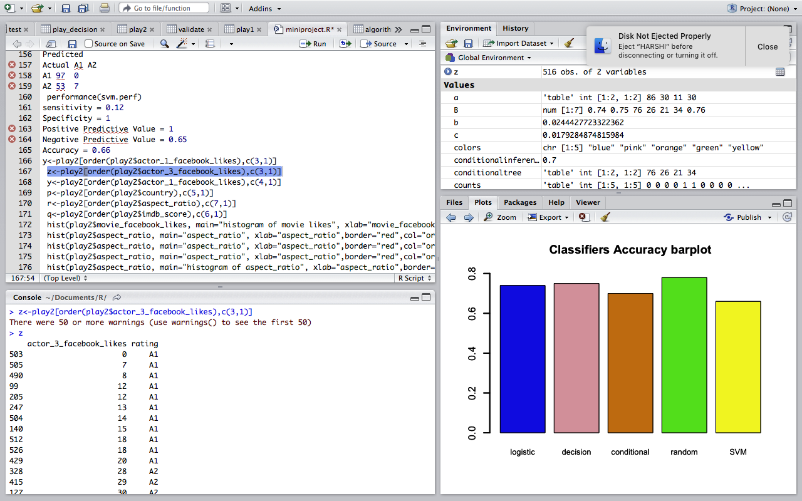

**5. TEST RESULTS:**

**5.1 TEST CASESES:**

**5.1.1 Test Case -1:**

|  |  |
| --- | --- |
| Use Case ID: | 1 |
| Use Case Name: | Validate package creation |
| Description: | The packages to be used must be installed without any malfunction |
| Trigger | For the execution of code |
| Preconditions: | Type package name in text box and click install. |
| Post conditions: | 1) Successfully installed  2)The details of package are displayed. |
| Normal Flow : | 1)The System displays the list of packages.  2) Displays message “successfully installed” |
| Alternative Flows: | Unsuccessful installation |

**5.1.2 Test Case Generation :2**

|  |  |
| --- | --- |
| Use Case ID: | 2 |
| Use Case Name: | Giving appropriate parameter to plot graph |
| Description: | The parameter act as an input so that we can get graphs as output |
| Preconditions: | Packages should be installed already |
| Post conditions: | 1)A graph is displayed |
| Normal Flow | 1)Give limit values for x and y axis  2) Plot the graph based on the given parameters.  3) Result is a graph . |
| Alternative Flows: | 1) Error in given parameters.  2) No graph |

**5.1.3 Test Case Generation 3:**

|  |  |
| --- | --- |
| Use Case ID: | 3 |
| Use Case Name: | Categorical and numerical datasets |
| Description: | Given datasets should be either numerical or categorical no special characters are allowed. |
| Trigger: | To predict the ratings of movies using Imdb data set. |
| Preconditions: | Obtaining the datasets from CIS repository |
| Post conditions: | not applicable |
| Normal Flow: | Taking datasets from 2011 - 2016 |
| Alternative Flows: | Error in getting datasets. |

1. **RESULTS AND DISCUSSIONS:**

Data mining techniques are applied on the taken dataset IMDB. Performance analysis of classical decision tree, conditional Inference tree , random Forest , linear regression and support vector machine is calculated. Out of these all randomForest gets the highest accuracy. As we know the classifier with more accuracy will be within realm of usage. In this by feature selection important features that highly effect rating are analyzed which can be used for reference.

**6.1 Outputs/Results**

**6.1.1 Dataset**

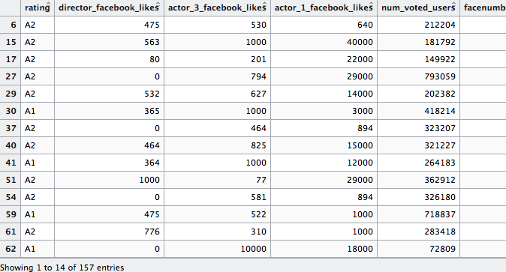

**6.1.2 Histograms**

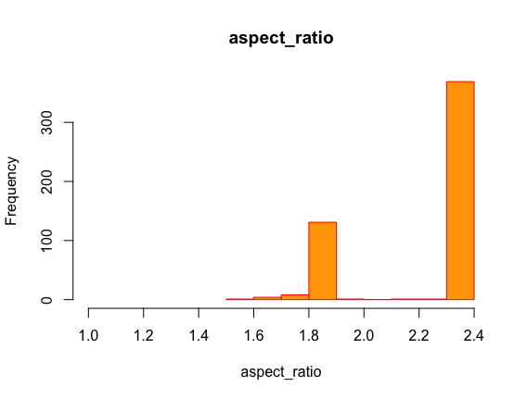

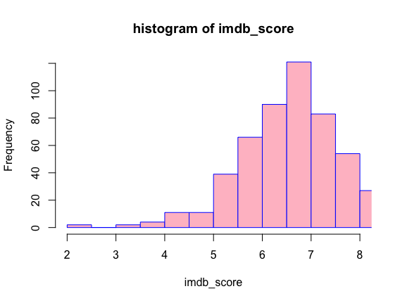

**6.1.3 Decision Tree:**

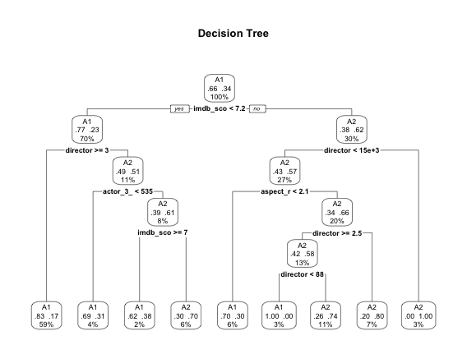

**6.1.4 Dtree Graph**

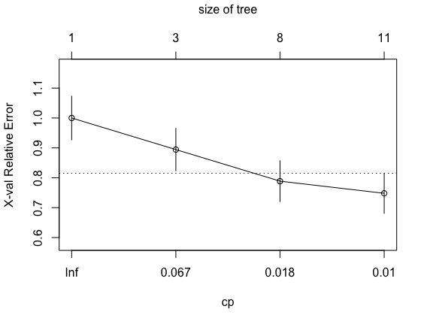

**6.1.5 Conditional Inference Tree**

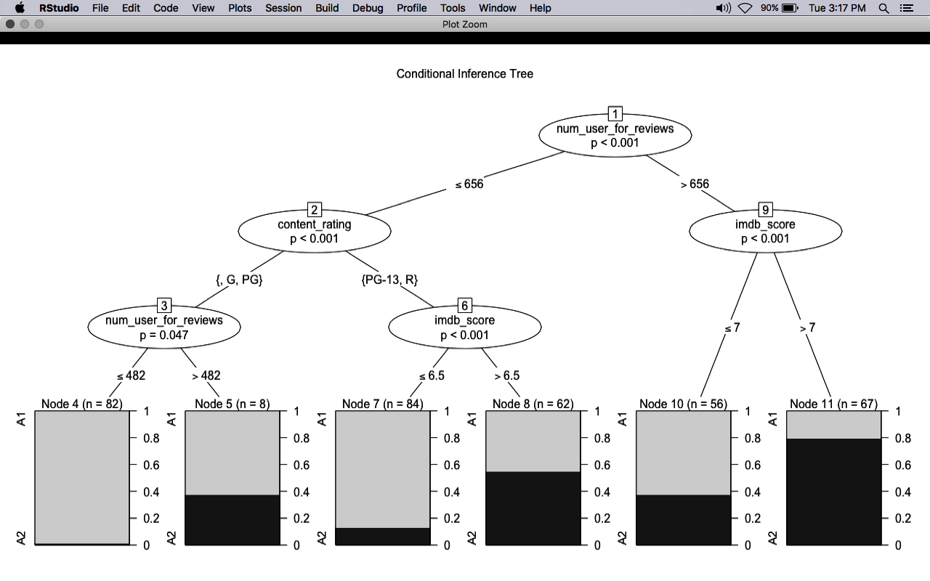

**6.1.6 Lorenz curve**

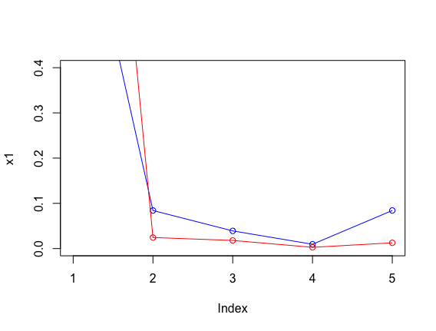**6.1.6 Logistic Regression:**

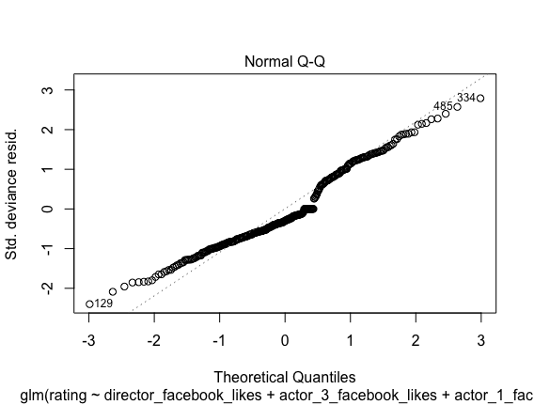

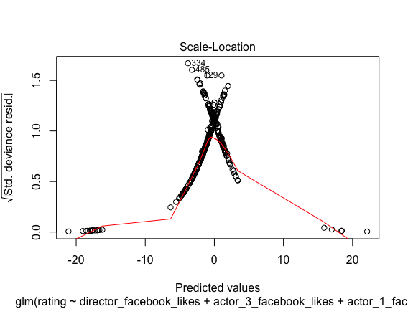

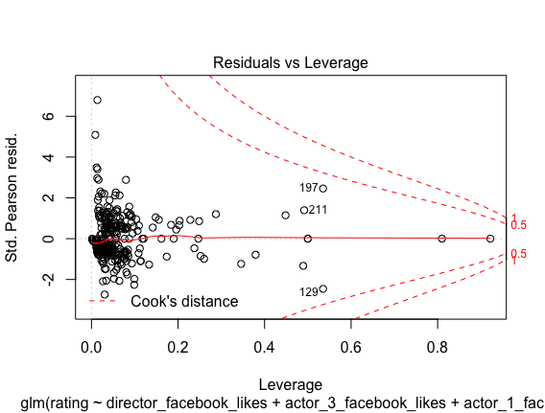

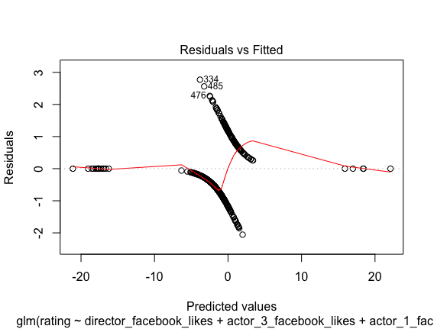

**Performance Analysis:**

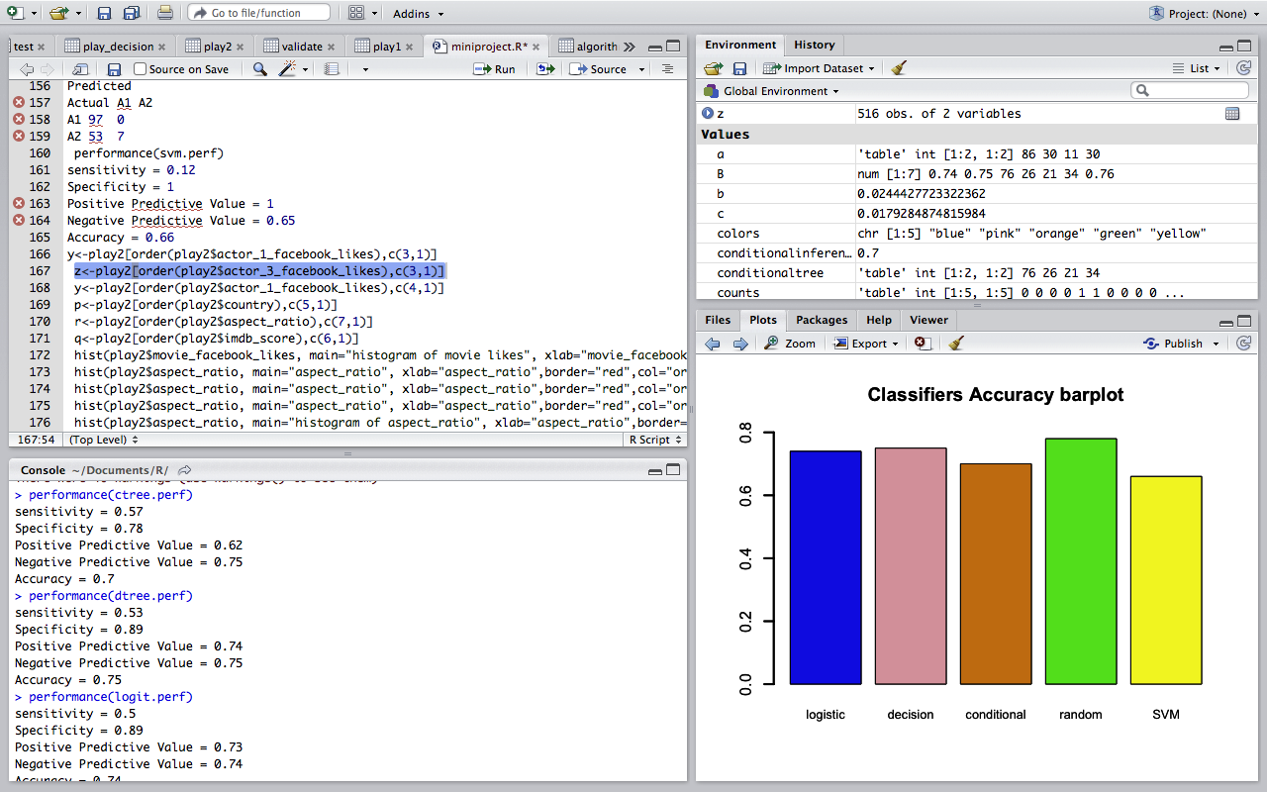

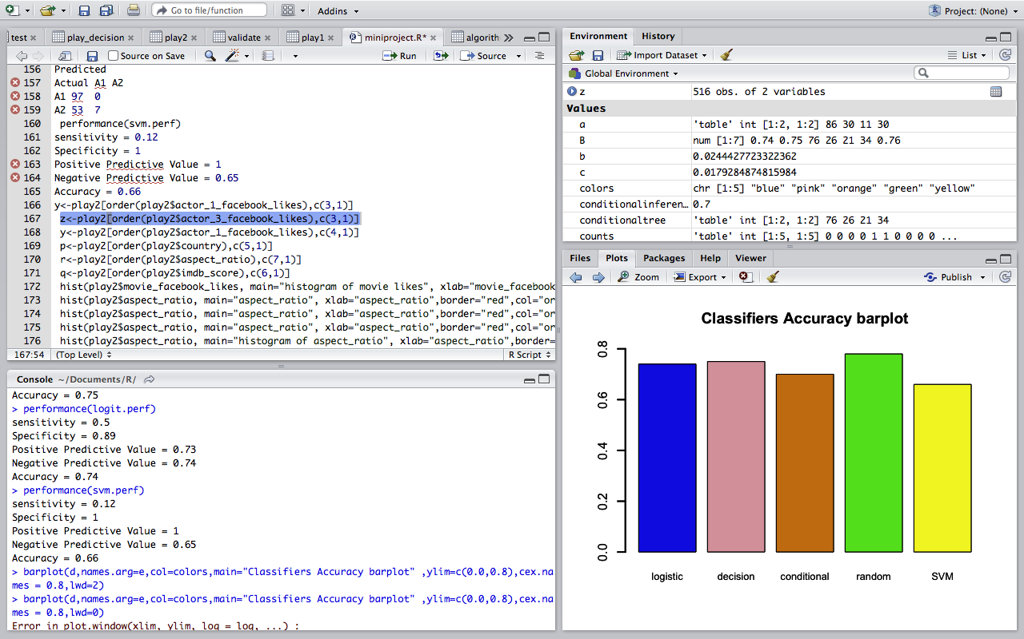

**6.1.7 Random Forest**

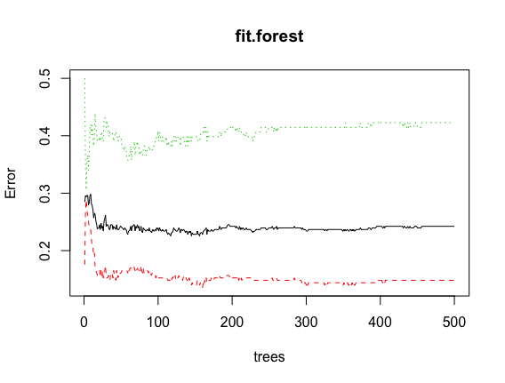

**6.1.8 Bar graph**

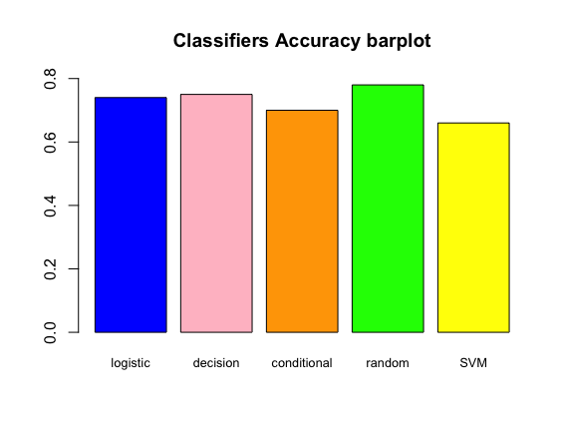

1. **CONCLUSION AND FUTURE WORK:**
   1. **Conclusion**

we took the features that have a highly impact on the movie ratings and performed data preprocessing. This is done only after required feature selection from the IMDB is done. Derived results can be used by user to predict rating of a movie. Data mining techniques are applied on the taken dataset IMDB. Performance analysis of classical decision tree, conditional Inference tree , random Forest , linear regression and support vector machine is calculated. Out of these all randomForest gets the highest accuracy. As we know the classifier with more accuracy will be within realm of usage. In this by feature selection important features that highly effect rating are analyzed which can be used for reference. So the one with the highest accuracy can be used for reference by the user in future.

* 1. **Future Work**

Although the proposed techniques are very effective based on the studies, further improvements can still be made. Creating a GUI and integrating them with the new packages can bring changes to the way that the implementation of the system works.

1. **REFERENCES:**

[1] A. Tripathi and S. K. Trivedi, "Sentiment analyis of Indian movie review with various feature selection techniques," *2016 IEEE International Conference on Advances in Computer Applications (ICACA)*, Coimbatore, 2016, pp. 181-185.

[2] Nithin VR, Pranav M, Sarath Babu PB, Lijiya A “Predicting Movie Success Based on IMDB Data”- *International Journal of Data Mining Techniques and Applications ,*June 2014.

[3] Muhammad Hassan Latif, Hammad Afzal “Prediction of Movies popularity Using Machine Learning Techniques” *International Journal of Computer Science and Network Security*, VOL.16 No.8, August 2016

[4] D. Mumtaz and B. Ahuja, "Sentiment analysis of movie review data using Senti-lexicon algorithm," *2016 2nd International Conference on Applied and Theoretical Computing and Communication Technology (iCATccT)*, Bangalore, 2016, pp. 592-597.