

Course: DS7002 2526 (T2)- Spatial Data Analysis

Assignment Title: DS7002 Spatial Data Analysis Portfolio

Instructor: Dr. Yang Li
Student Name: Keshav Poudel

Submission Date: May 5, 2026
Student ID: 3064995

Contents
Session 5 – Thinking London Spatially Further (Spatial Query with SpatiaLite Advance) 5
Task 1: Spatial Extent of London 5
Task 4: Business / Services within Boroughs (Points within Polygons) 6
Task 6: Motorways across London Boroughs (Intersection) 8
Task 7: Tube Stations near Motorways in London (Distance between Points and Lines) 10
Task 8: Buffers of Motorways 11
Session 6 – Preparation / Integration of Spatial Data 14
Task 2: Segregating and Aggregating Spatial Study Areas (Intersect) 14
Task 3: Creating Spatial Study Areas (Voronoi Polygons) 15
Task 4: Preparing Remote Sensing Data (Height Extraction) 16
Task 6: Handling Non-Spatial Attributes 18
Session 7 – Exploring and Mapping the Social Landscape of London 22
Task 1: Exploring Health Data across London Boroughs (Rate and Risk Maps) 22
Task 2: Thematic Mapping of Crime Data across London Boroughs 24
Session 8 – Hotspot / Classification and Travel Cost / Accessibility 26
Task 1: Hotspots of GP Surgeries in the London Borough Haringey (Spatial Clustering Analysis) 26
Task 4: Accessibility to GP Surgeries from Tube Stations in the London Borough of Haringey (Network Analysis) 28
Session 9 – Near Things More Related Than Distance Things in London 31
Task 1: Spatial Dependence / Correlation of Crimes and Deprivation in London 31
Task 2: Spatial Regression of Health Indicators in London 41
Task 3: Population Surface in Haringey (Interpolation Analysis) 43
Appendix 46

List of Figures
Figure 1: 1 km Buffer around Motorways 12
Figure 2: 1 km to 2.5 km Buffer Ring around Motorways 12
Figure 3: Intersect of Postcode Areas and London Regions 14
Figure 4: Voronoi Polygons of Credit Unions 15
Figure 5: Extracted Height Map (DSM – DTM) 17
Figure 6: Obesity Rate Map (Raw Rate) 22
Figure 7: Obesity Risk Map (Excess Risk) 23
Figure 8: Thematic Map of Crime Rate (CRIME_1000) in London Boroughs 24
Figure 9: Heatmap of GP Surgery Hotspots in Haringey 27
Figure 10: Accessibility of GP Surgeries to Underground Stations in Haringey 29
Figure 11: Univariate Local Moran’s I Cluster Map (DEPRIV – Deprivation) 32
Figure 12: Univariate Moran Scatter Plot (DEPRIV – Deprivation) 32
Figure 13: Univariate Local Moran’s I Cluster Map (CRIME_1000 – Total Crime) 33
Figure 14: Univariate Moran Scatter Plot (CRIME_1000 – Total Crime) 33
Figure 15: Univariate Local Moran’s I Cluster Map (BURGLARY – Burglary Rate) 34
Figure 16: Univariate Moran Scatter Plot (BURGLARY – Burglary Rate) 34
Figure 17: Bivariate Local Moran’s I Cluster Map (DEPRIV vs CRIME_1000) 35
Figure 18: Bivariate Moran Scatter Plot (DEPRIV vs CRIME_1000) 35
Figure 19: Local Moran’s I Cluster Map with Empirical Bayes Rate (BURGLARY) 36
Figure 20: Moran Scatter Plot with Empirical Bayes Rate (BURGLARY) 36
Figure 21: Bivariate Local Moran’s I Cluster Map (DEPRIV vs BURGLARY) 37
Figure 22: Bivariate Moran Scatter Plot (DEPRIV vs BURGLARY) 37
Figure 23: Univariate Local Moran’s I Cluster Map (Ward-Level Total Crime) 38
Figure 24: Univariate Moran Scatter Plot (Ward-Level Total Crime) 38
Figure 25: Differential Local Moran’s I Cluster Map (Population Change) 39
Figure 26: Differential Moran Scatter Plot (Population Change) 39
Figure 27: IDW Interpolated Population Surface Map (Haringey) 44

List of Tables
Table 1: Spatial Extremes of London Boroughs (London Guinness Book) 5
Table 2: london_guinness_book 5
Table 3: Underground stations within London boroughs 8
Table 4: Motorways across London boroughs 9
Table 5: Underground stations within 1 km of motorways 10
Table 6: London borough attributes with calculated population density and household size 20
Table 7: Moran’s I Summary 40
Table 8: Comparison of OLS and Spatial Lag Model Results 42
Table 10: Ordinary Least Squares (OLS) Regression Results for Male Life Expectancy 46
Table 11: Spatial Dependence Tests (london_weights) 47
Table 12: Spatial Lag Model Regression Results for Male Life Expectancy 48

Session 5 – Thinking London Spatially Further (Spatial Query with SpatiaLite Advance)

Task 1: Spatial Extent of London
Objective
The objective is to identify London boroughs exhibiting extreme spatial characteristics, including the largest and smallest area, the highest and lowest population density, and geographic extremes in each cardinal direction.
Method
Spatial SQL queries were used with functions like:
- Area() to find the size of each borough
- MbrMinX(), MbrMaxX(), MbrMinY(), and MbrMaxY() to measure the spatial extent
- MAX() and MIN() to find the highest and lowest values
Result
London Borough | Region | Largest Area | Smallest Area | Highest Population Density | Lowest Population Density | Northernmost | Southernmost | Most East | Most West
Bromley | Outer | 1 | 0 | 0 | 1 | 0 | 0 | 0 | 0
Havering | Outer | 0 | 0 | 0 | 0 | 0 | 0 | 1 | 0
Enfield | Outer | 0 | 0 | 0 | 0 | 1 | 0 | 0 | 0
Islington | Inner | 0 | 0 | 1 | 0 | 0 | 0 | 0 | 0
Island Borough | Outer | 0 | 1 | 0 | 0 | 0 | 1 | 0 | 1
Table 1: Spatial Extremes of London Boroughs (London Guinness Book)

London Borough | Region | Area (sq.Km) | Density: Population / sq.Km | North | South | East | West
an island | Outer | 0.000013 |  | 10 | 5 | 10 | 5
Islington | Inner | 14.85665 | 14202.39 | 187968.7 | 181659.1 | 533484.5 | 528832.4
Enfield | Outer | 82.20019 | 3860.088 | 200933.9 | 191460.9 | 537813 | 525568.6
Havering | Outer | 114.4573 | 2094.231 | 194889.3 | 178410.9 | 561957.5 | 548106.9
Bromley | Outer | 150.1349 | 2091.453 | 173658.3 | 156480.9 | 550541.2 | 533531.5

Table 2: london_guinness_book

Interpretation
The table presents key spatial characteristics of London boroughs, such as area, population density, and geographic extent defined by northern, southern, eastern, and western boundaries. These metrics facilitate the identification of boroughs exhibiting extreme spatial properties.
The results show that Bromley possesses the largest area and is the southernmost borough, whereas Islington has the smallest area and the highest population density. Havering exhibits the lowest population density and is the easternmost borough, while Enfield is identified as the northernmost borough. These findings underscore distinct differences in size, density, and spatial positioning among London boroughs.
This analysis demonstrates the application of spatial SQL to examine geographic characteristics through functions such as area calculations and minimum bounding rectangle (MBR) coordinates. These techniques support urban analysis, regional comparison, and planning activities. The query may be enhanced by refining filters, eliminating extraneous records, and presenting results in a more concise summary format.

Task 4: Business / Services within Boroughs (Points within Polygons)
Objective
The objective is to identify the business and service locations, specifically credit unions and underground stations, situated within each London borough based on spatial relationships.
Method
Spatial SQL queries were employed to analyse the data using the following functions:
- ST_Contains() was used to determine whether point features, such as credit unions and underground stations, are located within borough polygons.
- JOIN and LEFT JOIN operations were utilised to associate point and polygon tables.
- COUNT() and DISTINCT to calculate the number of underground stations
Additional calculations were performed to normalise the number of stations by borough area and population, borough area and population.
Result
Group | London Borough Name | Number of Tube Stations | Number of Lines | Stations / sq.Km | Stations / 1000 pop
Inner | Camden | 19 | 8 | 0.871988 | 0.084444
Inner | City | 14 | 8 | 4.445319 | 1.842105
Inner | Hackney | 1 | 1 | 0.052496 | 0.003967
Inner | Hammersmith and Fulham | 15 | 5 | 0.874428 | 0.08338
Inner | Haringey | 6 | 3 | 0.202714 | 0.023175
Inner | Islington | 11 | 6 | 0.740409 | 0.052133
Inner | Kensington and Chelsea | 11 | 5 | 0.888258 | 0.070558
Inner | Lambeth | 10 | 5 | 0.366981 | 0.032237
Inner | Lewisham | 2 | 1 | 0.05663 | 0.007102
Inner | Newham | 27 | 5 | 0.699879 | 0.08596
Inner | Southwark | 5 | 3 | 0.167149 | 0.017036
Inner | Tower Hamlets | 27 | 6 | 1.251449 | 0.102662
Inner | Wandsworth | 6 | 2 | 0.170357 | 0.019462
Inner | Westminster | 36 | 10 | 1.634131 | 0.160786
Outer | Barking and Dagenham | 5 | 2 | 0.132277 | 0.026233
Outer | Barnet | 12 | 1 | 0.138331 | 0.032967
Outer | Brent | 21 | 4 | 0.485744 | 0.06673
Outer | Ealing | 15 | 3 | 0.270054 | 0.044027
Outer | Enfield | 4 | 1 | 0.048662 | 0.012606
Outer | Greenwich | 5 | 2 | 0.099124 | 0.019223
Outer | Harrow | 10 | 4 | 0.198166 | 0.041254
Outer | Havering | 4 | 1 | 0.034948 | 0.016688
Outer | Hillingdon | 15 | 3 | 0.129644 | 0.053229
Outer | Hounslow | 9 | 2 | 0.159052 | 0.034736
Outer | Merton | 5 | 2 | 0.132891 | 0.024728
Outer | Redbridge | 10 | 1 | 0.177172 | 0.035137
Outer | Richmond upon Thames | 2 | 1 | 0.034036 | 0.010576
Outer | Waltham Forest | 4 | 2 | 0.103072 | 0.015232
Table 3: Underground stations within London boroughs
The table above presents how underground stations are spread across London boroughs. It lists the number of stations and lines, and measures adjusted for area and population.
Interpretation
The results show that underground stations are not evenly spread across London boroughs. Inner London areas like Westminster, Newham, and Tower Hamlets have many more stations and lines than most outer boroughs. This reflects their importance as main transport and economic hubs.
When adjusting for area and population, central boroughs have a much higher station density. For example, Westminster has the most stations and strong connections. Smaller boroughs like the City of London also have high station density because they are compact. In contrast, outer boroughs such as Havering and Richmond upon Thames have fewer stations and lower density, which means people there have less access to underground transport.
This shows that transport infrastructure is concentrated in central London, and there are clear differences in service between inner and outer boroughs.
Comment
This task demonstrates how point-in-polygon spatial queries using the ST_Contains() function can determine whether point features lie within specific boundaries. This method is common in transport planning, accessibility studies, and urban research. The analysis could be improved by adding more variables, like population, land use, or socio-economic factors, to better understand how services are distributed and what people need.

Task 6: Motorways across London Boroughs (Intersection)
Objective
The objective is to determine which motorways pass through each London borough using spatial intersection analysis.
Method
Spatial SQL queries were employed as follows:
- The ST_Intersects() function was used to assess whether motorway lines intersect with borough polygons.
- JOIN to combine motorway and borough tables
- Attribute selection to extract motorway names, borough names, and regional classifications
Result
Motorway | London Borough | Region | Direction
M1 | Barnet | Outer | NS
M1 | Harrow | Outer | NS
M11 | Redbridge | Outer | NS
M25 | Bromley | Outer | EW
M25 | Enfield | Outer | EW
M25 | Havering | Outer | EW
M25 | Hillingdon | Outer | EW
M4 | Hillingdon | Outer | EW
M4 | Hounslow | Outer | EW
Table 4: Motorways across London boroughs
Motorways across London boroughs
The table above lists the motorways that cross each London borough, along with their regional classification and general direction.
Interpretation
The results show that most major motorways are in outer London boroughs. This reflects their purpose of connecting regions and the country, rather than serving central London. The M25, which circles London, passes through several outer boroughs like Bromley, Enfield, Havering, and Hillingdon. Other motorways, such as the M1, M4, and M11, link London to other parts of the UK and are mostly found in boroughs on the city's edge.
This pattern shows that there are few motorways in inner London, where roads are busier, and space is limited. Instead, most major roads are in the outer boroughs to facilitate long-distance travel and ease traffic in the city centre. This task demonstrates how spatial intersection analysis using the ST_Intersects() function can identify where motorways cross borough boundaries. This method is common in transport planning, infrastructure management, and environmental studies. The analysis could also include measuring how much motorway runs through each borough or looking at how close motorways are to homes or businesses

Task 7: Tube Stations near Motorways in London (Distance between Points and Lines)
Objective
The objective is to identify underground stations situated within 1 km of motorways and to analyse their proximity using spatial distance functions.
Method
Spatial SQL queries were employed to conduct the analysis, utilising the following functions and operations:
- The Distance() function was used to calculate the shortest distance between underground stations (represented as points) and motorways (represented as lines).
- JOIN and LEFT JOIN operations were applied to combine the underground station and motorway datasets.
- A filtering condition (Distance < 1000 metres) was implemented to identify stations located within 1 km of motorways.
Result
Motorway | Station | Line | Distance (km < 1km)
M1 | Hendon Central | Northern | 0.76
M1 | Colindale | Northern | 0.99
M11 | Theydon Bois | Central | 0.91
M11 | Debden | Central | 0.54
M11 | Roding Valley | Central | 0.82
M11 | Chigwell | Central | 0.98
M11 | South Woodford | Central | 0.88
M25 | Terminal 5 | Piccadilly | 0.94
M4 | Chiswick Park | District | 0.99
M4 | Gunnersbury | District | 0.45
M4 | Boston Manor | Piccadilly | 0.36
Table 5: Underground stations within 1 km of motorways

Underground stations within 1 km of motorways
The table above lists underground stations near motorways, along with the lines they serve and their distances from the motorways.
Interpretation
The results show that several underground stations are within 1 km of major motorways, especially along the M1, M4, M11, and M25. Stations like Boston Manor and Gunnersbury are very close to these roads, which suggests there is a strong connection between road and rail networks in some areas.
This proximity is more common in outer London, where motorways are more prevalent. In contrast, inner London has fewer overlaps due to the limited number of motorways. The findings highlight how transport infrastructure integrates in some areas, supporting multimodal connectivity between road and underground networks.
Comment
This task demonstrates distance-based spatial analysis between point and line features using the Distance() function. Such analysis is important in transport planning, environmental assessment, and accessibility studies. The approach can be extended by identifying the nearest motorway for each station or analysing the impact of proximity on noise, pollution, or passenger accessibility.

Task 8: Buffers of Motorways
Objective
The objective is to generate motorway buffer zones and buffer rings to visualise areas influenced by motorway proximity in London.
Method
Spatial SQL queries were employed to generate buffer geometries surrounding motorway lines. The following functions were utilized:
- Buffer() was used to create zones at specified distances from motorways.
- CastToMultiPolygon() was applied to store the output as multi-polygon geometry.
- Difference() was used to generate the outer ring by subtracting the 1 km buffer from the 2.5 km buffer.
Two outputs were generated:
- A 1 km motorway buffer.
- A 1 km to 2.5 km motorway buffer ring.
These layers were subsequently visualized as maps and exported in PNG format.
Result
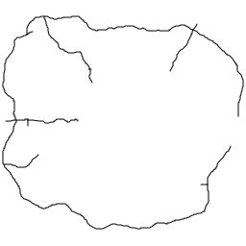
Figure 1: 1 km Buffer around Motorways
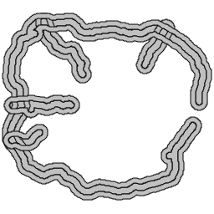
The first map displays the motorway network and highlights a 1 km buffer zone along each motorway. The shaded area marks the region directly next to the motorway routes.

Figure 2: 1 km to 2.5 km Buffer Ring around Motorways
The second map displays the outer buffer ring, which covers the area between 1 km and 2.5 km from the motorways. This ring was made by subtracting the inner 1 km buffer from the larger 2.5 km buffer.
Interpretation
The maps reveal that motorway influence is mostly found in the outer areas of London, where the main road corridors are. The 1 km buffer marks the areas closest to the motorways and helps identify zones with direct access, higher traffic volumes, and potential environmental impacts such as noise or air pollution.
The buffer ring from 1 km to 2.5 km shows a broader area affected by the motorway, beyond the immediate road corridor. This outer ring helps us see how motorway effects reach into nearby areas and lets us compare places that are near, but not right next to, major roads. These maps together clearly show how buffer analysis can model the influence of transport infrastructure as a function of distance.
Comment
This task demonstrates how spatial buffer analysis can be used to analyse linear transport features. Buffer methods are commonly used in transport planning, environmental studies, and urban analysis to delineate areas influenced by roads, railways, or rivers. The approach could also be expanded by combining the buffers with other data, like underground stations, residential zones, or population figures, to study accessibility and exposure more closely.

Session 6 – Preparation / Integration of Spatial Data

Task 2: Segregating and Aggregating Spatial Study Areas (Intersect)
Objective
The objective is to segment postcode areas into smaller spatial units according to their overlap with Inner and Outer London regions, thereby facilitating analysis at multiple geographic scales.
Methodology
Spatial overlay operations were conducted using QGIS geoprocessing tools.
- The Intersect (AND) operation was applied to combine postcode areas with London regional boundaries.
- Input layer: postarea.shp
- Intersect layer: london_io.shp
The intersect operation divides postcode areas into smaller units depending on whether they are located within Inner London, Outer London, or outside London.
Result
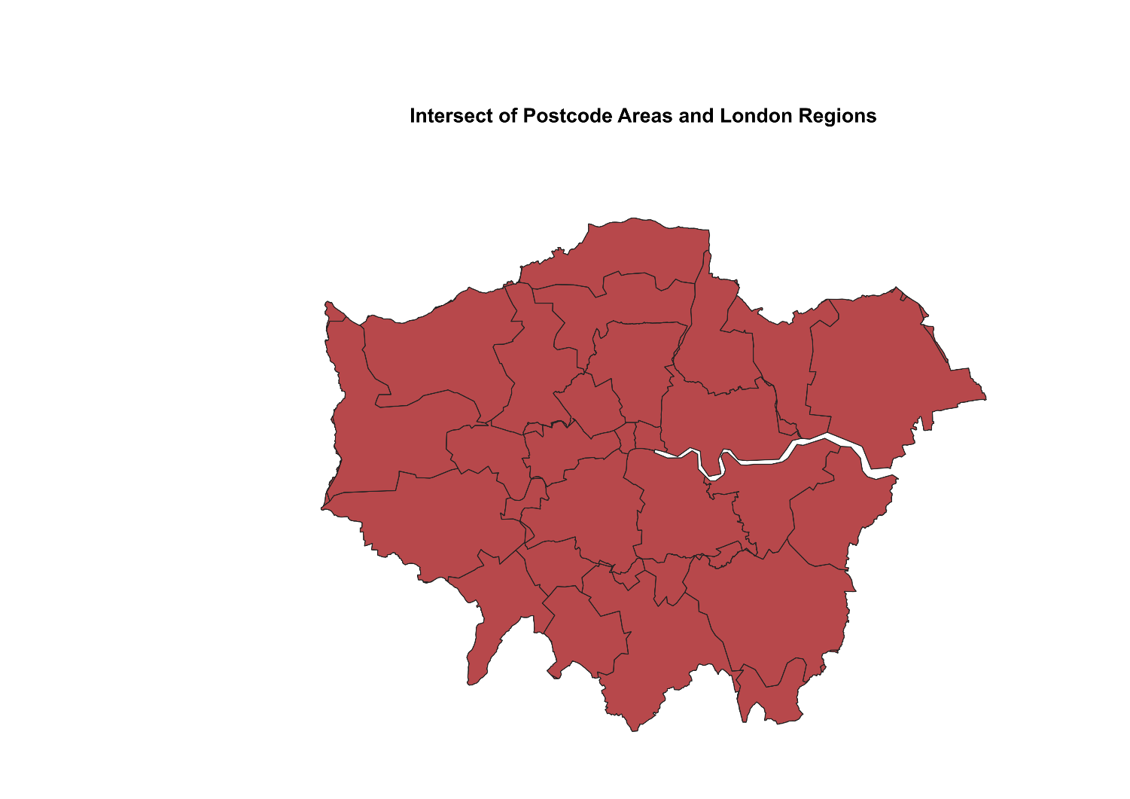
Figure 3: Intersect of Postcode Areas and London Regions
The map displays what happens when postcode areas are combined with London’s regional boundaries. Each postcode area is split into smaller sections, depending on whether it falls within Inner or Outer London.
Interpretation
The intersect operation breaks up large postcode areas into smaller, more detailed sections. This means postcode areas that cross over different regions are split based on whether they are in Inner or Outer London. This makes it possible to do spatial analysis more accurately and at a finer level.
This approach is especially helpful when studying data that changes from one region to another. It helps ensure local details are included, rather than relying on broad averages for large areas.
Comment
This task shows how spatial overlay operations, like the Intersect function, can combine different spatial datasets. These methods are common in geographic analysis to make study areas more precise and improve accuracy. You can also add other datasets, such as population or land use, to support even more detailed analysis.

Task 3: Creating Spatial Study Areas (Voronoi Polygons)
Objective
Catchment areas were created around credit union locations to facilitate analysis of spatial coverage and service accessibility.
Method
Spatial geometry tools within QGIS were utilised as follows:
- Voronoi polygons were generated to delineate catchment areas around each credit union location.
- A 10% buffer region was added to ensure comprehensive coverage of the study area.
- The input layer used was credit_union.shp.
The Voronoi method partitions space into regions, with each polygon representing the area nearest to a specific credit union.
Result
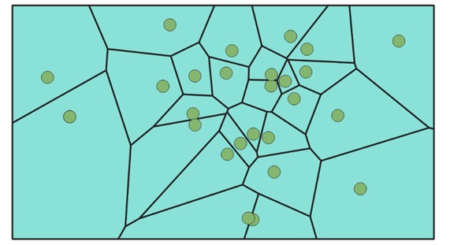

Figure 4: Voronoi Polygons of Credit Unions
The map displays Voronoi polygons created from the locations of credit unions. Each polygon marks the area that is nearest to one credit union compared to the others.
Interpretation
The Voronoi polygons show the catchment areas for each credit union, dividing the study area by how close each location is. Smaller polygons mean there are more credit unions nearby, which suggests people have better access to services. Larger polygons show that credit unions are farther apart, so access is lower.
This method helps us see how services are spread out and points out areas where more services might be needed.
Comment
This task shows how Voronoi polygons can be used to create catchment areas based on how close locations are. This method is common in urban planning, healthcare studies, and service distribution research. The analysis could also include population or demand data to check if each area has enough services.

Task 4: Preparing Remote Sensing Data (Height Extraction)
Objective
Height information of surface features was extracted from LiDAR data by calculating the difference between the Digital Surface Model (DSM) and the Digital Terrain Model (DTM).
Methods
Raster data processing was performed using QGIS software tools:
- The Raster Calculator was utilised to compute height values.
- The input datasets included TQ2278_DSM_2M.asc (surface elevation) and TQ2278_DTM_2M.asc (ground elevation).
- Height values were calculated using the following formula: Height = DSM-DTM
This operation eliminates ground elevation, thereby retaining the height of objects such as buildings and vegetation.
Result
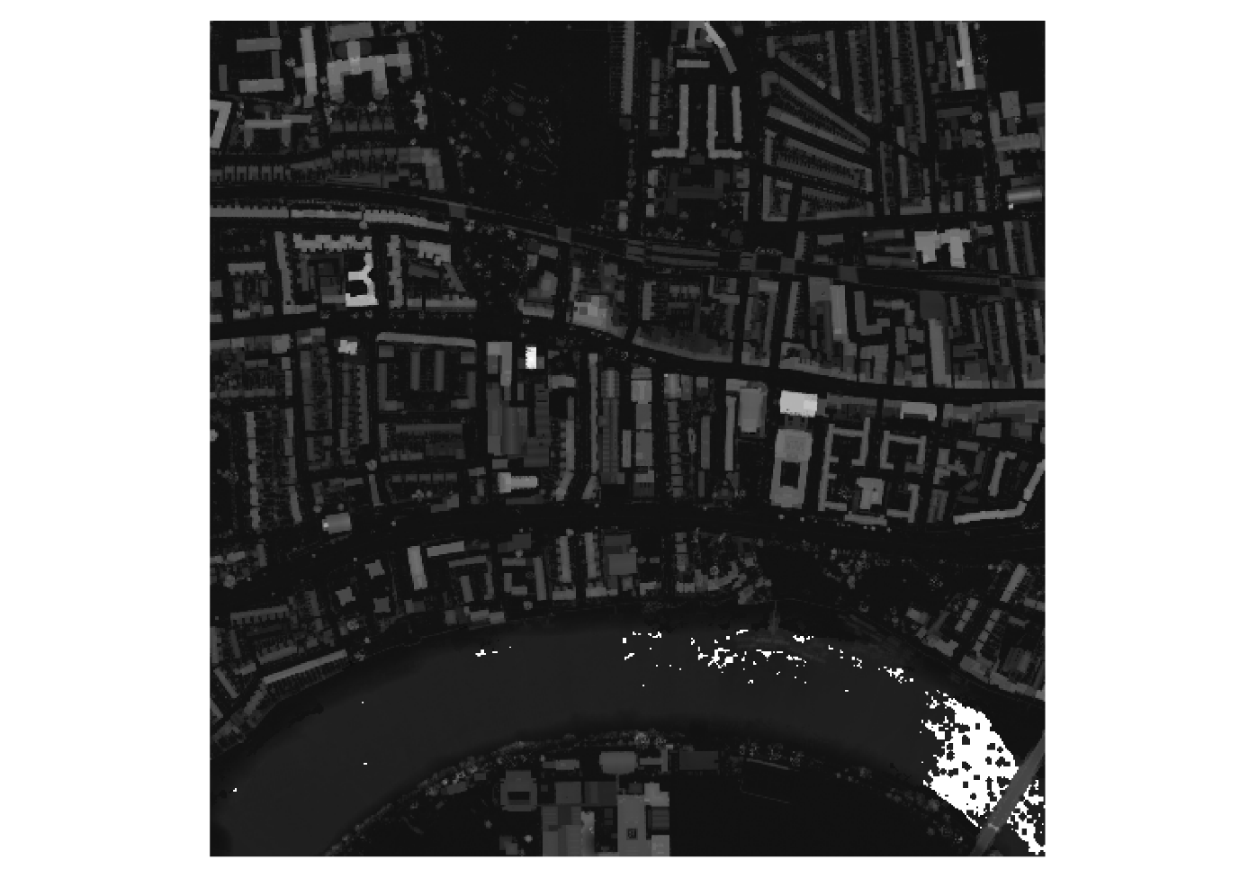
Figure 5: Extracted Height Map (DSM – DTM)
The image displays how heights vary across features in Ravenscourt Park. Brighter spots indicate higher elevations, such as buildings, while darker areas mark lower or ground-level features.
Interpretation
The height map makes it easy to tell apart raised features like buildings and trees from the ground. Brighter areas indicate taller structures, while darker regions indicate roads, open spaces, or water.
This method helps accurately measure building heights and other vertical features, which is useful for urban analysis, environmental modelling, and planning infrastructure. The data can also help with tasks such as determining roof slopes or measuring building volumes.
Comment
This task shows how raster calculations can create new spatial information from remote sensing data. The DSM–DTM method is common in urban studies, environmental monitoring, and 3D modelling. The analysis can go further by adding vector data, such as building outlines, to obtain more precise height information for specific features.

Task 6: Handling Non-Spatial Attributes
Objective
The objective was to generate two new attribute variables, population density and household size, for London boroughs using the attribute table in QGIS.
Methods
The attribute table of london_boroughs.shp was modified in QGIS according to the following procedure:
- The attribute table was opened and editing mode was enabled.
- Two new fields, pop_densit and hh_size, were created.
- Population density was calculated by dividing the population by the area.
- Household size was determined by dividing the population by the number of households.
These steps enabled the addition of new non-spatial variables to the borough dataset for subsequent analysis.
Results
A CSV table was exported from the updated london_boroughs layer, which included the newly created variables population density and household size.

NAME | HECTARES | LA_CODE01 | LA_CODE11 | IN_OUT | X_CENTROID | Y_CENTROID | Pop | HH | pop_densit | hh_size
Kingston upon Thames | 3726.117 | 00AX | E09000021 | Outer | 519505 | 166134 | 163900 | 63639 | 43.987 | 2.575
Croydon | 8649.554 | 00AH | E09000008 | Outer | 533922 | 163449 | 368900 | 145010 | 42.65 | 2.544
Bromley | 15013.49 | 00AF | E09000006 | Outer | 542035 | 165071 | 314000 | 130862 | 20.915 | 2.399
Hounslow | 5658.541 | 00AT | E09000018 | Outer | 514531 | 174962 | 259100 | 94902 | 45.789 | 2.73
Ealing | 5554.428 | 00AJ | E09000009 | Outer | 515796 | 181961 | 340700 | 124082 | 61.338 | 2.746
Havering | 11445.74 | 00AR | E09000016 | Outer | 555032 | 186650 | 239700 | 97199 | 20.942 | 2.466
Hillingdon | 11570.12 | 00AS | E09000017 | Outer | 508167 | 183733 | 281800 | 100214 | 24.356 | 2.812
Harrow | 5046.275 | 00AQ | E09000015 | Outer | 515356 | 189957 | 242400 | 84268 | 48.035 | 2.877
Brent | 4323.27 | 00AE | E09000005 | Outer | 520507 | 186468 | 314700 | 110286 | 72.792 | 2.853
Barnet | 8674.837 | 00AC | E09000003 | Outer | 523472 | 191948 | 364000 | 135916 | 41.96 | 2.678
Lambeth | 2724.94 | 00AY | E09000022 | Inner | 531118 | 175167 | 310200 | 130017 | 113.837 | 2.386
Southwark | 2991.34 | 00BE | E09000028 | Inner | 534034 | 175751 | 293500 | 120422 | 98.117 | 2.437
Lewisham | 3531.706 | 00AZ | E09000023 | Inner | 537888 | 174589 | 281600 | 116091 | 79.735 | 2.426
Greenwich | 5044.19 | 00AL | E09000011 | Outer | 542377 | 176482 | 260100 | 101045 | 51.564 | 2.574
Bexley | 6428.649 | 00AD | E09000004 | Outer | 549409 | 175841 | 234300 | 92604 | 36.446 | 2.53
Enfield | 8220.025 | 00AK | E09000010 | Outer | 531691 | 196197 | 317300 | 119916 | 38.601 | 2.646
Waltham Forest | 3880.793 | 00BH | E09000031 | Outer | 537327 | 190698 | 262600 | 96861 | 67.667 | 2.711
Redbridge | 5644.225 | 00BC | E09000026 | Outer | 544061 | 189480 | 284600 | 99105 | 50.423 | 2.872
Sutton | 4384.698 | 00BF | E09000029 | Outer | 526735 | 163640 | 193600 | 78174 | 44.154 | 2.477
Richmond upon Thames | 5876.111 | 00BD | E09000027 | Outer | 517721 | 172687 | 189100 | 79835 | 32.181 | 2.369
Merton | 3762.466 | 00BA | E09000024 | Outer | 526025 | 169505 | 202200 | 78757 | 53.741 | 2.567
Wandsworth | 3522.022 | 00BJ | E09000032 | Inner | 525627 | 174183 | 308300 | 130493 | 87.535 | 2.363
Hammersmith and Fulham | 1715.409 | 00AN | E09000013 | Inner | 523930 | 179217 | 179900 | 80590 | 104.873 | 2.232
Kensington and Chelsea | 1238.379 | 00AW | E09000020 | Inner | 525764 | 179843 | 155900 | 78536 | 125.89 | 1.985
Westminster | 2203.005 | 00BK | E09000033 | Inner | 527508 | 180816 | 223900 | 105772 | 101.634 | 2.117
Camden | 2178.932 | 00AG | E09000007 | Inner | 527755 | 184282 | 225000 | 97534 | 103.262 | 2.307
Tower Hamlets | 2157.501 | 00BG | E09000030 | Inner | 536458 | 181372 | 263000 | 101257 | 121.9 | 2.597
Islington | 1485.664 | 00AU | E09000019 | Inner | 531158 | 181372 | 211000 | 93556 | 142.024 | 2.255
Hackney | 1904.902 | 00AM | E09000012 | Inner | 534562 | 181372 | 252100 | 101690 | 132.343 | 2.479
Haringey | 2959.837 | 00AP | E09000014 | Inner | 531279 | 181372 | 258900 | 101955 | 87.471 | 2.539
Newham | 3857.806 | 00BB | E09000025 | Inner | 541567 | 181372 | 314100 | 101519 | 81.419 | 3.094
Barking and Dagenham | 3779.934 | 00AB | E09000002 | Outer | 547682 | 181372 | 190600 | 69681 | 50.424 | 2.735
City | 314.942 | 00AA | E09000001 | Inner | 532404 | 181372 | 7600 | 4385 | 24.131 | 1.733

Table 6: London borough attributes with calculated population density and household size
The table shows that inner London boroughs usually have much higher population density than outer boroughs. Islington has the highest density at 142.024, with Hackney at 132.343 and Kensington and Chelsea at 125.89. In comparison, outer boroughs like Bromley and Havering have much lower densities, which reflects their larger size and less compact settlements.
Household size does not vary as much as population density, but there are still some differences. Newham has the largest average household size at 3.094, while the City has the smallest at 1.733. This shows that the City has a small residential population and a unique urban layout.
Interpretation
The calculated data shows key differences in the demographics of London boroughs. Inner boroughs have much higher population density because land is used more intensively and housing is more compact. Outer boroughs usually have lower density since they cover larger areas and often include more suburban land.
Household size follows a different trend. Although the differences are smaller, boroughs like Newham and Harrow have larger average household sizes, while central boroughs such as the City and Kensington and Chelsea have smaller ones. These numbers help explain differences in housing, service needs, and city layout across London, which is useful for later spatial analysis.
Comment
This task shows how non-spatial data can be created and updated directly in a GIS attribute table. These calculations matter because many spatial analyses rely on both geometry and demographic indicators. These methods are common in urban studies, social geography, and planning. The task could be expanded by adding more indicators, such as households per hectare, dependency ratio, or growth rate, to enable deeper comparisons between boroughs.
Suggestions for Improving QGIS Functionalities
QGIS offers many powerful spatial analysis tools, but there are ways to make it easier and more efficient to use. The interface for geoprocessing tools could be improved with clearer instructions and built-in examples for each function, which would help beginners. Also, better error messages and troubleshooting support would help users understand what went wrong when something goes wrong.
Automation features could also be improved by making it easier to create workflows or scripts for repetitive tasks, such as batch processing spatial operations. Adding data validation tools would help make sure the data is good before analysis. Improving performance on large raster datasets, such as LiDAR data, would also speed up processing and enhance the user experience.
Overall, QGIS is a strong open-source platform, but these changes could make it easier to use, more efficient, and more reliable for both new and experienced users.

Session 7 – Exploring and Mapping the Social Landscape of London

Task 1: Exploring Health Data across London Boroughs (Rate and Risk Maps)
Objective
This study investigates the spatial distribution of public health in London by analysing obesity patterns through geostatistical methods implemented in GeoDa.
Method
Geostatistical analysis was conducted in GeoDa utilising the london_life_polygon.shp dataset. The analysis involved the following steps:
- Basic exploratory tools, including Histogram, Boxplot, Scatterplot, and Bubble Chart, were employed to examine the distribution of health variables.
- A Rates-Calculated Map (Raw Rate) was utilised to determine obesity rates based on population data.
- An Excess Risk Map was applied to compare obesity levels relative to the overall average.
- The obesity variable (OBESE) was normalised using population data to enable equitable comparison across boroughs.
Result

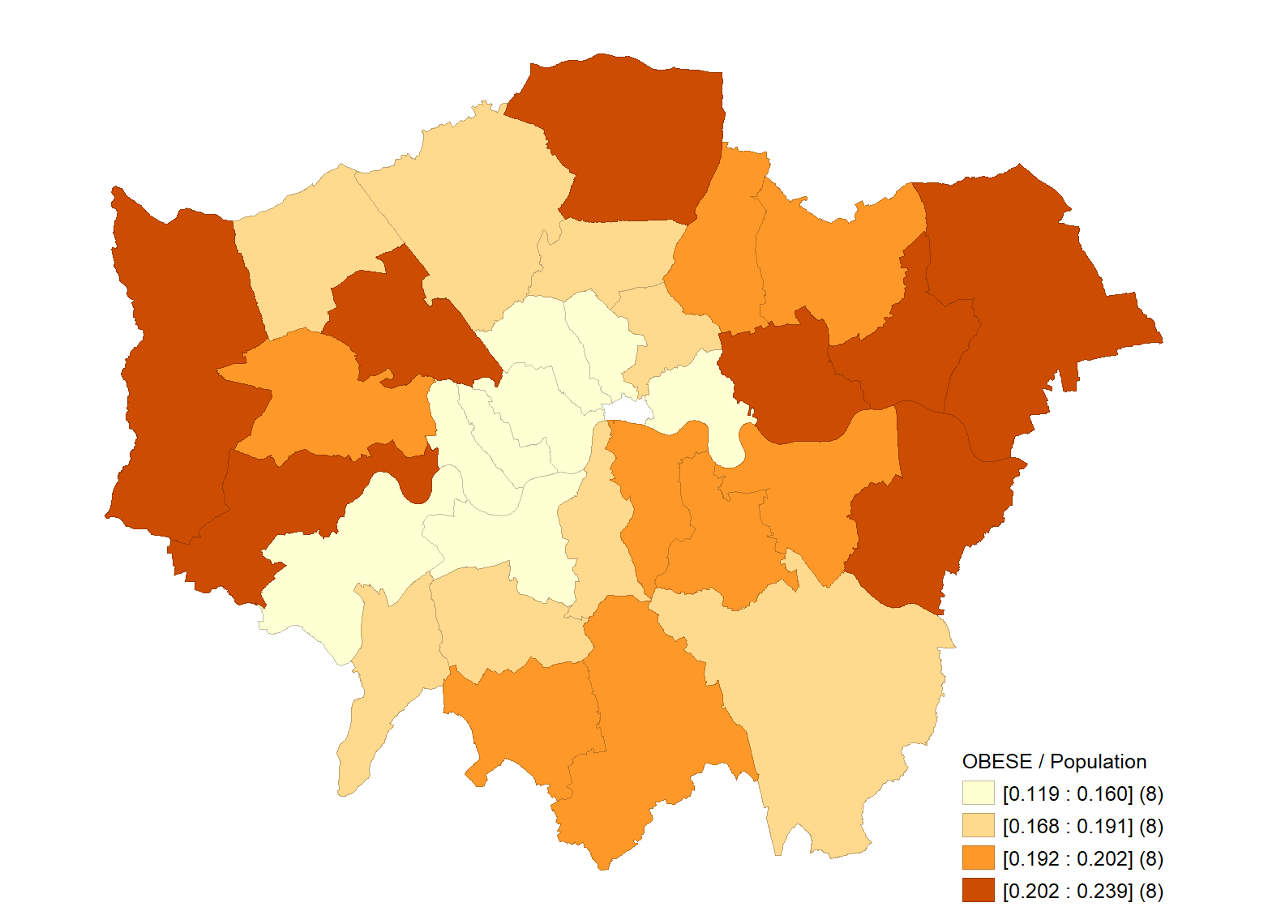

Figure 6: Obesity Rate Map (Raw Rate)
This map displays the percentage of people who are obese in each London borough, using different shades of colour to show the differences.

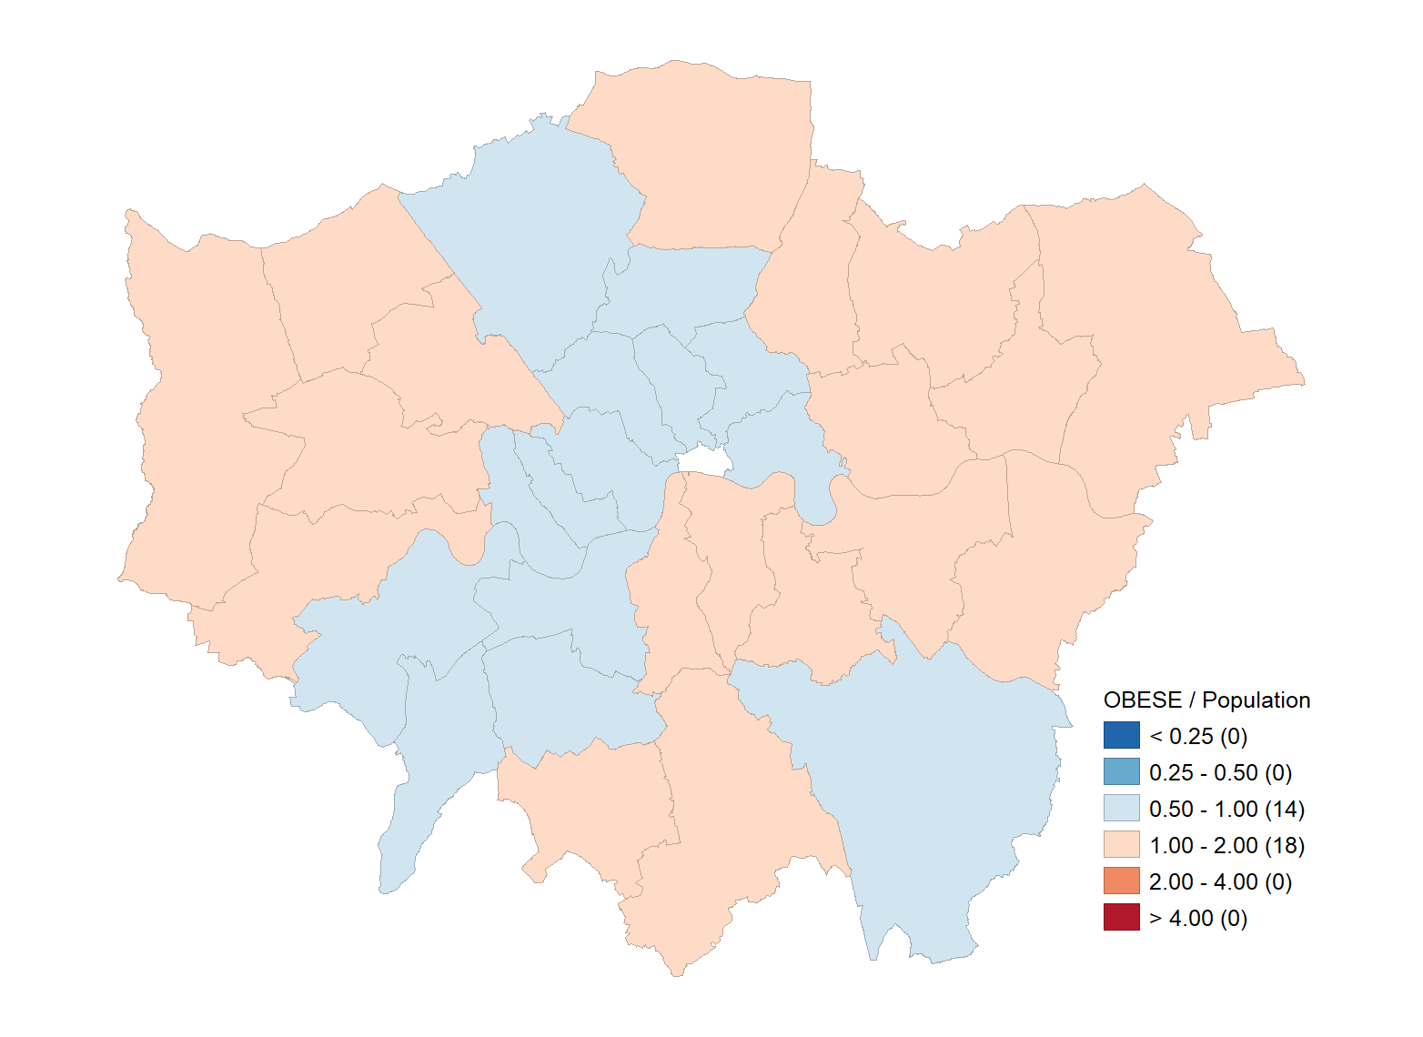

Figure 7: Obesity Risk Map (Excess Risk)
The map points out which areas have obesity rates higher or lower than the London average.
Interpretation
The map shows that obesity rates vary across London, with some outer boroughs having higher rates than central ones. This means health outcomes are not the same everywhere and could be affected by social and environmental factors.
The excess risk map makes it easier to compare boroughs by showing where obesity risk is above or below the London average. Higher-risk areas may need more public health attention, while lower-risk areas seem to have better health.
These maps together show that obesity is not spread evenly across London. They can help guide future public health research and planning.
Comment
This task shows how geostatistical tools in GeoDa can be used to study health data patterns across different areas. Unlike regular statistical tools, GeoDa includes location information, so you can see patterns on a map. You can also add other factors like income, education, or healthcare access to learn more about why health differences exist between areas.

Task 2: Thematic Mapping of Crime Data across London Boroughs
Objective: To create thematic maps visualising the spatial distribution of crime across London boroughs using geographic information systems (GIS) and geostatistical tools.
Methods
Thematic mapping was conducted using both GeoDa and QGIS software.
GeoDa was used for the following analyses:
- Thematic maps were generated using Quantile Map, Percentile Map, Box Map, Standard Deviation Map, and Cartogram techniques.
- The variables included burglary, crime damage, drug offences, vehicle theft, and violence, each measured per 1,000 persons.
QGIS was employed for the following procedures:
- Graduated Symbology was applied to map the total crime rate (CRIME_1000).
- Colour classification schemes were implemented to represent variations in crime levels.
- Exported the final map using: Project → Import/Export → Export Map to Image
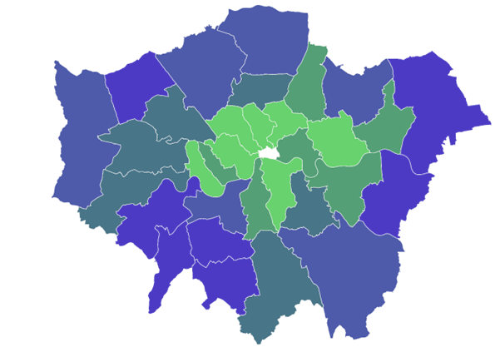
Result

Figure 8: Thematic Map of Crime Rate (CRIME_1000) in London Boroughs
The map shows the spatial variation in crime rates across London boroughs using a graduated colour scheme, with different colours representing different levels of crime intensity.
Interpretation
The thematic map reveals clear spatial variation in crime rates across London. Central boroughs tend to have higher crime rates than some outer boroughs, reflecting differences in population density, economic activity, and urban structure.
Using a range of colours makes it easier to spot areas with more or less crime. This kind of map helps people find crime hotspots and make better decisions for crime prevention and city planning.
Comment
This task shows how thematic maps can help us see patterns in socio-economic data. GIS tools like QGIS let users choose different ways to group data and select colours, so maps can meet different needs. You can also combine crime data with other factors, like population density or deprivation, to learn more.
Difference between Geostatistics and Conventional Statistical Packages
Geostatistical tools like GeoDa take spatial relationships and location into account during analysis. They let users explore patterns, clusters, and how data points relate to each other on maps.
On the other hand, standard statistical programs like SPSS or Excel primarily focus on numbers and do not incorporate spatial context. They are good for general calculations, but they miss spatial patterns unless used with GIS tools. This is why geostatistics provides a better understanding of the spread of data across locations.
Effect of Classification Methods and Colour Schemes in Thematic Maps
- Different ways of grouping data and choosing colours can greatly change how we see patterns on a map.
- Grouping methods like quantile, equal interval, or standard deviation sort data in different ways. This can make some patterns stand out or hide them.
- The choice of colour scheme affects how easily we notice differences. Some colour schemes make contrasts clearer than others.
Because of this, the same data can look very different depending on how it is grouped and shown. It is important to choose grouping methods and colours carefully to make sure the map is accurate and useful.

Session 8 – Hotspot / Classification and Travel Cost / Accessibility

Task 1: Hotspots of GP Surgeries in the London Borough Haringey (Spatial Clustering Analysis)
Objective
The objective is to identify spatial clusters of GP surgeries in Haringey through hotspot analysis to inform and enhance healthcare service planning.
Method
Spatial analysis was performed in QGIS using Kernel Density Estimation (KDE) to identify areas with high and low concentrations of GP surgeries.
- The analysis utilised haringey_gp.shp for GP locations and haringey_boundary.shp to define the study area boundary.
- The Heatmap (KDE) tool was applied to generate a continuous surface that represents the density of GP locations.
- A search radius of 500 metres was selected to capture local clustering patterns.
- The Quartic kernel function was employed.
- Output raster resolution was adjusted to approximately 300 rows for suitable detail
- The resulting heatmap was clipped to the Haringey boundary using the following procedure:
Raster → Extraction → Clip Raster by Mask Layer
- Visualisation was enhanced by applying single-band pseudocolour symbology to highlight variations in density.
Result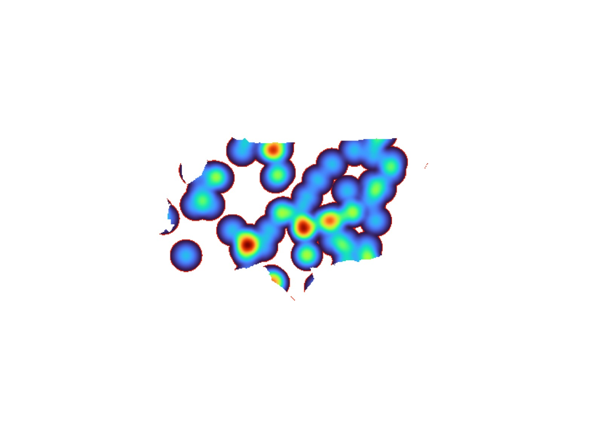
Figure 9: Heatmap of GP Surgery Hotspots in Haringey
The map shows how GP surgeries are distributed. Brighter spots indicate more surgeries close together, while darker spots indicate fewer surgeries.
Interpretation
The heatmap shows that GP surgeries are grouped in some parts of Haringey. Hotspots appear where surgeries are clustered, which means people there have better access to healthcare. Darker areas indicate fewer surgeries and possible gaps in service.
This pattern shows that healthcare facilities are not evenly distributed. They often cluster in areas where more people live or where demand is higher. This could also be because planners want to serve busier or more central neighbourhoods.
Comment
This task shows how kernel density estimation can be used to study where things are grouped. Heatmaps help identify hotspots in many areas, such as healthcare planning, crime analysis, and urban studies. The method can also include population data to check whether services match demand or to compare access across regions.

Task 4: Accessibility to GP Surgeries from Tube Stations in the London Borough of Haringey (Network Analysis)
Objective
Spatial accessibility to GP surgeries was assessed by calculating the distance from each GP surgery to the nearest underground station.
Methods
Spatial analysis was performed in QGIS following these steps:
- Input layers included haringey_gp.shp and UndergroundStations.shp.
- The Distance Matrix tool was used to calculate the nearest distance between GP surgeries and underground stations.
- Only the nearest (k = 1) underground station was selected for each GP surgery. The output was saved as Distance.csv.sv
- Distance results were joined with GP surgery data using attribute joins.
- A thematic map was created using graduated symbology to represent accessibility levels.
Additionally, spatial SQL in SpatiaLite was employed to validate the results:
- The minimum distance between each GP surgery and underground station was calculated.
- An accessibility table was created and visualised in QGIS.
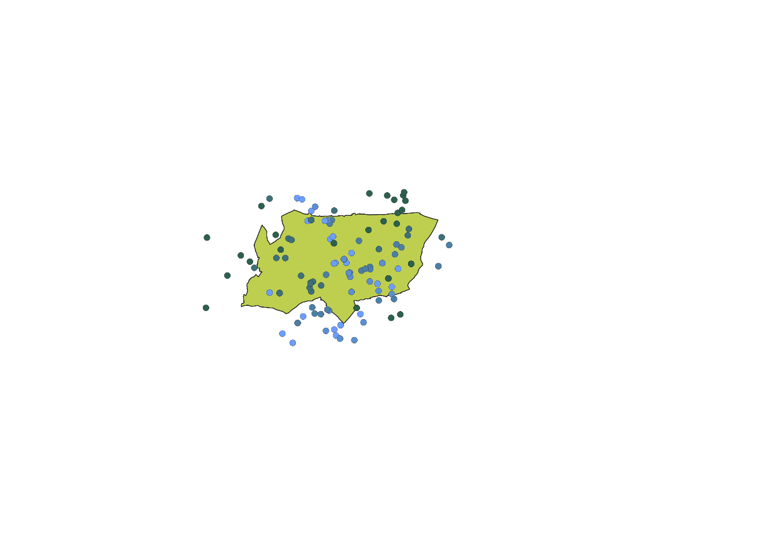
Result
Figure 10: Accessibility of GP Surgeries to Underground Stations in Haringey
The map displays where GP surgeries are located, with colours showing how far each one is from the nearest underground station. Each colour stands for a different level of accessibility.
Interpretation
The map shows that accessibility to GP surgeries in Haringey varies. Surgeries closer to underground stations are easier to reach, while those farther away are less accessible.
There is a clear pattern: GP surgeries in central or well-connected areas have better access to underground transport. Surgeries on the edges or in less connected parts of the borough have lower accessibility.
This pattern shows how transport infrastructure affects access to healthcare and points out areas where it may be harder to reach services.
Comment
This task shows how spatial accessibility analysis can be done using distance-based methods. The Distance Matrix tool makes it easy to measure how close different types of places are to each other. This kind of analysis is common in healthcare planning, transport studies, and checking how easy it is to reach services. The method could be improved by using network-based distances, such as travel time, instead of straight-line distance to provide a more realistic view of accessibility.
Q. Could you identify hotspots of GP surgeries in Haringey? What does such a spatial pattern reflect?
Ans: Yes, you can spot hotspots of GP surgeries in areas where the heatmap is brighter. These hotspots show clusters of healthcare facilities. This pattern means GP services are not evenly distributed. Some areas have better access because of these clusters, while others have fewer facilities, which could lead to service gaps.

Session 9 – Near Things More Related Than Distance Things in London

Task 1: Spatial Dependence / Correlation of Crimes and Deprivation in London
Objective
The objective is to measure spatial dependence and identify clustering patterns of deprivation and crime across London boroughs using Moran’s I to determine whether these variables exhibit spatial structure.
Methods
- The dataset london_life_polygon.shp was loaded into GeoDa.
- Spatial weights were created using the Rook Contiguity method.
- Univariate Moran’s I was performed for the following variables:
  - DEPRIV
  - CRIME_1000
  - BURGLARY
- Bivariate Moran’s I was conducted for the following variable pairs:
  - DEPRIV and CRIME_1000
  - DEPRIV and BURGLARY
- Empirical Bayes (EB) Rate Moran’s I was applied to the following ratio:
  - BURGLARY divided by CRIME_1000
- Ward-level Moran’s I was conducted using the london_ward_met_per1000.shp dataset.
- Differential Moran’s I was performed for the following variable:
  - Population change between Year 1 and Year 6
- All Moran scatter plots and cluster maps were exported.
Result

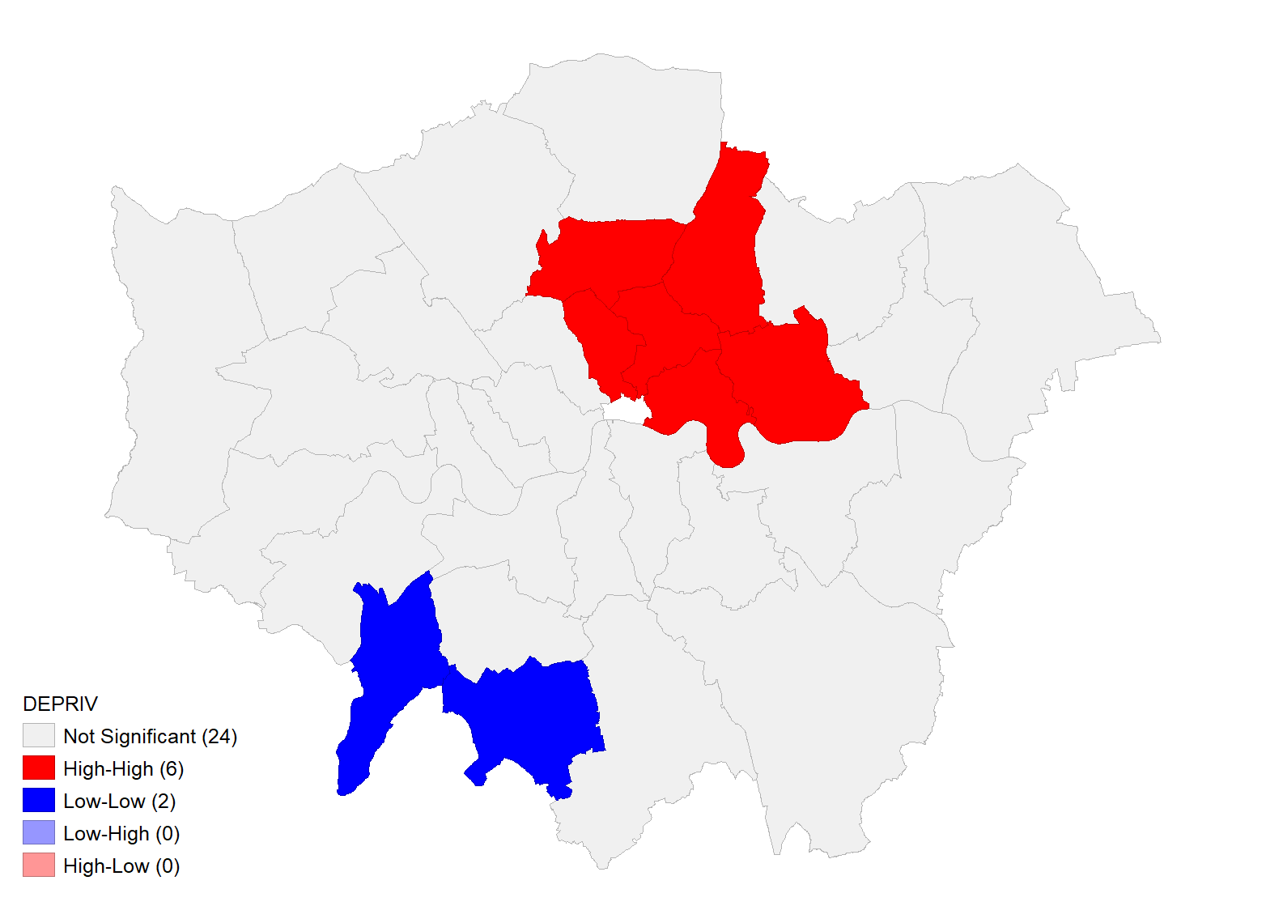
Figure 11: Univariate Local Moran’s I Cluster Map (DEPRIV – Deprivation)
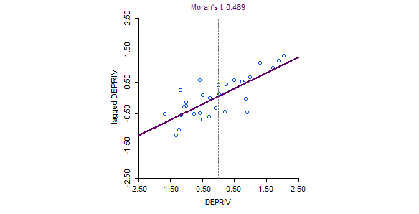

Figure 12: Univariate Moran Scatter Plot (DEPRIV – Deprivation)

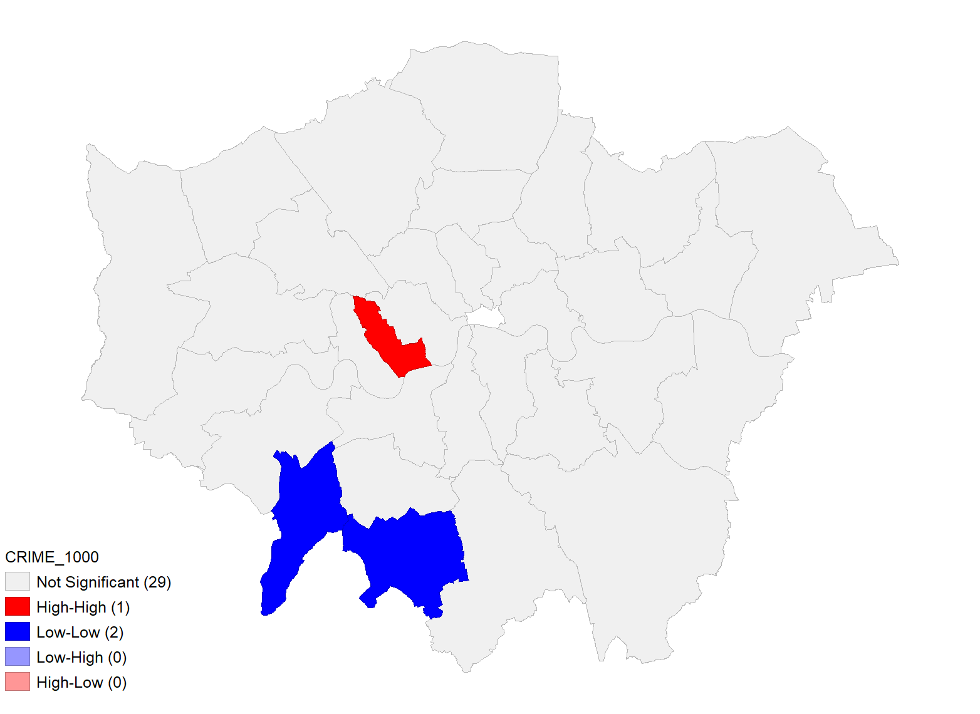

Figure 13: Univariate Local Moran’s I Cluster Map (CRIME_1000 – Total Crime)

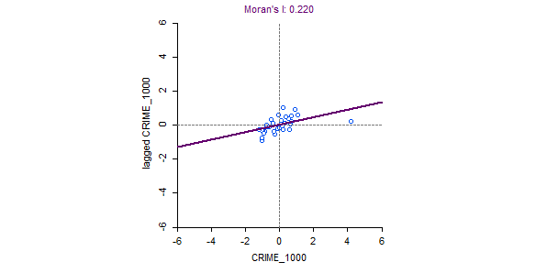

Figure 14: Univariate Moran Scatter Plot (CRIME_1000 – Total Crime)
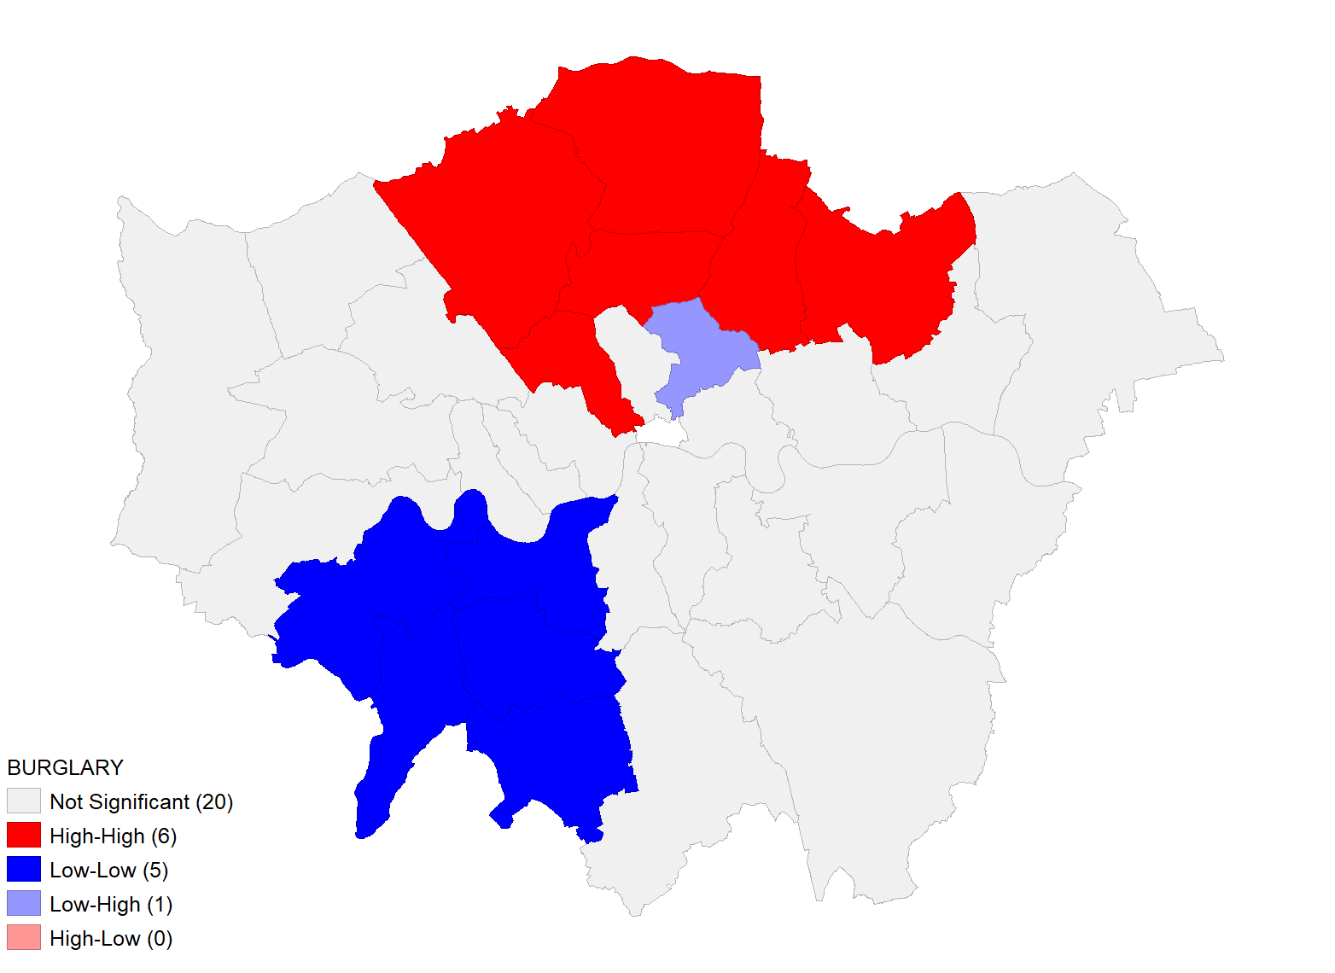

Figure 15: Univariate Local Moran’s I Cluster Map (BURGLARY – Burglary Rate)
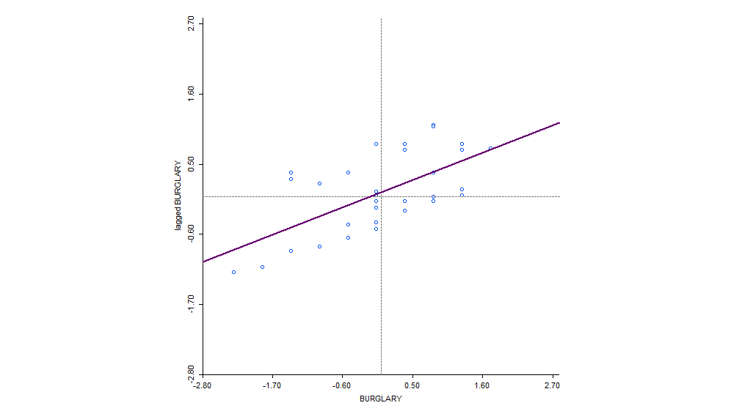

Figure 16: Univariate Moran Scatter Plot (BURGLARY – Burglary Rate)

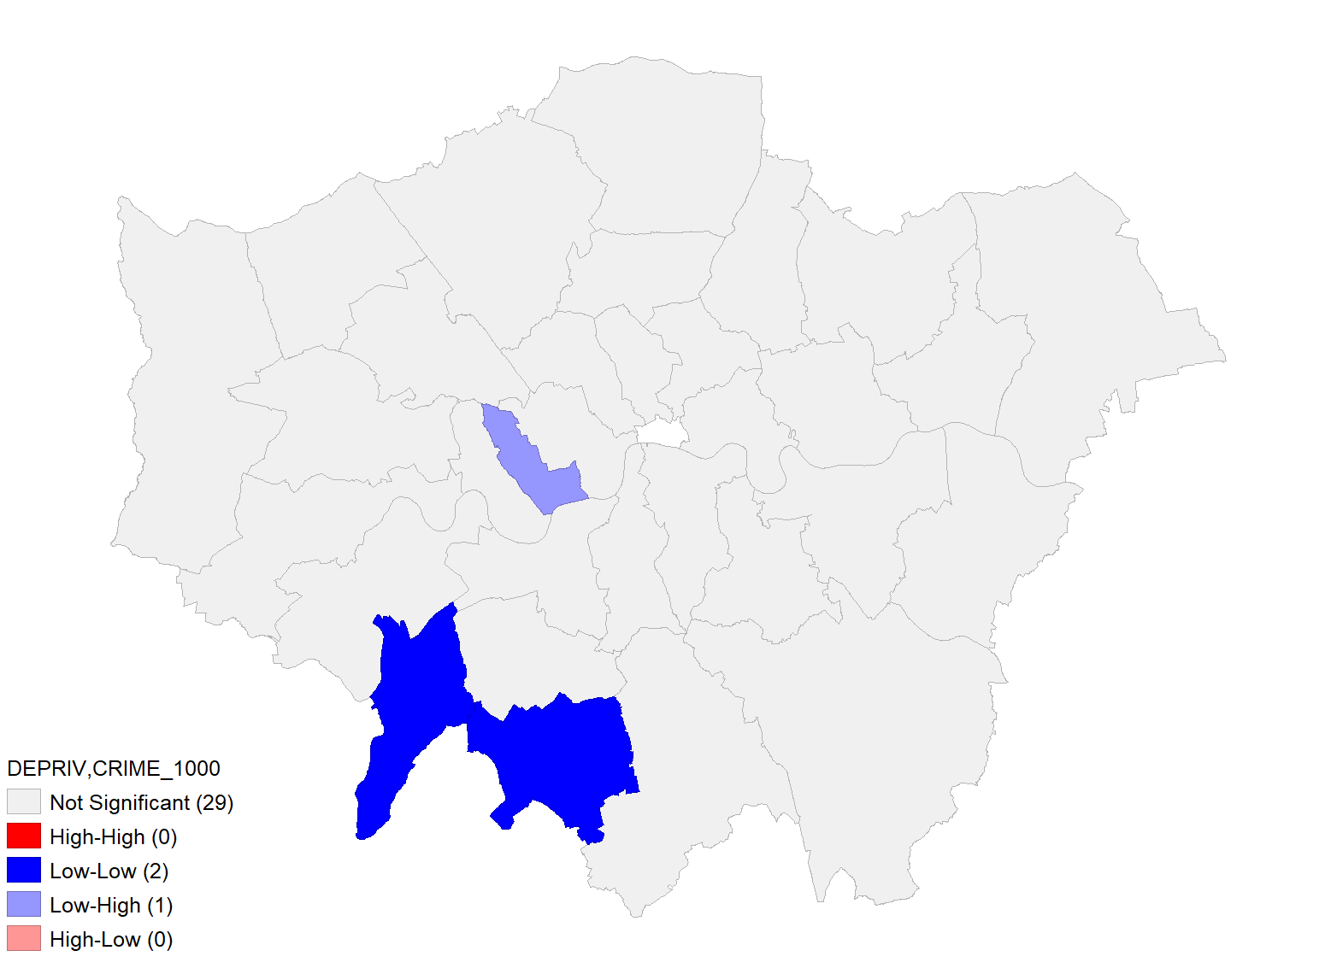

Figure 17: Bivariate Local Moran’s I Cluster Map (DEPRIV vs CRIME_1000)

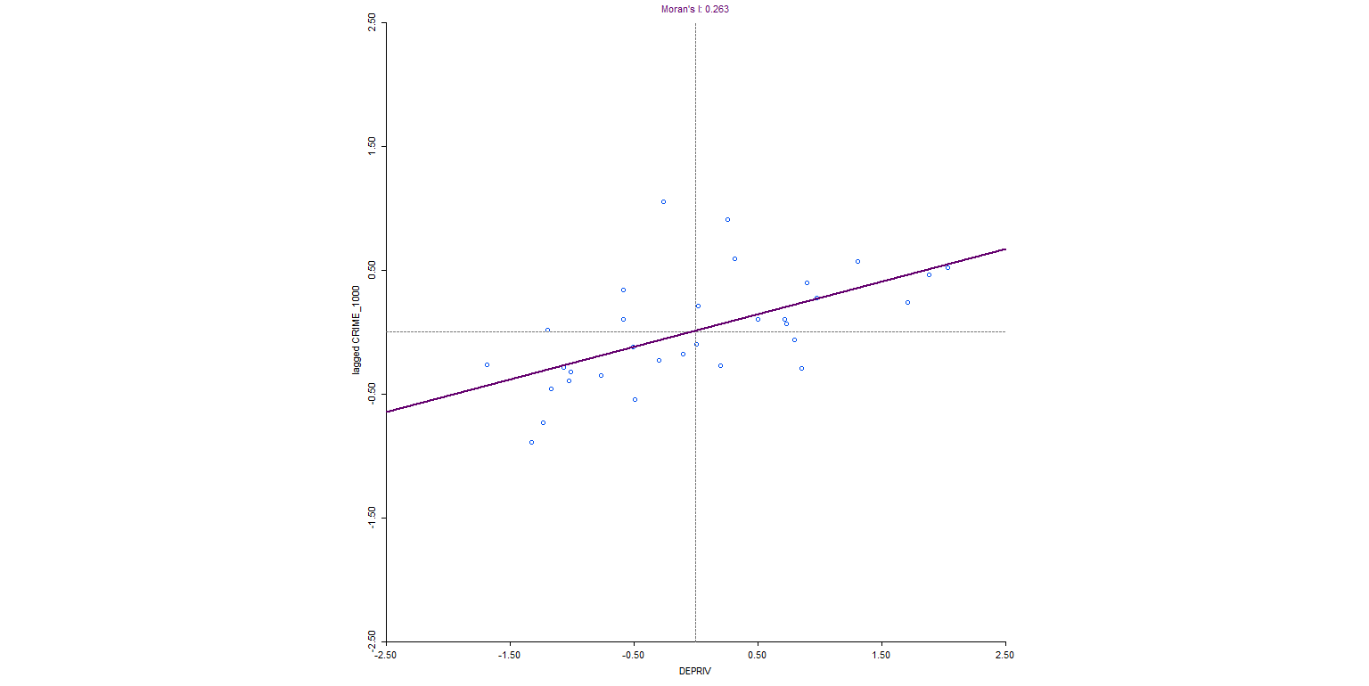

Figure 18: Bivariate Moran Scatter Plot (DEPRIV vs CRIME_1000)
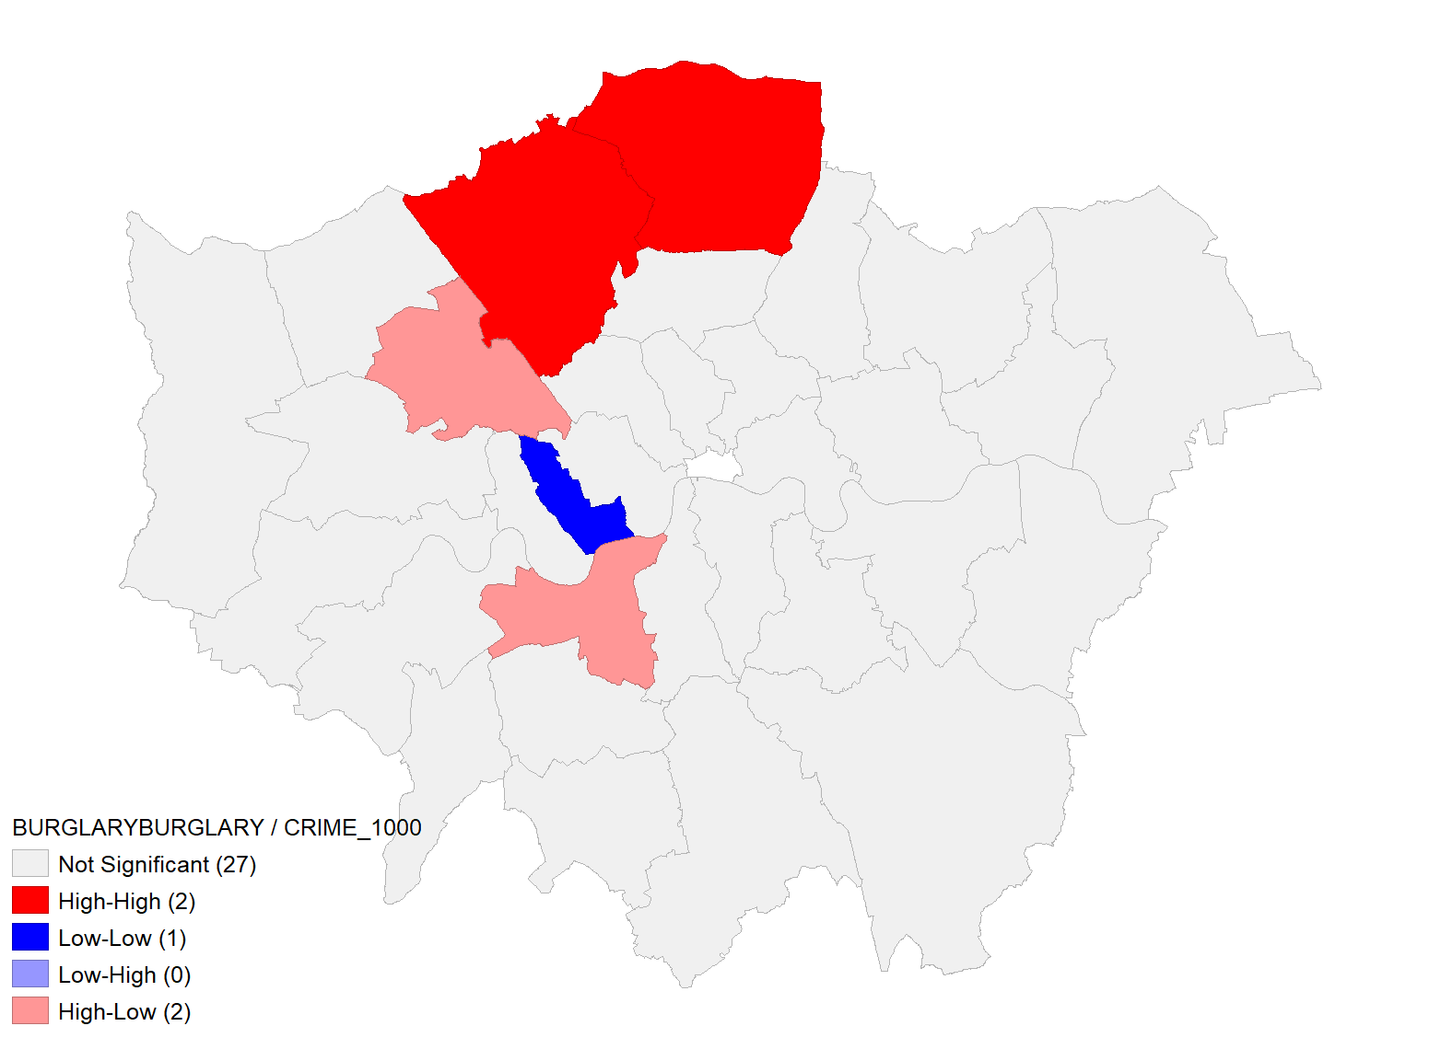

Figure 19: Local Moran’s I Cluster Map with Empirical Bayes Rate (BURGLARY)
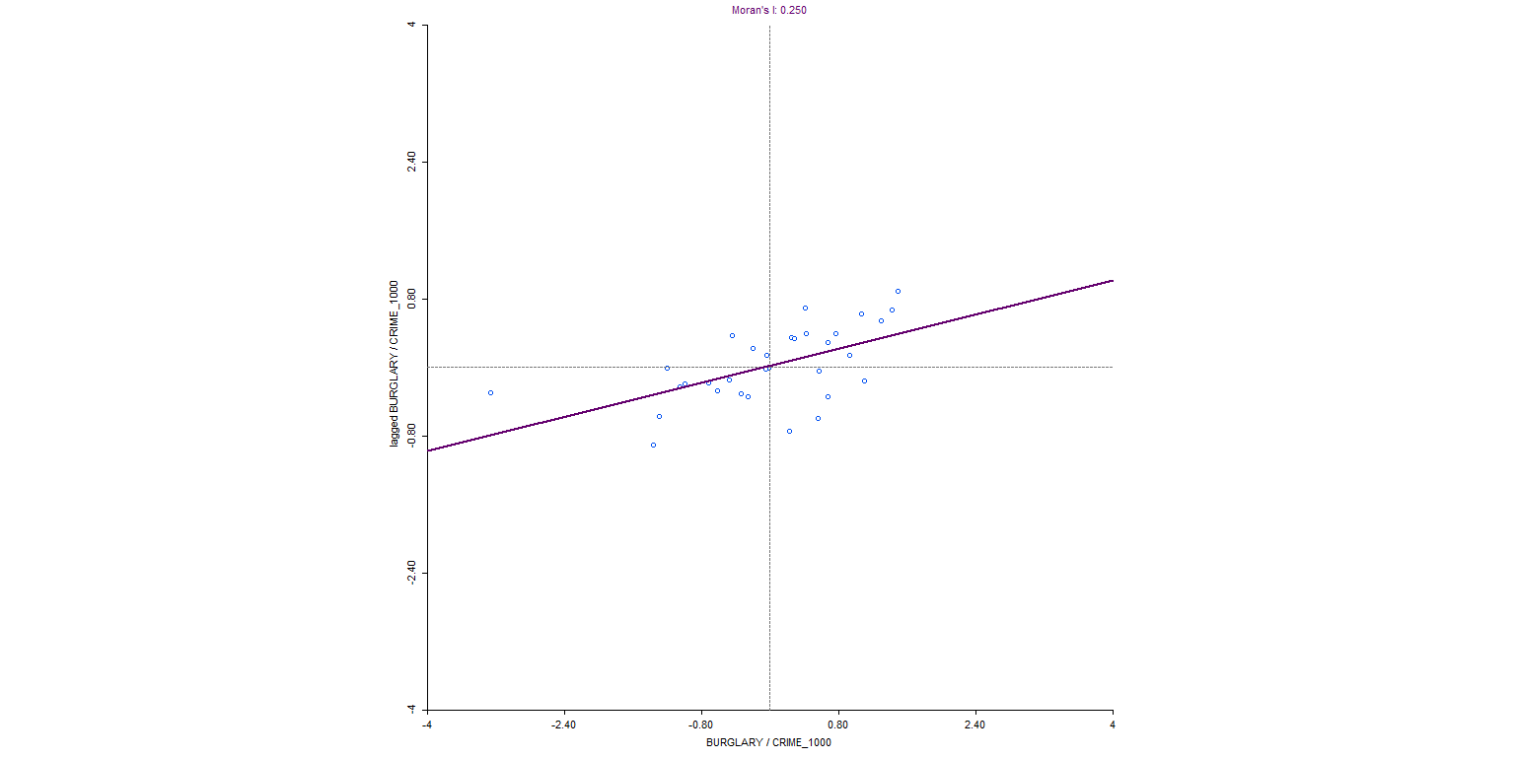

Figure 20: Moran Scatter Plot with Empirical Bayes Rate (BURGLARY)

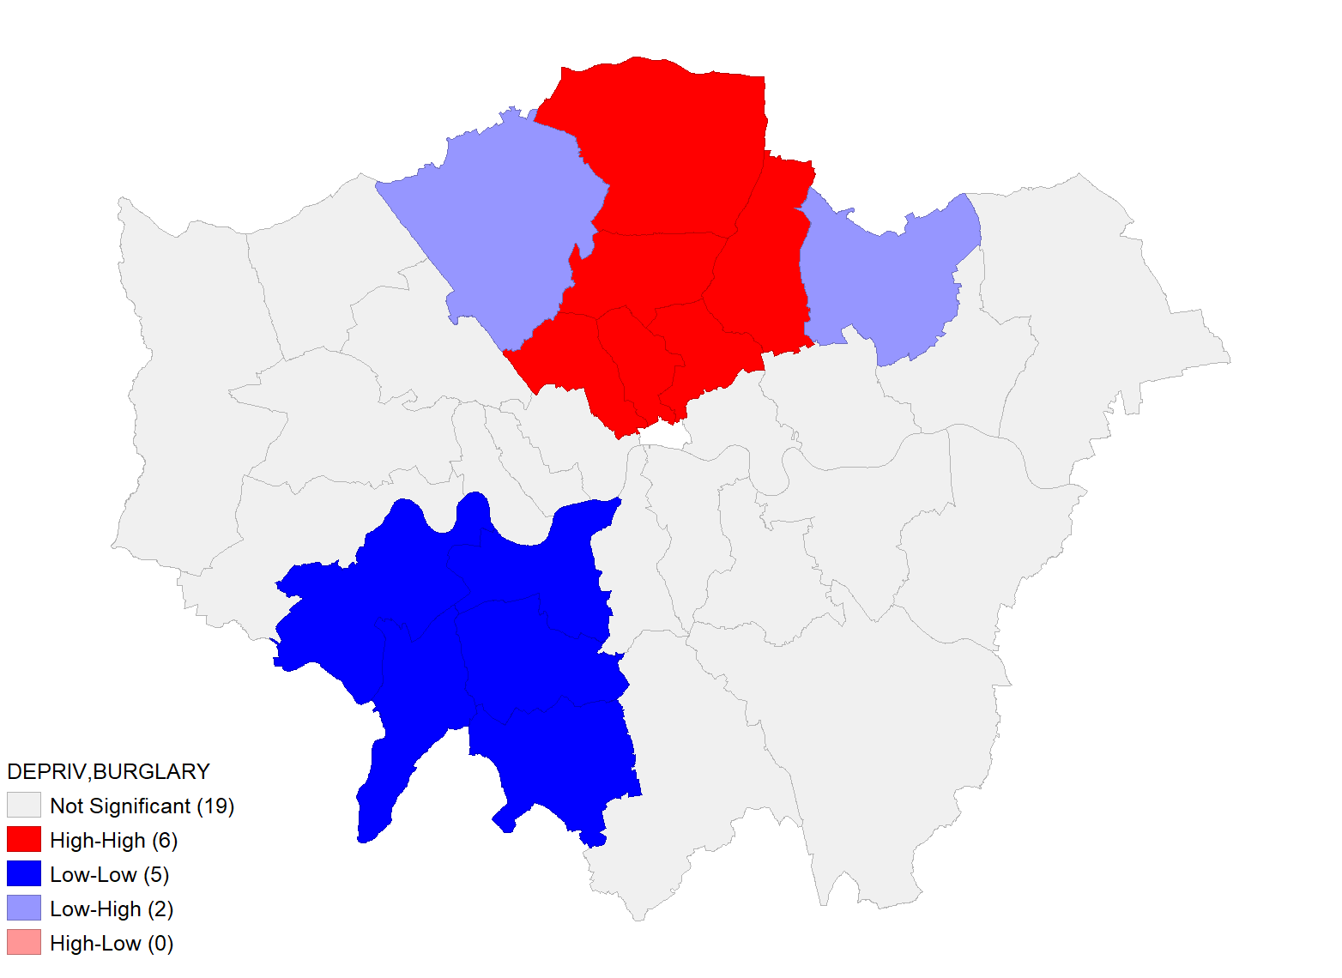

Figure 21: Bivariate Local Moran’s I Cluster Map (DEPRIV vs BURGLARY)

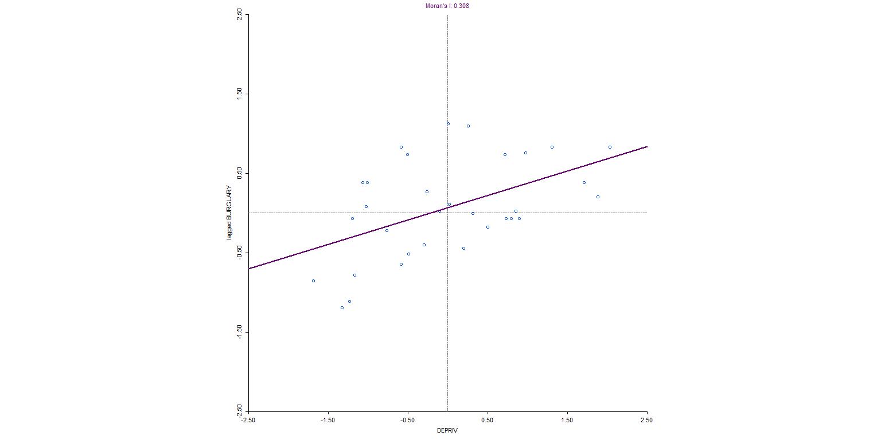
Figure 22: Bivariate Moran Scatter Plot (DEPRIV vs BURGLARY)
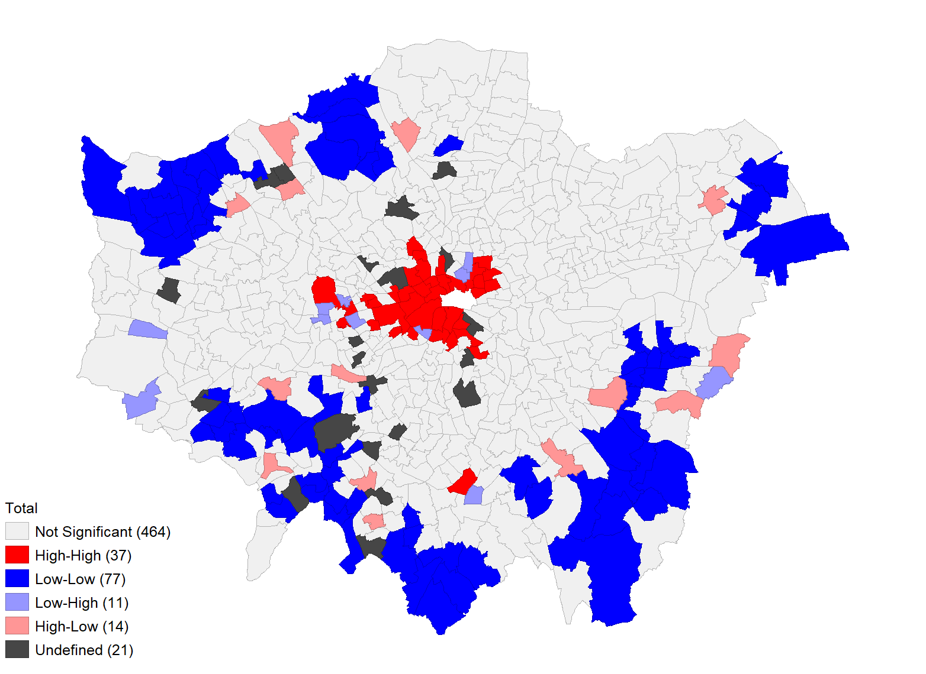

Figure 23: Univariate Local Moran’s I Cluster Map (Ward-Level Total Crime)

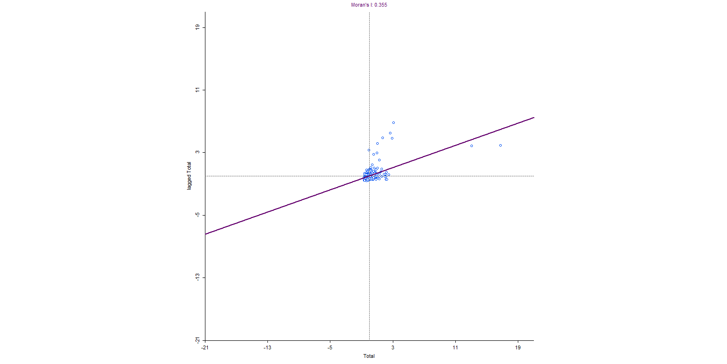
Figure 24: Univariate Moran Scatter Plot (Ward-Level Total Crime)

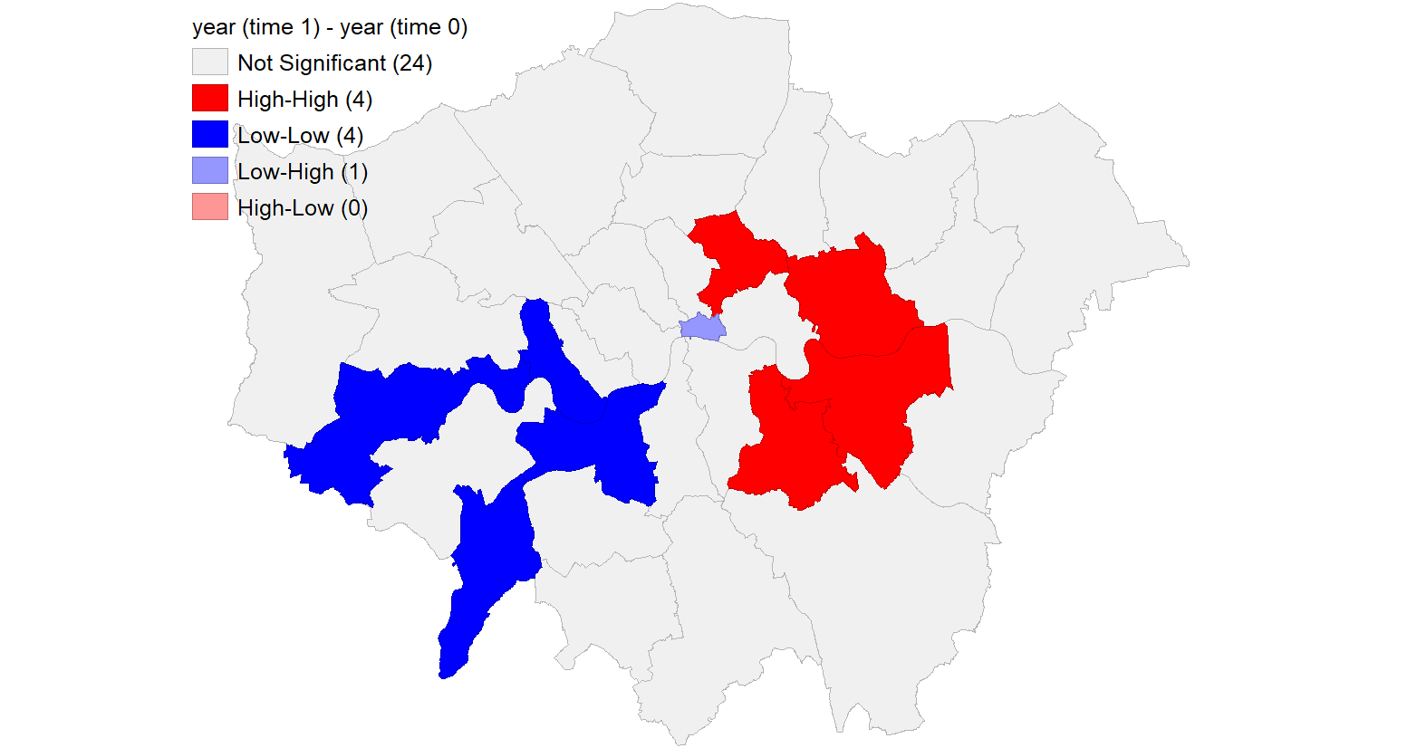
Figure 25: Differential Local Moran’s I Cluster Map (Population Change)
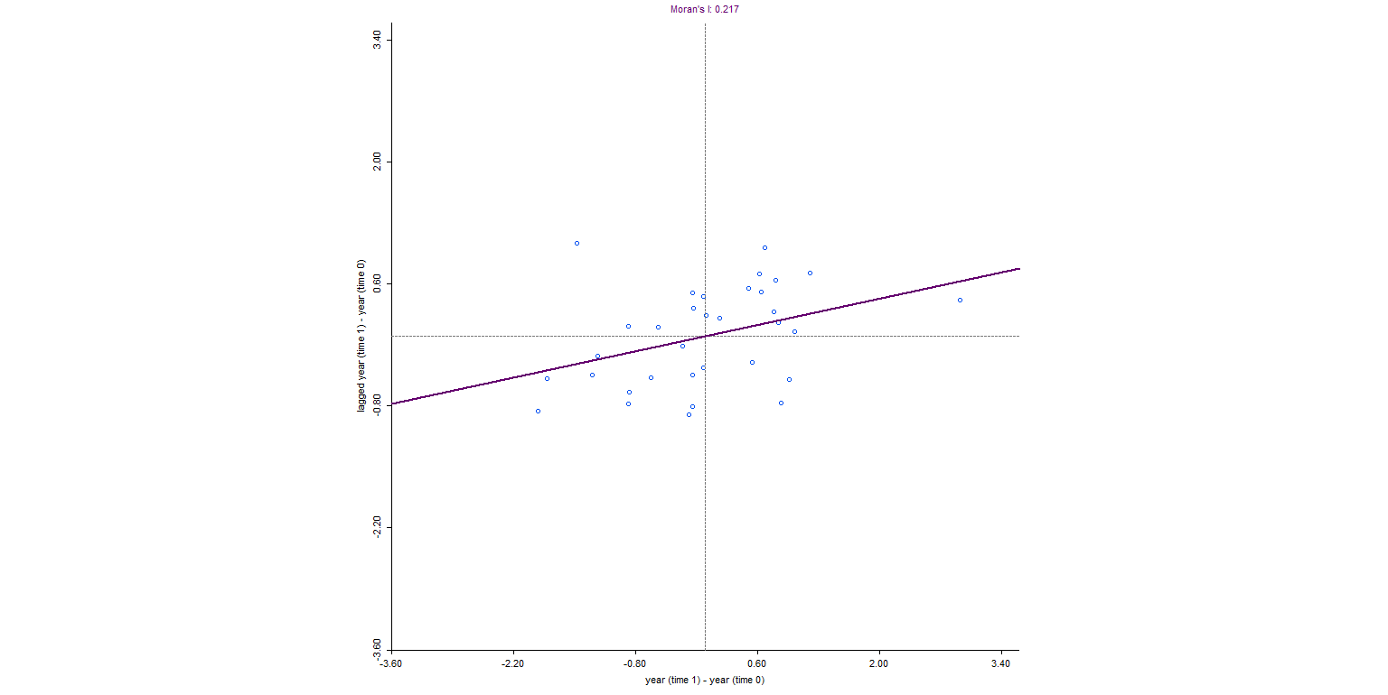

Figure 26: Differential Moran Scatter Plot (Population Change)

Variable | Moran’s I | Interpretation
DEPRIV | 0.489 | Strong spatial clustering
CRIME_1000 | 0.22–0.35 | Moderate clustering
BURGLARY | 0.25–0.39 | Moderate to strong clustering
Population Change | 0.217 | Weak clustering
Table 7: Moran’s I Summary

Interpretation
The results show that neither deprivation nor crime is spread randomly across London boroughs. Deprivation, in particular, is highly clustered, with areas of high deprivation often located near each other. This pattern points to deep-rooted socio-economic inequalities that are tied to specific parts of the city.
Crime also tends to cluster in certain areas, but not as strongly as deprivation does. Burglary, for example, is more likely to be concentrated in specific places than overall crime, suggesting that some crimes are more affected by factors such as how easy an area is to access and its local environment. Areas with many crimes close together are hotspots, while areas with few crimes are safer.
The bivariate Moran’s I analysis shows that places with greater deprivation tend to have higher crime rates. Still, this link is not the same everywhere, which means other factors like policing, infrastructure, and the number of people living in an area also affect crime patterns.
The EB Rate analysis helps create clearer and more reliable maps by reducing the impact of extreme values, especially in sparsely populated areas. Looking at data by ward shows the Modifiable Areal Unit Problem (MAUP), which means that patterns can change depending on the size of the area studied. The Differential Moran’s I results show that population changes are less clustered than crime or deprivation, so demographic shifts are not as tied to location.
Conclusion
The analysis shows that deprivation and crime are clearly clustered in certain parts of London, rather than being spread out at random. Deprivation is the most strongly clustered, while crime is moderately clustered and closely connected to social and economic factors. These findings show how important it is to consider the scale of analysis and the methods used when looking at geographic data. In short, spatial factors are key in shaping city patterns and should be taken into account when making plans or decisions.

Comment
This task shows how helpful Moran’s I is for finding clusters and understanding patterns in geographic data. These methods are useful for real-world issues such as preventing crime, planning cities, and deciding how to allocate resources. The analysis could be improved by exploring alternative ways to measure spatial relationships and by adding time-series data to see how things change.

Q: Does deprivation exhibit strong spatial dependence? Which crime demonstrates the highest spatial dependence? What are the implications of these results?
Answer:
Deprivation shows strong spatial dependence, indicated by a Moran’s I value of 0.489. This reflects a clear pattern of clustering, with highly deprived boroughs near other deprived areas. Among the crime variables, burglary has the highest spatial dependence, with a Moran’s I value of 0.391. This suggests burglary incidents are more geographically concentrated than other types of crime. Overall, these results show that both deprivation and crime are not randomly distributed but exhibit significant spatial clustering at the borough level. Neighbouring areas tend to share similar socio-economic and crime characteristics, highlighting underlying spatial processes that influence crime distribution across London.

Task 2: Spatial Regression of Health Indicators in London
Objective
This study aims to analyse the relationship between male life expectancy and various socio-economic and health-related variables, and to assess whether incorporating spatial effects enhances model performance.
Methodology
- The dataset 'london_life_polygon.shp' is loaded for analysis.
- Dependent variable definition:
  - LIFE_MALE (male life expectancy)
- Independent variables definition:
  - DEPRIV
  - P_SMOKE
  - P_BINGE
  - P_OBESE
  - P_HEALTHY
- Ordinary Least Squares (OLS) regression is conducted using GeoDa.
- Run Spatial Lag Model (GeoDa)
- Regression analysis is also performed in R using the lm() function.
- The results from each model are compared to evaluate performance and consistency.
Results
Model | R² | Spatial Effect (Rho) | Key Variable
OLS | 0.804 | – | P_HEALTHY
Spatial Lag | 0.804 | -0.0139 (Not significant) | P_HEALTHY
Table 8: Comparison of OLS and Spatial Lag Model Results
Detailed regression outputs, including coefficients, diagnostics, and statistical tests, are provided in the Appendix. The summary results presented here highlight key findings for model performance and interpretation.
Interpretation
The model accounts for about 80% of the variation in male life expectancy, which shows it fits the data well. Of the independent variables, P_HEALTHY shows a statistically significant positive association, meaning that boroughs with healthier residents tend to have higher life expectancy.
On the other hand, P_BINGE has a negative relationship, so higher binge drinking is linked to lower life expectancy, but this result is only marginally significant. DEPRIV also shows a negative association, but it is not statistically significant, suggesting its effect may be indirect or influenced by other factors.
The spatial lag coefficient (ρ) is very small and not statistically significant, which means there is little spatial dependence. This suggests that once socio-economic and health factors are considered, neighbouring boroughs have little effect on each other's life expectancy.

Comparison: GeoDa vs R
The results from GeoDa and R are consistent with each other. Both models find P_HEALTHY to be significant, and their overall performance is similar. Neither approach finds a strong spatial effect. This consistency shows that the findings are reliable and do not depend on which software is used.
Comment
The findings demonstrate the utility of regression models for understanding spatial health patterns. Although spatial models are intended to capture geographic dependence, incorporating a spatial lag term does not substantially enhance model performance in this context.
These results indicate that variations in life expectancy across London boroughs are primarily attributable to local socio-economic and behavioural factors, rather than to spatial spillover effects.
Nevertheless, the model exhibits certain limitations. The relatively high multicollinearity, as indicated by the condition number, may compromise the stability of coefficient estimates. Furthermore, the exclusion of key variables such as income levels, education, and healthcare accessibility may limit the model's ability to fully explain variation in life expectancy.
Future research should consider alternative spatial models, such as the spatial error model, and incorporate additional variables to enhance explanatory power.
Conclusion
The results show that using spatial regression does not make the model perform better. The spatial lag coefficient is not statistically significant, and diagnostic tests do not find strong spatial dependence. So, a standard OLS model is enough to explain differences in male life expectancy across London boroughs.

Task 3: Population Surface in Haringey (Interpolation Analysis)
Objective
To develop a continuous population surface using interpolation techniques to analyse spatial variation across Haringey.
Method
Spatial interpolation was performed in QGIS following these steps:
- Input datasets included:
  - Population_Haringey_LSOA_PWC.shp
  - haringey_boundary.shp
- IDW (Inverse Distance Weighting) interpolation was applied:
  - A distance coefficient of 4 was used.
  - The map extent was set to the study area.
  - The output resolution was approximately 300 rows.
- A raster surface representing population distribution was generated.
- The raster was clipped using the Haringey boundary.
- Single-band pseudocolour symbology was applied for visualisation.
- The interpolated raster map was exported.
Result

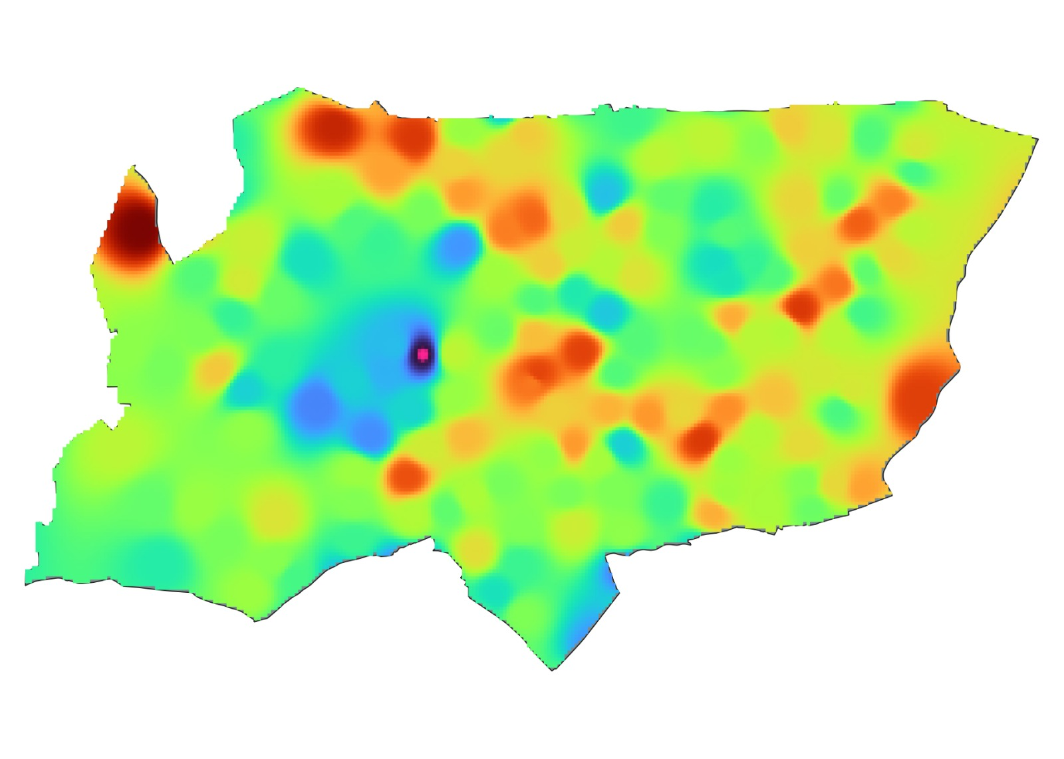
Figure 27: IDW Interpolated Population Surface Map (Haringey)
The raster surface shows how the population is spread across Haringey. Darker areas mean more people live there, while lighter areas have fewer residents.
Interpretation
The interpolated surface shows that the population is not spread evenly across Haringey. Some areas have many people living close together, forming clear clusters. These clusters are probably linked to where people live, city infrastructure, and how easy it is to get around. Areas with fewer people are more spread out, suggesting these places are less densely populated or have more open space.
The smooth transition from high to low population values across the map indicates that population density varies gradually rather than suddenly. This is common in cities, where the number of people usually shifts slowly from one area to another. Overall, the results show that people are clustered in certain areas rather than spread out randomly.
Comment
This task shows how interpolation methods can turn separate data points into a smooth map, making it easier to see and study patterns. The IDW method works well for showing local differences because it gives more weight to nearby data than to points that are farther away.
However, how reliable the results are depends on the methods and settings used, like the type of interpolation and the values chosen for distance and resolution. Using different settings or methods could lead to different patterns, so it is important to interpret the results carefully.
The analysis could be improved by:
- Applying alternative interpolation methods such as Kriging
- Testing different parameter settings
- Comparing multiple interpolation outputs to assess consistency

Q: Is interpolation sensitive to methods and parameter settings?
Answer:
Interpolation is sensitive to both the chosen method and parameter settings. Various interpolation techniques and parameter selections can generate different spatial surfaces, potentially influencing the accuracy and smoothness of the results. Consequently, rigorous selection and evaluation of methods and parameters are necessary to achieve reliable spatial analysis.

Appendix
Appendix A: Ordinary Least Squares (OLS) Regression Output (GeoDa)
Data set: london_life_polygon
Dependent Variable: LIFE_MALE
Number of Observations: 32
Model Summary
- R-squared: 0.803673
- Adjusted R-squared: 0.765918
- F-statistic: 21.2864 (p < 0.001)
- Log Likelihood: -39.1514
- Akaike Information Criterion (AIC): 90.3029
- Standard Error of Regression: 0.912437
Variable | Coefficient | Std. Error | t-Statistic | Probability
CONSTANT | 69.3676 | 3.9595 | 17.5194 | 0.00000
DEPRIV | -0.0399811 | 0.0302057 | -1.3236 | 0.19715
P_SMOKE | 0.101164 | 0.0802025 | 1.2614 | 0.21838
P_BINGE | -0.361891 | 0.198456 | -1.8235 | 0.07974
P_OBESE | 0.0444868 | 0.0876369 | 0.5076 | 0.61599
P_HEALTHY | 0.35326 | 0.0791595 | 4.4626 | 0.00014
Table 10: Ordinary Least Squares (OLS) Regression Results for Male Life Expectancy
Diagnostics
Multicollinearity
- Condition Number: 70.463
Normality Test
- Jarque-Bera Test: 1.3617 (p = 0.50619)
Heteroskedasticity Tests
- Breusch-Pagan Test: 5.7773 (p = 0.32849)
- Koenker-Bassett Test: 6.3910 (p = 0.27001)
Spatial Dependence Tests (london_weights)
Test | Value | Probability
Moran’s I (error) | -0.0395 | 0.64303
Lagrange Multiplier (lag) | 0.0046 | 0.94577
Robust LM (lag) | 0.0466 | 0.82900
Lagrange Multiplier (error) | 0.1134 | 0.73627
Robust LM (error) | 0.1555 | 0.69338
LM (SARMA) | 0.1601 | 0.92308
Table 11: Spatial Dependence Tests (london_weights)

Appendix B: Spatial Lag Model Output (GeoDa)
Data set: london_life_polygon
Spatial weights: london_weights
Dependent Variable: LIFE_MALE
Number of Observations: 32
Model Summary
- R-squared: 0.803713
- Log Likelihood: -39.1488
- Akaike Information Criterion (AIC): 92.2976
- Standard Error of Regression: 0.822375
- Spatial Lag Coefficient (ρ): -0.0139335
Variable | Coefficient | Std. Error | z-value | Probability
W_LIFE_MALE (ρ) | -0.0139335 | 0.180354 | -0.0773 | 0.93842
CONSTANT | 70.3696 | 13.9556 | 5.0424 | 0.00000
DEPRIV | -0.0412571 | 0.0328003 | -1.2578 | 0.20845
P_SMOKE | 0.100128 | 0.0760677 | 1.3163 | 0.18807
P_BINGE | -0.355534 | 0.203054 | -1.7509 | 0.07996
P_OBESE | 0.0469733 | 0.0834921 | 0.5626 | 0.57370
P_HEALTHY | 0.353448 | 0.0717953 | 4.9230 | 0.00000
Table 12: Spatial Lag Model Regression Results for Male Life Expectancy
Diagnostics
Heteroskedasticity
- Breusch-Pagan Test: 5.7305 (p = 0.33333)
Spatial Dependence
- Likelihood Ratio Test: 0.0053 (p = 0.94215)

