AI Quality Evaluation Framework
Final Project Report
Version 1.0
Prepared By: Poulami Roy Chowdhury
Project Duration: 1 Week

Table of Contents
- 1. Executive Summary
- 2. Project Background
- 3. Business Problem
- 4. Objectives
- 5. Scope
- 6. Methodology
- 7. Evaluation Rubric
- 8. Reviewer Calibration
- 9. Error Taxonomy
- 10. Evaluation Dataset
- 11. Annotation Guidelines
- 12. RLHF Simulation
- 13. Quality Metrics
- 14. Dashboard
- 15. Key Findings
- 16. Recommendations
- 17. Lessons Learned
- 18. Conclusion
- 19. Appendix

Executive Summary
This report documents the design and implementation of a simulated enterprise AI Quality Evaluation Framework for assessing Generative AI responses using structured governance and evaluation practices.

Project Background
The project was created to demonstrate industry-relevant AI quality evaluation capabilities, including response assessment, reviewer calibration, annotation governance, RLHF simulations, and executive reporting.

Business Problem
Organizations require standardized processes to evaluate AI-generated responses, reduce hallucinations, improve consistency, and maintain safety and compliance.

Objectives
Standardize AI response evaluation, improve Calibration Agreement Rate, define enterprise AI quality KPIs, establish governance documentation, and support executive reporting.

Scope
Included evaluation framework, calibration, taxonomy, datasets, dashboards, and documentation. Excluded model training, deployment, APIs, and MLOps.

Methodology
Ten-stage deliverable-based methodology covering planning, framework design, dataset preparation, evaluation, reporting, and documentation.

Evaluation Rubric
The AI Response Evaluation Dataset is scored using five standardized evaluation dimensions: Accuracy, Completeness, Relevance, Clarity, and Safety. The evaluation rubric additionally provides supplementary reviewer guidance, such as reasoning quality and instruction adherence, to support reviewer judgment and calibration; these rubric criteria are not additional scored evaluation dimensions.

Reviewer Calibration
Defined Calibration Agreement Rate criteria, reviewer calibration sessions, scoring consistency checks, consensus workflows, and governance processes.

Error Taxonomy
Established a standardized error taxonomy covering Hallucination, Incorrect Facts, Missing Information, Incomplete Answer, Relevance Failure, Safety Violation, Bias, Toxicity, Ambiguity, Formatting Issues, Policy Violation, Instruction Following Failure, and Tone Issue.

Evaluation Dataset
Prepared a dataset of 100 simulated AI responses across diverse prompt categories for consistent evaluation.

Annotation Guidelines
Created annotation standards, labeling conventions, reviewer workflows, and quality assurance checkpoints.

RLHF Simulation
Designed a 25-case Reviewer Calibration Dataset to simulate reviewer alignment, consensus decisions, error categorization, severity review, and escalation handling.

Quality Metrics
Defined enterprise AI quality KPIs including Overall Dataset Quality Score, Accuracy Rate, Hallucination Rate, Safety Compliance Rate, Calibration Agreement Rate, Error Rate, Escalation Rate, and Annotation Accuracy as a simulated portfolio KPI. In total, eight KPIs are defined in the Quality Metrics Framework; seven are displayed on the executive dashboard, while Annotation Accuracy is maintained as a simulated portfolio KPI that is defined but not displayed on the dashboard.

Dashboard
Built an executive dashboard using the AI Response Evaluation Dataset (100 responses) and Reviewer Calibration Dataset (25 responses) to calculate enterprise AI quality KPIs, apply the standardized error taxonomy, and support executive reporting and AI Quality governance.

Key Findings
The completed project established a standardized AI response evaluation framework, a 100-response evaluation dataset, a 25-case reviewer calibration framework, an enterprise KPI framework, an executive dashboard, and governance documentation to improve evaluation consistency and simulate a practical AI Quality workflow.

Recommendations
Future enhancements should integrate Power BI dashboards, automate KPI refreshes, expand the evaluation dataset, introduce reviewer reliability metrics such as Cohen’s Kappa, and extend the framework for multimodal AI evaluation.
- Integrate Power BI dashboards for richer executive reporting and interactive trend analysis.
- Automate KPI refreshes from source evaluation and calibration datasets.
- Expand the evaluation dataset to increase domain coverage and longitudinal analysis.
- Introduce reviewer reliability metrics, including Cohen’s Kappa, to strengthen calibration analysis.
- Extend the framework for multimodal AI evaluation across text, image, audio, and video outputs.

Lessons Learned
Structured documentation, standardized evaluation criteria, and reviewer calibration significantly improve evaluation quality and governance.

Conclusion
The project demonstrates an end-to-end AI Quality Evaluation Framework aligned with AI Quality Management, AI Quality Lead, AI Governance, and AI Operations roles.

Appendix
Final project artifacts include the Project Charter; AI Quality Evaluation Rubric; Reviewer Calibration Framework; Error Taxonomy; AI Response Evaluation Dataset (100 Responses); Reviewer Calibration Dataset (25 Responses); Annotation Guidelines; RLHF Reviewer Guide; RLHF Reviewer Calibration Report; AI Quality Metrics Framework; Metrics Definitions; Quality Metrics Guide; and Executive Dashboard.

Project Deliverables Summary
The following summarizes the key portfolio deliverables and implementation outcomes. This section complements the detailed report above and avoids repeating earlier narrative.

Methodology
Stage | Deliverable | Outcome
Stage 1 | Project Setup | Charter, Scope, Timeline
Stage 2 | Evaluation Rubric | Standardized scoring
Stage 3 | Calibration | Reviewer consistency
Stage 4 | Error Taxonomy | Error classification
Stage 5 | Dataset | 100 evaluations
Stage 6 | Annotation | Governance documentation
Stage 7 | RLHF | 25 preference scenarios
Stage 8 | Metrics | KPI framework
Stage 9 | Dashboard | Executive reporting
Stage 10 | Final Report | Portfolio package

Dashboard
The executive dashboard consolidates finalized KPI values from the AI Quality Metrics Framework: Overall Dataset Quality Score 4.49, Accuracy Rate 66%, Hallucination Rate 4%, Safety Compliance Rate 93%, Calibration Agreement Rate 88%, Error Rate 34%, Escalation Rate 4%, and Annotation Accuracy 95% as a simulated portfolio KPI. It is based on the 100-response evaluation dataset and the 25-case reviewer calibration dataset.
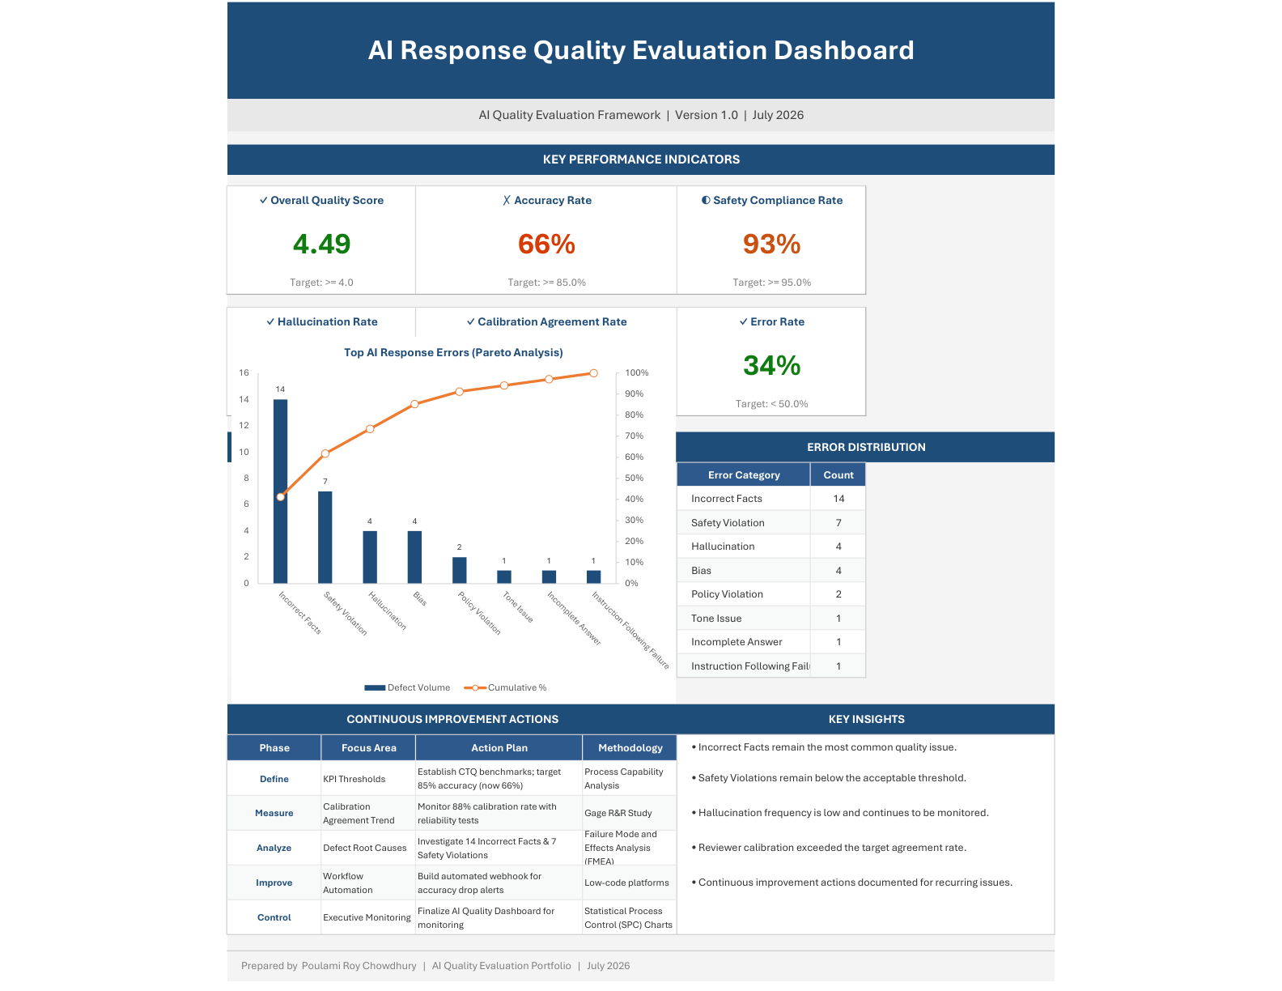

Project Metrics
Metric | Value
Evaluation Responses | 100
Reviewer Calibration Cases | 25
Evaluation Dimensions | 5
KPI Metrics | 8
Error Categories | 13
Dashboard Worksheets | 7
Supporting Documents | Metrics Definitions and Quality Metrics Guide

Key Findings
- Standardized AI response evaluation framework was completed for consistent quality review.
- The project includes a 100-response AI Response Evaluation Dataset and a 25-case Reviewer Calibration Dataset.
- Enterprise KPI reporting was finalized through the AI Quality Metrics Framework.
- The executive dashboard supports AI Quality governance using standardized KPI and error taxonomy definitions.
- Governance documentation supports repeatable evaluation, annotation, reviewer calibration, and reporting workflows.
- The completed portfolio demonstrates a practical AI Quality workflow simulation suitable for analyst and governance roles.

Lessons Learned
- Importance of consistent reviewer calibration.
- Value of structured annotation guidelines.
- Need for measurable KPIs.
- Benefits of executive dashboards.
- Importance of governance documentation.

