Ques: **Complete the below task:**

1. Explain the below AWS Architecture
2. Implement the same in the AWS(only do a proper connection between service)

**NOTE:** *Submission can be done by sharing the proper screenshots of implementation and doc for explanation!*

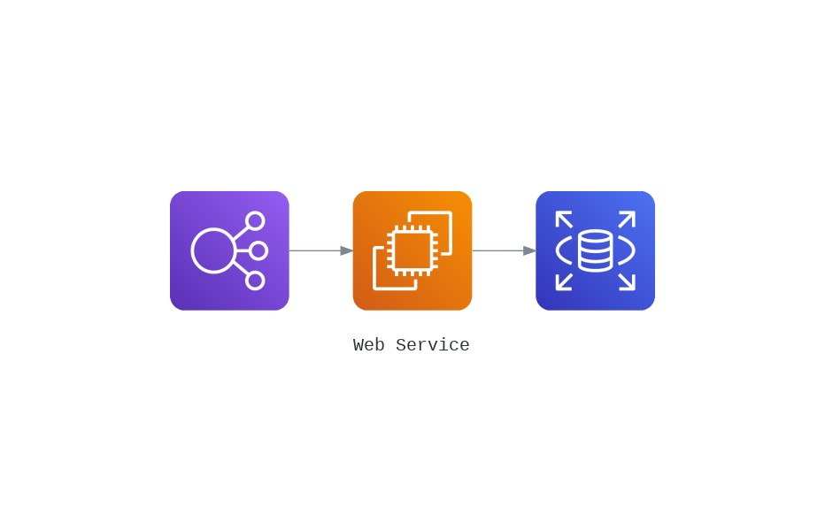\

1. Leftmost one is a Load Balancer connected with compute instance on AWS which is EC2 and a RDS is connected to the EC2 instance.
2. I have implemented it and here are the screenshots:

**VPC Resource Map -**   
I have created two Availability zones with two public subnets for the two Instances and a private subnet for running RDS on the same availability zone as the EC2 it is connected (to save costs).  
Both of the public subnets are associated to the custom route table which is in turn connected to the Internet gateway.  
Here's a screenshot of the same:  
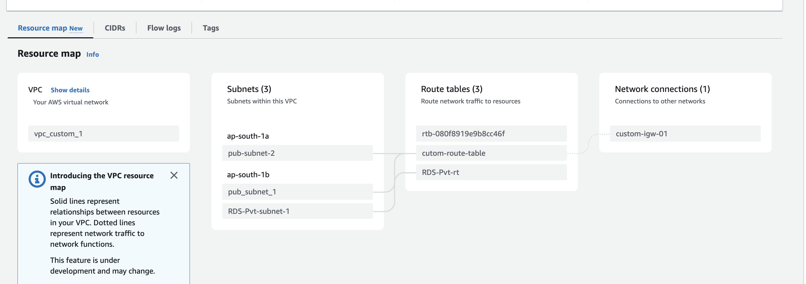

**Load Balancer:**

I have chosen an application load balancer to distribute load across the two instances that I have created around two different availability zones (*ap-south-1a* and *ap-south-1b*).

Here’s a screenshot of the same –

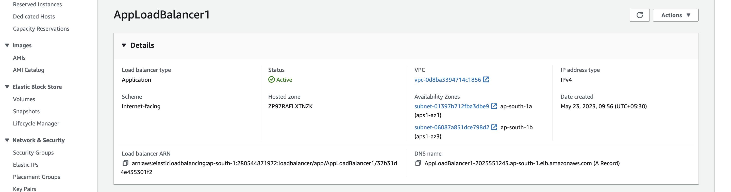

**EC2 Instances:**

Below are the two instances across two different availability zones that are connected by load balancer.

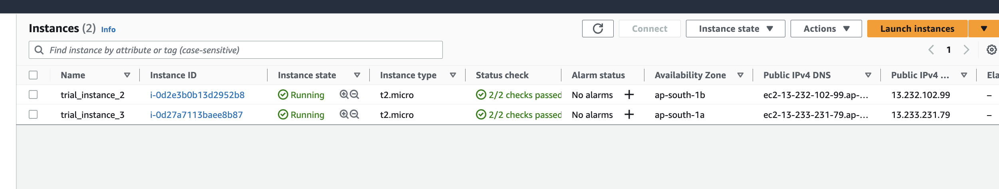

**RDS:**

Here’s the screenshot of the RDS instance on the same VPC and on the same availability zone as of trial_instance_3.

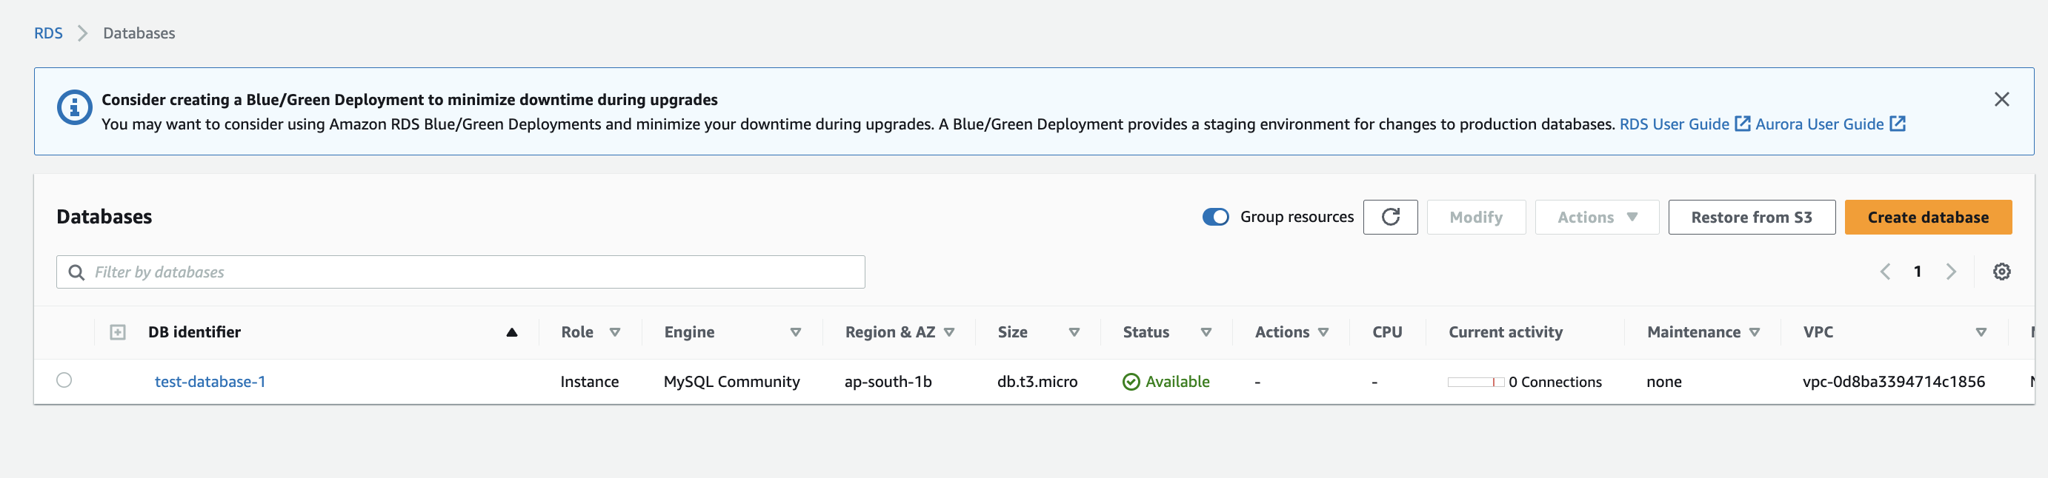

Below is the screenshot of the RDS instance setup on the private security group

