CBC: Decision Trees
The trees we obtained for the 6 emotions are as follows:
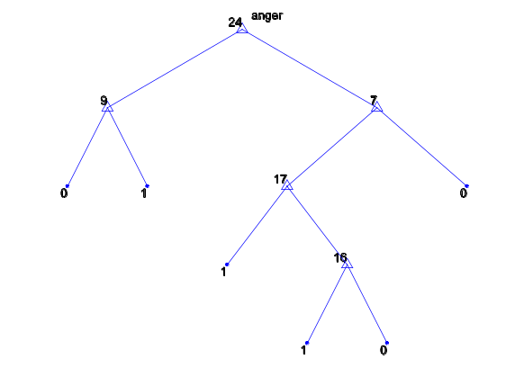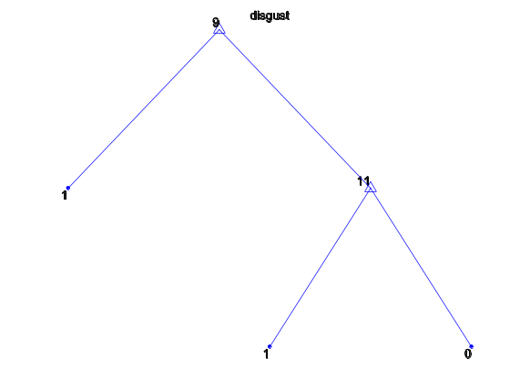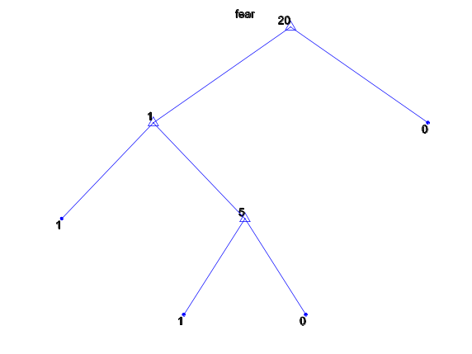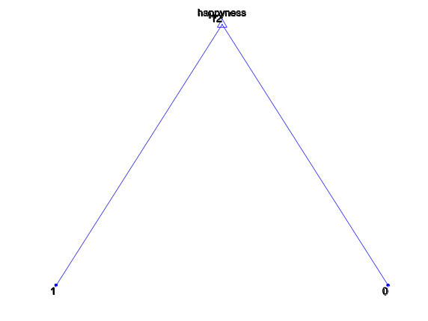
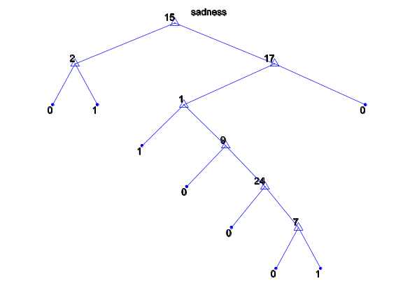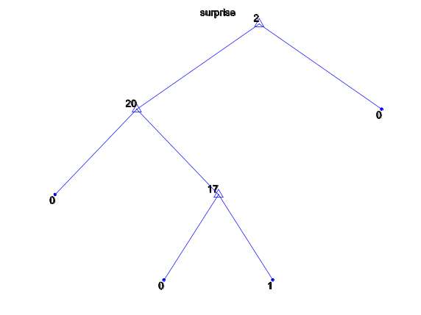

The confusion matrix:
1 2 3 4 5 6
1 6 0 1 0 5 0
2 1 21 0 0 0 0
3 2 0 4 0 1 0
4 0 1 0 23 0 0
5 2 0 0 0 10 0
6 0 0 0 0 0 23
Emotion | Average recall | Precision rate | F1-measure
1 | 0.5000 | 0.5455 | 0.5217
2 | 0.9545 | 0.9545 | 0.9545
3 | 0.5714 | 0.8 | 0.6667
4 | 0.9583 | 1 | 0.9787
5 | 0.8333 | 0.6250 | 0.7143
6 | 1 | 1 | 1

Pruning
Pruning is important in the field of decision trees, due to overfitting.
Overfitting refers to the fact that as the decision tree grows, it is becomes more and more specific to the training data and less of an accurate approximation to the true target function.

We can see this from the graphs produced by the pruning_example() function. The curves represent the cost (i.e. the misclassification error, or, the percentage of examples classified into the wrong category) and the tree size.
The first figure gives us the curve produced using 10-fold validation, while the second figure gives us the curve produced using resubstitution.

10-fold validation essentially emulates us having separate training and validation sets, so we can check how well the trained tree works on data which was not used to train it.
It clearly shows that the improvement in accuracy by increasing the tree size is only possible up to a certain point, after which there is even a tendency to decrease the accuracy. This is because the tree has specialized too much to the training set.
An extreme / fun example of the above effect may be as follows:
Let’s say we want to train a decision tree that classifies objects into whether the object is a human or not. We may give it a sample of 1 person.
The tree may then look as follows:
Human <- (hasArms /\ hasLegs /\ hasHair /\ hairColour=blonde).
While this would perfectly classify the training data (of size 1), it would obviously not generalize very well to the general case of humans, as many humans are not blonde (or don’t have any hair).
It may then be better to remove some parts of the tree (pruning), e.g. hasHair and hairColour, to improve the chances of classifying objects as human if they are. However, as most humans have legs and arms, it would not be a good idea to remove those two attributes. Thus the process of pruning is all about finding the statistical likeliness of a certain attribute appearing in the general population, and pruning those subtrees which decrease the accuracy / don’t increase it significantly.
The resubstition curve shows us how the tree is better able to classify the training data as the tree grows (until perfect classification is achieved). However, it is an overestimate of the true performance of the tree, which is better approximated using a validation set / 10-fold method.
10-fold validation curve: Resubstitution curve:
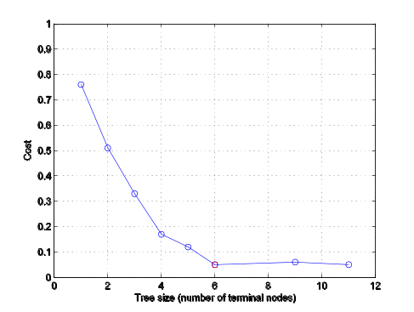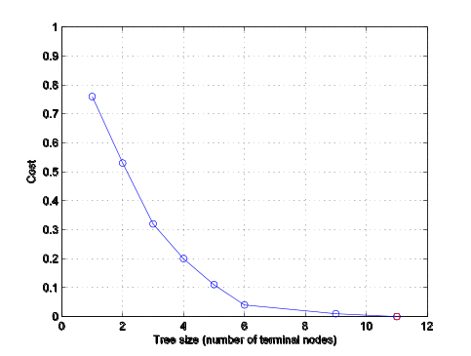

Combining decision trees
We started with 6 binary decision trees that classified a list of AU’s into +ve / -ve examples of the given emotion.
We used them to allows us to classify our examples into one of the 6 possible emotions using the following scheme:
Go through all the decision trees.
Case 1) One decision tree classifies the example as +ve, then pick this emotion as the classification.
Case 2) There are more than one decision trees which classify the example as +ve, pick the decision tree through which we went through the fewest levels. This is a usage of Occams razor, preferring decisions which had the fewest attributes involved in them (also, this would reduce the error associated with noise, as the fewer the attributes used, the lower the chance of incorrect attributes being used).
Case 2.1) If we multiple trees went down the same number of levels to classify it as +ve, then pick randomly from them.
Case 3) If none of the trees classify the example as +ve, then pick the tree where we went down the highest number of levels before classifying the example as –ve. This is so that we pick those emotions with which the example shares the highest number of attributes (thus assuming that the remaining attributes are not shared with the tree due to noise).

An alternative to case2 and case3 would be to classify an example as a ‘neut’. This would be useful in commercial applications of machine learning where accuracy is important, as it would simply ask for the AU’s to be inserted again (e.g. take another picture of the user and extract the AU’s) rather than to classify to something it isn’t sure of.

