CBC: Decision Trees

Combining decision trees
We started with 6 binary decision trees that classified a list of AU’s into positive and negative examples of the given emotion.
We used them to allow us to classify our examples into one of the 6 possible emotions by going through and evaluating with all the decision trees to produce a list of the classifiers that returns positive. From this, we get a single classification result based on one of the following cases:

- Case 1) If only one decision tree classifies the example as positive, then pick this emotion as the classification.
- Case 2) There are more than one decision trees which classify the example as positive, pick the decision tree through which we went through the fewest levels. By the method of construction of the decision tree, the attributes that are closer to the root are the ones that provide the most information gain and hence should be the most discriminatory in classifying an example. This is also usage of Occam’s razor, preferring decisions which had the fewest attributes involved in them (also, this would reduce the error associated with noise, as the fewer the attributes used, the lower the chance of incorrect attributes being used).
- Case 2.1) If multiple trees went down the same number of levels to classify it as positive, then pick randomly from them. There is no other further way of choosing the best match so from here it would be guesswork. This is similar to how humans might resolve this situation in real life.
- Case 3) If none of the trees classify the example as positive, then pick the tree where we went down the highest number of levels before classifying the example as negative. This is the opposite to case 2) so that the further it travels down the tree, the less confident the classifier would be of a negative result as it bases the decision on less and less discriminatory information. This then means that we pick those emotions with which the example shares the highest number of attributes (thus assuming that the remaining attributes are not shared with the tree due to noise). This gives us the closest approximation we to the classification given what the decision tree learns from the training data.
- Case 3.1) If multiple trees went down the same number of levels to classify it as negative, then pick randomly from them. This is a similar situation to case 2.1)

An alternative to case 2 and case 3 would be to classify an example as a ‘neut’. This would be useful in commercial applications of machine learning where accuracy is important, as it would simply ask for the AU’s to be inserted again (e.g. take another picture of the user and extract the AU’s) rather than to classify to something it isn’t sure of.

The trees we obtained for the 6 emotions are as follows:

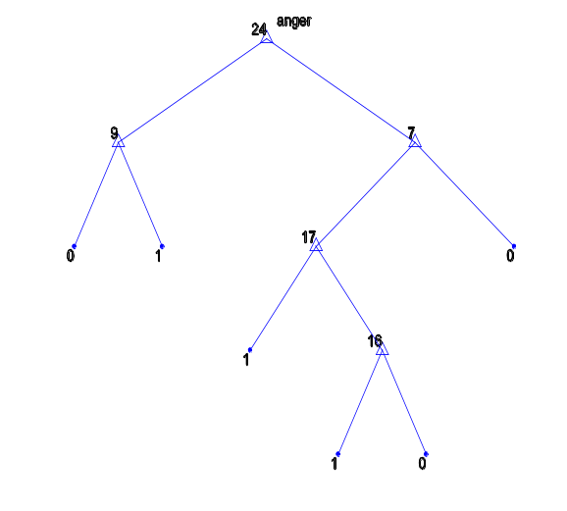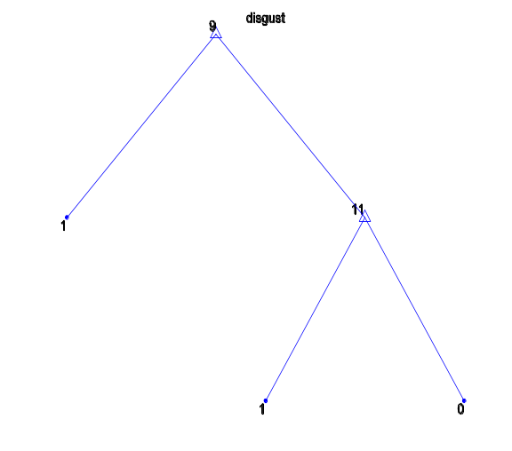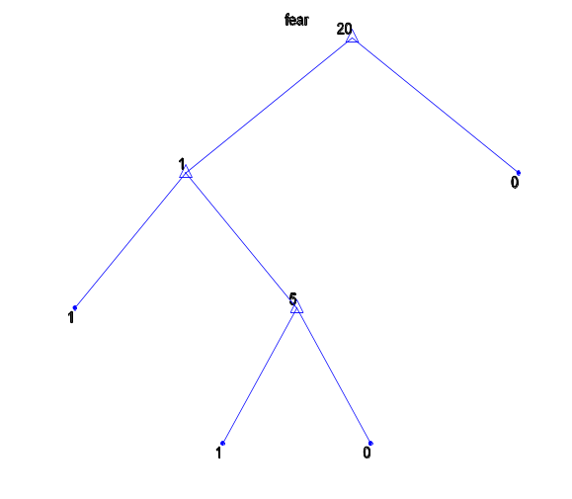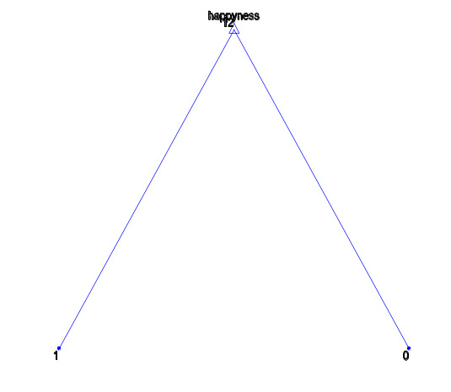
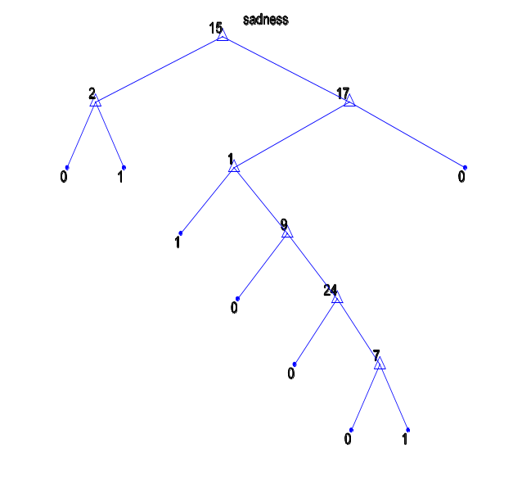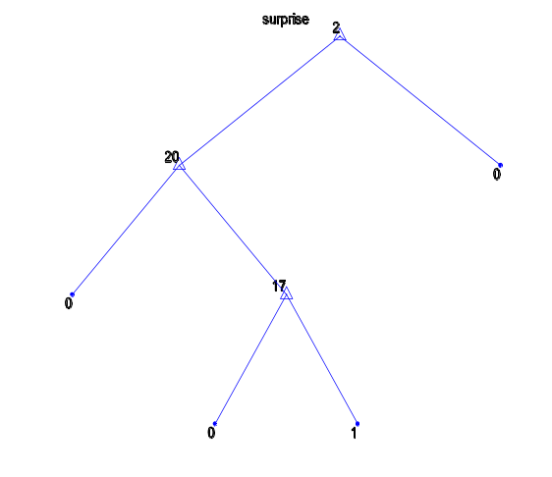

The evaluation of the trees using the 10-fold cross-verification gave us the following results:

The confusion matrix:
1 2 3 4 5 6
1 6 0 1 0 5 0
2 1 21 0 0 0 0
3 2 0 4 0 1 0
4 0 1 0 23 0 0
5 1 0 0 0 10 1
6 0 0 0 0 0 23
Emotion | Recall | Precision | F1-measure
1 (Anger) | 0.5000 | 0.6000 | 0.5455
2 (Disgust) | 0.9545 | 0.9545 | 0.9545
3 (Fear) | 0.5714 | 0.8000 | 0.6667
4 (Happy) | 0.9583 | 1.0000 | 0.9787
5 (Sad) | 0.8333 | 0.6250 | 0.7143
6 (Surprise) | 1.0000 | 0.9583 | 0.9787
As we can see from the results, the decision trees have the most problems recognizing anger and fear. From the confusion matrix it can also be seen that they have the most trouble trying to distinguish between anger and sadness. The classifiers that tend to be most accurate are the ones with shorter trees. There can be a slight variation in the results because of the randomness factor we put into the classifications for case 2.1) and case 3.1).

Pruning
Pruning is important in the field of decision trees, due to overfitting. Overfitting refers to the fact that as the decision tree grows, it becomes more and more specific to the training data and less of an accurate approximation to the true target function.

We can see this from the graphs produced by the pruning_example() function. The curves represent the cost (i.e. the misclassification error, or, the percentage of examples classified into the wrong category) and the tree size.
The first figure gives us the curve produced using 10-fold validation, while the second figure gives us the curve produced using resubstitution. 10-fold validation essentially emulates us having separate training and validation sets, so we can check how well the trained tree works on data which was not used to train it.
It clearly shows that the improvement in accuracy by increasing the tree size is only possible up to a certain point, after which there is even a tendency to decrease the accuracy. This is because the tree has specialized too much to the training set.
An extreme / fun example of the above effect may be as follows:
Let’s say we want to train a decision tree that classifies objects into whether the object is a human or not. We may give it a sample of 1 person.
The tree may then look as follows:
Human <- (hasArms /\ hasLegs /\ hasHair /\ hairColour=blonde).
While this would perfectly classify the training data (of size 1), it would obviously not generalize very well to the general case of humans, as many humans are not blonde (or don’t have any hair).
It may then be better to remove some parts of the tree (pruning), e.g. hasHair and hairColour, to improve the chances of classifying objects as human if they are. However, as most humans have legs and arms, it would not be a good idea to remove those two attributes. Thus the process of pruning is all about finding the statistical likeliness of a certain attribute appearing in the general population, and pruning those subtrees which decrease the accuracy / don’t increase it significantly.
The resubstition curve shows us how the tree is better able to classify the training data as the tree grows (until perfect classification is achieved). However, it is an overestimate of the true performance of the tree, which is better approximated using a validation set / 10-fold method.
10-fold validation curve: Resubstitution curve:
