Ubuntu Server Hardening Blue-Team Lab
From Fresh Ubuntu Install to Evidence-Ready Security Baseline
A hands-on Linux hardening project demonstrating infrastructure security, blue-team validation, audit evidence generation, and operational troubleshooting.
Author: Poul Mhiripiri
• Project focus: Ubuntu Server hardening after installation
• Security tooling: Lynis, UFW, Fail2Ban, Auditd, RKHunter, SSH hardening and sysctl tuning
• Evidence approach: before-and-after logs, screenshots, post-hardening reports and validation steps
• Portfolio value: demonstrates Linux administration, infrastructure security and blue-team operational thinking

Executive Summary
This screenshot walkthrough documents a complete Ubuntu Server hardening lab, starting from a fresh installation and ending with validated security controls and human-readable reporting. The project is designed not only Bash automation, but also operational discipline: review before execution, audit-only testing, controlled hardening, validation, troubleshooting, and evidence production.
The activity reflects practical infrastructure experience: patching, service review, SSH protection, firewall validation, brute-force protection, audit logging, and security posture measurement using Lynis. The screenshots demonstrate the end-to-end process that a Linux administrator, infrastructure engineer, or blue-team analyst would follow when securing a newly installed server.

Step 1: Fresh Ubuntu Server Installation
The lab begins with a clean Ubuntu Server installation in VMware. Starting from a fresh build gives the hardening activity a realistic Day-0 baseline and allows the project to demonstrate how security controls are applied immediately after provisioning.
Rationale/Value: shows the ability to build and secure systems from the ground up, not only operate prebuilt environments.
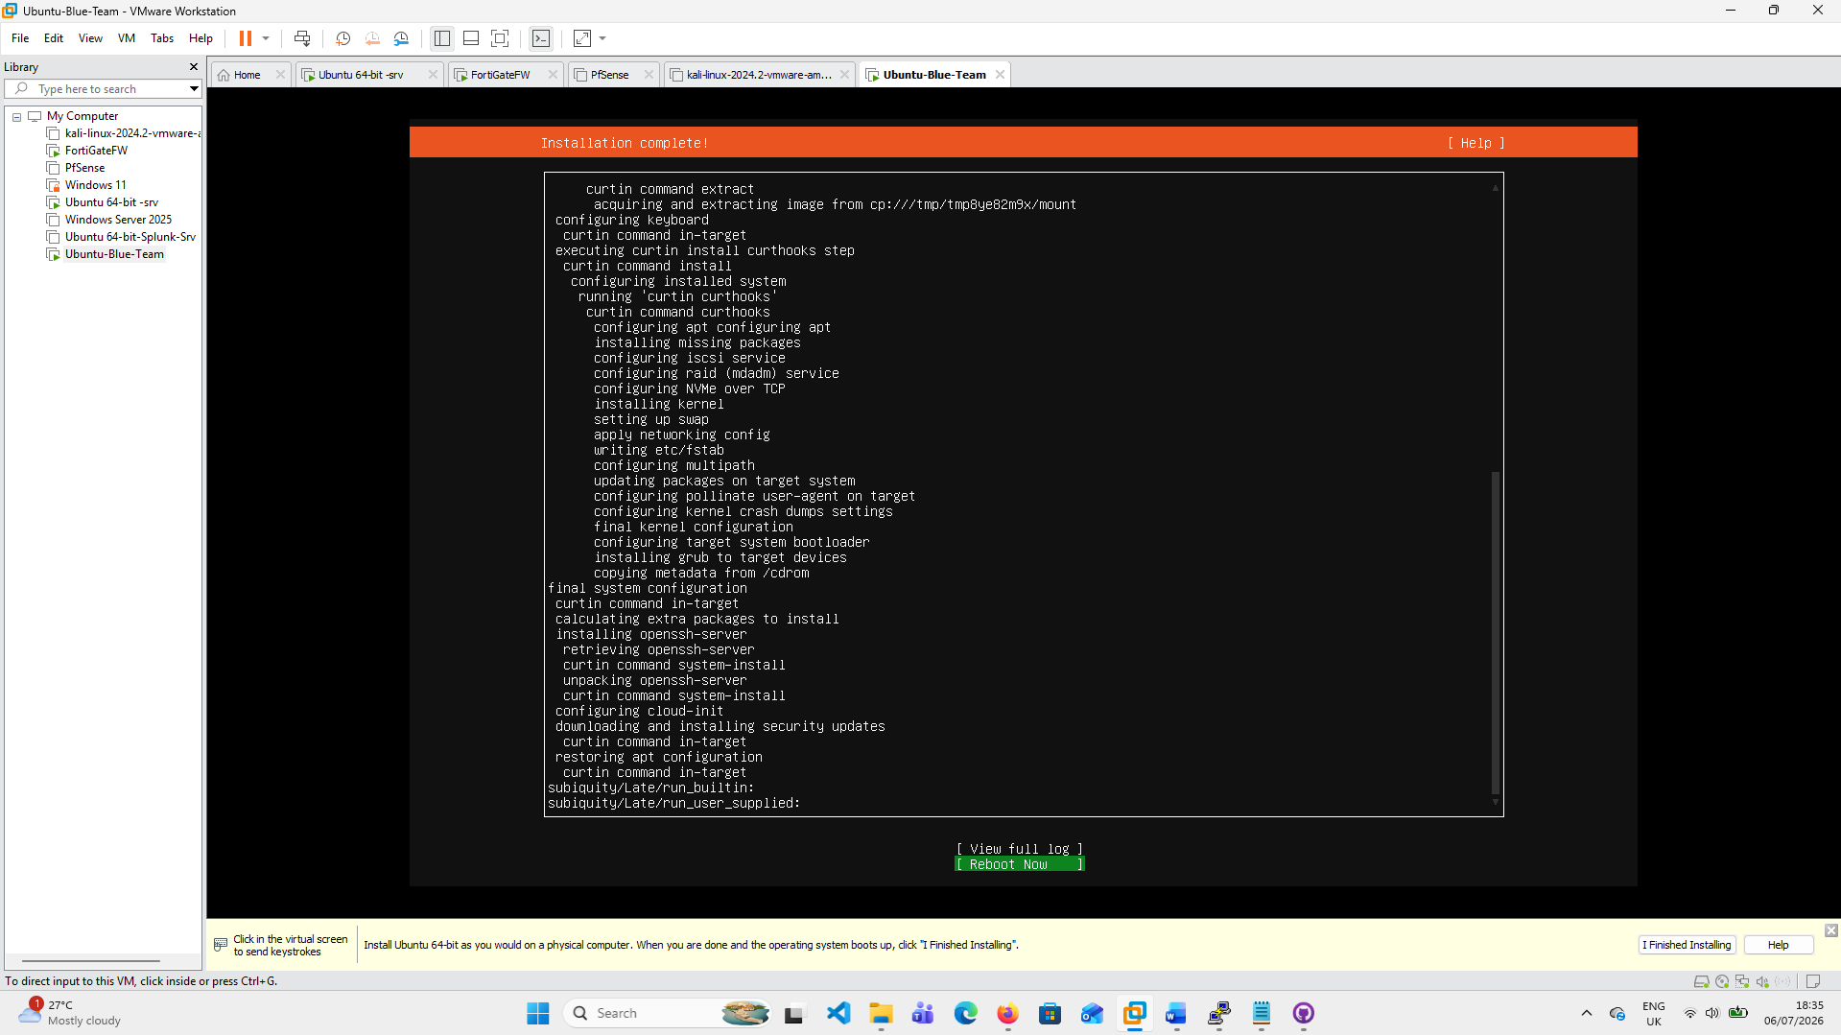
Figure 1: Fresh Ubuntu Server Installation evidence screenshot

Step 2: Baseline Confirmation: Installation Date and Host Readiness
The installation timestamp and initial server state were checked before running the hardening workflow. This establishes traceability and shows that the hardening evidence was captured from a newly provisioned lab server rather than an already-tuned system.
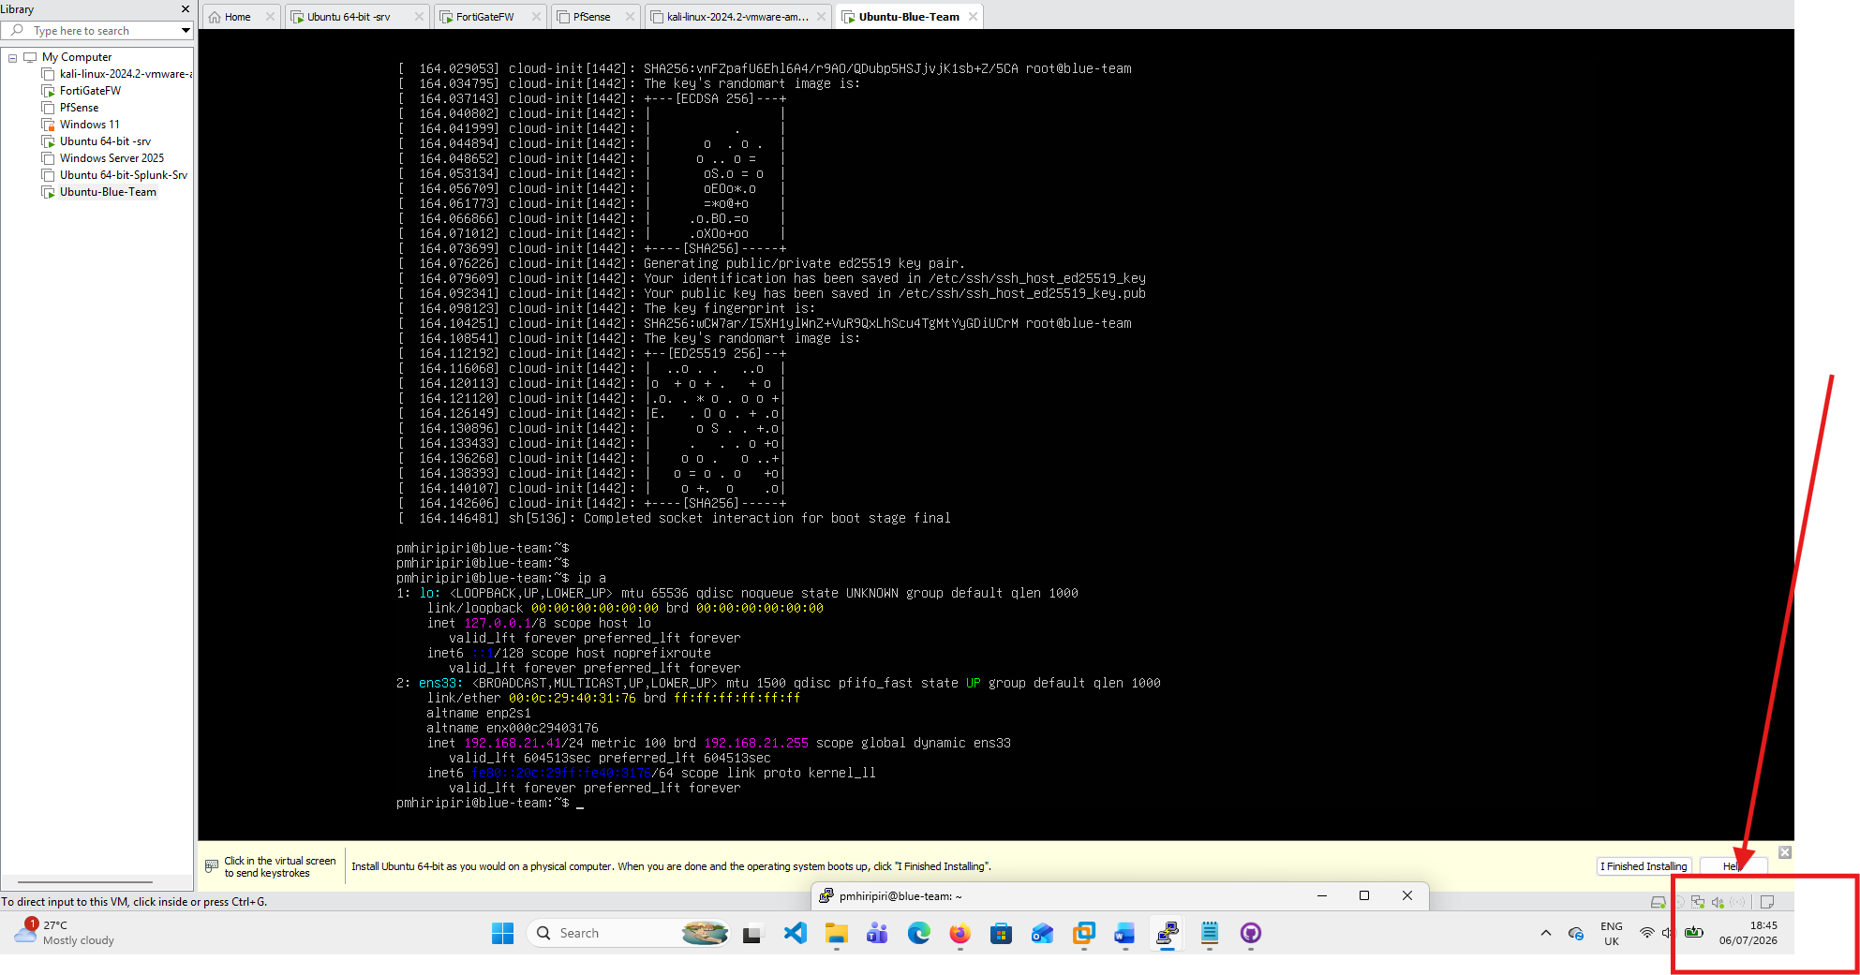
Figure 2: Baseline Confirmation: Installation Date and Host Readiness evidence screenshot
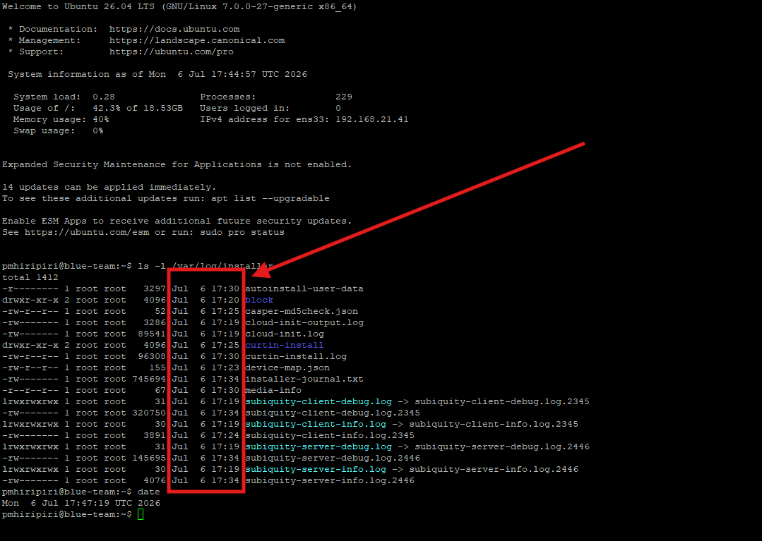
Figure 3: Baseline Confirmation: Installation Date and Host Readiness evidence screenshot

Step 3: Install Git and Clone the Hardening Toolkit
Git was installed so the Ubuntu server could pull the project directly from GitHub. This demonstrates a practical deployment pattern: clone the repository, review the script, and execute the workflow from the server being secured.
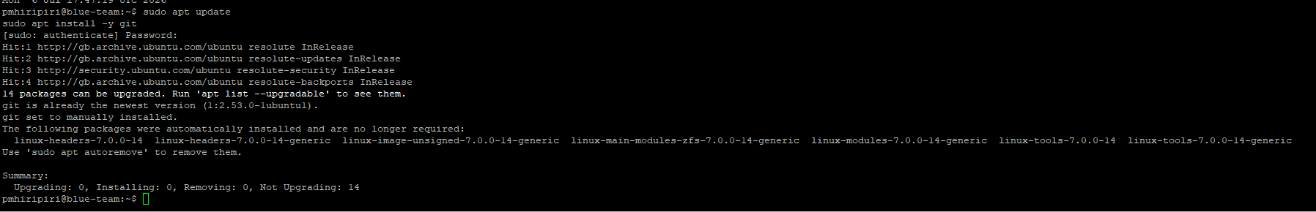
Figure 4: Install Git and Clone the Hardening Toolkit evidence screenshot
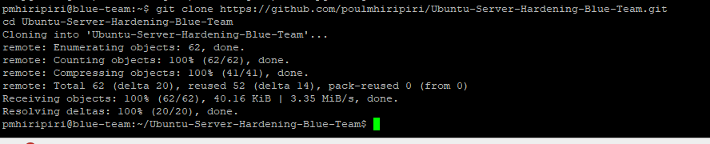
Figure 5: Install Git and Clone the Hardening Toolkit evidence screenshot

Step 4: Repository Clone Validation
The repository was successfully cloned from GitHub and the working directory was changed into the project folder. This confirms that the toolkit can be consumed as a normal GitHub-based operational project.
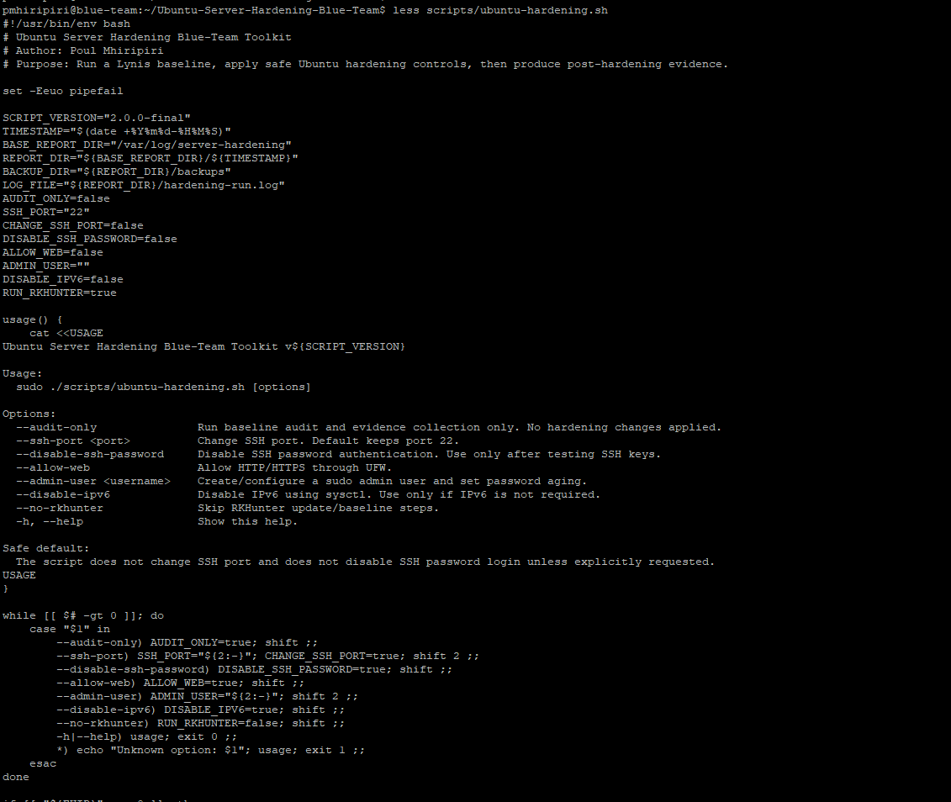
Figure 6: Repository Clone Validation evidence screenshot

Step 5: Script Review Before Execution
The script was reviewed using the terminal before execution. Reviewing automation before running it as root is an important operational control, especially for infrastructure and security hardening tasks.
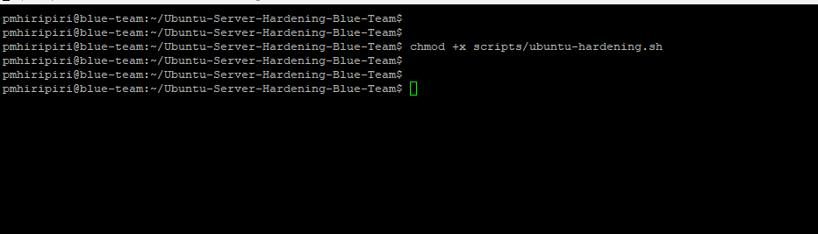
Figure 7: Making the script executable screenshot

Step 6: Safe Audit-Only Mode
The first execution used audit-only mode. This allows Lynis and the evidence collection logic to capture the baseline posture without making configuration changes, reducing the risk of unplanned disruption.
Value: demonstrates safe testing by collecting baseline evidence before changing server configuration.
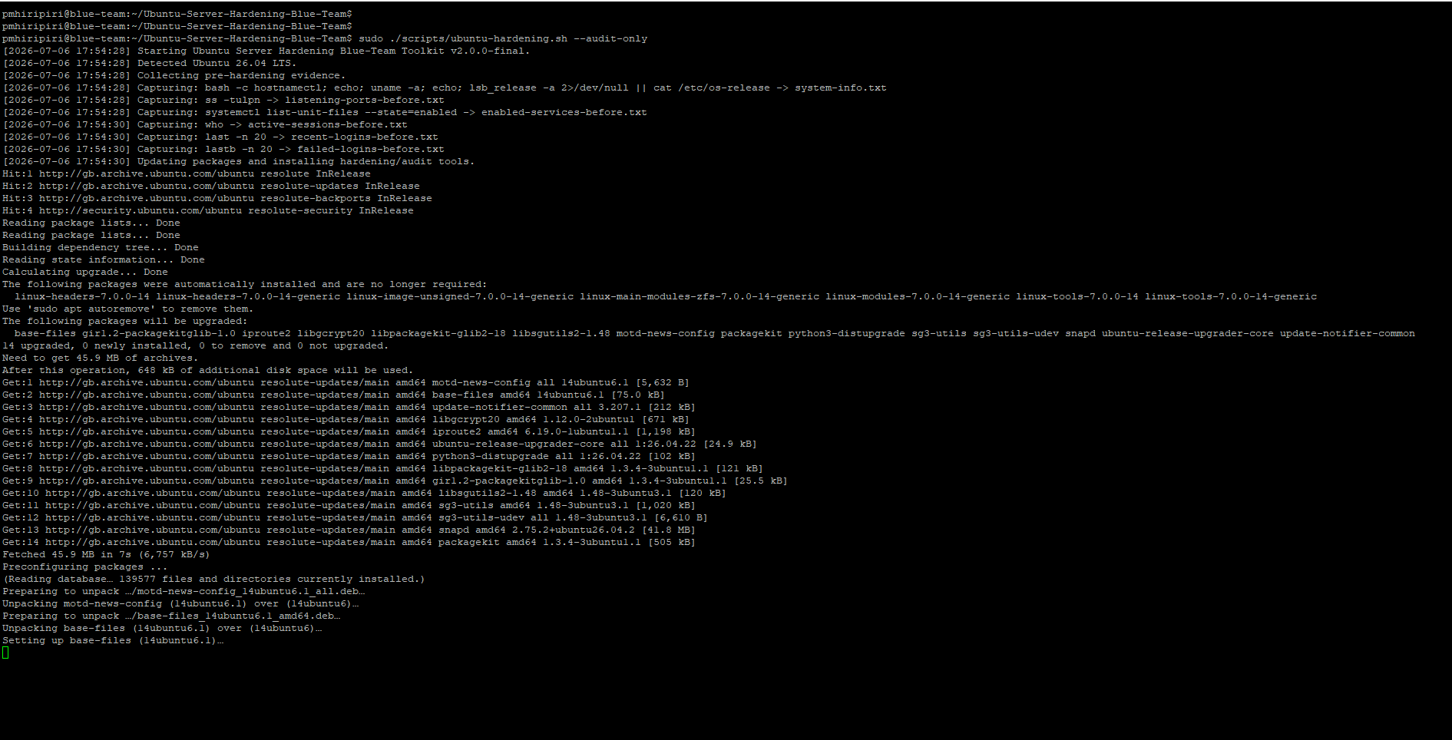
Figure 8: Safe Audit-Only Mode evidence screenshot

Step 7: Full Hardening Workflow Execution
The hardening workflow was then executed with safe defaults. The script applied security controls while avoiding risky lockout actions such as changing the SSH port or disabling password authentication without explicit confirmation.
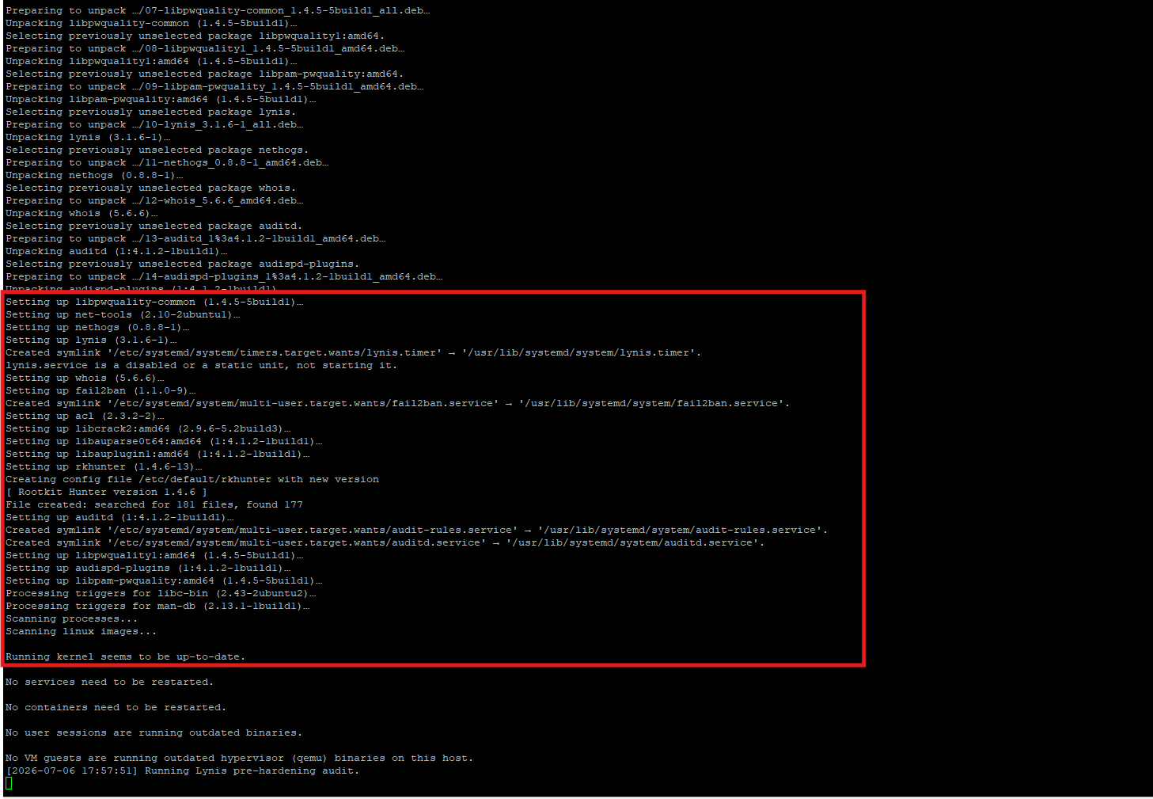
Figure 9: Full Hardening Workflow Execution evidence screenshot
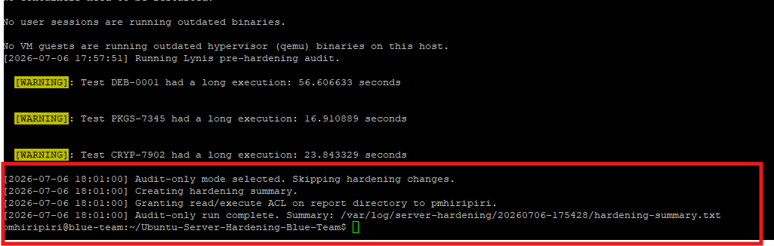
Figure 10: Full Hardening Workflow Execution evidence screenshot

Step 8: Lynis Audit Execution and Completion
The workflow ran Lynis as part of the security posture assessment. Lynis output provides a recognized Linux audit trail and supports measurable before-and-after security validation.
Value: demonstrates knowledge of Linux audit tooling and measurable security posture reporting.
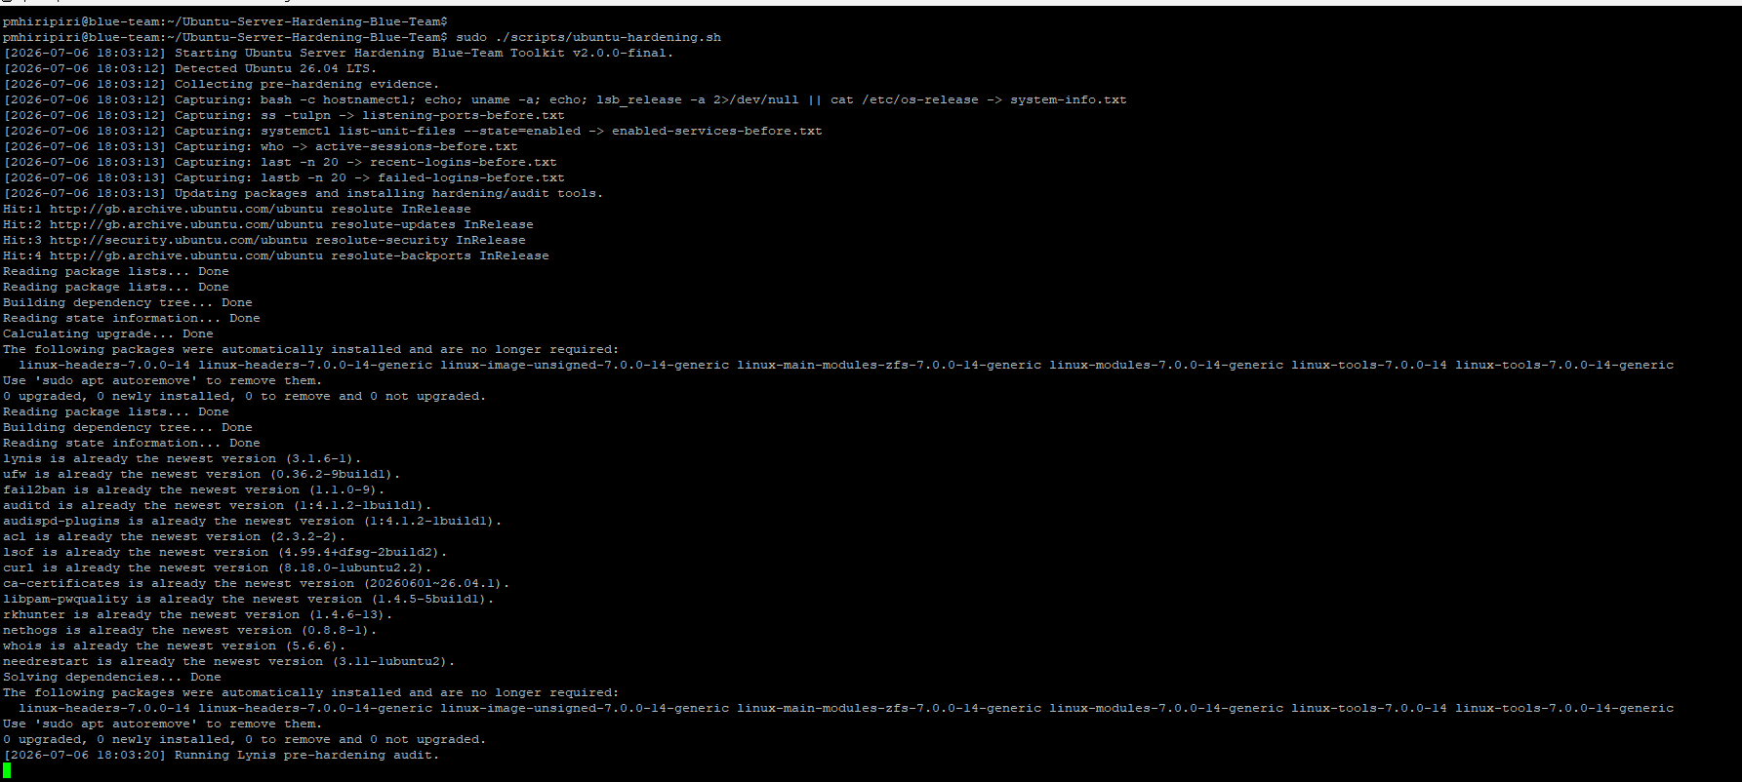
Figure 11: Lynis Audit Execution and Completion evidence screenshot
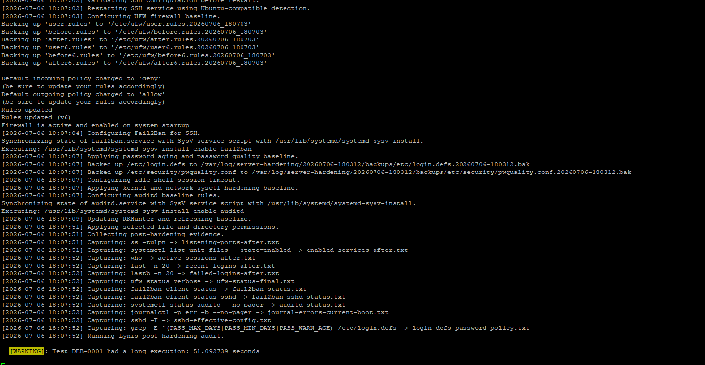
Figure 12: Lynis Audit Execution and Completion evidence screenshot

Step 9: Hardening Summary Generated
The script completed successfully and generated a hardening summary under /var/log/server-hardening/latest. This creates a single entry point for evidence review and simplifies follow-up validation.
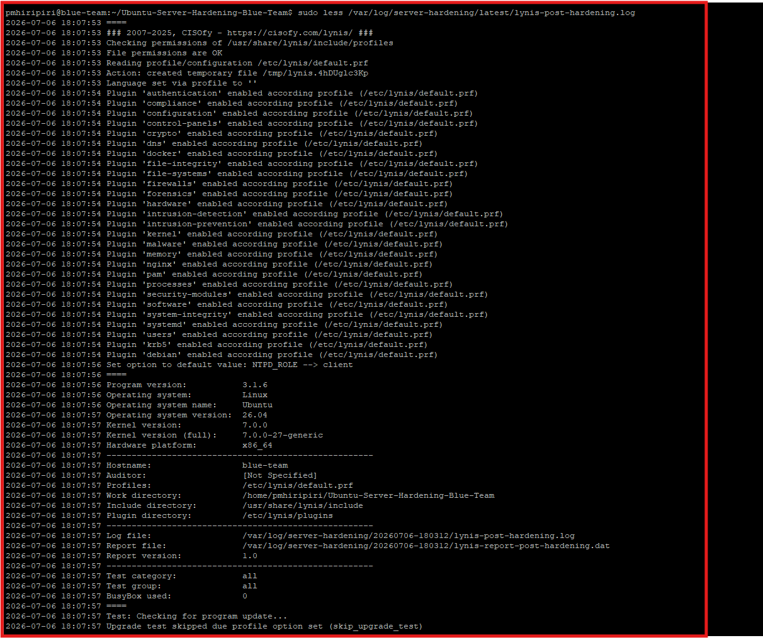
Figure 13: Hardening Summary Generated evidence screenshot

Step 10: Accessing Generated Evidence Files
The evidence directory contains the outputs created during the workflow, including service lists, listening ports, Fail2Ban status, SSH configuration, Lynis logs, and the hardening summary. These files support repeatable audit and portfolio evidence.
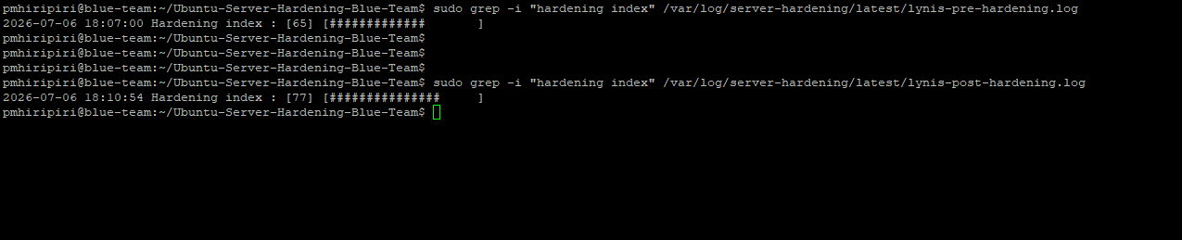
Figure 14: Accessing Generated Evidence Files evidence screenshot
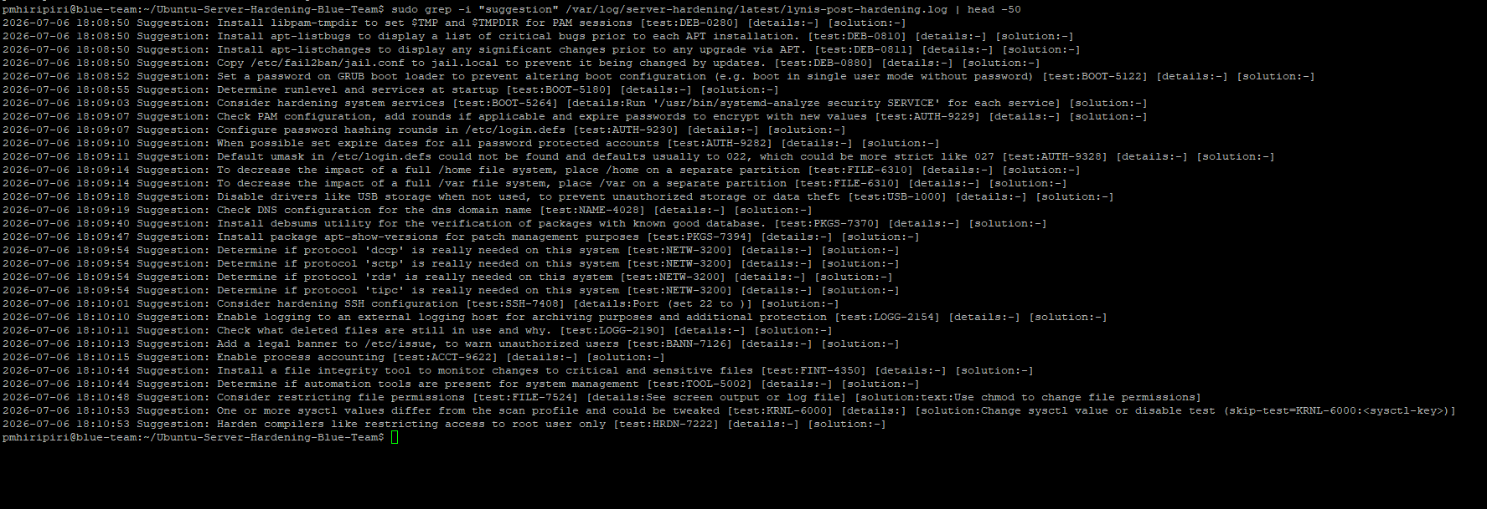
Figure 15: Accessing Generated Evidence Files evidence screenshot

Step 11: Viewing the Post-Hardening Lynis Report
The post-hardening Lynis log was opened for review. This is the main report used to verify which controls were improved and which recommendations remain for future tuning.
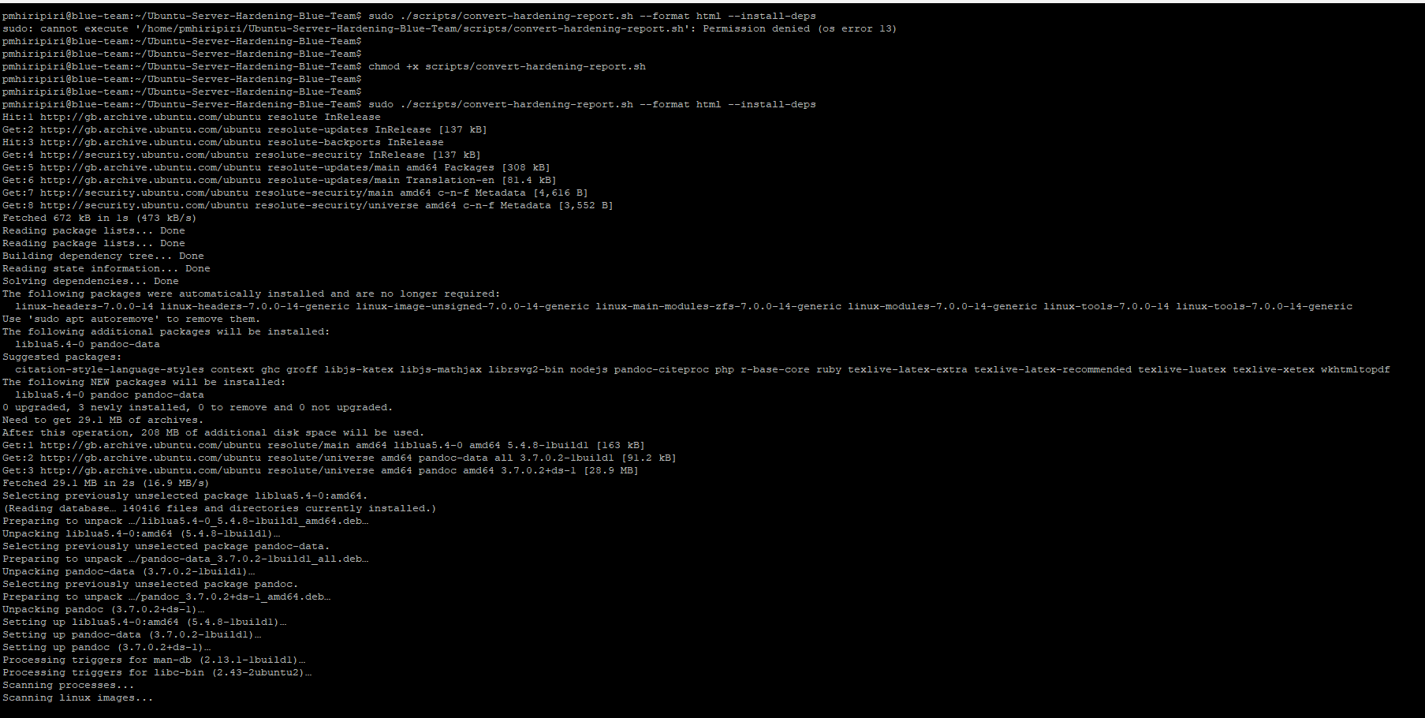
Figure 16: Viewing the Post-Hardening Lynis Report evidence screenshot

Step 12: Pre- and Post-Hardening Score Comparison
The Lynis hardening index was checked before and after the workflow. The lab evidence shows improvement from a pre-hardening score of 65 to a post-hardening score of 77, demonstrating measurable security improvement.
Recruiter value: provides measurable improvement that can be discussed in interviews and portfolio reviews.
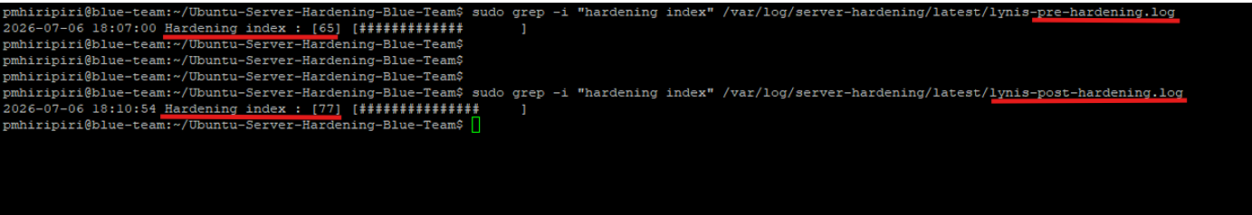
Figure 17: Pre hardening and Post Hardening index

Step 13: Reviewing Lynis Suggestions
Remaining Lynis suggestions were reviewed to identify future hardening opportunities. This shows a realistic security approach: hardening is iterative and must be validated, reviewed, and improved over time.
Figure 21: Generate Human-Readable Reports evidence screenshot

Step 15: Legal SSH Banner Validation
Narration: The SSH legal warning banner was validated by initiating a new SSH connection. This confirms the banner control is visible to users before authentication, supporting acceptable-use and monitoring notices.
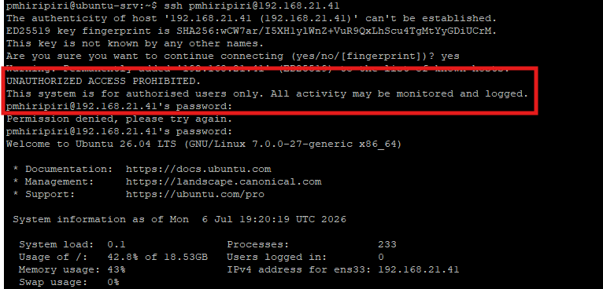
Figure 18: Legal SSH Banner Validation evidence screenshot

Step 16: Fail2Ban Detection and Blocking Validation
Fail2Ban was tested by triggering SSH authentication failures. The evidence shows the sshd jail in effect and confirms that a source IP was banned after repeated failed login attempts, demonstrating active brute-force protection.
Validates an active defensive control rather than simply claiming Fail2Ban was installed.
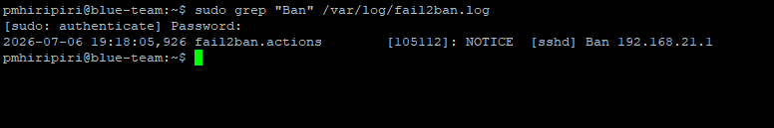
Figure 19: Fail2ban evidence screenshot
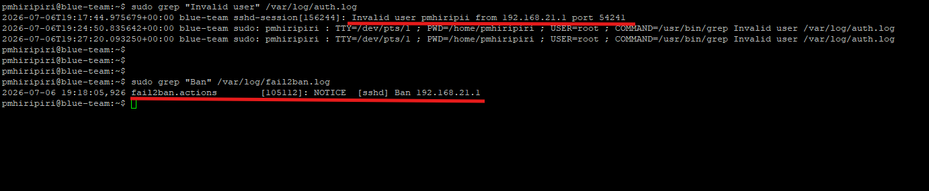
Figure 20: Fail2Ban Detection and Blocking Validation evidence screenshot

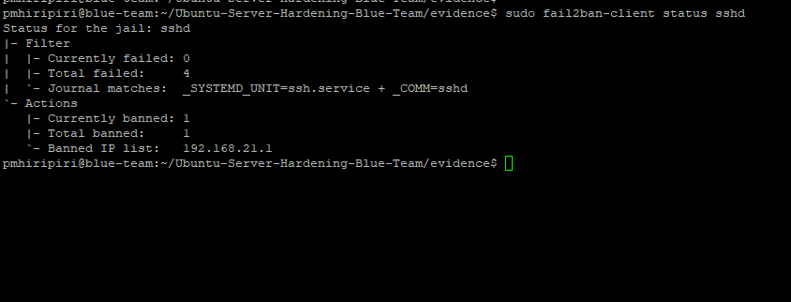
Figure 21: Fail2Ban Detection and Blocking Validation evidence screenshot

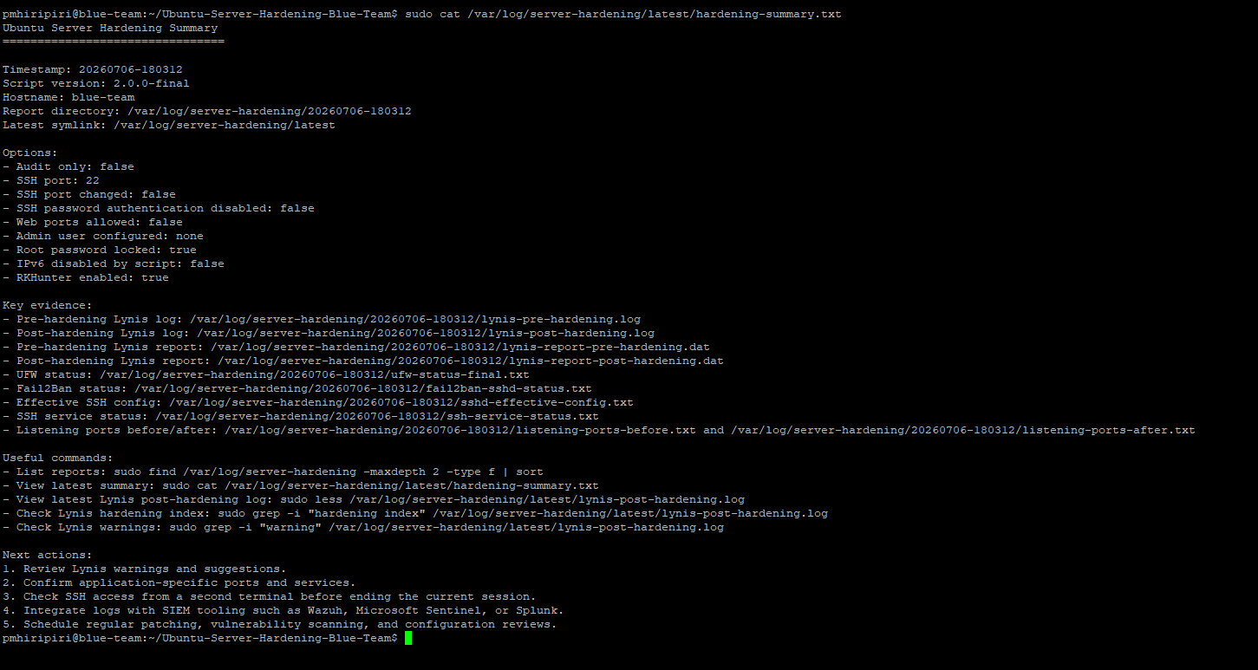

Lessons Learned and Operational Notes
Safe defaults matter: The hardening workflow intentionally keeps SSH password authentication and port 22 unchanged unless the operator explicitly requests stricter settings. This reduces the risk of remote lockout during first-time testing.
Ubuntu service names matter: The project handles Ubuntu SSH service naming by using ssh.service first and falling back to sshd.service where appropriate.
Evidence must be readable: Raw logs are useful for technical validation, but Markdown, HTML and PDF summaries make the output easier to present to recruiters, reviewers and team leads.
Hardening is iterative: The Lynis score improved, but remaining warnings and suggestions should be reviewed as part of regular configuration management and vulnerability management.
Controls must be validated: The SSH banner and Fail2Ban tests demonstrate that controls were not only configured, but also tested from the operator perspective.
Summary: I built and tested an Ubuntu Server hardening toolkit that starts with a baseline Lynis audit, applies controlled hardening for SSH, firewalling, Fail2Ban, audit logging, password policy and kernel parameters, then generates before-and-after evidence and human-readable reports. The lab demonstrates how I combine hands-on Linux infrastructure experience with blue-team security validation and audit-ready documentation.

