Dsdsd

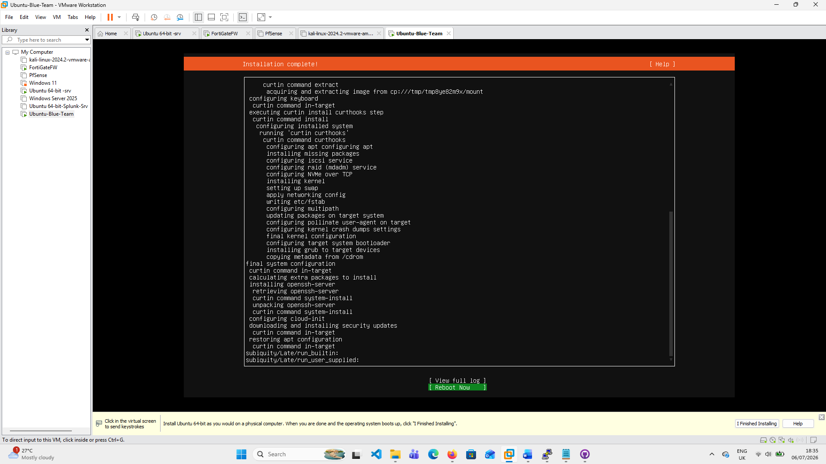
Figure 1: Fresh Ubuntu installation
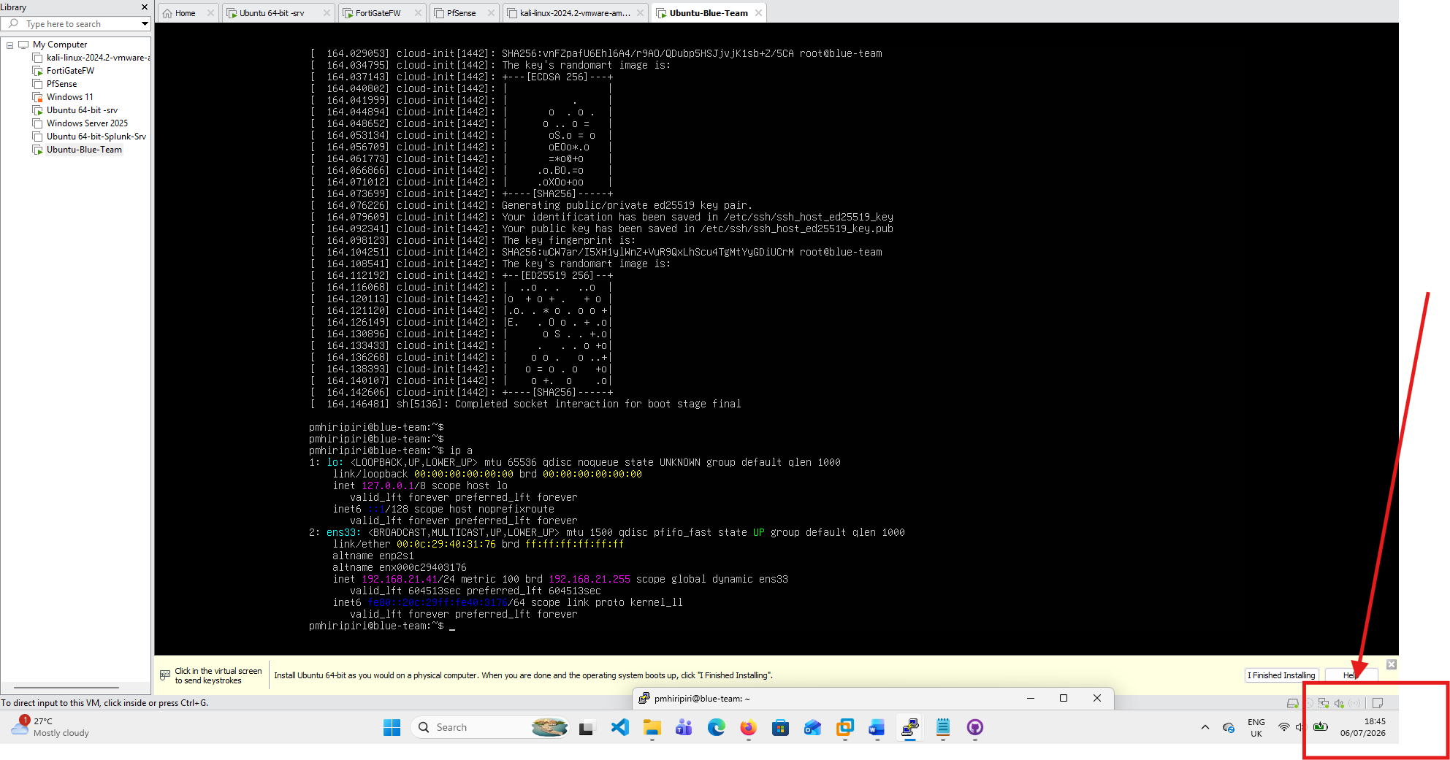

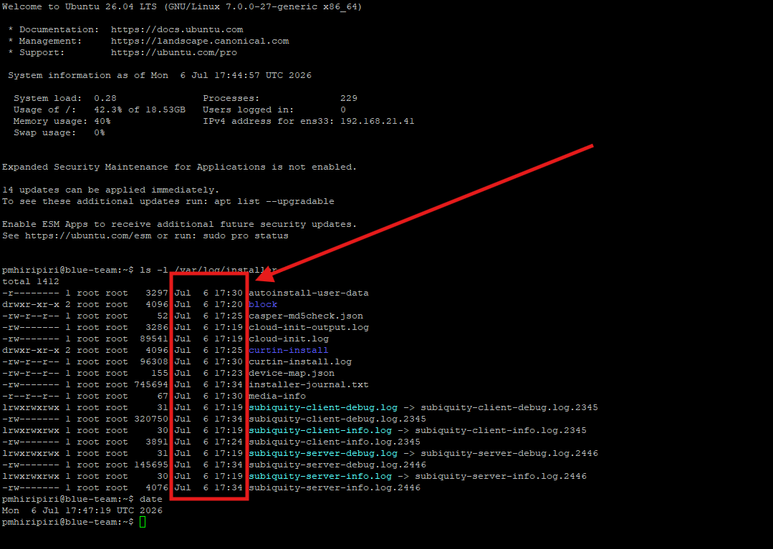
Figure 2: Confirming date and time when Ubuntu was installed

sudo apt update
sudo apt install -y git

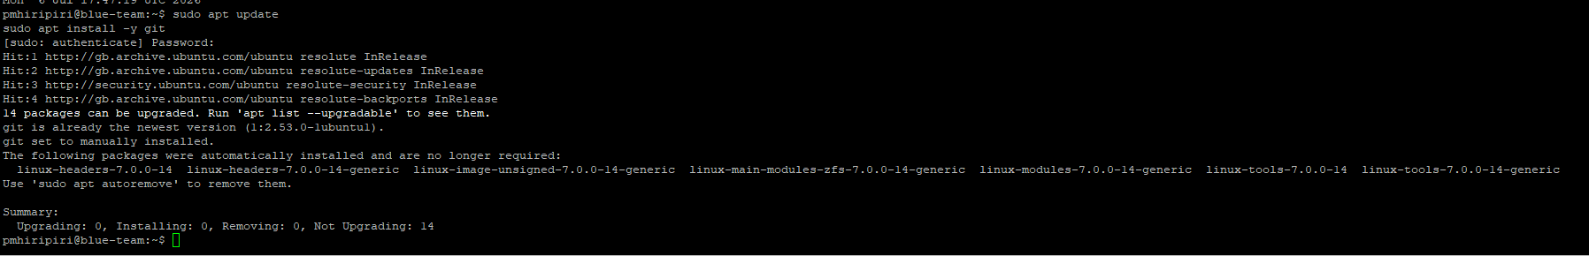

git clone https://github.com/poulmhiripiri/Ubuntu-Server-Hardening-Blue-Team.git
cd Ubuntu-Server-Hardening-Blue-Team

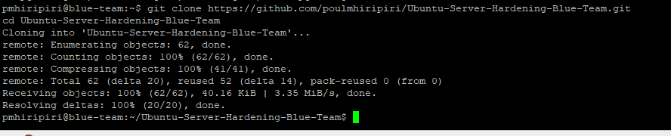

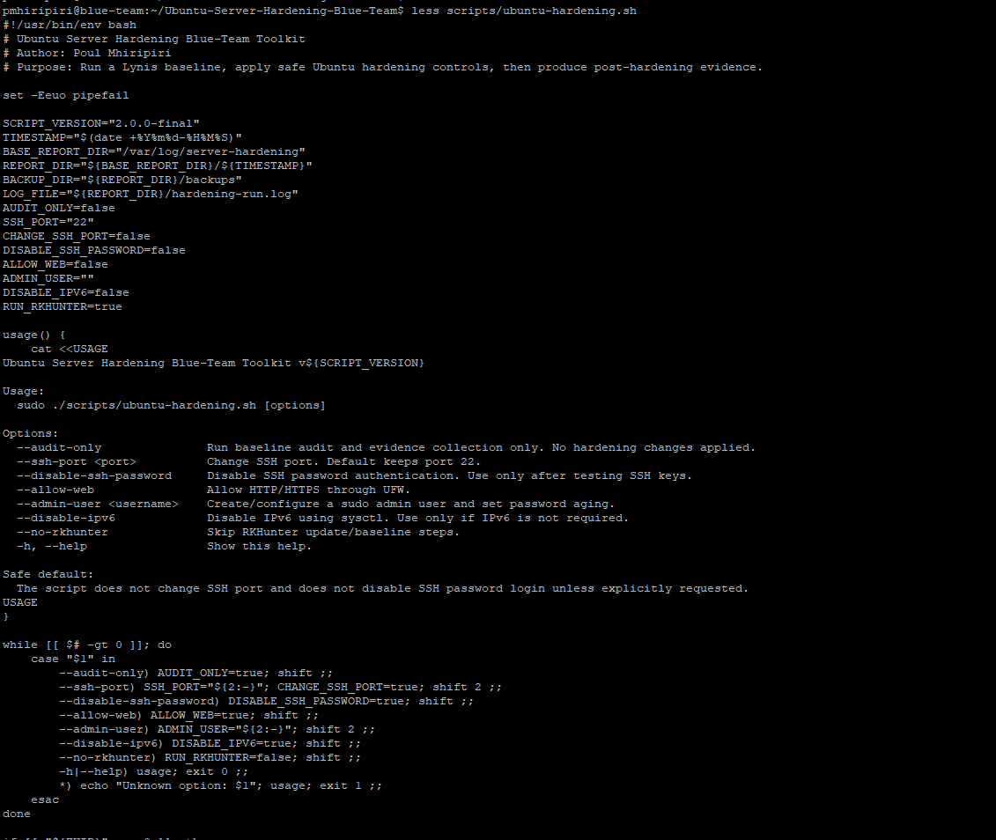

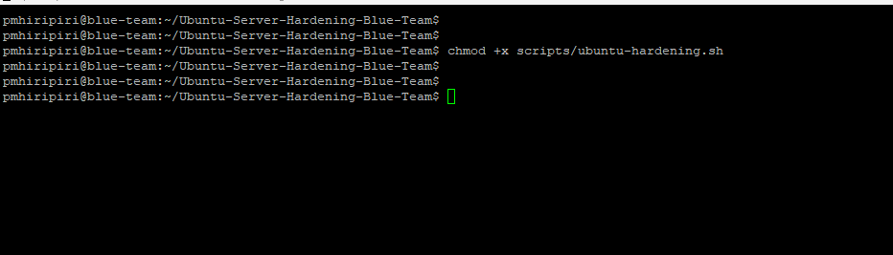

sudo ./scripts/ubuntu-hardening.sh --audit-only
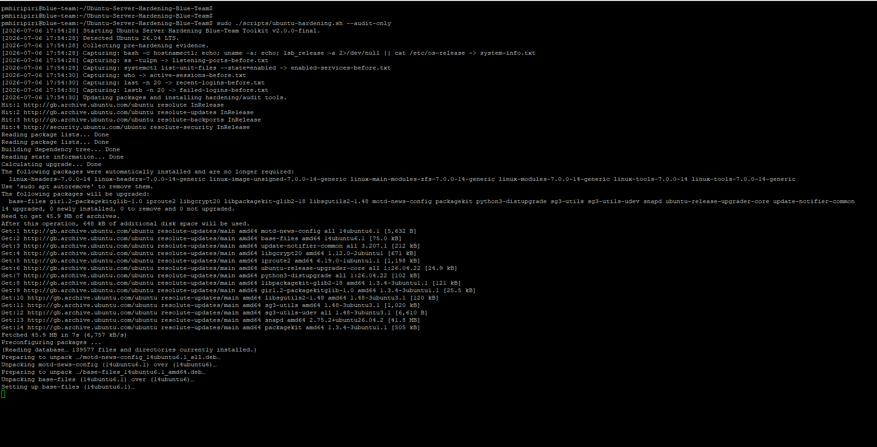

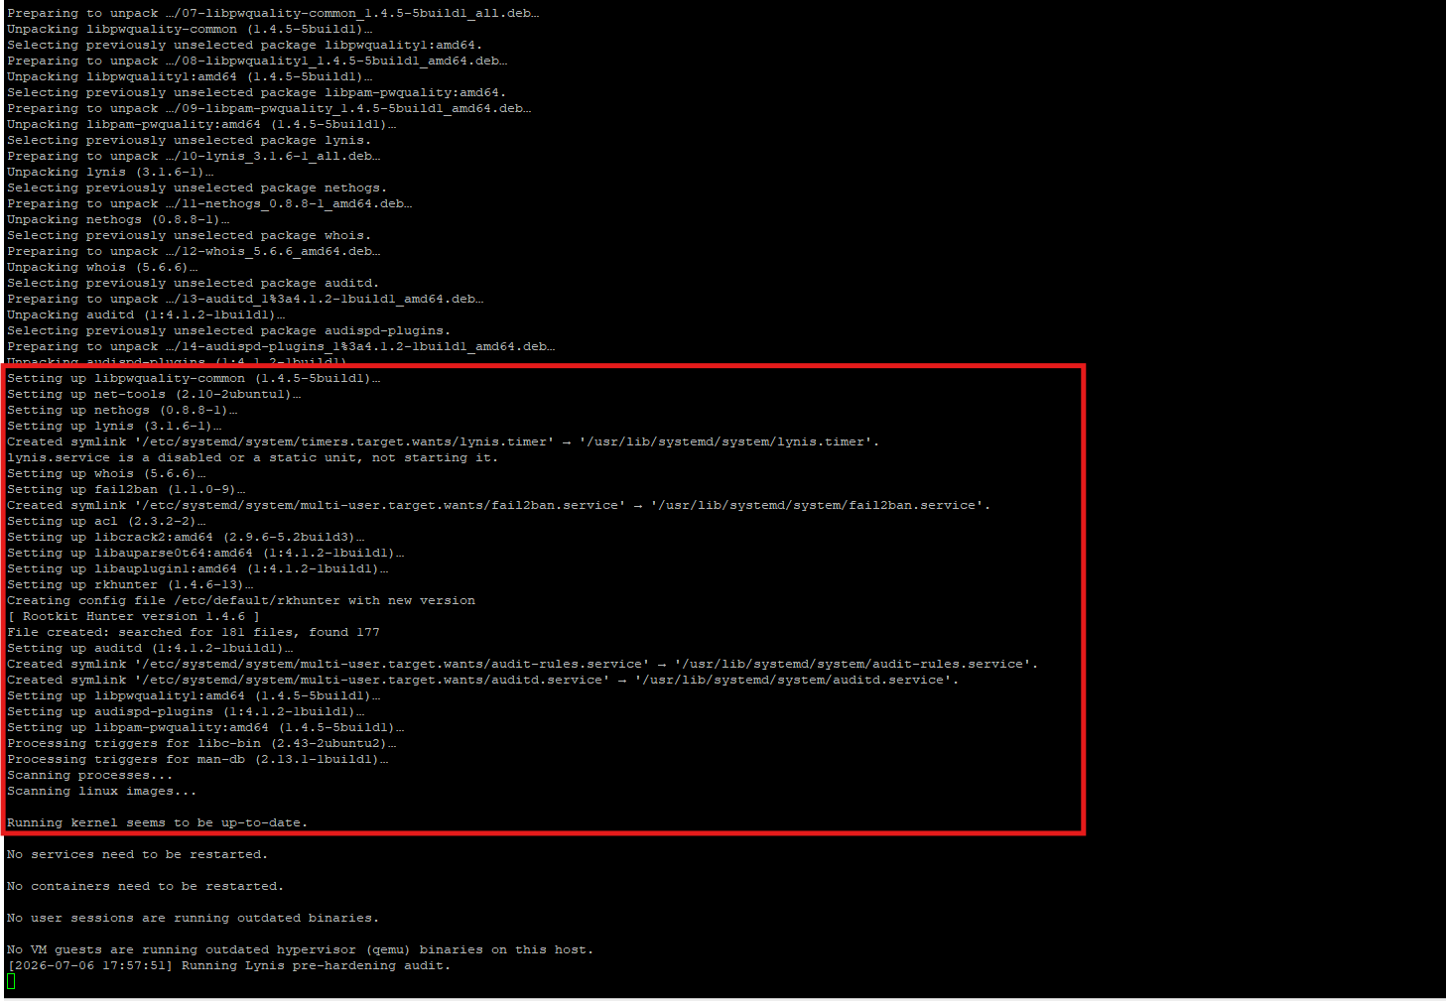

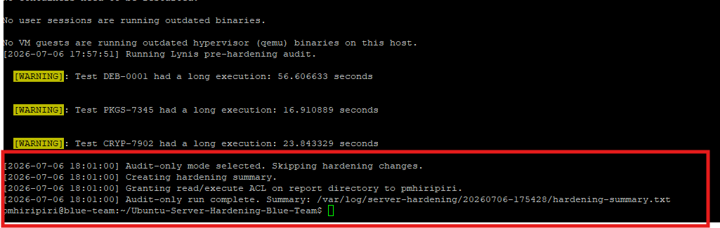

sudo ./scripts/ubuntu-hardening.sh
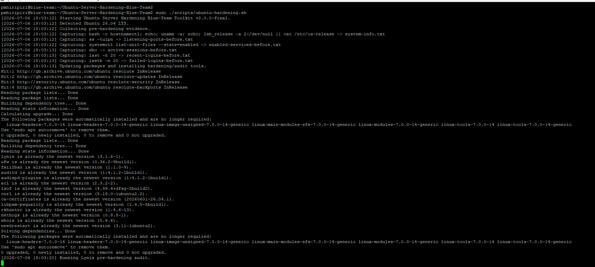

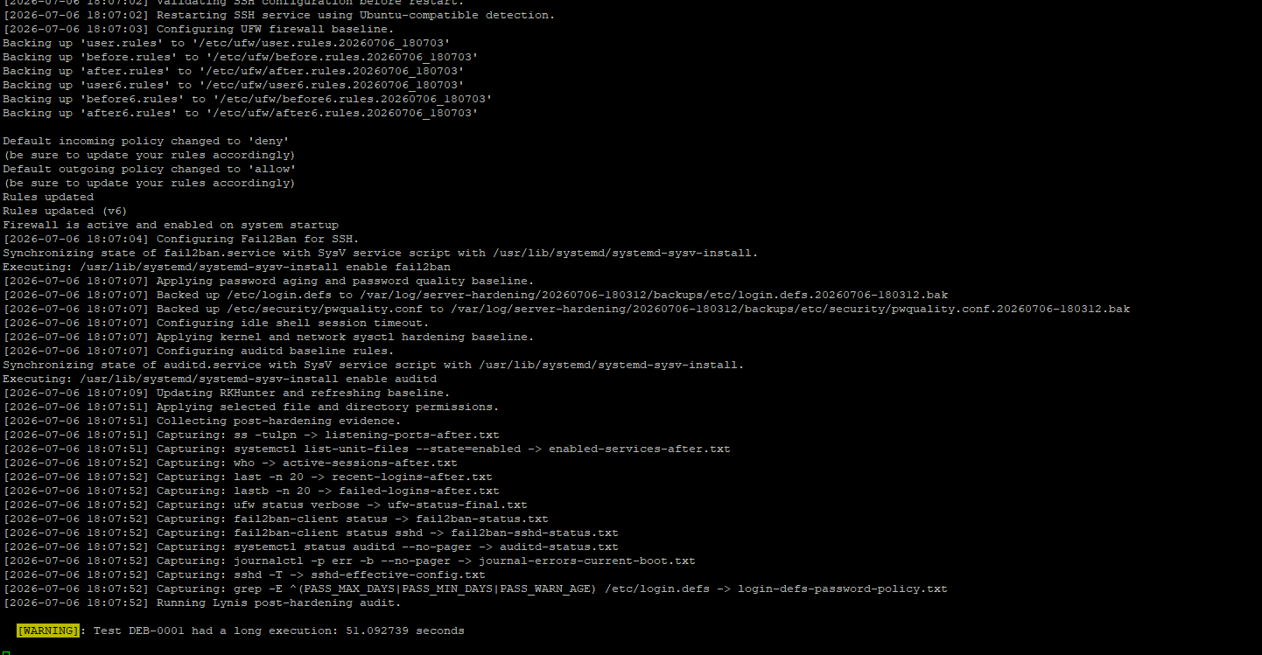

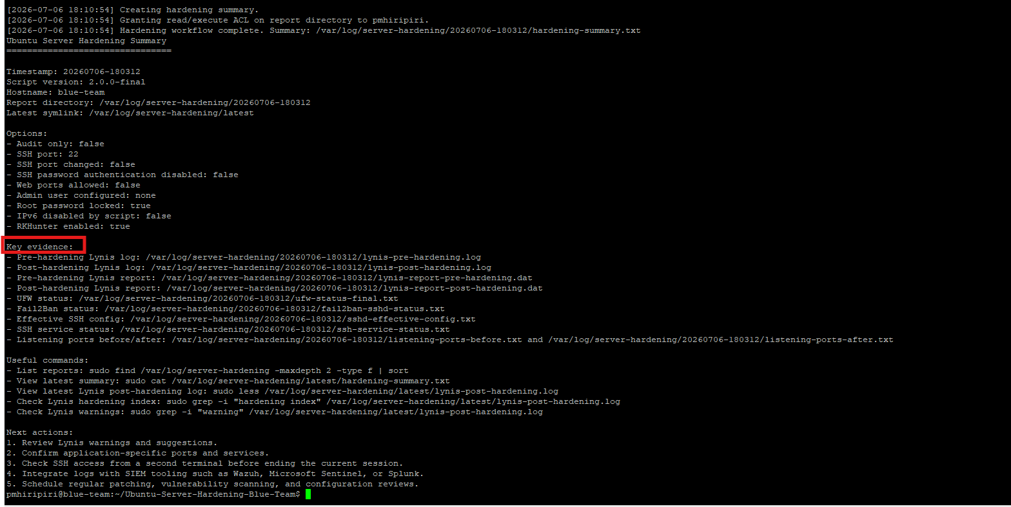

Viewing Reports
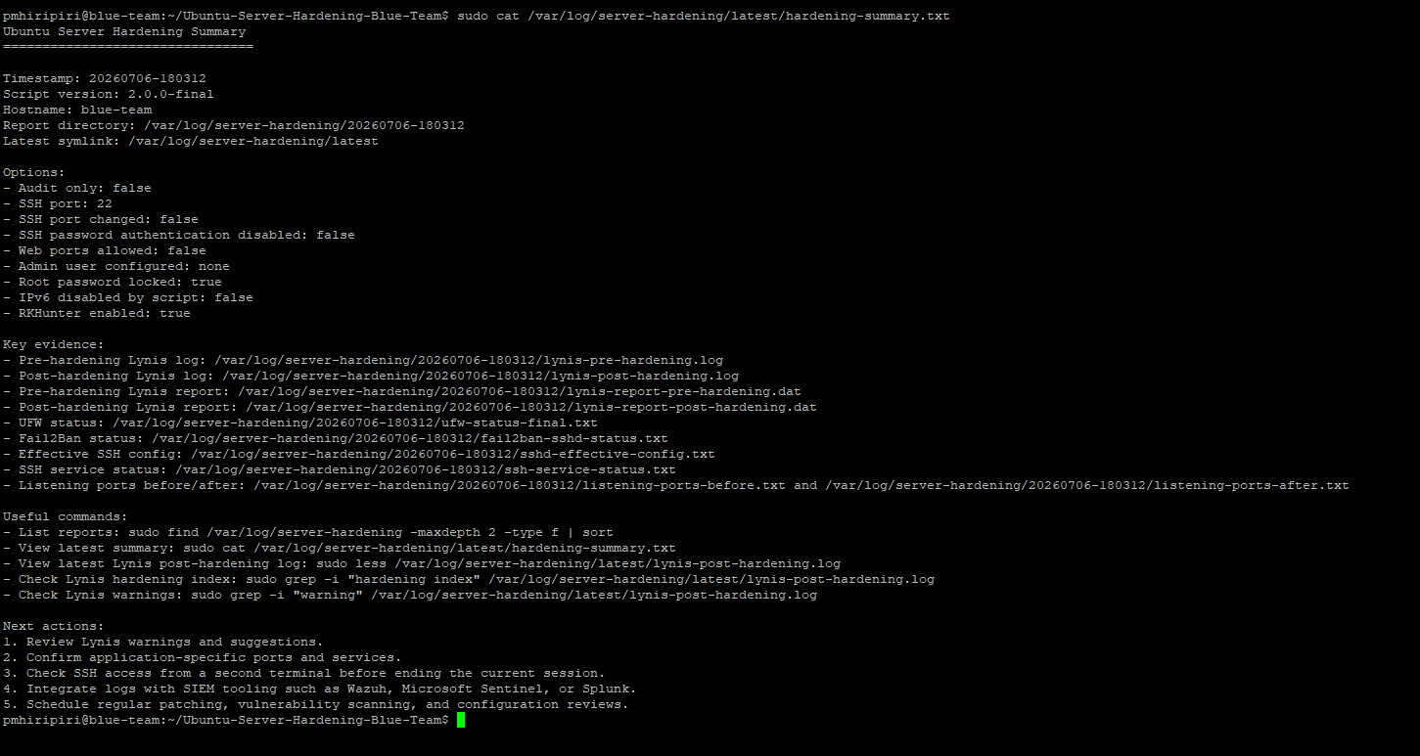

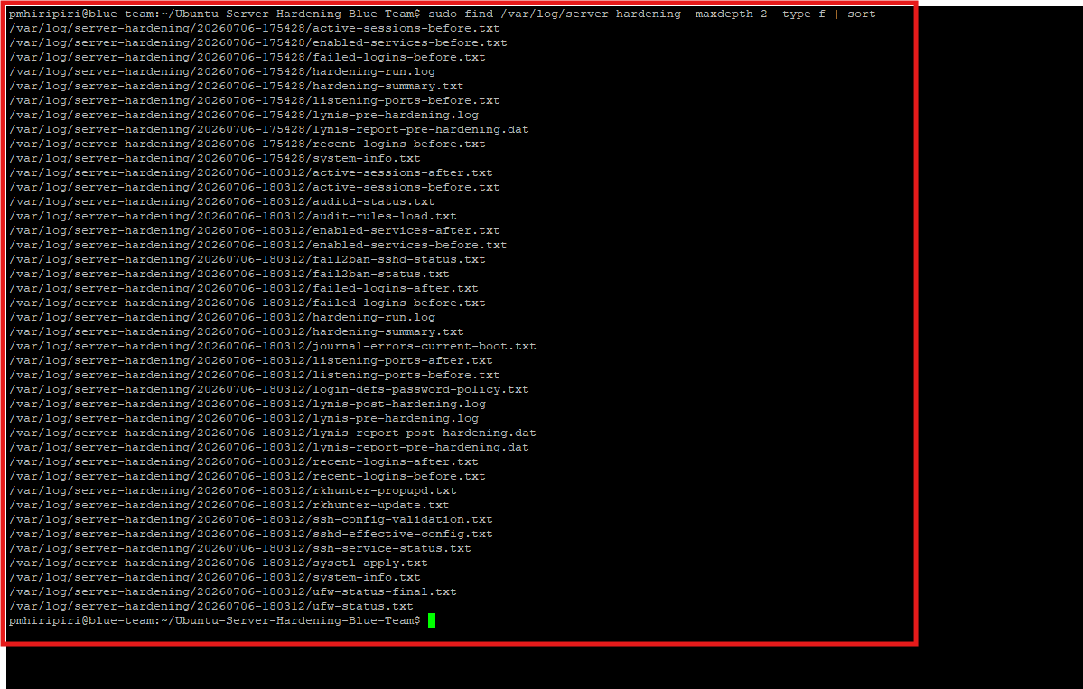

sudo less /var/log/server-hardening/latest/lynis-post-hardening.log
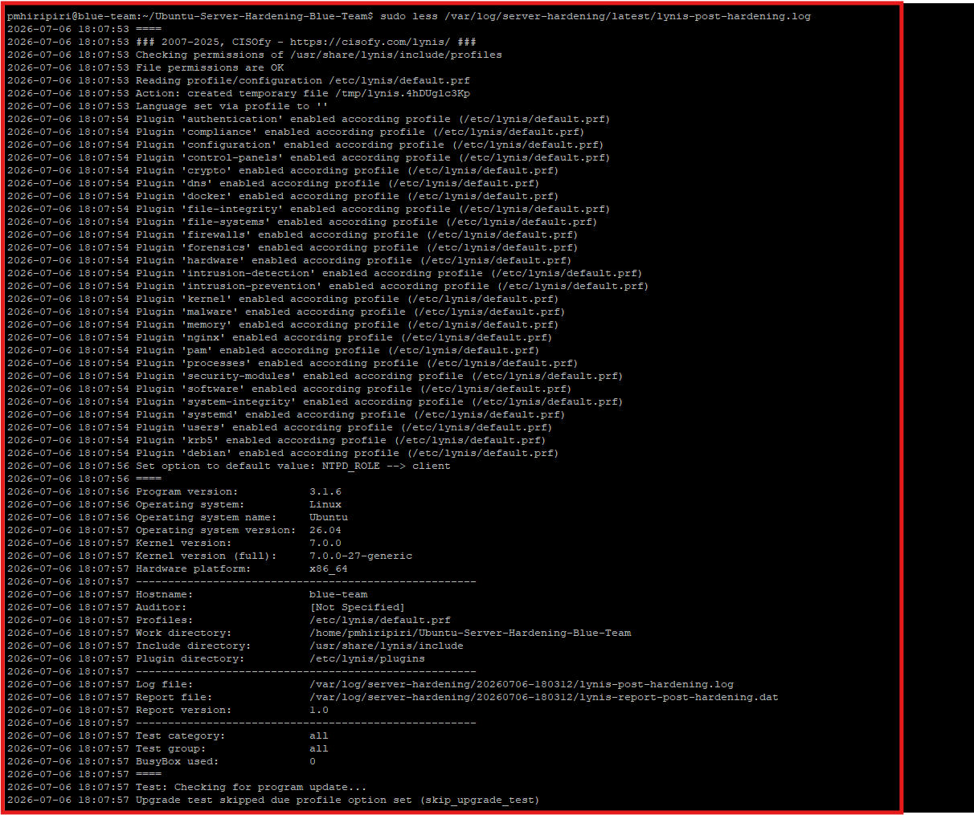

Check the Lynis hardening index: Pre ad Post harderning
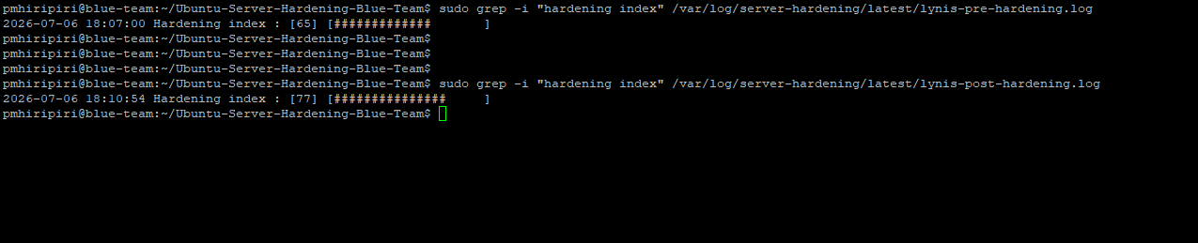
Figure 3: Pre-Hardening index:65 Post-Hardening index:77

Check Lynis suggestions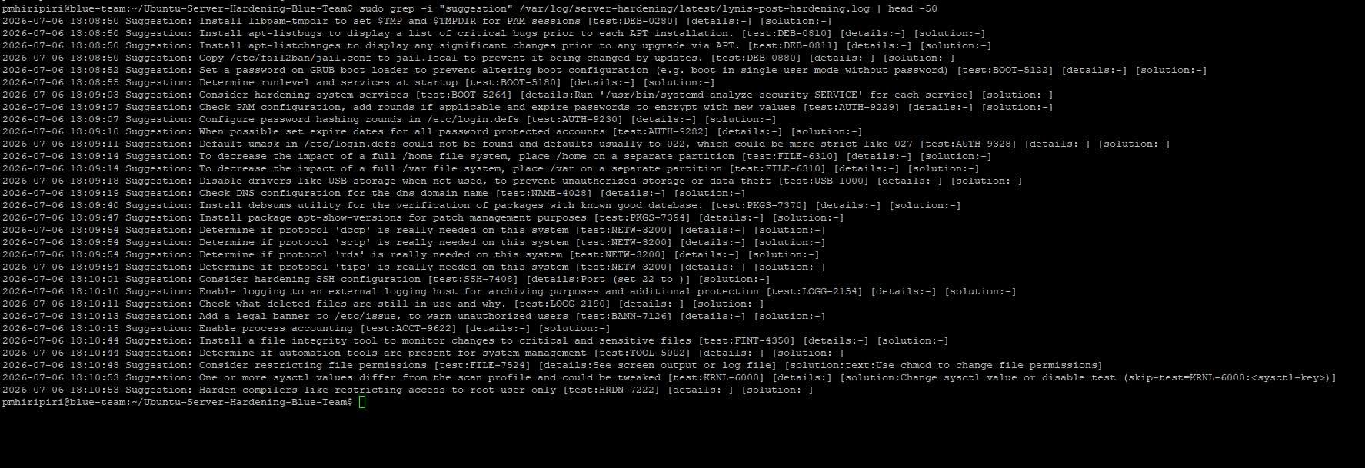

Generate Human-Readable Reports
After running the hardening workflow, the raw evidence is stored under /var/log/server-hardening/latest. You can generate a clean Markdown report from those files.
Create a Markdown report:
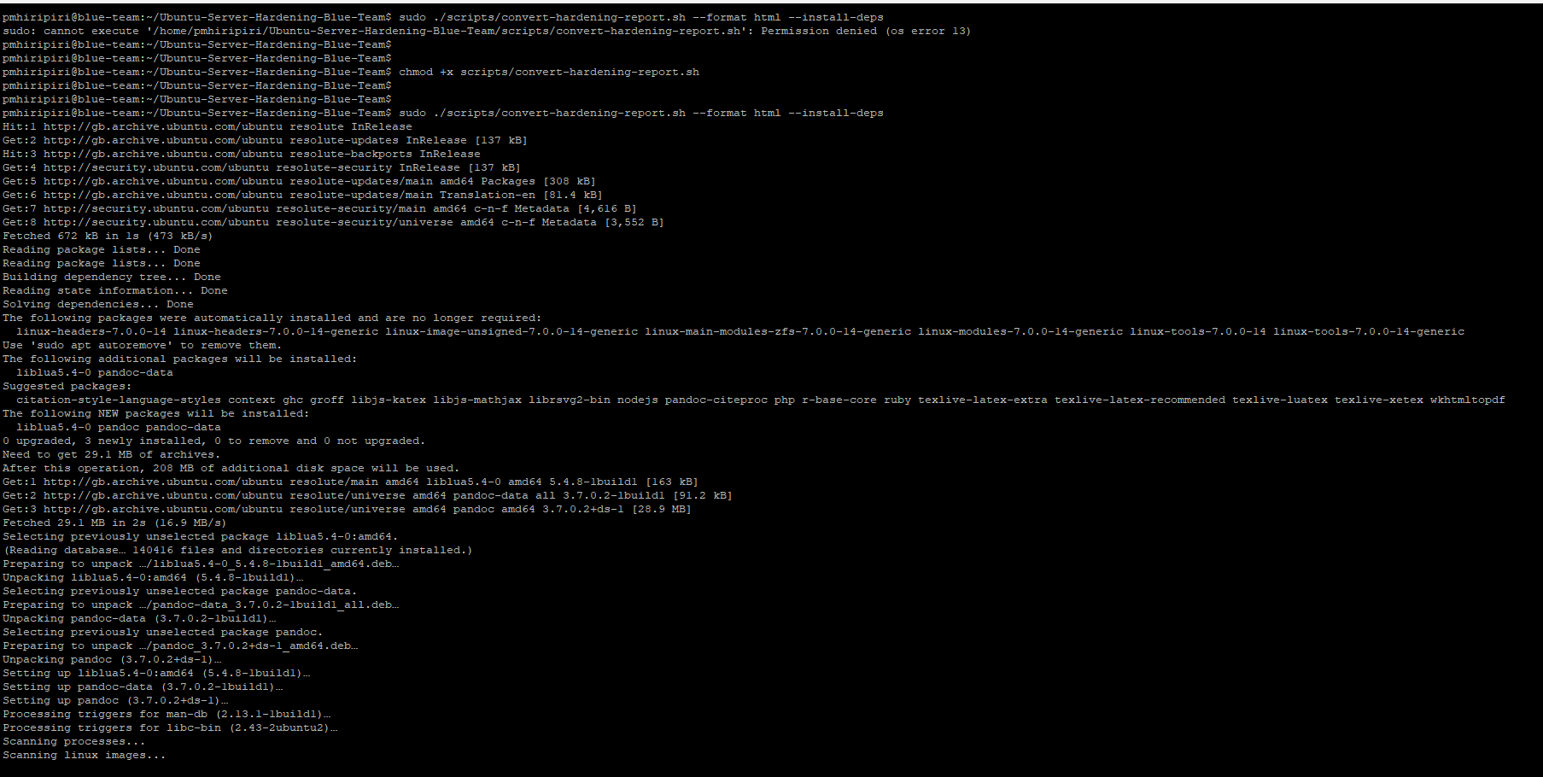
The output will be created here:
evidence/hardening-report.html

Convert the Markdown report to PDF:
./scripts/convert-hardening-report.sh --format pdf --install-deps
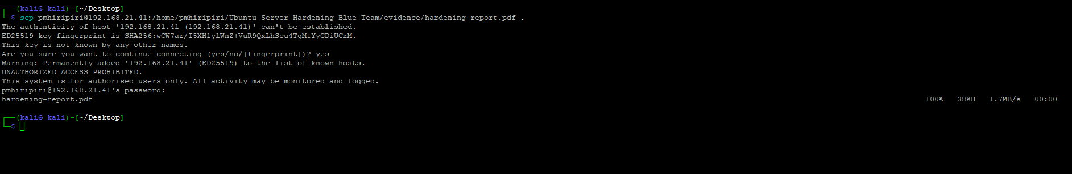

Banner has been configured
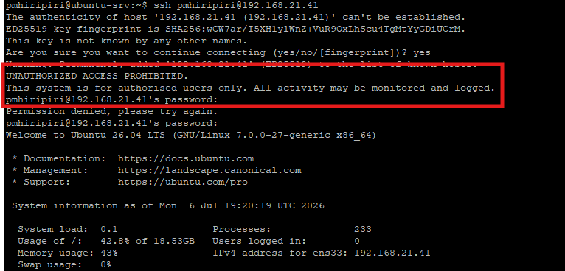

Fail2Ban in effect