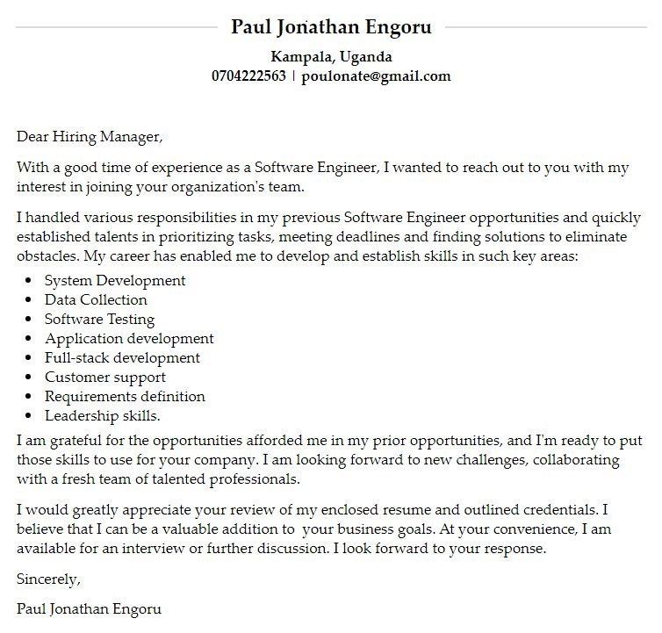

CURRICULUM VITAE

# PERSONAL INFORMATION



|  |  |
| --- | --- |
| **NAME** | **:** ​ ​**ENGORU PAUL JONATHAN** |
| **DATE OF BIRTH** | **:**​ 23/12/1995 |
| **SEX** | **:**​ MALE |
| **NATIONALITY** | **:** UGANDAN​ |
| **MARITAL STATUS** | **:** SINGLE​ |
| **MOBILE** | **:** 0704333234​ |
| **Email** | **:** ​poulonate@gmail.com |

# PERSONAL PROFILE



I am an enthusiastic Ugandan who is honest, hardworking, proactive, confident, intelligent, and eager to learn with strong networking and communication skills. I am a dependable, self-driven team player who believes in collective responsibilities in achieving a common goal beyond established expectations and always brings out and promotes the strengths of others. Paul is a fast learning individual who easily adapts to new environments with a passion for excellence, strong commitment, dedication and is able to work under minimum supervision.​

# CAREER OBJECTIVE



To professionalize in Programming, Desktop Applications, Website Designer and System’s Administration. This will help me gain insight in invention and innovation of high quality affordable and sustainable products that meet the society’s current needs. I intend to further my studies in the fields of Programming, Software Engineering and System Administration, which will give me a better platform to benefit the industry.

# SUMMARY



Driven Programmer Analyst with excellent experience and highly developed skills in programming and systems analysis. Accomplished in creating project parameters based on client specifications and tailored to individual users' needs. Talented in providing outstanding and effective solutions while managing project deadlines to deliver work on time.

# EDUCATION BACKGROUND

|  |  |  |
| --- | --- | --- |
| **YEAR** | **INSTITUTION** | **Qualification** |
| 2018-2021    2016-2017    2012-2015  2005-2011 | Aptech Computer Center    Rock High School, Tororo  Otino Waa Comprehensive Secondary School  Otino Waa Primary School | Software Engineering    Uganda Advanced  Certificate of Education    Uganda Certificate of Education  Primary Leaving  Examination |
| EXPERIENCE |  |  |

**March 2016 to June 2018:** Cosmetics and Beauty Business.​

* Purchasing the stock; cosmetics, braids and hair accessories.
* Balancing the books of accounts.
* Provided advisory services to the customers on the right products for them, like the right cosmetics for their skin, right weave or braids and color.
* Selling in the counter of the shop.
* Opening and closing the shop.



**February-2021 to August-2021**:​ Internship at Post Bank City under Future Technologies Limited.

* Provide technical support and advice as required across the HR and Payroll Management System, Procurement and Disposal Management System, Assets Management System and IT users.
* Responding in a timely manner to service issues and requests.
* Provide additional training to the required users.
* To monitor and keep a log of all issues and changes in the system.
* Test and evaluate the new changes or updates in the system with the users.
* Support rollout of e-Recruitment and other modules.
* Coordinate the project management tasks.
* Prepare and Submit Weekly Report to the head of IT.

## Responsibilities Held



**2018-2021**:​ Worship Leader at Watoto Church

**2016-2017**:​ TOT in DML and Youth Leader at PAG Tororo.

**2012-2015**:​ Students’ Bee Manager at Otino Waa Children’s Village

**2013- 2015**:​ Vice president of Science club, Otino Waa Comprehensive Secondary School.

**2007-2010**:​ Class monitor, Otino Waa Primary School.

|  |  |
| --- | --- |
| **Skills and competences** | **Unique attributes** |
| * Microsoft Suite Package * Proficient in C#, Java, PHP, Java   Script, HTML5 and CSS   * Quality assurance testing * Project development * Debugging * Developing databases * Application development * Object oriented languages * Developing tests * Full-stack development * Software testing * Customer support * Expertise in HTML5, PHP and C# * Requirements definition * Client implementation support | * Self -driven * Team work at all levels • Initiate and coordination programs. * Ability to work under pressure. * Leadership skills. |

|  |  |
| --- | --- |
| **LANGUAGES** | **HOBBIES** |
| * English – Fluent * Kumam – Very Good * Luo – Very Good * Swahili - Good • Luganda – Fair | * Making Music * Playing guitar * Visiting and interacting with friends • Listening to gospel music. * Indoor games. |

**REFEREES**



|  |  |  |
| --- | --- | --- |
| **Rev. Dickens Oyup**  Administrator, Otino  Waa. P.O. Box. 117,  Lira. Tel: 075675588 | **Dr. Wanjala Geoffrey** The Karen Hospital  Tel: +256 772423428 | **Mr. Esolu Steven**  Easter Coordinator FUO Mbale.  Tel: +256 703313207 |
|  |  |  |

**Pastor Moses Onyonge.**

Royal Life World Ministries.

Tel: +256 757861853.

