Final Swing project

tetris

Sat Dec 2 2017

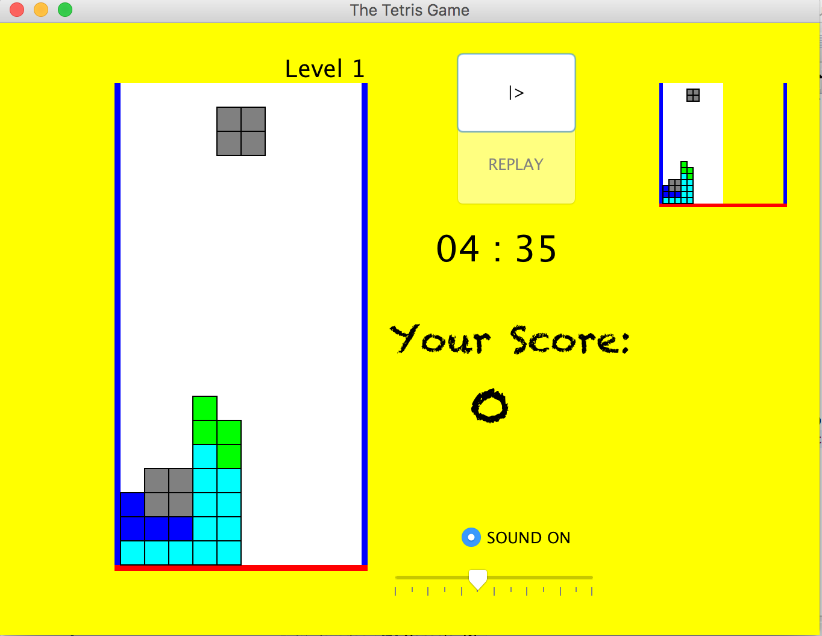

This is a snapshot of what my runnable program looks like., I have the following:

* Start/Pause: This is a JButton associated with basically starting the game, Pause and Resume whenever you want to. I made PauseController class as an ActionListener for what the button does.
* I created a REPLAY button as well and in it’s actionListener I basically had new Tetris(). It does create work fine/ restart the game but it created 5 new JFrame. I wasn’t able to figure out where I went wrong before the due date.
* Timer: As soon as you hit the start button, it triggers the start function in GameTimer class which basically sets a timer for 5 minutes. You start at level 1 and if you are able to score 2000 points before the 5 minutes time runs out, you go to level 2 which resets the timer to another 5 minutes. However Pausing the game doesn’t pause the timer.
* Score: This JLabel is responsible for displaying score. 100 points is earned everytime a row is cleared. You need 2000 points to proceed to next level. That 2000 limit increases as you proceed towards next levels along with the speed that new pieces falls in. the delay time is decreased by 0.05 seconds until you get to 0.4 seconds which is the max speed as you go to higher levels.
* Sound : For gameSound, I squeezed 4 random beats from garageBand to create a wav file and just looped it. You can turn the sound Off/On but you have to pause the game to do so.

I would love to hear any comments/ ideas. I would happy to know where I did wrong.

Thank you very much.