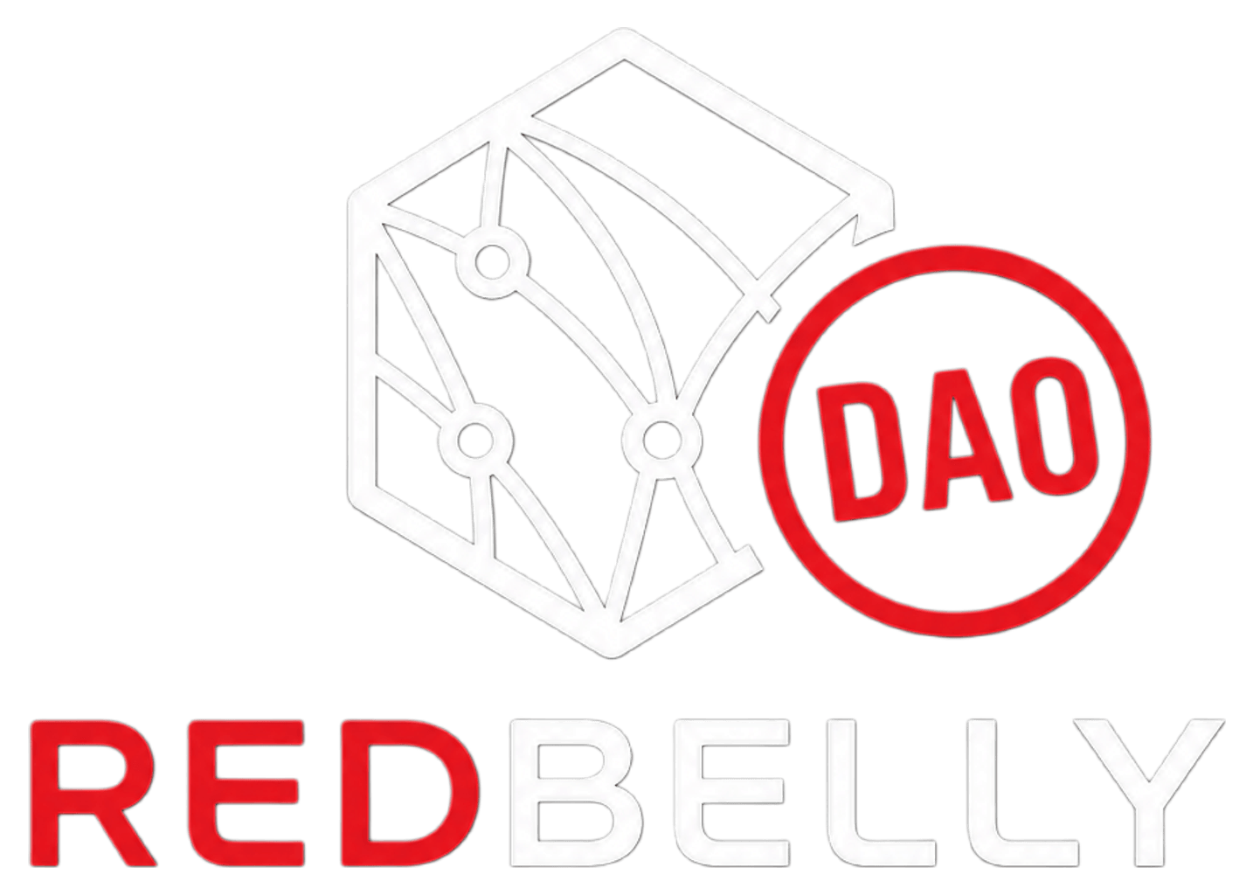
REDBELLY DAO TASK BOARD · TASK-23
GOVERNANCE RECORD
Constitution and
Governance Changelog
Every approved structural change, dated, sourced to its Snapshot record, and checked against whether it was actually implemented.
DATA CAPTURED 15 AUG 2026, VERIFIED VIA SNAPSHOT GRAPHQL
Redbelly Community DAO operates under two ratified governing documents, both ratified by Snapshot vote, not by the Google Form process examined separately below.
• Constitution v1.2, ratified via Snapshot vote 20 Sep 2025 (proposal #2, 100% For, 1.8m RBNT voted)
• Code of Conduct v1.0, ratified via Snapshot vote 6 Oct 2025 (proposal #9, 92.97% For)
Of the 30 Snapshot proposals on record for rbnt.eth, 18 passed, 8 were rejected (including Guild Structure Consolidation, corrected below), 3 were multi-choice elections with no single pass or reject label, and 1 was a test proposal with no governance effect. Governance activity spans 3 Sep 2025 to 24 Jul 2026.
01 THREE FINDINGS RESOLVED
1. The Sep 2025 ratification gap is closed. Constitution v1.2 was ratified via Snapshot proposal #2 on 20 Sep 2025. The 11 to 14 Feb 2026 Google Form is a separate, later poll and is not how the Constitution was actually ratified. It should not be logged as a ratification event.
2. Guild Structure Consolidation did not pass and was not implemented. Snapshot proposal #5 closed 20 Sep 2025 with 42.95% For, short of a majority against a 56.71% Abstain plurality and 0.34% Against. Constitution Section 3, Working Groups (Pods), still lists all five original pods, direct evidence the consolidation never took effect.
3. No quadratic voting proposal exists anywhere in the 30-proposal Snapshot record. It remains an unimplemented, Discord-only item pending Snapshot evidence.
02 GUILD CONSOLIDATION: REASONED CONCLUSION
Not passed, not implemented. Snapshot proposal #5 ("DAO Guild Structure, Consolidation") closed 20 Sep 2025 with 42.95% For, short of a majority, against a 56.71% Abstain plurality and 0.34% Against. On a majority-of-all-votes-cast reading, Abstain outpolled For, so the proposal did not pass. Constitution Section 3, Working Groups (Pods), still lists all five original pods, Marketing, Builder/Develop, Researcher, Community, Partnerships, with no trace of the Partnerships-and-Research merger this proposal asked for. If the merge had taken effect, Section 3 would list fewer than five pods. It lists five, which is evidence the consolidation never happened, not evidence that it did.
Snapshot's own frontend displays a "Passed" badge for this proposal, because its UI compares only For against Against and treats Abstain as neutral, under which For (42.95%) beat Against (0.34%) by a wide margin. This changelog applies a stricter majority-of-all-votes-cast standard consistently: Abstain's 56.71% plurality means For did not achieve a majority, so this entry records the proposal as Rejected. The live page's badge reflects a different methodology, not a data disagreement.
03 WHITELIST REQUIREMENT: RESOLVED
Passed, not implemented. Snapshot proposal #28 passed 5 Jul 2026, 53.76% For, and states it removes the whitelist requirement for general DAO voting participation, retaining geographic limits for High Council and Leadership. The Snapshot GraphQL strategies field for the two proposals created after it, Amendment to Leadership Structure and High Council Elections, still lists a whitelist strategy, unchanged in kind from every proposal before #28 back to the Constitution ratification. The vote passed. The DAO’s own voting configuration was not updated to match it.
04 DISPUTED AND UNRATIFIED ITEMS
FEB 2026 GOOGLE FORM
Not the ratification event. The actual ratification is Snapshot proposal #2, closed 20 Sep 2025, matching the version history inside the Constitution document itself. The form is a separate, later, 9 to 10 respondent poll run through a self-defined 60% threshold that appears nowhere in Constitution Section 9's amendment process (7-day notice, 5-day token-weighted vote).
CONSTITUTION V1.3 REFERENCE
Snapshot proposal #28 (Jul 2026) lists a "Constitution v1.3" as a supporting document. No v1.3 file exists in the supplied repository or resource links, all of which point to v1.2 as current. Open item: either a v1.3 draft exists elsewhere and was not shared, or the proposal referenced a document not yet formally version-controlled under Section 9.
05 UNIMPLEMENTED CASES
QUADRATIC VOTING
No proposal titled or referencing quadratic voting appears anywhere in the 30-item Snapshot record. Section 2.3 of Constitution v1.2 specifies RBNT-weighted voting only. Discord-only, unimplemented, pending any future Snapshot submission.
06 DATA GAPS
• Resolved. Exact percentages and exact dates for all 30 proposals are sourced directly to the Snapshot GraphQL API (hub.snapshot.org/graphql), no authentication required. No entry carries an approximate date or an unsourced margin.
• Resolved. The GraphQL strategies field confirms a whitelist strategy attached to every substantive proposal from Constitution ratification (#2) through High Council Elections (#30). See Whitelist Requirement above.
• The Constitution v1.3 document referenced in proposal 28 was not located.
• Proposals 10, 18, and 30 are multi-choice or ranked votes, not For/Against/Abstain, reported as winner-by-power instead of Passed/Rejected.
07 CHRONOLOGICAL SNAPSHOT CHANGELOG
Passed and Rejected labels come directly from Snapshot’s configured strategy. Closed means Snapshot displayed no pass or reject label. For proposals 19 to 24, the call comes from the DAO’s Discord results announcement, independently cross-checked against per-voter Snapshot data.
# | DATE | TITLE | RESULT | SECTION | SRC
1 | 3-6 Sep 2025 | Testing | PASSED · Abstain 53.15% | Not applicable, test | View
2 | 17-20 Sep 2025 | Redbelly Community DAO Constitution, Ratification | PASSED · 100% | Ratifies the Constitution | View
3 | 17-20 Sep 2025 | Proposal Submission Limit per Round | PASSED · 100% | Section 4, Governance Process | View
4 | 17-20 Sep 2025 | Budget Allocation per Proposal | PASSED · 80.89% | Section 6, Treasury Mgmt | View
5 | 17-20 Sep 2025 | DAO Guild Structure, Consolidation | REJECTED · not applied · For 42.95% | Section 3, Working Groups | View
6 | 3-6 Oct 2025 | Snapshot Voting Duration | PASSED · 92.97% | Section 4, Governance Process | View
7 | 3-6 Oct 2025 | Adoption of Standardised Proposal Evaluation Criteria | PASSED · 100% | Section 4, Governance Process | View
8 | 3-6 Oct 2025 | Update DAO Proposal Submission Template | PASSED · 100% | Section 4, Governance Process | View
9 | 3-6 Oct 2025 | Community Code of Conduct | PASSED · 92.97% | Ratifies Code of Conduct v1.0 | View
10 | 6-12 Nov 2025 | Choose the Official DAO Logo, Community Vote | CLOSED · non-binary | Not applicable | View
11 | 7-12 Dec 2025 | Community Consultation Policy Authorization | PASSED · 99.99% | Section 4, Governance Process | View
12 | 8-12 Dec 2025 | Redbelly Africa Campus Tour Revival and Global Expansion | REJECTED · For 26.52% | Section 3, Marketing scope | View
13 | 11-16 Dec 2025 | REDBELLY DAO Education, Growth and Community Ambassador | PASSED · 98.92% | Section 7, Contributor Exp. | View
14 | 16-21 Dec 2025 | Redbelly X-Tipping Campaign | PASSED · 84.27% | Section 7, Contributor Exp. | View
15 | 16-21 Dec 2025 | Accelerating Community Growth via Deep Research | REJECTED · For 25.16% | Section 3, Researcher scope | View
16 | 18-23 Dec 2025 | Redbelly Q1 2026 Awareness and Growth Campaign | REJECTED · For 4.19% | Section 3, Marketing scope | View
17 | 19-24 Dec 2025 | Redbelly Developer Docs, Onboarding System | REJECTED · For 28.53% | Section 3, Builder scope | View
18 | 28-31 Jan 2026 | DAO Leadership Elections | CLOSED · Majnoon 50.22% | Section 2, Governance Structure | View
19 | 1-6 Mar 2026 | Staking Proposal | PASSED · For 61.51% | Section 6, Treasury Mgmt | View
20 | 1-6 Mar 2026 | Marketing Press Only, FINPR Agency | PASSED · For 85.42% | Section 6, Treasury Mgmt | View
21 | 1-6 Mar 2026 | Communication Strategy Proposal | REJECTED · Against 44.26% | Section 3, Marketing scope | View
22 | 1-6 Mar 2026 | Redbelly Mascot Design Competition | REJECTED · Against 47.66% | Section 3, Marketing scope | View
23 | 1-6 Mar 2026 | Redbelly Internship Pilot, Youth Documentation | PASSED · For 52.81% | Section 7, Contributor Exp. | View
24 | 1-5 Mar 2026 | Community Task Board Initiative | PASSED · For 90.68% | Section 3 and 4, new infra | View
25 | 29 Jun-4 Jul 2026 | Temporary Suspension of New Treasury-Funded Activities | PASSED · 100% | Section 6, Treasury Mgmt | View
26 | 29 Jun-4 Jul 2026 | Continuation of Marketing and PR with FINPR | REJECTED · Against 71.36% | Section 6, budget renewal | View
27 | 29 Jun-5 Jul 2026 | Redbelly DAO Discord Bot Development and Hosting | PASSED · 100% | Section 8, Community Involv. | View
28 | 30 Jun-5 Jul 2026 | Increase Governance Accessibility and Contributor Privacy | PASSED · not applied · 53.76% | Section 2.3, Voting Power | View
29 | 11-16 Jul 2026 | Amendment to Leadership Structure | PASSED · 97.48% | Section 2 and 9 | View
30 | 21-24 Jul 2026 | High Council Elections | CLOSED · Buffy 32.94% | Section 2, Governance Structure | View

Note on proposal 30: the three winners by voting power, Buffy, NekoyaManeki, Light, match the 24 Jul 2026 formal High Council roster already reported via Discord, confirming the election handoff independently from the Snapshot side.
Back to the Redbelly DAO Task Board

