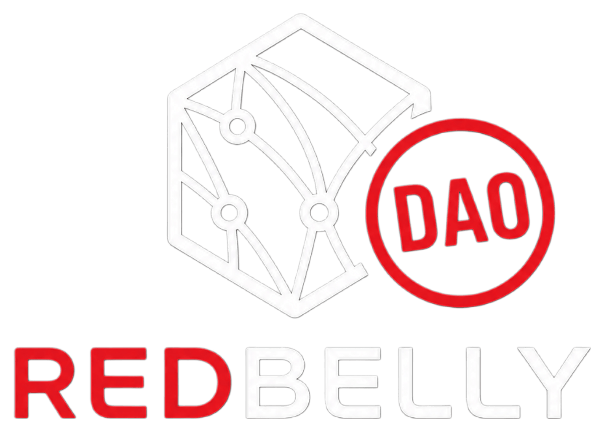
REDBELLY DAO TASK BOARD · TASK-20
COMPANION · PAIRS WITH THE VENUE GRAPHIC
Spot vs Futures, in Plain Terms

LAST VERIFIED AUGUST 21, 2026
A spot listing lets you buy and sell the actual token. Once the trade settles, you own RBNT or wRBNT.
A futures listing is a leveraged contract on RBNT's price. You never own the token, and the position can be liquidated.
These are two separate things. One being delisted does not mean the other changed. A spot delisting is not a futures delisting, and a futures delisting is not a spot delisting. Check each one independently before reacting.
No live futures or perpetual market currently exists for RBNT on any tracked exchange.

Full venue list, contract addresses, and verification steps: see the canonical reference, Where to Buy & Trade RBNT.

