Thanks for downloading the source code files for *Beginning ArcGIS for Desktop Development Using .NET!*

The source code for the examples that appear in the book (and even more for chapter 13) are organized by chapter, with all the files for the examples from each chapter in a separate folder.

Within each of the folders, you’ll find a set of zipped files along with other necessary files that correspond to many of the Try It Out exercises. It is recommended that you walk through the exercises from start to finish and use the code samples as a simple guideline where needed.

In order to run the code samples you need to perform the following in Visual Studio (after unzipping each zip file):

1- Check the version of ArcGIS in the configuration file for Desktop Add-Ins (Config.esriaddinx file)

2- Check the installation path of ArcMap (or ArcCatalog) in Debug tab of project properties (for both Desktop Add-ins and Extending ArcObjects project)

3- Check the Esri References

Following sections illustrate each step:

1- Open the solution file (*.sln) by double clicking it. Open Config.esriaddinx file using Solution Explorer window and check the version attribute of the Target platform. Then change it to match your ArcGIS version (“10.1” or “10.0”).

Note: This step is only needed for Desktop Add-in projects.

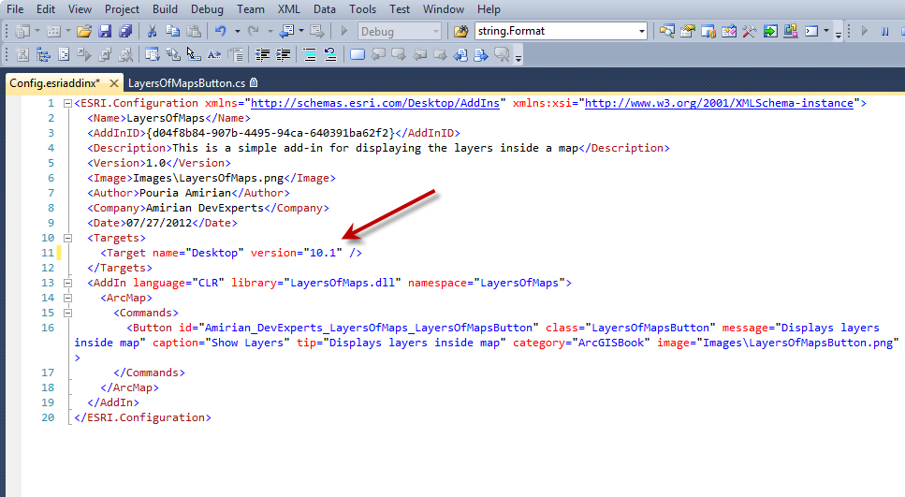

2- Right click on your project in the Solution Explorer window and choose properties from the context menu.

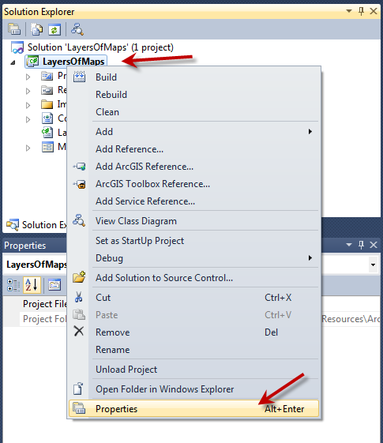

Then go to the Debug tab and set the address of ArcMap or ArcCatalog (depending on the type of your project as path of external program).

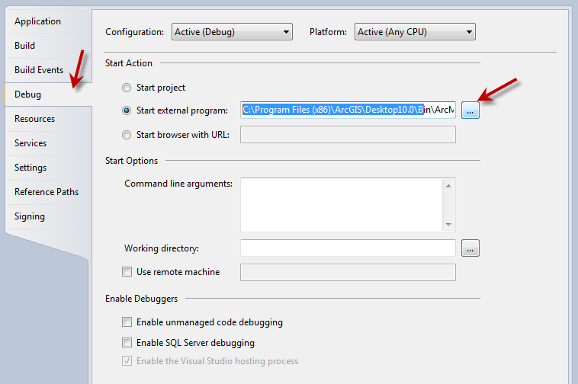

**Note: This step is needed since ArcGIS (like other software) can be installed in various paths on different machines (I have installed ArcGIS on D:\ on my laptop, but for my PC, ArcGIS is installed on C:\)**

3- If you get an “are you missing a using directive or an assembly reference” error, or any similar run-time error (red underlines in Visual Studio), it means that you have to set the physical address of the Esri assemblies on your machine (see the note in step 2). The following screen shot illustrates the broken reference error.

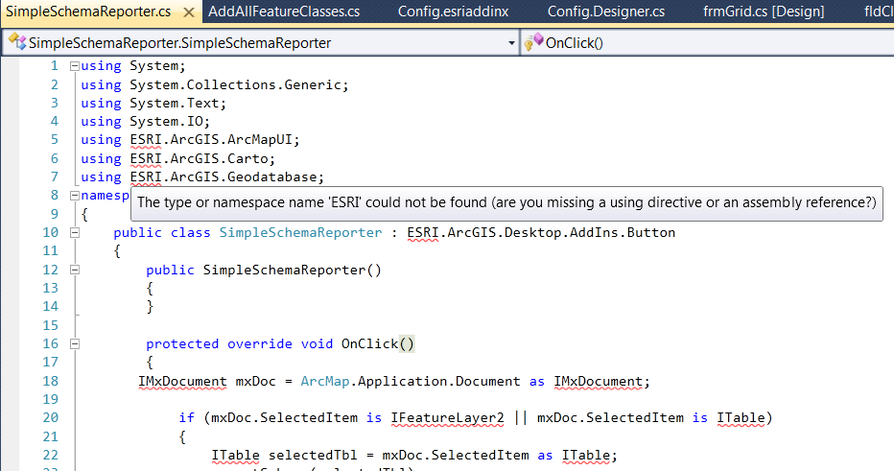

To fix the broken reference error, do the following for each reference:

a) Remove the reference by right clicking it in the Solution Explorer window and select Remove from the context menu.

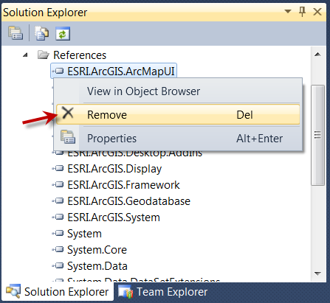

b) Add the removed reference by right-clicking the References folder in the Solution Explorer window and selecting Add ArcGIS Reference.

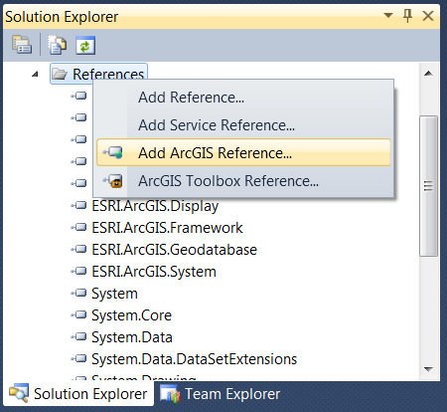

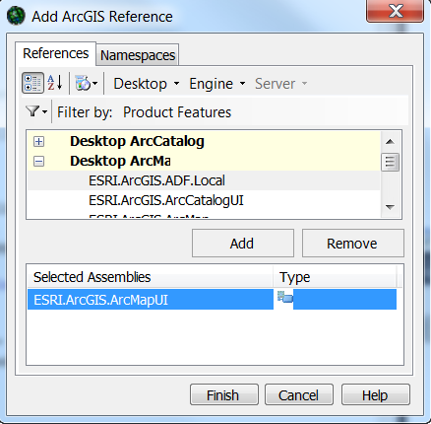

Perform steps a) and b) for all ESRI.ArcGIS.XXX references.

Note: Sometimes fixing just one of the Esri references results in changing the physical address of all Esri assemblies. As a result, this might fix the broken reference error for all the other Esri references. So first fix one reference and then fix the others if they aren’t fixed automatically.

I hope you find the book and the samples useful. You can contact me at **PouriaAmirian.ArcObjects@gmail.com** to send comments, feedback, recommendations, bug reports, etc.

Sincerely,

Pouria Amirian

The author of *Wrox Beginning ArcGIS for Desktop Development using .NET*