Thanks for downloading the source code files for *Beginning ArcGIS for Desktop Development Using .NET!*

The source code for the examples that appear in the book (and even more for chapter 13) are organized by chapter, with all the files for the examples from each chapter being in a separate folder.

Within each of the folders, you’ll find a set of zipped files along with other necessary files that correspond to many of the Try It Out exercises. It is recommended that you walk through the exercises from start to finish and use the code samples as simple guideline where needed.

**Note for VB code samples:**

The only difference between C# and VB code samples is the Category in which the Add-ins being created. The “ArcGISBook” is used throughout the book for the Category attribute of Add-in commands (for C#). For sake of simplicity, for VB.NET code samples this has been changed to “ArcGISBook_VB”.

In order to run the code samples you need to perform the following in Visual studio (after unzipping each zip file):

1- Check the version of ArcGIS in the configuration file for Desktop Add-Ins (Config.esriaddinx file)

2- Check the installation path of ArcMap (or ArcCatalog) in Debug tab of project properties (for both Desktop Add-ins and Extending ArcObjects project)

3- Check the Esri References

Following sections illustrate each step:

1- Open the solution file (*.sln) by double clicking it. Open Config.esriaddinx file using Solution Explorer window and check the version attribute of the Target platform. Then change it to match your ArcGIS version (“10.1” or “10.0”).

Note: This step is only needed for Desktop Add-in projects.

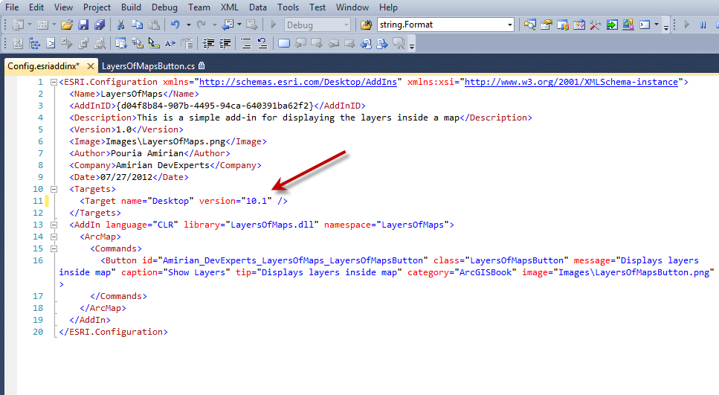

2- Right click on your project in Solution Explorer window and choose properties from the context menu.

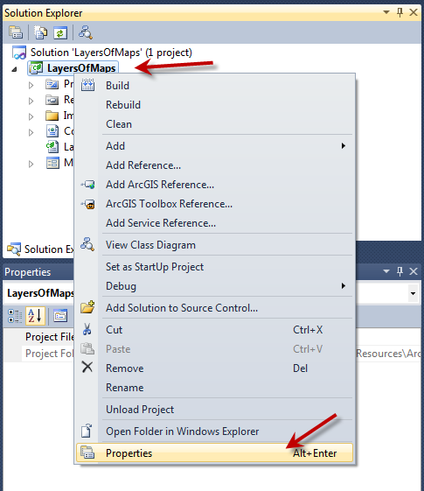

Then go to Debug tab and set the address of ArcMap or ArcCatalog (depending on the type of your project as path of external program).

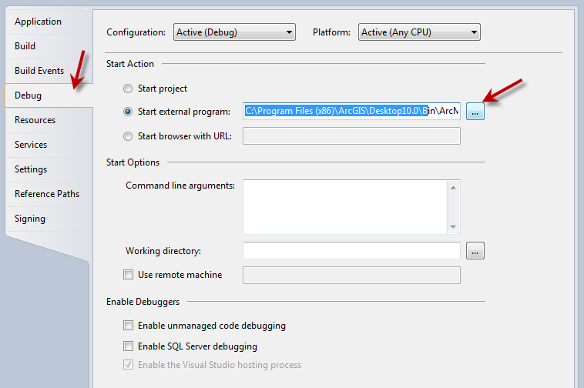

**Note: This step is needed since the ArcGIS (same as other software) can be installed in various paths on different machines (I have installed ArcGIS on D:\ on my laptop but for my PC the ArcGIS is installed on C:\)**

3- If you got “are you missing a using directive or an assembly reference” error or any similar run-time error (red underlines in Visual Studio), this would mean that you have to set the physical address of the Esri assemblies on your machine (see the note in step 2). Following screen shot illustrate the broken reference error.

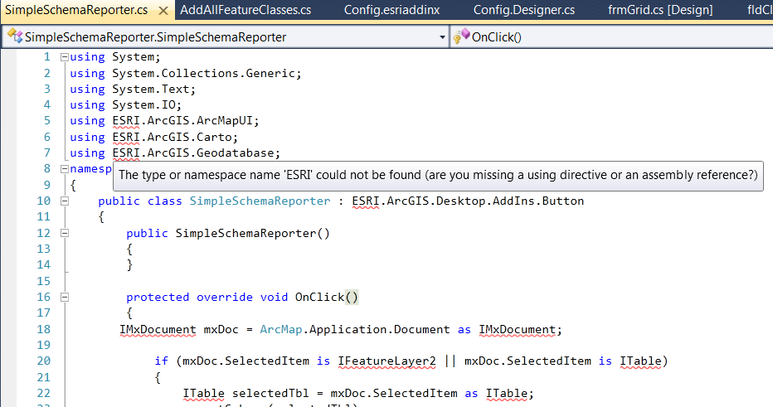

For fixing the broken reference error do the following for each reference:

a) Remove the reference by right clicking it in Solution Explorer window and select Remove from the context menu.

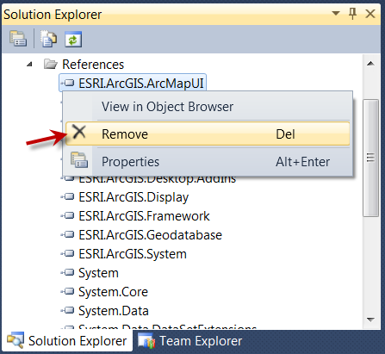

b) Add the removed reference by right clicking the References folder in Solution Explorer window and select Add ArcGIS Reference

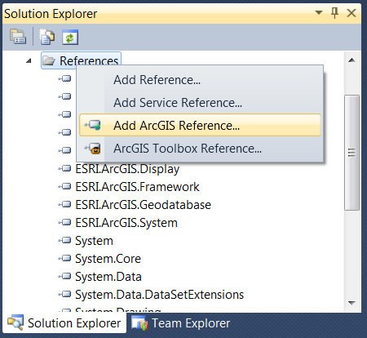

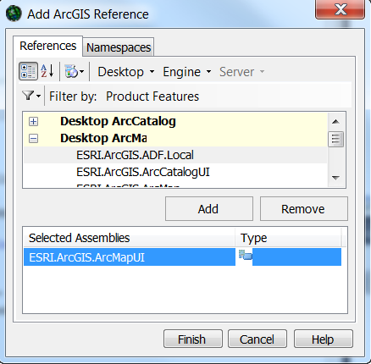

Perform steps a and b for all ESRI.ArcGIS.XXX references.

Note: Sometimes fixing just one of the Esri’s references results in changing the physical address of the all Esri’s assemblies. As a result this might fix the broken reference error for all the other Esri’s references. So first fix one reference and then fix the others if they don’t fixed automatically.

I hope you find the book and the samples useful. Please use the **PouriaAmirian.ArcObjects@gmail.com** to send comments, feedbacks, recommendations, bug reports, etc.

Sincerely,

Pouria Amirian

The Authors of Wrox Beginning ArcGIS for Desktop Development using .NET