The Effect of Vitamin C on Tooth Growth in Guinea Pigs

Ali Pourkhesalian

8 July 2019

### Overview

In this report, first a basic exploratoy analysis is performed on the “ToothGrowth” dataset in R, and then, a statistical inferential analysis is carried out. In the end, it is concluded that vitamin C has a statistically significant direct effect on the tooth growth of experimental subjects.

### Dataset

A dataset that is included in R is called “ToothGrowth”. As the name implies, the dataset includes data on tooth growth rate of some guinea pigs who are given doses of vitamin C. The dataset has 60 observations on 3 variables: 1. len : Tooth length (numeric), 2. supp : Supplement type, VC or OJ (factor), 3. dose : Dose in milligrams, mgr/day, (numeric)

### Experiment

The response variable in the dataset is the length of odontoblasts (cells responsible for tooth growth) in 60 guinea pigs. Each animal received one of three dose levels of vitamin C (0.5, 1, and 2 mg/day) by one of two delivery methods, orange juice or ascorbic acid (a form of vitamin C and coded as VC).

### Basic Exploratory Analysis

The dataset has 3 columns/variables and 60 rows/observations. Below is brief a summary of the dataset:

## [1] "Min. : 4.20 " "Mean :18.81 " "Max. :33.90 "

So, the summary shows that the average tooth growth in the test subjects was 18.81, the minimum growth was 4.2 and the maximum was 33.9. Now, let’s explore the data using a graph. It can be seen from the plot that as dosage increases, the tooth length also increases. Also, it seems that the growth rate for lower doses is more significant. To check if the observed differences are statistically significant, we have to perform a statistical inference analysis.

### Assumptions

The first step is to make a few assumptions:  
1. The test subjects are randomly selected; 2. The variables are independent and identically distributed (IID); 3. Variances are not equal; they change with supplement and dosage; 4. Measurements are not paired.

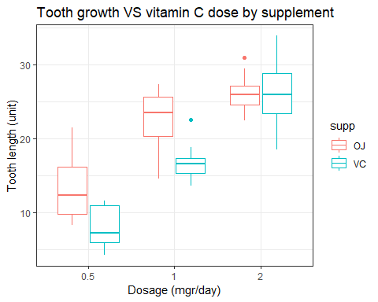

### Tests, CIs, P Values

A confidence interval of 95% is used for all confidence interval calculations. As there are only 60 observations, T distribution is used for all of the following calculations. To make the report shorter only the confidence interval of the T test is shown. First, it is checked if the vitamin C dosage has a statistically significant effect on the length.

t.test(x=ToothGrowth$dose,y=ToothGrowth$len)[[4]][1:2]

## [1] -19.62881 -15.66453

The null hypothesis is that different doses of vitamin C does not affect tooth growth and any variations from the mean is due chance. As it can be seen from the T test, the confidence interval does not contain zero and the P value is equal to 1.38023615694495e-25.It means that observed variations can not be explained by accepting the null hypothesis and that we can reject the null hypothesis. So, it can be said that vitamin C may affect the tooth growth. Next step, we check if there is a statistically significant differnce in tooth growth of guinea pigs if the vitamin C is administerred directly compared to when it is fed through orange juice.

t.test(len ~ supp, paired=FALSE, var.equal=FALSE, data=ToothGrowth)[[4]][1:2]

## [1] -0.1710156 7.5710156

The result of running a T test on the data shows that there is not a statistically significant differnce between OJ and VC. Here the null hypothesis is that OJ and VC are not of significant effect on the response variable; and due to the fact that the calculatedd confidence interval range contains zero, it implies that the difference in calculated means of respond variable in two cases of OJ and VC are not statistically significant. However, looking at the boxplot, it seems that there might be a signifacant effect caused by the type of administration (OJ or VC) in lower doses of vitamin C. So let’s check run the T test for each dosage. For vitamin C dosage of 0.5 mgr/day:

t.test(len ~ supp, paired=FALSE, var.equal=FALSE, data=ToothGrowth[which(ToothGrowth$dose==.5),])[[4]][1:2]

## [1] 1.719057 8.780943

For vitamin C dosage of 1 mgr/day:

t.test(len ~ supp, paired=FALSE, var.equal=FALSE, data=ToothGrowth[which(ToothGrowth$dose==1),])[[4]][1:2]

## [1] 2.802148 9.057852

For vitamin C dosage of 2 mgr/day:

t.test(len ~ supp, paired=FALSE, var.equal=FALSE, data=ToothGrowth[which(ToothGrowth$dose==2),])[[4]][1:2]

## [1] -3.79807 3.63807

So after running the T test for each dosage, it can be said that for both doses of 0.5 and 1 mgr/day, feeding vitamin C through orange juice is more effective than feeding ascorbic acid directly. Both P values are less than 0.05 so the null hypothesis can be rejected. But in the third case, 2 mgr/day, there is no significant difference between ascorbic acid and orange juice.

### Conclussion

Based on the statistical inference analysis carried out on the “ToothGrowth” dataset, the following can be concluded:  
1. Dosage of vitamin C has statistically significant direct effect on tooth length in the experimented guinea pigs, regardless of supplement method.  
2. While at 2 mgr/day dosage there is no difference beween supplement method, at 0.5 and 1 mgr/day OJ method is more effectual.

### Appendix

The Rmd file to generate this report can be found [here](https://github.com/pourkhesalian/statistical-inference-course-project).