Moment of Truth: Does Central Limit Theorem Work on an Exponential Distribution?

Ali Pourkhesalian

7 July 2019

## Overview

This reports investigates the exponential distribution in R and compares it with the Central Limit Theorem (CLT).

##Simulations The exponential distribution is simulated in R with rexp(n, lambda), where lambda is the rate parameter. The mean of exponential distribution is 1/lambda and the standard deviation is also 1/lambda. In this report, lambda is set to 0.2 for all of the simulations. The CLT is tested on the distribution of averages of 40 exponentials for a thousand simulations.

lambda<-.2;n<-40;mns = NULL;for (i in 1 : 1000) mns = c(mns, mean(rexp(n,lambda)))  
h<-hist(mns, breaks=20,xlab="Means", main="Means of Exponential Distribution VS CLT")   
xfit<-seq(min(mns),max(mns),length=80)   
yfit<-dnorm(xfit,mean=mean(mns),sd=sd(mns))   
yfit <- yfit*diff(h$mids[1:2])*length(mns)   
lines(xfit, yfit, col="blue", lwd=2)  
yfitt<-dnorm(xfit,mean=mean(1/lambda),sd=(1/lambda)/sqrt(n))   
yfitt <- yfitt*diff(h$mids[1:2])*length(mns)   
lines(xfit, yfitt, col="red", lwd=2)  
abline(v=mean(mns), col='blue', lwd=2, lty=2);abline(v=1/lambda, col='red', lwd=2, lty=2)  
legend(x= 'topright', legend= c("Sample distribution", "Sample mean", "Theoritical distribution", "Theoritical mean"), col = c('blue','blue','red','red'),text.col = c('blue','blue','red','red'), lty = c(1,2,1,2),merge = TRUE)

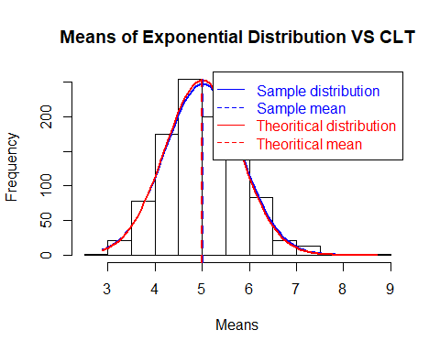

## Sample Mean VS Theoretical Mean

The theoretical mean of the distribution is 5, with a standard deviation of 0.79, where the sample mean and standard deviation are calculated as being 5.0165993, and 0.805899 respectively matching with the theoritical values very closely.

## Sample Variance VS Theoretical Variance

As it can be seen in the above plot, the distribution of means of an exponential distribution (the histogram) matches almost perfectly with a theoritical normal distribution (the red line) and the sample normal distribution (blue line). The variance of the distribution is calculated to be 0.6495 comparing to the theoritical value of 0.625, they are quite close.

## Distribution

The above plot clearly shows that the sample means of an exponential distribution is distributed normally as expected according to the Central Limit Theorem (CLT). Hence, it all boils up to: **CLT works!**

## Appendix

This document was created by R Markdown. The R Markdown code to generate the document can be found [here](https://github.com/pourkhesalian/statistical-inference-course-project).