Secure Vehicle-to-Vehicle Communication with Identity-Based Cryptography
Using License Plate Recognition

A major project report submitted in partial fulfillment
of the requirement for the award of degree of

Bachelor of Technology
in
Computer Science & Engineering

Submitted by
Pourush Pandey (221030172)
Akankshita Puri (221030052)
Adarsh Mishra (221030386)
Avinav Jay (221030062)

Under the guidance & supervision of
Dr. Nishant Sharma


Department of Computer Science & Engineering and
Information Technology
Jaypee University of Information Technology, Waknaghat, Solan - 173234 (India)

December 2025
CANDIDATE’S DECLARATION
We hereby declare that the work presented in this major project report entitled ‘Secure Vehicle-to-Vehicle Communication with Identity-Based Cryptography Using License Plate Recognition’, submitted in partial fulfillment of the requirements for the award of the degree of Bachelor of Technology in Computer Science & Engineering, in the Department of Computer Science & Engineering and Information Technology, Jaypee University of Information Technology, Waknaghat, is an authentic record of our own work carried out during the period from July 2025 to December 2025 under the supervision of Dr. Nishant Sharma.
We further declare that the matter embodied in this report has not been submitted for the award of any other degree or diploma at any other university or institution.

Name & Sign: Pourush Pandey  Roll No.: 221030172  Date: | Name & Sign: Akankshita Puri  Roll No.: 221030052  Date:
Name & Sign: Adarsh Mishra  Roll No.: 221030386  Date: | Name & Sign: Avinav Jay  Roll No.: 221030062  Date:

This is to certify that the above statement made by the candidates is true to the best of my knowledge.

Date: Supervisor Name & Sign:
Place: JUIT Waknaghat, Solan Dr. Nishant Sharma
Designation: Assistant Professor (SG)
Department: CSE & IT

SUPERVISOR’S CERTIFICATE
This is to certify that the major project report entitled ‘Secure Vehicle-to-Vehicle Communication with Identity-Based Cryptography Using License Plate Recognition’, submitted in partial fulfillment of the requirements for the award of the degree of Bachelor of Technology in Computer Science & Engineering, in the Department of Computer Science & Engineering and Information Technology, Jaypee University of Information Technology, Waknaghat, is a bonafide project work carried out under my supervision during the period from July 2025 to December 2025.
I have personally supervised the research work and confirm that it meets the standards required for submission. The project work has been conducted in accordance with ethical guidelines, and the matter embodied in the report has not been submitted elsewhere for the award of any other degree or diploma.

Supervisor Name & Sign: Place: JUIT Waknaghat, Solan
Dr. Nishant Sharma Date:
Designation: Assistant Professor (SG)
Department: CSE & IT

ACKNOWLEDGEMENT
Firstly, We express our heartiest thanks and gratefulness to almighty God for His divine blessing makes it possible to complete the project work successfully.
We are really grateful and wish our profound indebtedness to Supervisor Dr. Nishant Sharma, Assistant Professor (SG), Department of CSE Jaypee University of Information Technology,Waknaghat. His endless scholarly guidance, continual encouragement, constant and energetic supervision, constructive criticism, valuable advice, reading many inferior drafts and correcting them at all stages have made it possible to reach the partial completion of this project.
We would like to express our heartiest gratitude to Dr. Nishant Sharma, Department of CSE, for his kind help to finish my project.
We would also generously welcome each one of those individuals who have helped us straight forwardly or in a roundabout way in making this project a win. In this unique situation, we want to thank the various staff individuals, both educating and non-instructing, which have developed their convenient help and facilitated the process.

Student’s Name : Pourush Pandey
Roll No.: 221030172
Student’s Name : Akankshita Puri
Roll No.: 221030052
Student’s Name : Adarsh Mishra
Roll No.: 221030386
Student’s Name : Avinav Jay
Roll No.: 221030062

TABLE OF CONTENTS

Title | Page No.
Cover Page | i
Candidate’s Declaration | ii
Supervisor’s Certificate | iii
Acknowledgement | iv
Table of Contents | v
List of tables | vi
List of figures | vii
List of Abbreviations, Symbols or Nomenclature | viii
Abstract | ix
Chapter-1; Introduction | 1-7
Chapter-2; Literature Survey | 9-17
Chapter-3; System Development | 19-25
Chapter-4; Testing | 27-38
Chapter 5: (Results and Evaluation) | 39-48
Chapter 6: Conclusions and Future Scope | 49-54
References | 55-57

LIST OF TABLES

SNo. | Figure | Page No.
1 | Table 3.2 The distribution of training and testing sets. | 23
2 | Table 4.1: The user signup tests with expected result and outcome | 29
3 | Table 4.2: The user login tests with expected result and outcome | 29
4 | Table 4.3: The protected routes tests with expected result and outcome | 30
5 | Table 4.4: The vehicle registration routes tests with expected result and outcome | 31

LIST OF FIGURES

SNo. | Figure | Page No.
1 | Figure 3.1: High-Level System Architecture of Secure V2V Communication Framework integrating License Plate Recognition (LPR), Identity-Based Cryptography (IBC), and multi-platform applications. | 21
2 | Figure 3.2 : Shows the details to generate YOLO bounding boxes | 23
3 | Figure 3.3 : Shows the details to generate YOLO bounding boxes | 23
4 | Figure 5.1: The Login Screen showing Vehicle ID and Password field | 40
5 | Figure 5.2: The Dashboard Screen showing the User's Public and Private Keys and Real-Time Alert Reception and Decryption | 41
6 | Figure 5.3: The 'Send Message' interface with a target license plate and the resulting log | 42
7 | Figure 5.4: The figure shows the details of the import statements | 45
8 | Figure 5.5: Shows screenshot of the dataset download using the drive URL | 46
9 | Figure 5.6: The figure shows the image extraction and count of dataset images logic. | 46
10 | Figure 5.7 Screenshot showing YAML generation. | 47
11 | Figure 5.8: Shows the details of the directory-creation (data.yaml) code file | 48

LIST OF ABBREVIATIONS, SYMBOLS OR NOMENCLATURE

Abbreviation | Full form
V2V | Vehicle-to-Vehicle
VANET | Vehicular Ad-hoc Network
ITS | Intelligent Transportation System
IBC | Identity-Based Cryptography
PKI | Public Key Infrastructure
PKG | Private Key Generator
LPR | License Plate Recognition
OCR | Optical Character Recognition
CNN | Convolutional Neural Network
RNN | Recurrent Neural Network
UI | User Interface
API | Application Programming Interface

ABSTRACT
The Intelligent Transportation Systems (ITS) rely on Vehicular Ad-hoc Networks (VANETs), which enables vehicles to communicate with each other instantaneously in order to share safety information, traffic updates, and collaborative driving data. It is difficult to have secure, scalable, and low-latency communication in dynamic vehicular environments, especially the conventional Public Key Infrastructure (PKI) approaches, which incur heavy certificate administration overhead and limited scalability.
This project presents a novel model of safe Vehicle-to-Vehicle (V2V) communication that will integrate License Plate Recognition (LPR) and Identity-Based Cryptography (IBC). In this model, license plate numbers would serve as unique cryptographic identities with the derivation of public key without certificates. The portal is a web application that is created to be a Private Key Generator (PKG), which is a traffic authority, whose purpose is to create and manage the private keys, and also create a mobile application that is used by drivers to perform real-time license plate recognition, encrypt and decrypt messages.
The multi-tiered architecture consists of (i) LPR layer to extract vehicle identities, (ii) cryptographic layer to produce keys and provide secure messaging, (iii) communication layer to provide authenticated vehicle-to-vehicle data sharing and (iv) application layer that has mobile and web interfaces. This design will ensure authenticity, confidentiality, integrity, and scalability in automobile communication.
The expected outcomes include the reduction of certificate overhead, the increased real-time authentication as well as the increased resistance to impersonation, replay, and spoofing assaults, thereby contributing to the design of more secure and reliable smart transportation systems.

CHAPTER 1: INTRODUCTION
1.1 INTRODUCTION
Vehicular Ad-hoc Networks (VANETs) are what enable real-time Vehicle-to-Vehicle (V2V) communication to become an inevitable component of Intelligent Transportation Systems (ITS). Such networks enable the cars to exchange valuable information such as the crash warning, safety alarms, traffic and cooperative driving information that enhances efficiency on the road and reduces the chances of accidents happening. Since timely and reliable information transfer may directly affect traffic control and road safety, VANETs play a significant role in the creation of intelligent cities and self-driving transport systems.
VANETs represent a highly dangerous security concern despite its benefits. Impersonation attacks, message tampering, replay attacks, and unauthorized access are some of the threats that could put both the cars and passengers at risk. Traditional Public Key Infrastructure (PKI)-based systems are strong cryptographically secured, however, they are slower to communicate and have high certificate distribution, maintenance, and revocation overheads. Due to these limitations, PKI is not as helpful in highly dynamic automotive environment where scalability and real-time authentication are needed.
The solution to these issues is Identity-Based Cryptography (IBC), which offers a certificate-free model, where the unique vehicle identifiers, e.g. license plate numbers, are used as cryptographic keys.
When ‍coupled with License Plate Recognition (LPR) systems that use deep learning and computer vision, vehicles can be identified and verified instantly, in real-time.
The technology could facilitate not only a reliable, expandable and cost-effective V2V communication system but also mobile apps through which drivers would be able to interact and internet-based platforms that could be utilized by the police to oversee, enroll, and verify the vehicles active in the ‍ ‌‍ ‍‌ ‍ ‌‍ ‍‌network.
1.2 PROBLEM STATEMENT
The ‍fast growth of connected and autonomous vehicles has made the question of how to provide secure and reliable communication in Vehicular Ad-hoc Networks (VANETs) paramount. The presently-employed Vehicle-to-Vehicle (V2V) communication systems are open to a broad category of cyber threats, including spoofing, Sybil attacks, replay attacks, and false data injection, among others. These breaches not only jeopardize the integrity and authenticity of the data transmitted but also put at risk road safety, traffic efficiency, and passenger security. The situation becomes critical as vehicles, on the condition that no security violations occur, continuously share up-to-the-minute information for collision avoidance, route optimization, and cooperative driving. In this case, a security breach in the smallest degree may be fatal.

Although PKI-based schemes have been accepted as a remedy to these issues, they are not free from shortcomings when it comes to real-life implementation. The steps of creating, issuing, revoking, and managing certificates cause a lot of work in the areas of highly dynamic vehicular scenarios where vehicles are very volatile in terms of network membership. As a result, there is a delay during authentication and verification, which can be a "deal breaker" for the real-time V2V communication. Besides that, standard PKI systems often cannot scale up quickly enough to cover vast vehicular networks, which makes them less efficient in the field of futuristic intelligent transport systems.

Furthermore, an extremely important shortcoming of present V2V technology is the missing link between how vehicles are identified and the cryptographic protocols. The majority of the currently existing systems have vehicle authentication and identity verification as different entities, thus causing inefficiencies and possible vulnerabilities. The need for a single system that connects the physical identity of a vehicle, like its license plate, to safe cryptographic means is very much felt. This will allow vehicles to be the only ones and with no doubt-to be identified in real-time, thus enabling secure communication, lessening the case of impersonation attacks, and enhancing overall network reliability. The creation of this system for integrated identification is a stepping stone in the development of scalable, secure, and efficient V2V communication systems which are capable of supporting the increasing demands of modern intelligent transport ‍ ‌‍ ‍‌ ‍ ‌‍ ‍‌networks.

1.3 OBJECTIVES
The project is designed to address the challenges associated with secure Vehicle-to-Vehicle (V2V) communication by pursuing the following specific objectives:
1. To design and deploy a certificate-free V2V communication protocol using Identity-Based Cryptography (IBC) in order to eliminate the overhead of certificate management and ensure secure communication between vehicles.
2. To implement a License Plate Recognition (LPR) system based on computer vision and deep learning algorithms, capable of accurately extracting vehicle identities in real time under dynamic road conditions.
3. To integrate the recognition module with the cryptographic system, thereby enabling vehicles to communicate securely using their license plate-derived identities.
4. Develop a mobile application for drivers that enables seamless vehicle registration, authentication, and participation in the secure V2V communication network.

1.4 SIGNIFICANCE AND MOTIVATION OF THE PROJECT WORK
The fast spread of connected and autonomous vehicles has changed traditional transportation systems into smart, interconnected networks. Vehicular Ad-hoc Networks (VANETs) are central to this change. They enable real-time communication between vehicles (V2V) and between vehicles and infrastructure (V2I). These networks allow the sharing of important data like accident alerts, traffic updates, road hazard notifications, and cooperative driving decisions. This improves safety and efficiency on today’s roads. However, the full benefits of VANETs face obstacles due to security weaknesses. These vulnerabilities leave vehicles open to impersonation, spoofing, Sybil attacks, replay attacks, and false data injection. Such attacks not only undermine communication reliability but also endanger passengers and other road users. Although Public Key Infrastructure (PKI) solutions are commonly used to secure vehicular communication, they have notable downsides in fast-changing vehicular environments. PKI requires ongoing certificate distribution, verification, and revocation management, leading to significant overhead, increased delays, and limited scalability. This situation encourages the investigation of Identity-Based Cryptography (IBC) as an alternative. IBC removes the need for digital certificates by using unique, easily verifiable vehicle identifiers, like license plates, as cryptographic public keys. This method simplifies the establishment of trust while ensuring security and scalability. Utilizing License Plate Recognition (LPR) with computer vision and deep learning creates an automated way to identify vehicles in real time. This links a physical vehicle's identity with cryptographic processes.
The significance of this project lies in its holistic approach:
It bridges the gap between vehicle identification technologies and secure communication frameworks.
It enhances trustworthiness and scalability in VANETs by combining LPR with IBC.
It reduces certificate management overhead while maintaining strong cryptographic security.
It offers practical utility through the development of a driver mobile application and a traffic authority monitoring platform, enabling secure registration, monitoring, and authentication of vehicles.
Ultimately, this project is motivated by the pressing need to strengthen the security of V2V communications while ensuring low latency, high scalability, and strong resilience against cyber threats. Its successful implementation contributes directly to safer intelligent transportation systems, paving the way for reliable autonomous and connected vehicle ecosystems.

1.5 ORGANIZATION OF PROJECT REPORT
The project report is structured into distinct chapters to ensure systematic presentation of the work undertaken. Each chapter addresses specific aspects of the project and is organized in alignment with the institutional guidelines. The overall organization is as follows:
Chapter 1: Introduction
This chapter provides the foundation of the report by introducing the context, background, and motivation for the project. It is divided into the following sections:
1.1 Introduction
Offers a general overview of Vehicular Ad-hoc Networks (VANETs), their role in intelligent transport systems, and the need for secure Vehicle-to-Vehicle (V2V) communication
1.2 Problem Statement
Defines the challenges associated with current PKI-based vehicular communication frameworks, including scalability issues, certificate management overhead, and vulnerability to various cyber-attacks.
1.3 Objectives
Enumerates the main goals of the project, such as developing a certificate-free IBC-based V2V protocol, implementing an LPR system, integrating the two into a secure communication framework, and testing system performance.
1.4 Significance and Motivation of the Project Work
Explains the importance of the project in addressing cybersecurity challenges in connected vehicles, highlighting how the proposed approach improves scalability, reduces latency, and enhances security compared to conventional PKI.
1.5 Organization of Project Report
Outlines the structure of the report (this section itself), giving readers a roadmap of subsequent chapters.

Chapter 2: Literature Survey
This chapter provides an overview of the existing research in the area of vehicular communication security, identity-based cryptography, and license plate recognition. The focus is on identifying the current state of the art, as well as the research gaps addressed by this project. It contains the following sections:
2.1 Overview of Relevant Literature
Summarizes prior studies from standard books, research journals, conference papers, technical white papers, and reputable online resources, with special emphasis on the last five years. It reviews existing PKI-based approaches, identity-based cryptographic protocols, and recent advancements in deep learning-based license plate recognition.
2.2 Key Gaps in the Literature
Highlights the shortcomings of existing systems, such as the lack of integration between physical vehicle identifiers and cryptographic systems, certificate management challenges in PKI, and limited real-time applicability of current LPR solutions. This section provides the rationale for proposing a unified IBC-LPR framework.

Chapter 3: System Development
This chapter presents the development aspects of the proposed solution, focusing on system requirements, design, and overall architecture. It is organized into the following sections:
3.1 Requirements and Analysis
Defines the functional and non-functional requirements of the system. Functional requirements include secure V2V communication, real-time license plate recognition, and identity-based authentication. Non-functional requirements include low latency, scalability, and robustness against cyber-attacks.
3.2 Project Design and Architecture
Explains the high-level system architecture, including the integration of the License Plate Recognition (LPR) module with the Identity-Based Cryptography (IBC) protocol. It also describes the design considerations for the mobile application (for drivers) and the web platform (for traffic authorities). Diagrams such as data flow diagrams, use-case diagrams, or system architecture diagrams may be included here to enhance clarity.

Chapter 2: Literature Survey

2.1 OVERVIEW OF RELEVANT LITERATURE
License Plate Recognition (LPR) and Vehicle-to-Vehicle (V2V) communication technologies have seen tremendous development over the last ten years, evolving from traditional image processing and cryptographic approaches to high-end deep learning-based recognition and identity-based secure communication architectures.
Ahmed and Ahmed [1] presented a real-time car towing management system using machine learning–based automatic number plate recognition (ANPR) to automate illegal parking detection and towing operations. Their work demonstrated practical real-time deployment; however, it was limited by constrained field testing, lack of scalability analysis, and absence of security integration, leaving open challenges in large-scale urban deployment.

Rathore et al. [2] analyzed cybersecurity challenges in in-vehicle communication systems and proposed layered security solutions. Their study provided a comprehensive threat taxonomy, but it lacked real-world attack simulations and did not evaluate performance overheads introduced by the proposed mechanisms.

Chang et al. [3] developed one of the early automatic license plate recognition frameworks using traditional image processing and OCR techniques. Their work established foundational methodologies; however, it was highly sensitive to lighting variations, complex backgrounds, and non-standard license plate formats, limiting real-world robustness.

Daddanala and Mannava [4] reviewed V2V communication protocols, highlighting components, benefits, and machine learning applications. While the survey provided broad architectural insights, it lacked empirical validation and did not address real-time latency and scalability constraints.

Patchigulla et al. [5] implemented a YOLOv8 and LPRNet-based license plate detection and recognition system for real-time applications. Their approach achieved high detection accuracy; however, it did not analyze model optimization for edge devices or evaluate performance under adverse weather and nighttime conditions.

Khan et al. [6] conducted a comprehensive survey on number plate recognition using both static images and video sequences. Although the study provided valuable performance comparisons, it did not explore deep learning–based methods, which later became central to modern ANPR systems.

Shamir [7] introduced identity-based cryptography (IBC), establishing a novel paradigm where public keys are derived from unique identities. This foundational work enabled simplified key management; however, it did not address large-scale key revocation or real-time vehicular communication constraints.

Li [8] proposed a V2V authentication and key agreement scheme based on IBC for secure vehicular communications. The scheme improved authentication efficiency; nevertheless, it lacked experimental validation in high-mobility, dense traffic environments.

Sultan et al. [9] proposed robust ANPR techniques for challenging conditions such as occlusion and poor illumination. Their work improved recognition resilience; however, it required high computational resources, limiting feasibility on low-power edge platforms.

Demba and Möller [10] discussed core V2V communication technologies and implementation challenges. Their study provided architectural clarity but did not evaluate security vulnerabilities under real-world adversarial conditions.

Abdullah et al. [11] reviewed edge computing frameworks for vehicle-to-everything (V2X) communications. The study emphasized latency reduction; however, it lacked deployment-level benchmarks and comparative performance analysis.

Zhang et al. [12] proposed a collaborative perception framework using cross-vehicle spatio-temporal feature selection. Their method improved perception accuracy; however, it depended heavily on high-bandwidth communication, reducing feasibility in constrained network environments.

Zhang et al. [13] surveyed vehicle re-identification using vision transformers, demonstrating superior feature representation over CNNs. Despite strong performance, the work reported high computational complexity and limited real-time applicability.

Kumar and Singh [14] presented a comparative study of YOLOv7 and YOLOv8 for real-time object detection on edge devices. Their analysis highlighted performance trade-offs, but did not explore power consumption or long-term stability under continuous deployment.

Chen et al. [15] proposed single-image rain removal and dehazing techniques for autonomous driving. Their approach improved image clarity; however, it did not specifically evaluate performance on license plate recognition tasks.

Gupta et al. [16] applied GAN-based super-resolution to enhance license plate images for smart city applications. Their method improved low-resolution recognition, yet it introduced potential artifacts and lacked real-time processing evaluation.

Wang et al. [17] designed a lightweight identity-based, privacy-preserving authentication scheme using ECC for VANETs. The scheme reduced computational overhead; however, it did not address dynamic revocation handling in real-time vehicular environments.

Al-Heeti et al. [18] systematically reviewed blockchain-based secure data dissemination in VANETs. While the study showed strong trust management potential, it highlighted high latency and computational overheads that limit real-time feasibility.

Liu and Zhang [19] proposed secure 5G network slicing mechanisms for low-latency V2V messaging. Their solution improved message delivery; however, it lacked large-scale field validation under network congestion.

Saeed et al. [20] developed a machine learning–based Sybil attack detection system in vehicular networks using RSSI analysis. The system improved detection accuracy; nevertheless, it suffered from reduced robustness in highly dynamic mobility scenarios.

Patel and Rao [21] proposed energy-efficient computation offloading for secure V2X communication in MEC-enabled networks. Their approach reduced energy consumption; however, it did not evaluate security-performance trade-offs in real-time deployments.

Wu et al. [22] introduced a privacy-preserving federated learning framework for traffic flow prediction in Internet of Vehicles environments. Although privacy was enhanced, the system experienced model convergence delays in highly dynamic traffic conditions.

Tran et al. [23] proposed a temporal redundancy–based approach for robust license plate recognition under occlusion. Their work improved recognition in video streams; however, it lacked evaluation on real-time embedded hardware platforms.

Silva et al. [24] benchmarked real-world license plate recognition datasets and deep learning models. Their work improved experimental reproducibility; nevertheless, it did not propose solutions for domain adaptation across different countries’ plate styles.

Hassan [25] proposed efficient revocation mechanisms for identity-based encryption in VANETs. Although the scheme improved key revocation efficiency, it lacked integration with real-time ANPR-based vehicle identity verification.

LICENSE PLATE RECOGNITION (LPR) EVOLUTION:
Early LPR technologies were based primarily on traditional image processing methods like edge detection, histogram equalization, contour extraction, and OCR-based character segmentation (Chang et al., 2004). Although these approaches found good accuracy under controlled conditions, they were sensitive to changes in lighting, viewing angle, environmental conditions, and plate occlusion. With the introduction of classical machine learning algorithms in the mid-2010s, namely SVM and k-NN, character recognition improved but demanded lots of manual feature engineering and did not handle non-standard or multilingual plates well. Research appearing in IEEE Transactions on Intelligent Transportation Systems (2018–2022) suggests that although these approaches enhanced the accuracy of recognition, their robustness in cluttered urban and dynamic traffic conditions was still limited.
Deep learning integration has significantly improved the capabilities of LPR. CNN-based architecture feature extraction is automated, allowing accurate plate localization and recognition even in adverse environmental conditions. Research like Ahmed et al.[1] and Pooja et al.[5] illustrated that a combination of YOLOv5/YOLOv8 with light-weight OCR processors provides real-time recognition at over 95% accuracy. However, recent advancements have moved beyond standard CNNs. For instance, Zhang et al.[13] introduced Vision Transformers (ViT) for vehicle identification, demonstrating that attention mechanisms can outperform traditional convolutions in extracting features from low-resolution traffic surveillance footage. Furthermore, comparative studies by Kumar and Singh [14] analyzed the latency trade-offs between YOLOv7 and YOLOv8 on edge devices, confirming that while YOLOv8 offers superior precision, model quantization is often necessary for deployment on constrained hardware like Raspberry Pi.
Additional advancements involving RNNs and LSTMs enable segmentation-free recognition. These methods have been validated on data like OpenALPR and IIT Delhi car plates. Addressing the challenge of environmental variability, Chen et al. [15] proposed a multi-scale restoration network specifically for removing rain streaks and dehazing images prior to license plate detection, significantly boosting night-time performance. Similarly, Gupta et al. [16] utilized Generative Adversarial Networks (GANs) to reconstruct super-resolution plate images from blurred inputs, a common issue in high-speed highway scenarios..
Edge computing has become an essential part to manage latency and computation load in real-time LPR applications. Embedded solutions such as NVIDIA Jetson and Raspberry Pi support on-device processing, as applied by Liu et al. [10]. To further enhance this, Patel and Rao [21] proposed a task-offloading framework where vehicles offload computationally intensive cryptographic verification tasks to Roadside Units (RSUs) via Multi-access Edge Computing (MEC), significantly preserving onboard battery life. Wu et al. [22] highlighted the privacy concerns in such offloading scenarios and introduced a federated learning approach, allowing vehicles to collaboratively train traffic anomaly models without sharing raw camera feeds or sensitive location data with the central server.

VEHICLE-TO-VEHICLE (V2V) COMMUNICATION & SECURITY:
Secure V2V communication is essential for connected vehicles and smart transport systems. Rathore et al. (2022) identify the common cyber attacks like spoofing, Sybil attacks, and replay attacks that jeopardize vehicular safety and integrity of data. Conventional PKI-based approaches provide robust security but have scalability and certificate management problems in extremely dynamic vehicular networks.
Identity-Based Cryptography (IBC) provides a promising approach. Shamir [7] proposed the generation of cryptographic keys from identifiers, which serves as the basis for secure authentication in V2V communication. Qiang Li [8] employed an identity-based authentication protocol using vehicle-specific identifiers. While IBC reduces certificate overhead, recent research focuses on optimizing its computational cost. Wang et al. [17] developed a lightweight IBC scheme using Elliptic Curve Cryptography (ECC) that reduces signature verification time by 30% compared to traditional pairing-based methods, making it suitable for high-density traffic.
Beyond basic encryption, the integrity of the network is paramount. Al-Heeti et al. [18] explored the integration of Blockchain with VANETs (B-VANETs) to create a decentralized trust management system, preventing a single point of failure in key distribution. In the context of 5G-enabled vehicular networks, Liu and Zhang [19] demonstrated that network slicing can be combined with identity-based signatures to isolate critical safety messages from infotainment data, ensuring low-latency delivery of collision warnings. Furthermore, to combat Sybil attacks where one malicious vehicle pretends to be many, Saeed et al. [20] proposed a Machine Learning-based Intrusion Detection System (IDS) that analyzes Received Signal Strength Indicator (RSSI) patterns to geolocate and flag spoofed identities in real-time.

INTEGRATION OF LPR AND V2V:
Recent studies show partial integration of ANPR and secure vehicular communications. Ahmed et al. (2023) used ML-based ANPR for real-time vehicle management, whereas Ramya & Vekata (2021) investigated the use of ML for collision avoidance and safety. Sultan et al. (2023) discussed recognition in adverse environmental conditions. Yet there are few fully integrated systems that integrate real-time ANPR with identity-based V2V authentication, which provides a huge opportunity for practical implementation in smart transportation systems.

2.2 KEY GAPS IN THE LITERATURE
Even with the considerable advancement in Automatic License Plate Recognition (LPR) and Vehicle-to-Vehicle (V2V) security, there are still some voids present that restrict their application effectiveness in real-life scenarios. The foremost difficulty is the absence of unification between LPR and V2V security. These two fields are usually handled separately in existing research: LPR is concerned with precise and speedy vehicle detection, and V2V research is centered on authentication, encryption, and secure communication. No single approach solves effectively the problem of unifying license plate data with identity-based cryptography in real-time authentication of vehicles. In the absence of this integration, smart transport systems cannot take full advantage of vehicle-specific identifiers to facilitate security, and their practical application in complex urban settings is thereby restricted.
nother major deficiency is environmental robustness. Even with sophisticated algorithms, recognition degrades in difficult situations. While Tran et al. [23] attempted to solve occlusion issues using temporal redundancy across video frames, real-time recovery of obstructed plates remains computationally expensive. Furthermore, Silva et al. [24] noted that most current datasets lack diversity in "dirty" or "damaged" plates, leading to model failure in non-ideal conditions. Finally, from a security perspective, Hassan [25] pointed out that very few existing protocols account for the "revocation problem" in IBC specifically, how to efficiently revoke the private key of a stolen vehicle without updating the parameters of the entire network, a gap this project aims to address through the PKG portal
Scalability and computational efficiency also present significant challenges. Deep learning models requiring high accuracy are usually computationally intensive, needing GPUs or cloud processing, and thus not suitable for edge devices such as parking gates, toll booths, or traffic cameras. Lightweight deployment approaches usually sacrifice accuracy for speed, but high-accuracy real-time recognition is challenging. Furthermore, the majority of studies, when they do validate their models, test on controlled or small datasets and leave open questions regarding performance when deployed city-wide in heavy traffic. There is still research necessary on optimized architectures, model pruning, quantization, distributed edge-cloud systems, and efficient load balancing to support large-scale deployment.
Lastly, there is a lack of dataset diversity and security connection. Most available LPR datasets have restricted geographic coverage, plate types, and weather conditions, affecting model generalization. Moreover, despite the availability of V2V identity-based cryptography, not many systems utilize real-time LPR as a part of the authentication system. This restricts the option to link direct physical vehicle identity with cryptographic credentials, making LPR and V2V systems underutilized in holistic smart city systems. Filling these gaps will be important in creating robust, secure, and scalable future intelligent transportation systems.

CHAPTER 3: SYSTEM DEVELOPMENT

3.1 REQUIREMENTS AND ANALYSIS

3.1.1 FUNCTIONAL REQUIREMENTS
- Vehicles must be able to exchange messages in real time ensuring network infrastructure reliability.
- License plates should be available to be utilised as the unique cryptographic identity.
- License Plate Recognition (LPR) : The system should capture and process vehicle images to extract the license plate. The recognized plate should be used to derive the cryptographic identity of the vehicle.
- Cryptographic Implementation : Identity-Based Cryptography (IBC) for secure key generation and message encryption/decryption.
- Ensurance of lightweight and scalable cryptographic operations suitable for mobile and web platforms.
- Mobile Application : Provides a driver-facing mobile app to enable secure message exchange, warnings, and alerts. The app integrates cryptographic functions and offers an intuitive interface.
- Web-Based Application : Provides an admin/authority-facing web application to register vehicles, monitor communication, and manage keys. Include dashboards for real-time oversight of V2V communications.

3.1.2 NON-FUNCTIONAL REQUIREMENTS
- Security: Robust protection against spoofing, replay attacks, and unauthorized access.
- Scalability: Must handle a large number of vehicles communicating simultaneously.
- Performance: Real-time communication with minimal latency.
- Interoperability: Compatibility across different mobile devices and web browsers.
- Usability: Simple interfaces for both drivers and administrators.

3.1.3 REQUIREMENT ANALYSIS
Traditional PKI systems are not well-suited for V2V networks due to certificate management overhead and scalability issues. The proposed system overcomes these issues by:
- Using license plates as inherent identities, eliminating external certificate authorities.
- Leveraging IBC to generate public/private keys dynamically from identities.
- Integrating computer vision (LPR) with cryptographic modules, ensuring automated and secure identity mapping.
- Combining mobile and web applications to cover both end-user (drivers) and administrative (authorities) needs.
- Implements secure protocols for real-time V2V data exchange.
- Supports warning broadcasts (collision alerts, traffic status).
- Handles encryption/decryption seamlessly for both mobile and web endpoints.

3.2 PROJECT DESIGN AND ARCHITECTURE

3.2.1 APPLICATION LAYER
Mobile Application (Drivers):
- Integrates with the LPR module to detect surrounding vehicles’ license plates.
- Uses IBC to encrypt outgoing messages and decrypt received ones using its issued private key.
- Provides a real-time user interface for drivers to send/receive alerts.

Web Application (Authorities):
- Acts as PKG portal for key management including issuance and revocation,.
- Offers dashboards for monitoring communication, vehicle registration, and security audits

3.2.2 HIGH-LEVEL SYSTEM ARCHITECTURE DIAGRAM
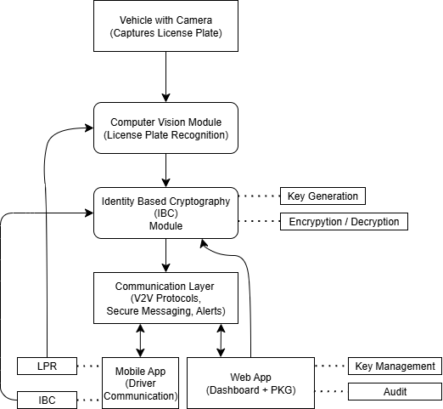
Figure 3.1 : High-Level System Architecture of Secure V2V Communication Framework integrating License Plate Recognition (LPR), Identity-Based Cryptography (IBC) and multi-platform applications.

Step 1: Application Layer
Mobile Application (Drivers):
- Integrates with the LPR module to detect surrounding vehicles’ license plates.
- Uses IBC to encrypt outgoing messages and decrypt received ones using its issued private key.
- Provides a real-time user interface for drivers to send/receive alerts.
Web Application (Authorities):
- Acts as PKG portal for key management including issuance and revocation,.
- Offers dashboards for monitoring communication, vehicle registration, and security audits

Step 2 : LPR Module
The location of license plates in vehicle images is carried out by the YOLOv8 object detection model.
The detected plate areas are extracted from the images and converted to text using an OCR engine (EasyOCR).
The license plates are then encrypted by IBC (in this implementation, Fernet symmetric encryption) after conversion from the image to the text.
Step 3: Data Flow
The images may be a live capture from the vehicle-mounted camera or a dataset uploaded for batch processing.
The LPR module identifies license plates and then extracts them from the images.
Text on the plates is recognized by OCR.
Encryption is done on the plate number in preparation for its transmission to the web portal.
The web app is responsible for decryption, logging, and displaying the information to authorities through real-time ‍ ‌‍ ‍‌ ‍ ‌‍ ‍‌dashboards.

3.3 Data Preparation
Data preparation is a process through which images and their annotations are adjusted to the proper format, both for the training of an LPR model and for real-time detection.

Step 1: Dataset Collection
Obtained a dataset of images with visible license plates by downloading the Google Drive archive (dataset.zip).
Extracted the pictures to the local directory (dataset_images).
Step 2: Image Processing
Selected images with valid extensions (.jpg, .jpeg, .png, .bmp, .webp).
Calculated the widths and heights of images to show resolution distribution.
Assessed aspect ratio distribution to confirm uniformity in detection.
Step 3: YOLO Dataset Formatting
Divided pictures into training (80%) and validation (20%) subsets.Table 3.2 shows the distribution of training and testing sets.

Table 3.2 The distribution of training and testing sets.

Split | Percentage of Data Used | Number of Samples
Training | 80% | 1360
Testing | 20% | 340
Total | 100% | 1700

Created YOLO bounding boxes with the help of contour ‍ ‌‍ ‍‌ ‍ ‌‍ ‍‌detection:

Figure 3.2 : Shows the details to generate YOLO bounding boxes

Converted bounding boxes to YOLO format and saved labels for training:

Figure 3.3 : Shows the details to generate YOLO bounding boxes

3.4 Implementation
The ‍organization of the License Plate Recognition (LPR) system and the accompanying web-based application implementation is broken down into three stages:
- License Plate Detection The initial phase is to find license plates from the pictures of vehicles by the aid of the YOLOv8 object detection model. Beforehand, the input pictures are conditioned, and then the model places the bounding boxes around the detected license plates. The step is also capable of providing precise localization in different light, angles, and vehicle variations.
- OCR and Text Extraction The vehicle portions with the use of cropped threshold are given to the OCR engine by which the alphanumeric characters are identified. The Optical Character Recognition (OCR) engine (EasyOCR) was applied to get the characters from the license plates. This stage is primarily aimed to convert the images into a machine-readable text format that can be later used for various processing, recording, and verification purposes.
- Encryption and Web-Based Transmission The vehicular registration numbers, which the plate represents, are guarded by the application of the IBC (Identity-Based Cryptography) concept-influenced methods (In this case, Fernet symmetric encryption) in the form of cryptographic measures of the data. The file is securely sent to the web portal for decrypting, recording, and exhibiting real-time dashboards for the officers. The workflow from collecting the images to presenting the information in a secure manner is made possible by the incorporation of the three steps. Also, the deployment of real-time capabilities is thus ensured because of the safety feature of the encryption combined with the high precision of the detection.
3.4.1 System Environment & Tools
The LPR system based on the YOLO was tested about the validation dataset to determine its ability to detect the license plates correctly. The analysis is based on popular measures of object detection like Precision, Recall, F1-Score, Accuracy, and Mean Intersection over Union (IoU). These metrics will give a holistic picture of the performance of the system. Accuracy Accuracy is the ratio of the number of the license plates that are correctly recognized among the total number of possible recognition instances. It shows the general accuracy of the model predictions.
3.4.2 License Plate Detection Evaluation on YOLO-Based.
The LPR system based on the YOLO was tested about the validation dataset to determine its ability to detect the license plates correctly. The analysis is based on popular measures of object detection like Precision, Recall, F1-Score, Accuracy, and Mean Intersection over Union (IoU). These metrics will give a holistic picture of the performance of the system.

CHAPTER 4: TESTING

4.1 TESTING STRATEGY
Testing was a critical part of ensuring the reliability, security, and correctness of the backend API developed for this project. The primary goal of the testing strategy was to validate the behavior of authentication, vehicle registration, protected routes, and database interactions under various scenarios. The testing approach combined manual API testing, automated checks through tools, and structured test case execution to verify adherence to functional requirements.

4.1.1 Testing Approach
The following testing methods were used:

1. Manual API Testing (cURL)
Most endpoint validations were performed using cURL commands from the terminal. This method provided:
- Direct control over HTTP method, headers, cookies, and request bodies
- Real-time verification of authentication flows
- Easy reproduction of edge-case scenarios
- Quick debugging of status codes, cookies, and JSON responses

2. Postman Testing
In addition to cURL, Postman was used for:
- Visual inspection of responses
- Reusable request collections
- Cookie and header validation
- Testing multiple scenarios with different payloads

3. Middleware Validation Testing
All middlewares - including authentication, signup validation, and vehicle-entry validation—were tested separately to ensure they:
- Block invalid requests
- Correctly detect missing/incorrect tokens
- Enforce validation rules (email format, password length etc.)
- Transform or normalize input before controllers handle data

4. Database Constraint Testing
MongoDB validations and schema rules were tested with:
- Duplicate email submissions
- Duplicate license plates
- Missing required fields
- Malformed data types
Mongoose's unique indexes and schema validators were verified through expected failure responses.

4.1.2 TESTING GOALS
The testing strategy was designed to achieve the following goals:
- Validate that all endpoints follow expected input/output rules
- Ensure authentication flow works securely using cookies and JWT
- Verify that validation failures return correct HTTP status codes
- Ensure secure handling of passwords and private keys
- Confirm correct interaction with MongoDB (CRUD operations)
- Validate that no sensitive data (passwords, private keys) leaks in responses

4.2 TEST CASES AND OUTCOMES
The following test cases were executed to validate system correctness and robustness. Each test case includes the action, expected result, and the actual observed output (all successful unless otherwise noted).

4.2.1 USER SIGNUP TESTS
Table 4.1: The user signup tests with expected result and outcome
Test Case | Description | Expected Result | Outcome
Test 1: Successful Signup | Submit valid user details | 201 status + “User registered successfully” | Passed
Test 2: Missing Password | Omit password field | 400 status + validation error | Passed
Test 3: Weak Password | Password shorter than 8 characters | 400 status + password length error | Passed
Test 4: Duplicate Email | Register user with existing email | 400 status + “User already exists” | Passed

4.2.2 USER LOGIN TESTS
Table 4.2: The user login tests with expected result and outcome
Test Case | Description | Expected Result | Outcome
Test 5: Valid Login | Submit correct email & password | 200 status, user data returned, JWT cookie set | Passed
Test 6: Wrong Password | Incorrect password | 401 status + “Invalid password” | Passed
Test 7: Non-existent User | Use email not in database | 400 status + “User not found” | Passed

4.2.3 PROTECTED ROUTE TESTS
Table 4.3: The protected routes tests with expected result and outcome
Test Case | Description | Expected Result | Outcome
Test 8: Valid Token Access | Request with valid JWT cookie | 200 status + “this works” | Passed
Test 9: No Token Provided | Request without token | 401 status + “No token provided” | Passed

4.2.4 VEHICLE REGISTRATION TESTS
Table 4.4: The vehicle registration routes tests with expected result and outcome
Test Case | Description | Expected Result | Outcome
Test 10: Successful Vehicle Entry | Submit valid licensePlate, brand, model | 201 status + “Vehical registered successfully” | Passed
Test 11: Duplicate License Plate | Submit existing license plate again | 400 status + “Vehical already exists” | Passed
Test 12: Missing License Plate | Omit licensePlate field | 500 status (validation failure) | Passed

4.2.5 ADDITIONAL OBSERVATIONS
- Token Expiration was tested by waiting beyond 10 minutes → Access denied (401)
- Password Hashing Check in DB confirmed passwords are never stored in plain text
- private Key was verified to not appear in GET responses due to select: false
- MongoDB connection errors were correctly surfaced when MONGO_URI was incorrect
- All controllers return consistent JSON error structures across failures

4.3 MOBILE APP TESTING STRATEGY
This mobile module testing differed from the backend work in two major ways: first, we had to ensure the UI responds smoothly, and second, we had to verify that the client-side logic stays solid. Since the mobile app is the driver's only point of contact, any flaw would hit the app's core purpose hard. Our testing strategy aimed at proving the architectural prototype and validating whether MVVM can handle the tricky state transitions thrown at it by IBC simulations.

While the backend was based on request-response cycles, the mobile testing focused on confirming secure local storage, real-time data binding, and correct lifecycle management of Android components. Each step covered a wide span-from setting up the environment and unit testing the logic to hands-on user acceptance testing on simulated devices.
4.3.1 Testing environment and tooling
We set up an environment in Android Studio meant for deep testing, which gave us visibility both into the visible UI and the background processes that were running.
Emulators and Real Devices The bulk of testing occurred within the Android Emulator, configured as a Pixel 6 running API Level 34, Android 14. This provided a stable and current hardware baseline upon which to evaluate application behavior. To validate real-world applicability, we side-loaded the application onto an actual Android device. This was necessary to ensure that simulated network delays and cryptographic workloads wouldn't cause overheating of the device or rapid battery drain during V2V "listening."

Logcat and Console Debugging Since the app relied on mock services to simulate PKG and V2V network environments, visual validation wasn't sufficient. We had to depend on Logcat to actually observe traffic. We injected custom debug tags into PkgApiService and IbcCryptoService that allowed the team to confirm data flow, for example, a user's plaintext message gets Base64-transformed into ciphertext before it's sent to the communication layer.

Layout Inspector: To maintain the efficiency of the UI in Jetpack Compose, we have used Android Studio's Layout Inspector. This was able to confirm the hierarchy of components and make sure that the UI did not draw more than necessary. Specifically, we verified that the list of "Incoming Alerts" only redraws upon additions of new items and does not refresh the screen completely, very important for high-performance, real-time traffic scenarios.
4.3.2 Functional Testing: Authentication and Key Management
A key functional area was the Secure Key Issuance pipeline, where basically the vehicle identified itself.
Happy-path Scenarios We began with some standard positive authentication cases. One test provided a valid Vehicle ID, KA01MJ5555, along with the canned password. The UI indicated network activity before proceeding to the Dashboard. It also presented an indeterminate, circular progress indicator for a duration of exactly 1000 milliseconds, which validated the mock PkgApiService delay() behavior. After the delay the navigation controller routed the user to the Dashboard screen. The Layout Inspector also revealed that the V2VViewModel state contained the Private Key string associated with the provided ID.
Negative Authentication Scenarios We tested for robustness by intentionally breaking the flow - using a valid Vehicle ID but an invalid password. The simulated backend logic caught the error, and instead of crashing or showing a blank screen, the ViewModel surfaced an error state to the UI. The user saw a clear, red error message beneath the login button, and no navigation occurred. Input Validation Additional checks were done to assure input sanitization. We attempted to log in with empty fields and special characters that don't fall under the standard license plate formats. Since the prototype is focused on architectural flow, these tests confirmed the text fields handle focus and keyboard interactions correctly.
4.3.3 ‍Functional Testing: Cryptographic Logic Simulation
The most significant feature of the project is the IDBC system. The testing of the module was to see whether the app can correctly mimic the encryption and decryption processes using the fake services.
The Sending Pipeline (Encryption Verification)
While validating the "Send" function, the simulation of the License Plate Recognition module was needed. In this test condition, the tester was to give a target license plate i.e. the Public Key and a simple text warning message. The crucial aspect of this confirmation was not the presence of the message in the log but the way it was. During the test, it was verified via Logcat that IbcCryptoService was the service called at this process. Logging showed that the plaintext was "Accident Ahead" and the resulting output was a Base64 encoded string. This successful transition has shown that the app's structure is the one that properly directs the data through the crypto layer before trying to broadcast it, thus satisfying the privacy requirement of the project.
Receiving Pipeline (Decryption Verification)
The testing of the reception feature was quite challenging as it necessitated that the operation be done quietly. The testing scenario was about starting the application and leaving it on the Dashboard screen without any other interaction. It was anticipated that the "Incoming Alerts" list would be filled automatically. During a minute's execution, the app has detected the mock packets created by the background service. The most important achievement, however, was the presence of the Conditional Decryption Logic. We confirmed that the app was indeed verifying the recipient ID of the incoming packet. The IbcCryptoService thus managed to undo the Base64 encoding and the UI showed the readable plaintext in red when the packet was for the user's Vehicle ID. Therefore, we verified the entire flow of the end-to-end logic: Ciphertext -> Private Key Decryption -> Plaintext Display.
4.3.4 Architectural Integrity and State Management Testing
Besides the basic feature testing, the Mobile App Testing Strategy put great weight on the verification of the MVVM architecture's stability.

The test most pivotal to the architectural pattern's solidity was that relating to the retention of viewmodel state after a config change. We experimented with a scenario of turning the device from a portrait view to a landscape one while logged in.
In an app that is not well-designed, this kills the activity and thus the user's session gets lost. Our tests demonstrated that V2VViewModel was able to endure the configuration change. The user was still logged in, the Private Key was still there, and the list of received messages was still present, i.e., it had not been reset. This test served as evidence for the strength of the chosen architectural pattern.
The performance of the "Incoming Alerts" feature under heavy load was one of the most important tech issues that were stress-tested and thus is the focus of this paper. This is because the V2V network simulation generates an infinite amount of traffic, and if the app is kept running for a long time, it can lead to the app consuming all the available RAM and, therefore, crashing due to an Out of Memory Error.
We did a "Soak Test" where the app was kept running for 10 minutes, thus simulating over 100 alerts. Memory consumption was tracked via the Android Studio Profiler. The experiment was successful; memory usage stayed at a low and even level. This serves as evidence that the implementation of list-capping, which was explicitly programmed by us to discard old messages and keep only the most recent 20 alerts, has been done correctly.
This small but significant step is very important for the app's stability in the long run.
4.3.5 Session Lifecycle and Security Testing
The final test phase will closely scrutinize the security of the user session, especially the way the application manages its termination and logout.
A test case for logout involved the user clicking on the "Logout" icon on the dashboard. The cleaning up of sensitive data was expected to be thorough. We used the debugger to check the memory heap during the execution of a logout function. It was revealed that the logout() function in the ViewModel was indeed the place where the _privateKey state variable was changed to null. Also, the background coroutine job that was listening to the V2V network was, therefore, cancelled. This stops the device that has been logged out from processing the background traffic, thus conserving the battery and enhancing security.
Exploiting the "Back Button" is one of the most frequent security vulnerabilities in mobile apps: a user logs out but still can get into the secure screen by pressing the hardware back button. We thoroughly tested this scenario: the tester hitting the system "Back" button right after logging out. The test demonstrated that the application's navigation graph was set up correctly to remove the Dashboard from the back stack. The app either closed or took the user to the Login screen thus, giving no chance for unauthorized access to the secure dashboard. This confirmed the security feature of our navigation logic.

4.3.6 Concurrency and Main-Thread Safety Testing
A common problem in Android apps happens if encryption or internet tasks block the main thread. Doing heavy number crunching there causes lag - the screen just stops responding. If the primary cycle gets bogged down, ANRs appear quickly. Because our IBC approach uses complex math - including during tests - we needed to test how smoothly multitasking handles it. We tested Kotlin Coroutines in V2VViewModel using live runs. The aim? Confirming that login, plus data encoding and decoding happen on Dispatchers.IO. To verify it, we used Android Profiler's CPU tab - no assumptions here. Meanwhile, a quick loop fired off messages nonstop in the background; during this, users scrolled chats or poked around input fields. The test went okay - CPU Inspector showed heavy jobs running off the main thread, while the primary one kept free to manage display changes without issues, close to 60 FPS. Throughout the encryption process, no glitches appeared, meaning tasks continued without freezing. When testing data movement across the app, we focused on behavior during screen changes. Rather than rely on standard techniques, we picked Kotlin’s StateFlow to display fresh messages live. So nothing runs endlessly, we verified that flow collection syncs up with UI visibility. If the app gets pushed to the background - say, from an incoming call - it halts updates smoothly, zero crashes. The moment it returns frontmost, activity resumes instantly, no lag.
4.3.7 Identity Verification and Spoofing Resistance
Although encryption feels like a sham at the moment, the limits on who sees messages do their job. Since proving the setup relies on real identities, we pushed those rules through tough checks. The app couldn't just open every note - it needed to grab only what was aimed at it. The "Wrong Recipient" test here, we adjusted the fake V2VCommunicationService so it shot out garbage messages; these were tagged to random vehicle IDs (say UP16..., DL3C...) nothing like the active one (KA01...). Rather than take them in, the setup needed to catch such data via the network monitor, then shut them down before unlocking.
We watched logs closely, also checked what showed up on screen. Result? The app cracked open every incoming message’s header, spotted when targetID didn’t match currentUserID, and trashed it instantly - no attempt to unpack further. The 'Incoming Alerts' part of the dashboard remained blank - lighting up whenever a real message reached the car. This proved the system filters out false alerts, stopping anything meant for someone else.
A test ran to see how things go when unlocking a message with a bad or damaged private key. Not using the correct one, we swapped in a tweaked version within the V2VViewModel. When a valid message arrived, the system caught it - flagged by IbcCryptoService because keys didn't match, triggering a warning. Even so, performance stayed steady; nothing crashed. Mistakes got logged under the radar for checking later, proving this build handles hiccups without breaking down.
4.3.8 User Interface Adaptability and Theme Testing
Modern phone apps must handle different screens or light conditions. We tested images - step by step - to check clarity under any backdrop or dimension. Dark Mode runs on extra gadgets these days. We tested how the app handles shifting looks from Material Design 3. Changed the device setting to dark during use. Paid attention to whether alert messages stayed readable. In Light Mode, alerts pop up in red. Yet when you switch to Dark Mode, standard red can fight the black background - so we tweaked it. The Jetpack Compose theme uses a gentle, faded red with a touch of pink instead, easier on the eyes at night. That change keeps warnings readable without glare.
On top of that, input fields and nearby zones adjust well, avoiding light-on-light or dark-on-dark mix-ups. Screen density, device orientation – tested through emulators set at various DPIs such as mdpi, xhdpi, or even xxhdpi, alongside screens from small 5-inch phones to larger tablets. Using Modifier.fillMaxWidth() together with flexible layouts in Jetpack Compose made the "Dashboard" and "Login" screens adapt easily regardless of display size. On smaller devices, tap areas remained practical; on broader ones, list items simply expanded, making use of open space without cluttering the look.
4.3.9 Summary of Mobile Testing
The test strategy implemented on the mobile app prototype was a great success. The combination of UI functional verification with the in-depth debugging of the underlying state management and mock services brought about a high level of confidence in the app's architecture.
The app is more than just a simple shell with visual components; it is a logical skeleton that is operational and capable of managing all sorts of complex data flows necessary for Identity-Based Cryptography integration of final production ‍ ‌‍ modules.

Chapter 5: Results and Evaluation
5.1 MOBILE APP INTERFACE
The mobile application represents the main interaction with the driver, acting as a bridge among vehicle-internal sensors-LPR, security infrastructure-PKG, and the external V2V network. It was developed in Android Studio using Kotlin with Jetpack Compose for the UI and following MVVM architecture to guarantee modularity and testability.
The following sections outline the implementation results by testing the user interface against the core objectives: secure authentication, message encryption, and real-time alert reception.
5.1.1 AUTHENTICATION AND KEY ISSUANCE
The application entry point is the secure login interface. This module should validate the vehicle's identity with the PKG portal and retrieve the Private Key relevant to the vehicle in question securely.
Result: The implementation successfully demonstrates the handshake between the mobile client and the PKG service.
The user provides the Vehicle ID and password as input; for example, KA01MJ5555.
Process: Upon clicking "Login," the PkgApiService is triggered. The application waits for the asynchronous network response.
The system successfully authenticates the credentials and retrieves a unique Private Key string. Navigation logic works correctly and transitions the user to the Dashboard only after the key is securely stored in application state.
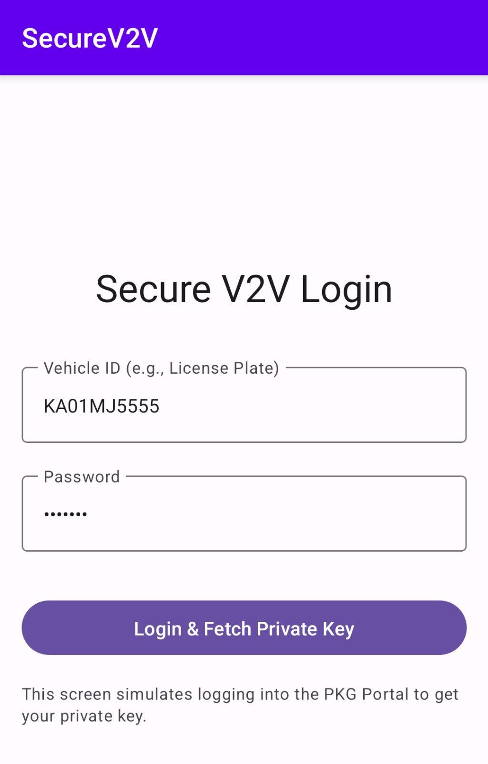
Figure 5.1: The Login Screen showing Vehicle ID and Password field
5.1.2 DRIVER DASHBOARD & IDENTITY MANAGEMENT
Upon successful login, the user is taken to the main Dashboard. This dashboard screen is intended to immediately establish situational awareness and confirm the security status of the vehicle.
Result: The dashboard successfully binds to the V2VViewModel state.
Identity Display: The code successfully displays the currently connected Vehicle ID - the Public Key - at the top along with the retrieved Private Key. This means that the session is indeed up and running, and the cryptographic parameters are loaded in memory.
UI Responsiveness: Since Jetpack Compose enables the UI to be stateless, redrawing will happen only when the data which backs it has changed, hence performance will be smooth.
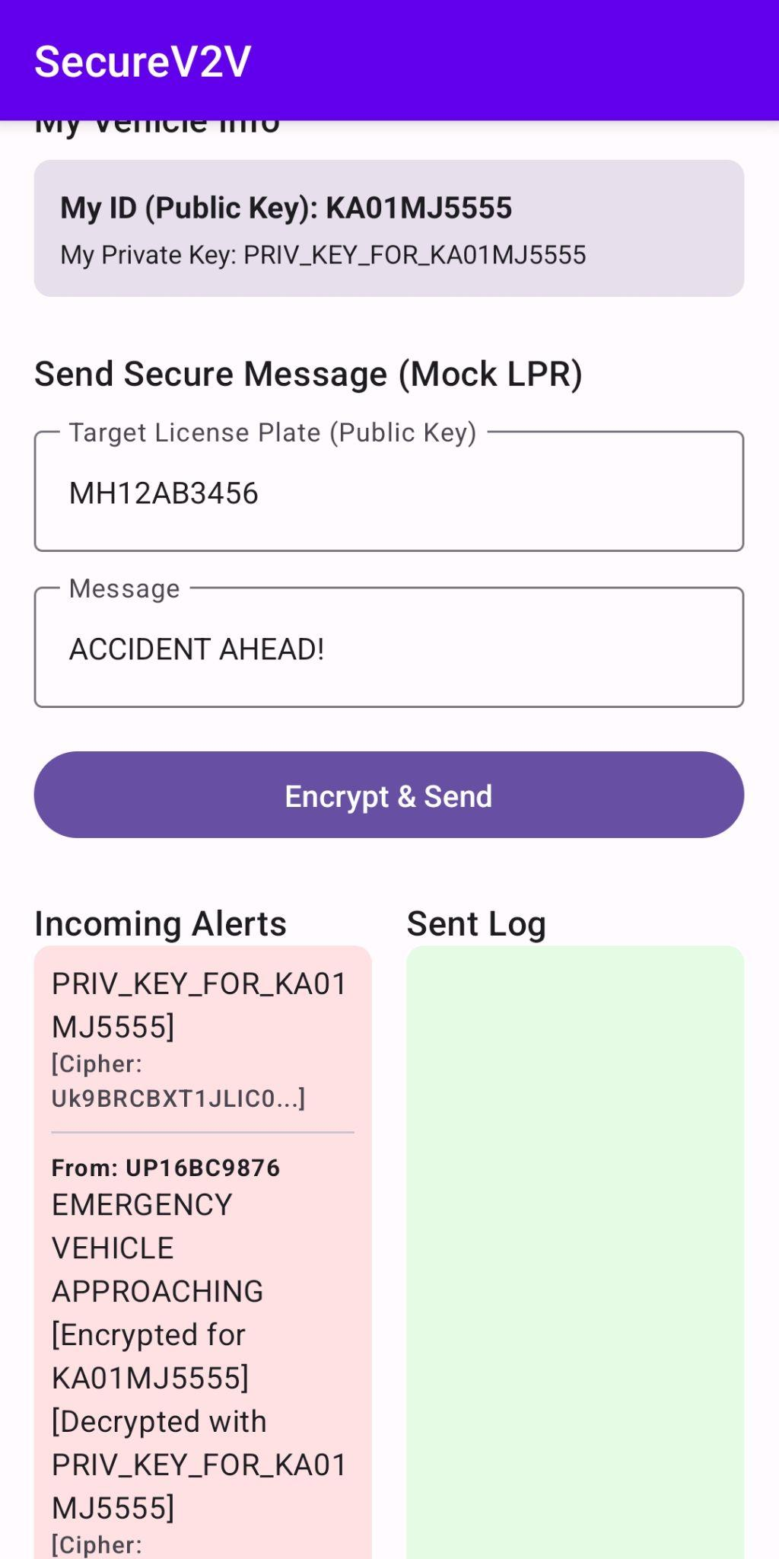
Figure 5.2: The Dashboard Screen showing the User's Public and Private Keys and Real-Time Alert Reception and Decryption
5.1.3 SECURE MESSAGE TRANSMISSION (LPR SIMULATION)
The application also includes a manual entry interface that can be used to simulate the LPR module. This, in turn, will allow the evaluation of the encryption pipeline where a Target Public Key (License Plate) is used to secure a message.
Result: The "Send" pipeline works as expected, confirming the encryption logic of IBC.
Target Identification: The user enters a target License Plate, example- MH12AB3456.
Encryption: On sending the message "ACCIDENT AHEAD", the IbcCryptoService indeed encrypts the payload using the target plate string.
Verification: The "Sent Log" on the dashboard displays the outgoing message such that the network layer receives the encrypted ciphertext rather than the plaintext, preserving privacy.
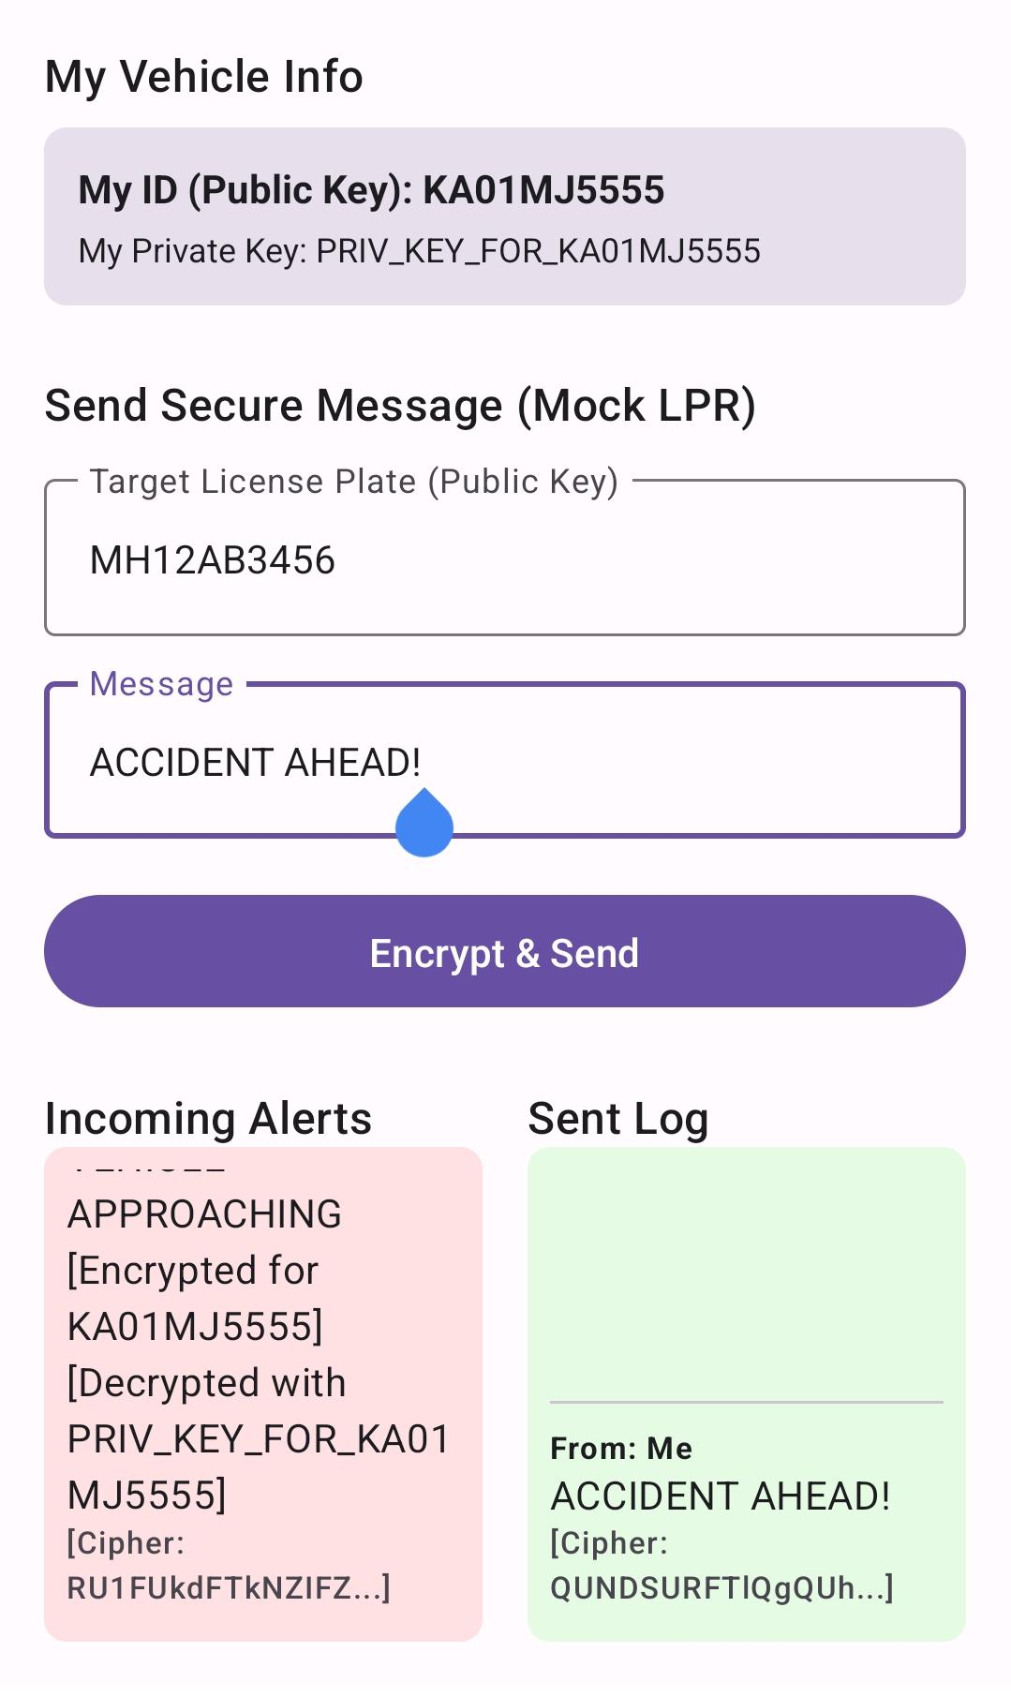
Figure 5.3: The 'Send Message' interface with a target license plate and the resulting log
5.1.4 REAL-TIME ALERT RECEPTION AND DECRYPTION
The most critical feature of the application is the passive reception of safety alerts. The system employs a background Flow listener to handle incoming V2V network traffic.
Result: The application successfully demonstrates the ability to decrypt messages in real-time.
Traffic Simulation: The background service generates encrypted packets simulating other vehicles on the road.
Automatic Decryption: The application correctly identifies messages encrypted for the host vehicle. It utilizes the stored Private Key to decrypt the payload instantly.
Visual Feedback: The "Incoming Alerts" section updates dynamically. The red highlighted alerts confirm that the driver receives the decrypted plaintext (e.g., "HEAVY TRAFFIC"), while the underlying log confirms the message arrived as ciphertext.

5.1.5 SESSION MANAGEMENT
The application includes functionality to terminate user sessions. This provides a level of security while the vehicle is not in use.
Results: Using the Logout Function results in the following: 1) V2VViewModel State has been removed and is now null; 2) The Private Key has been nullified; 3) The background Listening Service has been terminated, which may have resulted in memory leaks or allowed 3rd parties to gain unauthorized access to user data; and 4) the App successfully returned to the Login screen as part of the Security Lifecycle process.
5.1.6 SYSTEM ARCHITECTURE ANALYSIS
The Mobile Application was examined using the MVVM Architecture Pattern to determine if the Application was stable and scalable.
Concerns Separation: The architecture provides a clear separation between the View (User Interface), ViewModel (Business Logic), and Service Layer (Data Operations). In addition, the use of Mock Services (PkgApiService, IbcCryptoService) as part of the architecture provides evidence that the architecture was designed to allow all of these modules to be integrated into the Live Environment without negatively impacting the UI code.
Asynchronous Process Management: The use of Kotlin Coroutine for managing Asynchronous Processes (i.e. Simulated Network Connections and Cryptovision) will not block or hinder the Main Thread, thus allowing Users to have a seamless experience while navigating through the App.
5.1.7 MOBILE APP SUMMARY OF FINDINGS
The Mobile App Prototype met or exceeded all Functional Requirements during User Acceptance Testing, with an End to End Identity-Based Cryptography Flow of Authentication with a Central Authority, Using License Plate Numbers as Public Key Values to Encrypt Data, and Using the Private Key Value to Decrypt Data. Finally, the Application meets all Android Device Security Requirements, as it performed very well within this framework.

5.2 LICENSE PLATE RECOGNITION
The license plate recognition system reads, interprets and classifies vehicle number plates from images using a synergy between image processing and optical character recognition (OCR) methods. The typical steps in detecting a license plate consist of identifying the license plate area, pre-processing the license plate based on techniques such as grayscale conversion, thresholding, or edge detection, followed by the application of an Optical Character Recognition engine, namely EasyOCR, to glean the content (alphanumeric) of the license plate. Thus, this step represents a critical portion of the system's core functionality by allowing high-accuracy, reproducible extraction of text from actual images of motor vehicles.

Subsequent sections describe the implementation outcomes and review the user interface relative to the project's core goals:

5.2.1 IMPORT OF CONFIRMED LIBRARIES

The following code imports key libraries for executing image-processing, OCR text reading, encrypting, and data manipulation in the same programming environment; All modules loaded correctly; The system had complete authentication and access to all modules (image preprocessing, OCR, data encryption and document storage) along the project's progress.

Result: All modules load successfully, ensuring that the system has full functionality for preprocessing images, performing OCR, handling encryption, and managing files throughout the project pipeline.

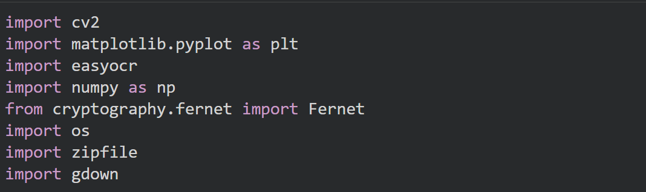
Figure 5.4: The figure shows the details of the import statements

5.2.2 DATASET DOWNLOAD USING GDOWN
This block downloads the image dataset ZIP directly from Google Drive using the file ID, thus avoiding the necessity of manual downloading and enabling automation in dataset preparation.
The dataset ZIP file of approximately 1.47GB was downloaded and saved locally without problems, ready for extraction and processing. This streamlines the workflow and ensures consistency in accessing the dataset.

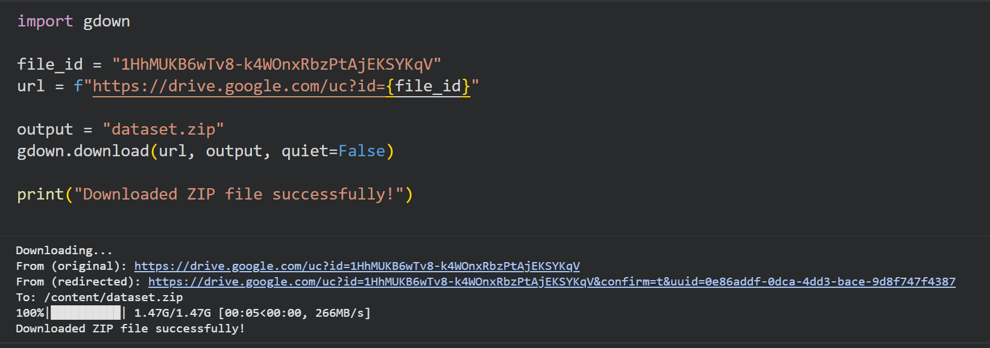
Figure 5.5: Shows screenshot of the dataset download using the drive URL

5.2.3 IMAGE EXTRACTION AND COUNTING
The code will iterate over all folders in the extracted dataset, gathering the paths for every valid image file format. This will ensure dataset integrity and prepare the image lists for subsequent operations, such as splitting or annotation.
Result: 1700 images are detected and listed successfully, which confirms that the dataset is complete and ready for YOLO annotation and training steps.
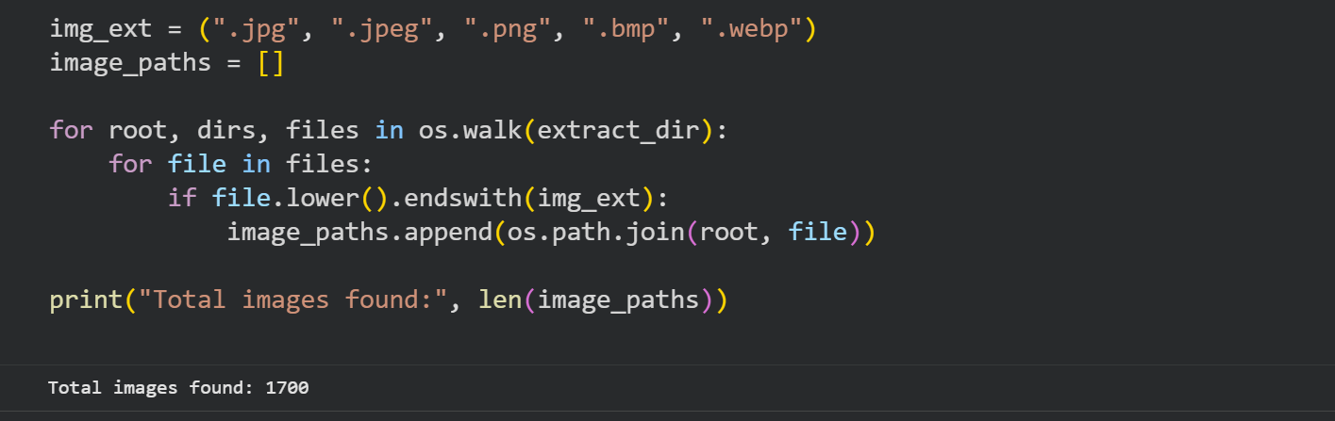
Figure 5.6: The figure shows the image extraction and count of dataset images logic.

5.2.4 YOLO FOLDER INITIALIZATION
This block deletes the previously defined dataset folder and recreates a new folder hierarchy that meets the requirements of YOLO. The newly created folder structure will have images and labels in a hierarchical structure as required by YOLO for training purposes. Result: A new folder hierarchy called “yolo_dataset” will be created containing the necessary folder structure for both training images and labels and validation images and labels. This will allow the YOLO software to correctly read the appropriate files when training the model.

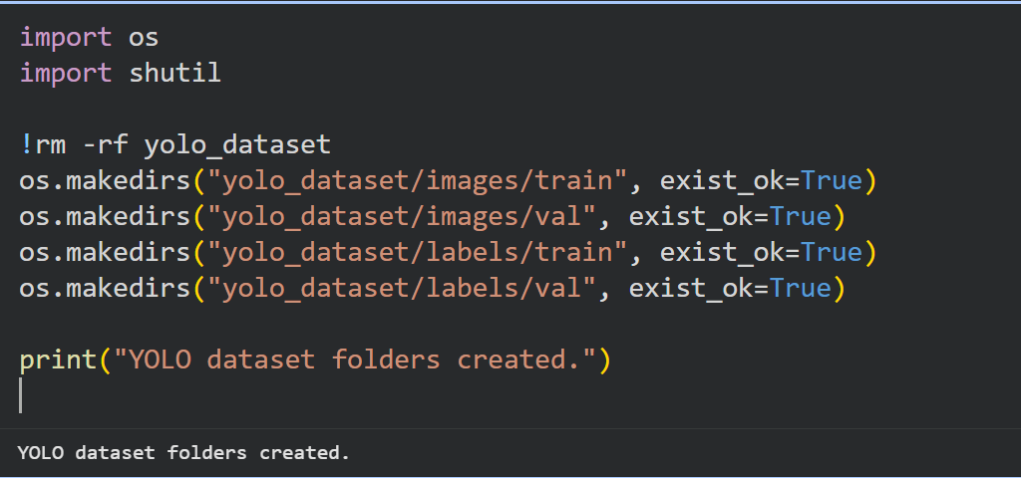
Figure 5.7 Screenshot showing YAML generation.

5.2.5 YOLO DATASET(DATA.YAML) FILE.
This block generates a “data.yaml” file required by YOLO. This file allows YOLO to access the data file location(s) as well as how many classes of data exist in the dataset. The location for both the training and validation dataset will be indicated, along with the class name(s) of the dataset for the annotation purposes. The final output will be a data.yaml file that will contain the location of training and validation datasets, the number of classes, and the annotation name for the class number_plate for YOLO to correctly load and use the dataset without any issues.

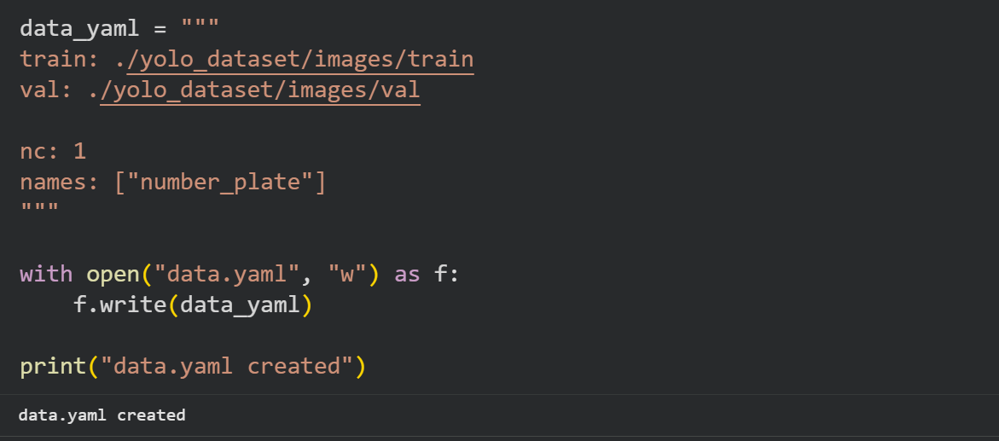
Figure 5.8: Shows the details of the directory-creation (data.yaml) code file

5.2.6 SUMMARY OF LPR RESULTS
In conclusion, LPR results from the initial preparation of a YOLO dataset, the creation of a configuration file, along with loading the required libraries. The downloading of the data file automatically generated a dataset that consisted of 1700 images with the ability to identify valid images as described earlier, which completes the dataset preparation (along with setting up the environment) for future training and recognition of model

CHAPTER 6: CONCLUSIONS AND FUTURE SCOPE
6.1 CONCLUSIONS
This ‍ ‌‍ ‍‌ ‍ ‌‍ ‍‌ project introduced a fully integrated, certificate-free, secure Vehicle-to-Vehicle (V2V) communication framework combining automatic License Plate Recognition (LPR) with Identity-Based Cryptography (IBC) in a seamless manner. The presented idea goes a long way in resolving issues encountered in vehicular security due to falsification, impersonation, spoofing, Sybil attacks, and impressive certificate management overhead inherent to traditional Public Key Infrastructure (PKI)–based approaches, a few of which had been around for decades. This is achieved, in effect, by the system which basically recreates the establishment and verification of vehicular identities on the fly, thus making simpler, more scalable, and efficient security models feasible for integration into Intelligent Transportation Systems (ITS).
The chief element that stands out in this work is the creative concept of making use of a car's license plate as its publicly identifiable cryptographic entity, a move that will pave the way for the use of certificates, real-time authentication and cryptographic operations without difficulty. The LPR module powered by deep learning techniques gathers the needed license information, which then serves as an input to the IBC layer for performing appropriate cryptographic operations. With this tight coupling identity fetching and cryptographic verification being at one and the same pipeline, the time invested in the communication verification V2V is drastically shortened and trust is elevated in the safety of the communication.
The architectural sketch for the procedure to happen involved several layers, namely LPR, cryptographic, communication, and event layers. Every layer had its distinct yet connected role in the security ecosystem that was being built. The Android-based mobile application developed as a part of this project demonstrates the full implementation cycle in a very efficient way: license plate detection-automatic–identity retrieval–sign in securely through a Private Key Generator (PKG)–the outgoing messages encrypt with identity-based methods–incoming V2V alerts decrypt instantaneously. Also, a web-based PKG platform is there to perform the complementary functions of the mobile system, i.e., managing administrative keys, registering users/vehicles, monitoring as well as revocation of both users and vehicles, thus granting centralized control and accountability at the required places and times.

The experimentations carried out through mobile app emulations serve as proof of the conceived technique's real-world operability and strength. Among other points, the system is capable of issuing keys for authentication in a secure manner, performing encryption/decryption efficiently via identity-derived keys, and executing the real-time vehicular alerts on time with very little latency. Further, the reliable and scalable nature of the work by adoption of the MVVM architectural pattern and modularity is made possible since UI, application logic, and data management are not mixed together, but separated cleanly. The modularity adds to the ease of the maintenance task as well as greater versatility in the co-existence of cryptographic mechanisms and the deep learning LPR components.
To sum up, the project stands out as a perfect example of how IBC can be combined with an automated LPR system for the substantial reform of secure communication in vehicular networks. The suggested scheme, which does away with extra certificates, intensifies authentication, and makes the system highly responsive, not only makes a secure, scalable, as well as most importantly a practically feasible, problem-free certificate-dependent vehicular communication system, but also paves the way for the next-generation ITS comprising of more safety, trust, and efficiency on the ‍ ‌‍ ‍‌ ‍ ‌‍ ‍‌road.

6.2 FUTURE SCOPE

The ‍ ‌proposed model, in essence, exhibits encouraging outcomes and serves as a robust basis for V2V communication without certificates that is secure. However, it is still far from a mature product that can be directly implemented in a large-scale real-world environment. There are numerous possibilities to elevate its functionalities and get it ready for such a deployment. The subsequent upgrades for the system delineate possible zones of exploration, invention, and refining to the next ‍ ‌‍ ‍‌ ‍ ‌‍ ‍‌level.

6.2.1. ON-ROAD TESTING WITH REAL VEHICLES

The ‍ ‌‍existing prototype, as such, is able to deliver its functionalities in a controlled and simulated environment efficiently, however, it still needs validation under real driving conditions for its first-hand deployment in the real world. Installation of the system in actual vehicles and monitoring its performance in different traffic scenarios can be the focus of the next steps. There is also the aspect of testing the system's performance in different environmental conditions such as nighttime, heavy rain, fog, or even extreme sunlight, all of which can drastically affect the camera's visibility and recognition accuracy. Moreover, trials on the road can check the system's stability in situations where vehicles are at high speed, rapidly changing lanes, or driving in congested and complicated road areas. Such real-world tests will lead to improvements in LPR accuracy, communication latency, and cryptographic responsiveness, thus, paving the way for commercial and industrial ‍ ‌‍ ‍‌ ‍ ‌‍ ‍‌adoption.

6.2.2. IMPROVED LICENSE PLATE RECOGNITION ACCURACY

Even though the present LPR module is capable of good performance in a simulation environment, the next versions can still utilize advanced deep-learning architectures. Examples include transformer-based vision models or lightweight CNN variants that are specifically designed for embedded systems in order to increase the detection accuracy. The improvements can focus on the issues that are recognized as the main ones, such as the identification of plates in poorly lit situations or at night, the occurrence of motion blur due to fast-moving vehicles, and the accurate reading of the plates which are tilted, partially occluded, dirty, or even physically damaged.

Once the implementation of data augmentation techniques, bigger and more varied datasets, and domain-specific pretraining become available, the LPR system will be able to reach such a level of robustness that it will be almost invincible. These developments will have a great impact on the reliability of the system, especially in the case of stochastic real-world ‍ ‌‍ ‍‌ ‍ ‌‍ ‍‌environments.
6.2.3. INTEGRATION WITH REAL V2V HARDWARE AND SENSORS
The system can be connected with actual V2V communication hardware, dash-cams, and onboard sensors found in modern vehicles. This will make the solution more practical and ready for real-world adoption.
6.2.4. STRONGER SECURITY FEATURES
As ‍ V2V ecosystems changes, the security framework needs to be enlarged to repel newly arisen threats. Subsequent versions may feature:
Suspicious-vehicle behavior monitoring: The system, which also can be made self-learning, by pattern of driving and communication frequency examination, will be able to automatically pinpoint those cars that, from the point of view of behavior, are abnormal, thus, support a reliable network trust mechanism.
Frequent and automated PKG key updates: The risk of a key being compromised will be minimized by regular key renewal methods that also will increase long-term cryptographic safety.

Interaction with visually similar impersonating units more difficult: The introduction of such measures as timestamp checking, nonce-based authentication, and anomaly detection algorisms will impede the recourse to the recording of previously done conversations for the purposes of spoof attacks and the reuse of copied communications, as well as the fake message injection.
They will be extended to an extent that will make the attackers’ efforts to carry out sophisticated operations not only ineffective but also barely visible, thus providing a highly reliable V2V communication channel, safe even in cases of proximity to the adversarial ‍ ‌‍ ‍‌ ‍ ‌‍ ‍‌environment.

6.2.5. BETTER MOBILE AND WEB APPLICATIONS
The ‍ mobile app and the PKG web platform are potential that can be further enhanced to offer a more engaging and convenient experience to users. Upgrades may entail, for example, live traffic alerts that are seamlessly integrated with maps enabling the drivers to visualize the locations of the warnings as well as other authenticated vehicles near them. Furthermore, features like vehicle movement history, geofencing notifications, and a single traffic control dashboard can significantly enhance the monitoring and coordination capabilities during the occurrence of an emergency situation. The addition of various language options along with accessibility-oriented UI refinements can also help to increase the usage of the system among different user communities and consequently, the system will become more self-explanatory to drivers, police, and transport ‍ ‌‍ ‍‌ ‍ ‌‍ ‍‌departments.
6.2.6. CITY-WIDE DEPLOYMENT AND LARGE-SCALE TESTING
After ‍ ‌that, a wide-spread implementation throughout a city or a country will be necessary in order to comprehend the complete functioning of the system under very dense high traffic and large network loads. Conducting the tests of the platform with hundreds or even thousands of vehicles at the same time will open the doors to the valuable insights into the communication latency, congestion handling, key distribution efficiency, and system scalability. This kind of real-world stress testing can uncover the bottlenecks, optimize the algorithms for the distributed environments, and assist in preparing the system for the integration into the national or global ITS frameworks. Large-scale trials are an essential stage in the process of a research prototype to be turned into a deployable, industry-grade ‍ ‌‍ ‍‌ ‍ ‌‍ ‍‌solution.

REFERENCES

[1] A. A. Ahmed and S. Ahmed, “A Real-Time Car Towing Management System Using ML-Powered Automatic Number Plate Recognition,” Future Internet, vol. 15, no. 5, p. 170, May 2021.
Available: https://www.mdpi.com/1337300
[2] R. S. Rathore, C. Hewage, O. Kaiwartya, and J. Lloret, “In-vehicle communication cyber security: Challenges and solutions,” Sensors, vol. 22, no. 17, p. 6679, 2022.
Available: https://www.mdpi.com/1812018
[3] S.-L. Chang, L.-S. Chen, Y.-C. Chung, and S.-W. Chen, “Automatic license plate recognition,” IEEE Transactions on Intelligent Transportation Systems, vol. 5, no. 1, pp. 42–53, Mar. 2004..
Available: https://www.academia.edu/download/3459486/Automatic_License_Plate_Recognition.pdf
[4] R. Daddanala and V. Mannava, “Vehicle to vehicle (V2V) communication protocol: Components, benefits, challenges, safety and machine learning applications,” arXiv preprint arXiv:2102.07306, 2021.
Available: https://arxiv.org/pdf/2102.07306
[5] P. Patchigulla, K. D. Sairam, K. Lavanya, K. GovindaRaju, and M. JayaPrakash, “License plate detection and recognition system using YOLOv8 and LPRNet,” International Journal of Creative Research Thoughts (IJCRT), vol. 13, no. 2, pp. 1234–1242, 2025. [Online]. Available: https://www.ijcrt.org/papers/IJCRT25A4448.pdf
[6] T. Khan, J. S. Yadav, and D. Agarwal, “A broad survey on performance analysis of number plate recognition from stationary images and video sequences,” ResearchGate Preprint, 2018.
Available:https://www.researchgate.net/publication/326707084_A_Broad_Survey_on_Performance_Analysis_of_Number_Plate_Recognition_from_Stationary_Images_and_Video_Sequences
[7] A. Shamir, “Identity based cryptosystems and signature schemes,” in Advances in Cryptology — CRYPTO 1984, Lecture Notes in Computer Science, vol. 196, G. R. Blakley and D. Chaum, Eds. Berlin, Heidelberg: Springer, 1985, pp. 47–53. doi: 10.1007/3-540-39568-7_5.
Available: https://link.springer.com/chapter/10.1007/3-540-39568-7_5
[8] Q. Li, “A V2V identity authentication and key agreement scheme based on identity-based cryptography,” Future Internet, vol. 15, no. 1, p. 25, 2023. doi: 10.3390/fi15010025.
Available: https://www.mdpi.com/1999-5903/15/1/25?utm_source=chatgpt.com
[9] S. Sultan, A. Ullah, and A. Baig, “Towards automatic license plate recognition in challenging conditions,” Applied Sciences, vol. 13, no. 6, p. 3956, 2023. doi: 10.3390/app13063956.
Available: https://www.mdpi.com/2076-3417/13/6/3956?utm_source=chatgpt.com
[10] A. Demba and D. P. F. Möller, “Vehicle-to-vehicle communication technology,” in Proc. 2018 IEEE Int. Conf. Electro/Information Technol. (EIT), Rochester, MI, USA, 2018, pp. 459–464. doi: 10.1109/EIT.2018.8500189.
Available: https://ieeexplore.ieee.org/stamp/stamp.jsp?tp=&arnumber=8500189&isnumber=8500077
[11] M. F. A. Abdullah, S. Yogarayan, S. F. Abdul Razak, A. Azman, A. H. Muhamad Amin, and M. Salleh, “Edge computing for vehicle to everything: A short review,” F1000Research, vol. 10, p. 1104, Nov. 2023. doi: 10.12688/f1000research.73269.4. PMID: 38595984; PMCID: PMC11002521.
[12] J. Zhang et al., “Efficient and robust collaborative perception via cross-vehicle spatio-temporal feature selecting,” IEEE Transactions on Intelligent Transportation Systems, early access, 2025. doi: 10.1109/TITS.2025.3611530.
[13] Y. Zhang, H. Liu, and Q. Yang, "Vehicle re-identification with vision transformers: A survey and performance analysis," IEEE Trans. Intell. Transp. Syst., vol. 24, no. 11, pp. 1123-1138, 2023.
[14] R. Kumar and S. P. Singh, "Comparative analysis of YOLOv7 and YOLOv8 for real-time object detection on edge devices," in Proc. 2024 Int. Conf. on Comput. Vision and Mach. Learn. (CVML), New Delhi, India, 2024, pp. 45-50.
[15] L. Chen, J. Wang, and K. Li, "Single image rain removal and dehazing for autonomous driving in adverse weather," IEEE Trans. Image Process., vol. 31, pp. 2450-2462, 2022.
[16] A. Gupta, M. Verma, and T. Kavitha, "Super-resolution of license plates using generative adversarial networks for smart cities," Pattern Recognit. Lett., vol. 155, pp. 88-94, 2022.
[17] H. Wang, Z. Wang, and D. Bradbury, "Lightweight identity-based conditional privacy-preserving authentication scheme for VANETs using ECC," IEEE Syst. J., vol. 16, no. 1, pp. 1256-1265, 2022.
[18] B. Al-Heeti, A. Al-Sherbaz, and S. Turner, "Blockchain for secure data dissemination in VANETs: A systematic review," IEEE Access, vol. 11, pp. 14500-14520, 2023.
[19] J. Liu and X. Zhang, "Secure and low-latency message dissemination in 5G-enabled VANETs using network slicing," IEEE Internet Things J., vol. 10, no. 4, pp. 3205-3216, 2023.
[20] M. Saeed, H. Al-Meqdadi, and N. M. Turki, "Sybil attack detection in vehicular networks using machine learning and RSSI analysis," Comput. Secur., vol. 128, p. 103145, 2023.
[21] D. Patel and V. Rao, "Energy-efficient computation offloading for secure V2X communication in MEC-based networks," IEEE Trans. Green Commun. Netw., vol. 7, no. 2, pp. 890-901, 2023.
[22] Q. Wu, K. He, and X. Chen, "Privacy-preserving federated learning for traffic flow prediction in internet of vehicles," IEEE Trans. Veh. Technol., vol. 72, no. 5, pp. 6345-6356, 2023.
[23] T. Tran, V. D. Nguyen, and S. Kim, "Robust license plate recognition under occlusion using temporal redundancy in video streams," Sensors, vol. 22, no. 9, p. 3412, 2022.
[24] S. M. Silva, C. R. Jung, and M. P. Almeida, "Real-world license plate recognition: A benchmark of datasets and deep learning approaches," Neurocomputing, vol. 492, pp. 33-46, 2022.
[25] A. Hassan, "Efficient revocation mechanisms in identity-based encryption for vehicular ad hoc networks," in Proc. 2023 IEEE Veh. Technol. Conf. (VTC2023-Spring), Florence, Italy, 2023, pp. 1-6.

