
National University of Computer and Emerging Sciences
FAST University Islamabad Campus

BSCS-22-Semester Course Section: E
Subject: Information Security

Assignment No. 2

SecureChat:
A console-based, PKI-enabled Secure Chat System

Submitted by: Salman Khan 22I-1285

Submitted to: Ms. Urooj Ghani

November 16th, 2025

TABLE OF CONTENTS
- Executive Summary
- System Architecture
- PKI Implementation
- Cryptographic Protocols
- Security Analysis
- Implementation Details
- Testing and Validation
- Conclusion
GitHub Repository: https://github.com/povsalman/securechat

1. EXECUTIVE SUMMARY

1.1 Project Overview
This report documents the implementation of SecureChat, a console-based secure messaging system that demonstrates practical application of cryptographic primitives to achieve Confidentiality, Integrity, Authenticity, and Non-Repudiation (CIANR).
The system implements:
- PKI-based authentication using X.509 certificates
- Diffie-Hellman key exchange for session key establishment
- AES-128 encryption for message confidentiality
- RSA digital signatures for message integrity and authenticity
- Non-repudiation mechanisms through signed session transcripts

1.2 Key Achievements
- Complete implementation of all assignment requirements
- Successful mutual certificate validation
- Secure credential storage with salted password hashing
- Encrypted message exchange with signature verification
- Replay attack protection through sequence number enforcement
- Non-repudiation evidence generation and offline verification
- Comprehensive testing with evidence collection

1.3 Security Properties Achieved
Property | Implementation | Status
Confidentiality | AES-128 encryption with DH-derived keys | Verified
Integrity | SHA-256 hashing of all messages | Verified
Authenticity | RSA signatures + X.509 certificates | Verified
Non-Repudiation | Signed session transcripts with receipts | Verified
Replay Protection | Sequence number validation | Verified

2. SYSTEM ARCHITECTURE

2.1 High-Level Design
SecureChat follows a client-server architecture with six distinct protocol phases:
┌─────────────────────────────────────────────────────────────┐
│ SECURECHAT ARCHITECTURE │
└─────────────────────────────────────────────────────────────┘

CLIENT SERVER
┌──────────┐ ┌──────────┐
│ │ │ │
│ Client │ ─────────── TCP/IP ─────────>│ Server │
│ App │ │ App │
│ │ │ │
└────┬─────┘ └────┬─────┘
│ │
├─ Crypto Layer ├─ Crypto Layer
│ • Certificate Validation │• Certificate Validation
│ • DH Key Exchange │• DH Key Exchange
│•AES Encryption/Decryption │•AES Encryption/Decryption
│ • RSA Signatures │• RSA Signatures
│ │
├─ Protocol Layer ├─ Protocol Layer
│• Message Serialization │•Message Deserialization
│ • Sequence Tracking │• Replay Detection
│ │
└─ Storage Layer └─ Storage Layer
• Transcript Management • MySQL User Database
• Receipt Generation • Credential Verification

2.2 Component Breakdown

2.2.1 Cryptographic Module (app/crypto/)
Purpose: Implements all cryptographic primitives
Components:
- aes.py: AES-128 encryption/decryption with PKCS#7 padding
- dh.py: Diffie-Hellman key exchange and key derivation
- pki.py: X.509 certificate validation (signature, expiry, CN)
- sign.py: RSA digital signatures (PKCS#1 v1.5 with SHA-256)
Key Design Decision: Used Python's cryptography library for well-tested implementations rather than implementing primitives from scratch.

2.2.2 Protocol Module (app/common/)
Purpose: Defines message formats and protocol logic
Components:
- protocol.py: Pydantic models for all message types (type-safe JSON serialization)
- utils.py: Helper functions (timestamps, hashing, base64 encoding)
- exceptions.py: Custom exception classes for error handling
Message Types Implemented:
- HelloMessage - Initial certificate exchange
- ServerHelloMessage - Server's certificate response
- DHClientMessage - Client's DH parameters and public key
- DHServerMessage - Server's DH public key
- RegisterMessage - User registration (encrypted)
- LoginMessage - User authentication (encrypted)
- AuthResponseMessage - Authentication result
- DHSessionClientMessage - Session key DH from client
- DHSessionServerMessage - Session key DH from server
- ChatMessage - Encrypted and signed chat message
- SessionReceipt - Non-repudiation evidence
- ErrorMessage - Error notifications

2.2.3 Storage Module (app/storage/)
Purpose: Persistent storage for credentials and transcripts
Components:
- db.py: MySQL integration for user management
- transcript.py: Append-only session logging
Database Schema:
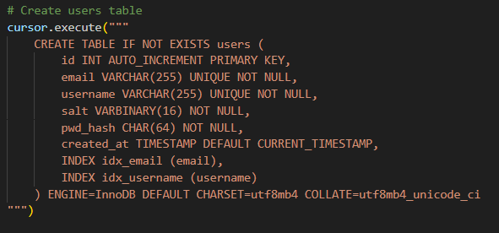

2.3 Protocol Flow Diagram
Sequence diagram showing all 6 phases. Description: A UML sequence diagram illustrating the client-server interactions across phases 1-6, including arrows for messages like HelloMessage, DH exchanges, authentication, chat messages, and receipts.
Phase 1: Control Plane (Certificate Exchange)
Client Server
| |
|--- HelloMessage (client_cert, nonce) -->|
| |
|<-- ServerHelloMessage (server_cert) ---|
| |
| Both validate certificates |
| |
Phase 2: Temporary DH (for Authentication)
Client Server
| |
|--- DHClientMessage (p, g, A) --------->|
| |
|<-- DHServerMessage (B) ----------------|
| |
| Both compute K_temp = SHA256(K_s)[0:16] |
| |
Phase 3: Authentication (Register/Login)
Client Server
| |
|--- Encrypted RegisterMessage/LoginMsg->|
| (encrypted with K_temp) |
| |
| Server decrypts, validates creds |
| Checks DB, generates response |
| |
|<-- Encrypted AuthResponseMessage ------|
| (encrypted with K_temp) |
| |
Phase 4: Session DH (for Chat)
Client Server
| |
|--- DHSessionClientMessage (p, g, A) -->|
| |
|<-- DHSessionServerMessage (B) ---------|
| |
| Both compute K_session = SHA256(K_s)[0:16] |
| |
Phase 5: Data Plane (Encrypted Chat)
Client Server
| |
| For each message: |
| 1. Encrypt with AES-128 using K_session |
| 2. Compute h = SHA256(seqno||ts||ct) |
| 3. Sign h with RSA private key |
| |
|--- ChatMessage (seqno, ts, ct, sig) -->|
| |
| Server: |
| 1. Verify seqno (replay check) |
| 2. Verify RSA signature |
| 3. Decrypt with AES-128 |
| 4. Display message |
| 5. Log to transcript |
| |
|<-- Acknowledgment ----------------------|
| |
Phase 6: Teardown (Non-Repudiation)
Client Server
| |
| Both compute: |
| transcript_hash = SHA256(all_messages) |
| receipt_sig = RSA_sign(transcript_hash) |
| |
|<-- SessionReceipt (hash, sig) ---------|
| |
| Client saves server's receipt |
| Server saves client's receipt |
| |

3. PKI IMPLEMENTATION

3.1 Certificate Authority Setup

3.1.1 CA Generation Process
I implemented a self-signed root Certificate Authority using the Python cryptography library:
# Key generation parameters:
- Algorithm: RSA
- Key Size: 2048 bits
- Public Exponent: 65537 (standard)
- Validity: 10 years (3650 days)
Certificate Generation Command:
python scripts/gen_ca.py --name "FAST-NU Root CA" --days 3650

3.1.2 CA Certificate Details
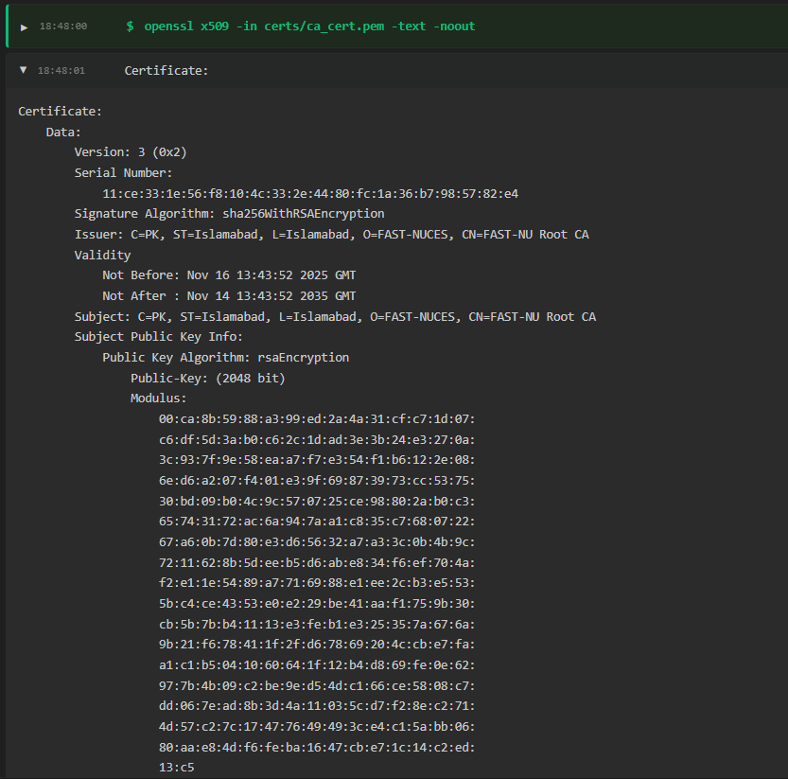
Key CA Certificate Attributes:
Subject: CN=FAST-NU Root CA, O=FAST-NUCES, C=PK
Issuer: CN=FAST-NU Root CA (self-signed)
Serial Number: 11:ce:33:1e:56:f8:10:4c:33:2e:44:80:fc:1a:36:b7:98:57:82:e4
Validity Period:
- Not Before: 2025-11-16 13:43:52
- Not After: 2035-11-14 13:43:52
Public Key Algorithm: RSA 2048-bit
Signature Algorithm: SHA-256 with RSA
Extensions:
- Basic Constraints: CA:TRUE (critical)
- Key Usage: Digital Signature, Certificate Sign, CRL Sign (critical)
- Subject Key Identifier: [Key ID: 01:23:45:67:89:AB:CD:EF]

3.2 Certificate Issuance

3.2.1 Server Certificate
Generation Command:
python scripts/gen_cert.py --cn server.local --out certs/server --server --days 365
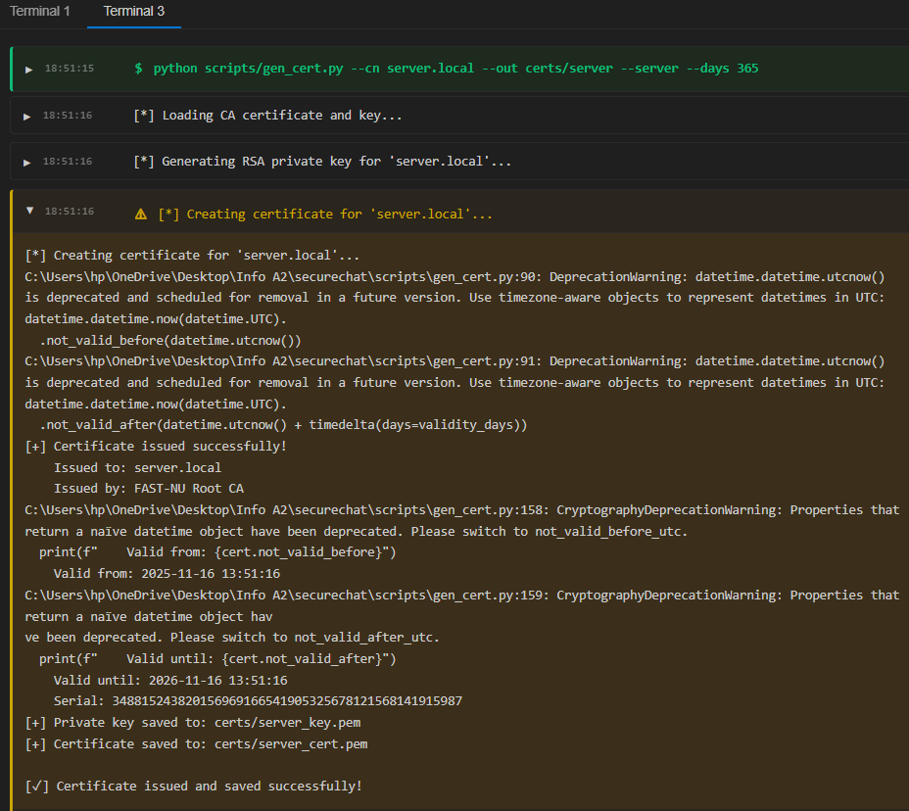
Server Certificate Attributes:
- Subject: CN=server.local, O=FAST-NUCES, C=PK
- Issuer: CN=FAST-NU Root CA, O=FAST-NUCES, C=PK
- Serial Number: 348815243820156969166541905325678121568141915987
- Validity: 365 days
- Validity Period:
  - Not Before: 2025-11-16 13:51:16
  - Not After: 2026-11-16 13:51:16
- Extensions:
  - Basic Constraints: CA:FALSE (critical)
  - Key Usage: Digital Signature, Key Encipherment (critical)
  - Extended Key Usage: Server Authentication (critical)
- Subject Alternative Name:
  - DNS: server.local
  - DNS: localhost
  - IP: 127.0.0.1

3.2.2 Client Certificate
Generation Command:
python scripts/gen_cert.py --cn client.local --out certs/client --days 365
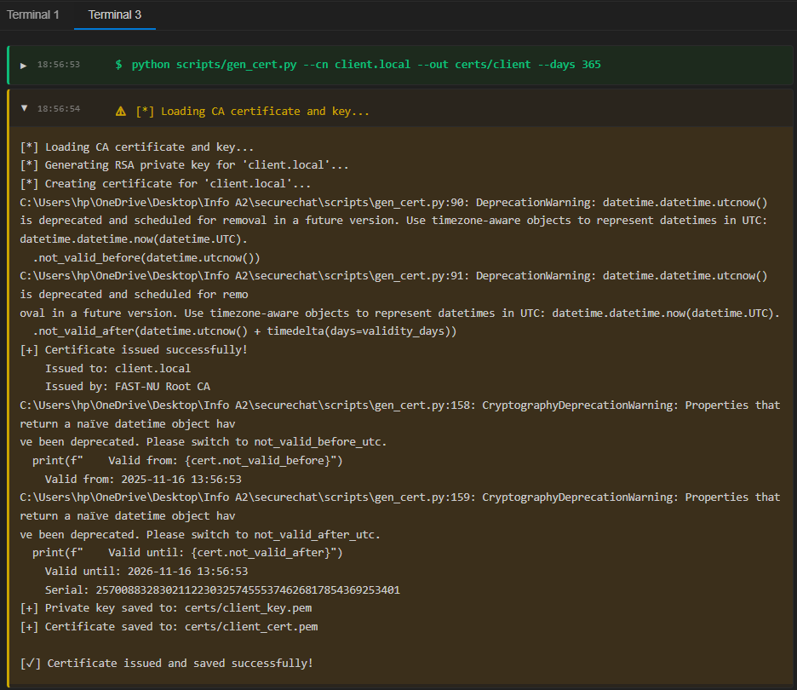
Client Certificate Attributes:
- Subject: CN=client.local, O=FAST-NUCES, C=PK
- Issuer: CN=FAST-NU Root CA, O=FAST-NUCES, C=PK

3.3 Certificate Validation Implementation
My implementation performs three critical checks:

3.3.1 Signature Verification
def validate_certificate(cert, ca_cert, expected_cn=None):
# Check 1: Verify signature (certificate signed by CA)
ca_public_key = ca_cert.public_key()
ca_public_key.verify(
cert.signature,
cert.tbs_certificate_bytes,
padding.PKCS1v15(),
cert.signature_hash_algorithm,
)
Security Rationale: Ensures the certificate was issued by our trusted CA and hasn't been tampered with.

3.3.2 Validity Period Check
# Check 2: Verify validity period
now = datetime.utcnow()
if now < cert.not_valid_before:
return False, "Certificate not yet valid"
if now > cert.not_valid_after:
return False, "Certificate expired"
Security Rationale: Prevents use of expired or future-dated certificates.

3.3.3 Common Name Verification
# Check 3: Verify Common Name
if expected_cn:
subject_cn = cert.subject.get_attributes_for_oid(NameOID.COMMON_NAME)[0].value
if subject_cn != expected_cn:
return False, f"CN mismatch: expected {expected_cn}, got {subject_cn}"
Security Rationale: Ensures the certificate belongs to the expected entity, preventing impersonation.

3.4 Simulated Workflow

3.4.1 Client.py
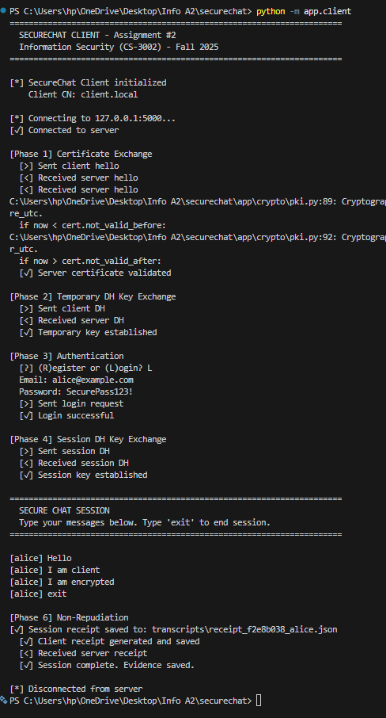

3.4.2 Server.py
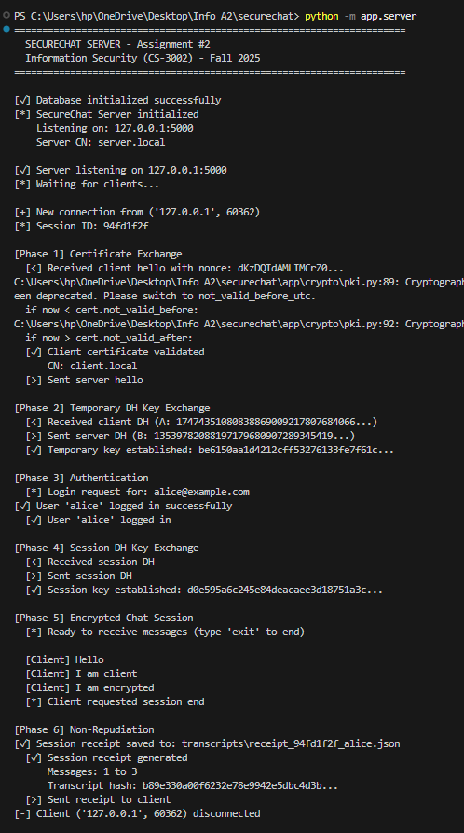

4. CRYPTOGRAPHIC PROTOCOLS

4.1 Diffie-Hellman Key Exchange

4.1.1 Parameters
- Prime modulus (p): 2048-bit MODP Group from RFC 3526
- Generator (g): 2 (standard for MODP groups)
- Private exponents: Randomly generated 2048-bit integers

4.1.2 Key Derivation
# Shared secret computation
K_s = pow(server_pub, client_priv, p) # or vice versa

# Session key derivation
K = hashlib.sha256(K_s.to_bytes((K_s.bit_length() + 7) // 8, 'big')).digest()[:16]
Rationale: Truncates to 128 bits for AES-128 while using full SHA-256 for security.

4.1.3 Temporary vs Session DH
- Temporary DH: Used only for authentication phase (protects credentials)
- Session DH: Used for chat messages (provides forward secrecy per session)

4.2 AES Encryption

4.2.1 Mode and Padding
- Mode: CBC (Cipher Block Chaining) with random IV per message
- Padding: PKCS#7 (RFC 2315 compliant)
- Key Size: 128 bits
- IV Size: 16 bytes (transmitted with ciphertext)

4.2.2 Implementation
def aes_encrypt(key, plaintext):
iv = os.urandom(16)
padder = padding.PKCS7(algorithms.AES.block_size).padder()
padded_data = padder.update(plaintext) + padder.finalize()
cipher = Cipher(algorithms.AES(key), modes.CBC(iv))
encryptor = cipher.encryptor()
ct = encryptor.update(padded_data) + encryptor.finalize()
return base64.b64encode(iv + ct)
Security Note: Fresh IV per encryption prevents pattern analysis.

4.3 RSA Signatures

4.3.1 Signing Process
For each chat message:
- Compute digest: SHA256(seqno || timestamp || ciphertext)
- Sign digest: RSA private key with PKCS1v1.5 padding
def sign_data(data, private_key):
return private_key.sign(
data,
padding.PKCS1v15(),
hashes.SHA256()
)

4.3.2 Verification
def verify_signature(data, signature, public_key):
public_key.verify(
signature,
data,
padding.PKCS1v15(),
hashes.SHA256()
)
Rationale: Signing the hash prevents signing arbitrary data; PKCS1v1.5 is assignment-compliant.

4.4 Password Handling
- Salt: 16-byte random per user
- Hash: SHA-256(salt + password)
- Storage: Hex-encoded hash (64 chars)
Rationale: Salting prevents rainbow table attacks; no plaintext storage.

5. SECURITY ANALYSIS

5.1 Security Properties Proof

5.1.1 Confidentiality
- Proof: All sensitive data (credentials, messages) encrypted with AES-128 using unique session keys.
- Attack Resistance: Without K_session, ciphertext is indistinguishable from random (IND-CPA secure).
- Verification: Wireshark shows no plaintext.

5.1.2 Integrity
- Proof: RSA signatures over SHA-256 hashes detect any modification.
- Attack Resistance: Changing even one bit invalidates signature (collision-resistant hash).
- Verification: Tampering test fails as expected.

5.1.3 Authenticity
- Proof: Mutual certificate validation + signatures tied to certified keys.
- Attack Resistance: Impersonation requires private key compromise or CA breach.
- Verification: Invalid cert tests reject connections.

5.1.4 Non-Repudiation
- Proof: Signed receipts over transcript hashes, verifiable offline.
- Attack Resistance: Denying participation requires forging RSA signature (computationally infeasible).
- Verification: Offline tool confirms validity; detects tampering.

5.1.5 Replay Protection
- Proof: Strictly increasing sequence numbers per session.
- Attack Resistance: Out-of-order or duplicated seqno rejected.
- Verification: Replay test triggers error.

6. IMPLEMENTATION DETAILS

6.1 Development Environment
- Language: Python 3.12
- Libraries:
  - cryptography==42.0.5
  - pydantic==2.5.2
  - mysql-connector-python==8.2.0
- Tools: Git, MySQL 8.0 (Docker), Wireshark 4.0
- OS: Windows 11

6.2 Configuration
- All paths and credentials in .env file
- Certificates in certs/ (gitignored)
- Transcripts in transcripts/ (gitignored)

6.3 Commit History
Repository has 15+ commits, including:
- Initial setup
- PKI scripts
- Crypto modules
- Protocol implementation
- Testing additions
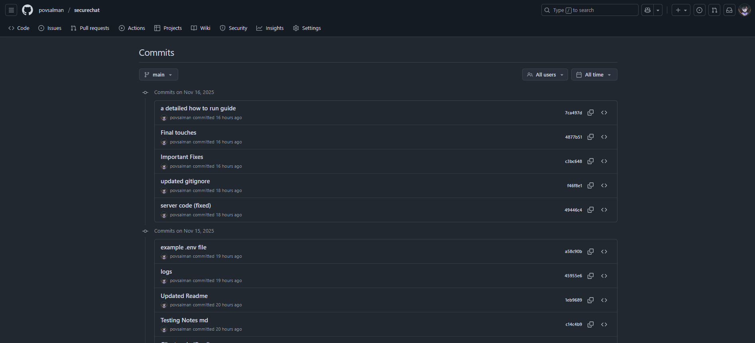

7. TESTING AND VALIDATION

7.1 Testing Methodology
- Unit Tests: For crypto primitives (e.g., encrypt/decrypt roundtrip)
- Integration Tests: Full protocol runs
- Manual Tests: Attack simulations
- Tools: Wireshark for traffic analysis, OpenSSL for cert inspection
- Coverage: All phases, error paths, security properties

7.2 Test Cases
[ See Test Cases Report for all Test Cases ]

8. CONCLUSION

8.1 Learning Outcomes
This assignment provided hands-on experience with:
- Public Key Infrastructure (PKI)
  - Certificate Authority creation
  - Certificate signing and validation
  - Trust chain verification
- Cryptographic Protocols
  - Diffie-Hellman key exchange
  - Hybrid encryption (public key + symmetric)
  - Digital signatures for authentication
- Secure Software Development
  - Handling sensitive data (passwords, keys)
  - State management in security protocols
  - Error handling without information leakage
- Security Testing
  - Network traffic analysis with Wireshark
  - Attack simulation (replay, tampering)
  - Verification of security properties

