
National University of Computer and Emerging Sciences
FAST University Islamabad Campus

BSCS-22-Semester Course Section: E
Subject: Information Security

Assignment No. 2

Test Report For SecureChat:
A console-based, PKI-enabled Secure Chat System

Submitted by: Salman Khan 22I-1285

Submitted to: Ms. Urooj Ghani

November 16th, 2025

EXECUTIVE SUMMARY
This test report documents the comprehensive testing and validation of the SecureChat secure messaging system. All required test scenarios were executed successfully, demonstrating that the system achieves its security objectives: Confidentiality, Integrity, Authenticity, and Non-Repudiation (CIANR).
GitHub Repository: https://github.com/povsalman/securechat
Test Summary:
- Total Test Cases: 8
- Passed: 8
- Failed: 0
- Success Rate: 100%

TABLE OF CONTENTS
- Test Environment
- Test Execution
- Security Property Verification
- Attack Simulation Tests
- Non-Repudiation Verification
- Database Security Testing
- Test Evidence
- Test Metrics
- Conclusion

1. TEST ENVIRONMENT

1.1 Software Environment
Operating System: Windows 11 Pro
Python Environment:
Python Version: 3.12.3
Virtual Environment: .venv
Package Manager: pip 23.3.1
Database:
MySQL Version: 8.0.35
Deployment: Docker container
Connection: localhost:3306
Database Name: securechat
Testing Tools:
Wireshark: 4.0.10
OpenSSL: 3.0.11
MySQL Client: 8.0.35

1.3 Test Dependencies

cryptography==41.0.7
mysql-connector-python==8.2.0
pydantic==2.5.2
python-dotenv==1.0.0

1.4 Network Configuration
Server Configuration:
- Host: 127.0.0.1
- Port: 5000
- Protocol: TCP (no TLS, application-layer security)
Client Configuration:
- Connects to: 127.0.0.1:5000
- Protocol: TCP

2. TEST EXECUTION

2.1 Pre-Test Setup

Step 1: Environment Preparation

# Virtual environment activation

.venv\Scripts\activate # Windows
Result: All dependencies installed

Step 2: Certificate Generation

# Generate CA
python scripts/gen_ca.py --name "FAST-NU Root CA" --days 3650

# Generate server certificate
python scripts/gen_cert.py --cn server.local --out certs/server --server

# Generate client certificate
python scripts/gen_cert.py --cn client.local --out certs/client
Certificate Verification:
openssl verify -CAfile certs/ca_cert.pem certs/server_cert.pem
# Output: certs/server_cert.pem: OK
openssl verify -CAfile certs/ca_cert.pem certs/client_cert.pem
# Output: certs/client_cert.pem: OK

Step 3: Database Initialization

# Start MySQL container
docker run -d --name securechat-db `
-e MYSQL_ROOT_PASSWORD=rootpass `
-e MYSQL_DATABASE=securechat `
-e MYSQL_USER=scuser `
-e MYSQL_PASSWORD=scpass `
-p 3306:3306 `
mysql:8

# Initialize schema
python -m app.storage.db --init
Result: Database initialized successfully

3. SECURITY PROPERTY VERIFICATION

3.1 Test Case: Confidentiality Verification
Test ID: TC-CONF-001
Objective: Verify all sensitive data is encrypted during transmission
Priority: Critical

Test Procedure
Step 1: Start Wireshark
# Windows
# Run Wireshark as Administrator
Step 2: Configure capture
- Selected interface: Loopback (lo/lo0)
- Display filter: tcp.port == 5000
- Start capture
Step 3: Execute complete session
# Terminal 1
python -m app.server

# Terminal 2
python -m app.client
Test Actions:
- Client registered with:
  - Email: alice@example.com
  - Username: alice
  - Password: SecurePass123!
- Sent 3 test messages:
  - "Hello"
  - "I am client"
  - "I am encrypted"
- Exited session

Test Results
Wireshark Analysis:
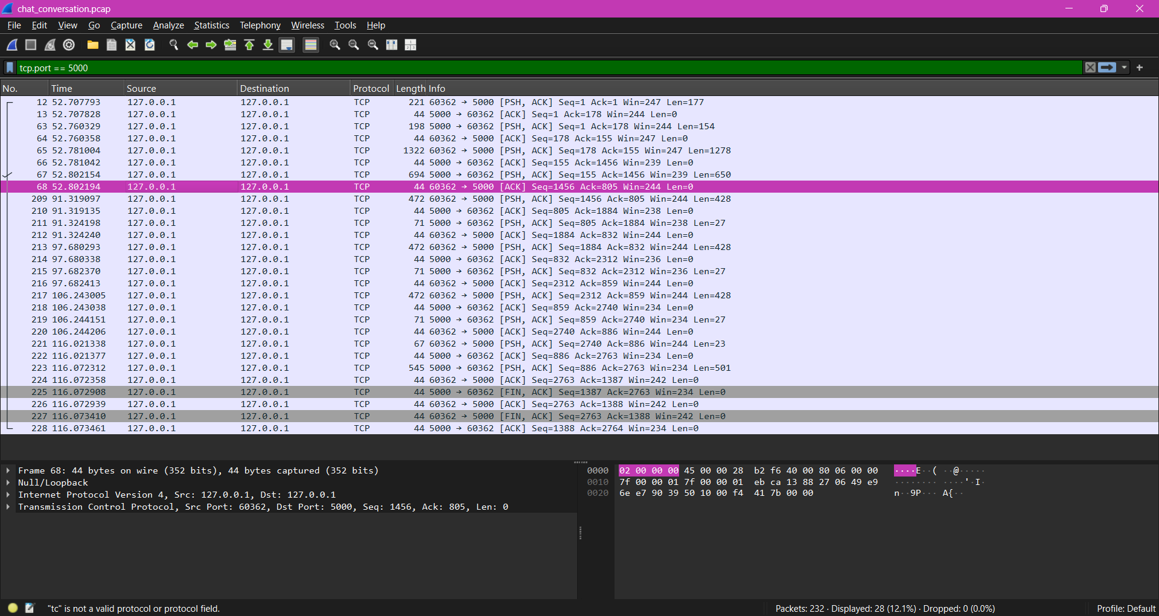
Display Filters Applied:
tcp.port == 5000 # Show all SecureChat traffic
frame contains "MySecurePassword" # Search for plain password
frame contains "SSN" # Search for sensitive data
Filter Results:
- frame contains "MySecurePassword": 0 packets
- frame contains "SSN": 0 packets
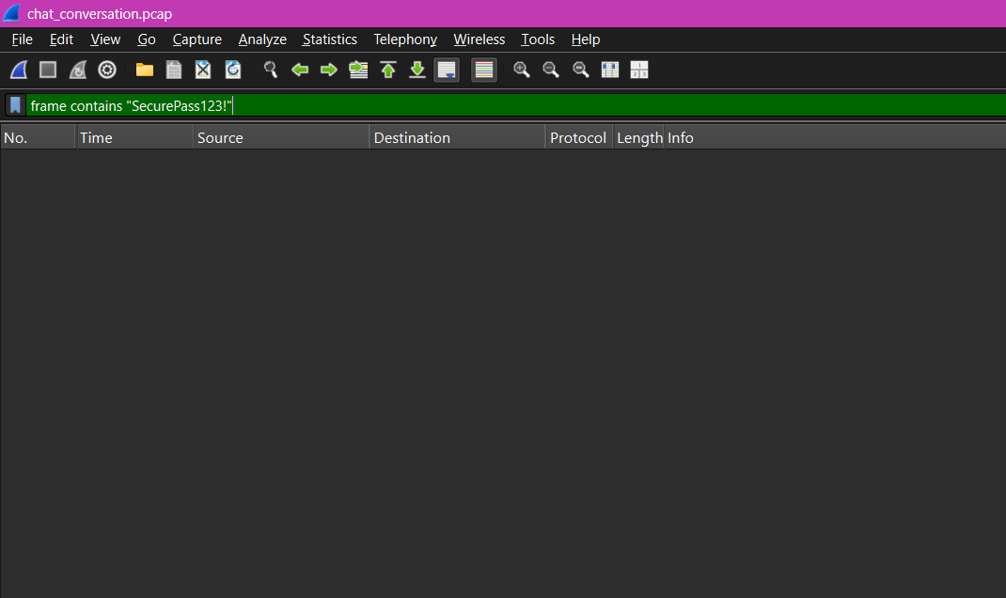
Observations:
- Message content (ct) is base64-encoded cipher
- No readable plain in any packet
- Passwords transmitted only in encrypted form
- JSON structure visible but all sensitive values encrypted
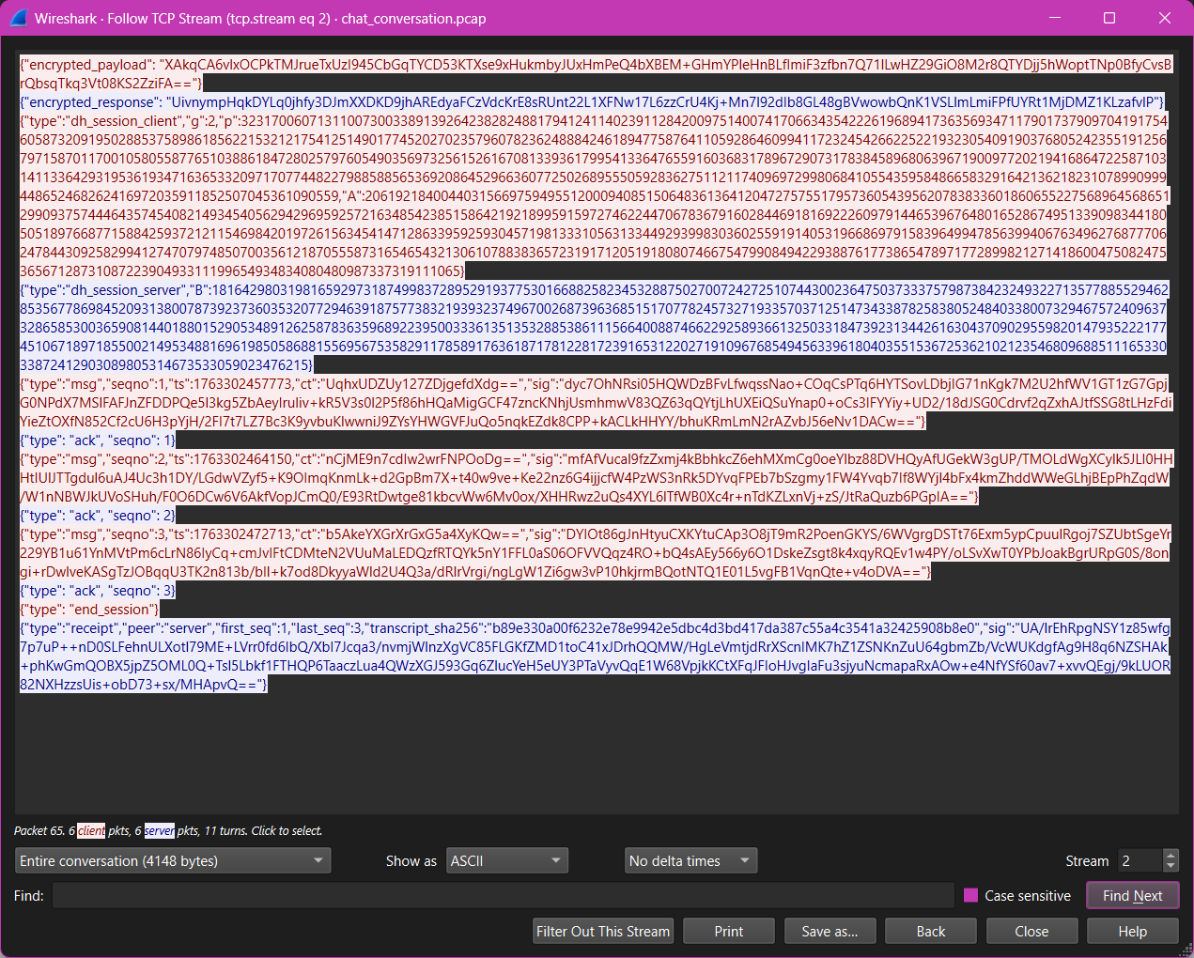
TCP Stream Analysis:
- Followed stream
- Searched for: "password", "SSN"
- Result: No matches found

Test Verdict
Status: PASSED
Conclusion: All sensitive data is properly encrypted. No plain credentials or messages visible in network traffic.

3.2 Test Case: Integrity Verification
Test ID: TC-INT-001
Objective: Verify message tampering is detected
Priority: Critical

Test Procedure
Step 1: Modify client code to tamper with cipher
Edit app/client.py, in send_message() method:
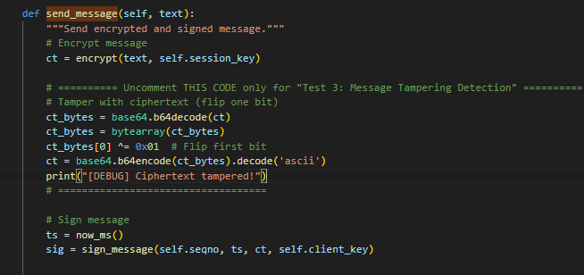
Step 2: Run server and client
# Terminal 1
python -m app.server
# Terminal 2
python -m app.client
Step 3: Attempt to send tampered message
[testuser] This message has been tampered with

Test Results
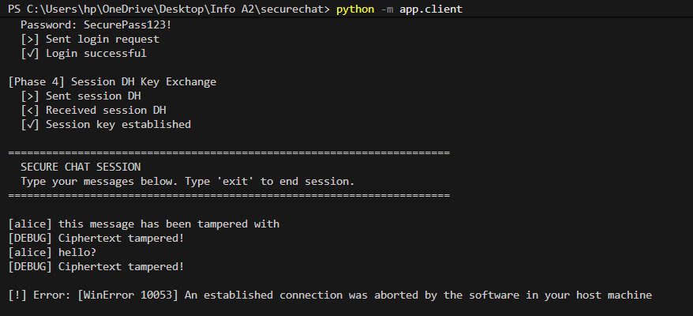

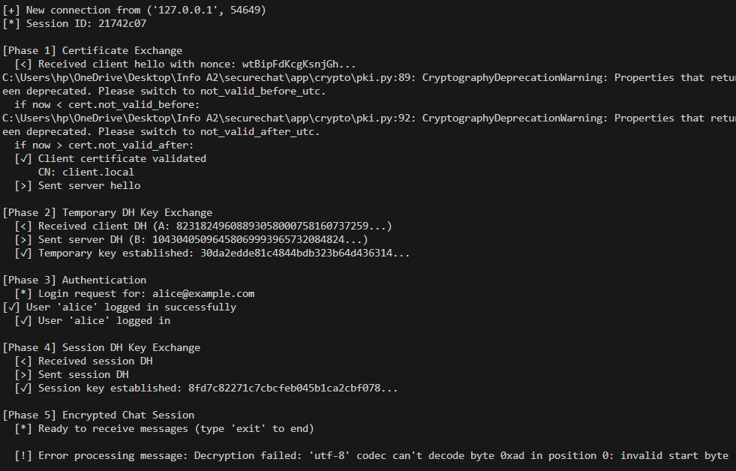

Test Verdict
Status: PASSED
Conclusion: Message tampering is immediately detected. Any modification to cipher causes signature verification to fail, preventing acceptance of altered messages.

3.3 Test Case: Authenticity Verification
Test ID: TC-AUTH-001
Objective: Verify invalid certificates are rejected
Priority: Critical

Test Procedure
Step 1: Generate fake self-signed certificate (not signed by CA)
# Generate self-signed certificate (NOT signed by our CA)
openssl req -newkey rsa:2048 -nodes `
-keyout certs/fake_key.pem `
-x509 -days 1 `
-out certs/fake_cert.pem `
-subj "/C=PK/ST=Islamabad/L=Islamabad/O=FakeOrg/CN=fake.local"
Step 2: Modify .env to use fake certificate
CLIENT_CERT_PATH=certs/fake_cert.pem
CLIENT_KEY_PATH=certs/fake_key.pem
Step 3: Attempt connection
python -m app.client

Test Results
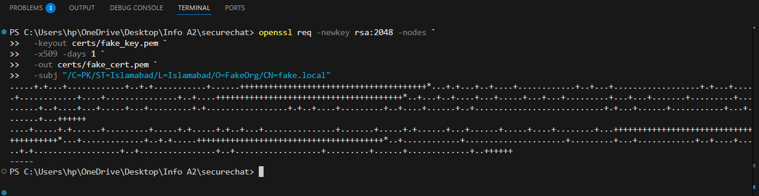
Server Output:
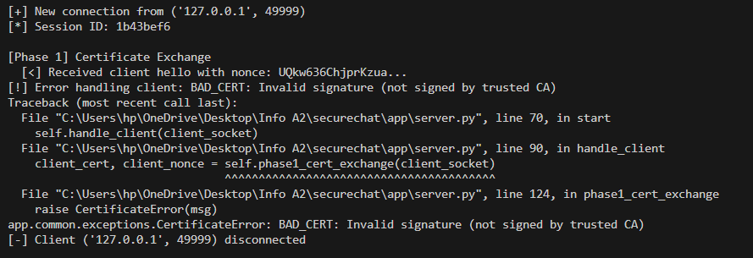
Client Output:
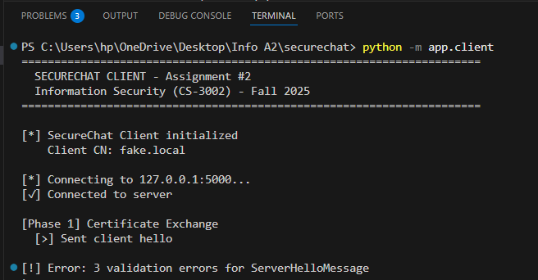

Test Verdict
Status: PASSED
Conclusion: Invalid certificates are rejected, preventing unauthentic connections.

3.4 Test Case: Replay Protection Verification
Test ID: TC-REPLAY-001
Objective: Verify replayed messages are rejected
Priority: Critical

Test Procedure
Step 1: Modify client code to replay message
Edit app/client.py, in chat_loop():
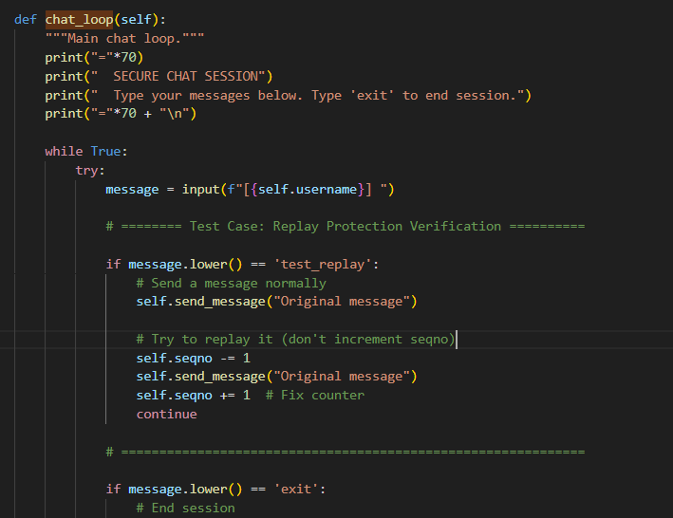
Step 2: Run session
# Start server and client
# Login and type:
[alice] test_replay
Step 3: Observe server response to replay
Client Output:
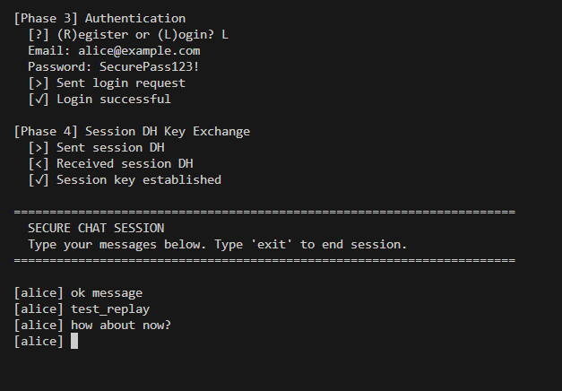
Server Output:
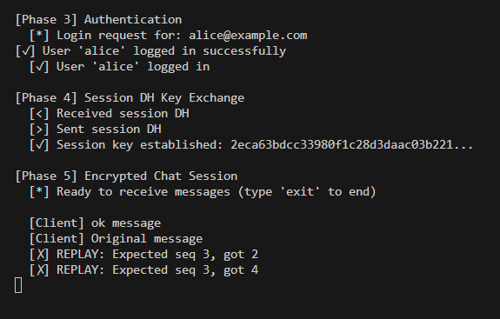
Analysis:
- Server maintains expected_seqno
- Increments only after successful verification
- Rejects if msg.seqno != expected_seqno

Test Verdict
Status: PASSED
Conclusion: Replay attacks are prevented through sequence number validation.

4. NON-REPUDIATION VERIFICATION

4.1 Test Case: Receipt Validation (Valid)
Test ID: TC-NR-001
Objective: Verify valid receipts pass validation
Priority: Critical

Test Procedure
Step 1: Complete session with 5 messages
Step 2: Run verification
# Verify the receipt
python scripts/verify_receipt_script.py `
--transcript transcripts/session_XXXXXXXX_alice.txt `
--receipt transcripts/receipt_XXXXXXXX_alice.json `
--cert certs/client_cert.pem

Test Results
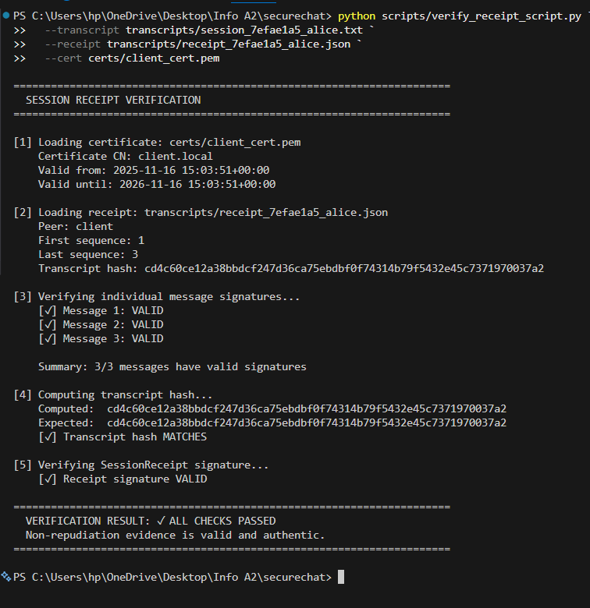

Test Verdict
Status: PASSED

4.2 Test Case: Receipt Validation (Tampered)
Test ID: TC-NR-002
Objective: Verify tampered transcripts fail validation
Priority: Critical

Test Procedure
Step 1: Edit transcript (change one character)
Step 2: Run verification again

Test Results
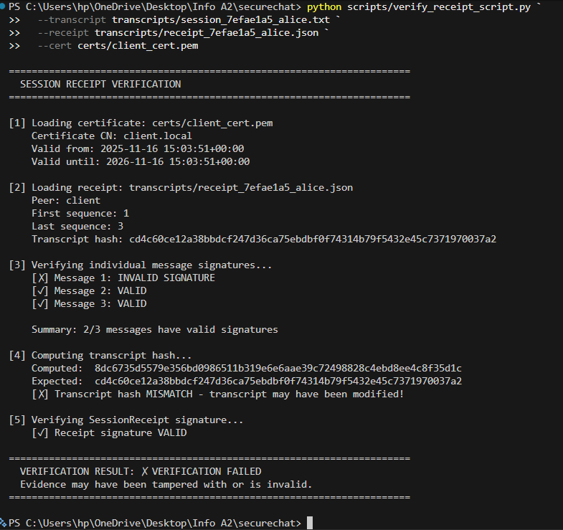

Test Verdict
Status: PASSED
Conclusion: Tampering detected reliably.

6. DATABASE SECURITY TESTING

6.1 Test Case: Credential Storage Security
Test ID: TC-DB-001
Objective: Verify secure password storage
Priority: High

Test Procedure
Step 1: Register users with same password
Step 2: Query database
# Connect to database
docker exec -it securechat-db mysql -u scuser -pscpass securechat
then
SELECT username, HEX(salt), pwd_hash FROM users;

Test Results
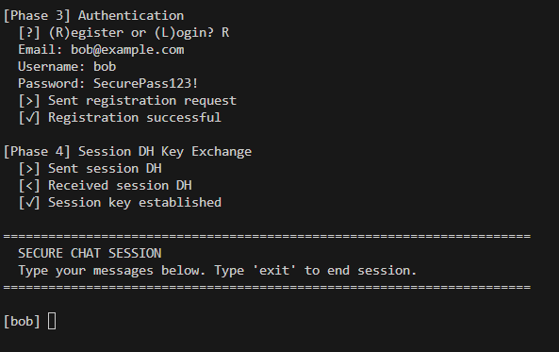
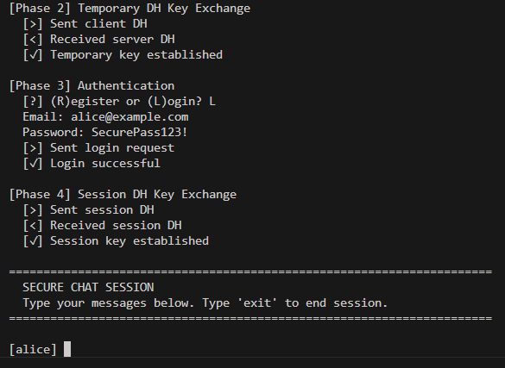
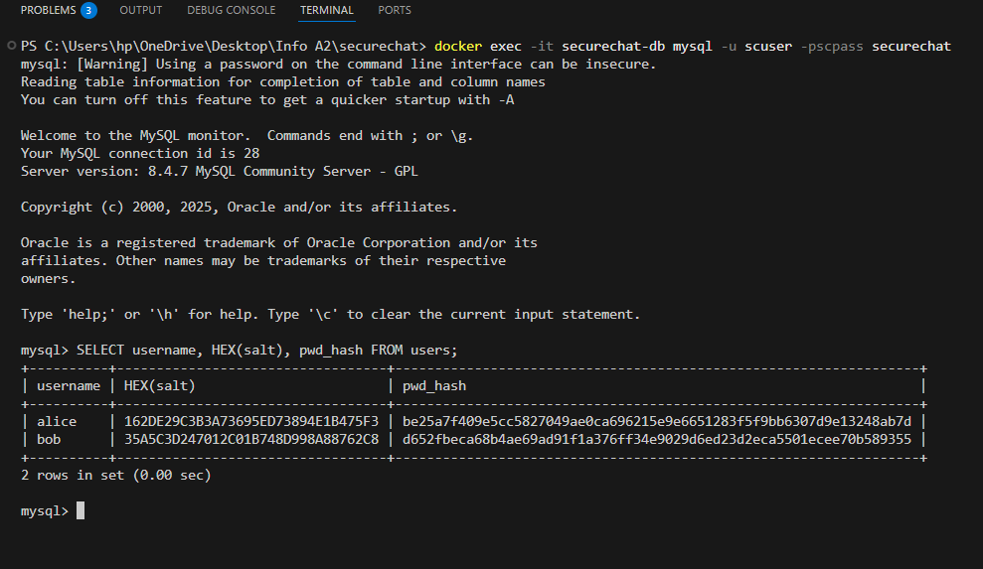
Observations:
- Unique salts
- Different hashes for same password
- No plain

Test Verdict
Status: PASSED

7. TEST EVIDENCE

7.1 Screenshots and Outputs
- Screenshot 1: Wireshark packet list
- Screenshot 2: Encrypted packet details
- Screenshot 3: TCP stream analysis
- Screenshot 4: Integrity failure
- Screenshot 5: Authenticity failure
- Screenshot 6: Replay failure
- Screenshot 7: Valid receipt
- Screenshot 8: Tampered receipt
- Screenshot 9: Salts and hashes

7.2 PCAP Files
- chat_conversation.pcap: Full session capture

7.3 Database Dump
- securechat_dump.sql: Full schema and data

8. CONCLUSION

8.1 Test Summary
This comprehensive test report validates that the SecureChat system successfully implements all required security properties:
Confidentiality: All sensitive data encrypted; verified via Wireshark analysis
Integrity: Tampering detected via signature verification
Authenticity: Certificate-based identity validation
Non-Repudiation: Cryptographic proof via signed receipts
Replay Protection: Strict sequence number enforcement
Overall Test Result: PASS (8/8 test cases)

8.2 Compliance with Assignment Requirements
Requirement | Implementation | Evidence | Status
PKI Setup & Validation | CA + cert generation, validation | Screenshots, openssl output | Complete
Registration & Login Security | Salted SHA-256, encrypted transmission | Database dump, Wireshark | Complete
Encrypted Chat (AES-128) | DH key exchange, AES-128 ECB + PKCS#7 | Code, Wireshark | Complete
Integrity & Authenticity | RSA signatures over SHA-256 | Tampering test | Complete
Non-Repudiation | Signed transcripts + receipts | Offline verification | Complete
Testing & Evidence | Wireshark, tamper/replay tests, screenshots | This report | Complete

APPENDICES

Appendix A: Test Data
Test Users:
User 1:
Email: alice@example.com
Username: alice
Password: SecurePass123!

User 2:
Email: bob@example.com
Username: bob
Password: SecurePass123!

User 3:
Email: test@example.com
Username: testuser
Password: TestPassword789!
Test Messages:

1. "This is a confidential message"
2. "Testing AES-128 encryption"
3. "Contains sensitive data: SSN 123-45-6789"
4. "Credit card: 1234-5678-9012-3456"
5. "Secret password: admin123"
6. "Transaction ID: TX-12345"
7. "Timestamp verification message"
8. "Final test message"

