**1, load_players()**

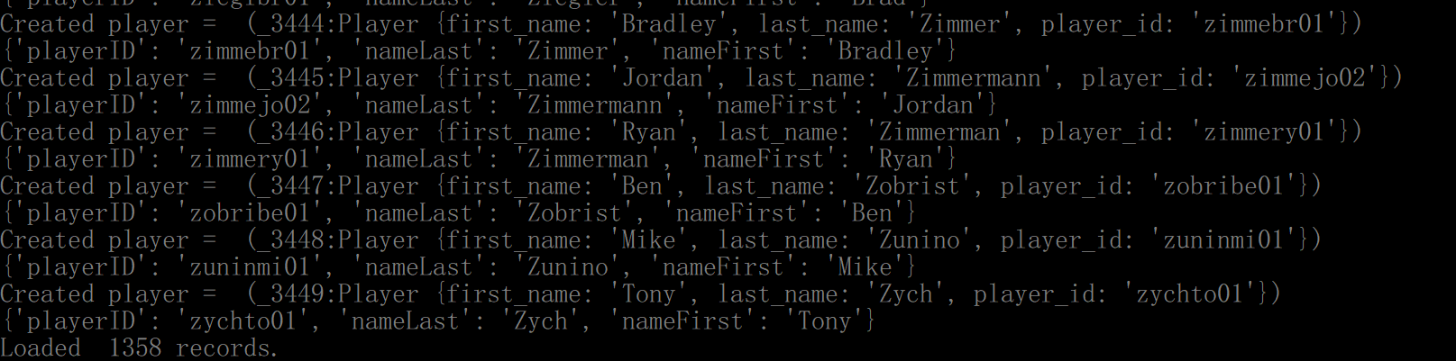

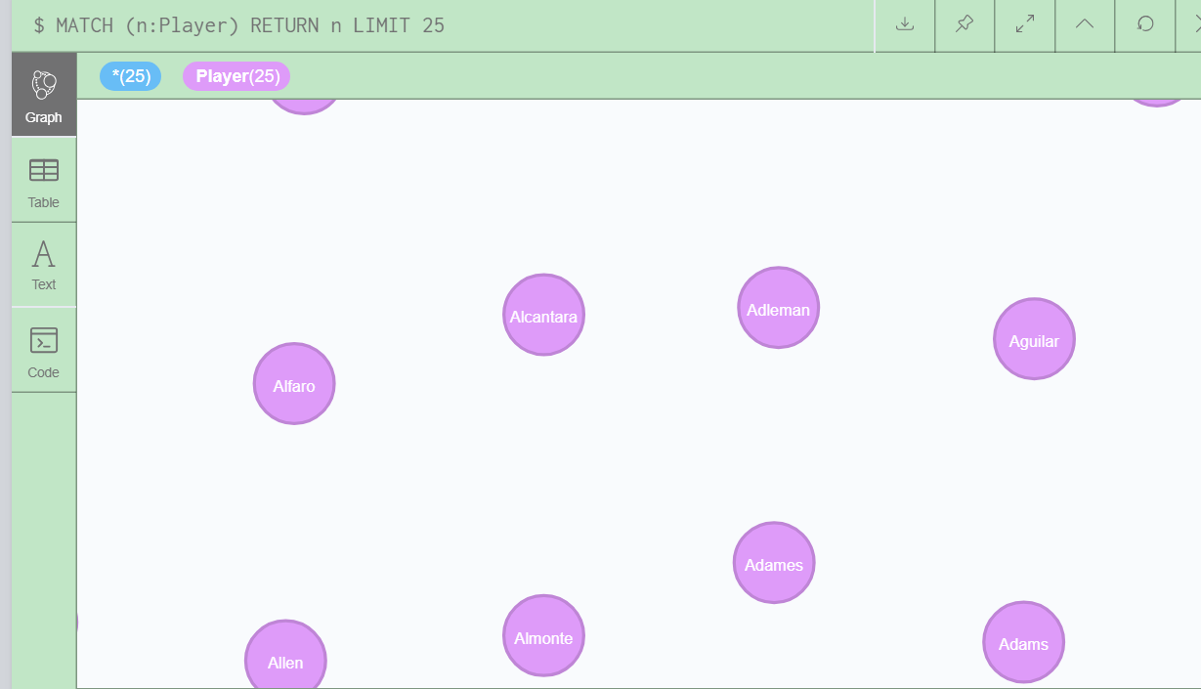

**2, load_teams()**

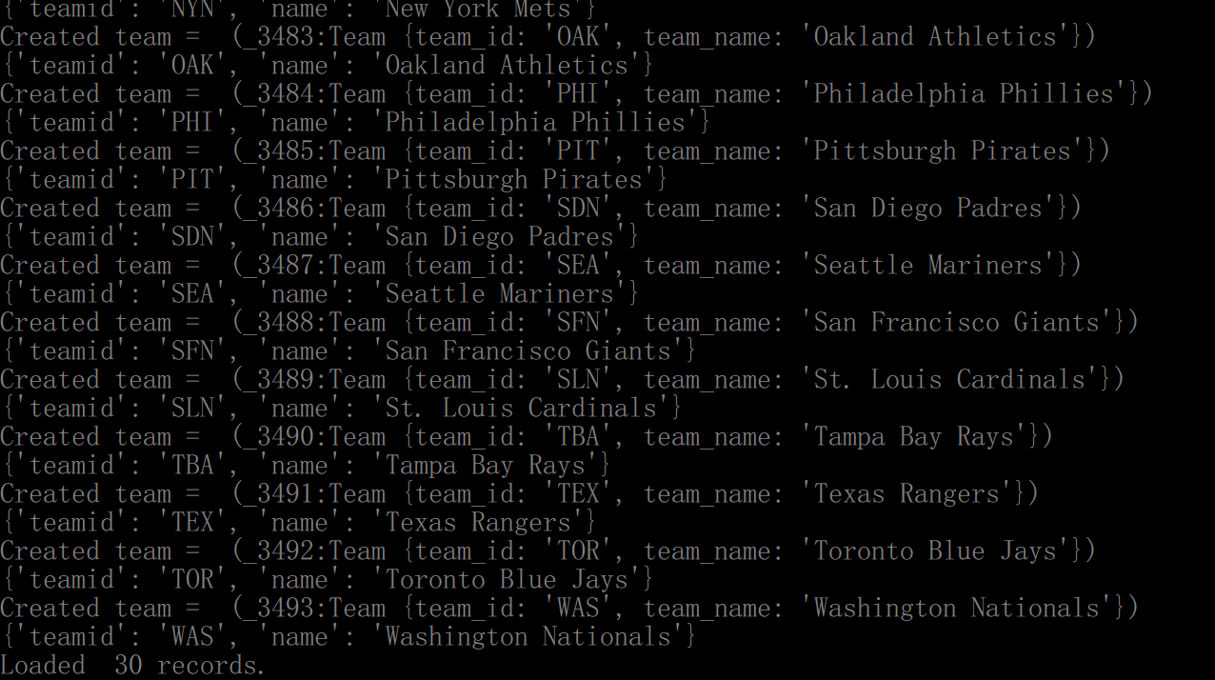

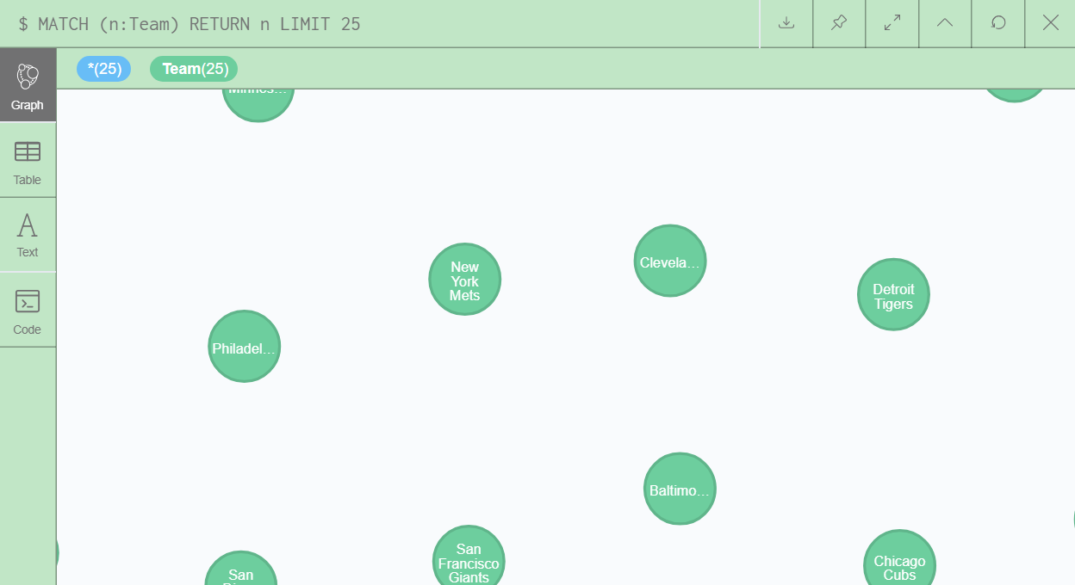

**3, load_apperances**

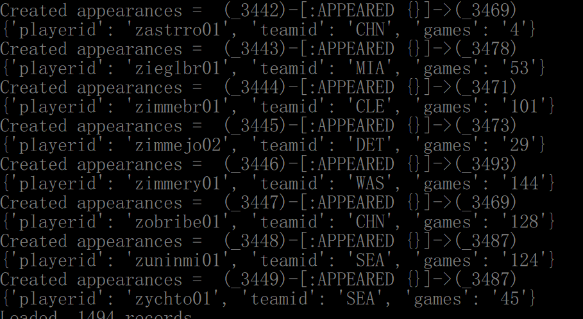

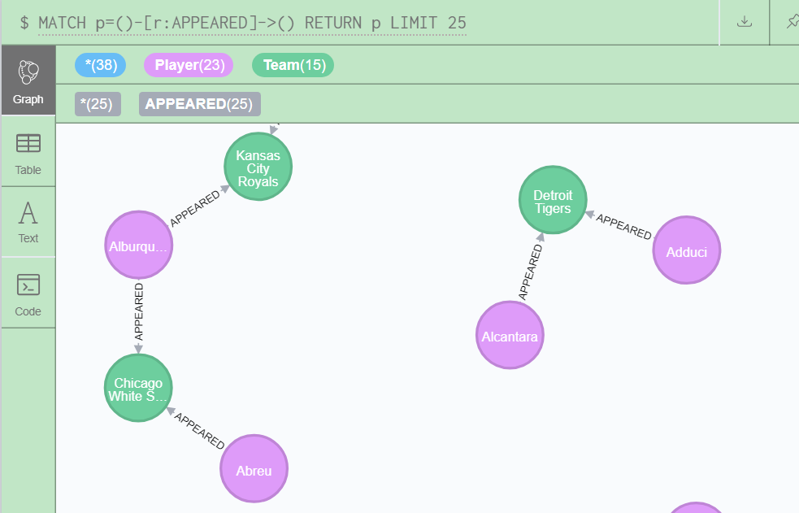

**4, load_follows_fans() and create_supports()**

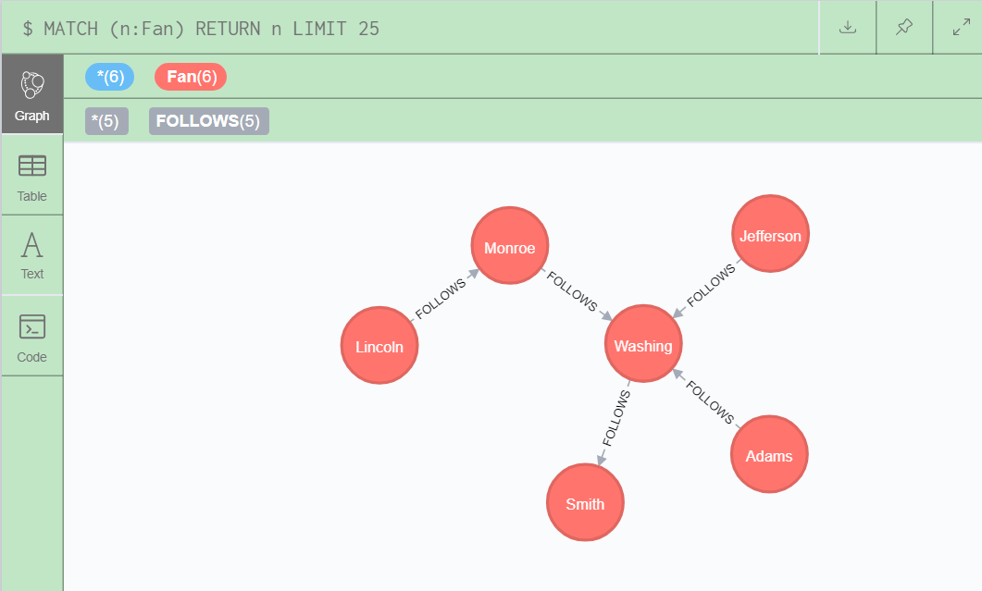

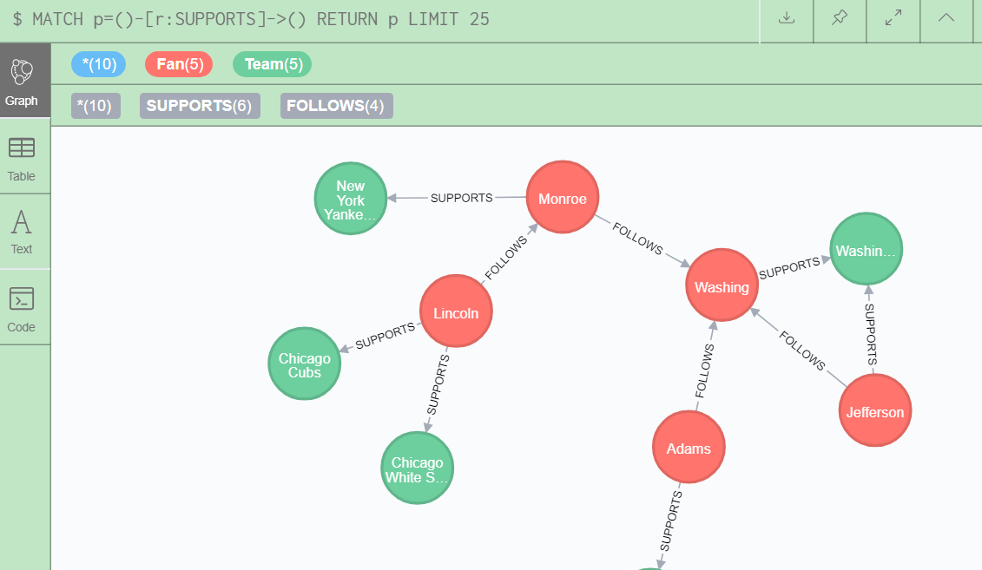

**6, test_create_comments()**



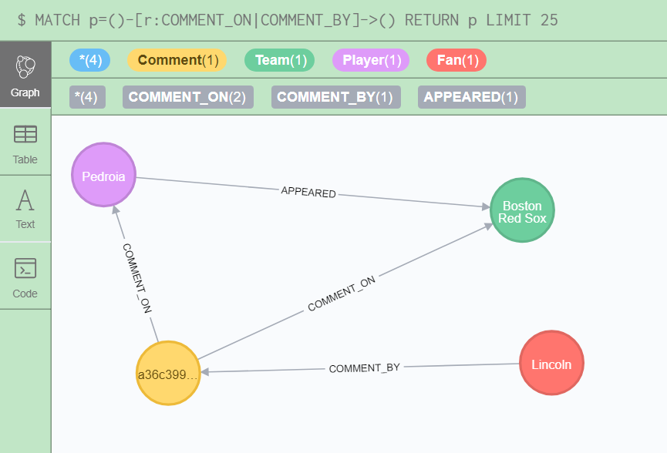

**7, test_create_sub_comments()**

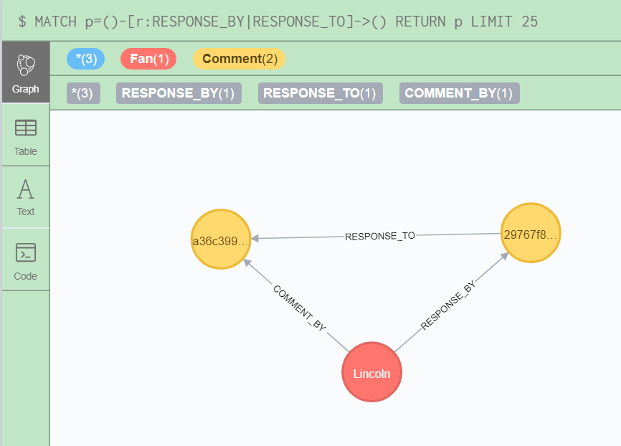

8, test_get_player_comments

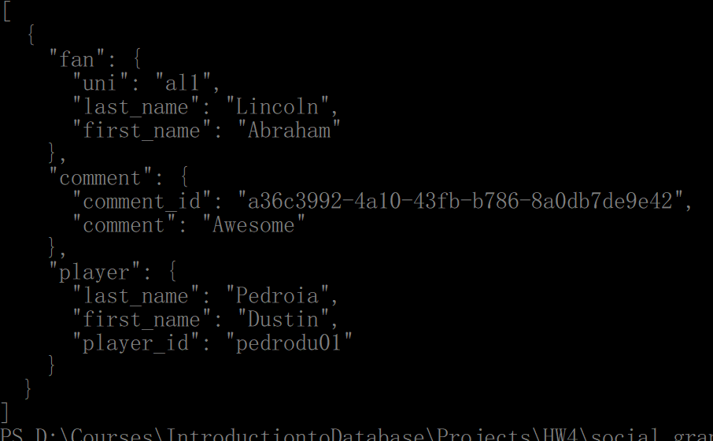

9, test_get_team_comments

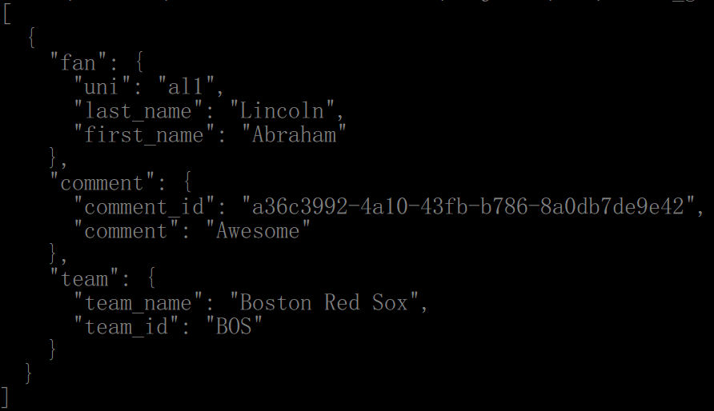

10， test_create_comment2



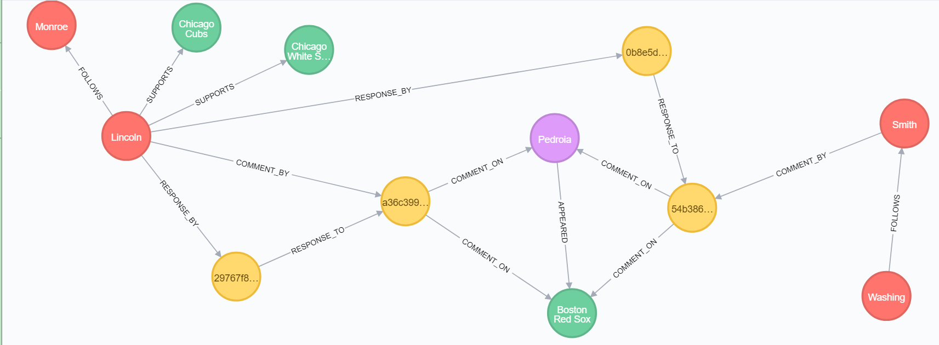

Now, we can see a complete relation graph between the player, team, fan and comments, the Simit comment on the player Pedroia, while Lincoln sub-comment on his comment. Also, Lincoln comment directly to the team BOS and player Pedroia, also, Lincoln comments on himself.

11， test_get_comment2

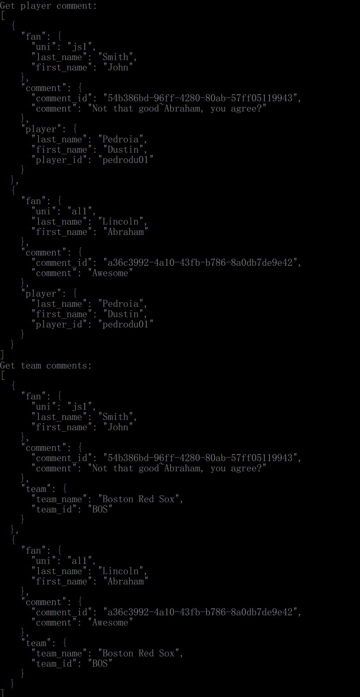

12, test_create_player_comment_only



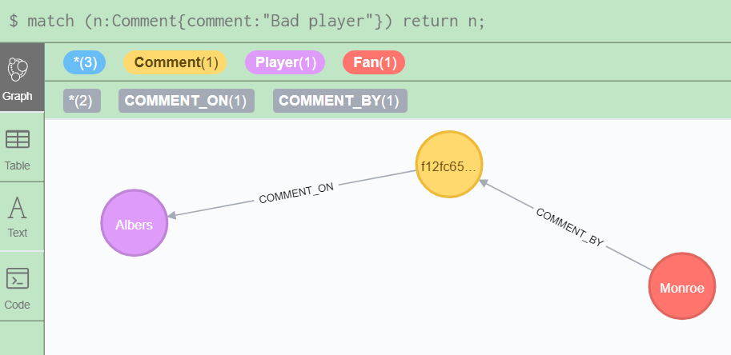

13, 12, test_create_team_comment_only



